EXP NO: 08
DATE: 19-09-2025
optical flow computation algorithm.
Aim: Implement optical flow computation algorithm.
Algorithm:
- Read two consecutive video frames.
- Convert both to grayscale.
- Compute optical flow using cv2.calcOpticalFlowFarneback().
- Visualize motion vectors using color coding.
- Overlay flow on original image.
- Display motion visualization.

Code:
import cv2
import numpy as np
from google.colab.patches import cv2_imshow

cap = cv2.VideoCapture('video.mp4')
ret, old = cap.read()
old_gray = cv2.cvtColor(old, cv2.COLOR_BGR2GRAY)

# Initial feature points
p0 = cv2.goodFeaturesToTrack(old_gray, maxCorners=50, qualityLevel=0.3, minDistance=7)
mask = np.zeros_like(old)

# Parameters for Lucas-Kanade optical flow
lk = dict(winSize=(15, 15), maxLevel=2,
criteria=(cv2.TERM_CRITERIA_EPS | cv2.TERM_CRITERIA_COUNT, 10, 0.03))

frame_count = 0
while True:
ret, frame = cap.read()
if not ret:
break
frame_gray = cv2.cvtColor(frame, cv2.COLOR_BGR2GRAY)

# Calculate optical flow
p1, st, _ = cv2.calcOpticalFlowPyrLK(old_gray, frame_gray, p0, None, **lk)

# Select good points
good_new = p1[st == 1]
good_old = p0[st == 1]

# Draw motion vectors every 5th frame only
if frame_count % 5 == 0:
mask[:] = 0 # clear mask for clean output
for (new, old_pt) in zip(good_new, good_old):
a, b = new.ravel()
c, d = old_pt.ravel()
mask = cv2.line(mask, (int(a), int(b)), (int(c), int(d)), (0, 255, 0), 2)
frame = cv2.circle(frame, (int(a), int(b)), 3, (0, 0, 255), -1)
motion = np.mean(np.linalg.norm(good_new - good_old, axis=1))
print(f"Frame {frame_count}: Avg motion = {motion:.2f}")
cv2_imshow(cv2.add(frame, mask))

# Update previous frame and points
old_gray = frame_gray.copy()
p0 = good_new.reshape(-1, 1, 2)
frame_count += 1

if cv2.waitKey(30) & 0xFF == 27: # ESC to quit
break

cap.release()
cv2.destroyAllWindows()

Output:
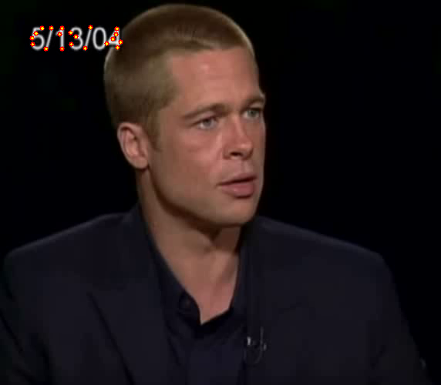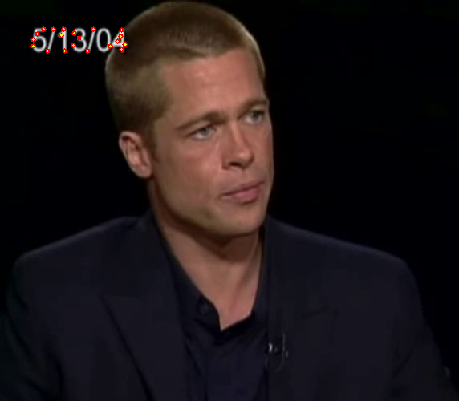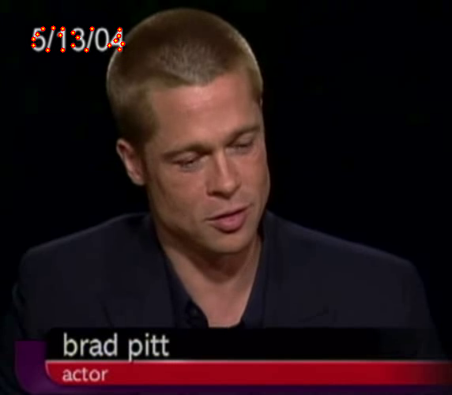
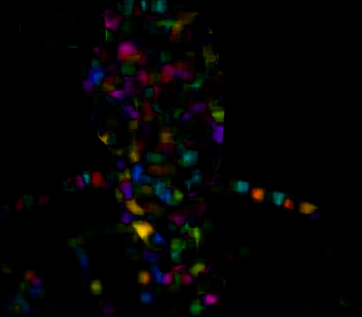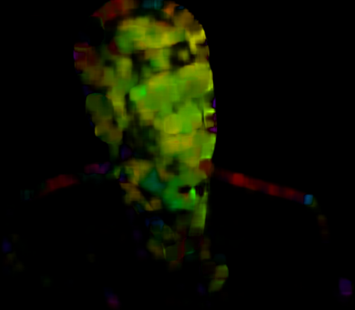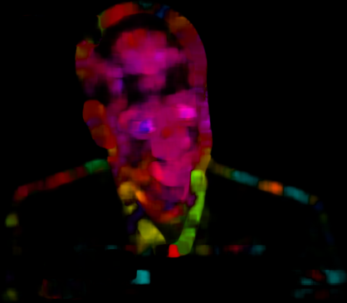

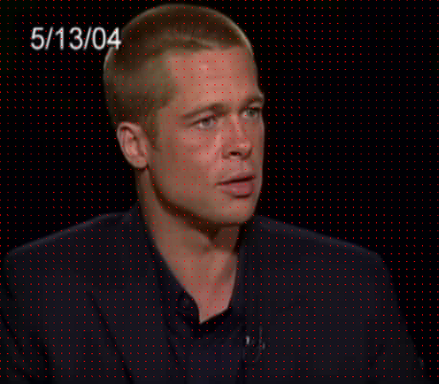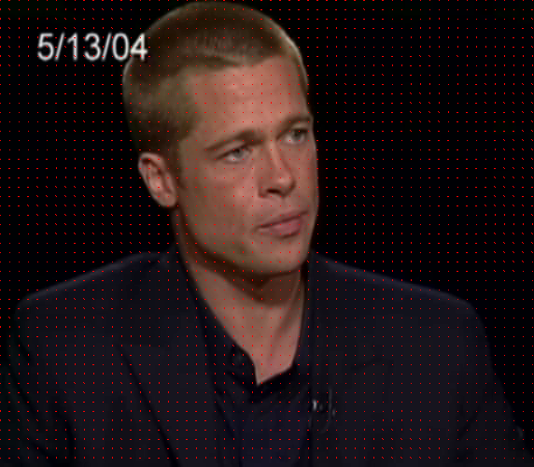

Result: Thus, optical flow computation algorithm was implemented successfully.

