EXP NO: 09
DATE: 26-09-2025
Face Detection
Aim: Face Detection on available online human face image datasets
Algorithm:
- Load pretrained Haar Cascade or DNN face detector.
- Read image or video frame.
- Convert to grayscale for faster detection.
- Detect faces using detectMultiScale().
- Draw bounding boxes around faces.
- Display and save output.

Code:
import cv2
from google.colab.patches import cv2_imshow
face_cascade = cv2.CascadeClassifier(cv2.data.haarcascades+'haarcascade_frontalface_default.xml')
img = cv2.imread('face.jpg'); gray = cv2.cvtColor(img, cv2.COLOR_BGR2GRAY)
faces = face_cascade.detectMultiScale(gray, 1.3, 5)
for (x,y,w,h) in faces: cv2.rectangle(img,(x,y),(x+w,y+h),(0,255,0),2)
cv2_imshow(img)

import dlib, cv2
from google.colab.patches import cv2_imshow
detector = dlib.get_frontal_face_detector()
img = cv2.imread('face.jpg'); rgb = cv2.cvtColor(img, cv2.COLOR_BGR2RGB)
for d in detector(rgb): cv2.rectangle(img,(d.left(),d.top()),(d.right(),d.bottom()),(0,255,0),2)
cv2_imshow(img); cv2.waitKey(0); cv2.destroyAllWindows()

from mtcnn import MTCNN
import cv2
from google.colab.patches import cv2_imshow
detector = MTCNN(); img = cv2.imread('face.jpg')
res = detector.detect_faces(cv2.cvtColor(img, cv2.COLOR_BGR2RGB))
for r in res: x,y,w,h = r['box']; cv2.rectangle(img,(x,y),(x+w,y+h),(0,255,0),2)
cv2_imshow(img); cv2.waitKey(0); cv2.destroyAllWindows()

import cv2
from google.colab.patches import cv2_imshow

net = cv2.dnn.readNetFromCaffe('deploy.prototxt','res10_300x300_ssd_iter_140000.caffemodel')
img = cv2.imread('face.jpg'); h,w = img.shape[:2]
blob = cv2.dnn.blobFromImage(cv2.resize(img,(300,300)),1.0,(300,300),(104,177,123))
net.setInput(blob); dets = net.forward()
for i in range(dets.shape[2]):
if dets[0,0,i,2]>0.5:
box = dets[0,0,i,3:7]*[w,h,w,h]; x1,y1,x2,y2 = box.astype(int)
cv2.rectangle(img,(x1,y1),(x2,y2),(0,255,0),2)
cv2_imshow(img); cv2.waitKey(0); cv2.destroyAllWindows()

Output:
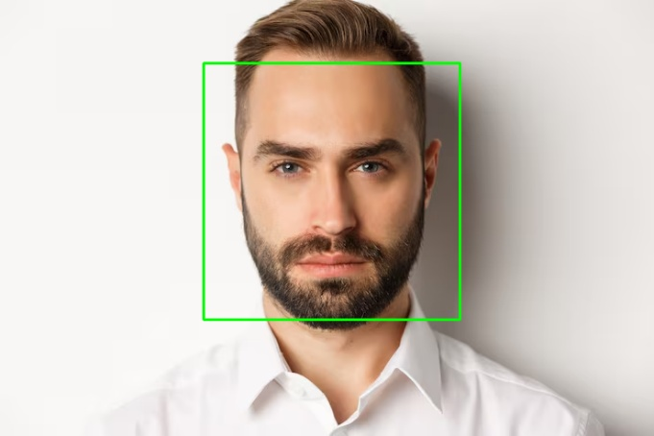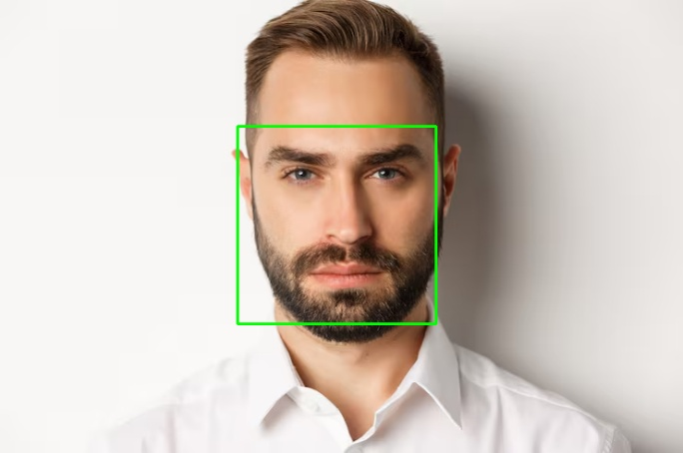

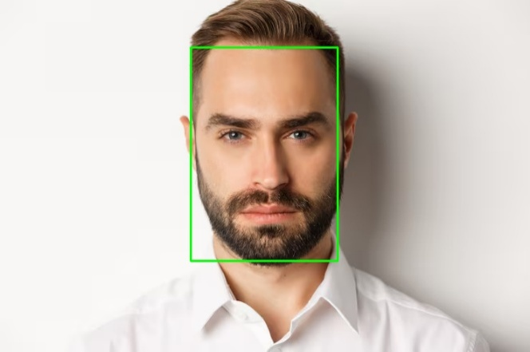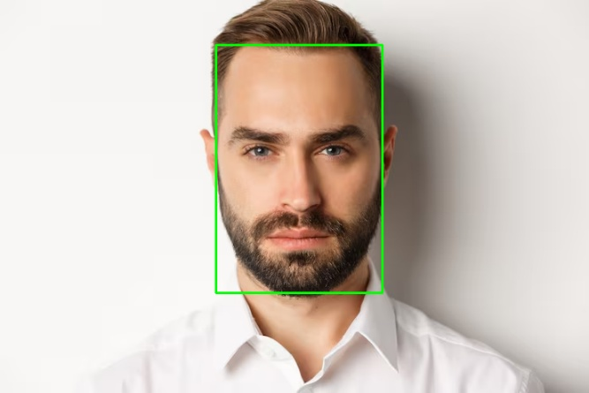

Result: Thus, Face Detection on available online human face image datasets was implemented successfully.

