**Change Background Colour and Font Style of Application**

AIM:

Develop an application to change the font and colour of the text and display toast message when the user presses the button.

CODE:

activity_main.xml

<?xml version="1.0" encoding="utf-8"?>  
<RelativeLayout xmlns:android="http://schemas.android.com/apk/res/android"  
 android:id="@+id/mainLayout"  
 android:layout_width="match_parent"  
 android:layout_height="match_parent"  
 android:padding="16dp"  
 android:background="#FFFFFF">  
  
 <TextView  
 android:id="@+id/myText"  
 android:layout_width="wrap_content"  
 android:layout_height="wrap_content"  
 android:text="Hello Kotlin!"  
 android:textSize="24sp"  
 android:layout_centerInParent="true"  
 android:textStyle="normal" />  
  
 <Button  
 android:id="@+id/changeButton"  
 android:layout_width="match_parent"  
 android:layout_height="wrap_content"  
 android:layout_below="@id/myText"  
 android:layout_centerHorizontal="true"  
 android:layout_marginTop="20dp"  
 android:text="Change Style" />  
</RelativeLayout>

MainActivity.kt

package com.example.myapplication  
  
import android.graphics.Color  
import android.graphics.Typeface  
import android.os.Bundle  
import androidx.appcompat.app.AppCompatActivity  
import android.widget.Button  
import android.widget.RelativeLayout  
import android.widget.TextView  
  
class MainActivity : AppCompatActivity() {  
 private var toggled = false  
  
 override fun onCreate(savedInstanceState: Bundle?) {  
 super.onCreate(savedInstanceState)  
 setContentView(R.layout.*activity_main*)  
  
 val layout = findViewById<RelativeLayout>(R.id.*mainLayout*)  
 val text = findViewById<TextView>(R.id.*myText*)  
 val button = findViewById<Button>(R.id.*changeButton*)  
  
 button.setOnClickListener **{** if (!toggled) {  
 layout.setBackgroundColor(Color.parseColor("#FFEB3B")) // Yellow  
 text.setTypeface(null, Typeface.*BOLD_ITALIC*)  
 } else {  
 layout.setBackgroundColor(Color.*WHITE*)  
 text.setTypeface(null, Typeface.*NORMAL*)  
 }  
 toggled = !toggled  
 **}** }  
}

Output:



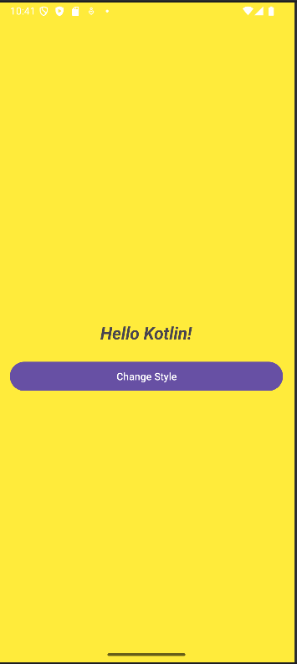

Result: Thus, background colour and font style was changed on click, successfully