Login Form using servlet

AIM:

Write a Servlet to demonstrate session tracking using HttpSession. Implement a simple login system where the users session is tracked.

Code:

log.html

<!-- login.html -->

<!**DOCTYPE** html>

<**html**>

<**head**><**title**>Login Page</**title**></**head**>

<**body**>

<**h2**>Login Form</**h2**>

<**form** action=*"login"* method=*"post"*>

Name: <**input** type=*"text"* name=*"username"*><**br**><**br**>

<**input** type=*"submit"* value=*"Login"*>

</**form**>

</**body**>

</**html**>

loginservlet.java

package com.user;

import jakarta.servlet.ServletException;

import jakarta.servlet.annotation.WebServlet;

import jakarta.servlet.http.HttpServlet;

import jakarta.servlet.http.HttpServletRequest;

import jakarta.servlet.http.HttpServletResponse;

import jakarta.servlet.http.HttpSession;

import java.io.IOException;

/**

* Servlet implementation class LoginServlet

*/

*@WebServlet*("/LoginServlet")

public class LoginServlet extends HttpServlet {

private static final long ***serialVersionUID*** = 1L;

/**

* **@see** HttpServlet#HttpServlet()

*/

public LoginServlet() {

super();

// **TODO** Auto-generated constructor stub

}

/**

* **@see** HttpServlet#doGet(HttpServletRequest request, HttpServletResponse response)

*/

protected void doGet(HttpServletRequest request, HttpServletResponse response) throws ServletException, IOException {

// **TODO** Auto-generated method stub

//response.getWriter().append("Served at: ").append(request.getContextPath());

}

/**

* **@see** HttpServlet#doPost(HttpServletRequest request, HttpServletResponse response)

*/

protected void doPost(HttpServletRequest request, HttpServletResponse response) throws ServletException, IOException {

// **TODO** Auto-generated method stub

//doGet(request, response);

String name = request.getParameter("username");

// Start session

HttpSession session = request.getSession();

session.setAttribute("name", name);

// Redirect to welcome page

response.sendRedirect("welcome");

}

}

welcomeservlt.java

package com.user;

import jakarta.servlet.ServletException;

import jakarta.servlet.annotation.WebServlet;

import jakarta.servlet.http.HttpServlet;

import jakarta.servlet.http.HttpServletRequest;

import jakarta.servlet.http.HttpServletResponse;

import jakarta.servlet.http.HttpSession;

import java.io.IOException;

import java.io.PrintWriter;

/**

* Servlet implementation class WelcomeServlet

*/

@WebServlet("/welcome")

public class WelcomeServlet extends HttpServlet {

private static final long serialVersionUID = 1L;

/**

* @see HttpServlet#HttpServlet()

*/

public WelcomeServlet() {

super();

// TODO Auto-generated constructor stub

}

/**

* @see HttpServlet#doGet(HttpServletRequest request, HttpServletResponse response)

*/

protected void doGet(HttpServletRequest request, HttpServletResponse response) throws ServletException, IOException {

// TODO Auto-generated method stub

//response.getWriter().append("Served at: ").append(request.getContextPath());

HttpSession session = request.getSession(false); // don’t create if it doesn't exist

PrintWriter out = response.getWriter();

response.setContentType("text/html");

if (session != null && session.getAttribute("name") != null) {

String name = (String) session.getAttribute("name");

out.println("<h1>Welcome, " + name + "!</h1>");

out.println("<a href='logout'>Logout</a>");

} else {

out.println("<h2>You are not logged in!</h2>");

out.println("<a href='log.html'>Login Again</a>");

}

}

/**

* @see HttpServlet#doPost(HttpServletRequest request, HttpServletResponse response)

*/

protected void doPost(HttpServletRequest request, HttpServletResponse response) throws ServletException, IOException {

// TODO Auto-generated method stub

//doGet(request, response);

}

}  
  
logoutservlet.java

package com.user;

import jakarta.servlet.ServletException;

import jakarta.servlet.annotation.WebServlet;

import jakarta.servlet.http.HttpServlet;

import jakarta.servlet.http.HttpServletRequest;

import jakarta.servlet.http.HttpServletResponse;

import jakarta.servlet.http.HttpSession;

import java.io.IOException;

import java.io.PrintWriter;

/**

* Servlet implementation class LogoutServlet

*/

@WebServlet("/logout")

public class LogoutServlet extends HttpServlet {

private static final long serialVersionUID = 1L;

/**

* @see HttpServlet#HttpServlet()

*/

public LogoutServlet() {

super();

// TODO Auto-generated constructor stub

}

/**

* @see HttpServlet#doGet(HttpServletRequest request, HttpServletResponse response)

*/

protected void doGet(HttpServletRequest request, HttpServletResponse response) throws ServletException, IOException {

// TODO Auto-generated method stub

//response.getWriter().append("Served at: ").append(request.getContextPath());

HttpSession session = request.getSession(false);

if (session != null) {

session.invalidate(); // Bye-bye session

}

response.setContentType("text/html");

PrintWriter out = response.getWriter();

out.println("<h2>You are logged out.</h2>");

out.println("<a href='log.html'>Login Again</a>");

}

/**

* @see HttpServlet#doPost(HttpServletRequest request, HttpServletResponse response)

*/

protected void doPost(HttpServletRequest request, HttpServletResponse response) throws ServletException, IOException {

// TODO Auto-generated method stub

//doGet(request, response);

}

}

**Output:**

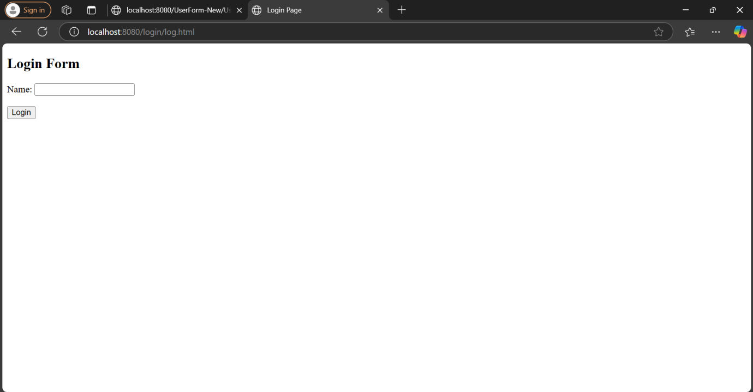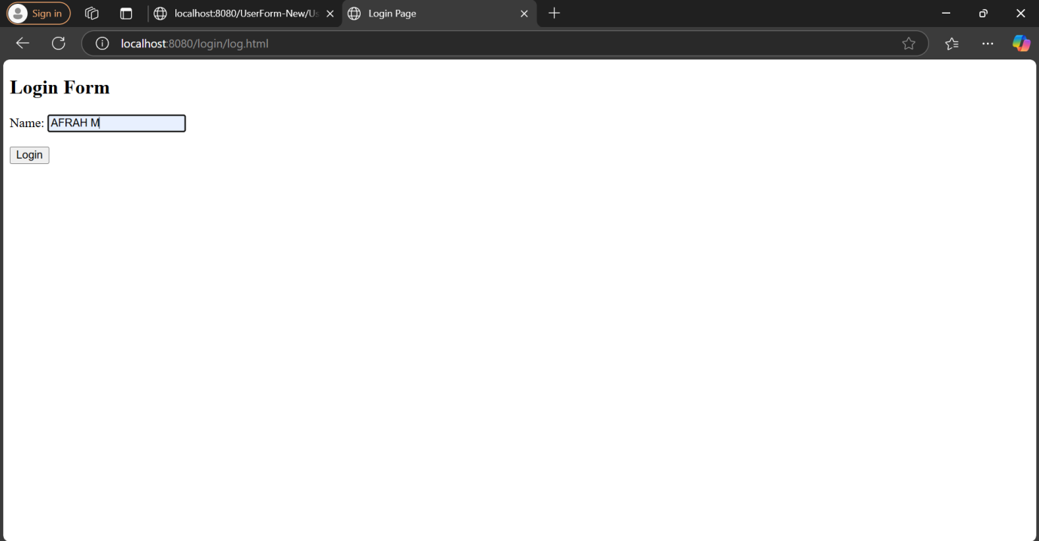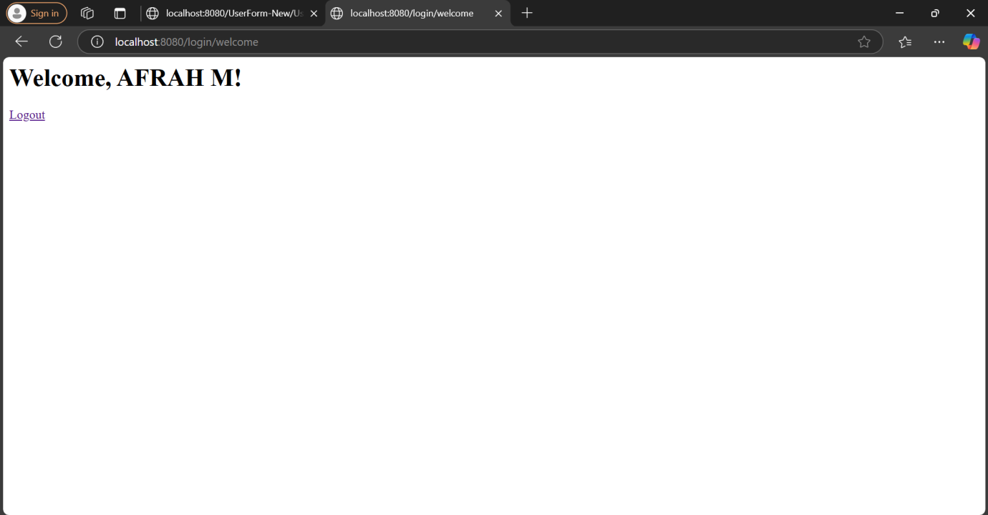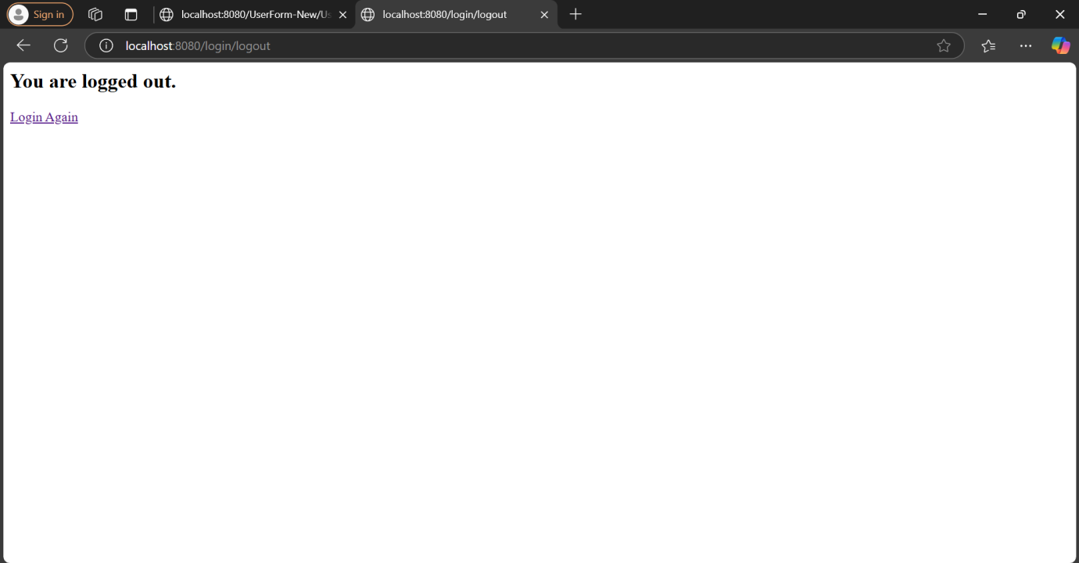

Result: Login System working successfully.