Preference Cookies

AIM:

Write a Servlet program to store a users preferences (like theme or language) using cookies. Retrieve and display these preferences on subsequent visits.

CODE:

package com.example;

import jakarta.servlet.ServletException;

import jakarta.servlet.annotation.WebServlet;

import jakarta.servlet.http.Cookie;

import jakarta.servlet.http.HttpServlet;

import jakarta.servlet.http.HttpServletRequest;

import jakarta.servlet.http.HttpServletResponse;

import java.io.IOException;

import java.io.PrintWriter;

/**

* Servlet implementation class PreferenceServlet

*/

*@WebServlet*("/preferences")

public class PreferenceServlet extends HttpServlet {

private static final long ***serialVersionUID*** = 1L;

/**

* **@see** HttpServlet#HttpServlet()

*/

public PreferenceServlet() {

super();

// **TODO** Auto-generated constructor stub

}

/**

* **@see** HttpServlet#doGet(HttpServletRequest request, HttpServletResponse response)

*/

protected void doGet(HttpServletRequest request, HttpServletResponse response) throws ServletException, IOException {

// **TODO** Auto-generated method stub

//response.getWriter().append("Served at: ").append(request.getContextPath());

response.setContentType("text/html");

PrintWriter out = response.getWriter();

// Retrieve existing cookies

String theme = "Default";

String language = "English";

Cookie[] cookies = request.getCookies();

if (cookies != null) {

for (Cookie cookie : cookies) {

if (cookie.getName().equals("theme")) {

theme = cookie.getValue();

}

if (cookie.getName().equals("language")) {

language = cookie.getValue();

}

}

}

// Display preferences

out.println("<html><body>");

out.println("<h2>Your Preferences</h2>");

out.println("<p>Theme: " + theme + "</p>");

out.println("<p>Language: " + language + "</p>");

// Form to set preferences

out.println("<form method='post'>");

out.println("Select Theme: <select name='theme'>"

+ "<option>Light</option>"

+ "<option>Dark</option>"

+ "<option>Colorful</option>"

+ "</select><br><br>");

out.println("Select Language: <select name='language'>"

+ "<option>English</option>"

+ "<option>Hindi</option>"

+ "<option>Spanish</option>"

+ "</select><br><br>");

out.println("<input type='submit' value='Save Preferences'>");

out.println("</form>");

out.println("</body></html>");

}

/**

* **@see** HttpServlet#doPost(HttpServletRequest request, HttpServletResponse response)

*/

protected void doPost(HttpServletRequest request, HttpServletResponse response) throws ServletException, IOException {

// **TODO** Auto-generated method stub

//doGet(request, response);

// Read user inputs

String theme = request.getParameter("theme");

String language = request.getParameter("language");

// Create cookies

Cookie themeCookie = new Cookie("theme", theme);

Cookie languageCookie = new Cookie("language", language);

// Set cookie expiry (e.g., 7 days)

themeCookie.setMaxAge(7 * 24 * 60 * 60);

languageCookie.setMaxAge(7 * 24 * 60 * 60);

// Add cookies to response

response.addCookie(themeCookie);

response.addCookie(languageCookie);

// Redirect to GET method to display updated preferences

response.sendRedirect("preferences");

}

}

OUTPUT:

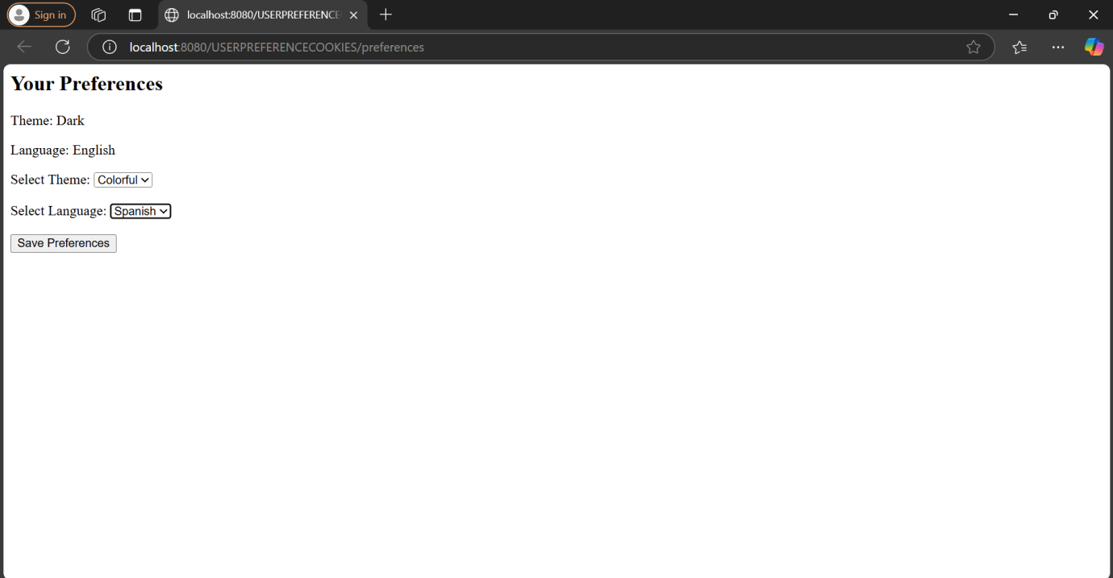

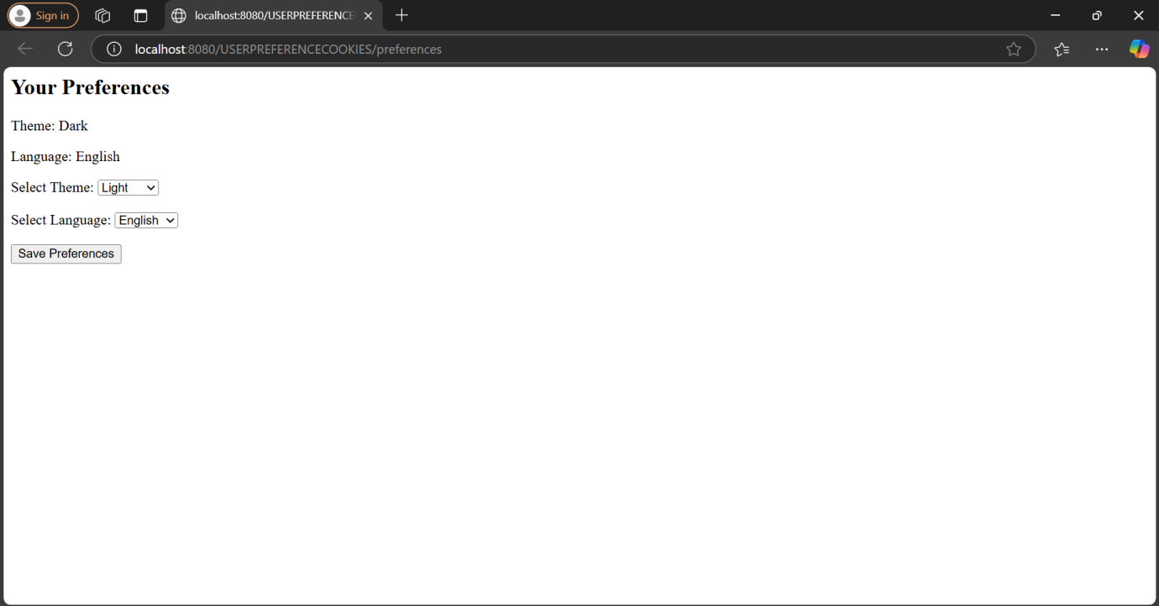

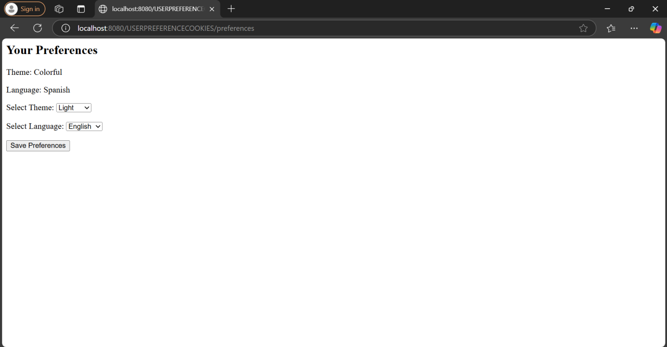

RESULT: Thus user preference cookies was implemented successfully.