Building New FC2 Changes

- Pull the latest changes for both FC2 and AresLib. A lot of the time AresLib will not change, but it’s good practice to pull both just to be safe.
- Build AresLib. At this point it doesn’t matter if the build fails or succeeds, we just need to start a build.
- Right click on the AresLib solution on the solution explorer (far-right). In this menu you’ll find an option labeled “Manage Nuget Packages for Solution”, click on it.
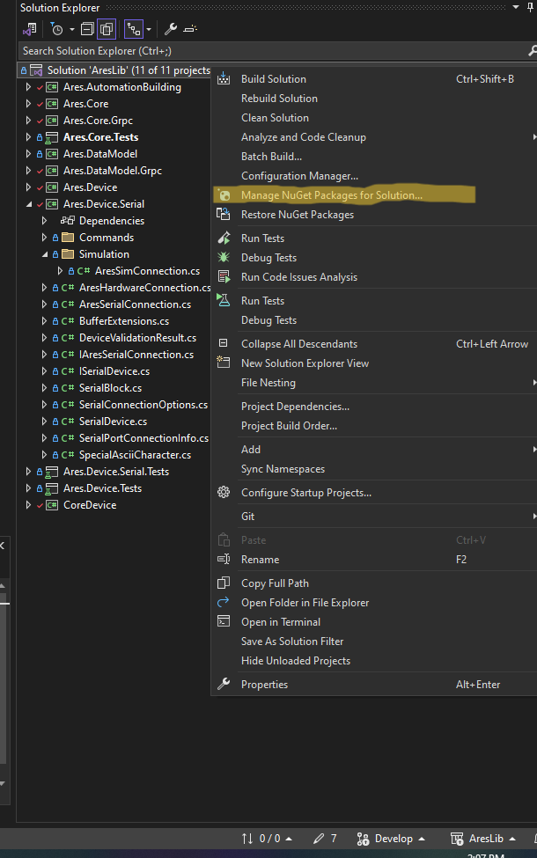

- In this screen, you’ll need to ensure your nuget package source is set to AresLib and then click on the ‘Updates’ tab. Select any packages that appear here and click update before rebuilding. Repeat these steps until you no longer have any nuget packages left to update and your build succeeds. AresLib is now finished being updated.
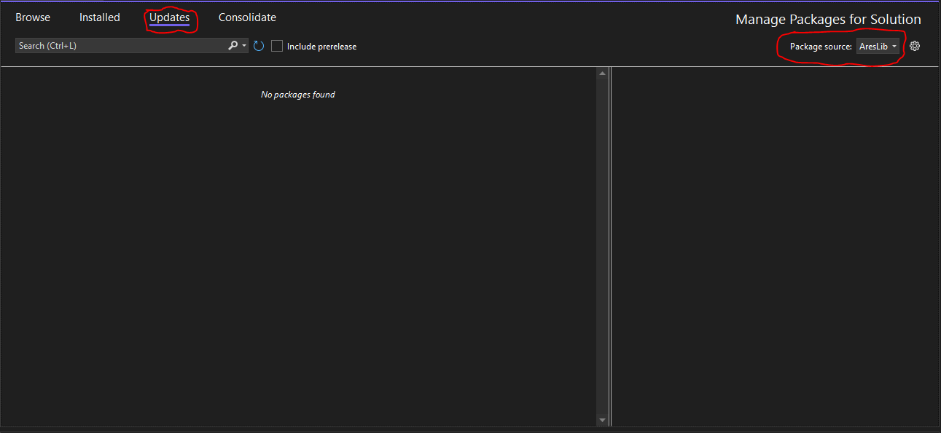

- Repeat this package updating process for FC2. Steps 2 – 4 should look the same in the FC2 Visual Studio window. Once you’ve gone through this process, all your errors should be gone and FC2 should be ready for launch.

