Resetting the FC2 Database
**IMPORTANT**
If you have devices you don’t want to re-add manually you will need to save that information before resetting the database! To do so follow these steps:
1. Open SQL Server Management Studio, you’ll receive a prompt to connect to the database, but the information should be auto populated. Hit connect, and you should see information populate in the left sidebar.
2. Under the databases folder find “FC2”. Rick click on the FC2 database, and under the “Tasks” section hit “Generate Scripts”. Hit next.
3. You should see a screen like pictured below. Select the option “Select specific database objects”. Doing this will expand your list of available tables, you’ll need to select two: “dbo.Any” and “dbo.DeviceConfigs”. Hit next.
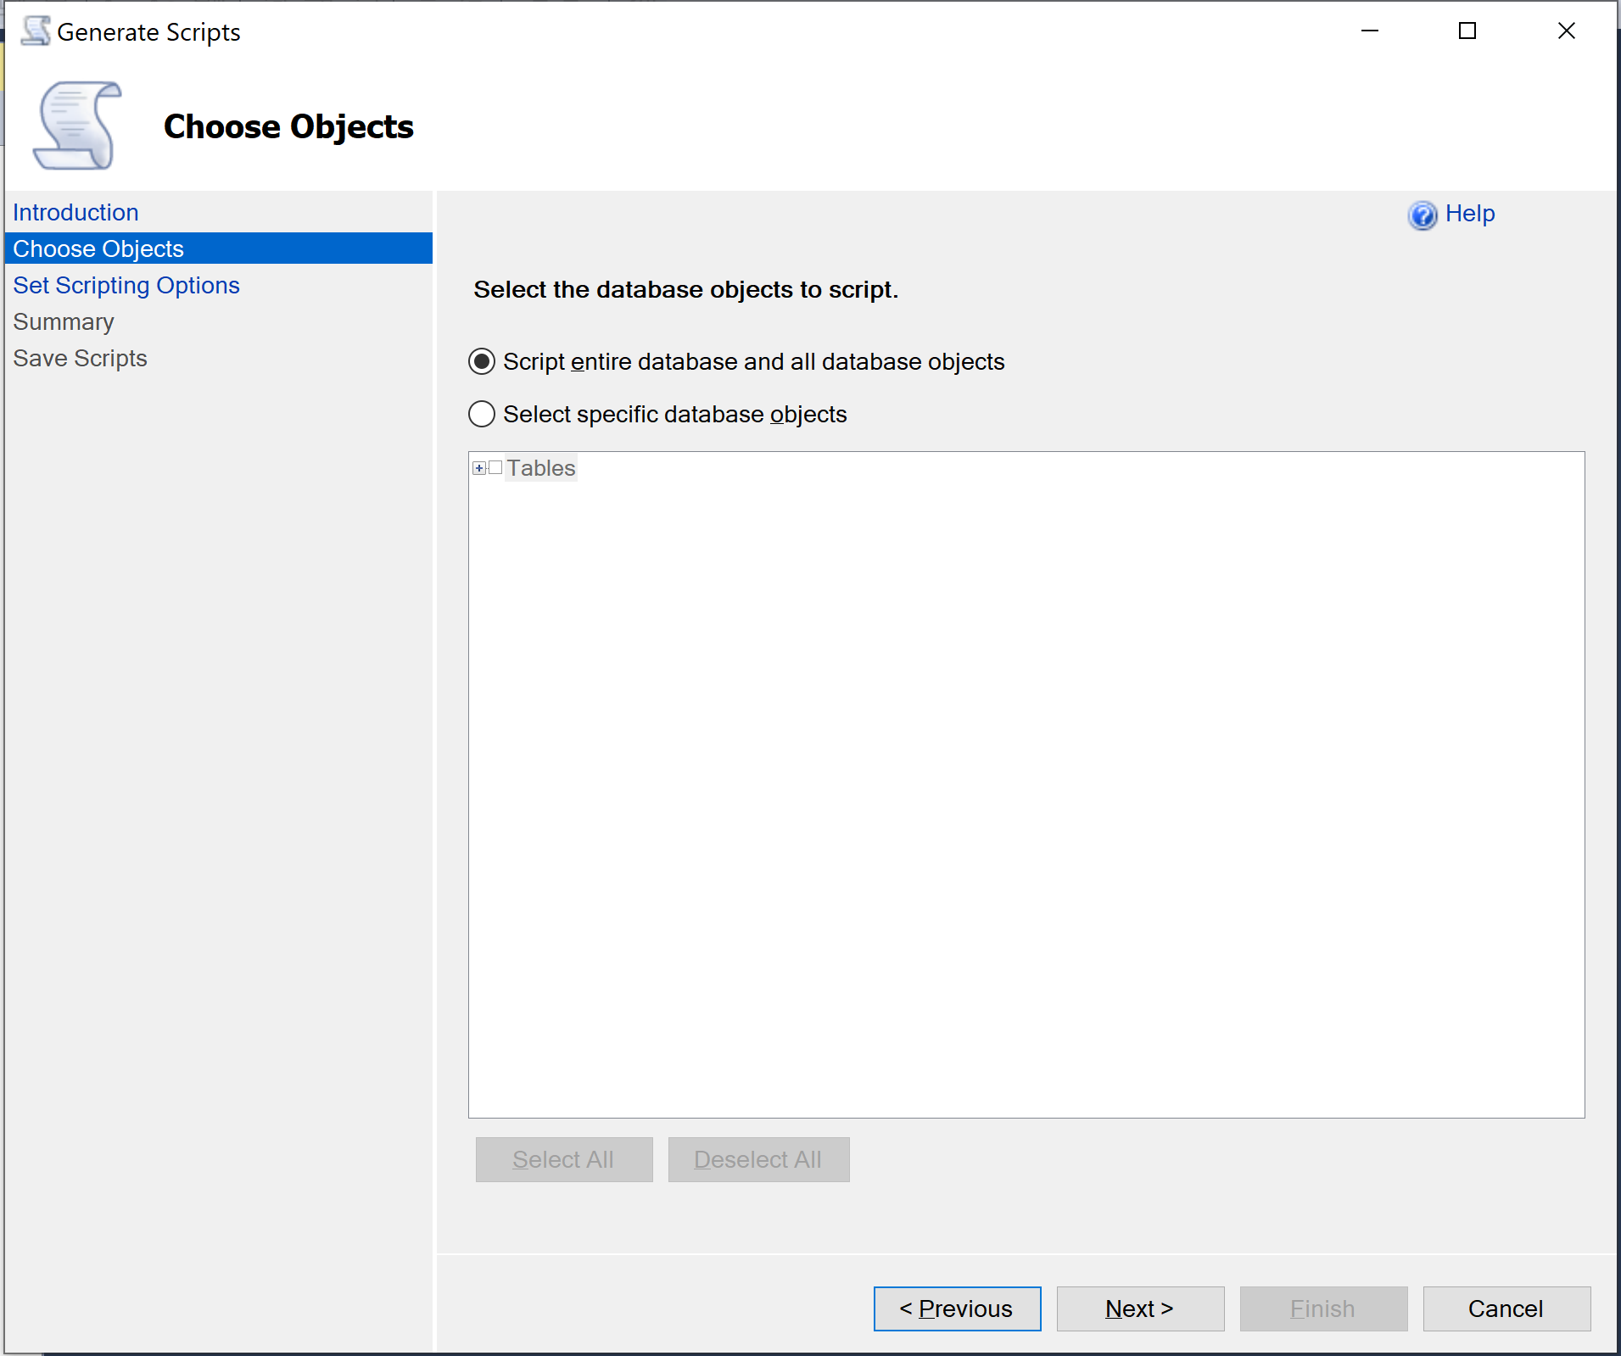

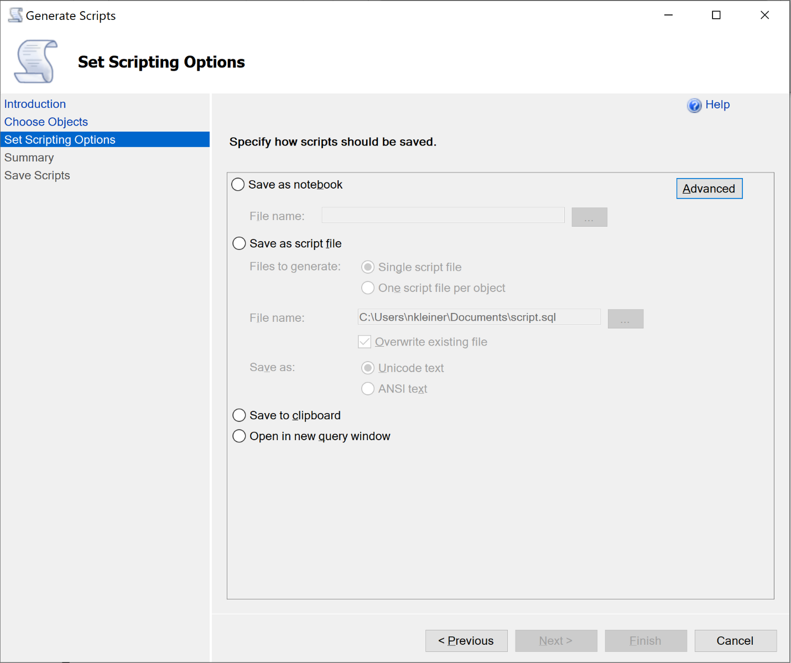
4. You should now see a scripting options screen like shown below. First, hit the advanced button. In this window, find the option (under the General section) called “Types of data to script”. By default, this is set to schema only; change it to data only. Next, you’ll want to select the “Save as a script file”. You can save this wherever you want as long as you remember where you save it to.

5. Hit next, then hit next again. You should see the program attempt to save the file; if you get no errors then proceed to start the database reset.

Manual Database Reset
- Step one to resetting the database for FC2 requires you to open the FC2 project either in Visual Studio or file explorer. Navigate to the FC2Core folder in the FC2 project. Here you should find a folder called Migrations, delete it.

- With the migrations folder deleted, you should now be able to build FC2. Try building the software, if you still encounter errors then something other than the database is causing issues. Once you successfully build FC2 move on to step three.

- With FC2 rebuilt, you will need to run the database reset script. This will be located in the FC2Service folder and is called “ResetDatabase.ps1”. You can either run this in a PowerShell window or using PowerShell ISE which can be accessed by right clicking the script in Visual Studio and selecting “Open with PowerShell ISE”. This script will most likely output some warnings, but this will not interfere with the reset process.

- Once you’ve successfully run the database reset script, if you saved off your device states earlier you will now need to re-insert their information into the database. To do this, open SQL Server Management Studio. If you had this open before you reset your database; right click on the FC2 database and select the “refresh” option.

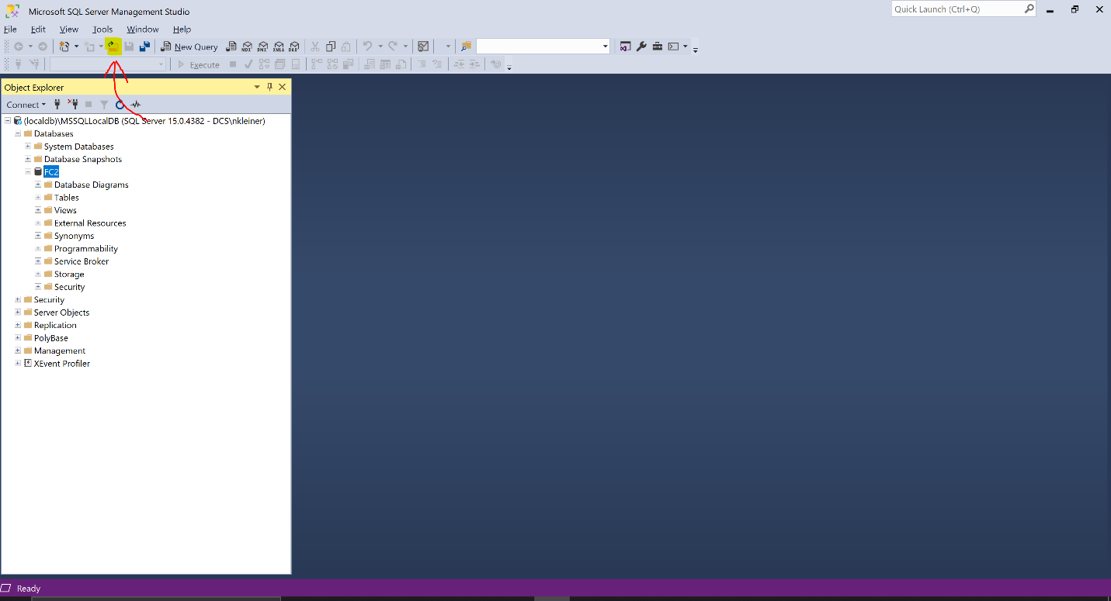
- With the database refreshed in SQL Server Management Studio, click the open file button highlighted in the example image below. A file explorer window will open up, use this to find and select the SQL script you saved earlier. Once loaded, click the green execute button to run your script. If you receive no errors, your database has been re-populated successfully.

- The last step to your reset is to build FC2. Once you build FC2, you can launch the application and should see all your devices present as they were before the reset.

