Step - 1 : Create EKS Management Host in AWS
- Launch new Ubuntu VM using AWS Ec2 ( t2.micro )
- Connect to machine and install kubectl using below commands
curl -o kubectl https://amazon-eks.s3.us-west-2.amazonaws.com/1.19.6/2021-01-05/bin/linux/amd64/kubectl
chmod +x ./kubectl
sudo mv ./kubectl /usr/local/bin
kubectl version --short --client
- Install AWS CLI latest version using below commands
sudo apt install unzip
curl "https://awscli.amazonaws.com/awscli-exe-linux-x86_64.zip" -o "awscliv2.zip"
unzip awscliv2.zip
sudo ./aws/install
aws --version
- Install eksctl using below commands
curl --silent --location "https://github.com/weaveworks/eksctl/releases/latest/download/eksctl_$(uname -s)_amd64.tar.gz" | tar xz -C /tmp
sudo mv /tmp/eksctl /usr/local/bin
eksctl version

Step - 2 : Create IAM role & attach to EKS Management Host & Jenkins Server
- Create New Role using IAM service ( Select Usecase - ec2 )
- Add below permissions for the role
  - IAM - fullaccess
  - VPC - fullaccess
  - EC2 - fullaccess
  - CloudFomration - fullaccess
  - Administrator - acces
- Enter Role Name (eksroleec2)
- Attach created role to EKS Management Host (Select EC2 => Click on Security => Modify IAM Role => attach IAM role we have created)
- Attach created role to Jenkins Machine (Select EC2 => Click on Security => Modify IAM Role => attach IAM role we have created)

Step - 3 : Create EKS Cluster using eksctl
Syntax:
eksctl create cluster --name cluster-name
--region region-name
--node-type instance-type
--nodes-min 2
--nodes-max 2 \ --zones ,
eksctl create cluster --name vinodses-cluster --region ap-south-1 --node-type t2.medium --zones ap-south-1a,ap-south-1b
Note: Cluster creation will take 5 to 10 mins of time (we have to wait). After cluster created we can check nodes using below command.
kubectl get nodes

Step-4 : Jenkins Server Setup in Linux VM
- Create Ubuntu VM using AWS EC2 (t2.medium)
- Enable 8080 Port Number in Security Group Inbound Rules
- Connect to VM using MobaXterm
- Instal Java
sudo apt update
sudo apt install fontconfig openjdk-17-jre
java -version
- Install Jenkins
sudo wget -O /usr/share/keyrings/jenkins-keyring.asc \
https://pkg.jenkins.io/debian-stable/jenkins.io-2023.key
echo deb [signed-by=/usr/share/keyrings/jenkins-keyring.asc] \
https://pkg.jenkins.io/debian-stable binary/ | sudo tee \
/etc/apt/sources.list.d/jenkins.list > /dev/null
sudo apt-get update
sudo apt-get install jenkins
- Start Jenkins
sudo systemctl enable jenkins
sudo systemctl start jenkins
- Verify Jenkins
sudo systemctl status jenkins
- Open jenkins server in browser using VM public ip
http://public-ip:8080/
- Copy jenkins admin pwd
sudo cat /var/lib/jenkins/secrets/initialAdminPassword
- Create Admin Account & Install Required Plugins in Jenkins

Step-5 : Configure Maven as Global Tool in Jenkins
- Manage Jenkins -> Tools -> Maven Installation -> Add maven

Step-6 : Setup Docker in Jenkins
curl -fsSL get.docker.com | /bin/bash
sudo usermod -aG docker jenkins
sudo systemctl restart jenkins
sudo docker version

Step - 8 : Install AWS CLI in JENKINS Server
Execute below commands to install AWS CLI
sudo apt install unzip
curl "https://awscli.amazonaws.com/awscli-exe-linux-x86_64.zip" -o "awscliv2.zip"
unzip awscliv2.zip
sudo ./aws/install
aws --version

Step - 9 : Install Kubectl in JENKINS Server
Execute below commands in Jenkins server to install kubectl
curl -o kubectl https://amazon-eks.s3.us-west-2.amazonaws.com/1.19.6/2021-01-05/bin/linux/amd64/kubectl
chmod +x ./kubectl
sudo mv ./kubectl /usr/local/bin
kubectl version --short --client

Step - 10 : Update EKS Cluster Config File in Jenkins Server
- Execute below command in Eks Management host & copy kube config file data
$ cat .kube/config
- Execute below commands in Jenkins Server and paste kube config file
$ cd /var/lib/jenkins
$ sudo mkdir .kube
$ sudo vi .kube/config
- Execute below commands in Jenkins Server and paste kube config file for ubuntu user to check EKS Cluster info
$ cd ~
$ ls -la
$ sudo vi .kube/config
- check eks nodes
$ kubectl get nodes
Note: We should be able to see EKS cluster nodes here.

Step - 11 : Create Jenkins CI CD Job
- Stage-1 : Clone Git Repo
- Stage-2 : Maven Build
- Stage-3 : Create Docker Image
- Stage-4 : Push Docker Image to Registry
- Stage-5 : Deploy app in k8s eks cluster

Jenkins Pipeline Script

pipeline {

agent any

tools{

maven "maven"

}

stages {

stage('Git Clone') {

steps {

git branch: 'main', url: 'https://github.com/AFSAL790/DevOpsProject2.git'

}

}

stage('Maven Build'){

steps{

dir('01_products_api'){

sh 'mvn clean package -DskipTests'

}

}

}

stage('Docker Image'){

steps{

dir('01_products_api'){

sh 'docker build -t afsal790/products_api .'

}

}

}

stage('Docker Image push'){

steps{

withCredentials([usernamePassword(credentialsId: 'docker_pwd', usernameVariable: 'DOCKER_USER', passwordVariable: 'DOCKER_PASS')]) {

sh 'docker login -u $DOCKER_USER -p $DOCKER_PASS'

sh 'docker push afsal790/products_api'

}

}

}

stage('k8s deployment'){

steps{

dir('01_products_api'){

sh 'kubectl apply -f Deployment.yml'

}

}

}

}

}

Step - 12 : Access Application in Browser
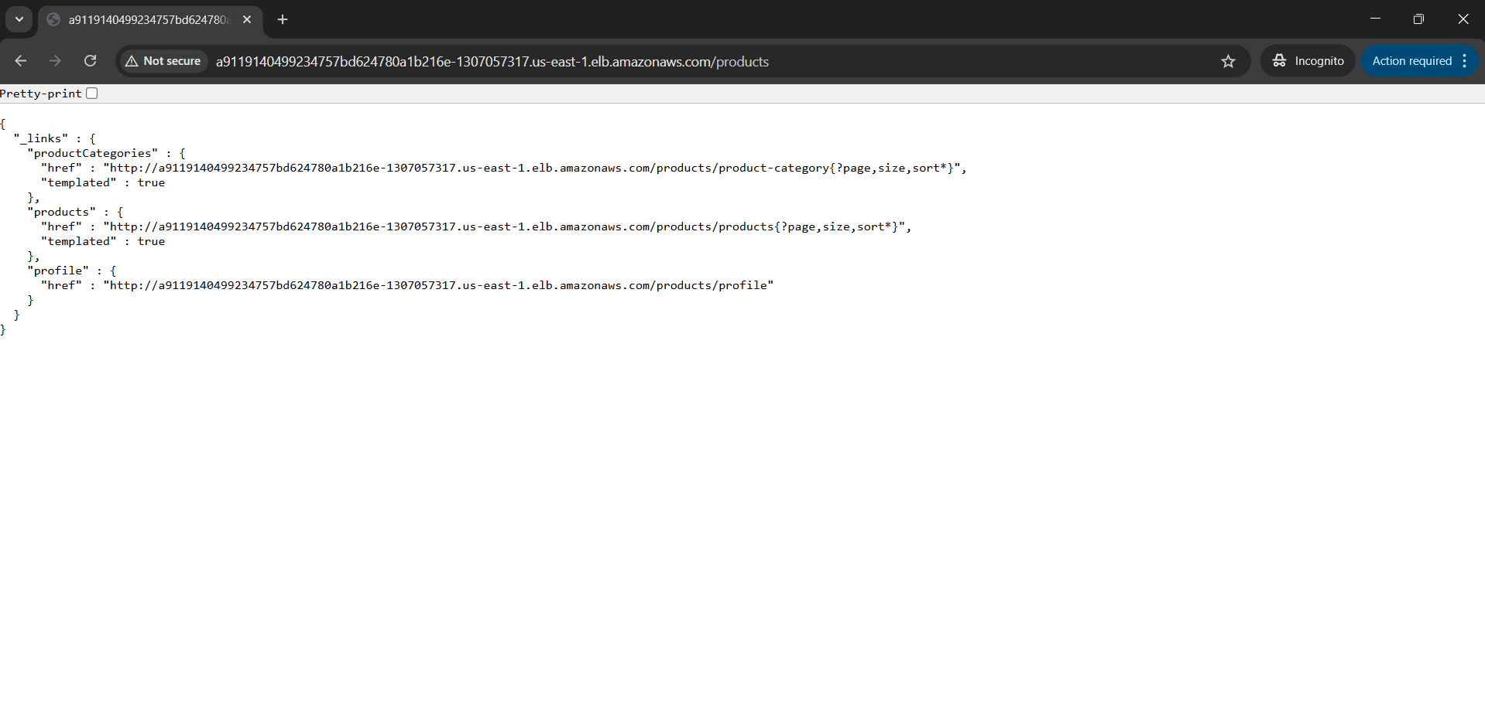
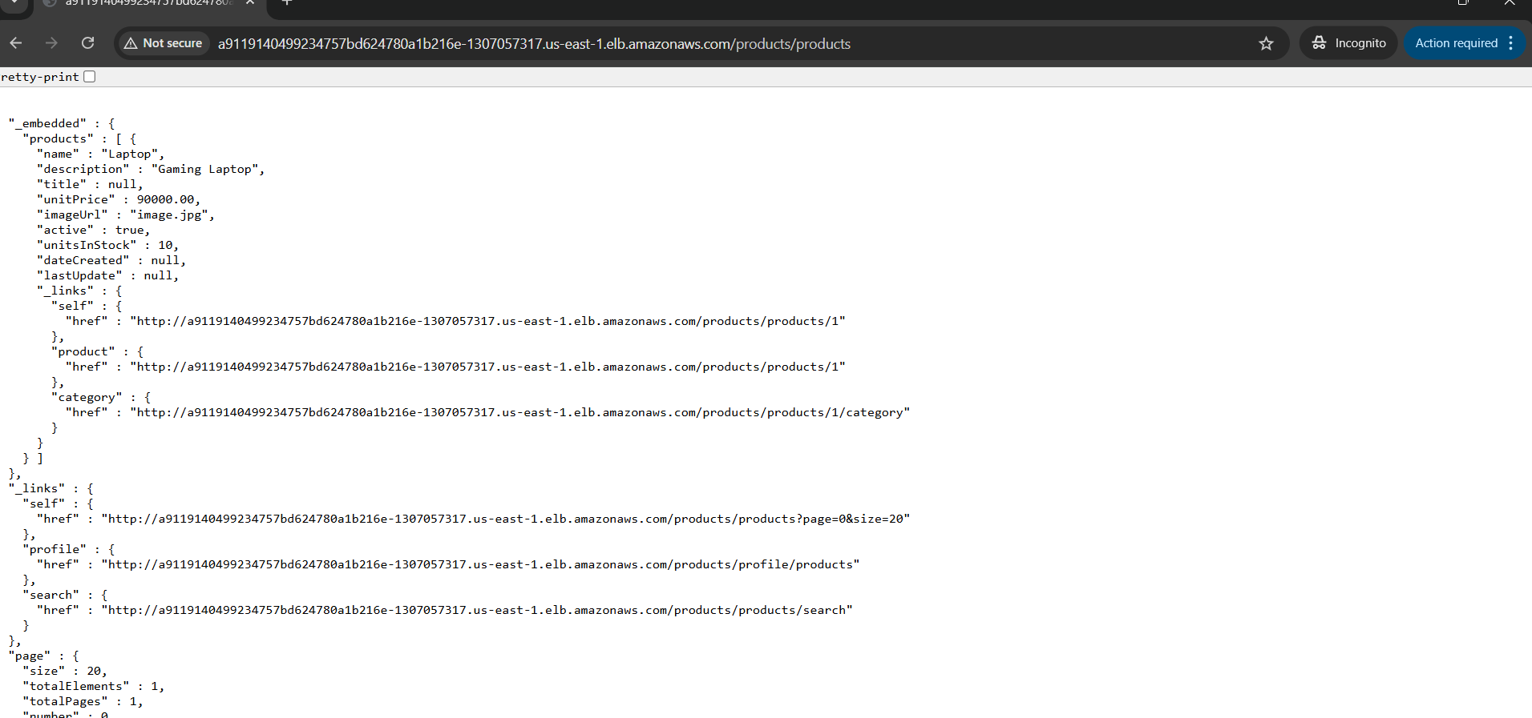
Scope of the project:

Deployment of springboot ecommerce application using kubernetes
