React is an open-source JavaScript-based frontend library rather than a language. Widely used in the development of web UI (User Interface). React goes beyond just the development of UI; it contains many extensions that covers the entire architecture of the application (Ex: Flux and Redux), allows us to create reusable UI components and provides server-side rendering. Apps like Facebook, Instagram, Skype, Pinterest, etc. are few examples that uses React.

The reasons that React framework popular among other frontend development frameworks are,

1. Creation of dynamic application gets easier with react since it require less coding and offers more functionality.
2. Improved performance as it uses Virtual DOM.
3. Reusability of the UI components.
4. Unidirectional data flow make it easier for user to detect and debug errors.
5. Used to develop both web and mobile apps.
6. Dedicated tools for debugging.
7. Finally, it’s very easy to learn as it require only HTML, JavaScript, and basic programming knowledge from the user.

**Features of React**

1. JSX

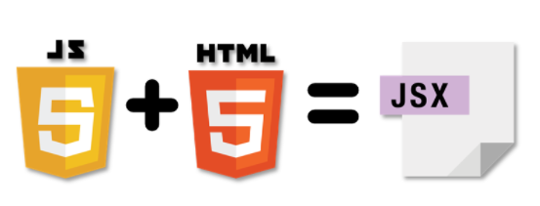

By utilizing the JSX extension, user will be able to write the HTML structure in the JavaScript (embedding HTML into JS code) as mentioned below,

const name = ‘world’;

const greet = <h1>Hello! {name}</h1>;

1. Virtual DOM

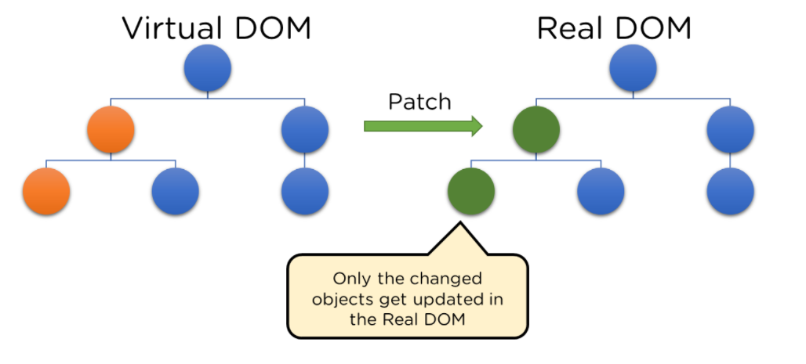

Virtual DOM compares the components’ previous states and update only that objects in the real DOM that were changed instead of updating all the objects. Hence, create web applications faster.

1. Architecture

Here **Model View Controller (MVC)** architecture being used where **Model** relates to all related logic; the **View** is used for UI logic and, the **Controller** is the interface between Model and View. Here React is the ‘View’ responsible for how the app looks and feel.

1. Debugging

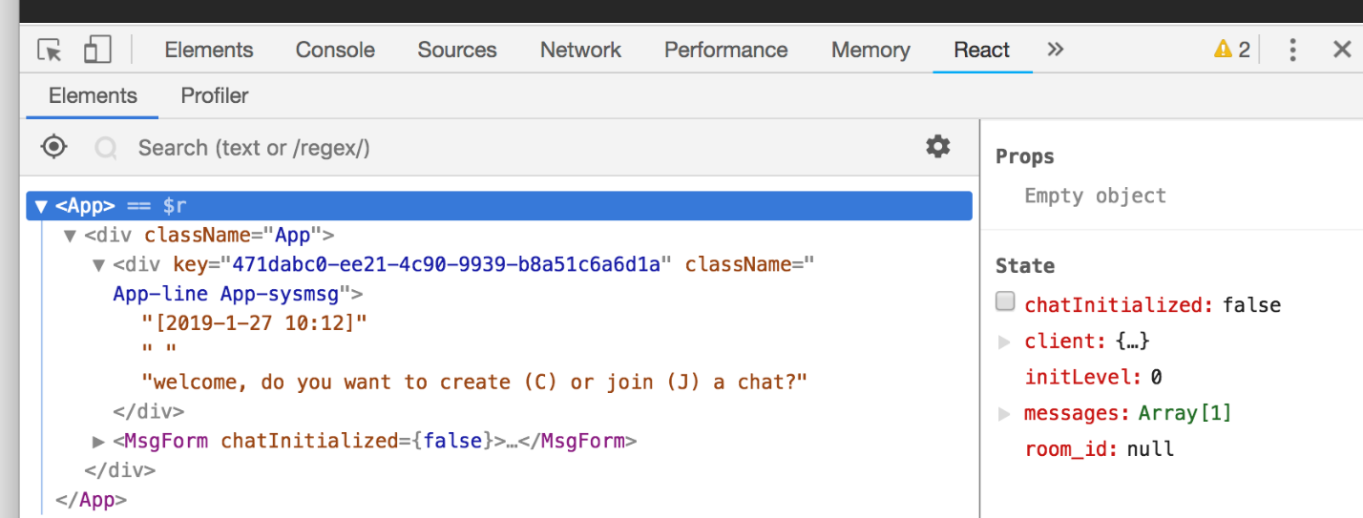

React applications are straightforward and easy to test. Browser extension provided by the Facebook adds a React tab in the developer tool option within chrome web browser. Tis makes it easier to inspect React components.

**Components in React**

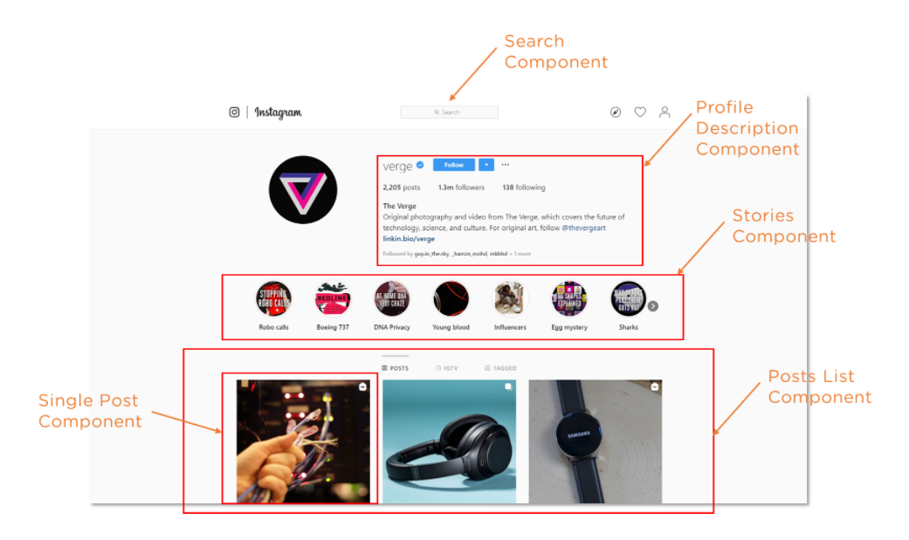

Components are the building blocks that comprise a React application which represents a part of the UI. React divides the UI into multiple components, which makes the code easier to debug, and each component has its own property and function.

**Properties in React**

Properties in React allows the user to pass arguments or data to components which helps the components more dynamic. Here properties are read-only and can’t be changed.

**State in React**

A state is an object that stores properties values for those attributes to a component that could change over time.

* State can change due to user’s action or change in the network.
* React re-renders the component to browser as the state of an object change.
* Multiple properties values can be stored in the state object.
* setState() function is used for altering the state object’s value.