# 3. APPROACH

IntelliRoast provides a customizable coffee roasting experience at an affordable price. By using a companion smartphone app, the user can create and save user-defined roast profiles. IntelliRoast uses a heating element and centrifugal fan operated by a microcontroller to agitate and roast the coffee beans to the chosen roast. Once the beans are roasted, they are blown out of the heating chamber for easy removal into a holding container.

# 3.1 System Overview

IntelliRoast includes several systems and controls that work together to create an automatic coffee roasting machine. The hardware includes a fan, a heating element, temperature probes, a roasting chamber, a chaff separation unit, a chaff collection system, a bean deposit system, and a microcontroller. The microcontroller will contain logic written in C to adjust fan speeds, heating element temperatures, and the bean deposit system.

The user begins by placing the green coffee beans in the roasting chamber and pressing the start button. Once the roast has been started, the microcontroller will adjust the air temperature and air speed to roast the beans according to a default roast profile. Users can also use a smartphone app to select from multiple roast profiles, view roast progress and details, and start or stop the roast. After the beans are roasted, the microcontroller will increase the fan speed to blow the beans from the roasting chamber into a holding container. After the roasting process finished, the user has enough freshly roasted coffee beans to brew a 12-cup pot of coffee.

# 3.2 Hardware

This section depicts the internal components comprising IntelliRoast. Internal components must be selected with respect to size, budget, and power because of the size limitations of commercial kitchen appliances. Component requirements were researched based on the current in-home coffee roasting process. Since IntelliRoast desires to compete with other products on the market, component standards were set higher than other similar products.

# 3.2.1 Heating System

The following sections cover the heating solution for IntelliRoast, separated into three categories: heating options, heating element, and electronics to control the heating element.

# 3.2.1.1 Heating System Options

The type of heating system affects IntelliRoast’s performance. Roasting coffee beans can be achieved by two heating systems: fluid bed heating and drum heating. IntelliRoast uses fluid bed heating for roasting the green coffee beans. Table 3.2.1.1 shows the comparison of heating options considered.

**Table 3.2.1.1 - Comparison of Heating System Options**

|  |  |  |
| --- | --- | --- |
| **System** | **Description** | **Properties** |
| Fluid Bed Heating | Uses heated air to agitate beans and roast beans evenly | Uses 100% convection |
| Drum Heating | Uses metal drum to hold beans over heated element while stirring beans | Uses 75% convection  Uses 25% conduction |

Best Option/Meets Option Does not Meet Requirements

Drum roasting is accomplished by rotating a large metal drum containing unroasted coffee beans heated from underneath by propane or natural gas. This style of roasting is most effective on a large scale, where pounds of beans are roasted at a time, and is therefore the most common choice for large companies in the industry. Since drum roasting directly heats the beans in the metal drum, the beans are less likely to have an even homogenous roast. Often, some beans have a darker roast on one side and a lighter roast on the other [1]. Drum roasting also requires more mechanical and chemical parts to operate, such as motors to rotate the drum and a supply of gases to ignite for heat. On a small scale, such as in-home roasting, drum roasting is not the preferred method due to it requiring constant supervision.

Fluid-bed roasting is accomplished by blowing heated air into the roasting chamber, agitating and roasting the beans. Fluid-bed roasting roasts a smaller amount of beans but takes about half as much time as a drum roaster [1]. Additionally, fluid-bed roasting requires less mechanical parts and provides for easier clean-up as a result. Fluid-bed roasting does not require gas or flame to roast the beans, but rather a heating element to heat the air needed for the roast. Fluid-bed roasting is faster, cleaner, and hands-free – making it the preferred method for in-home roasting

# 3.2.1.2 Heating Element

IntelliRoast uses the Master Appliance REPL Heating Element for HG501A to heat the green beans to be roasted. Table 3.2.1.2 shows a comparison of the heating elements considered for the system.

**Table 3.2.1.2 - Heating Element Characteristics**

|  |  |  |  |
| --- | --- | --- | --- |
| **Element** | **Price per Unit** | **Description** | **Properties** |
| REPL Heating Element for HG501A | 28.20 | Heating Element | 500°F~700°F (260°C~371°C) |
| Custom Resistive Wiring | 21.88/32ft | Nickel Chromium wire only | ~1850°F (~1010°C) |

Best Option/Meets Option Does not Meet Requirements

The custom resistive wiring solution is an alternative option to the heating element. The resistive wiring is made of the same material as the heating element and costs less per unit respectively. However, the resistive wiring solution would require an additional purchase of insulating material and time spent assembling a heating element. The wire itself has a higher temperature rating, but a new temperature rating would need to be calculated after assembly of a heating element.

The REPL Heating Element for HG501A is the heating element chosen to roast the green coffee beans. The heating element requires no assembly unlike the resistive wiring solution. The wiring of the heating element is also made of Nickel Chromium and provides a larger temperature threshold. The roasting chamber must sustain an ambient temperature of 300°C. The heating element will provide this temperature consistently throughout the roasting process since that temperature is within the element’s heating limits. Air will be blown over the heating element using the centrifugal fan. The now-heated 300°C air will agitate the beans and evenly roast them to a target temperature of 205°C-250°C. Figure 3.2.1.2 shows the schematic for this process.

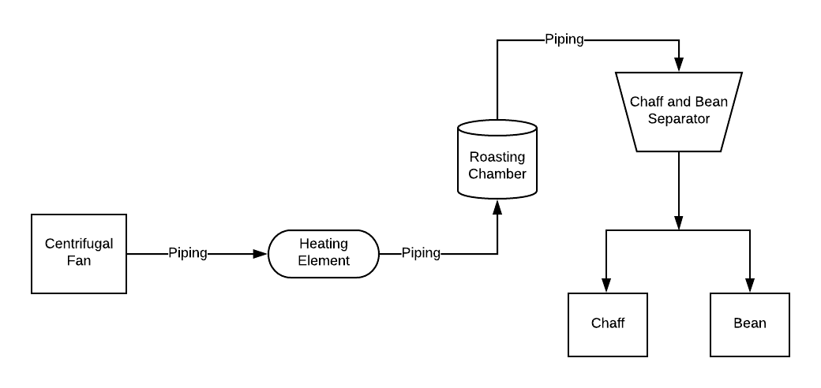

**Figure 3.2.1.2 - Heating Element and System Schematic**

# 3.2.1.3 Solid State Relays

The functionality of the IntelliRoast revolves around its ability to control the temperature of the air coming into the roasting chamber. This process is accomplished by the heating element solid state relay. Using a signal similar to Pulse Width Modulation (PWM) technology, a solid state relay can rapidly turn the heating element on and off. With the use of a custom Proportional-Integral Derivative (PID) software module, the temperature of the heating element can be controlled to match the roast profile.

The heating element measures 8.8 Ohms, and at 120 VAC, draws 13.6 amps. The Fotek SSR-25DA allows the operation of up to 380 VAC at 15 amps with only 3 VDC, making it the best candidate for the PWM heating element solid state relay. Fast response time is a key element in both the PWM control and PID loop, and this is addressed with the SSR-25DA’s 10 millisecond response time for both on and off triggering.

# 3.2.2 Heat Transfer/Insulation

The sections below discuss the hardware selections for the heat transfer and insulation requirements to keep the external enclosure surface temperature within acceptable levels.

# 3.2.2.1 Heat Transfer

Piping is utilized by IntelliRoast to transport air from the centrifugal fan through the heating element and to the coffee beans. Because the pipes have super-heated air pumped through, the material used must withstand high temperatures without oxidation, breakdown, or melting. Additionally, the air flowing through the system has both high airflow as well as a high pressure, therefore the piping must operate under these conditions while remaining airtight.

Black iron, galvanized steel, and copper piping were investigated for this purpose. Copper piping is used primarily for heating elements, as the metal absorbs heat exceptionally well, meaning this option will cause the most heat to be lost between the heating element and the beans being heated. In addition, the method of connecting copper pipe traditionally is through clamping the piping at a connection, meaning any necessary changes beyond initial installation would be difficult to accomplish. Alternatively, both black iron and galvanized steel do not absorb heat as efficiently, making them better for transfering the hot air with the least loss possible. Black iron and galvanized steel both have threaded ends to its piping, making connections and adjustment much easier. Galvanized metals have a significant drawback of peeling the toxic zinc coating at high temperatures, as designated by Figure 3.2.2.1a [2]. Due to this health hazard, black iron is the best option for the piping of the heat transfer area.

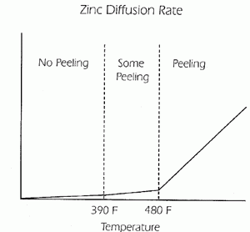

**Figure 3.2.2.1a - Zinc Diffusion Rate of Coat Peeling**

# 3.2.2.2 Insulation

IntelliRoast uses the ROXUL 2" x 48" x 24" Mineral Wool High Temperature Insulation to insulate the heating element from the rest of the system. Table 3.2.2.2 shows a comparison between the insulation materials considered for outside the heating chamber.

**Table 3.2.2.2 - Potential Insulation Material**

|  |  |  |  |  |
| --- | --- | --- | --- | --- |
| **Material S/N** | **Price (USD)** | **Description** | **Dimensions** | **Properties** |
| ROXUL #40205 | 16.80 | Mineral Wool High Temperature Insulation | 2” x 48” x 24” | 0°F to 1200°F (-18°C to 649°C) |
| STI #SSWRED2 | 56.09 | Fire Barrier Wrap Strip | 1.5” x 12’ x 1/8” | Up to 4 hr. Fire Rating |
| 3M #PM4 | 21.11 | Fire Barrier Packing Material | 4” x 20’ 6” x 1/2” | Up to 4 hr. Fire Rating |
| Fiberglass SKU: 541 | 13.10 | Fiberglass High Temp Tape | 1” x 100’ x 1/16” | Rated up to 1000°F (537°C) |

Best Option/Meets Option Does not Meet Requirements

The ROXUL Mineral Wool High Temperature Insulation is mineral wool which insulates between 0°F to 1200°F [3]. These temperature ranges are sufficient for insulating the area around the heating element, since the heating element is rated to 700°F [4]. This material has a length of 48 inches and a thickness of 2 inches, which can be altered to fit inside the system itself. Mineral wool was selected as the internal insulation material because of its insulation properties and its cost. Although mineral wool is closely related to fiberglass and requires special care to prevent skin irritation while handling, the other materials are not rated to insulate high temperatures. Fire barriers restrict fire from burning components and do not insulate areas from high temperatures.

With the STI Fire Barrier Wrap Strip, the internal components would be protected from fire for up to 4 hours [5]. This would not necessarily protect the internal components from the high temperatures emitting from the heating element. STI’s Fire Barrier Wrap Strap does not include standards and specifications, and there were too many unknowns with this material to reliably use. The lack of insulation is the primary reason why the material was not chosen; it would not help insulate materials and bring the surface temperature down to acceptable levels. Additionally, the cost was at least 3 times the cost of the mineral wool. This material had too many downsides and liabilities to safely use.

3M’s Fire Barrier Packing Material is similar to the STI Fire Barrier Wrap Strip with its fire rating. This material is compliant with ASTM E814 and UL 1479 standards [6], which outlines the fire-stopping abilities the material follows [7] [8]. Although the price is similar to the ROXUL mineral wool, the 0.5 inch thickness would require multiple stacked layers to use as effectively as the ROXUL. Additionally, the 3M Fire Barrier Packing Material is made of a woven fiberglass material, which would require the same handling constraints as mineral wool. These reasons, plus the lack of insulation properties, rendered the 3M Fire Barrier Packing material as a non-valid option for IntelliRoast.

The Fiberglass High Temperature Tape is used to insulate around pipes to prevent burns upon accidental contact [9]. Like the ROXUL mineral wool, the fiberglass tape is designed for high-temperature insulation, insulating up to 1000°F and would require special care while handling. Unlike standard tape, however, this high temperature tape does not contain an adhesive backing. Combined with a 1/16” thickness, multiple layers of tape would be necessary to fully utilize. Not having a reasonable method of securing this material inside IntelliRoast is a major source of concern, especially considering materials could be dislodged internally if IntelliRoast is moved. This presents the same issues as the 3M Fire Barrier Packing Material, which is the reason why this material was not selected for our insulation material, despite having the lowest cost.

# 3.2.3 Centrifugal Fan

In fluid bed coffee bean roasting, airflow and air pressure are the integral factors to a successful roast. These two characteristics are dictated by the inflow fan located at the beginning of heat transfer section. The two fan styles considered for providing airflow were axial fans and centrifugal fans. Axis style fans are more popular for proving airflow for large volume enclosures such as computer towers or, on a larger scale, rooms of a building. Centrifugal fans function well in smaller environments such as small piping. Both styles were readily available, however the centrifugal style fan was selected due to its smaller intake surface area, superior static pressure output, higher total airflow rated in CFM, and smaller output opening.

Focusing on a centrifugal style of fan, two models from the same supplier were considered: the CUI Inc. CBM-979533B-154 (154) and the CUI Inc. CBM-979533B-168 (168). Because these two products are manufactured by CUI Inc. and are in the same production family, they have an identical footprint. The key distinction between these two candidates is the raw input current maximum. The 168 model has a maximum input current for 4.02 amps, while the 154 model is limited to 1.84 amps. An increase in power caused by amperage directly correlates to an increase in total airflow and static pressure. An overview of the fan characteristics can be seen in Table 3.2.3.

There is an inverse relationship between static pressure and airflow obtainable from fans, both propeller style and centrifugal style. Both the 168 model and the 154 model have a near linear slope between airflow and static pressure, as shown in Figure 3.2.3a. Due to the limited inner diameter of the piping used for air and heat transfer, there will be a static pressure to limit the total available airflow. Because of this limitation, the 168 will be the best overall choice due to its higher maximum static pressure and airflow.

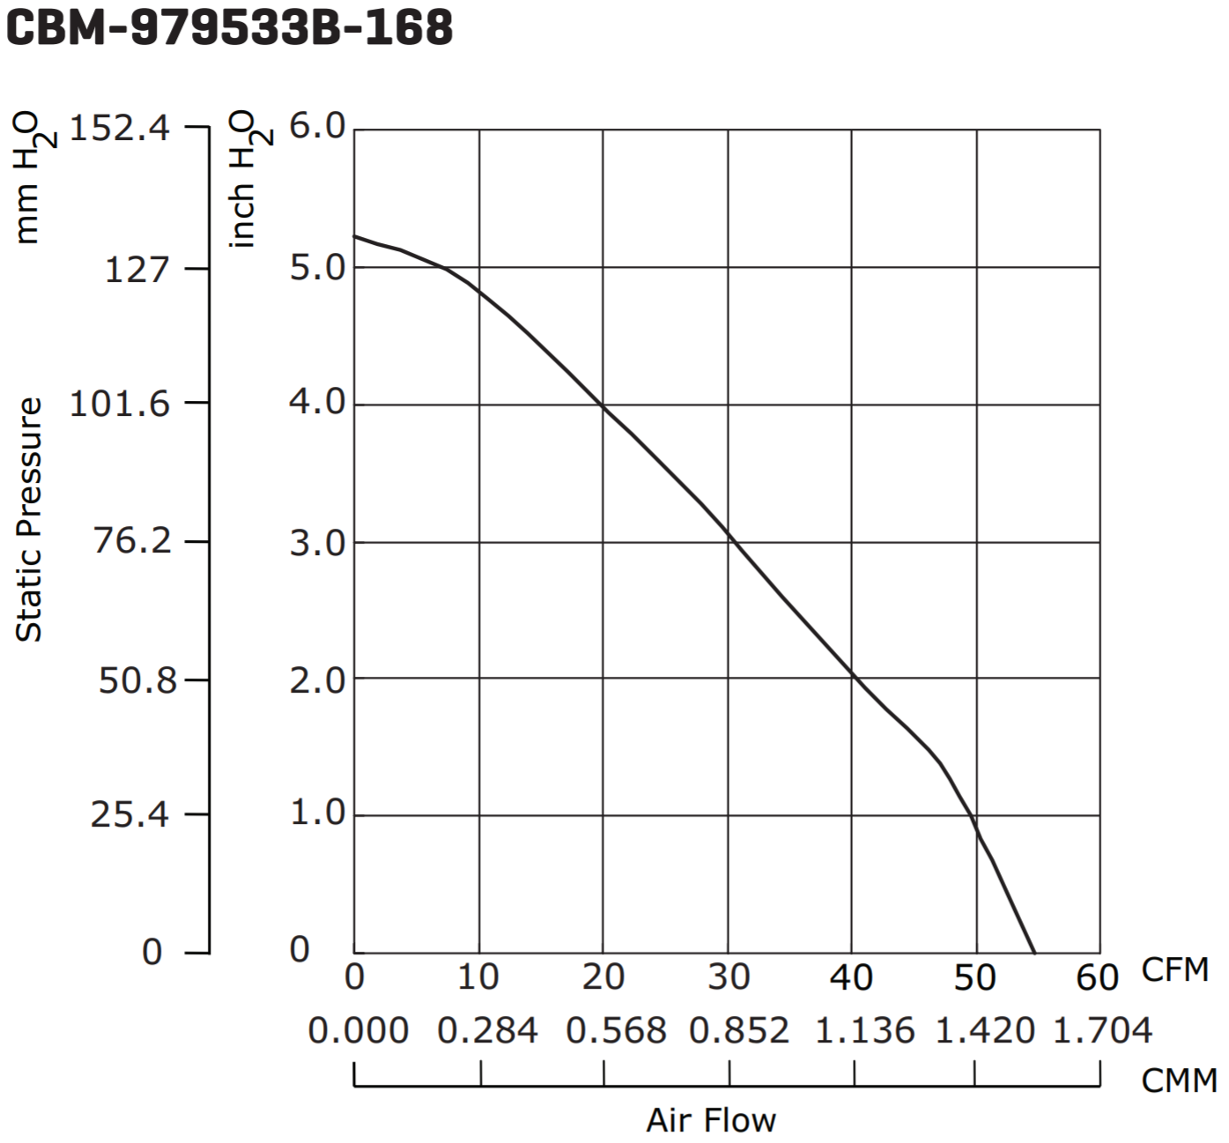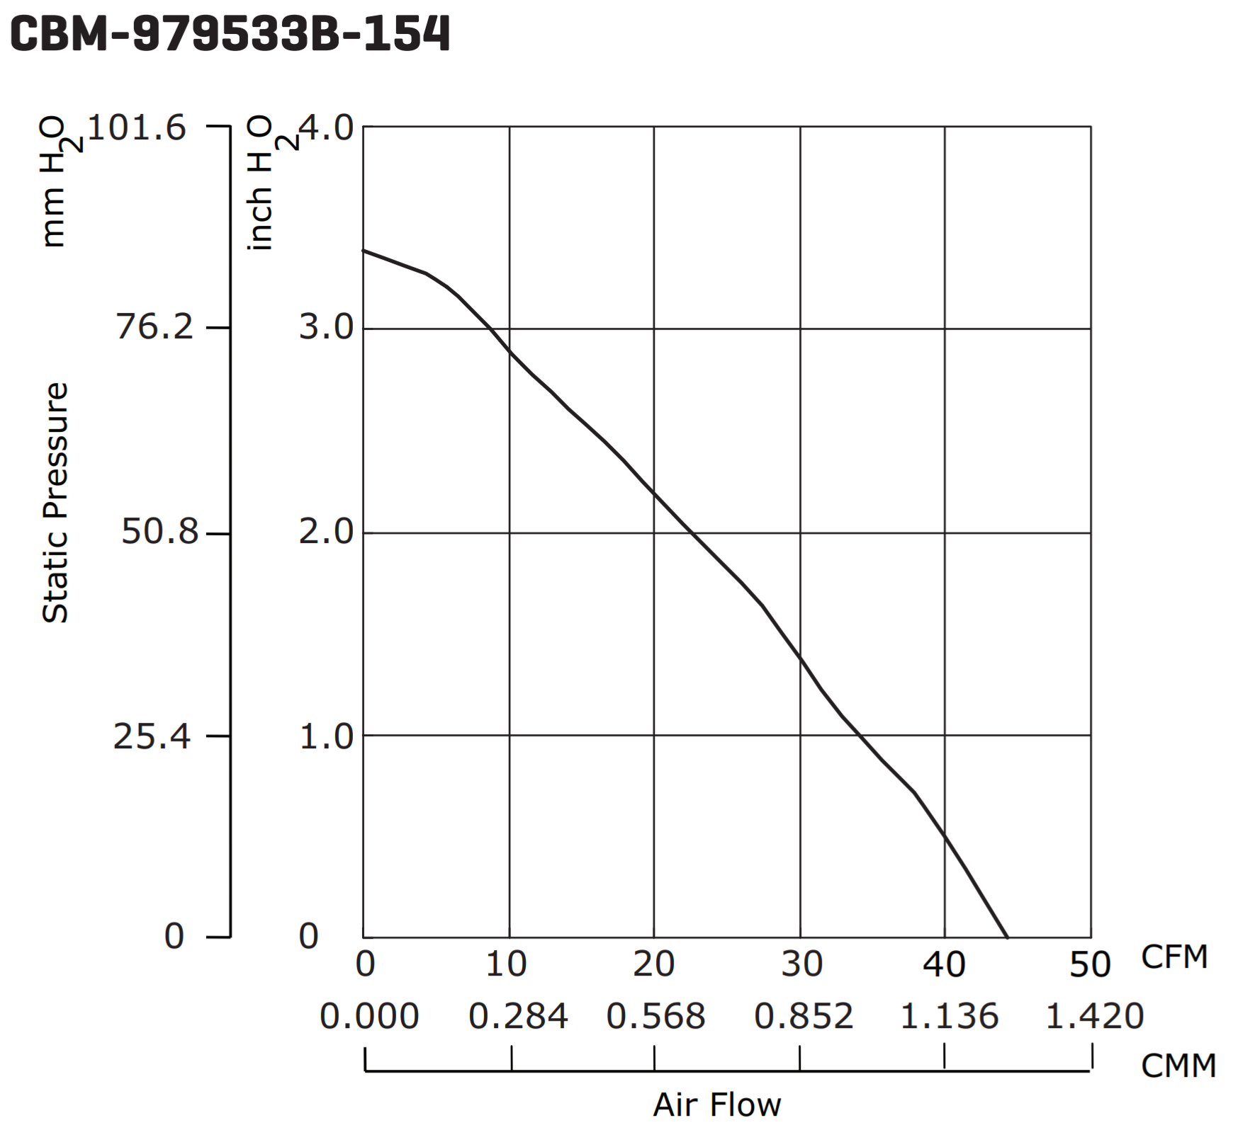

**Figure 3.2.3a - Comparison of CBM-979533B-168 and CBM-979533B-154**

**Table 3.2.3 - Fan Characteristics**

|  |  |  |  |  |
| --- | --- | --- | --- | --- |
| **Fan S/N** | **Max Power Input (W)** | **Max Air Flow (CFM)** | **Max Static Pressure  (inch H2O)** | **Price** |
| CBM-979533B-154 | 22.08 | 44.2 | 3.39 | $14.45 |
| CBM-979533B-168 | 48.30 | 54.7 | 5.22 | $18.35 |

Best Option/Meets Option Does not Meet Requirements

# 3.2.4 Roasting Chamber

The beans will be dumped into the roasting chamber to roast, and to keep from burning some beans and under-roasting others, air needs to agitate the beans enough to move them around throughout the entire process. IntelliRoast is using a chamber with small angled slits in the walls to allow air to circulate while rotating and mixing the beans . The chamber is able to hold approximately 120 grams of green coffee beans, enough for one 12-cup pot of coffee.

# 3.2.5 Hardware Control System

The hardware portion of the control system uses a number for parts to accomplish the task of roasting coffee. The microcontroller unit (MCU) is a STMicro STM32F207ZG. For the BLE subsystem, the STMicro SPBTLE-RF board provides an interface accessible over SPI. The temperatures of the various points in the heating system will be read using k-type thermocouples paired with a Maxim Integrated MAX31855 thermocouple-to-digital converter. The heating element is controlled using a Fotek SSR-DA25, as discussed in Section 3.2.1.3.

The STMicro STM32F207 MCU was chosen for a number of reasons. STMicro offers a competitively priced development board, the Nucleo-F207ZG, at $25 through popular distributors. The leading competitive product, the Arduino Uno R3, costs $22. The STMicro MCU bests the Arduino’s Atmega 328P chip in every category, from clock speed to amount of available flash memory on-chip. From a prototyping standpoint, the STM32F207 meets all of our requirements and has enough headroom to allow for additional features to be added after Intelliroast has hit the market. While the unit price of the MCU itself is more than the Atmega 328P, STMicro’s hardware abstraction layer (HAL) allows development to commence on this chip, while a lower cost STM32Fx chip can be swapped in and still work without incurring a development penalty down the road. Additionally, the STM32Fx line of chips is based on ARM’s Cortex-M3 architecture. This architecture is used by a number of different embedded systems manufacturers and allows for other development tools and code to be used with the STM32Fx chips.

**Table 3.2.5 - MCU Features and Specifications**

|  |  |  |  |  |  |
| --- | --- | --- | --- | --- | --- |
| MCU | Clock Speed | SRAM | Flash | GPIO Pins | Price |
| STMicro STM32F207 | 120MHz | 128KB | 1MB | 140 | $12.75 |
| Atmega 328P | 20MHz | 2KB | 32KB | 23 | $2.14 |

Best Option/Meets Option Does not Meet Requirements

# 

# 3.2.6 Filtering System/Cyclone Separator

Chaff is a paper-like by-product of the coffee bean roasting process, and it can create a fire hazard if not properly disposed. Additionally, coffee beans could unevenly roast if the chaff remains uncollected. A separator is necessary to separate the chaff from the rest of the beans inside the heating chamber. A cyclone dust separator is selected because of its ability to quickly and efficiently filter large debris from the air stream. An added benefit of the cyclone separator is the low maintenance required. Cyclone separators save money because of the lack of replacement filters and dust bags to replace [10]. Table 3.2.6 below outlines the options for different cyclone systems.

**Table 3.2.6 - Cyclone Separator Comparisons**

|  |  |  |  |  |
| --- | --- | --- | --- | --- |
| **Cyclone Separators** | **Efficiency** | **Weight** | **Dimensions** | **Price/Costs** |
| Cyclone Powder Dust Collector | 99% | 21.16 oz (600 g) | 11.81” x 7.09” x 6.30” (30 cm x 18 cm x 16 cm) | $23.99 |
| Custom 3D Printed Cyclone Separator | High | Adjustable | Adjustable | Filament for 3D Printing |

Best Option/Meets Option Does not Meet Requirements

The most comparable cyclone separator on the market meeting IntelliRoast’s chaff separation requirement is the SN50 High Efficiency Cyclone Powder Dust Collector. Its main use is to attach to shop vacuums, which are noticeable larger than consumer kitchen appliances. The SN50 can separate 99% of dust and debris without clogging the separator or reducing the airflow [10]. Although its features are desirable, IntelliRoast plans to use a smaller version of a similar separator. The dimensions on the SN50 separator are 11.81 inches long by 7.09 inches wide by 6.30 inches tall (30 x 18 x 16 cm), which are too large to fit inside a consumer-level coffee roaster.

Smaller separators than the SN50 are normally not available on the market. Since the cyclone separator will allow for little maintenance and upkeep, IntelliRoast will use a custom 3D-printed cyclone separator. This allows for the separator to contain similar features as the SN50 while minimizing its size. Additionally, the only cost from creating a custom cyclone separator is the printing costs, so this option is the more economic route for the cyclone separator.

# 3.3 Software

The software for IntelliRoast is split into two different components: the embedded software and the smartphone app. The embedded software controls all of the roasting process, from fan control to heating element control, and the smartphone app provides a high level view of the roasting process and communicates with the embedded software.

# 3.3.1 Software Control Systems

The control system, as discussed in Section 3.2.5, is built upon a STMicro STM32F2 series chip. The software stack is written in C. STMicro provides a number of C libraries, including drivers, a hardware abstraction layer (HAL), and middleware. In addition, these libraries are portable across STMicro’s STM32Fx line of processors by targeting the HAL instead of board specific code. These libraries allow for rapid development of the control subsystems. These subsystems include temperature control, fan control, communications, and user interface. They interface together to allow the system to follow a simple state diagram outlined in Figure 3.3.1a.

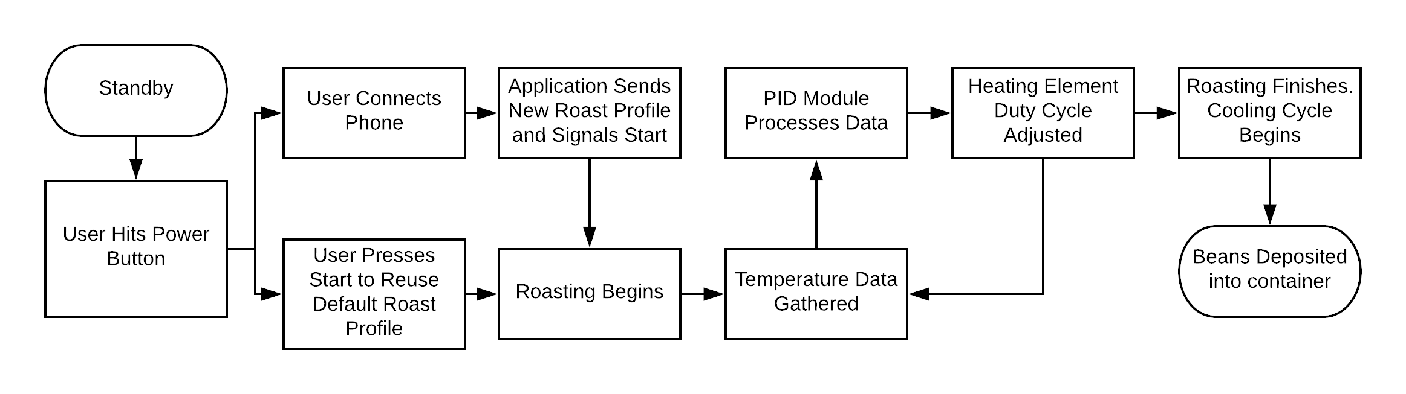

**Figure 3.3.1a - Control System Flowchart**

The temperature control system is made of two main components, the MAX31855 thermocouple sensor interface and the PID control system. Using the thermocouple interface, accurate temperature values can be fed into the PID system. The software PID system will determine the new duty cycle for the heating element. It will also return the rate of change of the temperature, which can determine markers for the progress of the roast. The temperature and rate of change will be stored in a simple buffer until it can be sent to the smartphone app through the communication subsystem.

The fan control system will be a simple PWM signal generated by a timer on the MCU. There will be two main power levels for the fan, roasting and ejecting. The roasting level will be used during the roasting and cooling phases. Ejecting will blast the beans up and out of the container.

Communication with the application is imperative to provide key additional features to IntelliRoast. Using Bluetooth Low Energy 4.1 (BLE), IntelliRoast will transmit and receive roast profiles, commands, and temperature readings to and from the smartphone app. The STMicro SPBTLE-RF is distributed with a STM32 HAL compatible library to facilitate ease of use.

The user interface on IntelliRoast itself are fairly rudimentary. It will include a pair of buttons that will signal “Power On” and “Start Roast”, respectively. This will be paired with LEDs which will provide the user feedback on what state the roaster is in currently. This includes signalling that the roaster has been brought out of standby, the roaster is scanning for the smartphone app, and the roaster has begun or finished roasting. Beyond this, the companion smartphone app provide the rest of the user interface for the roaster.

# 3.3.2 Smartphone App

The smartphone app is responsible for providing the user extra features and configuration of IntelliRoast: choosing a roast profile to use, viewing roast progress, and starting and stopping roasting. While not essential for a simple roast, the app provides further customization and control than the hardware alone allows for. The user will be allowed to choose from multiple roast profiles and view more detailed information about each roast profile. While IntelliRoast is roasting, the app will show overall progress and real time temperatures. Users can select their desired roast profile, start the roast, view roast progress, and stop the roast at any point in the roast, all from the app.

The smartphone interaction is shown in Figure 3.3.2a..

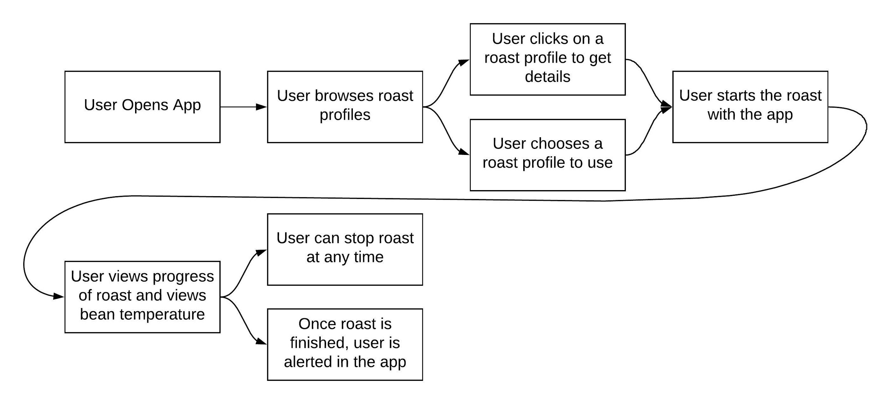

**Figure 3.3.2a - Smartphone App User Interaction**

The app will be made for Android smartphones, and it will use BLE to connect to IntelliRoast. Android includes BLE interfaces in the default libraries, so the app will use those libraries to send and receive data to and from IntelliRoast. The app will be written in Java using Android Studio. Android apps can be written in a few different languages, most commonly Java, and there is plenty of online support for Android apps written in Java.

# References

[1] “Drum vs Fluid Bed Roasters,” *Home*. [Online]. Available: https://www.coffeechemistry.com/quality/roasting/drum-vs-fluid-bed-roasters. [Accessed: 26-Sep-2018].

[2] B.A. Duran III, ‘Galvanized Steel’s Performance in Extreme Temperatures’, 2013. [Online]. Available: https://galvanizeit.org/education-and-resources/resources/technical-faq-dr-galv/galvanized-steels-performance-in-extreme-temperatures. [Accessed: 25 Sep. 2018].

[3] Grainger.com, ‘2" x 48" x 24" Mineral Wool High Temperature Insulation, Density 8#, Green’, 2018. [Online]. Available: https://www.grainger.com/product/ROXUL-2-x-48-x-24-Mineral-Wool-High-19NE78. [Accessed: 25 Sep. 2018].

[4] *Master Heat Gun: Instruction Manual, Rev. 3*, p. 1-12 [Online]. Available: http://www.masterappliance.com/content/sites/default/files/simple_products/downloads/Master-Heat-Gun-Instruction-Manual-58221.pdf. [Accessed: 25 Sep. 2018].

[5] Zoro.com, ‘Fire Barrier Wrap Strip, 12 ft. L’, 2018. [Online]. Available: https://www.zoro.com/sti-fire-barrier-wrap-strip-12-ft-l-sswred2/i/G0664587/feature-product?gclid=Cj0KCQjwuafdBRDmARIsAPpBmVU-zgW__t4FE9dBl-6CCvlSQttZg4QRxlWX8v9yUWIrc_fwbznL6N8aAlCiEALw_wcB&gclsrc=aw.ds. [Accessed: 25 Sep. 2018].

[6] Zoro.com, ‘Fire Barrier Packing Material, 20 ft. L’, 2018. [Online]. Available: https://www.zoro.com/3m-fire-barrier-packing-material-20-ft-l-pm4/i/G3129007/feature-product?gclid=Cj0KCQjwuafdBRDmARIsAPpBmVVJVN1bAS_MODQM0TKVp6fKnF7N954tLDcZmeIHcUV478hHBIyvGUwaAhAQEALw_wcB. [Accessed: 25 Sep. 2018].

[7] ASTM. *ASTM E814*. [Online]. Available: https://compass.astm.org/EDIT/html_annot.cgi?E814+13a(2017). [Accessed: 25 Sep. 2018].

[8] nfpa.org, *UL 1479, Standard for Fire Tests of Through-Penetration Firestops.* 2010 [Online]. Available: https://www.nfpa.org/Assets/files/AboutTheCodes/5000/s1479_3.pdf. [Accessed: 25 Sep. 2018].

[9] BuyInsulationProducts.com, ‘Fiberglass High Temp Tape’, 2018. [Online]. Available: http://www.buyinsulationproductstore.com/fiberglass-high-temp-tape/. [Accessed: 25 Sep. 2018].

[10] NeedBrightlife.com, ‘Cyclone Powder Dust Collector Filter for Vacuums White’, 2018. [Online]. Available: https://www.needbrightlife.com/products/cyclone-powder-dust-collector-filter-for-vacuums-white?variant=7986372313136. [Accessed: 25 Sep. 2018].