# 3. APPROACH

IntelliRoast provides a customizable coffee roasting experience at an affordable price. By using a companion smartphone application, the user can create and save user-defined roast profiles. IntelliRoast uses a heating element and a centrifugal fan operated by a microcontroller to agitate and roast the coffee beans to the chosen profile. Once the beans are roasted, they are blown out of the heating chamber for easy removal into a holding container.

# 3.1 System Overview

IntelliRoast includes several systems and controls that work together to create an automatic coffee roasting machine. The hardware includes a fan, a heating element, temperature probes, a roasting chamber, a chaff separation unit, a chaff collection system, a bean deposit system, and a microcontroller. The microcontroller will contain logic to adjust fan speeds, heating element temperatures, and the bean deposit system.

The user begins by placing the green coffee beans in the roasting chamber and pressing the start button. Once the roast has been started, the microcontroller will adjust the temperature and speed of the air to roast the beans according to a default roast profile. Users can also use a smartphone application to select from multiple roast profiles, view roast progress and details, and start or stop the roast. After the beans are roasted, the microcontroller will increase the fan speed to blow the beans from the roasting chamber into a holding container. After the roasting process finishes, the user will have enough freshly roasted coffee beans to brew a 12-cup pot of coffee.

# 3.2 Hardware

This section details the internal components comprising IntelliRoast. These components must be selected in terms of size, budget, and power, and they must conform to the constraints of an average home kitchen appliance. Component requirements were researched based on the current in-home coffee roasting process. Since IntelliRoast will compete with other products on the market, components were selected to outperform other similar products.

# 3.2.1 Heating System

The heating solution for IntelliRoast is separated into three categories: heating options, insulation, and electronics to control the heating element.

# 3.2.1.1 Heating System Options

The type of heating system affects IntelliRoast’s performance. Roasting coffee beans is achieved by one of two heating systems: fluid bed heating and drum heating. IntelliRoast uses fluid bed heating for roasting the green coffee beans. Table 3.2a shows the comparison of heating options considered.

**Table 3.2a - Comparison of Heating System Options**

|  |  |  |
| --- | --- | --- |
| **System** | **Description** | **Properties** |
| Fluid Bed Heating | Uses heated air to agitate beans and roast beans evenly | Uses 100% convection |
| Drum Heating | Uses a metal drum to hold beans overheated element while stirring beans | Uses 75% convection  Uses 25% conduction |

Best Option/Meets Requirements Does Not Meet Requirements

Drum roasting is accomplished by rotating a large metal drum containing unroasted coffee beans heated from underneath by propane or natural gas. This style of roasting is most effective on a large scale, where pounds of beans are roasted at a time, and is the most common choice for large companies in the industry. Since drum roasting directly heats the beans in a metal drum, the beans are less likely to have a homogeneous roast resulting in unevenly roasted beans [1]. Drum roasting also requires more mechanical and chemical parts to operate, such as motors to rotate the drum and a gas supply to ignite for heat. For small-scale applications, like in-home roasting, drum roasting is not the preferred method due to requiring constant supervision.

Fluid bed roasting blows heated air into the roasting chamber, agitating and roasting the beans. This method roasts a smaller amount of beans and takes about half as much time as drum roasting [1]. Additionally, fluid bed roasting requires fewer mechanical parts and provides for easier clean-up. No gas or flame is used to roast the beans; instead, a heating element heats the air needed for the roast. Since fluid bed roasting is faster, cleaner, and hands-free, it is the preferred method for in-home roasting.

# 3.2.1.2 Heating Element

IntelliRoast uses the Master Appliance REPL Heating Element HG501A [2] to heat the green beans to be roasted. Table 3.2b shows a comparison of the heating elements considered for the system.

**Table 3.2b - Heating Element Characteristics**

|  |  |  |  |  |
| --- | --- | --- | --- | --- |
| **Element** | **Price per Unit (USD)** | **Description** | **Properties**  **Required: 300°C** | **Power Rating** |
| REPL Heating Element for HG501A [2] | 28.20 | Heating element | 500 °F ~ 700 °F (260 °C ~ 371 °C) | 1680 W |
| Custom Resistive Wire | 21.88/32 ft | Nickel Chromium wire only | ~1850 °F  (~1010 °C) | 1000-1100 W |

Best Option/Meets Requirements Does Not Meet Requirements

A custom resistive wire solution is an alternative option to the heating element. The resistive wire is made from the same nickel chromium metal as the heating element and costs less per unit respectively. However, the resistive wire solution would require additional insulating material and time spent assembling a heating element. Furthermore, assembling a custom resistive wire solution would introduce uneven heat distribution since the coiling in the wire would be unevenly assembled. The wire itself has a higher temperature rating, but a new temperature rating would need to be calculated after assembly of a heating element.

IntelliRoast will use the REPL Heating Element for the HG501A, a pre-coiled heating element, to roast the green coffee beans. This heating element requires no assembly, unlike the resistive wire solution. The heating element will heat the air to a maximum of 300 °C consistently throughout the roasting process since the temperature is within the element’s heating limits. Air will be blown over the heating element using the centrifugal fan. The now-heated 300 °C air will agitate the beans and evenly roast them to the target temperature of 205 °C - 250 °C. Figure 3.2a shows the schematic for this process.

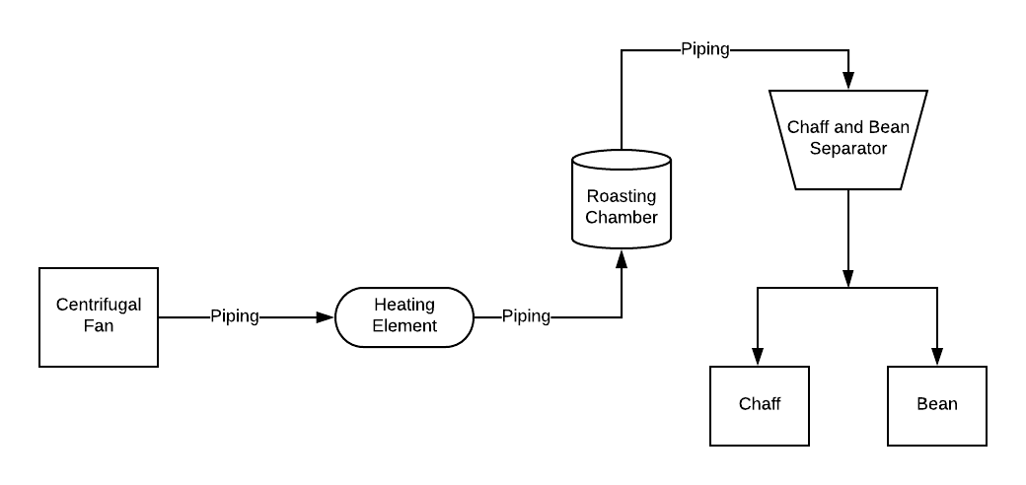

**Figure 3.2a - Heating Element and System Schematic**

# 3.2.1.3 Solid-State Relays

The functionality of IntelliRoast revolves around its ability to control the temperature of the air entering the roasting chamber. This process is accomplished with a solid-state relay. Using a signal similar to Pulse Width Modulation (PWM), but slower in frequency, a solid-state relay can turn the heating element on and off. With a custom Proportional-Integral-Derivative (PID) software module, the temperature of the heating element can be controlled to match the roast profile.

The heating element measures 8.8 Ohms and draws 13.6 amps at 120 VAC. Because of the high power consumption of the heating element, a solid-state relay with a high load rating is needed. Two solid-state relays were considered due to these high constraints: the TE SSRDC-200D12 and the Fotek SSR-25DA.

The TE SSRDC-200D12 has a load rating between 0 and 200 VAC and is rated up to 25 amps, well within the operating range of the heating element [3]. The Fotek SSR-25DA allows the operation of up to 380 VAC at 25 amps with only 3 VDC making it the best candidate for the PWM heating element solid-state relay [4]. Fast response time is also a key element in both the PWM control and PID loop, and while the TE has a much faster response time compared to the Fotek, its on and off cycle differ drastically, making its application in a PID loop less practical to implement. Due to the slow response time of heat dissipation, response time less than 1 ms is not practical. The SSR-25DA’s 10 millisecond response time for both on and off triggering, while slower, makes it the better choice for this specific application. Table 3.2c shows the comparison between the Fotek and TE solid-state relays.

**Table 3.2c - Solid-State Relay Comparison Characteristics**

|  |  |  |  |  |  |  |
| --- | --- | --- | --- | --- | --- | --- |
| **Solid-State Relay** | **Price per Unit (USD)** | **Input Rating** | **Voltage Load Rating** | **Amperage Load Rating** | **Response Time (on cycle)** | **Response Time (off cycle)** |
| **Requirements** | < $30 | 5 VDC | 120 VAC | 13.6 A | < 1 s | < 1 s |
| Fotek SSR-25DA [3] | $16.50 | 3-32 VDC | 24-380 VAC | 25 A | 10 ms | 10 ms |
| TE SSRDC-200D12 [4] | $40.06 | 3.5-32 VDC | 0-200 VAC | 25 A | 600 µs | 2.6 ms |

Best Option/Meets Requirements Does Not Meet Requirements

# 3.2.2 Heat Insulation

The sections below discuss the hardware selections for the heat transfer and insulation requirements to keep the external enclosure surface temperature within acceptable levels.

# 3.2.2.1 Piping

IntelliRoast uses black iron piping to transport air from the centrifugal fan through the heating element to the coffee beans. Because the pipes have superheated air pumped through them, the material used must withstand high temperatures without oxidation, breakdown, or melting. Additionally, high-pressure air flows through the system; therefore, the piping must remain airtight under these conditions.

Black iron, galvanized steel, and copper piping were investigated for this purpose. Copper piping is used primarily for heating elements as the metal absorbs heat exceptionally well, meaning this option will cause the most heat loss between the heating element and the beans. In addition, the traditional method of connecting copper pipe is through clamping the piping at a connection, meaning any necessary changes beyond initial installation would be difficult. Alternatively, both black iron and galvanized steel prevent heat absorption, making them better for transferring hot air with the least amount of heat loss. Black iron and galvanized steel both have threaded ends to their piping, making connections and adjustment much easier. As shown in Figure 3.2b, galvanized metals have a significant drawback of peeling the toxic zinc coating at high temperatures, which creates a health hazard [5]. For these reasons, black iron is the best option for the piping of the heat transfer area.

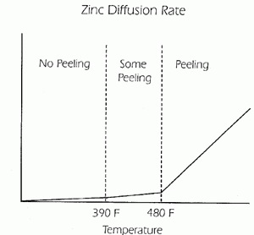

**Figure 3.2b - Zinc Diffusion Rate of Coat Peeling [5]**

**Table 3.2d - Piping Material Comparison**

|  |  |  |  |  |
| --- | --- | --- | --- | --- |
| **Material** | **Price per 3-inch Unit (USD)** | **Heat Absorption** | **Style of connection** | **Food Safe** |
| Black Iron | $1.55 | Low | Pipe Threading | Yes |
| Copper | N/A (Cut to size) | High | Friction Crimping | Yes |
| Galvanized Steel | $2.50 | Low | Pipe Threading | No |

Best Option/Meets Requirements Does Not Meet Requirements

# 3.2.2.2 Insulation

Two major types of fire protection are available on the current market: fire barriers and insulation. Fire barriers restrict the spread of fire by expanding itself to encapsulate the fire and prevent it from spreading to other areas. Fire barriers are used in large-scale applications like housing because of the amount of space available to decrease the environment temperature and trap fires. Meanwhile, insulation reduces heat transfer between objects of varying temperatures by reducing heat flow through an intermediate material between the two objects. Smaller-scale applications like kitchen appliances use insulation because of the lack of space available to trap fire. Dissipating high temperature is a necessity to prevent other internal components from catching on fire.

Effective insulation consists of materials with a high resistance to heat flow, which is a thermodynamic value called the R-value. An R-value is a normalized value which dictates how effective a material can resist heat flow through the object itself. This value depends on the thermal conductivity of the material – how well a material can attract and trap heat – and the thickness of the material. Equation (1) represents the R-value of a material [6]

(1)

where *l* is the thickness of the material and *λ* is the thermal conductivity of the material.

A material with either a lower thermal conductivity or a larger thickness will have a higher R-value. Good insulators have a higher resistance to heat flow and therefore a higher R-value. Therefore, IntelliRoast’s insulation requires a high R-value to provide maximum insulation effectiveness. Below, Table 3.2e shows a comparison between the insulation materials considered for the outside of the heating chamber.

**Table 3.2e - Insulation Material Comparison**

|  |  |  |  |  |
| --- | --- | --- | --- | --- |
| **Description** | **Price (USD)** | **Primary Material** | **Thickness (mm)** | **R-Value** |
| **Requirement** | < 20 | Fiberglass | 15.0 | 2 |
| ROXUL Mineral Wool/Foil Backing High-Temperature Insulation [7] | 15.65 | Fiberglass | 25.4 | 4 |
| STI Fire Barrier Wrap Strip [8] | 56.09 | Aluminum | 3.18 | 0.005 |
| 3M Fire Barrier Packing Material [9] | 21.11 | Fiberglass | 12.7 | 2 |
| Fiberglass High Temp Tape [10] | 13.10 | Fiberglass | 1.59 | 0.25 |

Best Option/Meets Requirements Does Not Meet Requirements

Both fire barrier strips and insulation were considered for this purpose. Fire barrier wrap strips, such as the STI product, are made of metals with a high thermal conductivity since these are meant to catch and restrict fire flow. Additionally, the lack of documentation and proper use cases for this product made the STI Fire Barrier Wrap Strip undesirable to use [7]. This, and their small thickness, made fire barrier strips an ineffective solution for IntelliRoast’s insulation, as seen by their small R values. Alternatively, the other products are fiberglass-based and have substantially higher R values compared to the STI Fire Barrier Wrap Strip. Both the 3M Fire Barrier Packing Material and the Fiberglass High-Temperature Tape are different types of loose-fill insulation. While easier to implement in hard-to-reach places, this is not ideal for IntelliRoast because of the commercial use of kitchen appliances. These appliances are prone to movement, and loose-fill insulation has a higher chance of becoming dislodged inside the device.

The ROXUL Mineral Wool/Foil Backing High-Temperature Insulation operates with a temperature range between -17.8 °C to 648.9 °C, which is sufficient for insulating the area around the heating element since the heating element is rated to 371 °C [7]. This material has a length of 1.21 meters and a thickness of 25.4 millimeters, which can be cut or stacked to fit inside the device itself. Furthermore, this material is not a loose-fill material and will not move around while inside IntelliRoast. ROXUL’s mineral wool was selected as the insulation of choice for IntelliRoast because of its high R-value for its price.

# 3.2.3 Centrifugal Fan

In fluid bed coffee bean roasting, airflow and air pressure are the integral factors for a successful roast. These two characteristics are dictated by the inflow fan located at the beginning of the heat transfer section. The two fan styles considered for providing airflow were axial fans and centrifugal fans. Axial fans are more popular for providing airflow for large volume enclosures such as computer towers or rooms of a building. Centrifugal fans function well in smaller environments such as small piping. The centrifugal style fan was selected due to its smaller intake surface area, superior static pressure output, and smaller output opening.

Two centrifugal fan styles from the same supplier were considered: the CUI Inc. CBM-979533B-154 (154) and the CUI Inc. CBM-979533B-168 (168). The key distinction between these two candidates is the maximum raw input current. The 168 model has a maximum input power of 48.30 watts, while the 154 model is limited to 22.08 watts [11]. An increase in power means the fan pushes more air through the same sized output. Table 3.2f shows an overview of the fan characteristics.

There is an inverse relationship between static pressure and airflow obtainable from fans, both axial- and centrifugal-style. Both the 168 model and the 154 model have a near-linear slope between airflow and static pressure, as shown in Figure 3.2c. Due to the limited inner diameter of the piping used for air and heat transfer, static pressure limits the total available airflow. This static pressure is important to the bean agitation process, as it provides the lifting motion needed to move the beans within the roasting chamber. Because of this, the 168 will be the best overall choice due to its higher maximum static pressure and airflow.

**Table 3.2f - Fan Characteristics**

|  |  |  |  |  |
| --- | --- | --- | --- | --- |
| **Fan S/N** | **Max Power Input (W)** | **Max Air Flow (CFM)** | **Max Static Pressure  (inch H2O)** | **Price** |
| CBM-979533B-154 [11] | 22.08 | 44.2 | 3.39 | $14.45 |
| CBM-979533B-168 [11] | 48.30 | 54.7 | 5.22 | $18.35 |

Best Option/Meets Requirements Does Not Meet Requirements

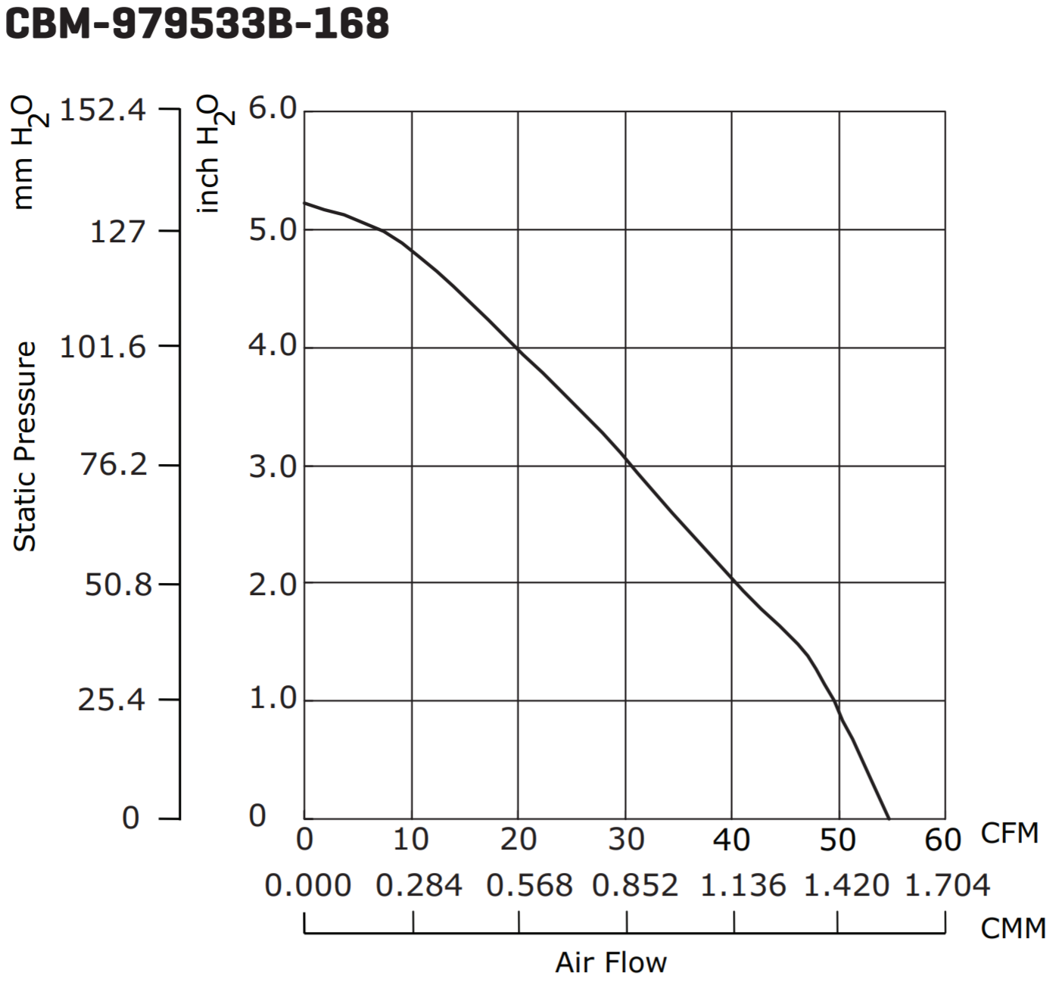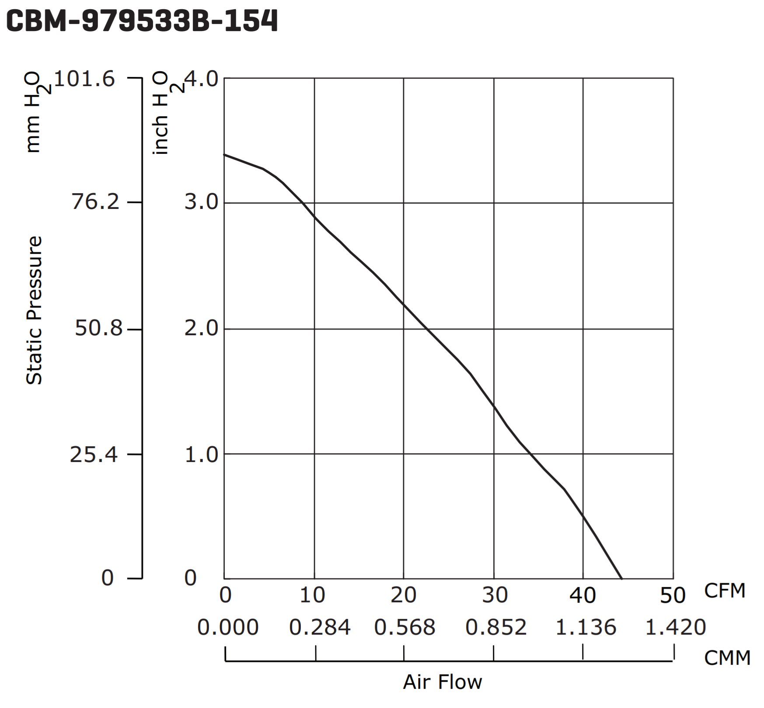

**Figure 3.2c - Comparison of CBM-979533B-168 and CBM-979533B-154 Air Flow to Static Pressure relation diagrams [11]**

Additionally, to agitate the beans, the maximum airflow the fan can produce while also allowing the air to be heated to 300 °C is calculated. If the air flows over the heating element too quickly, the fan will cool the heating element below the target temperature. Conversely, if the air moves too slowly, it will not agitate the beans and provide an even roast. Equation (2) finds the heat transfer rate where Qdot is the amount of heat transferred per second over an area, hc is the heat transfer coefficient, Ac is the cross-sectional area of the piping, Tfluid is the temperature of the air, and Tcoil is the temperature of the heating element.

(2)

The value of Qdot is then used in Equation (3) where mass flow rate ma represents the air flow in cubic feet per minute over the heating element, h1 and h2 are enthalpy values. Calculating ma is done to find the flow rate necessary to heat the air to the desired roasting temperature.

(3)

# 3.2.4 Roasting Chamber

A roasting chamber will be used to roast the beans. To prevent burning some beans and under-roasting others, air needs to agitate the beans enough to move them around throughout the entire process. IntelliRoast uses a pre-constructed chamber with small angled slits in the walls to allow air to circulate while rotating and mixing the beans. The chamber can hold approximately 120 grams of green coffee beans, enough for one 12-cup pot of coffee.

# 3.2.5 Hardware Control System

The hardware portion of the control system uses multiple parts to accomplish the task of roasting coffee. The microcontroller unit (MCU) is a STMicro STM32F207ZG [13]. For the BLE subsystem, the STMicro SPBTLE-RF board [14] provides an interface accessible over SPI. The temperatures of the various points in the heating system will be read using k-type thermocouples [15]. These will be paired with a Maxim Integrated MAX31855 thermocouple-to-digital chip [16]. The heating element will be controlled using a Fotek SSR-DA25, as discussed in Section 3.2.1.3.

**3.2.5.1 Microcontroller**

The STMicro STM32F207 MCU was chosen for several reasons. STMicro offers a competitively priced development board, the Nucleo-F207ZG, at $25 through popular distributors, while the leading competitive product, the Arduino Uno R3, costs $22. The STMicro MCU bests the Arduino Uno in every category except price, from clock speed to amount of available flash memory on-chip. From a prototyping standpoint, the STM32F207 meets all IntelliRoast’s requirements and has enough headroom to allow for additional added features after IntelliRoast hits the market. While the unit price of the MCU itself is more than the Atmega 328P, STMicro’s libraries allow development to commence on this chip, while a lower cost STM32Fx chip can be swapped in and still work without incurring a development penalty down the road. Additionally, the STM32Fx line of chips is based on ARM’s Cortex-M3 architecture. This architecture is used by several different embedded-systems manufacturers and allows for other development tools and code to be used with the STM32Fx chips.

**Table 3.2g - MCU Features and Specifications**

|  |  |  |  |  |  |
| --- | --- | --- | --- | --- | --- |
| **Development Board** | **Clock Speed** | **SRAM** | **Flash** | **GPIO Pins** | **Price** |
| STMicro Nucleo-F207 | 120 MHz | 128 KB | 1 MB | 140 | $24.47 |
| Arduino Uno | 20 MHz | 2 KB | 32 KB | 23 | $23.38 |

Best Option/Meets Requirements Does Not Meet Requirements

**3.2.5.2 Temperature Sensors**

K-type thermocouples are the most common thermocouples used in industry because of their inexpensive construction and high (482 °C) heat rating. These must be paired with a thermocouple amplifier as the change in voltage across the thermocouple leads can be as small as 10 µV/°C. This is too small for the analog-to-digital converter (ADC) on the microcontroller to be read accurately. Therefore, a voltage amplifier allows the small change in voltage to become a usable change in voltage. The Maxim Integrated MAX31855 combines an amplifier with calibration logic and an ADC in a single chip. It is a 14-bit ADC with a 0.25 °C resolution and a variance of 2 °C within the range of -200 °C to 700 °C.

**3.2.5.3 Fan Controller**

The fan control is integral to the design a fluid bed coffee roaster like IntelliRoast. The speed of the fan determines whether the heating element can roast coffee, whether the beans are agitated, and whether the beans can be ejected from the roasting chamber at the end of the roast. The fan can be accurately controlled using a microcontroller via a pulse width modulation (PWM) signal, which works by rapidly toggling a pin on and off at a high frequency. The ratio of time the pin is on versus off over a given period results in an average voltage. This type of signal can be applied to devices such as fans to simulate varying the voltage. Since the fan draws too much power to be connected directly to the microcontroller pin, a power MOSFET, such as the Vishay Siliconix SUP85N10-10, is placed between the fan and the microcontroller [16]. This MOSFET must be paired with a gate driver which can provide the correct voltage to the MOSFET’s gate and enough current to overcome the gate capacitance at a higher frequency PWM. Figure 3.2dbelow shows an example circuit that would allow the microcontroller to control the chosen fan.

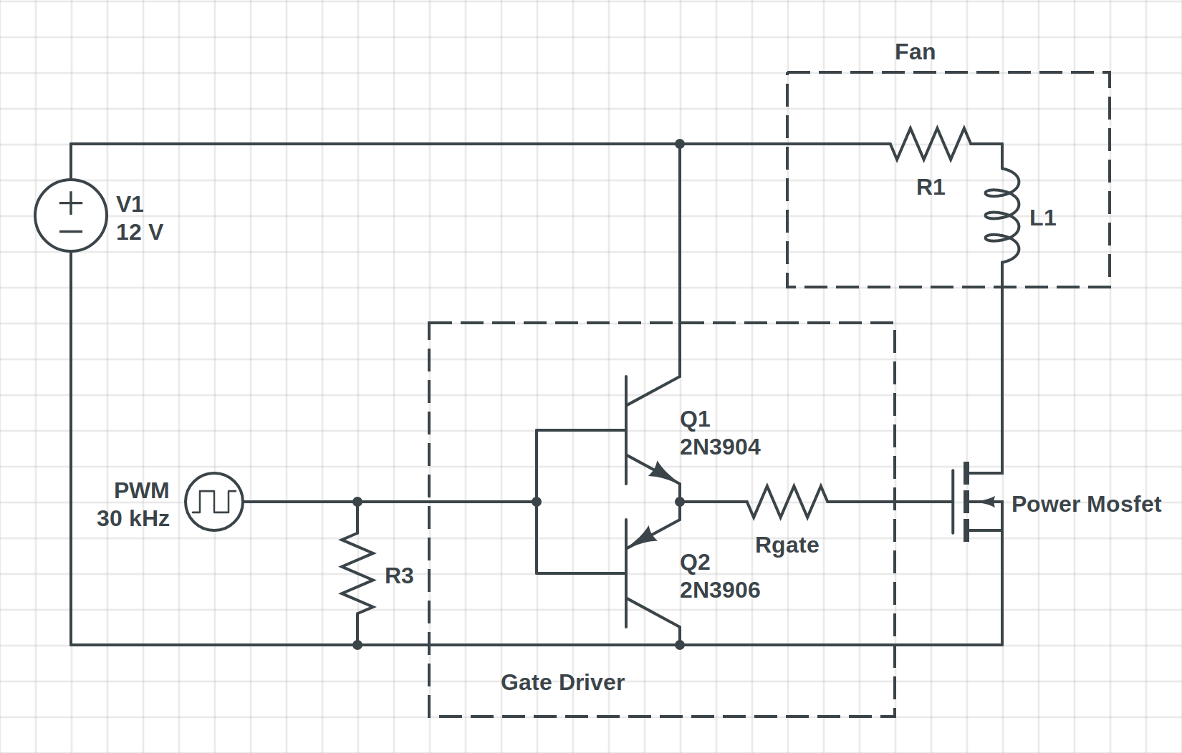

**Figure 3.2d - Fan Controller Circuit**

**3.2.5.4 Hardware User Interface**

The user interface on IntelliRoast itself is simple and easy to use. It will include a pair of buttons signaling “Power On/Off” and “Start Roast” respectively. These will be paired with LEDs which will provide the user with feedback on the roaster’s current state. This includes signaling that the roaster has been brought out of standby, the roaster is scanning for the smartphone app, and the roaster has begun or finished roasting. Beyond this, the companion smartphone application provides the rest of the user interface for the roaster. The buttons will be tied to an input pin on the microcontroller, and the LEDs will be low power LEDs that can be driven directly from output pins on the microcontroller.

# 3.2.6 Filtering System/Cyclone Separator

Chaff is a paper-like by-product of the coffee bean roasting process, and it can create a fire hazard if not properly disposed of. Additionally, coffee beans could unevenly roast if the chaff remains uncollected. A separator is necessary to separate the chaff from the rest of the beans inside the heating chamber. A cyclone dust separator was selected because of its ability to quickly and efficiently filter large debris from the air stream. An added benefit of the cyclone separator is the low maintenance required; cyclone separators save money because they do not require replacement filters or dust bags [18]. Table 3.2h below outlines the options for different cyclone systems.

**Table 3.2h - Cyclone Separator Comparisons**

|  |  |  |  |  |
| --- | --- | --- | --- | --- |
| **Cyclone Separators** | **Efficiency** | **Weight** | **Dimensions** | **Price/Costs** |
| Cyclone Powder Dust Collector | 99% | 21.16 oz (600 g) | 11.81” x 7.09” x 6.30”  (30 cm x 18 cm x 16 cm) | $23.99 |
| Custom 3D Printed Cyclone Separator | High | Adjustable | Adjustable | Filament for 3D Printing |

Best Option/Meets Requirements Does Not Meet Requirements

The cyclone separator that comes closest to meeting IntelliRoast’s chaff separation requirement is the SN50 High-Efficiency Cyclone Powder Dust Collector. Its main use is to attach to shop vacuums, which are noticeably larger than consumer kitchen appliances. The SN50 can separate 99% of dust and debris without clogging the separator or reducing the airflow. Although its features are desirable, IntelliRoast plans to use a smaller version of a similar separator. The dimensions on the SN50 separator are 30 x 18 x 16 cm, which are too large to fit inside a consumer-level coffee roaster.

Smaller separators than the SN50 are normally not available on the market. IntelliRoast will use a custom 3D-printed cyclone separator. This allows for the separator to contain similar features as the SN50 while minimizing its size. Additionally, the only cost from creating a custom cyclone separator is the printing cost, so this option is the more economical route for the cyclone separator.

# 3.3 Software

The software for IntelliRoast is split into two different components: the controls software and the smartphone app. The controls software oversees the roasting processes, from fan control to heating element control. It also handles communications with the user’s device. The smartphone application provides a high-level view of the roasting process and communicates with the control software.

# 3.3.1 Control Systems

These subsystems include temperature control, fan control, and communications. They interface together to allow the system to follow a simple state diagram outlined in Figure 3.3a.

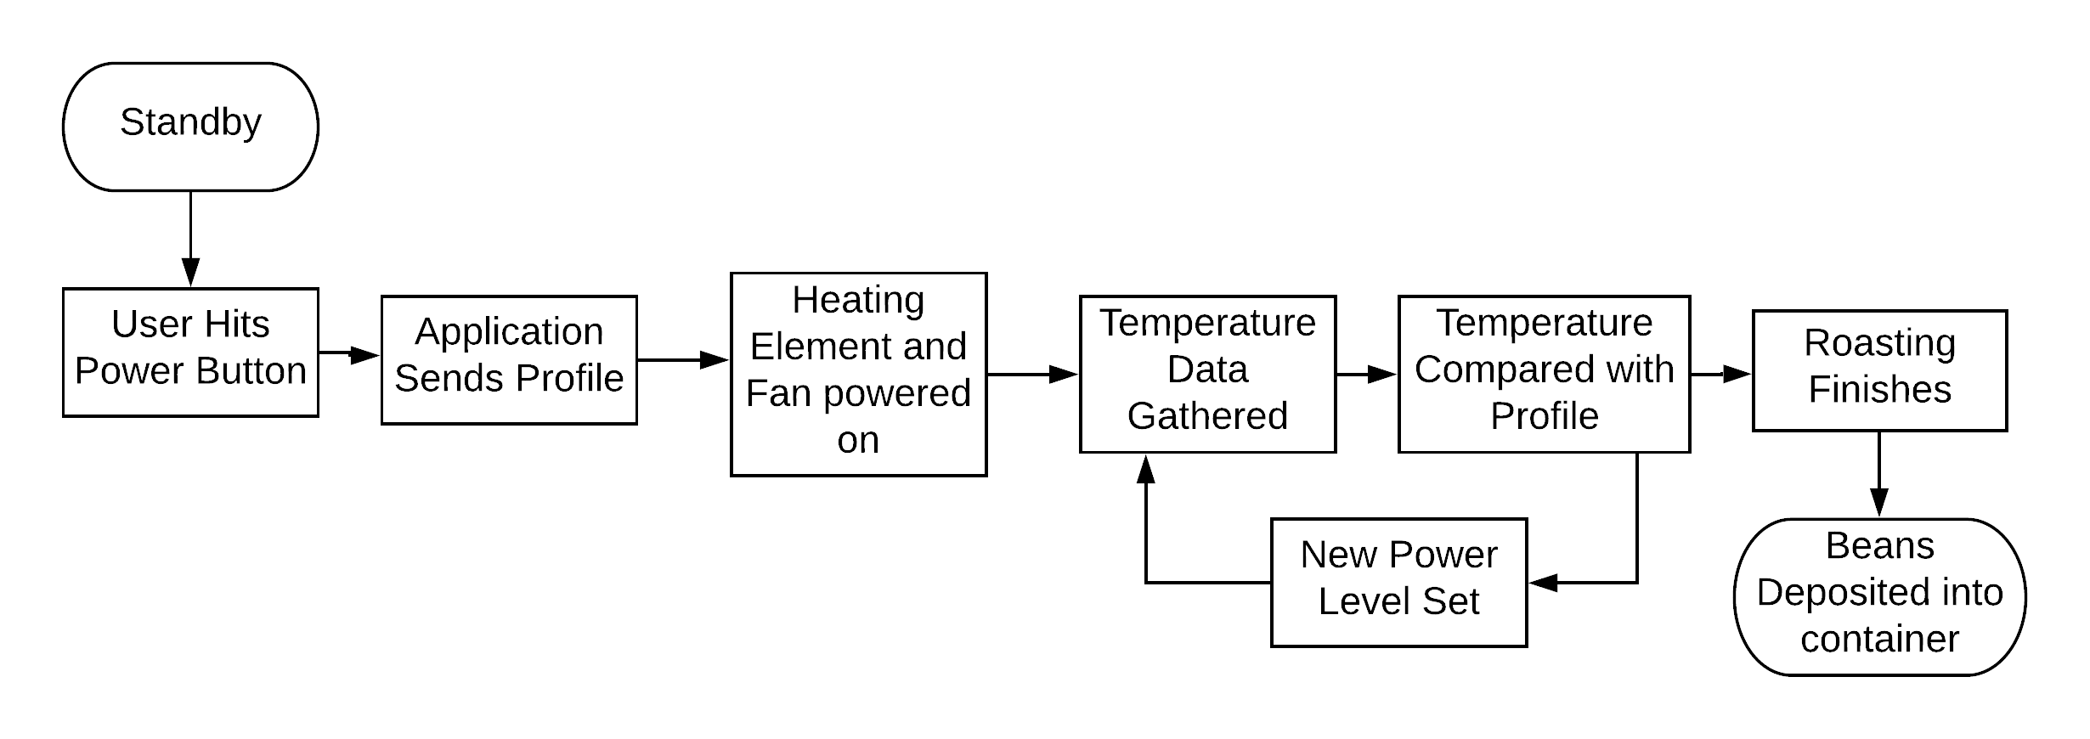

**Figure 3.3a - Control System Flowchart**

**3.3.1.1 Microcontroller**

The control system, as discussed in Section 3.2.5, is built upon a STMicro STM32F2 series chip. The software stack is written in C. STMicro provides several C libraries, including drivers, a hardware abstraction layer (HAL), and middleware. Beyond the easing of development, these libraries allow the code to be portable across STMicro’s STM32 line of processors by targeting the HAL instead of board-specific code.

**3.3.1.2 Temperature Control**

The temperature control system is comprised of three parts: the temperature sensors, fan, and heating element. These components interact with the microcontroller through common interfaces such as timers, interrupts, and SPI buses.

The MAX31855 breakout board allows the microcontroller to read the thermocouples accurately via a SPI bus interface. Each of the thermocouples will be tied to a MAX31855 chip, which will share a single bus. The chips can then be individually addressed by assigning each chip a select line and toggling that line when the temperature at its location is needed. When a chip select line is driven low, the chip provides a 14-bit signed fixed-point number representing the thermocouple temperature. Libraries are currently available for this chip but target the Arduino Uno. These will either be ported to the board directly or used as a reference in the process of writing a library that targets this board.

Using this thermocouple interface, accurate temperature values can be fed into a Proportional Integral Derivative (PID) function. This function determines the new duty cycle needed for the heating element such that the temperature matches the roast profile as time passes. The rate of change of the temperature will be calculated as part of that function. This is returned and sent to the user as a marker for if the roasting process is occurring as expected. The temperature and its rate of change are stored in a buffer until they can be sent to the smartphone application through the communication subsystem, and the new duty cycle is applied to the heating element.

Fan speed will be controlled by a PWM signal generated by a timer on the MCU. Depending on the phase, a different fan power level is applied. In the roasting phase, the fan is set to the minimum power level needed to allow the beans to properly agitate. If the fan is set too low, the beans in the bottom of the chamber will scorch while the rest will not roast at all. Too high of a power level forces the heating element to ramp up more than necessary and cause the roast to finish too quickly, inhibiting flavor development in the coffee. The cooling phase ramps up the fan to the highest possible power level without causing the beans to be blown out of the roasting chamber before they can cool down. Finally, the ejection phase sets the power level to the absolute maximum to blast the beans up and out of the roasting chamber. These power levels must be determined during prototyping by trial and error.

**3.3.1.3 Communication**

Communication with the application is imperative to provide key additional features to IntelliRoast. Using Bluetooth Low Energy 4.1 (BLE), IntelliRoast transmits and receives roast profiles, commands, and roast data to and from the smartphone app. STMicro provides an STM32 HAL compatible library to interface with the SPBTLE-RF chip over a full duplex SPI bus. STMicro’s libraries handle the setup and use of various Bluetooth profiles (or services) through the SPBTLE-RF chip.

Bluetooth communication is based on the idea of profiles which are specifications for what type of data will be transferred and how. For BLE, most profiles are derived from a single profile, Generic Attribute (GATT). GATT is a general specification for sending and receiving small pieces of data, known as attributes, between devices. IntelliRoast will primarily use this profile to send and receive commands, roast profiles, and roast data to and from the user’s smartphone.

# 3.3.2 Smartphone Application

The smartphone application is responsible for providing the user with extra features and configuration options for IntelliRoast: choosing a roast profile to use, viewing roast progress, and starting and stopping roasting. While not essential for a simple roast, the application provides further customization and control than the hardware alone provides. The user can choose from multiple roast profiles and view more detailed information about each roast profile, such as a temperature plot of the roast, estimated roasting time, and a description of the roast. During a roast, the application shows overall progress and real-time temperatures.

The smartphone interaction is shown in Figure 3.3b.

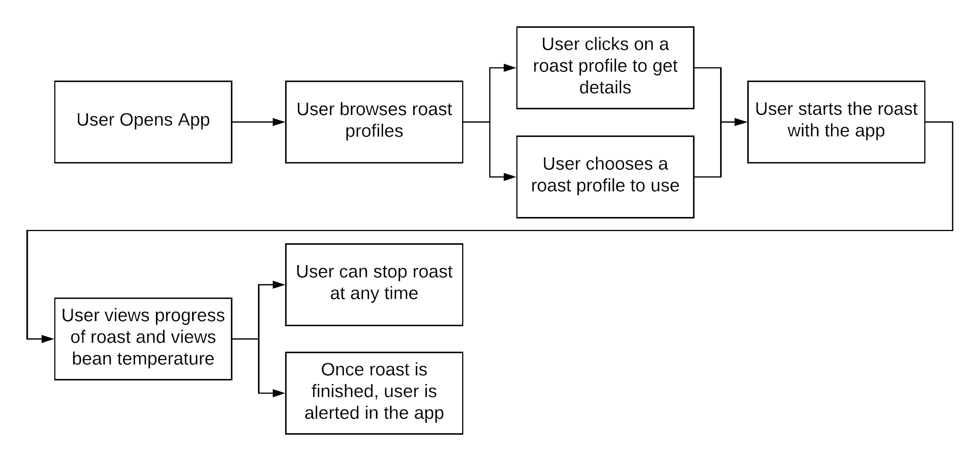

**Figure 3.3b - Smartphone Application User Interaction**

The smartphone application holds a selection of roast profiles for the user to select, which are stored locally on the user’s device. Since these profiles are not large, an online database is not necessary for profile storage. Roast profiles are stored as two-dimensional arrays with the temperature and the time required for the temperature. The smartphone application sends the array to the microcontroller, which is used to update the microcontroller’s PID loop.

The application initially supports Android devices and uses Bluetooth LE to connect to IntelliRoast. Android includes Bluetooth LE interfaces in the default libraries, and the application uses those libraries to send and receive data to and from IntelliRoast. Android apps are most commonly written in Java, but they can be written in several different languages. Due to the documentation and online support, IntelliRoast’s smartphone application will be written in Java.

# 3.3.3 Use Cases

The ideal “sunny-day” interaction is as follows: a user plugs in IntelliRoast, pours 120 grams of green coffee beans into the chamber, turns on IntelliRoast, opens their smartphone app, selects a roast profile, and starts the roast. When the roast is completed, the user removes a jar containing their roasted beans, and they need to clean out the chaff from the chaff collection jar before beginning a new roast. The interaction can be seen in Figure 3.3c.

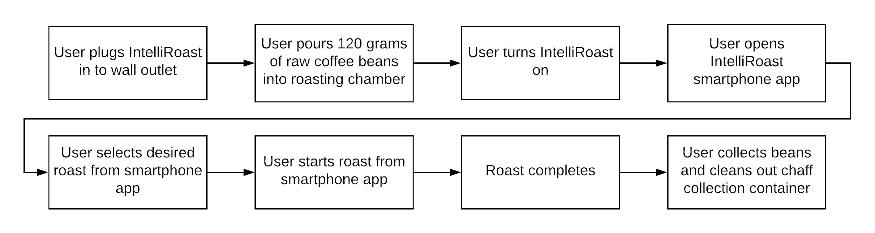

**Figure 3.3c - Sunny-Day User Interaction**

The worst-case “rainy-day” scenario would be if a user could not connect their smartphone to IntelliRoast over Bluetooth. In this case, the user would have to use the default roast profile by pressing the start button on the outside of IntelliRoast. This means the user would not be able to browse roast profiles and choose from multiple types of roasts, but instead they would have to use the roast profile already loaded into the device’s hardware. The default roast profile will be the last used roast or a standard medium roast if no roast has been used yet. A rainy-day interaction can be seen in Figure 3.3d.

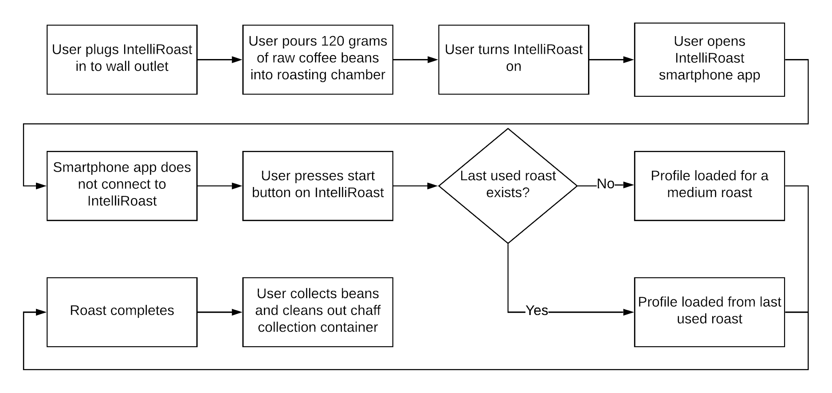

**Figure 3.3d - Rainy-Day User Interaction**

# References

[1] “Drum vs Fluid Bed Roasters,” *Home*. [Online]. Available: https://www.coffeechemistry.com/quality/roasting/drum-vs-fluid-bed-roasters. [Accessed: 26-Sep-2018].

[2] *Master Heat Gun: Instruction Manual, Rev. 3*, p. 1-12 [Online]. Available: http://www.masterappliance.com/content/sites/default/files/simple_products/downloads/Master-Heat-Gun-Instruction-Manual-58221.pdf. [Accessed: 25 Sep. 2018].

[3] ”SSRDC-200D12,” Digikey. [Online]. Available: https://www.digikey.com/product-detail/en/te-connectivity-potter-brumfield-relays/SSRDC-200D12/PB2566-ND/8612183. [Accessed: 17-Oct-2018].

[4] *FOTEK*. [Online]. Available: http://www.fotek.com.hk/solid/SSR-1.htm. [Accessed: 17-Oct-2018]

[5] B.A. Duran III, ‘Galvanized Steel’s Performance in Extreme Temperatures’, 2013. [Online]. Available: https://galvanizeit.org/education-and-resources/resources/technical-faq-dr-galv/galvanized-steels-performance-in-extreme-temperatures. [Accessed: 25 Sep. 2018].

[6] TheGreenAge.co.uk, ‘Thermal conductivity, R-Values and U-Values simplified!’, 2018. [Online]. Available: https://www.thegreenage.co.uk/article/thermal-conductivity-r-values-and-u-values-simplified/. [Accessed: 23 Oct. 2018].

[7] Grainger.com, ‘1" x 48" x 24" Mineral Wool/Foil Backing High Temperature Insulation, Density 8#, Dark Brown’, 2018. [Online]. Available: https://www.grainger.com/product/ROXUL-1-x-48-x-24-Mineral-Wool-Foil-19NE81?gclid=Cj0KCQjwi8fdBRCVARIsAEkDvnKOBQacVu7ui5M3ZSOQ3er3Onaty1FV-ZfzZaWkNGdFFPzwp7LGcKMaAmQdEALw_wcB&s_kwcid=AL!2966!3!70811101703!b!!g!!&ef_id=WhorIAAABRGtr1-i:20181001171643:s. [Accessed: 25 Sep. 2018].

[8] Zoro.com, ‘Fire Barrier Wrap Strip, 12 ft. L’, 2018. [Online]. Available: https://www.zoro.com/sti-fire-barrier-wrap-strip-12-ft-l-sswred2/i/G0664587/feature-product?gclid=Cj0KCQjwuafdBRDmARIsAPpBmVU-zgW__t4FE9dBl-6CCvlSQttZg4QRxlWX8v9yUWIrc_fwbznL6N8aAlCiEALw_wcB&gclsrc=aw.ds. [Accessed: 25 Sep. 2018].

[9] Zoro.com, ‘Fire Barrier Packing Material, 20 ft. L’, 2018. [Online]. Available: https://www.zoro.com/3m-fire-barrier-packing-material-20-ft-l-pm4/i/G3129007/feature-product?gclid=Cj0KCQjwuafdBRDmARIsAPpBmVVJVN1bAS_MODQM0TKVp6fKnF7N954tLDcZmeIHcUV478hHBIyvGUwaAhAQEALw_wcB. [Accessed: 25 Sep. 2018].

[10] BuyInsulationProducts.com, ‘Fiberglass High Temp Tape’, 2018. [Online]. Available: http://www.buyinsulationproductstore.com/fiberglass-high-temp-tape/. [Accessed: 25 Sep. 2018].

[11] “CUI Inc. CBM-97B DC Blower,” *CUI*, 09-Aug-2017. [Online]. Available: https://www.cui.com/product/resource/cbm-97b.pdf. [Accessed: 17-Oct-2018].

[12] Convective Heat Transfer. [Online]. Available: https://www.engineeringtoolbox.com/convective-heat-transfer-d_430.html. [Accessed: 18-Oct-2018].

[13] “STM32F207ZG”, *ST.com*, 2018. [Online]. Available: https://www.st.com/content/st_com/en/products/microcontrollers/stm32-32-bit-arm-cortex-mcus/stm32-high-performance-mcus/stm32f2-series/stm32f2x7/stm32f207zg.html [Accessed: 23-Oct-2018].

[14] “Bluetooth Low Energy expansion board based on SPBTLE-RF module for STM32 Nucleo ”,*ST.com*, 2018. [Online]. Available: https://www.st.com/en/ecosystems/x-nucleo-idb05a1.html.[Accessed: 23-Oct-2018].

[15] “Thermocouple Wire Duplex Insulated”, *Digilentinc.com*, 2018. [Online]. Available: https://reference.digilentinc.com/_media/reference/pmod/pmodtc1/pmodtc1_thermocouplewire.pdf. [Accessed: 23-Oct-2018].

[16] "MAX31855 Cold-Junction Compensated Thermocouple-to-Digital Converter - Maxim", *Maximintegrated.com*, 2018. [Online]. Available: https://www.maximintegrated.com/en/products/sensors/MAX31855.html. [Accessed: 23- Oct- 2018].

[17] “SUB85N10-10 product information”, *Vishay.com*, 2018. [Online]. Available: http://www.vishay.com/product?docid=71141. [Accessed: 23-Oct-2018]

[18] NeedBrightlife.com, ‘Cyclone Powder Dust Collector Filter for Vacuums White’, 2018. [Online]. Available: https://www.needbrightlife.com/products/cyclone-powder-dust-collector-filter-for-vacuums-white?variant=7986372313136. [Accessed: 25 Sep. 2018].