**4. EVALUATION**

The following section describes the testing of each subsystem IntelliRoast uses for operation. These components were separately tested using lab equipment to verify the component integrity and to ensure the system operates without issues. Table 4.0a outlines the five technical constraints tested to ensure intended system operation.

**Table 4.0a - Technical Design Constraints**

|  |  |
| --- | --- |
| **Name** | **Description** |
| Power Draw | IntelliRoast must draw under 15 A at 120 V to comply with NEC standards for kitchen circuit current limits. |
| Roasting Temperature | The heating element must heat the roasting chamber to a minimum of 300 °C. |
| Surface Temperature | IntelliRoast must comply with ASTM C1055 standards to protect the user from irreversible injuries. The device’s exterior enclosure must not exceed 60 °C. |
| Bean Agitation | IntelliRoast’s fan must lift a maximum of 120 grams of beans to agitate during roasting and eject from the chamber after the roast is finished. |
| Wireless Distance | IntelliRoast must connect to the user’s smartphone from a maximum distance of 3 meters. |

The sections below provide the test data for the subsystems listed in Table 4.0a

**4.1 Test Certification - Power Draw**

IntelliRoast’s power draw testing involved monitoring the power output for the different major electrical components. The elements tested include the centrifugal fan, the microcontroller, and the heating element as seen in Table 4.1a. The total power draw cannot exceed 1800W. From the table, the total power draw is found to be 1685.2, well below the constraint.

|  |  |  |  |
| --- | --- | --- | --- |
| **Element** | **Voltage Draw** | **Current Draw** | **Power Draw** |
| Centrifugal Fan | 12V | 7.025A | 48.3W |
| Microcontroller | 5V | 120mA | 0.6W |
| Heating Element | 120V | 13.64A | 1636W |
|  |  |  | **Total:** 1685.2W |

**Table 4.1a - Individual Element Power Draw**

**4.2 Test Certification - Roasting Temperature**

IntelliRoast’s temperature probes, seen in Figure 4.2a, must provide consistent, accurate readings to facilitate reliable and repeatable roasts. To test the accuracy, probes are placed in ice water to record the reading at 0.01 °C or the “triple point” of water. This will provide a low reference point. Next, the thermocouple is placed in 100 °C water, the boiling point. The recorded reading will provide the high reference point. The MAX31855 thermocouple amplifier provides an internal reference temperature and automatic calibration of the thermocouples. This calibration corrects the non-linear response of the thermocouple. Any recorded errors from the expected values are used to calculate the slope of the error. This can be applied to the reading at any temperature to increase accuracy.

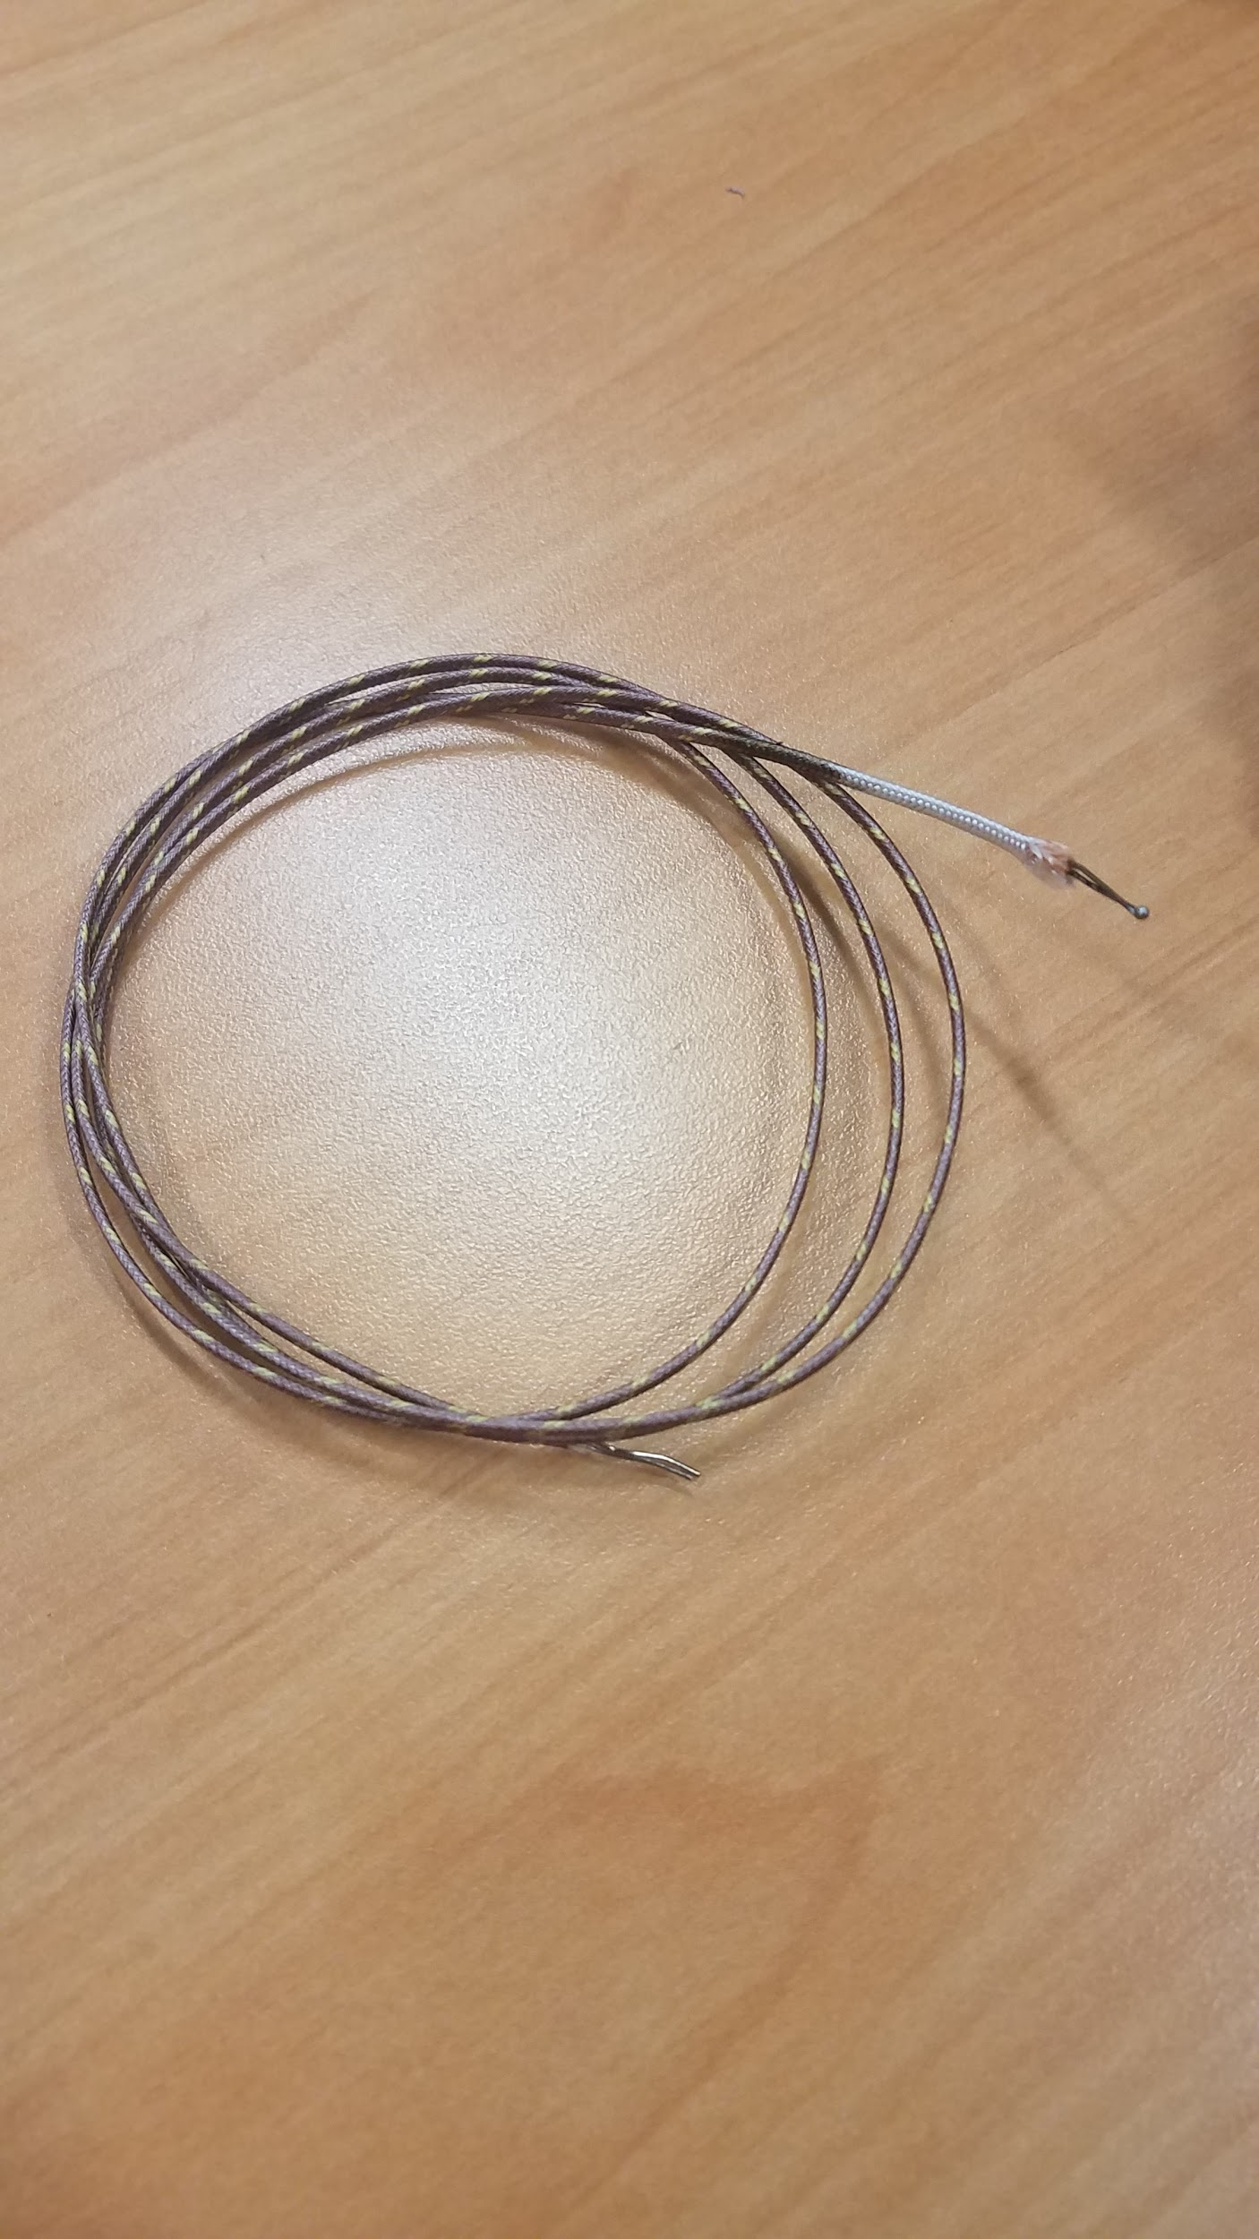

**Figure 4.2a - Thermocouple**

The MAX31855 amplifier provides a digital reading of the temperature over a SPI like interface. When the CS line is pulled low and a clock is applied to the CLK line, 32 bits are shifted out onto the data line. As can be seen in Figure 4.2b, the SPI bus acts as expected. The data can then be decoded following the information from the datasheet.

**\*\* INSERT PICTURE OF MAX31855 SPI OUTPUT \*\***

**Figure 4.2b - MAX31855 SPI Output**

IntelliRoast must provide a maximum roasting temperature of 300℃ in the roasting chamber. This temperature exceeds the maximum temperature of any bean roasting profile. The REPL Heating Element for HG501A provides a maximum rated temperature of 371℃. The heating element is tested by using a thermocouple inserted in the center of the element. The thermocouple, wired to the microcontroller, reads the temperature values in degrees Celsius as seen in Figure 4.2c. The duty cycle was varied and the temperature was sustained for 30 minutes to test the reliability of the heating element. During that time the heating element was found to sustain around 500℃ – far exceeding the rated temperature of 371℃.

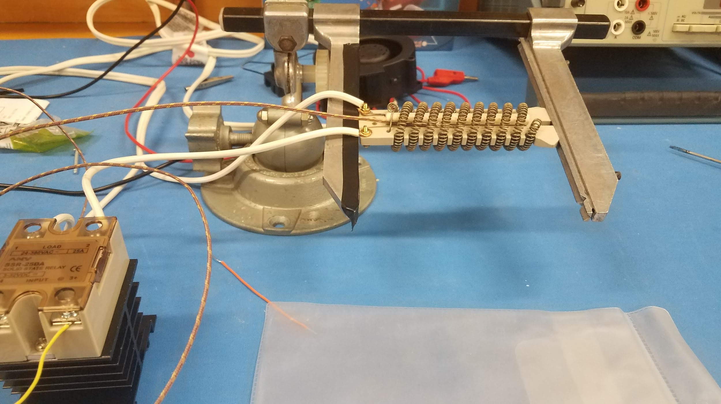

**Figure 4.2c - Thermocouple inserted in heating element connected to solid state relay**

To test the roasting temperature, a thermocouple was placed in the roasting chamber, seen in Figure 4.2c, to measure the temperature of the air entering the chamber. Once the temperature of the heating element was adjusted and the thermocouple read 300℃, the temperature was sustained for 30 minutes. This was repeated to ensure the reliability of the roasting chamber.

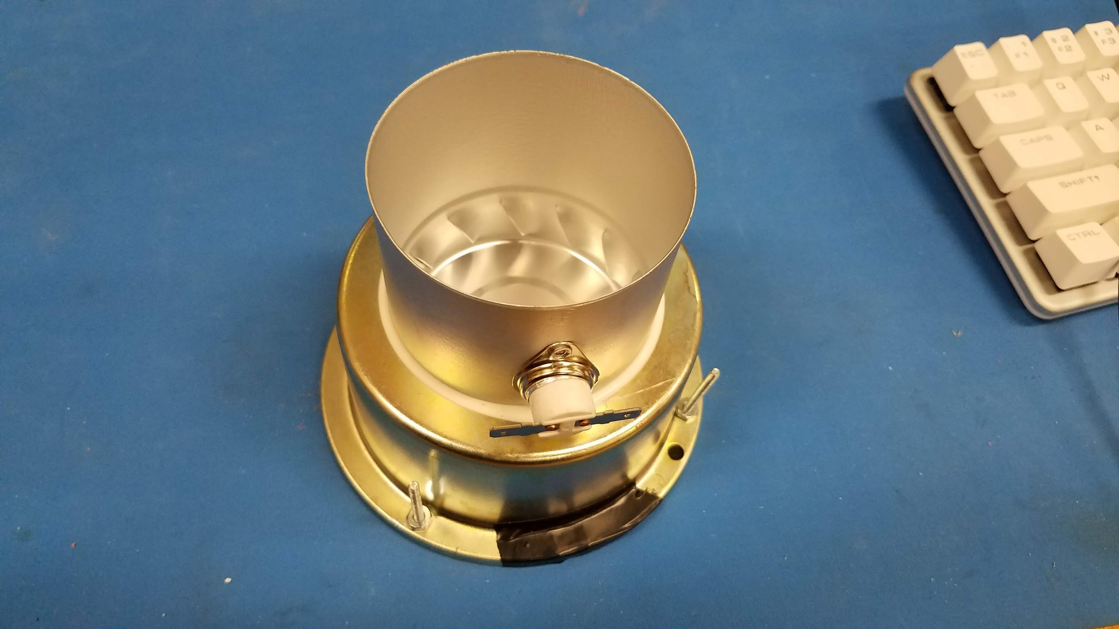

**Figure 4.2c - Roasting Chamber**

**4.3 Test Certification - Surface Temperature**

Since IntelliRoast’s internal temperature reaches an internal temperature of 300 °C, insulation is utilized to ensure the surface temperature remains below 60 °C. To test IntelliRoast’s surface temperature, a thermal measuring instrument is pointed at all of the exterior surfaces to verify the surface temperature while IntelliRoast is running at normal operation, as seen in Figure 4.3a. Table 4.3a shows the temperature values obtained during testing.

**\*Insert image here -> Full system test that cannot be performed until later\***

**Figure 4.3a - Surface Temperature Testing**

**Table 4.3a - Surface Temperature Test Results**

|  |  |  |  |
| --- | --- | --- | --- |
| **Surface** | **Measured Temperature (°C)** | **Difference from Max Acceptable Temperature (°C)** | **Pass/Fail** |
| Top | 23 | +37 | Pass |
| Front | 23 | +37 | Pass |
| Back | 23 | +37 | Pass |
| Left | 23 | +37 | Pass |
| Right | 23 | +37 | Pass |

**4.4 Test Certification - Fan Thrust**

IntelliRoast utilizes a fluid bed style of heating, where heated air is forced through the roasting chamber from the bottom. To evenly roast the coffee beans, there needs to be an airflow powerful enough to agitate the 120 grams of coffee in the roasting chamber. The CUI Inc. CBM-979533B-168 centrifugal fan has a maximum airflow output of 54.7 Cubic Feet per Minute (CFM) or 1.549 Cubic Meter per Minute (CMM) [1] with an exhaust size of 30 millimeters by 40 millimeters. The piping selected for air transfer has an inner diameter of 35 millimeters. The airflow efficiency (3) obtained by taking the area of both openings and dividing the area of the pipe (A2) (2) by the area of the centrifugal fan’s exhaust area (A1) (1).

(1) (2) (3)

The airflow efficiency is then multiplied by the maximum output of the centrifugal fan (U) to calculate the maximum achievable air flow (Umax) through the piping (4).

(4)

Using the graph correlating air flow to static pressure (Figure 4.4a), static pressure measured in millimeters of water (mmH2O) can be obtained [1].

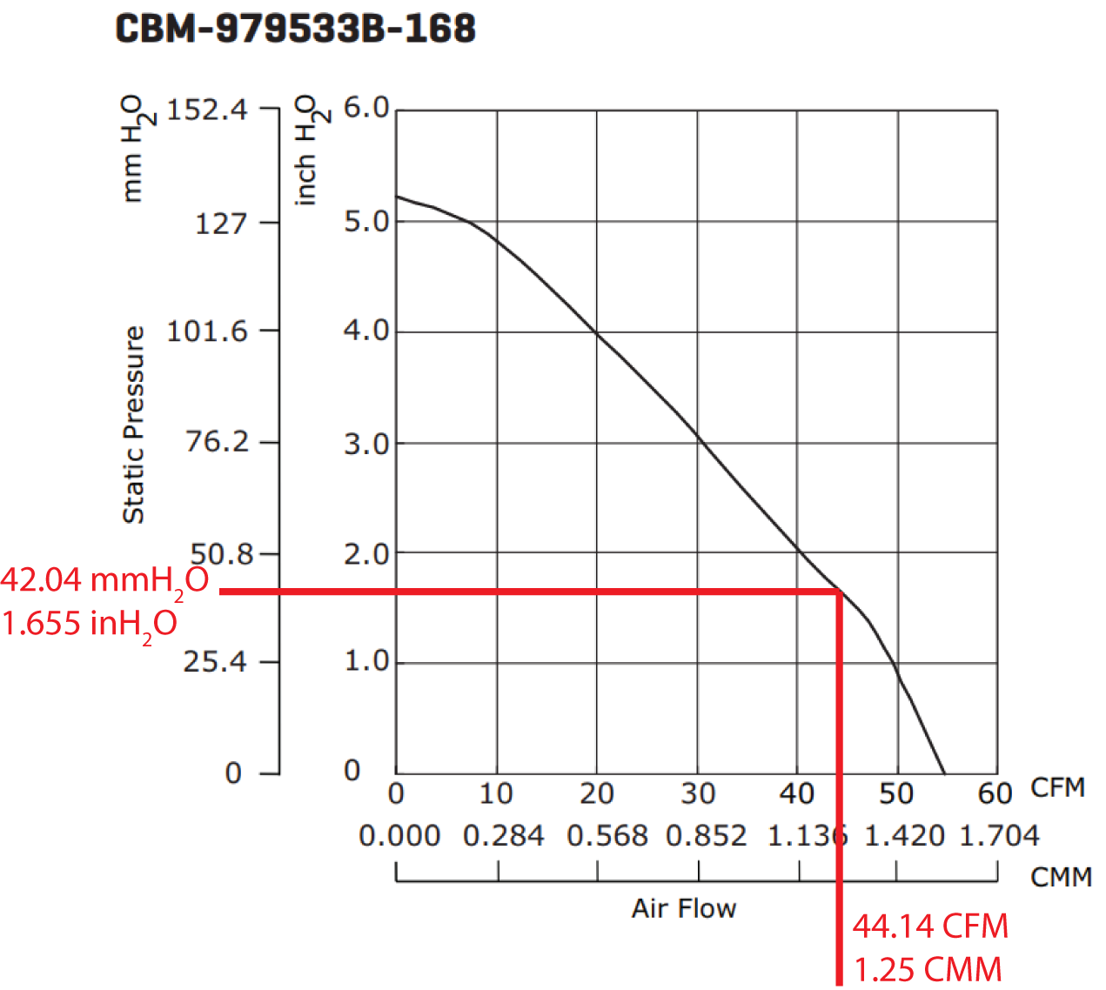

**Figure 4.4a - Airflow to static pressure relation**

Total thrust force (F) is calculated from mass flow rate (ṁ) times velocity (V) (5)

(5)

Where:

(6)  
 (7)

The density of air (ρ) is assumed at 25 ºC

(8)

Calculating area of the piping in meters (m), we can combine Equations 5 through 8 to obtain

(9)

Substituting in values:

Converting F to Newtons (FN):

(10)

The adapter piece shown in Figure 4.4b was designed using SolidWorks and 3D printed to connect these two pieces.

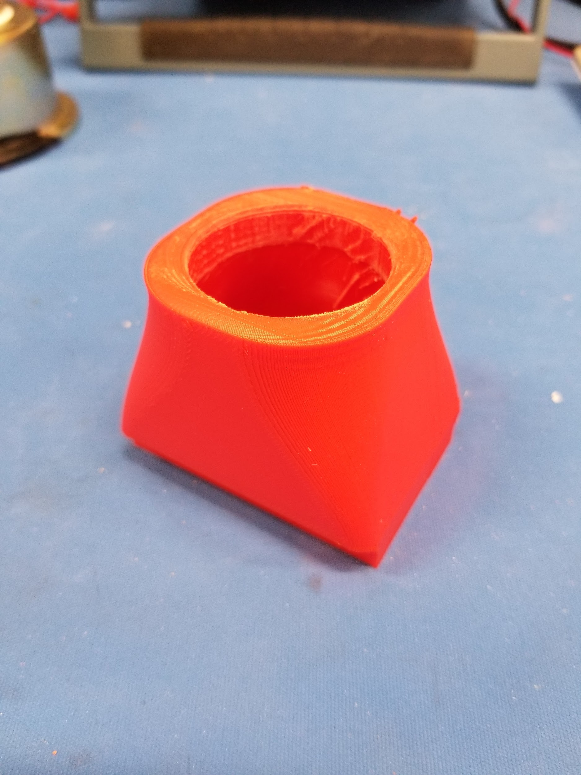

**Figure 4.4b - Centrifugal fan to 1¼ inch piping adapter**

Shown in Figure 4.4c, an anemometer was placed at the exhaust of the 1¼ inch piping connected to the centrifugal fan to calculate real air flow in meters per second and was recorded at 23.0 meters per second. With the velocity, we can solve for CFM using Equation 7 and obtain UMax = 1.327 CMM, and using Equation 10, FN = 623 mN, 13.7% higher than projected. Connecting the centrifugal fan to the roasting chamber, the fan was able to not only agitate the beans at approximately 60% power capacity but began ejecting beans from the roasting chamber at maximum power capacity. This bean ejection is surprising due to the roasting chamber having no way to expel air vertically into the beans, and instead relies on a cyclone like air distribution.

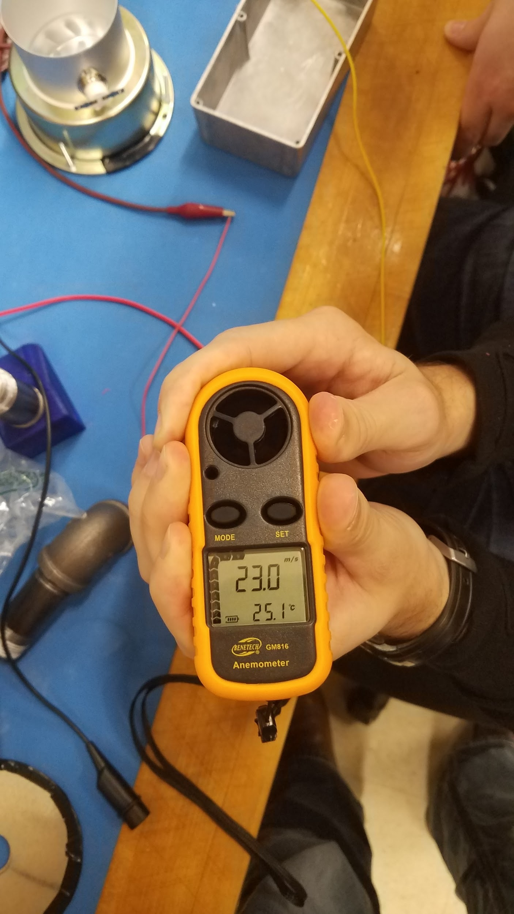

**Figure 4.4c - Real air flow velocity using Anemometer**

**4.5 Test Certification - Wireless Distance**

IntelliRoast uses Bluetooth LE (BLE) to connect to the companion smartphone app, and the app needs to be able to connect from 3 meters away. This distance allows the user to connect to IntelliRoast from anywhere in their kitchen. A standard kitchen is 100 square feet, and as seen in Figure 4.5a, a user can be 3 meters away from IntelliRoast and still be in the same kitchen as the device. Two different types of tests were run: one that measured the signal strength at 3 meters away and one that measured maximum wireless distance before disconnecting.

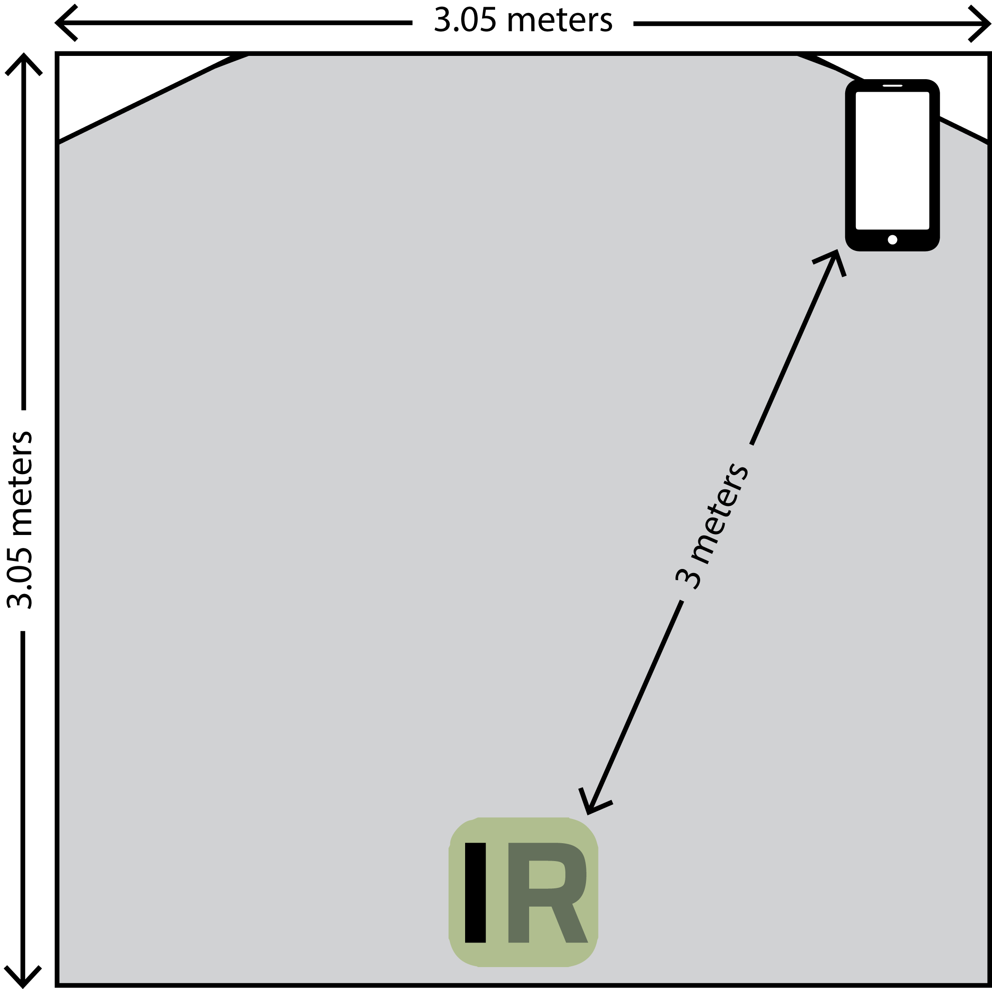

**Figure 4.5a - Smartphone Distance from IntelliRoast in a Standard Kitchen**

An app called Bluetooth Signal Meter, made by NeoFrontier Technologies, can measure the BLE signal strength from IntelliRoast [2]. The signal strength is measured in Received Signal Strength Indicator (RSSI) as a value in decibel-milliwatts (dBm) with a range from 0 dBm to -120 dBm, with values closer to 0 dBm representing stronger signals [3]. An RSSI less than -80 dBm is considered unacceptable, and an RSSI greater than -70 dBm is considered ideal. Figure 4.5b shows a screenshot of the Bluetooth Signal Meter app when 3 meters away from IntelliRoast. Figure 4.5c shows a normal distribution of the RSSIs collected from different positions 3 meters away from IntelliRoast. With a standard deviation of <STD DEV>, the RSSI is between <RSSI min> and <RSSI max> which is greater than -80 dBm and therefore will be a good signal.

[TODO: ADD FIGURE 4.5b - Bluetooth Signal Meter app screenshot]

[TODO: ADD FIGURE 4.5c - Normal Distribution of RSSIs]

A series of real-world tests can be run by connecting to IntelliRoast with the smartphone app and tracking how far away you can get from the device before the connection drops. A normal distribution of the data can be seen in Figure 4.5d. The normal distribution of <NORM DIST WIRELESS DISTANCE> shows that the wireless distance exceeds the constraint of 3 meters, and even with a standard deviation of <STD DEVIATION>, the wireless distance still exceeds 3 meters.

[TODO: ADD FIGURE 4.5d - Normal Distribution of Maximum Wireless Distance]

**4.6 Test Certification - System Test**

<INSERT TABLE WITH TECHNICAL CONSTRAINTS AND TESTS MEASUREMENTS>

The fan connects to black iron piping and blows air into piping, across a heating element, through more piping, and then into the roasting chamber. Figure 4.6a shows a top down view of the fan and heating element connected together. The heating element section drops the overall max air pressure down from 1.327 CCM to <INSERT CCM FROM SYSTEM TEST> CCM, which still provides enough bean agitation for the roast.

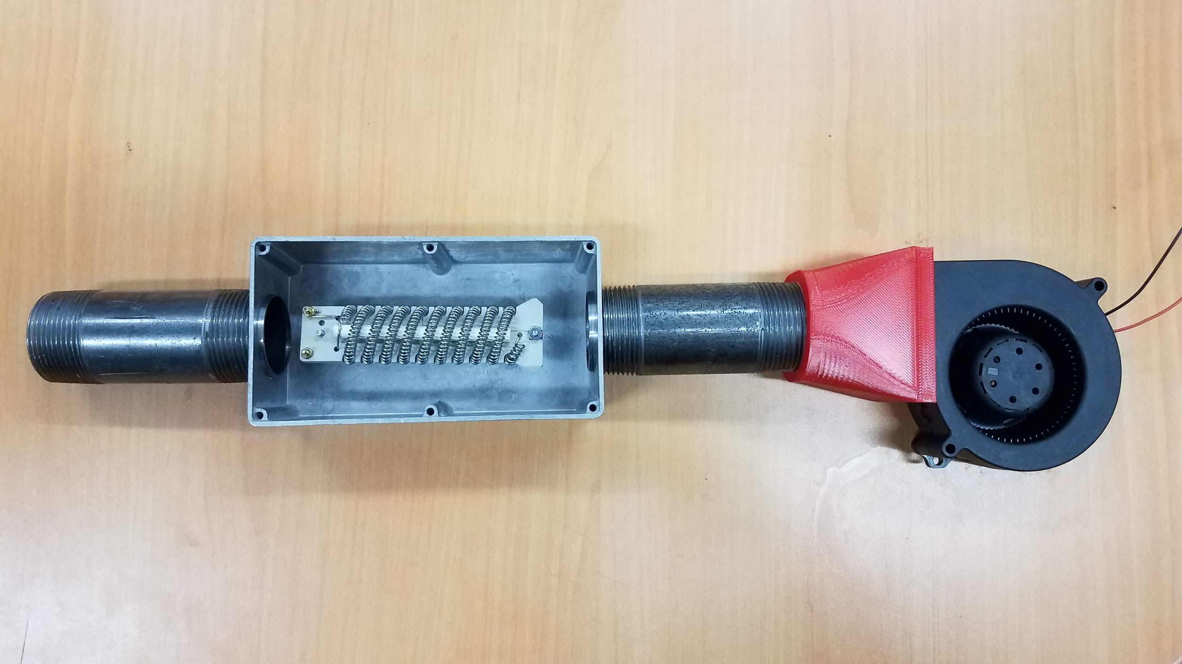

**Figure 4.6a - Fan attached to piping and heating element**

IntelliRoast is specifically made to only handle 120 grams of beans. If a user puts in too many or too few beans, the roast will be off and will either burn the beans or not roast the beans enough. The roast will continue as programmed and the beans will still be ejected. If too many beans are added to the chamber such that the beans can’t be ejected, manual intervention will be required, but the roast will abort when the beans overheat before it becomes a fire hazard.

In the case of power disconnecting from IntelliRoast in the middle of a roast, the user needs a way to retrieve the half-roasted beans from the chamber without running an entire roast again. There is an option from the app to eject leftover beans and debris which turns the fan on full blast and clears out the roasting chamber.

A sail switch is used to determine adequate airflow through the IntelliRoast. If the intake or exhaust is blocked such that airflow is restricted, the roast is stopped and the user is notified by the application. The user is given the option to manually eject the interrupted roast.

**References**

[1] “CUI Inc. CBM-97B DC Blower,” *CUI*, 09-Aug-2017. [Online]. Available: https://www.cui.com/product/resource/cbm-97b.pdf. [Accessed: 17-Oct-2018].

[2] NeoFrontier Technologies. Bluetooth Signal Meter [Mobile Application Software] Available: https://play.google.com/store/apps/details?id=com.infomultiverse.btmeter. [Accessed: 6-Nov-2018]

[3] “How does RSSI (dBm) relate to signal quality (percent) ?” SpeedGuide.net. [Online] Available: https://www.speedguide.net/faq/how-does-rssi-dbm-relate-to-signal-quality-percent-439. [Accessed: 5-Nov-2018]