**4. EVALUATION**

The following section describes the testing of each subsystem IntelliRoast uses for operation. These components were separately tested using lab equipment to verify the component integrity and to ensure the system operates without issues. Table 4a outlines the five technical constraints tested to ensure intended system operation.

**Table 4a - Technical Design Constraints**

|  |  |
| --- | --- |
| **Name** | **Description** |
| Power Draw | IntelliRoast must draw under 15 A at 120 V to comply with NEC standards for kitchen circuit current limits. |
| Roasting Temperature | The heating element must heat the roasting chamber to 300 °C minimum. |
| Surface Temperature | IntelliRoast must comply with ASTM C1055 standards to protect the user from irreversible injuries. The device’s exterior enclosure must not exceed 60 °C. |
| Bean Agitation | IntelliRoast’s fan must lift a maximum of 120 grams of beans to agitate during roasting and eject from the chamber after the roast is finished. |
| Wireless Distance | IntelliRoast must connect to the user’s smartphone from a maximum distance of 3 meters. |

The sections below provide the test data for the subsystems listed in Table 4.0a

**4.1 Test Certification - Power Draw**

IntelliRoast’s power draw testing involved monitoring the power output for the different major electrical components. The elements tested include the centrifugal fan, the microcontroller, and the heating element as seen in Table 4.1a. The total power draw cannot exceed 1800W. From the table, the total power draw is found to be 1685.2, well below the constraint.

**Table 4.1a - Individual Element Power Draw**

|  |  |  |  |
| --- | --- | --- | --- |
| **Element** | **Voltage Draw** | **Current Draw** | **Power Draw** |
| Centrifugal Fan | 12V | 7.025A | 48.3W |
| Microcontroller | 5V | 120mA | 0.6W |
| Heating Element | 120V | 13.64A | 1636W |
|  |  |  | **Total:** 1685.2W |

**4.2 Test Certification - Roasting Temperature**

IntelliRoast’s temperature probes must provide consistent, accurate readings to facilitate reliable and repeatable roasts. To test the accuracy, a probe is placed in the roasting chamber, and measurements are taken during the roasting process. The recorded temperature is compared to the recordings from an Infrared thermometer. Since the infrared thermometer measures the surface of the beans, it will provide an accurate reading compared to the thermocouple. The MAX31855 thermocouple amplifier provides an internal reference temperature and automatic calibration of the thermocouples. This calibration corrects the non-linear response of the thermocouple. Any recorded errors from the expected values are used to calculate the slope of the error. This can be applied to the reading at any temperature to increase accuracy. Seen in Figure 4.2a, the thermocouples do provide consistent accurate readings during this testing procedure.

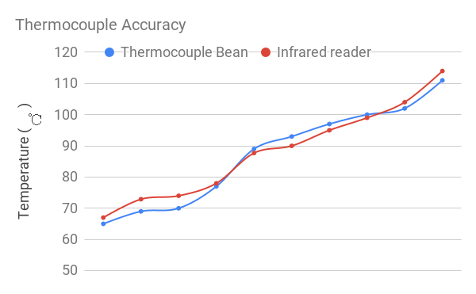

**Figure 4.2a - Thermocouple Accuracy vs Infrared Thermometer**

The MAX31855 amplifier provides a digital reading of the temperature over an SPI like interface. When the CS line is pulled low and a clock is applied to the CLK line, 32 bits are shifted out onto the data line. The data can then be decoded following the information from the datasheet.

IntelliRoast must provide a maximum roasting temperature of 300℃ in the roasting chamber. This temperature exceeds the maximum temperature of any bean roasting profile. The REPL Heating Element for the HG501A heat gun provides a maximum rated temperature of 371℃. The heating element is tested by using a thermocouple near the heating element in the heating chamber, allowing the air temp to be measured. The thermocouple, wired to the microcontroller, reads the temperature values in degrees Celsius as seen in Figure 4.2c. The duty cycle was varied and the temperature was sustained for 30 minutes to test the reliability of the heating element. During that time the heating element was found to sustain around 500℃ – far exceeding the rated temperature of 371℃.

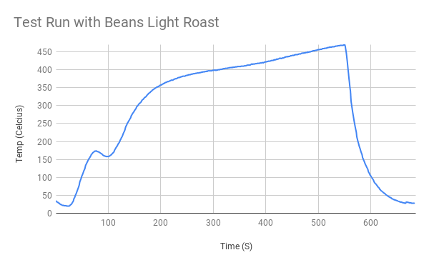

**Figure 4.2c - Temperature mapping of thermocouple In Heating Chamber**

To test the roasting temperature, a thermocouple was placed in the roasting chamber, seen in Figure 4.2c, to measure the temperature of the air entering the chamber. Once the temperature of the heating element was adjusted and the thermocouple read 300℃, the temperature was sustained for 30 minutes. This was repeated to ensure the reliability of the roasting chamber.

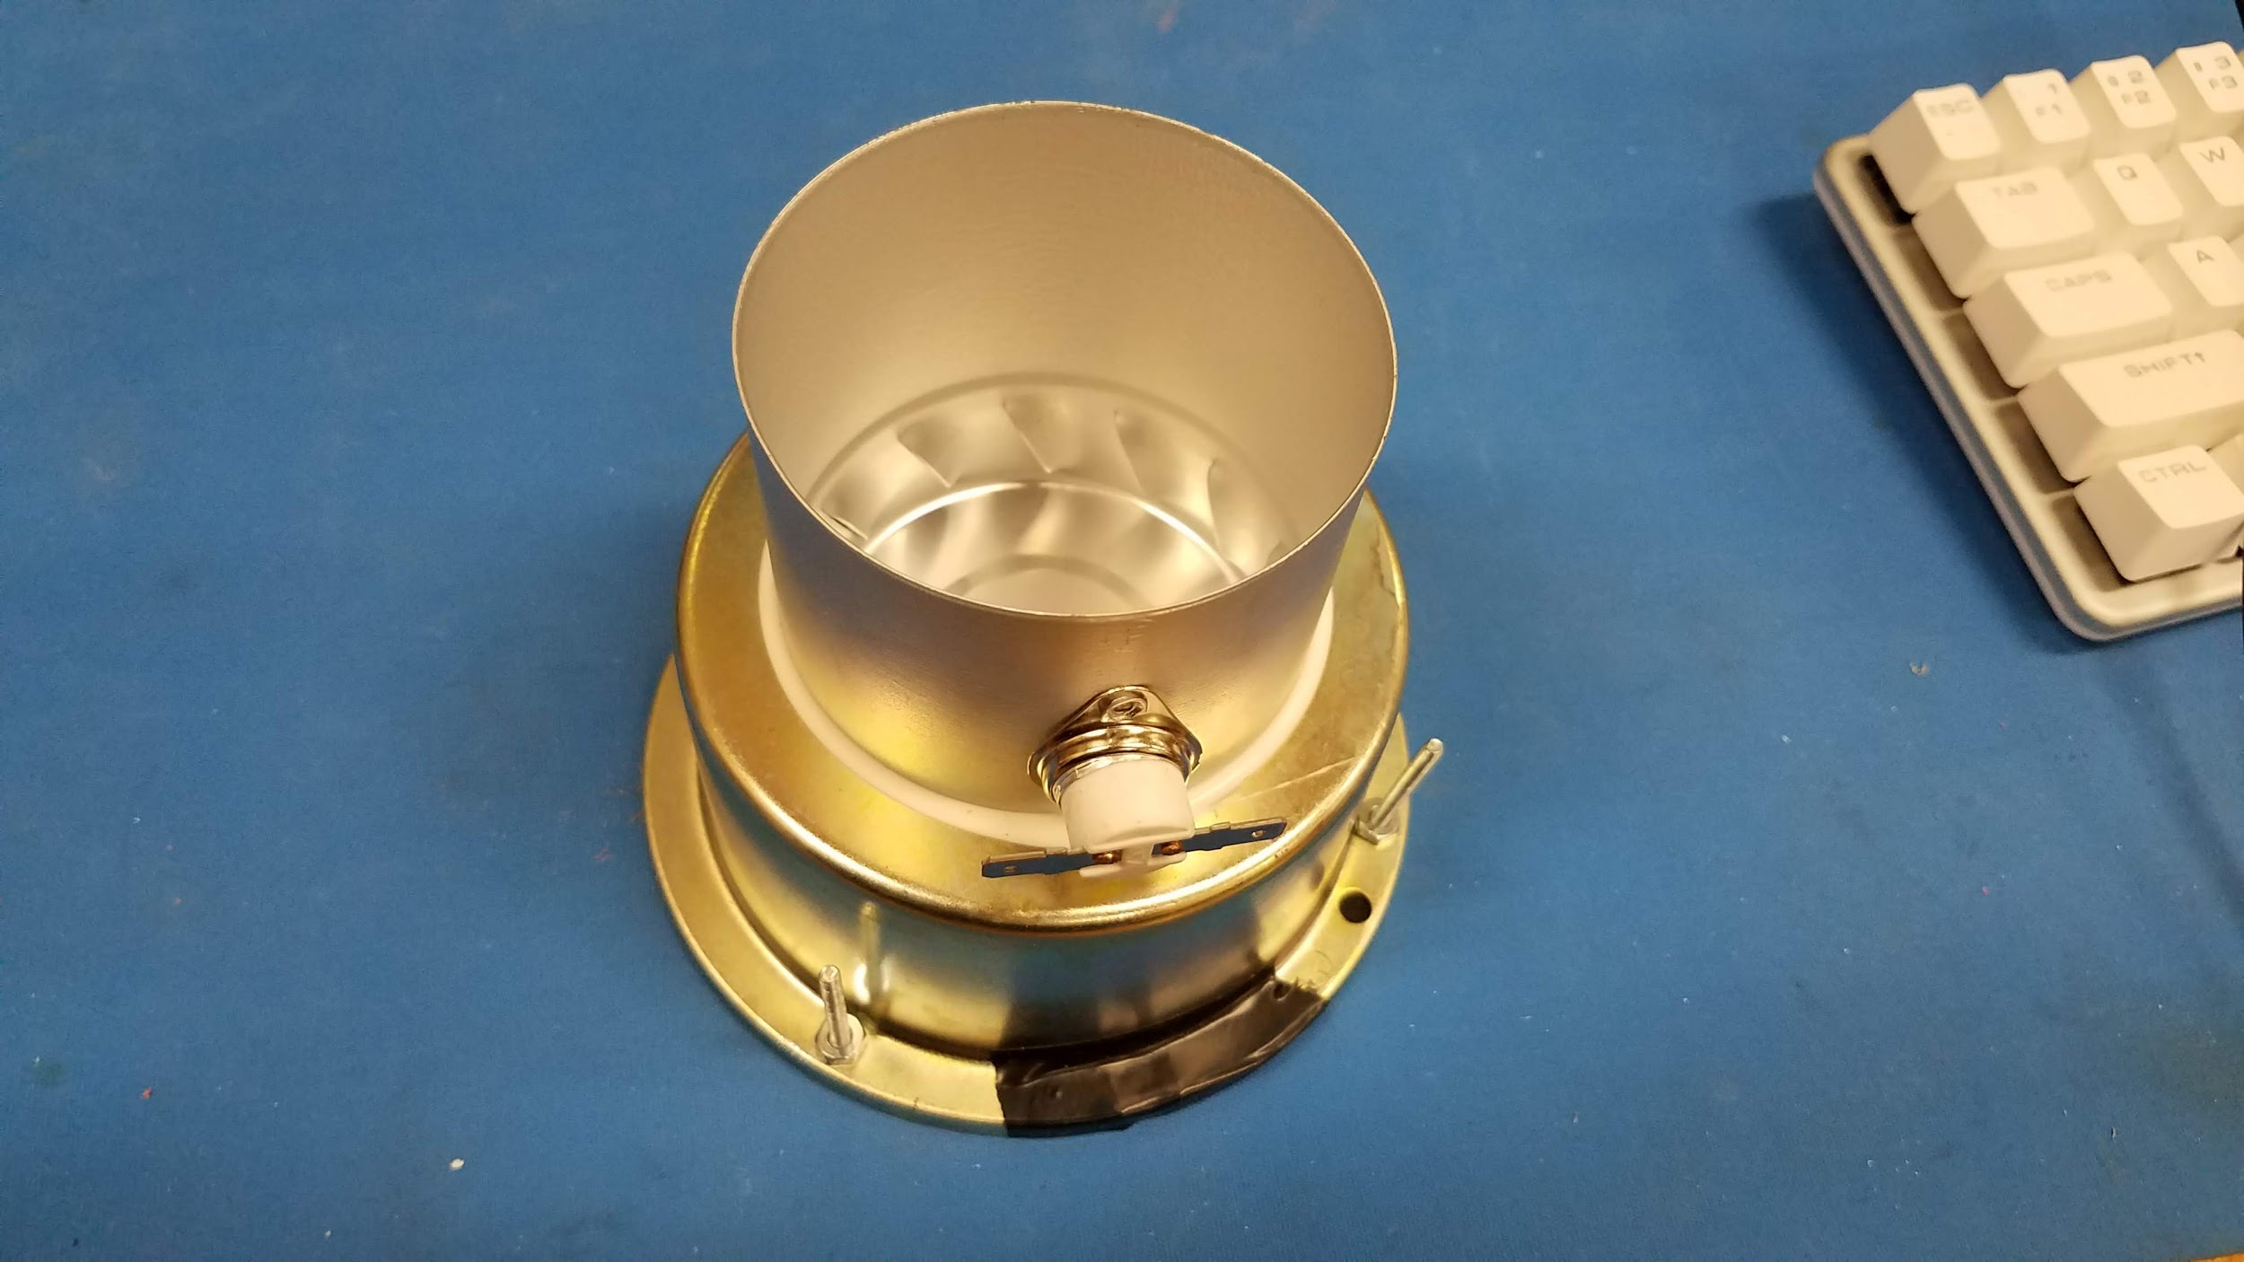

**Figure 4.2c - Roasting Chamber**

**4.4 Test Certification - Fan Thrust**

The adapter piece shown in Figure 4.4b was designed using SolidWorks and 3D printed to connect these two pieces.

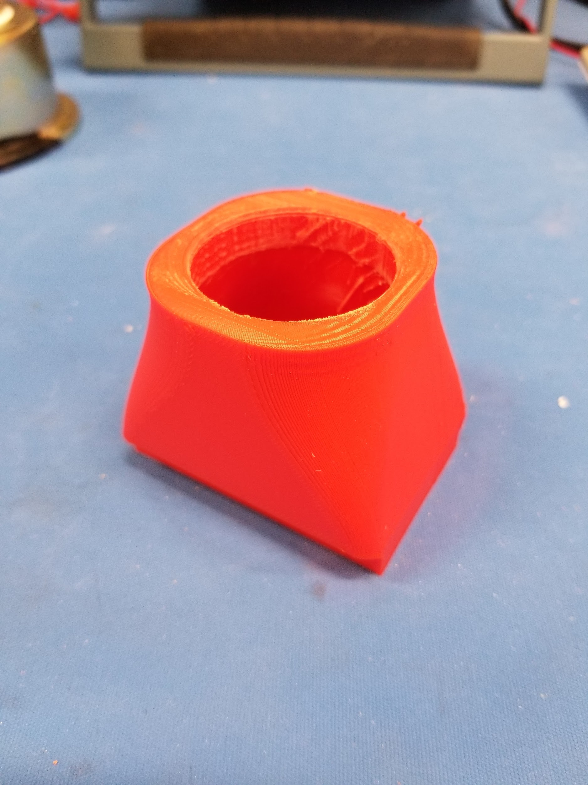

**Figure 4.4b - Centrifugal fan to 1¼ inch piping adapter**

Shown in Figure 4.4c, an anemometer was placed at the exhaust of the 1¼ inch piping connected to the centrifugal fan to calculate real air flow in meters per second and was recorded at 23.0 meters per second. With the velocity, we can solve for CFM using Equation 7 and obtain UMax = 1.327 CMM, and using Equation 10, FN = 623 mN, 13.7% higher than projected. Connecting the centrifugal fan to the roasting chamber, the fan was able to not only agitate the beans at approximately 60% power capacity but began injecting beans from the roasting chamber at maximum power capacity.

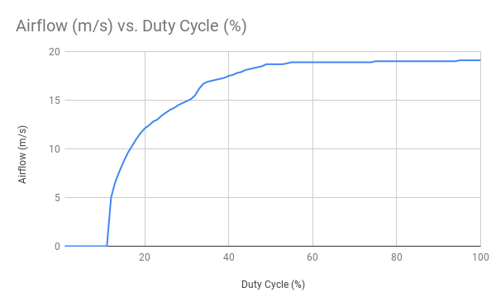

**Figure 4.4c - Real air flow velocity using Anemometer**

Bean agitation was measured by visual inspecting the roasting chamber at different duty cycles of our PWM fan. Shown in Table 4.4a, moderate to absolute agitation is achieved between a duty cycle of 30 and 35 percent up-time. Adequate bean agitation was defined as visible movement between all beans within the roasting chamber. Using Figure 4.4c, these duty cycles correspond to 15 and 16.5 m/s respectively.

**Table 4.4a - Bean Agitation compared to fan Duty Cycle**

|  |  |
| --- | --- |
| **Duty Cycle (%)** | **Bean Agitation** |
| 15 | No |
| 25 | Minor |
| 30 | Moderate |
| 35 | Yes |

**4.5 Test Certification - Wireless Distance**

IntelliRoast uses Bluetooth LE (BLE) to connect to the companion smartphone app, and the app needs to be able to connect from 3 meters away. This distance allows the user to connect to IntelliRoast from anywhere in their kitchen. A standard kitchen is 100 square feet, and as seen in Figure 4.5a, a user can be 3 meters away from IntelliRoast and still be in the same kitchen as the device. Two different types of tests were run: one that measured the signal strength at 3 meters away and one that measured maximum wireless distance before disconnecting.

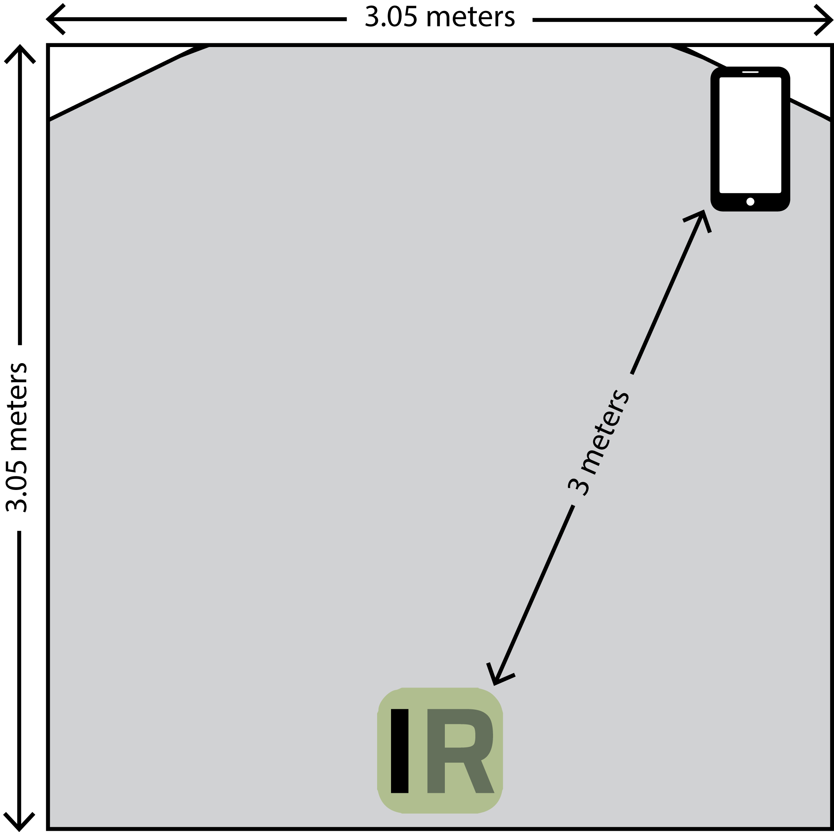

**Figure 4.5a - Smartphone Distance from IntelliRoast in a Standard Kitchen**

An app called Bluetooth Signal Meter, made by NeoFrontier Technologies, can measure the BLE signal strength from IntelliRoast [2]. The signal strength is measured in Received Signal Strength Indicator (RSSI) as a value in decibel-milliwatts (dBm) with a range from 0 dBm to -120 dBm, with values closer to 0 dBm representing stronger signals [3]. An RSSI less than -80 dBm is considered unacceptable, and an RSSI greater than -70 dBm is considered ideal. A series of real-world tests can be run by connecting to IntelliRoast with the smartphone app and tracking how far away you can get from the device before the connection drops. Figure 4.5b shows the RSSIs collected from different distances away from IntelliRoast. At a range of 3 meters or less, the RSSI remains greater than -70 dBm, and the RSSI is greater than -80 dBm up until 9 meters away.

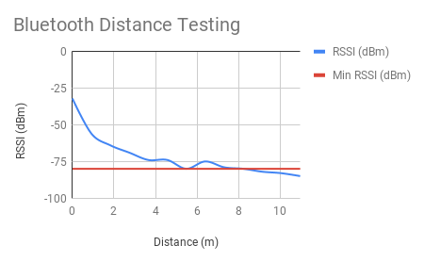

**FIGURE 4.5b - RSSI (dBm) vs Distance**

**4.6 Test Certification - Full System Test**

A full system test was performed once all the subsystems were integrated together. The integration of the fan and heating element is vital to the system and was tested separately prior to being fulling integrated. Once the correct operation of the system was verified, 120 grams of unroasted coffee beans were added to the roasting chamber. From there, full bean agitation, fan speed, and heating element temperature were verified.

The fan connects to black iron piping and blows air into piping, across a heating element, through more piping, and then into the roasting chamber. Figure 4.6a shows a top-down view of the fan and heating element connected together. The heating element section drops the overall max air pressure down from 1.327 CMM to 1.055 CMM, which still provides enough bean agitation for the roast.

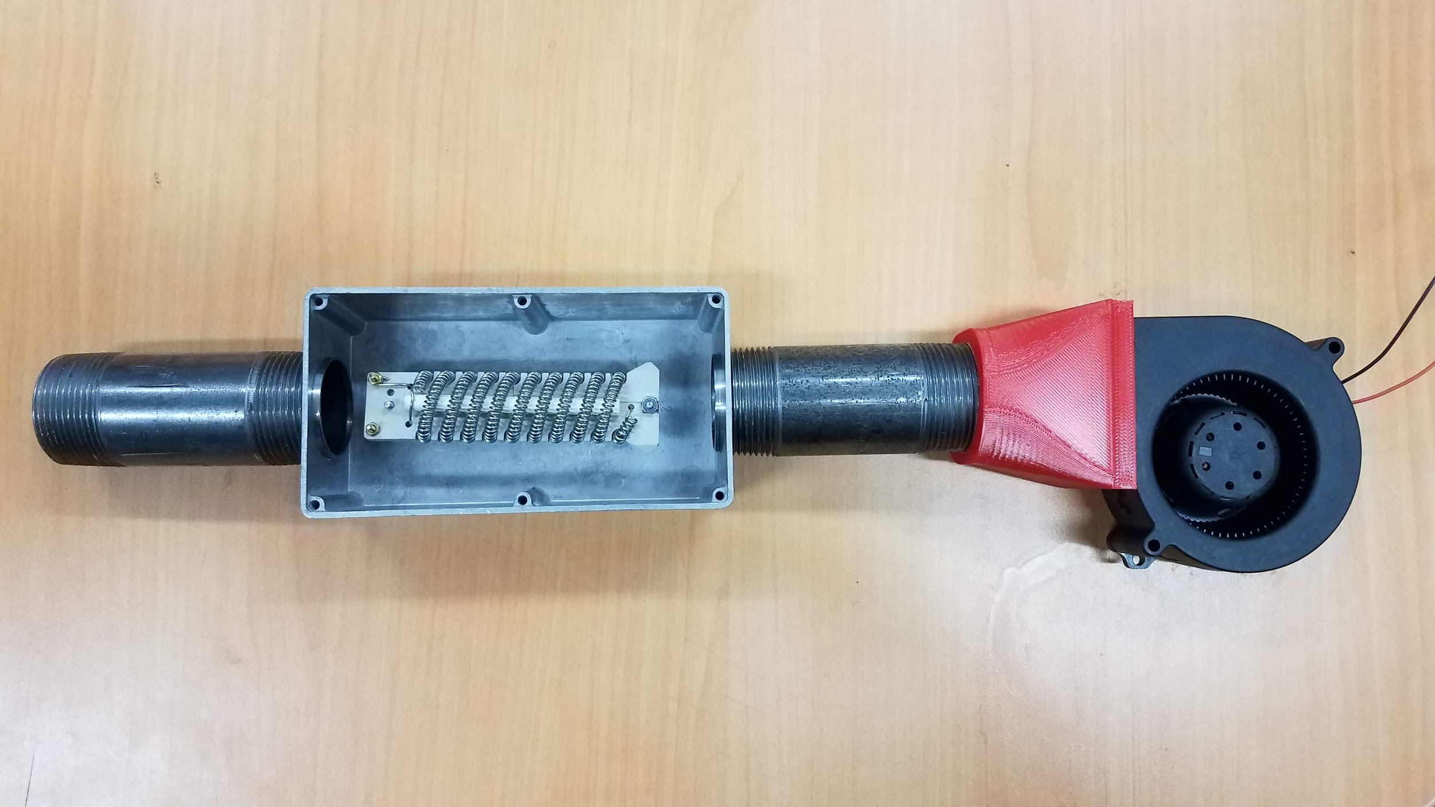

**Figure 4.6a - Fan attached to piping and heating element**

IntelliRoast is specifically made to handle 120 grams of beans. If a user puts in too many beans, for example, 180 grams, the roast still functions but will be uneven. If too few are added, the roast is not affected negatively. The roast will continue as programmed and the beans will still be ejected. If an amount of beans are added to the chamber such that the beans cannot be ejected, manual intervention will be required. The roast will abort if the beans overheat and cooling does not work, and the hot beans become a fire hazard.

In the case of power disconnecting from IntelliRoast in the middle of a roast, the user needs a way to retrieve the half-roasted beans from the chamber without running an entire roast again. There is] an option from the app to eject leftover beans and debris which turns the fan on full blast and clears out the roasting chamber.

To test the full system, a fully automated roast was performed. The roast was monitored and compared to one performed by a local coffee roaster with the same beans. The roast results can be seen in Figure 4.6b, with the local roaster’s results in Fahrenheit seen in Figure 4.6c. Two key components to a good roast are the final temperature and the rate of rise. The final temperature for a roast specifies what kind of roast is being performed, whether it be light, medium, or dark. The observed roast was a light roast with a final temperature of 200 ℃. As seen, the roast hit 200 ℃ and then switched to cooling the beans. The second component to look for in a roast is a consistent rate of rise. This is where Intelliroast excelled compared to the manual roast perform by the local coffee roaster. The latter half of the roast should have a steady rate of rise. The manual roaster performed well with only minor rises and falls in the rate of rise. IntelliRoast, having a fully automated control system, held a steady rate of rise during the latter half of the roast.

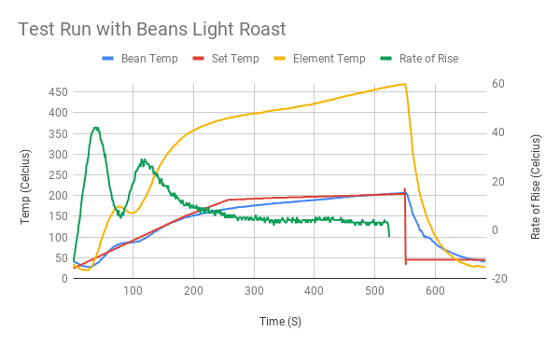

**Figure 4.6b - Roast results performed using IntelliRoast**

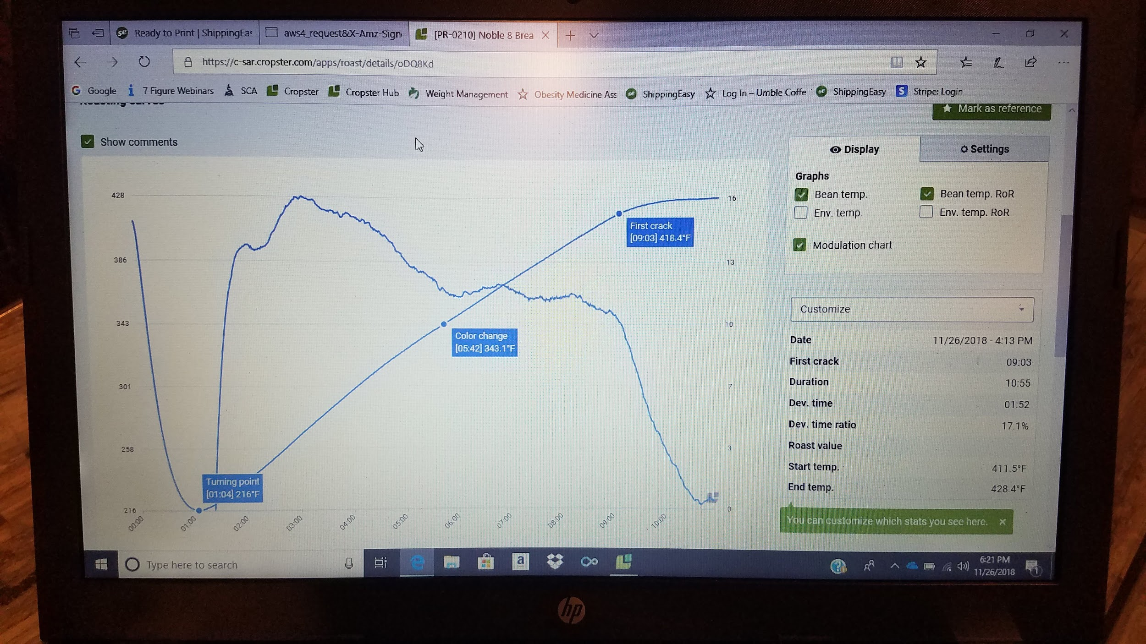

**Figure 4.6c - Roast results performed by Local Roaster**

**4.7 Future Work**

For the future, IntelliRoast must implement proper thermal insulation. This will be accomplished using mineral wool insulating the piping. Additionally, improvements in mechanical design machining for better airflow and heat transfer efficiency will be implemented. Currently, IntelliRoast is much larger than the desired kitchen appliance size constraint. Scaling down the project and removing unnecessary components will reduce the overall size of the package.

The roasting chamber will be redesigned in the near future. Currently, fins on the sides of the roasting chamber provide a horizontal, rotating motion to the air as it passes through the beans. This non-vertical air flow is not ideal for the ejection of beans at the conclusion of the roasting process, as the rotating motion created by the fins work against the vertical fan thrust.

IntelliRoast’s roast profiles will continue to be improved as more testing for taste and quality takes place. The local coffee roaster, Umble Coffee, and their resources will be vital to this next step as more knowledge about coffee roasting and its nuances is gained.

**4.8 Acknowledgements**

**Dr. Masoud Karimi**

Special thanks to Dr. Karimi for advising the team on power control and our element throughout development.

**Kopis Mobile**

Special thanks to Kopis Mobile for their continued sponsorship and gracious advice given throughout the development and testing phase of IntelliRoast.

**Umble Coffee**

Special thanks to Umble Coffee, the local coffee roaster, for their support and continued advice as IntelliRoast improves the roasting profiles necessary for great tasting coffee.

**References**

[1] “CUI Inc. CBM-97B DC Blower,” *CUI*, 09-Aug-2017. [Online]. Available: https://www.cui.com/product/resource/cbm-97b.pdf. [Accessed: 17-Oct-2018].

[2] NeoFrontier Technologies. Bluetooth Signal Meter [Mobile Application Software] Available: https://play.google.com/store/apps/details?id=com.infomultiverse.btmeter. [Accessed: 6-Nov-2018]

[3] “How does RSSI (dBm) relate to signal quality (percent) ?” SpeedGuide.net. [Online] Available: https://www.speedguide.net/faq/how-does-rssi-dbm-relate-to-signal-quality-percent-439. [Accessed: 5-Nov-2018]