**EXECUTIVE SUMMARY**

Coffee enthusiasts need access to freshly-roasted coffee beans at an inexpensive price.Large coffee companies provide cheap and convenient access at the cost of quality and freshness. Local roasters can provide a premium product at a price above what the average consumer may deem affordable. One way to access freshly roasted coffee is to roast beans at home. IntelliRoast is an in-home coffee roasting solution. By providing a companion smartphone app, a completely automated process, and the selection of custom roasts, IntelliRoast brings high-quality coffee to the masses.

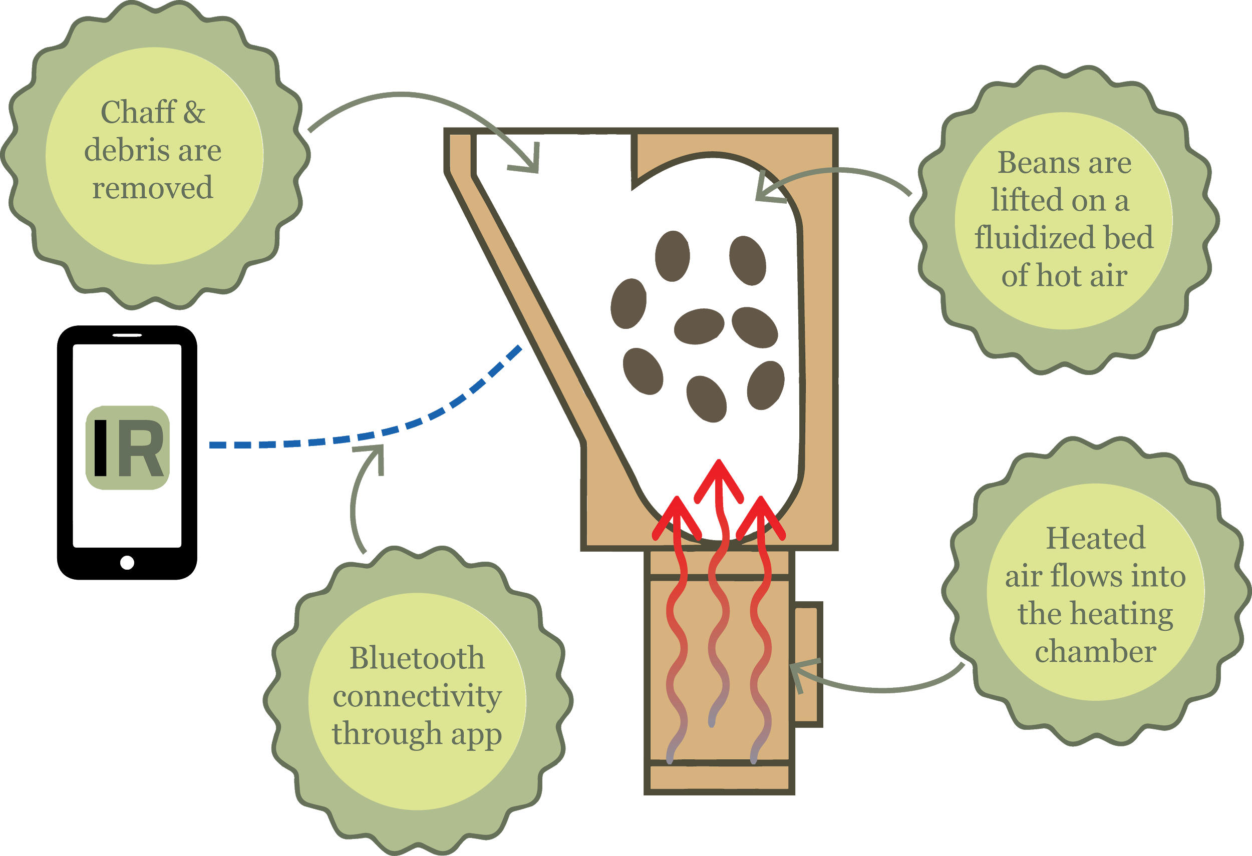

IntelliRoast must roast 120 grams of beans without user intervention. A standard 12 cup pot of coffee uses about 120 grams of roasted beans, so IntelliRoast roasts enough coffee for one pot. To allow for use inside an average sized kitchen, IntelliRoast must have a usable wireless range of at least 3 meters. IntelliRoast must draw less than 1800 W of power in order to stay within standard US power outlet specifications. To sufficiently roast coffee beans, IntelliRoast’s internal roasting temperature must reach a temperature of 300 °C while keeping the external surface temperature under 60 °C to prevent injuries to the user.

IntelliRoast uses an electrically-heated roasting chamber and a smartphone application which chooses between different roast profiles. It uses a centrifugal fan to blow air over the heating element, thereby heating the air. Once the air is heated up to 300 ℃, it is blown into the bottom of the roasting chamber to roast and agitate the beans. Chaff, a flammable paper-like substance, flakes off the roasting beans and is collected in a chaff collector. Once the beans are roasted to the desired roasting profile, they are blown into a bean collection bin for the user to retrieve. To keep costs down for the user, IntelliRoast uses high quality, inexpensive, and non-proprietary parts in its construction.

IntelliRoast offers affordable and fresh in-home coffee to entry-level lovers and enthusiasts. The microcontroller automates the roasting process and removes the steep learning curve many entry-level coffee enthusiasts face. Additionally, the paired smartphone application provides real-time feedback during the roast, such as the temperature of the roasting chamber and the progression through the roast profile. The ease of use coupled with the ability to monitor the roast makes IntelliRoast a powerful and useful tool for coffee lovers.