Created Micro service Rest Api.

File name : - marvelproj.go

* Created 3 api’s, each api gives the list of characters and its power level
* The 3 Api namely Avenger, Mutant, Anti Hero
* By providing the following Uri

<http://localhost:12345/Avenger>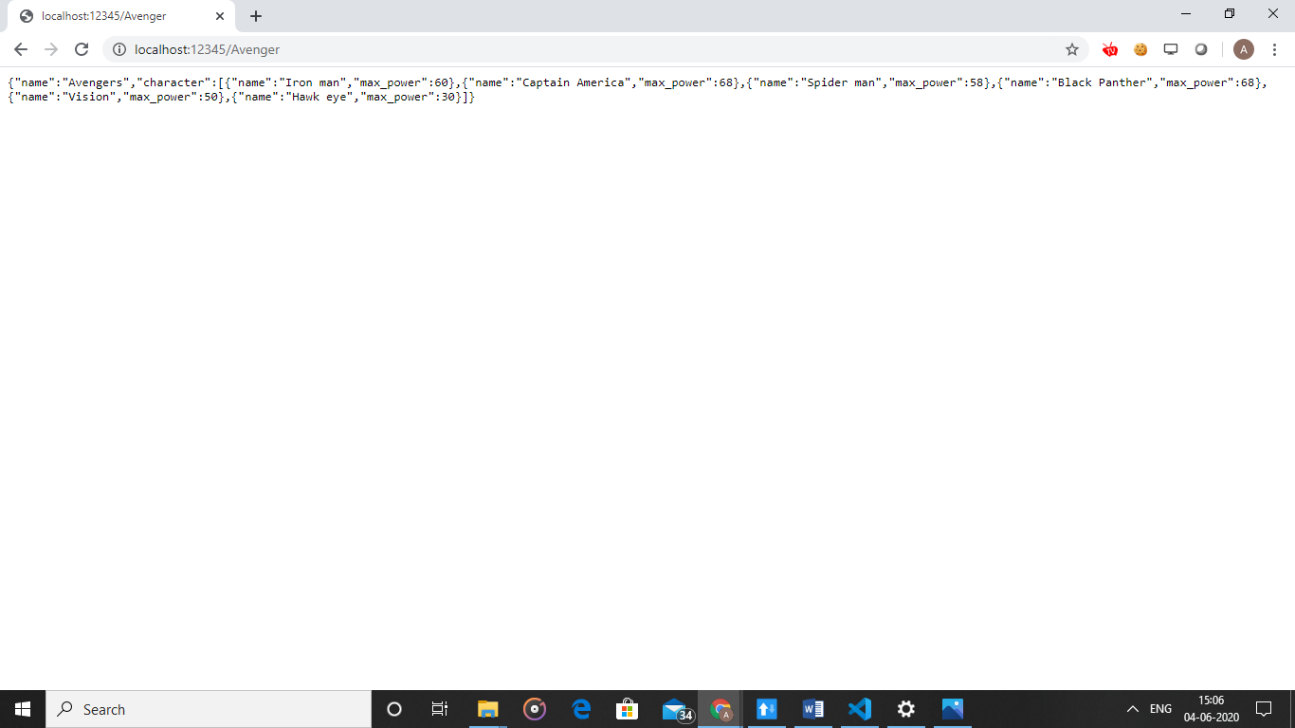

<http://localhost:12345/Mutant>

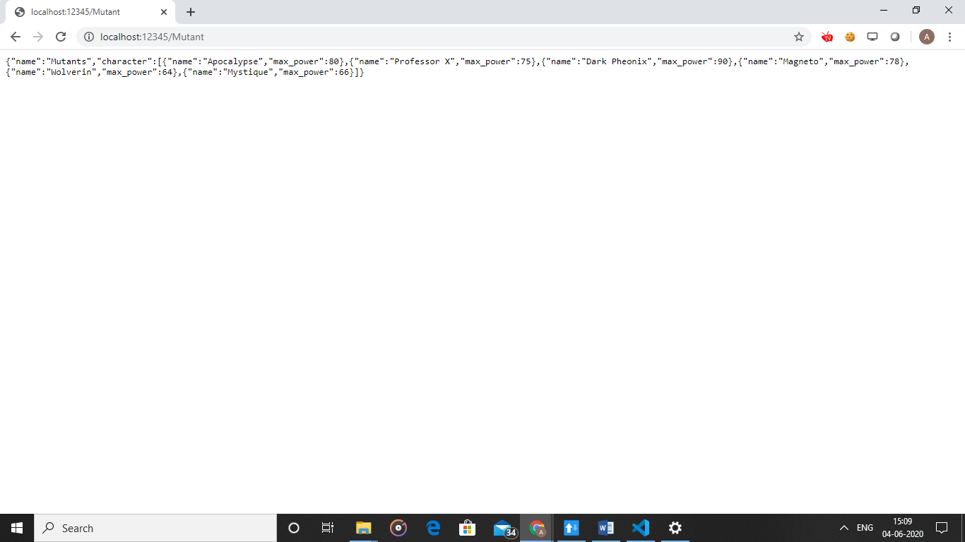

<http://localhost:12345/AntiHero>

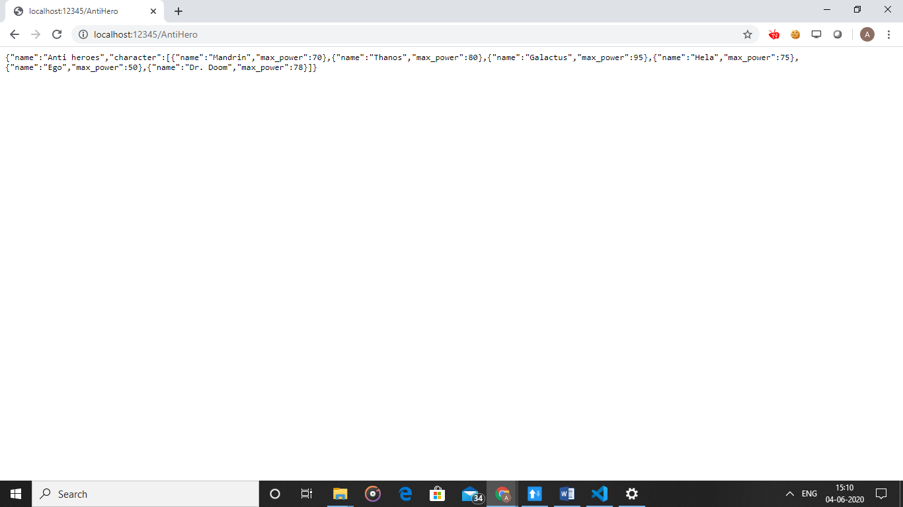

* Api which accepts the api and returns the power level back

<http://localhost:12345/Maxpower/Antihero/Hela>

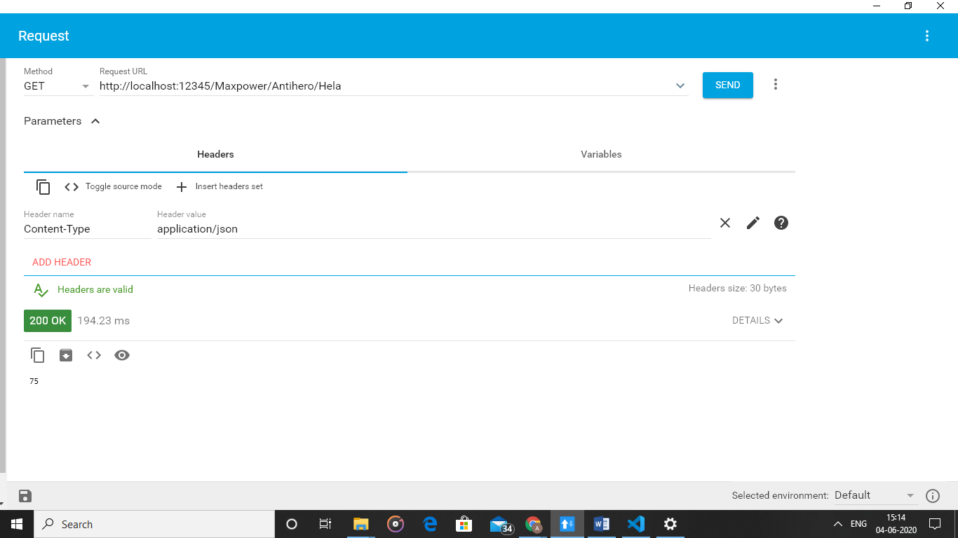

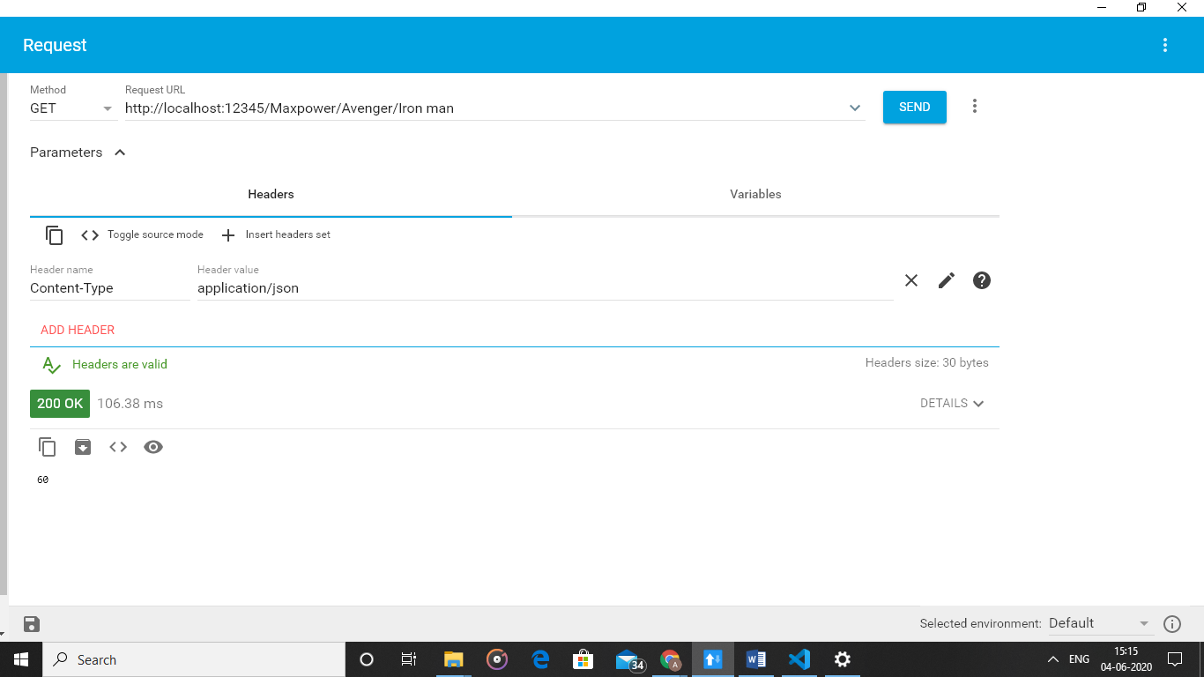

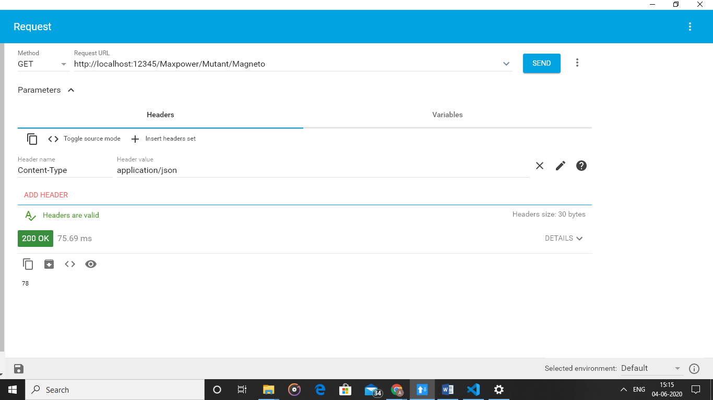

The data structure which holds 15 Character

<http://localhost:12345/Maxpower/Data>

