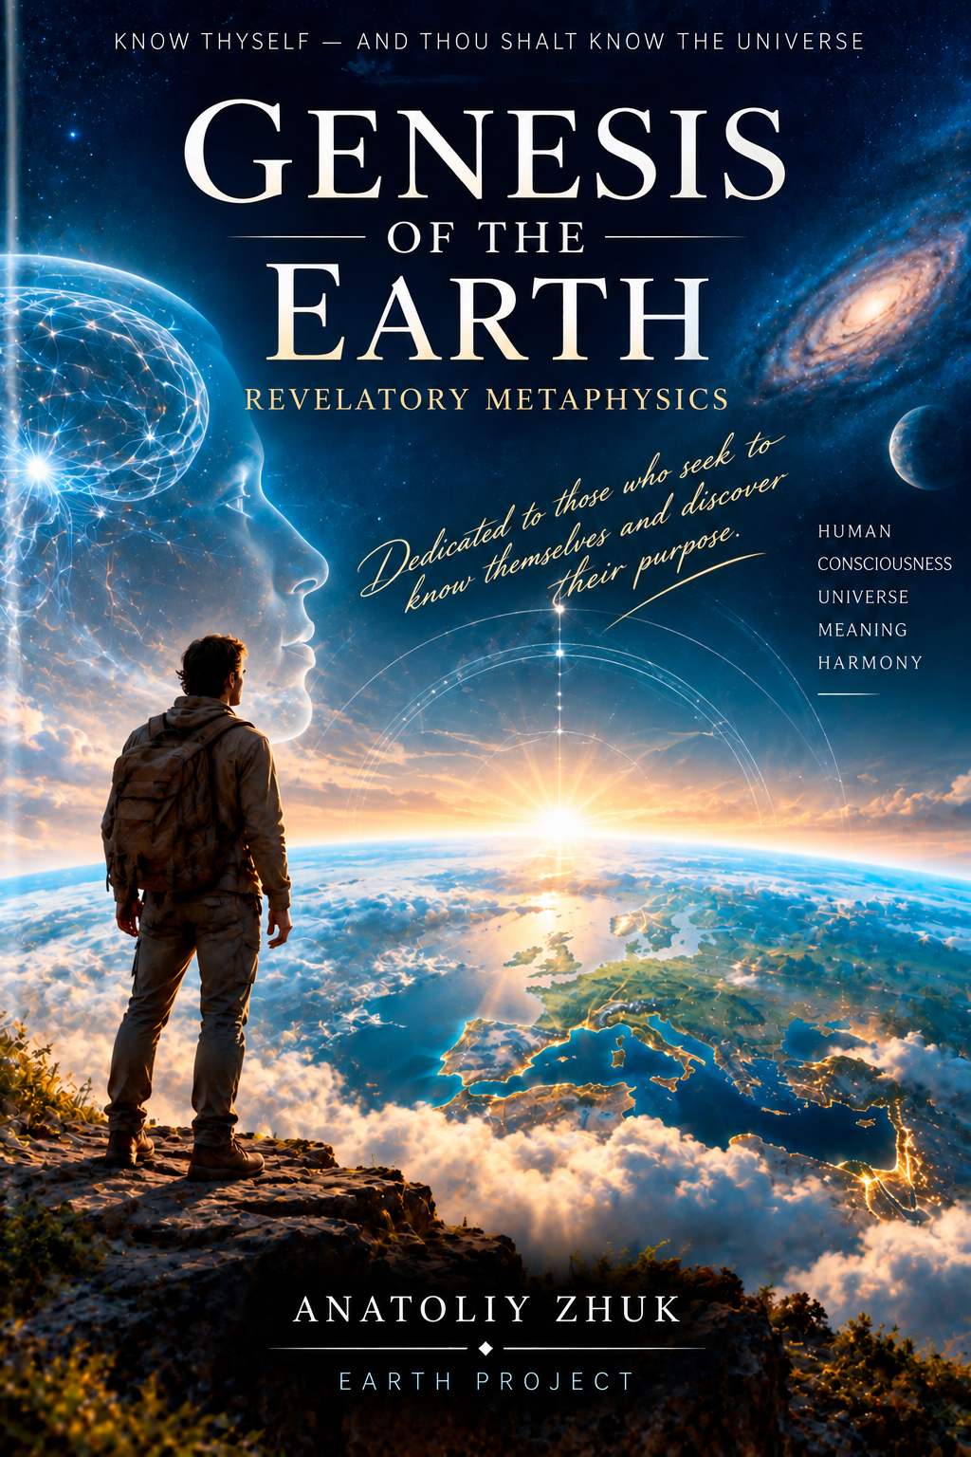

GENESIS OF THE EARTH
Revelatory Metaphysics
ANATOLIY ZHUK
PROJECT EARTH

Complete English text edition
Complete preface, Chapters I–XIV, epilogue, and consolidated references.

CONTENTS
Preface. Know Thyself—and Thou Shalt Know the Universe 4
Chapter I. How It All Began 12
From the First Impulse to Conscious Life
Chapter II. The Human Being at the Centre of the Universe 22
The Plan for the Creation of Earth as a Home for Representatives of Worlds and Civilizations
Chapter III. The Creation of Earth and the Creation of the Human Being 37
Preparing the World for the Emergence of the Human Being
Chapter IV. Adam and Eve 58
The Transition to the Astral Body
Chapter V. Noah and the Great Flood 66
The Transition to the Mental Body
Chapter VI. Intellect and Creation 76
The Age of the Mental Body
Chapter VII. Teachers of Humanity 90
From Intellect to Reason
Chapter VIII. Beyond Time 101
Chapter IX. On Sin, Murder, and Redemption 124
Chapter X. The Soul as a Diamond 135
Chapter XI. Was Darwin Right About Human Evolution? 143
Chapter XII. UFOs: Myth or Reality? 159
Chapter XIII. Artificial Intelligence at the Threshold of an Era 174
The Final Acceleration of the Mental Body and the Need for Reason
Chapter XIV. Torsion Fields 190
Science, Hypothesis, and Metaphysics
Epilogue. Know Thyself—and Thou Shalt Know the Universe 197
Sources and References 201

PREFACE
Know Thyself—and Thou Shalt Know the Universe
When a Human Being is born, a new star lights up in the sky.
Humanity has always sought to understand the Universe.
We have raised our eyes to the stars, tried to understand the movements of celestial bodies, built telescopes, created spacecraft, and sent them ever farther from Earth. With each new discovery, the boundaries of the known world have receded, while the Universe has appeared ever more immense, complex, and mysterious.
We have learned to see the light of distant galaxies, investigate the substance of stars, look deep into matter, and reconstruct billions of years of cosmic history.
Yet, as we gaze into the boundless depths of space, we often forget to look in the opposite direction—within ourselves.
What if these two directions lead to the same destination?
What if a human being is not an accidental observer stranded on a small planet among billions of stars, but a part of the very immeasurable Universe we are trying to comprehend?
What if knowing the world begins not only by studying what surrounds us, but also by seeking to understand the one who is studying it?
Know thyself—and thou shalt know the Universe.
This idea is one of the starting points of Project Earth.
We are accustomed to thinking of the human being primarily as a physical creature.
We study the body, the brain, the nervous system, and heredity.
We measure the brain's electrical activity, decode the genome, investigate cellular processes, and try to understand the mechanisms of consciousness.
And yet a simple question remains:
Is this all that a Human Being is?
Where does the feeling of love come from?
Why can a person sacrifice themselves for another?
Where does inspiration originate?
Why do we search for meaning in life when mere biological existence does not require it?
Why can a human being become aware of their own existence and ask why the Universe itself exists?
And, finally: who is it within us that asks these questions?
Perhaps the exploration of the Universe does not end at a telescope's lens.
Perhaps it continues within the human being—in our feelings and consciousness, in choice, love and fear, suffering and joy, in creativity, the ability to forgive, to make decisions, and to accept responsibility for their consequences.
By exploring the external world, we discover the laws of matter.
By exploring ourselves, we begin to discover the laws of our own existence.
And perhaps one day these two paths will meet.
Why This Book Was Written
Genesis of the Earth is not a scientific treatise.
Nor is this book an attempt to establish a new religion or present the reader with yet another system of dogma.
What lies before you is revelatory metaphysics.
The picture of the world presented in these pages took shape gradually, through reflection, observation, prayer, personal spiritual experience, unusual states of consciousness, and revelations received at different periods of my life.
Some of them were recorded many years ago.
I will reproduce some of these records directly in the book, preserving their dates and, as far as possible, their original form. I do not want to rewrite them in the language of my present understanding, because it matters to me to show not only the final picture but also how its individual parts were revealed over time.
At the time, I did not always understand how the separate ideas were connected. They existed like fragments of a vast mosaic. Only gradually did the larger picture begin to emerge.
Why does Earth exist?
Why is the Human Being constituted as we are?
Why have we been given freedom of choice?
Why is life filled with suffering as well as joy?
Why do human beings need love and forgiveness?
Why do civilizations arise, flourish, and disappear?
Why does humanity repeatedly pass through periods of great change?
What is happening to human consciousness?
What is the mission of the modern Human Being?
And what is my own mission?
Where, ultimately, does this path lead?
Thus, little by little, the idea I named Project Earth came into being.
Not Proof, but an Invitation to Reflect
I do not ask the reader to accept the picture of the world described here on faith. Still less do I seek to prove that the Universe is arranged in precisely this way. What interests me is something quite different.
As I worked on this book, I discovered that some thoughts arising from my personal experience and reflection unexpectedly echoed ideas expressed by people who lived thousands of years before us.
Similar questions appear in the Bible and the Quran, the Torah and the Upanishads, Buddhist writings and the Bhagavad Gita, Daoist tradition, and the philosophical teachings of different eras.
Questions about the Human Being.
About freedom.
About unity.
About suffering.
About love.
About the nature of consciousness.
About death.
About eternity.
About the relationship between the Human Being and the Creator.
Of course, these traditions do not say the same things in every respect. There are profound differences between them, and it would be a mistake to erase those differences artificially. That makes it all the more interesting to discover moments when people separated by centuries, languages, cultures, and thousands of miles turn to similar questions and sometimes arrive at surprisingly close answers.
I will offer these parallels not as proof that I am right.
I simply invite readers to see them.
And to reflect.
Science and the Boundaries of Knowledge
Throughout this book, we will inevitably turn to science as well.
To the structure of the Universe.
To the origin of life.
To genetics.
To the workings of the brain and nervous system.
To the nature of information.
To the physics of space and time.
To artificial intelligence.
But here a vital distinction must be made.
A scientific fact, a scientific hypothesis, a philosophical analogy, and a metaphysical proposition are not the same thing.
Where established scientific knowledge exists, I will try to treat it as knowledge.
Where competing hypotheses exist, I will treat them as hypotheses.
Where a scientific idea bears a remarkable resemblance to a metaphysical picture, I will present it as an analogy.
And where verifiable knowledge ends and my own experience or a revelation received by me begins, I will try not to conceal that boundary from the reader.
I do not wish to use science to manufacture a 'proof' of metaphysics.
Perhaps it is far more interesting to place two ideas side by side and ask: why do they resemble one another?
Each person is free to seek an answer for themselves.
The Human Being as Part of the Whole
One of the central ideas of Project Earth is that the Human Being is not an observer separate from the Universe, but a part of it.
We are made of the substance of this world.
We live according to its laws.
We perceive it.
We transform it.
At the same time, a human being is capable of awareness, feeling, choice, creation, and questioning their own origin.
In the metaphysical picture presented in this book, a Human Being is more than a temporary physical form.
Yet the physical body is not an incidental shell that the Soul must simply discard one day. It is the Human Being's earthly form of embodiment—the level of existence through which the Soul receives direct sensory experience of the material world.
Through the body we experience touch, warmth and cold, pain and pleasure, movement and the resistance of matter, fear and love, loss and discovery, solitude and unity.
But experience alone is not enough.
The Human Being has been given Freedom of Choice.
And with freedom inevitably comes Responsibility.
We choose.
We make decisions.
We act.
We face consequences.
We live through them.
And we transform what we have lived through into experience.
Thus, the human path may be represented as a sequence:
Sensory Experience → Freedom of Choice → Decision → Action → Consequences → Responsibility → Experience → Harmonization → State of the Human Being → Readiness for the Next Level.
It is experience, not knowledge alone, that gradually changes the Human Being.
Intellect and Reason
Throughout this book, it will be essential to distinguish two concepts that we often use as though they were synonymous:
Intellect and Reason are not the same thing.
Intellect can accumulate knowledge, compare, calculate, analyze, build models, and find solutions.
But a vast store of knowledge does not, in itself, make a person truly reasonable.
One can know the consequences of an action—and still commit it.
One can possess exceptional intellect—and use it to destroy.
One can construct an extraordinarily complex model of the world—and fail completely to understand oneself.
In the system of Project Earth, Intellect is primarily associated with the development of the Mental aspect of the Human Being.
Reason matures through experience.
Intellect arises from knowledge. Reason matures through experience.
Through states of feeling that have been lived through.
Through choice.
Through the consequences of choice.
Through the ability to accept responsibility.
Through a gradual understanding of causes and effects, not only in the external world but also in one's own life.
The path to the next level of human consciousness therefore cannot be completed simply by increasing the amount of knowledge one possesses.
A Human Being must live a life.
Freedom and the Inevitability of Change
Here, however, an apparent contradiction arises.
If a human being has been given freedom of choice, is anything predetermined at all?
In the worldview of Project Earth, these two principles do not contradict one another.
A Human Being is free to choose a path, but cannot overturn the laws governing the development of the Universe itself.
We may choose how to pass through change.
But we cannot abolish change itself.
I call this the Inevitability of Change.
It is not punishment.
It is not the wrath of God.
It is not a judgment passed upon humanity.
In the system of this book, it is one of the laws of development.
Every new form must mature.
Every new level requires the levels before it to be prepared.
You cannot force a seed to sprout prematurely without damaging it.
Nor can you prevent it from sprouting forever when its time has come.
Development, then, cannot be accelerated without consequences.
But neither can it be stopped.
Freedom exists within the Law.
The Teachers
Throughout human history, individuals have appeared whose words continued to transform people's lives centuries and millennia later.
Jesus Christ.
Muhammad.
Shakyamuni Buddha.
Krishna.
And other Teachers, philosophers, and spiritual guides of different peoples.
I do not intend to claim that all religions are identical or that all Teachers said exactly the same thing.
That would be far too great a simplification.
Instead, I suggest we consider something else.
Why do words about love return again and again?
Why does compassion arise?
Why do Teachers speak of freedom from attachment?
Why does forgiveness appear?
Why are human beings urged to seek truth first of all within themselves?
In Project Earth, I invite the reader to consider the possibility that different Teachers came to humanity in different eras not by chance.
And a special place here belongs to Christ.
Christ is Divine and a Teacher of humanity.
He cannot be confined to any single level or dimension.
Yet within the framework of this book, His earthly life, His actions, His commandments, and the possibilities of the Human Being revealed through Him may be considered a demonstration of humanity's nearest horizon of transformation and, at the same time, a path of preparation for a state associated with receiving the Causal Body—the Body of Reason.
For me, one of the simplest expressions of this path is:
If you wish to be like Christ, live and act as Christ did.
Do not strive first and foremost to possess His abilities.
Try to understand His actions.
Why Now?
We are living in an extraordinary time.
Humanity has created a technology that compels us to ask anew: what is a human being?
Artificial intelligence can already perform many activities that, until recently, were considered the exclusive province of human intellect.
It analyzes.
It compares.
It remembers.
It models.
It creates texts and images.
It proposes solutions.
And the more advanced artificial intelligence becomes, the more pressing another question grows:
If artificial intelligence can do all these things, what, then, is human Reason?
Perhaps it is precisely now that humanity must, for the first time, truly distinguish between these two concepts.
Intellect ≠ Reason.
Artificial intelligence can amplify humanity's intellectual capabilities many times over. Yet it also forces us to ask: if accumulating knowledge, analyzing it, comparing it, and forming new combinations of information can be entrusted to a machine, what remains distinctly human?
The choice nevertheless remains with the human being.
And so does responsibility for that choice.
Perhaps that is why artificial intelligence has appeared just as humanity approaches another inner transition.
Not as a replacement for humanity.
Not necessarily as an adversary.
But perhaps as a mirror in which human beings must finally see themselves.
An Invitation
I therefore invite you to read this book not as a textbook.
Nor as a sacred text.
Not as proof.
Not even as a ready-made answer.
I invite you to experience it as a journey.
We will try to travel from the birth of the Universe to the appearance of the Human Being.
From the physical body to feeling.
From feeling to thought.
From thought to Reason.
From individual consciousness to the question of a Single Consciousness.
We will turn to ancient texts and modern hypotheses, the history of humanity and personal experience, religion and philosophy, science and metaphysics.
At times these paths will diverge.
At times they will cross unexpectedly.
And at times we will reach a boundary beyond which we can no longer say, 'I know.'
Then we may still be able to say, 'I allow for the possibility.'
And continue on our way.
I do not know whether the reader will see the world as I have seen it.
Nor is that the purpose of this book.
The freedom of choice so often discussed in the following pages must apply to the book itself as well.
I can only share my experience.
Tell you what was revealed to me.
Show you the parallels I have found.
Ask questions.
But each reader must find their own answer.
For perhaps the greatest mystery of the Universe lies much closer than we are accustomed to think.
We search for it among the stars.
Yet all the while it has been looking at those stars through our eyes.
Know thyself—and thou shalt know the Universe.
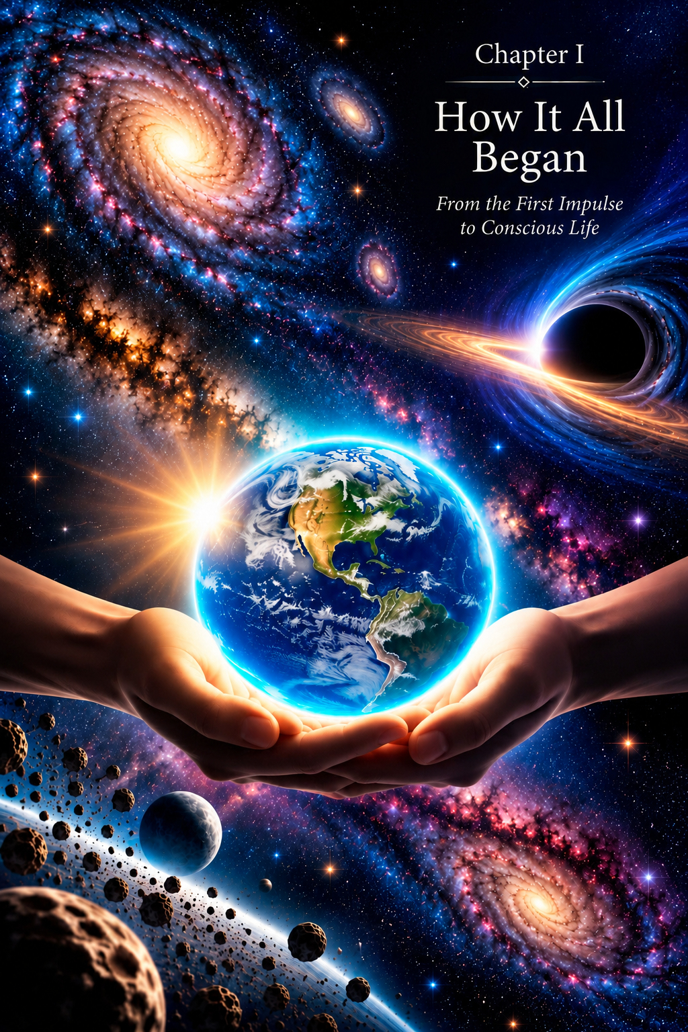
CHAPTER I
How It All Began
From the First Impulse to Conscious Life
“For thus says the Lord, who created the heavens, God himself who formed the earth and made it, who established it; he did not create it in vain, he formed it to be inhabited: I am the Lord, and there is no other.” (Isaiah 45:18)
Earth was not created in vain.
These few words of Scripture contain far more than they may appear to at first reading.
If Earth was created neither by chance nor in vain, then a Design preceded its appearance.
If it was formed “to be inhabited,” the next question is: inhabited by whom? Why was precisely such a world required? Why did Earth appear—with its matter, space, time, diversity of life, and, eventually, the Human Being?
Scripture tells us about the act of Creation itself, but reveals very little of the full architecture of that Design.
What if the creation of Earth and the Human Being was preceded by a history far older than the history of our planet?
What if Earth emerged not simply as one more world among countless existing worlds, but as an entirely new kind of space, intended to solve a task that could not be resolved in any other way?
What if, long before Earth appeared, worlds and civilizations already existed throughout the Universe, each possessing its own unique energy, its own mode of expression, and its own facet of the One Creation?
What if it was precisely the differences between these worlds—their greatness and uniqueness, but also their growing desire to prove their own exceptional nature—that eventually called for an entirely new solution?
Not to abolish differences.
Not to declare a victor.
Not to exalt one civilization above another.
But to create a space where differences could meet, join together, and one day achieve harmony.
That space was to be Earth.
And the being capable of containing this diversity was to be the Human Being.
This is where the account of Earth's creation begins—the picture that gradually opened before me through many years of reflection, prayer, and inner experience.
The Universe Created by the Creator Is Timeless and Infinite
Long before planet Earth appeared in the heavens, countless worlds and civilizations already existed in the Universe.
Each was a unique creation, just as no two flowers are identical in an endless garden.
Some civilizations possessed physical form; others existed as pure structures of energy; still others inhabited dimensions inaccessible to our perception.
Modern physics, too, considers models of reality that far exceed the familiar human picture of a three-dimensional world. Theoretical physics offers hypotheses involving additional dimensions, while cosmology explores various models of a multiverse.
These scientific constructions do not prove the picture of existence described in this book, but they show just how limited our familiar human understanding of reality's structure may be.
Coincidence?
Or are modern models gradually bringing human consciousness closer to an understanding of the complexity of existence that prophets, philosophers, and mystics have attempted to grasp for thousands of years?
In 1927, the British biologist J. B. S. Haldane wrote that the Universe may be not only stranger than we suppose, but stranger than we are capable of supposing.
That thought expresses the grandeur of the reality we are about to explore.
The Diversity of Worlds and Their Distinctive Qualities
The representatives of these ancient civilizations differed in temperament, culture, forms of communication, and even in the nature of the energy over which each possessed complete mastery.
Some expressed unconditional universal love, others creative power, and still others the depths of wisdom, peace, and service.
Each civilization was a living embodiment of one facet of the Creator, and in that lay its irreplaceable value.
Each possessed its own distinct quality, unlike anything else in the infinite Universe.
The created worlds contained different forms of life—from physical manifestations to purely energetic forms. And all this Creation of the one Creator of everything that exists, visible and invisible, was permeated by immeasurable love.
Yet it was precisely love for the Creator and a longing to be closer to Him that gradually revealed another side: the desire to demonstrate the exceptional nature of one's own energy. The representatives of these worlds sought dominance within the hierarchy, believing that their particular facet was the most precious in the eyes of the Creator.
Competition in itself is not evil. It may encourage development, the unfolding of one's own abilities, and self-improvement.
But when the desire to express uniqueness turns into a wish to dominate and suppress others, the harmony of the whole is disrupted.
In infinity, countless forms of expression are possible, but the freedom of one must not destroy the freedom of another.
Echoes of Ancient Events in Culture and Human Imagination
In the system of this book, a single information field permeates the Universe, preserving images, events, and possibilities of Creation. At times, a person may come into contact with them not through a sequence of rational analysis, but through a suddenly arising image, a dream, an insight, meditation, or a creative state.
That is why writers, artists, screenwriters, and film directors sometimes create worlds that resonate in remarkable ways with questions humanity has only just begun to ask. Within the metaphysical picture proposed here, such images may be regarded not only as works of artistic imagination, but also as possible moments of contact between consciousness and a wider informational space.
In his Foundation series, Isaac Asimov depicts civilizations and systems struggling over the future of an immense galactic domain.
In his Space Odyssey, Arthur C. Clarke explores the image of extraterrestrial intelligence influencing human development.
The Strugatsky brothers repeatedly examine the problem of a more advanced civilization intervening in the fate of another.
In Dune, Frank Herbert shows how conflict over resources, power, and exceptional status becomes intertwined with humanity's inner development.
These works are different, and none confirms the events described here. Yet the recurrence of such images raises a question: does human creativity always begin only with what the conscious mind already knows?
All these images do not arise out of emptiness. They are echoes of those distant times when competition between worlds was real. There is also, in the view presented here, scientific support for this idea: the anthropic principle in physics suggests that the Universe is finely tuned for the emergence of intelligent life. Could intelligence be not an accident, but the result of a long process of “tuning” through the experience of many civilizations?
The question can then be framed more broadly: why do the properties of the Universe we observe permit complex matter, life, and consciousness to emerge?
For science, this is a question of physical conditions and the selection of observable parameters.
For the metaphysics of Project Earth, it opens another possibility:
What if the emergence of conscious life is not an accidental by-product of the Universe's existence, but part of a far greater Design?
The Information Field of the Universe
Science-fiction writers, artists, screenwriters, and film directors have created countless works depicting worlds, civilizations, and events they have never observed directly.
But are such images always merely products of imagination?
Human consciousness is capable of coming into contact with information far more extensive than what a Human Being receives through the senses and personal earthly experience.
A single information field permeates the Universe.
Earth's information field is part of it and is directly linked to the informational space of the Universe.
Within it exist images, knowledge, events, and possibilities of Creation.
Thus, what a person sometimes experiences as a sudden flight of fancy, an unusual dream, an insight, or an inexplicable image may have an entirely different nature.
The Human Being is capable of receiving information.
Consciously or entirely spontaneously.
In sleep.
In meditation.
In prayer.
In a trance.
Through Intuition.
Through an image that appears without warning.
Sometimes at the most ordinary moment of life, while thinking about something else entirely.
This, in my view, is why one person may suddenly envision a technical device that does not yet exist.
Another—a piece of music.
A third—a mathematical relationship.
A fourth—an event that has yet to occur.
Prophets perceived images of unfolding events.
Artists and writers saw pictures of worlds they had never beheld with their physical eyes.
Scientists perceived solutions and structures that later became discoveries.
Inventors envisioned devices that had yet to take material form.
Does the Human Being create something new out of nothing?
Perhaps a significant part of what we call a discovery begins at the moment when a Human Being gains access to information that already exists in the space of Creation.
Not everyone can receive it in the same way.
And not every image received can be understood immediately.
Sometimes minutes pass between an image and the awareness of its meaning.
Sometimes years.
And sometimes a Human Being preserves what was seen for an entire lifetime, never finding the language in which to express it.
The history of human discovery has preserved many such episodes.
According to the recollections of Professor A. A. Inostrantsev, Dmitri Mendeleev told him that he had seen a table in a dream in which the chemical elements were arranged in the necessary order. Upon waking, he transferred what he had seen to paper.
August Kekulé described a vision of a snake forming a closed ring, after which a new understanding of benzene's structure arose.
Henri Poincaré recounted how a mathematical solution appeared to him unexpectedly as he was about to step onto an omnibus.
Nikola Tesla possessed the ability to visualize devices that did not yet exist so clearly that he could mentally assemble them, set them in motion, and observe their operation before beginning their physical manufacture.
Albert Einstein said that the first elements of his thinking did not appear as words, but as images, spatial sensations, and inner movement.
The story of Archimedes preserves the famous cry “Eureka!”—a moment when an entirely ordinary observation suddenly revealed a connection he had not seen before.
Newton saw an apple fall—a phenomenon humanity had observed for thousands of years—but in his consciousness it suddenly became connected with the far wider structure of the world.
In all these examples, the people, historical periods, circumstances, and content of the information received are different.
Yet they share one feature.
First, something arises that was not present in the conscious sequence of thoughts.
An image.
A connection.
Music.
A construction.
A formula.
A premonition of an event.
A Human Being receives something that still remains to be understood.
And it is precisely here, for me, that the boundary lies between ordinary reflection and sudden contact with the information field.
An Image of the future creation is the indispensable beginning of the Creative Process. The Image gives rise to a thought, which the Human Being begins to develop into an idea of their own.
An Image may enter consciousness unexpectedly.
A Human Being may be walking down the street, having a conversation, looking out a window, praying, resting, or sleeping—and suddenly receive an image entirely unrelated to what they are doing.
Where did it come from?
In my picture of existence, one answer lies precisely in the presence of a single information field of the Universe.
Another source may be the experience of the Soul itself.
If the Soul is eternal and passes through many incarnations, its experience is far greater than the memory available to the embodied Human Being.
Conscious memory of past incarnations is closed.
But that does not mean the accumulated experience of the Soul disappears.
Sometimes it may manifest as a sense of recognition.
As inexplicable understanding.
As an ability.
As an image.
As knowledge whose source the Human Being cannot explain.
Thus, one child may only just be beginning to explore the surrounding world, while another is already capable of hearing and creating music of a depth difficult to reconcile with the few earthly years they have lived.
Someone picks up an instrument for the first time—and seems to recognize it.
Someone looks at a mechanism—and almost immediately grasps how it works.
Someone receives a solution in a dream.
Someone sees an event long before it becomes part of physical reality.
This is how I understand many manifestations of the Universe's information field.
Not as accelerated thinking.
Not as exceptionally rapid analysis.
But as the reception of information.
Information may arrive before understanding.
An Image—before its explanation.
Knowledge—before the language needed to express it.
Only afterwards does the Human Being have to understand what has been received and find a way to embody it in the material world.
For this reason, I do not automatically regard fantasy, dreams, insights, prophetic images, or intuition as things divorced from reality.
Intuition is a spontaneous inner signal of warning:
do not do it;
do not go;
stop;
something is wrong.
It need not reveal an Image of the future result, nor is it a necessary beginning of the Creative Process.
Image, Foresight, and Intuition are different phenomena.
Creation follows its own sequence:
Image → Idea → Intellect → Creation.
Foresight allows the result or a possible course of events to be perceived before it manifests materially.
Intuition warns.
Sometimes, through these very abilities, a Human Being comes into contact with what already exists beyond their present perception.
Perhaps the Human Being does not so much create something new as gradually reproduce what already exists in the infinite space of Creation.
Competition as Both a Driving Force and a Dead End
Competition between civilizations was fierce.
The degree of ambition and tolerance toward representatives of other worlds was governed by the laws of Creation. Despite the fundamental principle of Unity as the highest form of being, a sufficiently intense competitive struggle existed among the worlds.
The desire to prove one's uniqueness and exceptional status sometimes led to battles.
The representatives of different worlds excelled in expressing forms of energy unavailable to others. Some embodied unconditional universal love, others creativity, still others peace and service, and so on.
Yet this rivalry gradually revealed its own dead end.
If each civilization represents a facet of Creation, then elevating one by destroying or suppressing another does not bring the whole closer to perfection. It merely deprives the whole of one of its unique facets.
The struggle for primacy became a struggle between different manifestations of the same Creator.
In infinity, countless forms of expression are possible, but the freedom of one must not destroy the freedom of another.
These words from a revelation express the inner contradiction of such struggle especially clearly. In striving to prove superiority, the worlds perpetuated the very division that prevented them from reaching Unity.
The solution, therefore, could not lie in the victory of any single civilization.
An entirely different path was needed.
The Design for the Creation of Earth
It was then, in the silence of eternity, that the Design arose which was to resolve this confrontation.
The Creator offered another principle: not to determine a victor, but to create a special world where the energies of different civilizations could meet within one new being.
That world was to be Earth.
That being was to be the Human Being.
The Plan for the creation of Earth as a home for representatives of worlds and civilizations demanded a fundamentally different relationship between them.
Instead of the power of one civilization over another—Freedom of Choice.
Instead of imposing one's own energy—a voluntary contribution to the shared human matrix.
Instead of destroying differences—joining them together.
Each civilization was to pass on to the Human Being a portion of its own unique energy, then allow the Human Being to experience the interaction of all these qualities personally.
No world was to be given the right to interfere with the Freedom of the Human Being.
No civilization was to receive an advantage when the Human Being chose whether to express that civilization's particular energy.
The choice had to belong to the Human Being alone and be made in complete Freedom.
Only free choice could turn the joining of different energies from an artificial construction into genuine harmony.
The Human Being as a Place of Meeting
Within the Human Being, energies that had previously existed separately were to meet.
But their union did not mean harmony would follow automatically.
Each energy had to be experienced.
The Human Being had to encounter its possibilities, extremes, and consequences.
Through personal choices, the Human Being would gradually learn to interact with all the diversity inherent in their nature.
Thus, the Human Being was to become not a battlefield for civilizations, but a place where they could meet.
Within the Human Being, differences could cease to be grounds for external conflict and become parts of a shared experience.
Not the elimination of differences, but the end of struggle between differences.
Freedom as a Condition of the Design
This Plan could not be carried out without Freedom.
If any civilization had been able to control the Human Being directly, it would inevitably have sought to develop its own energy above all others.
The ancient competition would simply have moved to Earth.
The Human Being therefore had to be given the right to make mistakes.
The right to choose.
The right to reject the offered path.
The right to return to it.
The right to discover the consequences of personal decisions through personal experience.
Freedom was not an incidental quality of the Human Being, but one of the fundamental conditions of the entire Design.
And with Freedom, Responsibility inevitably arose.
The choice belongs to the Human Being. The consequences of that choice become their experience.
The Architecture of the Task
Thus the cosmic prehistory becomes the architecture of the task humanity must undertake.
Many worlds possess different energies.
Every energy is unique.
The attempt to establish the superiority of one over the others leads to division.
The Creator offers another path—to unite differences without eliminating them.
For this purpose, Earth is created.
But Earth alone is not enough.
There must be a being capable of receiving the energies of different civilizations, living through them as personal experience, and, while preserving Freedom of Choice, gradually bringing them into harmony.
That being was to be the Human Being.
That is why the question of the Human Being becomes the next and central question of our narrative.
Why was it the Human Being who had to become the centre of this Design?
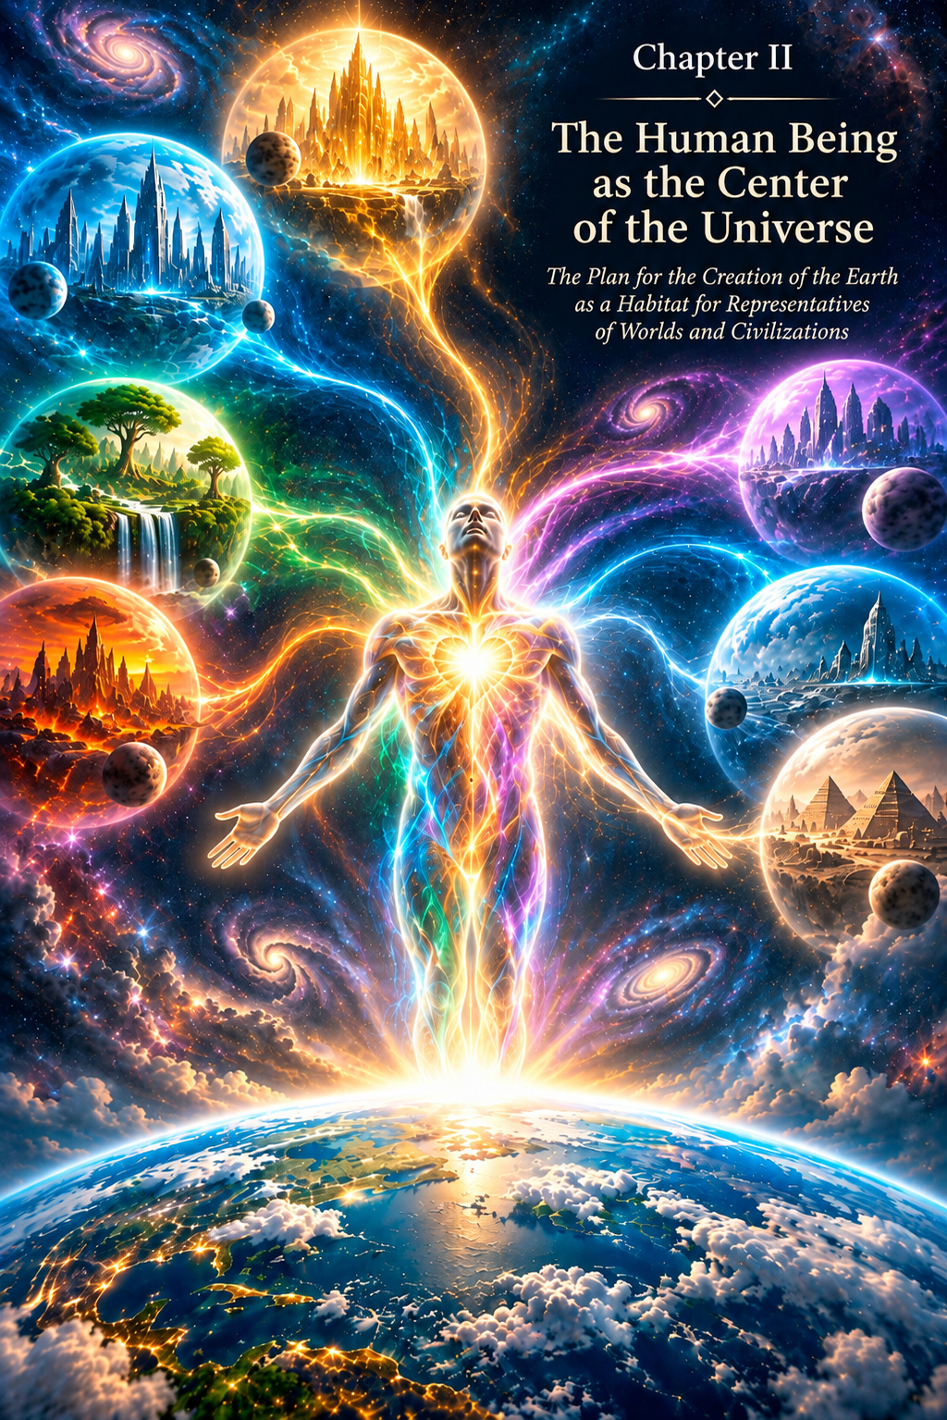
CHAPTER II
The Human Being at the Centre of the Universe
The Plan for the Creation of Earth as a Home for Representatives of Worlds and Civilizations
"Let Us make man in Our image, after Our likeness..." (Genesis 1:26)
If the Universe contains many worlds and civilizations, each possessing its own unique energy, its own form of experience, and its own understanding of perfection, an inevitable question arises: how can all this diversity be united without destroying the very differences that distinguish it?
In the framework of this book, the answer lies in a particular Design of the Creator.
Not to eliminate differences.
Not to force every world to become the same.
Not to proclaim a single victor.
But to create a space in which different energies can meet, interact, and gradually arrive at harmony.
Earth was to become that space.
And the Human Being was to stand at the centre of that Design.
The Creator's Design
Every world possesses its own uniqueness.
Every civilization develops a particular energetic quality and naturally regards that quality as being of the greatest importance.
Yet uniqueness can easily become the basis of division.
What distinguishes one world from another may become a cause of rivalry.
Each civilization seeks to demonstrate the value of its own path.
Each wishes to be closer to the Creator.
Each sees a special virtue in its own energy.
But the Creator has no need to choose among the manifestations He has created.
They all exist within the One. And all of this constitutes a unity of opposites.
The solution, therefore, could not lie in the victory of one energy over another, but in their union.
Not to eliminate differences, but to create a form capable of containing them all.
A World Intended for Life
This required a special space.
A world in which different energies could be present at the same time.
A world where they would not remain isolated, each within its own civilization, but would meet within a single system.
Yet such a space could not be merely a meeting place.
It had to make lived experience possible.
To make choices.
To make mistakes.
To correct those mistakes.
To love.
To fear.
To create.
To destroy.
To accept responsibility.
And gradually to come into harmony.
Thus arose the Plan for the Creation of Earth as a dwelling place for representatives of worlds and civilizations.
Earth was to become not a copy of an already existing world, but an entirely new space—a place of integration in which everything is embedded in three-dimensional space and time (3D + t).
The Human Being at the Centre of the Design
But the energies of different worlds could not be united at the planetary level alone.
Someone was needed who could contain them within themselves.
Thus the central figure of the Plan appears: the Human Being.
The Human Being becomes the centre of the Universe not because everything that exists was created solely for human convenience.
Nor because humanity is meant to dominate other worlds.
This central position has a different meaning.
The Human Being becomes a place where the energies of the Universe meet.
A point of integration.
A living space in which the energies of many worlds can gain a shared experience.
The Human Being is central not as the ruler of the Universe, but as the place where its diversity is brought together.
The Human Matrix
To fulfil such a task, the Human Being could not be created as a merely biological creature.
The architecture of the Human Being had to permit existence in several states at once.
It had to include a physical body capable of living in the material world.
A vital energetic system.
The ability to feel.
The ability to think.
The ability to understand causality.
The ability to experience Unity.
And, ultimately, the ability to dwell freely in harmony with the Will of the Creator.
Thus the human matrix becomes multilayered.
The physical body is only its visible part.
Beyond it lie more subtle levels—energetic bodies that will gradually unfold throughout human history.
From the very beginning, the Human Being is created as a potential far greater than the state in which the earthly journey starts.
The Physical Body
"Do you not know that your bodies are the temple of the Holy Spirit who is in you, whom you have from God, and that you are not your own?" (1 Corinthians 6:19)
The first instrument of earthly experience is the physical body.
It is through this body that the Human Being enters the material world.
The body makes it possible to sense the density of matter.
Temperature.
Pain.
Touch.
Taste.
Smell.
Movement.
Fatigue.
Pleasure...
It makes possible direct experience within a limited material form.
The physical body may be compared to a spacesuit that allows the Soul to act within the conditions of a dense world.
Yet this spacesuit is also a temple of the Soul.
For through it the Soul gains experience of the material world that cannot be obtained outside physical incarnation.
Therefore, the body should not be regarded as an accidental or unnecessary shell from which the Soul will one day merely be released. It is an integral part of the earthly Human Being and an essential condition of the experience for which the Soul enters incarnation.
Through the body, the Soul does not merely exist in the material world—it feels it.
The knowledge of touch cannot replace touching.
Pain cannot be known solely through a description of pain.
The taste of something cannot be obtained from information about its taste.
A loving embrace cannot be replaced by an understanding of what an embrace is.
It is the physical body that transforms knowledge about the material world into direct experience.
Herein lie both its limitation and its greatest value.
The body limits the Human Being—and precisely for this reason it creates the unique conditions of earthly experience.
In the Image and Likeness
The biblical words about the creation of the Human Being "in the image and likeness" are often understood in terms of outward form.
Yet it would be strange to assume that likeness to the Creator is determined by anatomy.
The Image is manifested above all in the very nature of human consciousness.
The Human Being is capable of creating.
Capable of loving.
Capable of choosing.
Capable of self-awareness.
Capable of bringing into existence something that did not previously exist in that form.
Capable of compassion.
Capable of seeking the Source of its own existence.
Capable of changing itself voluntarily.
It is these qualities that allow us to speak of a Divine beginning within the Human Being.
The Image of the Creator is not embedded in the shape of the body, but in the possibilities of consciousness.
The Soul
At the centre of human architecture is the Soul.
It is not a product of the physical world.
In the framework of this book, the Soul is a particle of the Creator that enters earthly incarnation for the sake of experience.
The physical body is matter and is subject to time.
It is born, changes, and disintegrates.
The Soul, however, is not limited to a single such cycle.
The Soul knows neither spatial dimensions nor time.
It enters a form, gains experience, and continues its journey.
Earthly life is therefore of immense value, but it is not the only form of human existence.
The body lives a life in time. The eternal Soul gains experience through that life.
Consciousness and the Brain
The physical brain is one of the most important instruments of the earthly Human Being.
Through it, signals from the sense organs are processed, responses are formed, memories are stored, and an enormous number of processes necessary for existence in the material world take place.
But in the metaphysical system of this book, consciousness is not reduced to the workings of the brain alone.
The brain and nervous system may be compared to a processor and an interface through which a broader human system interacts with physical reality.
Just as damage to an instrument can distort a received signal, the condition of the brain affects the way consciousness manifests through the physical body.
Yet the instrument itself is not necessarily the source of everything manifested through it.
Feelings
The Human Being was not meant to remain a creature that merely receives material signals.
It was to learn to experience the world inwardly.
Thus the human architecture came to require an essential energetic sheath—the Astral (Sensory) Body. (In Chapter III, I discuss the structure of all the human bodies in greater detail.)
Through it, love, fear, compassion, jealousy, joy, grief, attachment, and many other states become part of experience.
Feelings create inner depth.
The same external event may be experienced in entirely different ways by different people, and accordingly the way each chooses to live through that event will not be identical.
It is precisely in this difference that freedom begins to unfold.
Thought and Creation
The next level is connected with the Mental Body—the Body of Creation.
The Human Being acquires the capacity not merely to react to the world, but to create an internal model of it.
To imagine what does not yet exist.
To compare alternatives.
To discover a pattern.
To form a design.
And then to attempt to embody it in matter.
Thus the Human Being becomes not merely a participant in Creation, but a creator within the created world.
The Human Being does not create matter out of nothing.
But can combine what already exists in ways that have never existed before.
Creation becomes one of the most important manifestations of the Creator's Image in the Human Being.
The Gift of Each Civilization
If the Human Being was to become the place where different worlds are united, each civilization had to contribute a quality of its own to the human matrix.
Not necessarily in the form of knowledge or technology.
Above all, in the form of energy.
One civilization might contribute a quality that manifests in human experience as a particular ability.
Another—another state.
A third—another way of interacting with the world.
Each such contribution becomes part of the great mandala of the Human Being.
No energy should destroy the others.
Each must find its own place.
The perfection of the Human Being arises not from the victory of one energy, but from the harmony of many.
The Human Being as a Space of Unity
We can now understand why the Human Being occupies the central position in the Plan.
Qualities that previously existed separately had to meet within the Human Being.
It was necessary not simply to possess them, but to harmonize them.
Strength without love becomes destruction.
Love without freedom becomes dependence.
Intellect without responsibility can serve the ego.
Freedom without an awareness of consequences becomes arbitrariness.
Every quality is necessary.
But none should become absolute.
The Human Being becomes a space in which differences learn to coexist.
Freedom of Choice
But harmony cannot be created through coercion.
If the Human Being were prescribed every correct action in advance, there would be no personal experience of living through life.
If the possibility of error were removed, responsibility would disappear.
If someone were forced to love, love would cease to be love.
Thus Freedom of Choice becomes one of the fundamental laws of earthly experience.
This Freedom neither begins nor ends with the Soul's incarnation.
Before incarnation, the Soul freely chooses the experience it requires and the path of its further development. The Karmic Council prepares a scenario and sequence of events corresponding to that choice—karma, meaning the conditions under which the chosen experience may be gained.
After incarnation, the specific scenario is concealed from the Human Being. They do not know in advance the entire sequence of encounters, trials, and circumstances, and ordinary consciousness does not preserve the memory of former incarnations.
But God does not take away Freedom after birth. Once within the course of events, the Human Being remains free, during the time allotted to earthly life, to choose how to live through them: in love or hatred, joy or despondency, peacemaking or resentment, wisdom or recklessness.
Karma creates the conditions. The choice within those conditions remains with the Human Being.
And with this possibility comes responsibility.
Freedom without responsibility turns into chaos. Responsibility without freedom loses its meaning.
Why the Creator Does Not Intervene in Human Choice
People often ask: if the Creator exists, why does He not prevent every mistake, every pain, and every wrong choice?
But constant intervention would destroy the very meaning of Freedom and earthly experience.
The Human Being is the Creator's beloved child—His hands, feelings, and eyes in the material world. The Creator's love for the Human Being is absolute and boundless. It is precisely for this reason that God does not turn the Human Being into an automaton permitted to perform only an action predetermined as "correct."
The Human Being has been given the opportunity to encounter life, experience different states, see the consequences, and choose what is better.
Help may come through Teachers, inner impulses, meetings, circumstances, and signs. But help does not destroy Freedom.
God may reveal a direction. To live the journey instead of the Human Being would mean depriving them of the experience of that journey.
The Path of Life
Each incarnation becomes a space for a particular experience.
The Human Being is born into a particular family.
Within a particular culture.
Under particular historical circumstances.
With particular abilities, limitations, and relationships.
In the framework of this book, these are not regarded as a random collection of conditions.
Before incarnation, the Soul chooses not a list of future events, but the experience it needs and the direction of its further development.
The Karmic Council shapes a course of events sufficient for that experience to be lived: encounters, circumstances, opportunities, limitations, gains, losses, and the duration of the earthly path.
Here karma is not a punishment.
It is not a sentence.
It is the setting for a lesson.
Freedom Within the Program of Life
The existence of a karmic scenario does not destroy the Human Being's Freedom.
The scenario defines the course of events, but after incarnation it is concealed. The Human Being encounters circumstances as the reality of life, without knowing their place in the Soul's wider plan.
It is precisely within these circumstances that personal experience begins.
The same difficult period may be lived through in hatred or compassion, in despondency or hope, by destroying oneself or by preserving the ability to love and create.
The Human Being may refuse the lesson. God does not deprive anyone of even this Freedom. But the freedom to refuse an experience does not mean that the experience has been gained.
If the quality chosen by the Soul has not been mastered, the need for that experience remains. In another incarnation, a different course of events may be created in which the Soul encounters the unlearned lesson again.
Thus the outward conclusion of an event and the completion of a lesson are not the same thing.
Karma creates the conditions. The Human Being chooses how to live through them. The consequences of that choice become the Human Being's experience.
Forgetting the Past
For the integrity of earthly experience, the Human Being does not retain full conscious memory of previous incarnations.
The particular scenario of the present life is also concealed.
If the Human Being knew in advance the reasons for every meeting, the sequence of future events, and their place in the karmic program, the experience of living through them would itself change.
The Human Being would act not from the present state of consciousness, but from knowledge of a hidden scenario.
Forgetting therefore becomes part of the conditions of incarnation.
The Human Being enters life as though anew.
And comes to know love as love.
Pain as pain.
Betrayal as betrayal.
Forgiveness as an inner state that must still be acquired.
Only in this way does a lived experience become genuine experience.
Why One Lifetime Is Not Enough
A single earthly lifetime is not enough to encompass all the diversity of experience that the Soul must contain.
Therefore, within the system of this book, the human journey continues through many incarnations.
Each life presents new conditions.
Another family.
Another culture.
A different level of material well-being.
Different relationships.
Different opportunities and limitations.
Thus the Soul gains the possibility of seeing the human world from many sides.
Someone who held power in one life may experience dependence in another.
Someone who was wealthy may come to know deprivation.
Someone who was subject to another person's decisions may later have to decide another person's fate.
Not as a mechanical punishment.
But as an expansion of experience.
The Soul does not come in order always to have an easy life. It comes to gain the experience it needs.
Reincarnation: Beyond a Single Life
In the preceding section, we spoke of how a single earthly life is not sufficient for the variety of experience that the Soul must contain. We shall now approach this question more deeply, drawing not only on philosophical reasoning but also on personal experience that may be accessible to anyone willing to listen inwardly.
Memories of a Choice Before Birth
In a state of deep calm, in prayer, or simply in moments of inner stillness, a person may sometimes come into contact with what preceded birth.
I myself was given the experience of such a state. In it, I saw myself before birth. I saw the choice of parents, sensed the possible conditions of a future life, and understood that the Soul accepted them neither under pressure nor out of fear.
But this was not knowledge of the entire sequence of future events. The specific scenario of earthly life remained concealed.
I perceived this as a conscious and voluntary step by a Soul that understood what experience it needed and why it was entering this world.
Parents are not chosen by chance. Their destinies, characters, and even their weaknesses and limitations become part of the space in which the Soul will gain its necessary experience.
The place of birth, country, culture, language, and historical era also become part of the conditions of incarnation. Not as punishment or a lottery, but as a space in which the earthly journey will unfold.
The Karmic Council and the Architect of the Path
The Soul's choice takes place before incarnation. It freely chooses the necessary experience and the direction of its further development.
The Karmic Council does not direct the Soul or limit the Freedom given to it by the Creator. Its task is different: to create a course of events in which the chosen experience can be lived.
The Soul chooses the experience. The Karmic Council creates the scenario and conditions for its earthly incarnation.
These may include family, encounters, abilities, limitations, gains, losses, trials, and other circumstances that make up a human life.
But after incarnation, access to this scenario is closed.
The Human Being does not know what lies ahead, and precisely for this reason each experience remains real.
Karma creates the conditions. The choice of a path within those conditions remains with the Human Being.
The Sensation of Birth as a Transition Between States
In the same experience, I perceived myself not only before birth, but also at the moment of entering matter. The first thing I remember was heaviness. There was nothing negative about it. It was the sensation of passing from a state of lightness, in which everything was perceived simultaneously, into a state of density, where space and time become real and unavoidable.
It resembled the experience of someone who has been swimming in warm water for a long time and then steps onto land, suddenly feeling the weight of their own body and the pull of the Earth. The material world was precisely like this—dense, inert, demanding effort. And the first encounter with it through birth is the moment when eternal consciousness enters the form that will temporarily become its home.
Not everyone remembers this.
And there is a special mercy in that.
If each of us retained complete memory of what preceded birth from the very beginning, we could not experience this world as something entirely new.
We would constantly compare and evaluate, already knowing more than the architecture of incarnation permits.
Forgetting becomes a necessary condition of authentic experience.
Holograms of Experience Appearing in Wakefulness
Yet memories of the state preceding birth may sometimes manifest during life. Not as open access to the future scenario, but as sudden images—holograms that arise while awake.
Sometimes they came in response to a powerful feeling, sometimes in a moment of silence, and sometimes during ordinary daily life.
In an ordinary state of consciousness, without meditation or trance, images suddenly appeared that had no connection with the events of that day. They were associated with what had preceded my birth, with a sense of the direction chosen by the Soul and the preparation of the earthly path.
These holograms were unlike ordinary dreams. They were clear and stable, accompanied by an inner knowledge that life is not accidental and that each stage belongs to a broader process of becoming.
But they never became an open map of my future. The course of events remained concealed and continued to be lived as real life.
Reincarnation as an Expansion of Experience, Not Repetition
If we accept the possibility of many lives, it is important to understand that reincarnation does not mean an endless repetition of the same mistakes. It is not a closed circle from which there is no escape. It is, rather, an ascending spiral. Each incarnation expands experience.
Each adds a new facet of understanding. Each makes it possible to approach the state which, in this book, is associated with the highest state of human development—Heavenly Adam.
The Soul may choose different roles: man and woman, rich and poor, ruler and subject, teacher and student. Not as punishment, but as an opportunity to see the world from different sides. One who has held power may learn what it means to be subordinate. One who has been lonely may discover closeness. One who has caused pain may experience pain personally.
This is not revenge. It is learning. And it continues until all the energies placed within the Human Being have been brought into harmony. Then the journey continues beyond the familiar cycle of births and deaths.
Why Does This Matter?
Without an understanding of reincarnation, the picture presented in this book remains incomplete.
If a person lived only once, the meaning of many events would remain beyond our comprehension.
Within the system of this book, reincarnation makes it possible to see earthly life as one fragment of the Soul's much wider journey.
Some incarnations may open the way to new experiences. Others may return the Soul to what remained unfinished before.
The new course of events need not repeat the former one literally. People, circumstances, eras, and roles change, but the quality still to be acquired may once again present itself to the Human Being as a task.
The more experience the Soul has already acquired, the more complex a path of further development it can choose.
The complexity of such a path does not mean that the Creator has abandoned the Human Being. On the contrary, His love remains absolute. A trial should not exceed the Human Being's ability to endure it.
We see only one fragment of an immense journey.
Thus even a difficult event does not tell us in advance what its outcome will be. The course of events has been created, but the way it is lived remains within the Human Being's Freedom.
No Two People Follow the Same Path
It is precisely for this reason that human development cannot be measured by outward signs alone.
The age of the physical body does not reveal the volume of the Soul's experience.
Education does not determine the depth of consciousness.
Material success is not proof of inner maturity.
People may live side by side, belong to the same society, and yet face entirely different inner tasks.
This difference does not make one Soul more valuable than another.
All are particles of the Creator.
What differs is only the experience already acquired and what remains to be lived.
Why Is Such a Complex Path Necessary?
A natural question arises.
If the Soul is already a particle of the Creator, why must it pass through limitation, pain, choice, and many incarnations at all?
Because possibility and experience are not the same thing.
One may possess the potential for love and yet never experience a state of unconditional Love.
One may possess freedom and never accept responsibility.
One may have the capacity to create and yet create nothing.
Earthly incarnation transforms possibility into lived reality.
Through the Human Being, the Creator gains experience of His own manifestation under the conditions of limitation.
The Human Being becomes His eyes in the material world.
His hands.
His feelings.
His ability to create within dense matter.
His ability to experience Freedom.
Eternal consciousness gains through a limited form an experience that can arise only within limitation.
Heavenly Adam
In the system of this book, the ultimate aim of this immense journey is associated with the image of Heavenly Adam.
But Heavenly Adam is not a separate person and not another body.
It is a completed state of human harmony.
Within it must be united all the energies contributed by different worlds and civilizations.
All levels of human manifestation.
All acquired experience.
And the Soul as a particle of the Creator.
No energy is destroyed.
No stage already passed becomes meaningless.
Every part finds its place within the whole.
Not the destruction of differences, but the disappearance of struggle between differences.
It is toward this state that the Human Being must gradually move.
What Is All This For?
The whole Plan can now begin to form a single picture.
Many worlds possess many energies.
The Creator makes Earth a place where they can meet.
The Human Being is created as a form capable of gradually containing these energies.
The Soul enters material incarnation.
Before incarnation, it freely chooses the experience it needs.
The Karmic Council creates the course of events and the duration of the earthly journey.
After incarnation, the scenario is hidden, but Freedom remains: the Human Being chooses how to live through the events that arise.
A completed lesson becomes part of the Soul's experience. An uncompleted lesson does not become a punishment—it remains a task to which the Soul may return within a different course of events.
Through many states and incarnations, differences gradually come into harmony.
Through the successive development of the human form, ever higher levels of consciousness are revealed.
And ultimately there arises a Human Being capable of uniting within themselves the diversity of Creation without destroying any of its manifestations.
The Human Being was created in the Image, but the path toward Likeness must be travelled through personal effort.
The Next Step
Yet such a Human Being could not appear all at once.
First, Earth itself had to be created.
Matter had to be prepared.
Conditions for life had to be established.
The biological form had to take shape.
It had to learn to exist in a dense world.
And only then could the successive incorporation of those levels begin that would one day lead the Human Being toward Heavenly Adam.
The next stage of our narrative therefore returns us to the very beginning of Earth's history.
To a world still preparing to receive the Human Being.
To understand the path of the Human Being, we must first understand why and how Earth was created for that purpose.
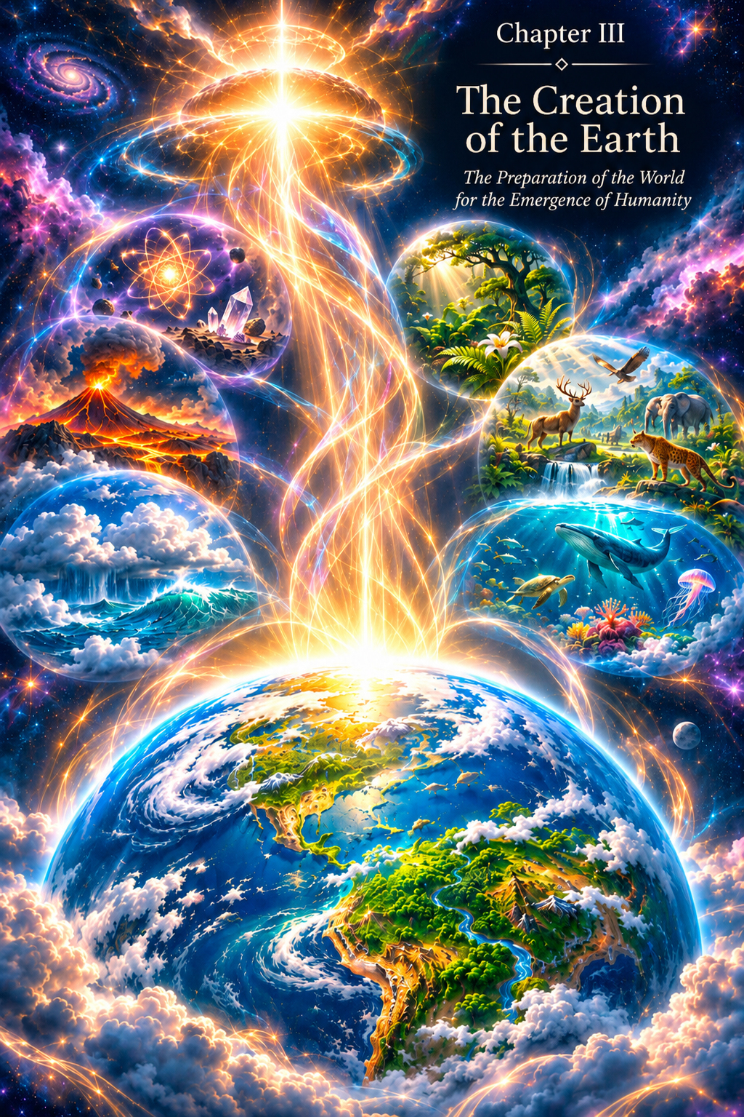
CHAPTER III
The Creation of Earth and the Creation of the Human Being
Preparing the World for the Emergence of the Human Being
The Creator's Design required a special world.
Not simply another planet among countless worlds and civilizations, but a space in which the energies of different forms of life could meet, interact and one day be united within the Human Being.
Such a world could not arise merely as a place to inhabit.
It had to become an environment of formation.
A school of experience.
A space of free choice.
And, at the same time, a living system capable of gradually preparing the human form to receive ever higher states of consciousness.
Earth was created not only so that the Human Being could live upon it. It was to become the place of human becoming.
“In the Beginning Was the Word”
In many ancient spiritual traditions, Creation is understood not only as the appearance of fully formed matter, but also as the manifestation of a Design that precedes it.
The Gospel of John says: “In the beginning was the Word, and the Word was with God, and the Word was God” (John 1:1). It then says: “All things were made by him” (John 1:3).
In the metaphysical interpretation offered by this book, the Word is understood not as an ordinary physical sound, but as the primary principle through which the Design becomes manifest.
It is the original Design.
Information.
The Image of what is to be brought into manifestation.
Before a form appears, the possibility of that form exists.
Before a world is created, there is a design for that world.
Before the Human Being appears, there is a design for the Human Being.
Thus Creation begins not with matter as the ultimate cause, but with information that gradually acquires material expression.
First comes the Design. Then comes a form capable of receiving it.
The Days of Creation
The biblical account of the Creation of the world unfolds through a succession of days (Genesis 1:1–31; 2:1–3).
But the human day arises only where Earth, its rotation and the familiar human means of measuring time already exist.
Therefore, in this book, the days of Creation are not understood as literal twenty-four-hour days on Earth.
They become an image of successive stages.
Each stage prepares the conditions for the next.
First, space.
Then matter.
Then an environment.
Then life.
Then increasingly complex forms of life.
And only after that, the human form.
This order corresponds to one of the fundamental principles of Creation:
A new form appears when the space is already capable of receiving it.
Time as a Condition of the Material World
To a human being, time appears absolute.
We are born.
We grow.
We age.
We observe the succession of events.
One thing happens before another.
But in the system of this book, time is associated primarily with the material, three-dimensional world.
It is here that a change of form requires a sequence.
A seed and a mature tree cannot exist simultaneously in the same physical state.
A house cannot be built before its foundations.
A new level of energy cannot be incorporated into a form that has not yet been prepared.
Time therefore becomes one of the conditions of earthly experience.
It allows Creation to unfold in stages.
Time gives material form the opportunity to become ready for what it is not yet capable of receiving.
Earth as a Special Environment
In physical terms, Earth brings together many conditions that have made life as we know it possible.
Matter had to be stable enough for complex structures to form.
Temperatures had to permit the prolonged existence of liquid water.
The atmosphere had to help sustain an environment suitable for developing life.
The Sun's energy had to provide one of the principal energy flows sustaining Earth's biosphere.
Gravity had to be one of the factors determining the structure of the planet, its atmosphere and the conditions in which living organisms exist.
Yet physical parameters are only part of what the Design requires.
Earth was to become a place where matter would gradually acquire the capacity to interact with life, and where life would become an increasingly complex bearer of experience.
The planet therefore appears here not as a motionless stage.
It participates in the process of Creation itself.
The Living Earth
Earth changes together with life.
Living organisms transform the atmosphere, soil, water and one another.
Each new form of life enters an existing system and changes it at the same time.
In this sense, life is not simply placed on the surface of the planet.
It becomes part of Earth's continuing transformation.
What is created at one stage becomes a condition for the next.
Earth prepares life, and life continues to prepare Earth.
The Plant World
One of the most important stages is the development of the plant world.
A plant brings together the matter of Earth, water, air and the energy of light in a living process.
Rooted in the material world, it is nevertheless capable of growing, responding to its surroundings, reproducing and transforming the space around it.
In the narrative logic of this book, the plant world becomes one of the most important elements of the system through which the planet continues to change.
Photosynthetic life takes part in transforming the atmosphere; later, plants become a vital part of that planetary exchange.
It produces organic matter.
Changes the soil.
Becomes the foundation of future food chains.
And at the same time demonstrates a fundamental principle of life:
Life does not merely consume its environment. It transforms that environment so that new forms of life may emerge.
The Animal World
Another line in the increasing complexity of life brings a growing capacity for active movement and behaviour within the environment.
A living creature is no longer tied to a single point in space.
It must search for food.
Avoid danger.
Find its way.
Distinguish what is beneficial from what is harmful.
As movement develops, interaction with the surrounding world becomes more complex.
Sense organs emerge and develop.
The nervous system.
Mechanisms of coordination.
Memory.
Learning.
The living organism gains an ever more complex interface for interacting with material reality.
In this way, the biological foundation of future human experience gradually takes shape.
Prehistoric Human Beings Before Adam and Eve
In the author's metaphysical account, the prehistoric human being of the Palaeolithic, or Stone Age, occupies a place among the major forms of animal life. This being became the prototype of modern humanity, but was not its biblical progenitor.
Prehistoric humanity was a crucial link in the creation of the Human Being.
Through this stage, the physical form intended for the biblical Human Being was adapted to life on planet Earth.
The structure of the physical body was refined.
The shape and proportions of the limbs were developed, together with the transition towards upright movement that distinguishes the human form in this account.
Through the prehistoric struggle for survival, the nervous system was refined and the instincts necessary for survival in the prepared natural environment were formed. These developments prepared the future model of the biblical Human Being, beginning with Adam and Eve.
The form adapted to gravity.
Solar radiation.
Temperature.
The composition of the atmosphere.
The biological environment.
Nutrition.
Microorganisms.
And many other conditions.
Through prehistoric humanity, the physical form was honed: the grace and mechanics of movement, the skeletal and muscular structure, and above all the central and peripheral nervous systems, which regulate the activity of the body's organs.
The functioning of the internal organs was refined.
The senses were further developed, preparing the future representative of the highest form of being on this planet.
What, then, distinguishes the prehistoric human being?
Above all, the structure of the bodies.
In the author's supposition, prehistoric humanity, like the animal world, possessed only the Physical and Etheric (energetic) Bodies.
The first was necessary for physical manifestation in the world created by the Creator.
The second provided energetic support and protection for the physical form.
In the event of injury or damage to the physical body, the energetic body immediately began to act.
Figuratively speaking, it “patched” the breaches caused by injury, seeking to preserve the integrity and life of its bearer.
The modern Human Being, created in the Image and Likeness, differs significantly in the structure of the bodies.
The prehistoric human being is not the biblical Human Being.
The biological preparation of the form and the creation of the biblical Human Being are not the same event. (This subject is examined in more detail in Chapter XI, “Was Darwin Right About the Evolution of the Human Being?”)
The World of Instinct
Instinct is not a sign of imperfection.
At a certain stage it is a perfect instrument.
To preserve its physical form, a living creature does not need to analyse every threat intellectually.
Its response must be immediate.
Hunger prompts the search for food.
Pain teaches avoidance of injury.
Fear helps preserve life.
Sexual desire ensures the continuation of the species.
Maternal instinct protects offspring.
Thus the necessary foundation takes shape.
Yet an instinct-driven human being remains almost entirely bound to the immediate event.
It responds to what is happening now.
For this reason, the Etheric level can be compared, figuratively, with the simplest dimension of consciousness: a direct line from stimulus to response.
This is not a statement about the physical one-dimensionality of space, but an image of a condition of energetic balance.
Event → Response → Preservation of Life.
The Early Human Being
At an early stage, the Human Being lives primarily through the body.
The world is immediate.
There are no complex philosophical systems.
No investigation of the causality of the Universe.
No sophisticated models of the future.
The being is learning the very fact of earthly existence.
Learning to move through the world.
To use the hands.
To find food.
To recognize danger.
To live in a group.
To care for offspring.
To adapt to the climate.
To make use of the simplest possibilities offered by the environment.
This stage may seem primitive only from the perspective of modern humanity.
Yet without it, everything that followed would have been impossible.
The physical form of the future Human Being had to become stable and complete.
Then came the time for the creation of the Human Being in the Creator's Image and Likeness: Adam and Eve.
The Structure of the Bodies of the Biblical Human Being
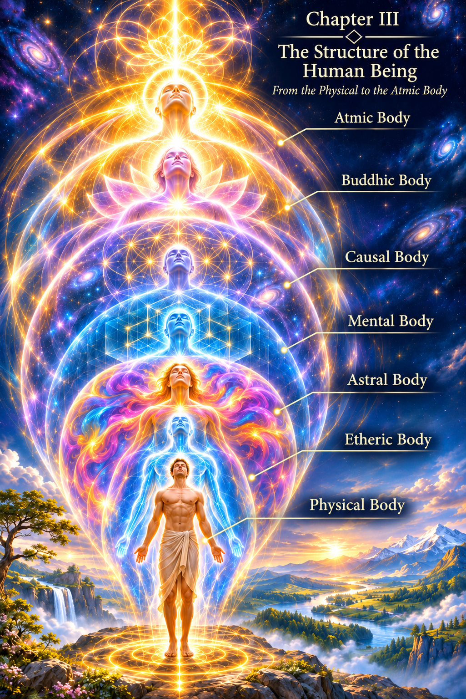
To understand the difference between the divine Human Being and prehistoric humanity, we need to consider the entire structure of the human bodies together.
The lowest level is the Physical Body.
1. The Physical Body
The Physical Body is the foundational level: the basis for receiving Spirit and Soul, the energies contributed by representatives of other civilizations, and the successive incorporation of other energetic bodies corresponding to stages in the development of consciousness.
It is upon this foundation that the structure of the Human Being develops—from the creation of Adam and Eve to Heavenly Adam, the highest form of harmonization of human nature within Divine Reality.
The Physical Body is the temple of the Soul.
It is an essential condition for human development.
Through it, the Human Being experiences contact with the material world.
It is a spacesuit for the Soul's earthly experience and the expansion of human consciousness.
It gives the unique ability to see and feel every aspect of material life in all its diversity.
The Physical Body is the necessary foundation of the future Human Being, together with the other energetic bodies incorporated into it.
Purpose
The Physical Body is the fundamental basis of earthly experience.
It is not merely a biological machine, but a spacesuit and temple for Soul and Spirit, created to interact with the dense world.
Its main purpose is to allow eternal consciousness to experience limitation.
Only within a dense form governed by the laws of space and time can there be a genuine choice that demands effort and the overcoming of obstacles.
Without a Physical Body, the Soul could not touch the material world, feel its resistance or become aware of its separateness, and then voluntarily return to Unity.
Properties
• Density and Locality. The Human Being exists at one point in space and time. This teaches the value of the present moment and the importance of being here and now.
• Sensory Interface. The body is a kind of antenna receiving signals from the material world—light, sound, temperature, pressure and pain. It translates physical interactions into sensations accessible to awareness.
• Fragility and Mortality. The body's limited resources—aging and illness—are powerful incentives for development. Awareness that earthly life is finite leads the Human Being to search for meaning and make responsible decisions. Yet, in the author's conception, this boundary disappears with the incorporation of the Causal Body, the Body of Reason, because the Human Being's relationship with space, time, energy and physical form changes.
• Biological Matrix. The body contains the genetic code, ancestral memory and reflexes contributed by representatives of different civilizations.
The body limits the Human Being—and precisely for that reason creates the unique conditions of earthly experience.
The Physical Body is the initial, low-vibrational level.
2. The Etheric Body
But physical form alone is not enough.
Matter by itself is not yet intelligent life.
In the system of this book, the next level is associated with the Etheric Body.
The Etheric Body sustains the vitality of the physical form.
It is connected with the organization of the inner energy of life, restoration, instinctive processes and the organism's ability to preserve itself.
At this stage, the Human Being does not yet possess a developed emotional or intellectual world.
The central task is simple and fundamental:
To live.
This is why the early Human Being is oriented first and foremost towards immediate existence.
Food.
Safety.
Warmth.
Reproduction.
Protection of offspring.
Response to danger.
The being lives primarily here and now.
Purpose
The Etheric Body is the “energetic double” of the Physical Body.
It is a bridge between dense matter and the higher levels of the human system.
If the Physical Body is an instrument, the Etheric Body is the energy that enables that instrument to function and maintain life.
Its task is to ensure the survival of the form in the material environment, preserve the integrity of the organism and connect the Human Being with the life force of the planet.
Different spiritual traditions have given this vital energy different names, including *prana*.
Properties
• Life Force. At the energetic level, it sustains biochemical processes, regeneration, breathing and the heartbeat.
• Instincts. It governs the basic programmes of survival: self-preservation, the search for food, reproduction and protection of territory.
• Energetic Circuit. It links the Physical Body to the energetic field of Earth and the cosmos, providing for the circulation of vital energy through meridians, or etheric channels.
• Connection with the Nervous System. It mediates between physical sensations, such as pain and warmth, and the organism's primary responses.
The Etheric Body is the guardian of life. It does not think or feel, but makes the very capacity for thinking and feeling possible.
The Nervous System: An Interface of Experience
The development of the nervous system becomes especially important for the future Human Being.
The material world acts upon the physical body.
Light reaches the eye.
Sound reaches the ear.
Temperature is perceived by the skin.
Injury gives rise to pain.
Smell and taste help distinguish substances.
Yet an external event alone is not enough to become experience.
It must be perceived.
The nervous system becomes one of the principal biological mediators between the effects of the external material world and the inner responses of the living organism.
External World → Sensation → Inner Response → Experience.
Through this interface the future human form can receive an immense amount of information about the material world.
3. The Astral Body
The Astral Body is a unique energetic envelope responsible for sensory and emotional experience. This experience is acquired and expanded throughout the human life journey: through interactions with the environment, relationships with others, emotions and feelings, awareness of one's abilities and desires, attachments and, in the author's account, interaction with natural phenomena.
In the metaphysical understanding of this book, ancient priests and spiritual practitioners who mastered this level of energy could, through particular states of feeling, interact with the forces of nature and turn towards Divine Reality.
The Astral Body is an immense ensemble of feelings: from Love to hatred, from pleasure to suffering, from desire to rejection.
Like the previous two levels, the Astral Body belongs to the low-vibrational part of the human structure.
For this reason, according to the book's conception, its development does not require special preparation of the Physical Body. That body is initially ready to receive it. Contact with manifestations of the material world is sufficient for the new level of emotional experience to unfold.
This, in my interpretation, is precisely what happened to the ancestors of humankind, Adam and Eve.
After Eve tasted the forbidden fruit, the Astral Body became active within the human system.
Sensory awareness opened immediately.
The taste of the fruit became not merely a physical registration of a substance, but an experience.
A whole ensemble of processes in the Physical Body was set in motion.
The sense organs.
The nervous system.
The internal organs.
And after the immediate sensation came new inner states.
Adam and Eve
The biblical account of Adam and Eve contains an image corresponding to this transition.
Before tasting the fruit, Adam and Eve “were both naked … and were not ashamed” (Genesis 2:25).
After tasting it, “the eyes of them both were opened, and they knew that they were naked” (Genesis 3:6–7).
They become aware of their own nakedness.
Then come fear, the desire to hide and a new awareness of their nakedness (Genesis 3:8–10).
A new relationship with themselves and with each other appears. This is explored in greater detail in Chapter IV, “Adam and Eve.”
It is here, without replacing the theological meaning of the biblical text, that I see a symbolic threshold essential to the architecture of *The Creation of Earth*.
Physical form already exists.
Life exists.
Instincts exist.
But now a space for feelings begins to open within the Human Being.
The Creation of Earth prepared the body. The story of Adam and Eve opens the next stage: the incorporation of the Human Being's sensory-emotional body, the Astral Body.
Purpose
The Astral Body is a unique energetic envelope of emotional experience.
If the Etheric Body is responsible for survival, the Astral Body is responsible for the quality of the experience of life.
It is the space in which emotions, desires, attachments and aversions arise.
Through the Astral Body the Human Being learns to distinguish states.
Through pain and pleasure.
Love and hatred.
Attraction and rejection.
The Human Being begins to understand what brings joy and what causes pain, and takes the first steps towards conscious choice.
Properties
• Emotional Spectrum. All kinds of experiences arise here: attraction—Love, affection, tenderness, delight, desire and care; rejection—hatred, anger, disgust, envy and contempt; fear and protection—apprehension, anxiety, terror, panic and jealousy; suffering—resentment, melancholy, grief, the pain of loss and guilt; social feelings—shame, pride, vanity and a sense of duty.
• Polarity. The Astral Body operates through duality: pleasant/unpleasant, I want/I do not want, attraction/rejection. It knows no middle ground.
• Resonance. Feelings pass from person to person. The Astral Body can attune itself to the vibrations of other people or of nature.
• Energy of Desire. This is where the impulse to act arises—passion, inspiration and motivation.
The Astral Body is the Soul's compass. It does not provide a map, but points towards the direction in which the necessary experience may be gained.
Yet the Astral Body alone does not determine the moral quality of an action.
A feeling arises.
An action is chosen.
4. The Mental Body (the Body of Creation)
If the Astral Body enabled the Human Being to experience the world, the Mental Body gave the Human Being the ability to understand and transform it.
In the metaphysical system presented here, the purpose of the Mental Body is to fulfil three principal tasks.
Understanding the Laws of the Material World. The Human Being had to learn how matter, time, space and causality are structured in order to cease being a passive victim of the elements.
Transformation of Reality. The Creator made the world, but the Human Being was given the right to continue Creation within it. The Mental Body is the instrument that makes it possible to combine what already exists into forms that do not occur in nature, from a stone axe to a spacecraft.
Formation of Personality and Individuality. The Mental Body allows the Human Being to recognize a separate “I,” capable of thinking, choosing, analysing and accepting responsibility for decisions.
The Mental Body is a bridge between the world of feelings and the world of forms. It translates invisible Images into material objects.
Properties of the Mental Body
Unlike the preceding bodies, which are more closely associated with natural and biological processes, the Mental Body possesses unique qualities absent from earlier levels.
A. Discreteness and Logic
While the Astral Body perceives the world as a whole and emotionally, the Mental Body divides the world into parts in order to understand it.
It enables the Human Being to:
Compare and classify.
Identify relationships of cause and effect.
Construct chains of reasoning.
Create models.
B. The Capacity for Abstraction
The Mental Body allows the Human Being to think about things that are not directly before the eyes:
Mathematics.
Philosophy.
The future.
God.
The structure of the Universe.
It works with symbols and concepts.
It is here that language, writing and science, culture and religions emerge.
C. Creative Imagination
This is one of the most important qualities of the Mental level.
The Mental Body is capable of forming an inner Image, or Idea, that does not yet exist in matter, and then finding a way to embody it.
First the architect sees the building in the mind.
Then the engineer calculates its strength.
Only afterwards do the builders raise it in stone.
The Mental Body is the Soul's drafting workshop.
D. An Amplifier (Its Dual Nature)
The Mental Body is not the source of morality. It is a powerful instrument that amplifies what already exists in the Astral Body.
If fear lives in the feelings, the Mental Body creates weapons and systems of surveillance.
If Love lives in the feelings, the Mental Body creates medicine, art and protection.
If pride lives in the feelings, the Mental Body creates ideologies of superiority.
This is why a high IQ or extensive knowledge does not make a person spiritually mature. Intellect determines the speed and power of information processing, but the direction of that processing depends on the level of human consciousness.
E. The Accumulation and Transmission of Experience
The Mental Body allowed the Human Being to reach beyond the duration of a single physical life.
Through books, writing, education and culture, knowledge accumulates and is passed down to descendants.
Thus civilization arose.
The Limits of the Mental Body: Why Is the Next Step Necessary?
Despite all its power, the Mental Body has a fundamental limitation, described throughout this book.
It answers the question:
“How can this be done?”
But without the development of Reason, it cannot fully answer another question:
“Should this be done?”
Intellect can split the atom, but it cannot foresee all the consequences of that knowledge for humanity.
The Mental Body sees the immediate result, but often not the more distant consequences. It works with linear causality—cause → effect—but cannot encompass the entire multidimensional structure of events.
It is here that the need for the transition to the Causal Body, the Body of Reason, arises.
Reason is the capacity to see causal relationships as a single structure, perceive consequences before they occur and harmonize one's actions with the whole.
The Era of the Mental Body and Its Completion
In the context of *The Creation of Earth*, the era of the Mental Body is an immense period of human history beginning after the Flood and continuing to the present day.
We live in the time of the Mental Body's final acceleration.
The appearance of Artificial Intelligence (AI) is the culmination of the development of the Mental level in its external, technological manifestation.
AI becomes an external instrument for working with the accumulated knowledge of humanity.
Yet this very acceleration reveals a limit: when the path from an idea to its realization is reduced to minutes, errors of thought can become immediate consequences in reality.
The speed of Creation begins to exceed the speed of awareness.
The Mental Body taught the Human Being to create. The next step must teach responsibility for what has been created.
The Mental Body is not simply the “mind” in the everyday sense. It is a magnificent instrument given by the Creator so that the Human Being may understand the world and continue Creation.
But like every instrument, it requires a mature master.
When the Mental Body is governed by lower emotions, it becomes destructive.
When it is harmonized and guided by Reason, it becomes the foundation for a new stage of human evolution.
The Mental Body is a high-vibrational body. Its incorporation requires the appropriate preparation of the Physical, Etheric and Astral Bodies and the fullest possible development of those levels.
Without physical readiness, the entire lower structure of the bodies may be destroyed.
The process of incorporating the Mental Body is described in more detail in Chapter V, “Noah and the Great Flood.”
5. The Causal Body (the Body of Reason)
Modern humanity stands on the threshold of a change—from the era of the Mental Body to the Body of Reason, the Causal Body.
In the author's interpretation, the events of the life of Jesus Christ provide a striking example of the manifestation of the Causal Body.
Christ and the Horizon of the Next State
During the earthly life of Jesus Christ, humanity witnessed events that, within the framework of this book, may be seen as demonstrations of the possibilities of a state far beyond modern Mental perception.
The casting out of evil spirits.
Healing.
The raising of Lazarus.
Christ's own Resurrection.
And finally, His Ascension in the body.
Yet it would be wrong to claim that Christ was merely a “bearer of the Causal Body.”
Christ is Divine and is a Teacher of humanity.
He cannot be confined to a single stage of human architecture.
Within this book, His earthly path reveals the nearest horizon of transformation available for humanity to contemplate.
To people of that time, many of the possibilities He revealed were incomprehensible and even frightening.
They went far beyond ordinary perceptions of the world.
This is why, after Christ's earthly ministry, the Apostles remained to continue revealing His Teaching.
The modern Human Being is at least capable of entertaining the possibility of a far wider state of Reality.
Our task is not, above all, to seek extraordinary powers, but to prepare our own human structure for a possible next transition.
It is not abilities that lead the Human Being to a higher state.
A higher state opens abilities.
The task of each person is to attain the greatest possible inner attunement and prepare for the transition ahead.
Purpose
The Causal Body—from the Latin *causa*, meaning “cause”—represents the next great transition.
If the Mental Body taught the Human Being to create, the Causal Body must teach the Human Being to see consequences and accept responsibility for them.
This is the Body of Reason.
Its purpose is to carry the Human Being beyond the three-dimensional world and linear time (3D + t), allowing life to be perceived not as a chain of random events but as a single hologram in which past, present and future are connected within one structure.
Properties
• Perception of Causality. The ability to perceive not merely a fact—what happened—but the root of an event, why it happened, and its consequences, what it will lead to.
• Multidimensionality (4D Perception). Time ceases to be a linear arrow. The Human Being gains access to events as a complete picture. In this state, clairvoyance and foresight—understood as reading information from the unified field—flourish, together with telepathy, teleportation and telekinesis.
• True Responsibility. The Human Being refrains from destruction not merely because it is forbidden, but because the person begins to see or directly perceive how an action enters the structure of causality and returns through its consequences to the individual and the Whole. This is an understanding of the law of Unity.
• Freedom from Material Dependence. Matter ceases to be the only condition of existence. The Human Being begins to recognize a multidimensional energy-information system within themselves, capable of interacting differently with space, time and physical form.
The Mental Body creates forms. The Causal Body sees how those forms will change the entire pattern of the Universe.
6. The Buddhic Body (the Body of the Soul and Intuition)
Purpose
The Buddhic Body—from the Sanskrit *buddhi*, associated here with awakening and intelligence—is the level at which the principal illusion of the three-dimensional world is overcome: the illusion of separateness.
If the Causal Body teaches the Human Being to see causal relationships and the consequences of choice, the Buddhic Body teaches the Human Being to feel and experience the unity of all that exists.
This Body is the dwelling place of unconditional Love, higher intuition and compassion.
Here the Human Being ceases to perceive themselves as a separate particle and begins to recognize themselves as part of the One Whole.
Properties
• Unconditional Love. This is no longer an emotion associated with the Astral Body, but a state of being: Love that demands nothing in return, divides no one into “us” and “them,” and does not depend on another person's actions.
• Identity of the “I” and the “Other.” The Human Being experiences another's pain as their own because the boundary between “I” and “you” disappears. To hurt another is to hurt oneself.
• Knowledge from the Information Field. Direct, instantaneous reading of truth without chains of logical reasoning. The Human Being simply knows what is right because they resonate with the field.
• Perfect Compassion. The capacity for compassion and forgiveness without condemnation, and for seeing the Creator's spark in every being.
The Buddhic Body is not what the Human Being does. It is what the Human Being is: a state in which Love and Reason merge into one.
7. The Atmic Body (the Body of Spirit)
Purpose
The Atmic Body is the divine spark, the Atman itself.
It is the highest level, at which the Human Being is no longer a “separate being striving towards God.” The Human Being recognizes themselves as a direct manifestation of the Creator's Will.
Here the path of individual salvation comes to an end and the path of co-Creation begins.
Properties
• Unity Without Losing the Self. This is not a drop dissolving into the ocean and disappearing. It is a drop recognizing that it is the ocean while preserving the unique experience of its own path. The state of “I Am” means not the loss of personality but the discovery of its true, divine scale. The Human Being does not cease to be themselves: they become their authentic self.
• Absolute Freedom. This does not mean the freedom to “do whatever I want,” but freedom to be what one was originally created to be. The Human Being's will coincides completely with the Creator's Will, not because it is suppressed, but because both are in harmony. Like a stream flowing into a river, it does not lose its water but gains the power of a larger current.
• Attunement to the Rhythms of the Universe. The Human Being acts not from the ego but from the “breath of the Higher,” becoming a conduit of Creation in the material world. Actions cease to be a struggle and become a natural continuation of the Divine flow.
• Fullness of Knowledge. In this state the Human Being does not merely believe or suppose, but knows. Not through the intellect alone, but through the whole of their being, because consciousness is united with the Source of all knowledge.
The Atmic Body is not the end of the Human Being's path. It is the beginning of true service. The Human Being was created in the Image, but the path towards Likeness must be travelled through personal effort. When this path is complete, the Human Being becomes a living continuation of the Creator in the material world.
The culmination of the harmonization of the entire human architecture is Heavenly Adam.
Preparing the Human Body
In the system of this book, the human physical body is not regarded as an accidental shell detached from the entire preceding history of life on Earth.
It had to unite a vast number of capacities already prepared.
The ability to move.
To sense.
To distinguish the surrounding environment.
To maintain the stability of its inner state.
To recover.
To reproduce.
To transmit biological information.
To learn.
To remember.
Yet the primary task of the human form was considerably broader.
It had to become the physical foundation for the successive incorporation of the subtle bodies.
The human body becomes more than an extraordinarily complex biological system. In the metaphysical architecture of this book, it is the earthly form of the multidimensional Human Being—the level through which the Soul receives direct sensory experience of the material world.
Why Could the Modern Human Being Not Be Created at Once?
If the final Design already existed, a natural question arises: why was the Human Being not created at once in the state in which they were ultimately intended to exist?
Because possessing a form does not yet mean being able to contain its contents in a stable way.
One can create a vessel, but if its structure is unsuited to the energy placed within it, the vessel will break.
Each new level of human architecture requires that the preceding levels be ready.
The physical form must learn to live before it can stably receive a complex emotional world.
Feelings must become part of human experience before Intellect gains the power to transform the surrounding reality.
Intellect must pass through its own school before the Human Being can approach Reason.
The Creation of the Human Being is not the instantaneous assembly of a finished creature. It is the gradual preparation of a form to receive ever higher energies.
The Principle of Incorporation
This principle becomes one of the central principles of human evolution in the author's metaphysical system.
Each succeeding body is not simply added to the preceding one.
It must be capable of being incorporated into the whole system that already exists.
The path can therefore be expressed as a simple sequence:
Incorporation → Experience → Harmonization → Readiness → Further Incorporation.
First a new energy enters the human system.
Then the Human Being receives experience through it.
Gradually learns to live with the new quality.
Harmonizes it with all the levels already present.
Only after that does the next transition become possible.
This is why the history of humanity is not a linear evolution of the Soul.
In the metaphysical system of this book, the Soul is eternal and does not undergo linear evolution in time. The Soul accumulates experience.
It is the form of the Soul's earthly manifestation that changes and is prepared.
It is not the Soul that must become “higher.” The Human Being in incarnation must gradually become capable of stably receiving and manifesting ever higher levels of their multidimensional nature.
The Physical Body is not discarded as an unnecessary shell: it, too, is part of this journey of transformation.
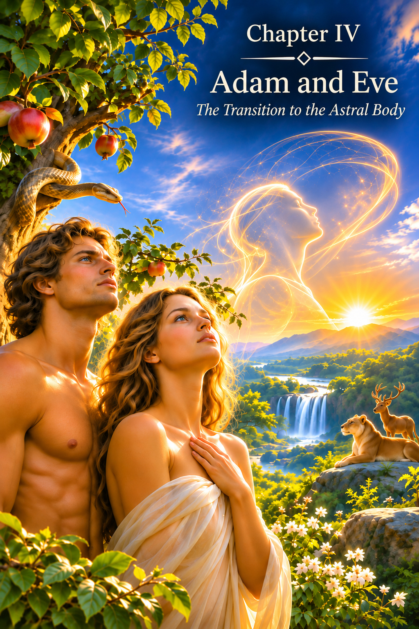
CHAPTER IV
Adam and Eve
The Transition to the Astral Body
By the time of the events associated with Adam and Eve in the biblical narrative, the human physical form had already undergone a long period of preparation.
The Human Being had learned to exist in the material world. The body was adapted to Earth's environment. The Etheric Body sustained the processes of life, while instincts helped preserve life, seek food, avoid danger and continue the human line.
But this was not enough for further development.
The Human Being was already alive.
Now the Human Being had to learn to feel.
Adam and Eve Are Not the Beginning of Biological Humanity
In the system presented in this book, the story of Adam and Eve does not signify the appearance of the first two biological beings on Earth.
By that time, the human physical form may already have existed for a very long period. It had developed, adapted to its surroundings and gradually become capable of receiving a higher energetic level.
Here, Adam and Eve are not merely a symbol of a great transition. They are the first representatives of the biblical Human Being, created by God in His Image and Likeness.
The biological form had been prepared earlier. Yet it is precisely with Adam and Eve that the history of a special Divine Creation begins: the Human Being capable of progressively incorporating the multidimensional structure laid down in the Design.
Adam and Eve mark the boundary between a human being whose life was governed primarily by physical needs and instincts, and a Human Being capable of experiencing both their own feelings and the feelings of another.
Adam and Eve represent the birth of the Human Being's experience of emotional and sensory states.
The Fruit of Knowledge
In the biblical narrative, the turning point comes after the fruit of the tree of the knowledge of good and evil is eaten.
Before this, Adam and Eve are naked and feel no shame. After eating the fruit, their eyes are opened, they become aware of their nakedness and try to cover themselves.
This detail has particular significance.
The physical body itself did not change in an instant.
What changed was the perception of the body.
For the first time, the Human Being saw themselves not only as a living creature, but as a separate “I” who could be seen by another.
A relationship to oneself emerged.
A relationship to another emerged.
Experience became an inner feeling.
Shame is no longer an instinct.
It is an emotional state.
The biblical image of their eyes being “opened” can therefore be read as a symbol of a new space opening within the Human Being.
The Human Being begins not only to see the world, but to experience their own relationship with the world and with themselves.
What Happened after the Fruit Was Eaten
We cannot know what specific physical event may have lain behind the ancient image of the fruit.
Perhaps the tradition preserved the memory of a real change in human nature.
Perhaps the fruit is only a symbol of transition.
Perhaps the image conceals an event whose language has been lost.
For the logic of this book, what matters is not the mechanism but the result.
The human form had become ready to receive the Astral Body.
From this moment, a new world enters human life: the world of emotional states.
What had once been only an external event now becomes an inner experience.
The Birth of the Astral Body
The Astral Body opens the world of feelings to the Human Being.
Love.
Attachment.
Tenderness.
Shame.
Fear.
Jealousy.
Envy.
Anger.
Resentment.
Compassion.
Grief.
Joy.
The Human Being receives an immense new world.
This world cannot be seen with the eyes or touched with the hands, yet it gradually comes to shape a great many human actions.
Previously, danger triggered an instinctive reaction.
Now a human being can fear something that has not yet happened.
Previously, procreation was a biological mechanism.
Now there arises love for another person, attachment to a child, fear of loss and the pain of separation.
Previously, another human being was part of the surrounding environment.
Now that person becomes a source of love, joy, jealousy, hatred, compassion and pain.
With the Astral Body, the world begins for the first time to exist not only around the Human Being, but within them.
Expulsion from Paradise
Traditionally, the expulsion of Adam and Eve from Eden is understood primarily as punishment for breaking a prohibition.
Within the framework of this book, another interpretation is possible.
The transition to a new level of consciousness inevitably changes the very existence of the Human Being.
Before the emergence of a developed emotional world, life may have been considerably simpler.
Without deep attachment, there is no fear of loss.
Without a sense of personal dignity, there is no humiliation.
Without love, there is no pain at the death of someone beloved.
Without awareness of another, there is no jealousy.
Yet one cannot experience love while excluding the possibility of suffering.
One cannot experience the joy of reunion without opening oneself to the pain of separation.
One cannot learn compassion without knowing what pain is.
Thus, departure from Eden can be seen as more than an expulsion.
It is a departure from a state of emotional innocence.
The Human Being leaves a world in which they merely live and enters a world in which they experience their own life.
Love
One of the greatest gifts of this new state is love.
Love cannot be reduced to the instinct of reproduction.
Instinct demands procreation.
Love creates an emotional bond.
The Human Being begins to perceive another not merely as a biological partner, but as someone whose existence has value in its own right.
A desire arises to be close.
To care.
To protect.
To share joy.
To feel another's pain.
Together with love comes the possibility of loss.
That is why love becomes one of the most powerful sources of human experience.
Motherhood
The birth of a child existed as a biological process even before the development of the human emotional world.
But the Astral Body changes its inner meaning.
A mother does not merely preserve her offspring.
She experiences the child as part of her own life.
An emotional bond arises that may be stronger than the instinct of self-preservation.
For the first time, the Human Being receives the experience of a love in which the value of another may be placed above personal safety.
This is an extraordinarily important step.
For it is precisely through such states that the boundaries of the “I” begin gradually to expand.
Cain and Abel
But the new body brings more than love.
The biblical story of Cain and Abel reveals another side of the emotional world.
Cain experiences a state that leads him to kill his own brother.
Envy.
Resentment.
Jealousy.
Anger.
For the first time, the Human Being faces a new inner danger.
Now it is not only an external predator or the surrounding environment that can bring about destruction.
The source of destruction can arise within the person themselves.
And here a fundamental condition of further development appears: Freedom of Choice.
The Human Being cannot always choose the first feeling that arises.
But gradually they must learn to choose what to do with that feeling.
A feeling arises. An action is chosen.
Feelings as the School of the Human Being
If the task were simply for a person to experience pleasant states, there would be no need for the vast palette of the Astral Body.
But the task is to acquire experience.
Love teaches openness.
Fear reveals the limits of inner freedom.
Jealousy exposes the desire to possess another person.
Anger reveals a reaction to an obstacle or to pain.
Resentment holds a person in the past.
Compassion makes it possible to experience the state of another.
Every feeling becomes material for the consciousness of the future.
Yet a feeling alone does not make a person better or worse.
What matters is what the person does with it.
Two people may experience the same loss.
One becomes cruel.
The other becomes compassionate.
The event is the same.
The experience gained is different.
It is not the event that determines the development of the Human Being. It is what the Human Being makes of what has been experienced.
Freedom within Feeling
At the early stages of Astral development, a feeling almost completely takes possession of the person.
Anger becomes action.
Fear becomes flight.
Desire becomes the urge to obtain immediately what one wants.
Jealousy becomes a struggle for possession.
But gradually a space begins to emerge between feeling and action.
In that space, choice is born.
The Human Being begins to recognize:
“I feel anger, but I do not have to kill.”
“I feel fear, but I can choose not to flee.”
“I feel jealousy, but another person does not belong to me.”
This is not yet Reason.
But it is a necessary preparation for Reason.
Freedom becomes possible only when the Human Being is able to recognize their own state without becoming completely absorbed by it.
The Astral Era
For an immense period of human history, it was the emotional world that shaped the development of society.
Fear of the unknown.
Reverence for the forces of nature.
Love for one's own kin.
Hostility toward outsiders.
Worship.
Sacrifice.
Heroism.
Revenge.
Devotion.
Religious ecstasy.
The Human Being was learning to experience an enormous spectrum of states.
Myths, rituals and the first complex forms of collective experience arose.
People came together not only for physical survival, but also around shared images, fears, hopes and beliefs.
Thus the Astral Body gradually became part of human nature.
But its development also created a new danger.
Why the Mental Body (the Body of Creativity) Could Not Be Given Immediately
The next level was to be the Mental Body: the ability to think, analyze, build complex models and transform the surrounding world.
But Intellect is a form of power.
It can multiply the capacities of the Human Being many times over.
If such power is given to a being completely governed by unharmonized feelings, Intellect will serve those feelings.
Fear will begin creating more sophisticated means of defense.
Greed will create more sophisticated means of accumulation.
Anger will create more sophisticated means of destruction.
The desire for power will create more sophisticated means of manipulating others.
Therefore, the transition to the Mental Body required a certain degree of mastery of Astral experience.
A higher energy does not abolish a lower one. It amplifies everything the Human Being brings with them.
That is why each new level requires the readiness of the structure that precedes it.
Preparing for the Next Transition
Gradually, humanity accumulated an immense experience of feelings.
It came to know love and hatred.
Loyalty and betrayal.
The joy of birth and the grief of death.
Compassion and cruelty.
Devotion and jealousy.
Fear and courage.
But a time came when emotional experience alone was no longer enough.
The Human Being had to learn not only to experience what was happening, but to understand it.
Not only to feel the world, but to investigate it.
Not only to react, but to form a Design.
Not only to live within nature, but consciously to transform it.
For this, the Mental Body was needed.
But its energy was already of a higher vibrational order.
Not every human form, with its nervous system, could withstand that new level.
And once again, a boundary approached.
A boundary beyond which humanity's former state could no longer continue unchanged.
In ancient memory, this boundary has been preserved as the story of the Great Flood.
Adam and Eve opened the world of feelings to the Human Being. Noah was to lead the Human Being toward the world of thought and creativity.
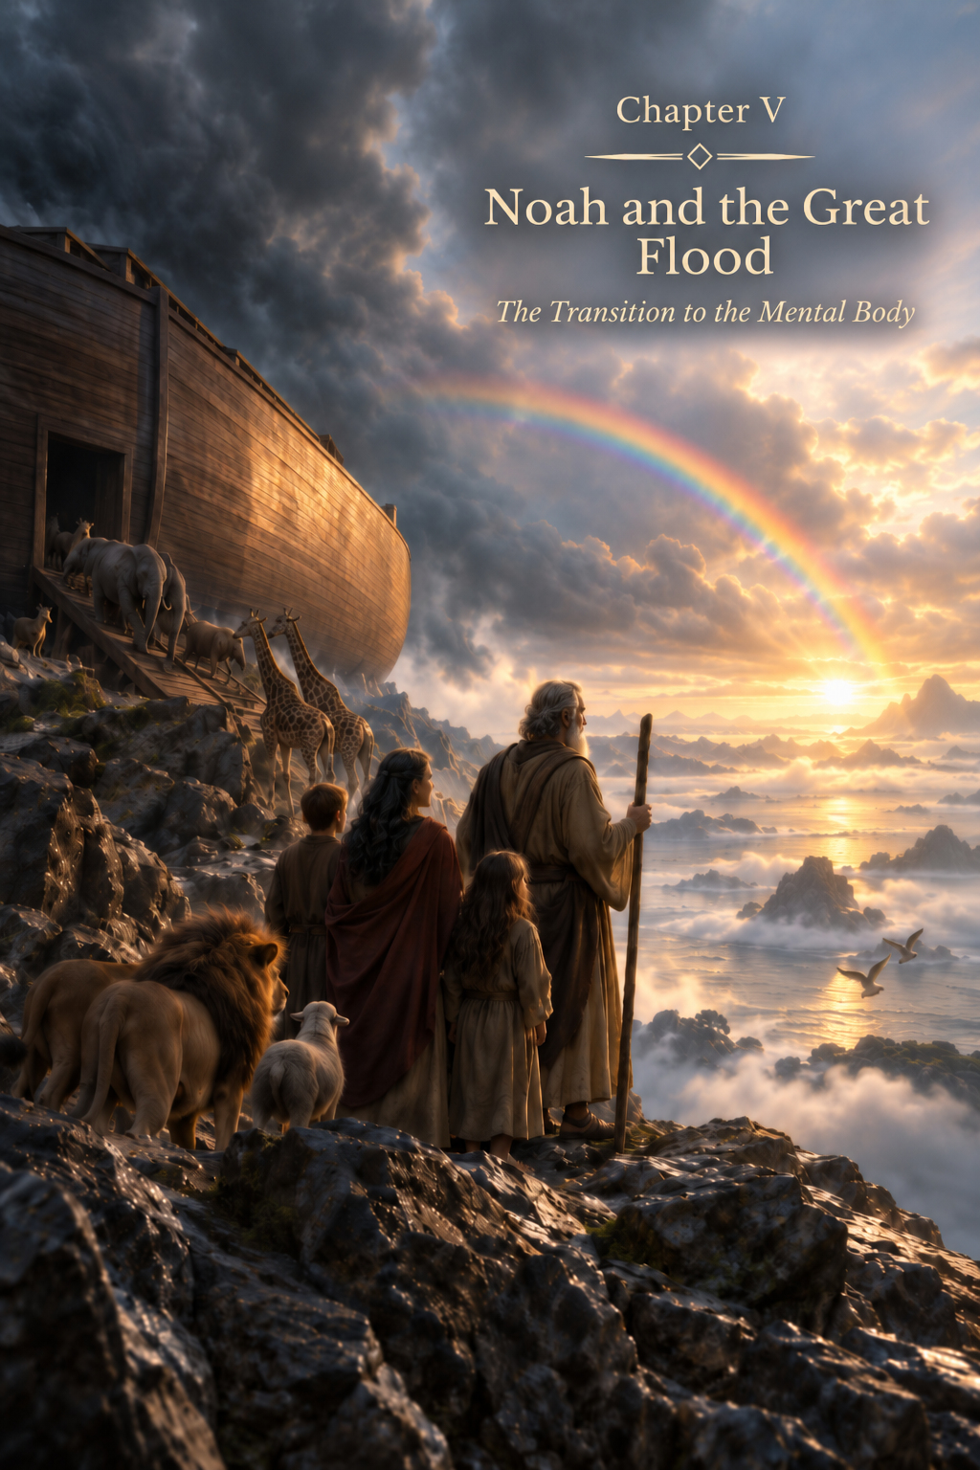
CHAPTER V
Noah and the Great Flood
The Transition to the Mental Body
The story of Adam and Eve opens in this book the age of the Astral Body — the age in which the Human Being learns to feel.
Love, jealousy, fear, compassion, anger, attachment, joy and grief become part of human experience. The Human Being no longer merely exists within nature. The Human Being experiences their own existence.
But development cannot stop at feelings.
A time comes when the Human Being must learn to understand what is being experienced, discern patterns in the surrounding world, form an inner image of the future and consciously transform matter.
For this, a new state is needed — the Mental Body, the Body of Creation.
And it is precisely at the threshold of this transition that the image of Noah and the Great Flood appears in humanity's ancient memory.
The Flood Is Not a Punishment
The biblical account of the Great Flood is traditionally associated with humanity's moral decline and God's judgment.
Within the metaphysical system of this book, the image receives another interpretation.
The Flood may be seen not as an expression of the Creator's wrath, directed toward destroying His own creation, but as the boundary between two states of the Human Being.
The previous human form had fulfilled its purpose.
The Physical Body had been formed.
The Etheric Body sustained its vitality.
The Astral Body opened the world of feelings and allowed humanity to accumulate an immense experience of emotion.
But the next stage required readiness for energy of a different level.
The arrival of this stage could not be postponed indefinitely.
The Creator does not punish the Human Being for not yet having become something different.
The time arrives when the form itself must be ready for its next state.
A New Energy
Each succeeding energetic body does more than add a new function.
It brings a higher energetic state.
The Etheric Body could be incorporated into a physical form prepared to sustain life.
The Astral Body required a form capable of containing the world of feelings.
The Mental Body was to open an entirely new capacity — thought and creation.
But thought, in the human sense, is not passive perception.
It makes it possible to perceive an image of something that does not yet exist.
To compare.
To remember.
To analyze.
To establish causal connections.
To choose among alternatives.
And, most importantly, to change the surrounding world consciously.
This is already an immense power.
Therefore, a form capable of incorporating the Mental Body had to be prepared not only physically, but also through the whole preceding history of its development.
Why the Transition Is Dangerous
Higher energy is not a reward.
It is a burden the structure must be able to bear.
If the structure is unable to sustain it, the new state does not develop that structure; it destroys it.
We have already encountered this principle.
One cannot build another storey when the foundation cannot bear its weight.
One cannot increase the voltage in a system indefinitely without changing the system itself.
Likewise, the human form had to reach a state in which the new energy could not merely be received for a moment, but could be incorporated and sustained.
Every new body must be preceded by the readiness of the form capable of receiving it.
Noah
It is at this point that Noah appears.
In the traditional narrative, he is distinguished from the people around him and is given the opportunity to save his family.
Within the system of this book, this may be understood as the image of a man whose physical and energetic structure was already prepared for the next transition. Moreover, Noah was a clear bearer of the Mental Body at the threshold between the ages.
Noah is not chosen because the Creator arbitrarily preferred one person over others.
He is the one through whom the human line can be preserved and continued in a new state.
This is a fundamental distinction.
Being chosen does not mean receiving a privilege.
It means readiness and responsibility.
Noah is preserved not because the Creator no longer has any need for other souls. Through him, a form is preserved that can continue the next stage of human development, having incorporated the higher-vibrational energy of the Mental Body.
Why the Family Is Preserved
Noah does not enter the Ark alone.
His family is preserved with him.
In biological terms, this ensures the continuation of the human line.
But within the logic of this book, the meaning is deeper.
The new age requires not the emergence of a single exceptional person, but the possibility of forming a new human generation.
One prepared form alone does not make a humanity.
A lineage is needed through which the new quality can become a stable characteristic of future incarnations.
Thus Noah's family becomes a bridge.
Through it, the human form continues to exist beyond the boundary marked by the Flood.
The Ark
The image of the Ark can likewise be understood as something greater than literal rescue from water.
The Ark preserves what must pass from the old world into the new.
After the Flood, humanity does not begin again from absolute nothingness.
Everything acquired before must be preserved.
The physical form.
Vital energy.
Instincts.
Astral experience.
The bond between generations.
The memory of the human journey.
The next stage does not destroy what came before.
It is built upon it.
The Ark becomes an image of carrying accumulated experience across the boundary between ages.
What Happens to the Others?
If the Flood marks a transition rather than a punishment, an inevitable question arises: what happens to those whose physical bodies cannot cross this boundary, who cannot receive this energy of a higher plane?
Within the system of this book, a distinction must be made between the Soul and the form of its earthly incarnation.
The Physical Body belongs to the material world.
It is born, changes and eventually disintegrates.
But the Soul is not confined to a single physical body.
It is part of the Creator and continues its journey beyond one earthly lifetime and in other spatial dimensions.
Therefore, the destruction of the former physical form does not mean the destruction of the Human Being.
The souls of those unable to pass through the transition in their former bodies are given the opportunity to incarnate again — now in human forms belonging to the new state. Noah's descendants already carry within themselves the seed of the Mental Body.
In this way, the acquired experience is preserved, while the instrument through which that experience continues is changed.
The Flood does not destroy the Soul. It brings to an end the existence of a form that no longer corresponds to the stage now beginning.
Not Punishment, but the Inevitability of Change
Here, one of the central laws to which we shall return more than once becomes particularly clear: the Inevitability of Change.
In the course of development, moments arrive that cannot be undone.
One may prepare for them.
One may resist.
One may try to hold on to what came before.
But the transition itself comes when its time arrives.
A child cannot remain a child forever.
A seed cannot remain a seed indefinitely once the process of growth has begun.
And humanity cannot remain permanently fixed in one energetic state.
The Human Being is free to choose how to pass through change. But the Human Being is not free to cancel change itself.
This does not abolish freedom.
Freedom exists within the Law.
The Human Being chooses an attitude.
Chooses an action.
Chooses the degree of their own readiness.
But the Human Being does not determine whether the development of Creation will continue at all.
Why Change Cannot Be Forced
The Inevitability of Change has another side.
Just as a transition whose time has come cannot be postponed indefinitely, it cannot be forced ahead of readiness without consequences.
Higher energy introduced into an unprepared structure can destroy it.
That is why Creation itself follows a sequence.
First, the foundation is formed.
Then it gains experience.
Then it is harmonized.
Only after this does the possibility arise of sustainably incorporating the next level.
We have already defined this sequence:
Incorporation → Experience → Harmonization → Readiness → Further Incorporation.
One cannot skip a stage without living through the experience for which it was created.
That is why humanity needed the long Astral age.
Feelings had to become part of the Human Being before the Human Being received an Intellect capable of multiplying the consequences of those feelings.
After the Flood
After the transition, a new stage begins.
The Human Being continues to feel.
But now there gradually emerges an ability to observe both one's own feelings and the surrounding world.
The Human Being begins to compare.
To notice repetition.
To remember patterns.
To pass on accumulated knowledge.
To form increasingly complex inner images.
Gradually, what will become the principal instrument of the new age is born — the Intellect.
If the Astral Body opened the question:
What do I feel?
Then the Mental Body adds:
What does it mean? Why is it happening? What can I do?
This is a fundamentally different level of interaction with the world.
Intellect
Intellect enables the Human Being to work with information.
It can receive information through the senses and other sources available to consciousness, retain it, compare it, analyze it and turn it into a decision.
The Human Being no longer needs to begin every experience anew.
The Human Being can remember.
Learn.
Pass knowledge to another.
Create a system.
Predict an outcome.
Choose the most effective option.
Thus begins the gradual movement from merely adapting to the surrounding world toward consciously transforming it.
But here it is necessary to draw an important distinction from the outset.
Intellect is not the source of information. It is the capacity to work with information.
It is rational.
It analyzes.
It generates alternatives.
It seeks a solution.
And it is this capacity that will open to the Human Being a world of Creation never before experienced on such a scale.
A New Danger
But with Intellect comes a new danger.
The Mental Body does not abolish the Astral Body.
The Human Being continues to love and hate.
To fear.
To feel jealousy.
To desire.
To seek power.
The difference is that these feelings now acquire an extraordinarily powerful instrument.
Anger armed with Intellect can create weapons.
Fear can build systems of oppression.
Greed can devise methods of limitless accumulation.
The desire for superiority can create mechanisms of control over others.
Yet that same Intellect, joined with love, curiosity and the desire to create, can build a home, compose music, develop a medicine and explore the stars.
The new body does not automatically make the Human Being better. It expands the space of freedom and increases the power of the consequences of choice.
The Mental Age
From this point begins an age in which humanity will gradually learn to build civilization.
Complex tools will appear.
Writing.
Mathematics.
Architecture.
Philosophy.
Science.
Art.
Technology.
The Human Being will investigate Earth ever more deeply and transform it ever more actively.
Humanity will learn to preserve knowledge so that the experience of one generation becomes the starting point for the next.
The pace of development will increase many times over.
But responsibility will grow alongside it.
For the ability to create inevitably raises the question of why something new is being created.
Every New Body Incorporates Those That Came Before
The transition after the Flood does not transform the Human Being into a purely Mental being.
The whole preceding history remains alive within the Human Being.
The Physical Body maintains the connection with the material world.
The Etheric Body sustains life.
The Astral Body continues to feel.
The Mental Body manifests thought and creation.
And further development depends not only on the strength of each level, but on their ability to exist together.
If Intellect is entirely subordinated to fear, it amplifies fear.
If feelings are separated from an understanding of consequences, they continue to govern actions.
If physical desires become the sole purpose of Intellect, civilization turns all its knowledge into a means of satisfying material needs.
The task ahead is therefore not to displace the lower bodies.
It is to harmonize them.
The evolution of the Human Being is not the replacement of one body with another, but a gradual expansion of the capacity to incorporate an ever more complex whole.
From Feeling to Thought
Thus, within the system of this book, the Great Flood becomes not a story about the end of humanity, but a story about its continuation.
One form of existence comes to an end.
Another begins.
Astral experience does not disappear.
It becomes the foundation upon which thought begins to develop.
The Human Being, who previously experienced the world primarily through feelings, now gains the possibility of investigating it.
The Human Being no longer merely fears thunder.
The Human Being begins to ask why thunder occurs.
No longer merely rejoices at the harvest.
The Human Being tries to understand what the harvest depends upon.
No longer merely looks at the stars.
The Human Being begins to seek patterns in their movement.
The question “What do I feel?” is gradually joined by the question “Why?”
And with this question, a new human age begins.
Noah carries not only human life through the Flood. He carries the Human Being to the threshold of thought and a new era of humanity's development.
Before the Age of Creation
The Mental Body will give the Human Being a capacity that had never before existed on such a scale.
The Human Being will be able to form an image of the future within consciousness and embody it in matter.
Earth will become not only a home, but a workshop.
Stone will become a tool.
Clay — a vessel.
Ore — metal.
Metal — a mechanism.
Observation — knowledge.
Knowledge — technology.
Thus, the Human Being will gradually begin not only to live within Creation, but also to participate in the creative process.
But with this power comes a new question, one that will eventually lead to the next threshold:
If I am capable of creating this, does it follow that I ought to create it?
Intellect alone will no longer be able to answer that question.
But first, humanity had to pass through the whole great age of the Mental Body — the age of Intellect and Creation.
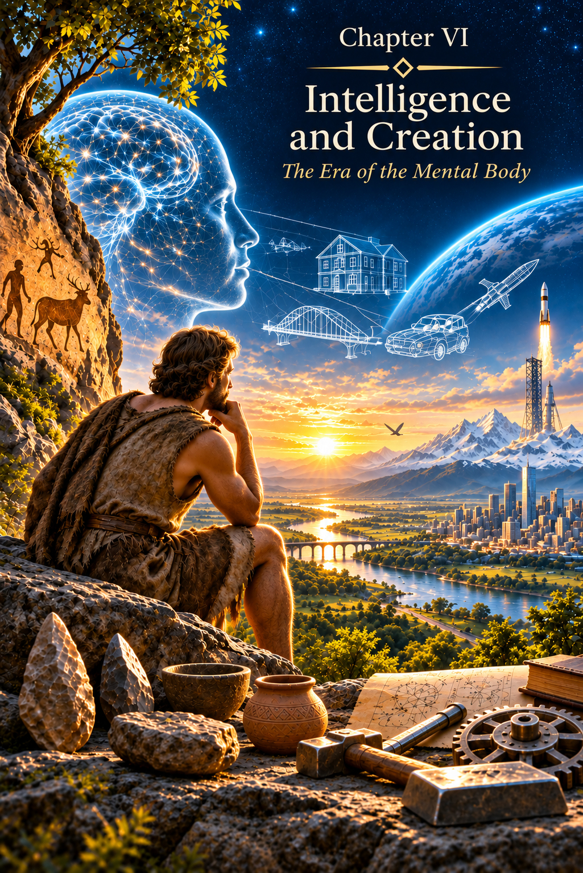
CHAPTER VI
Intellect and Creation
The Age of the Mental Body
After the transition symbolically associated in this book with Noah and the Great Flood, a new realm of development opened before the Human Being.
The Physical Body enabled the Human Being to exist in the material world. The Etheric Body sustained life. The Astral Body opened up the immense world of feelings. Now the Mental Body was added to this system.
The Human Being had to learn not only to live and to feel.
The Human Being had to learn to think.
Yet the Mental Body brought more than the ability to reflect. It opened up a capacity that would gradually change the entire face of Earth: the ability to form within consciousness an Image of something that did not yet exist, and then to embody that Image in the material world.
Image → Idea → Intellect → Creation.
The Mental Body became the foundation of Creativity.
The Birth of Intellect
The principal instrument of the Mental Body is Intellect.
Intellect receives information, retains it, compares facts, discovers patterns, analyzes possible alternatives and proposes solutions.
It can process immense amounts of accumulated experience.
It compares.
Calculates.
Classifies.
Models.
Predicts probable consequences.
But Intellect is not itself the source of information.
This is fundamentally important.
High intelligence does not mean that a person automatically knows more than others or obtains knowledge from an unknown source.
Above all, it means the capacity to work rapidly and in complex ways with what has already become available to consciousness.
Intellect is the capacity to process information, analyze it and find possible solutions. It is rationality.
From Adaptation to Transformation
Before the development of the Mental Body, the human being primarily adapted to the world.
When it was cold, the human being sought shelter.
When a predator was nearby, the human being avoided danger.
When food ran out, the human being moved to a place where it was more abundant.
But gradually an entirely new principle emerges.
The Human Being no longer merely changes behavior in response to the environment.
The Human Being begins to change the environment in accordance with an Image arising in consciousness.
A stone becomes a tool.
Wood becomes a dwelling.
Clay becomes a vessel.
Fire becomes an instrument.
Ore becomes metal.
Metal becomes a plough, a weapon, a mechanism.
Nature ceases to be merely a habitat.
It becomes the material of Creation. The Human Being no longer merely gathers food — the Human Being produces it.
Earth — the Human Being's First Workshop
Here it is especially important to understand the role of Earth itself.
In the system of this book, Earth is not a lifeless storehouse of resources created for endless consumption.
It is a living entity and a direct participant in the Plan of Creation.
Like a mother who allows her child to discover the world through touch, movement and personal experience, Earth, as a living entity, enables the Human Being to discover the properties of matter through interaction with her.
She gives stone.
Wood.
Clay.
Ore.
Metals.
Water.
Fire.
Sources of energy.
Every material becomes a new lesson.
The Human Being discovers hardness and plasticity, heat and cold, conductivity and resistance, density and lightness, and the capacity of matter to combine, break apart and take on a new form.
Earth becomes the Human Being's first workshop.
She allows the Human Being to experiment with her own matter, so that the Mental Body may learn not only to perceive what the Creator has made, but also to continue the process of creating new forms.
The Body of Creation
This is precisely why the Mental Body cannot be reduced to logic.
If its task were only calculation, human civilization would look entirely different.
The Human Being can see inwardly what does not yet exist in the external world.
A house before it is built.
A bridge before it connects two banks.
A melody before it is heard.
A painting before the brush touches the canvas.
A mechanism before its components are made.
A theory before it takes its final form.
The primary Image may arise before rational understanding.
An Idea is born from the Image.
Then Intellect enters into the process and seeks to understand how that Idea can be realized.
It searches for materials.
Compares alternatives.
Checks calculations.
Corrects errors.
Establishes a sequence of actions.
Thus the Mental Body becomes a space in which the Image of the future can appear before its material embodiment.
The Human Being first creates inwardly what does not yet exist, and then invites matter to take the form of that intention.
From a Stone Tool to a Spacecraft
The entire history of material civilization may be read as the development of this capacity.
The first deliberately shaped tool was already more than a stone found in nature.
Nature created the stone.
But the Human Being created the form of the tool.
Thus began an immense journey.
From the stone hand axe to metal.
From metal to the mechanism.
From the mechanism to the machine.
From the machine to the most complex technological systems.
From observing the sky to the spacecraft.
Every new stage begins in the same way.
First an Image appears.
Then Intellect tries to understand how that Image can be embodied.
It searches for materials.
Calculates.
Corrects errors.
Develops alternatives.
And at last the inner Image becomes part of physical reality.
The Image Before Understanding
Yet human creativity reveals another remarkable feature.
Not every new Image arises from a sequential process of rational reasoning.
Sometimes a person first sees the solution and only afterward tries to understand why it is correct.
Sometimes an unexpected connection appears between phenomena that previously seemed unrelated.
Sometimes a complete Image arises before there is language capable of explaining it.
Sometimes the Human Being first sees what is not yet understood, and only later begins to search for words with which to explain it.
Here we must distinguish Intellect from Intuition.
Intellect and Intuition
Intellect and Intuition often go hand in hand in the process of Creation.
Intellect helps the Human Being understand an Image that has arisen, develop it into an Idea, find ways of realizing it and embody the intended result in the material world.
Intuition may accompany this process, suggesting a direction, affirming the correctness of the chosen path or warning that a decision needs to be changed.
They do not replace each other; they complement each other.
Intuition is a spontaneous inner feeling.
It may suggest:
Do not do it that way.
Or, on the contrary, do exactly that.
Do not go there.
Or, go there.
Cancel the meeting.
Change your decision.
Intuition may draw the Human Being's attention to a possible danger, loss or favorable opportunity.
It can provide an inner signal before Intellect finds a rational explanation for it.
But where does Intuition come from?
Why does the Human Being sometimes feel an entirely inexplicable inner unease when external circumstances offer no reason for it?
A person is preparing to set out on a journey.
Everything is ready.
The route is known.
There is no visible danger.
Yet suddenly a feeling arises that the journey must be cancelled.
Or, conversely, a person doubts a decision already made, while an inner feeling urges action.
In such circumstances Intuition can help the Human Being become more certain of a chosen decision or reconsider it.
One may heed the inner signal.
Or ignore it.
And here lies a fundamental feature of Intuition.
It does not make decisions for the Human Being.
It suggests or warns.
But it does not compel.
It does not take away Freedom of Choice.
And it does not necessarily explain the reason for the feeling that has arisen.
Intuition is not a form of Intellect.
Intellect relies on available information, acquired knowledge, experience, analysis and the identification of cause-and-effect relationships.
Intuition may manifest before the Human Being possesses the information required for a rational explanation.
Intellect asks:
Why?
On what grounds?
What evidence is there?
Intuition may offer no answers to these questions.
It simply prompts attention to a decision already made or to a possible outcome of events.
Here lies the essential difference between these two mechanisms of human perception.
They may interact, but they are not the same phenomenon.
Within the metaphysical system of this book, one possible source of Intuition is the experience of the Soul.
The Soul passes through many incarnations.
It accumulates experience.
It preserves what it has lived through.
And this experience does not necessarily become available to the conscious memory of the incarnated Human Being.
Yet it is possible that some portion of the accumulated information manifests as an inner feeling for which the Human Being can find no rational explanation.
Another possible source is the informational field of the Universe.
If informational space contains knowledge of ongoing processes and possible events, human consciousness may come into contact with information that has not yet become part of its immediate earthly experience.
At the same time, the inner feeling itself does not prove where the information came from.
Not every feeling of unease is Intuition.
Sometimes it may arise from fear, anxiety, previous experience or an unconscious perception of surrounding circumstances.
That is why Intellect retains its essential function.
It helps the Human Being distinguish.
Compare.
Verify.
Make a conscious decision.
But Intellect does not always possess all the information.
This is why human life contains a space for interaction between rational knowledge and intuitive perception.
They need not oppose one another.
Each has its own purpose.
Intellect discovers the laws of the material world and devises ways to transform reality.
Intuition may support the direction already chosen or warn that it needs to be changed.
Foresight makes it possible to perceive a possible course of events.
And the Image becomes the primary condition of the Creative process.
Image → Idea → Intellect → Creation.
Thus the Human Being's capacity to create should not be equated with Intuition.
Intuition does not create the Image in the Human Being's place.
It is not an obligatory stage between the Idea and its embodiment.
It performs a separate function, although it may accompany the Creative process.
Perhaps this very interaction reveals one feature of the multidimensional nature of the Human Being.
The Human Being can not only think.
But also perceive.
Not only analyze.
But also foresee.
Not only create.
But also receive inner signals whose origin cannot yet be explained.
Intellect opens the possibility of consciously transforming the material world. Intuition helps the Human Being find direction in making a choice. But the final decision always belongs to the Human Being.
For neither knowledge, nor warning, nor foresight can cancel the greatest gift the Human Being has received from the Creator — Freedom of Choice.
The Informational Field
Where do Images come from when a person cannot derive them through a sequential chain of reasoning?
There are different answers to this question.
Psychology may speak of the workings of the unconscious, accumulated experience, hidden processing of information and sudden insight.
The history of science and art contains many accounts of solutions that came unexpectedly — in dreams, at rest, during a walk or at a moment when conscious work on a problem had ceased.
Within the metaphysical system of this book, there is another supposition.
Consciousness may be capable of perceiving information that does not arise directly within a sequential rational process.
I call this space the informational field of the Universe.
This does not mean that every sudden Image necessarily comes from outside. Still less does it mean that a person should give up checking what has been received.
But the possibility of such perception helps explain an important distinction:
Intellect does not necessarily create the primary Image. Sometimes its task is to recognize, understand and embody what has already appeared in consciousness.
The Human Being Continues Creation
When the Human Being transforms matter in accordance with an inner Image, an entirely new function begins to unfold.
The Human Being does not create matter out of nothing.
The Human Being uses what already exists in the world.
But can combine existing things in a way that nature had not produced before.
Nature does not create a violin.
Or a cathedral.
Or a book.
Or a mathematical formula written in human language.
Or a spacecraft.
All the materials from which these are made already existed.
But their new organization appeared through human consciousness.
In this sense creativity becomes a continuation of the act of Creation within the material world.
The Creator establishes the possibility.
In absolute Freedom, the Soul chooses the experience it needs.
The Karmic Council shapes the course of events, while the incarnated Human Being lives through them without knowing the script.
Within these events, Intellect becomes the instrument through which an intention acquires material form.
Freedom of Creation
But the power to create brings a new responsibility.
The same metal can become a plough or a sword.
The same energy can warm a home or destroy it.
The same knowledge can heal a person or cause harm.
Intellect is capable of creating both possibilities.
For Intellect does not itself determine the goal.
It answers the question:
How?
How to build.
How to extract.
How to win.
How to increase.
How to accelerate.
How to obtain.
But another question exists:
Ought this to be done?
And this question already begins to lead beyond Intellect alone.
When Intellect Serves the Astral Body
A new body does not destroy those that came before it.
The Mental Body comes to a Human Being who already possesses the Astral Body.
Therefore Intellect may become the servant of feelings.
When fear governs a person, Intellect creates ever more elaborate systems of protection.
When greed governs, Intellect finds ever more efficient ways to accumulate possessions.
When hatred governs, Intellect creates more sophisticated weapons.
When the desire for power governs, Intellect develops more complex ways of controlling another person.
Here it becomes clear why high intelligence in itself is not a sign of a higher state of consciousness.
Intellect amplifies the state it serves.
A harmonized feeling gains in it an instrument of creation.
An unharmonized passion gains an instrument of destruction.
The Civilization of Intellect
Nevertheless, it was the Mental Body that created civilization as we know it.
Writing appeared.
Mathematics.
Philosophy.
Science.
Architecture.
Law.
Complex forms of art.
Engineering.
Medicine.
Technology.
Knowledge no longer vanished with the death of a single person.
It could be recorded, passed on, tested and expanded.
Each new generation gained the possibility of beginning not from nothing, but from the experience accumulated by earlier generations.
Thus development accelerated.
Thousands of individual human intellects began to connect through language, writing, education and culture into an immense system of accumulated knowledge.
The Human Being transformed the surface of Earth.
But with this transformation, a new problem became increasingly apparent.
The capacity to transform was growing faster than the capacity to understand the consequences of transformation and the time required for consumed natural resources to recover.
The Mother Continues to Give
Earth continued to provide the Human Being with material for creativity.
The Human Being penetrated ever deeper into her body.
Extracted ore.
Coal.
Oil.
Gas.
Rare metals.
Made use of rivers.
Forests.
Fertile land.
Later, humanity learned to harness atomic energy.
Each new resource expanded the possibilities of civilization.
And each time Intellect asked above all:
What else can we do?
But the relationship between a child and a mother cannot remain forever a relationship of receiving alone.
A mother gives her child everything needed for growth.
Yet growing up brings a moment when the child begins to understand the cost of what has been given.
Likewise, humanity must gradually move from being able to take from Earth and transform her toward understanding the consequences of its own creativity.
Intellect taught the Human Being to take from Earth and transform her. Reason must teach the Human Being to understand the consequences of that transformation.
“Can” and “Ought”
The boundary between two ages emerges in this distinction.
Intellect asks:
Can I?
Reason asks:
Ought I?
Intellect can calculate the benefit.
Reason must see the cost.
Intellect can find a way to achieve a goal.
Reason must ask what trace that goal will leave upon the Human Being and the world.
Intellect can create power.
Reason must learn not to turn power into domination over others.
Thus humanity gradually approaches a new quality.
Intellect and Reason
In everyday speech these terms are often confused.
But within the system of this book, there is a fundamental boundary between them.
Intellect belongs primarily to the Mental Body.
It works with information.
Reason is associated with the future Causal state.
It matures through lived experience.
One can know about the consequences of another person's actions.
But knowledge has not yet become Reason. Only causality that has been lived through — one's own action, its consequences and accepted responsibility — transforms knowledge into experience.
One can read thousands of books about love.
But knowledge about love cannot replace the experience of love.
One can study forgiveness as a moral concept.
But the Human Being begins to understand its depth when personally living through a situation in which pain, forgiveness, consequences and responsibility cease to be abstractions and become lived experience.
Intellect is born of knowledge. Reason matures through experience.
How Experience Becomes Reason
The path from feeling to Reason follows a sequence that education alone cannot replace.
The Course of Events → Experience of Feeling → Action → Consequence → Responsibility → Experience → Harmonization.
The Human Being enters into a course of events whose script is unknown and experiences the state that arises.
The Human Being does not know in advance the full sequence of events or their place in the experience chosen by the Soul.
One acts from the state of consciousness one is capable of containing at that moment.
The action becomes part of the causality being lived through.
Then the Human Being encounters the consequences of what has happened.
And it is here that responsibility arises: not as knowledge of the hidden script, but as the necessity of living through and comprehending the causality of one's own action.
If responsibility can be accepted and understood, what has been lived through becomes experience.
If that experience is understood, it can change a person's inner state.
Thus the lower levels are gradually harmonized.
And it is this harmonization that creates readiness for the next body.
Meanwhile, the Soul accumulates the experience.
Why a High IQ Is Not Enough
Humanity has grown accustomed to admiring Intellect.
And this is natural.
The Mental Body created almost all of complex civilization.
But a high IQ does not imply a high degree of inner harmony.
A person may be a brilliant mathematician and remain enslaved by jealousy.
May create extraordinary technologies and be wholly dependent on the desire for power.
May understand the most complex laws of nature while failing to understand the self.
Therefore, the Causal Body cannot be attained through Intellect alone.
Accumulating knowledge is not enough.
The entire preceding vertical structure of the Human Being must be prepared for a higher energy.
It is not IQ that prepares the Human Being for the Causal level. What is needed is the harmonization of the entire preceding vertical structure.
Those Who Walk Ahead
But humanity never develops in perfect uniformity.
Even within a single age, there are people who advance far beyond the average state of civilization.
They are able to feel what the majority is only beginning to discover.
To perceive causal relationships that remain inaccessible to others.
To live from a state that seems almost impossible to those around them.
Such people become points of reference. At an early stage, Noah was such a person.
Sometimes they are philosophers.
Sometimes prophets.
Sometimes Teachers.
They do not abolish humanity's shared path, nor do they make others less valuable.
They show the direction of the next movement.
And when the Mental Age reached sufficient maturity, a new question had to arise before the Human Being.
Not how to create more.
Not how to know more.
Not how to become stronger.
But how to learn to use knowledge and strength rightly: not to possess them merely for the sake of possession, but to understand the consequences of their use.
A new technology alone could not answer this question.
For that, humanity needed Teachers.
The Mental Body taught the Human Being to create. The next step had to teach the Human Being to take responsibility for what had been created.
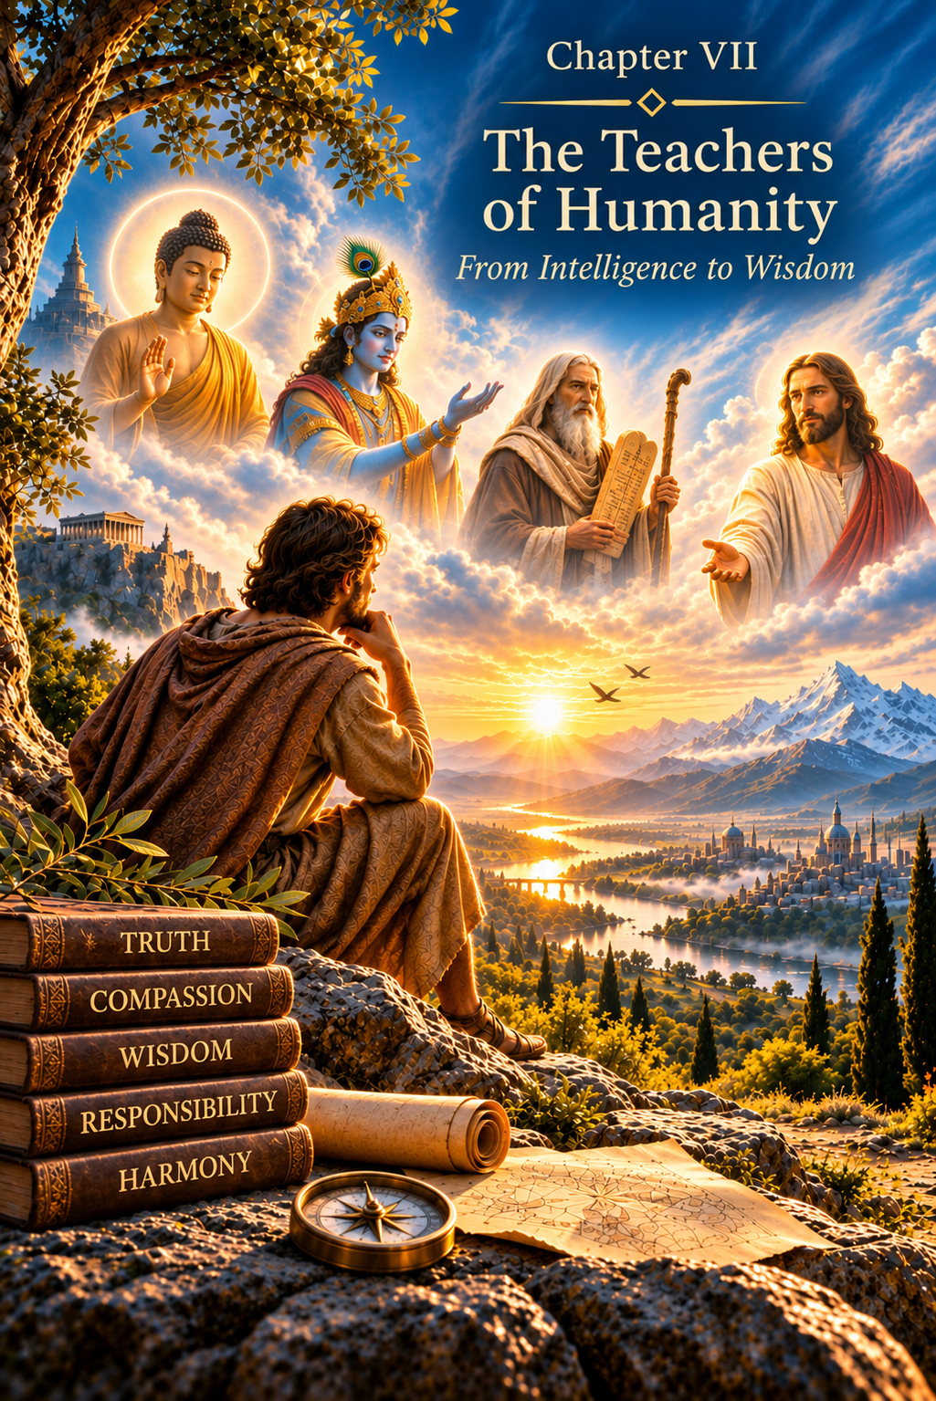
CHAPTER VII
Teachers of Humanity
From Intellect to Reason
The Human Being learned to think.
The Human Being learned to observe nature, preserve knowledge, build cities, create philosophical systems, discover the laws of the material world and transform Earth according to human intentions.
The Mental Body opened immense possibilities. Intellect made it possible to compare, analyze, calculate, model and choose among many alternatives.
But humanity gradually approached a boundary that could not be crossed simply by accumulating more knowledge.
One may know how to perform an action without understanding whether it ought to be performed.
One may possess enormous power without knowing how to use it.
One may create a perfect instrument and use it for destruction.
One may know thousands of moral rules and continue living as though one had never heard a single one.
Intellect can show the Human Being many paths. But it cannot live through the consequences of a chosen path on the Human Being's behalf.
Thus humanity came to need a further quality of consciousness: Reason.
Why Humanity Needed Teachers
Human development has never proceeded uniformly.
A civilization may have reached a particular stage, while certain individuals are capable of moving far beyond the prevailing state of the world around them.
It was such people who became prophets, Teachers, philosophers and spiritual guides.
In the system of this book, their appearance is not accidental.
When humanity approaches another boundary in its development, it needs to see a state that the majority have not yet attained.
A Teacher does not walk the path in another person's place.
A Teacher points the way.
A Teacher does not disclose to the Human Being the hidden script of an earthly life. A Teacher shows that it is possible to live differently.
This is fundamentally important.
The Creator granted the Soul absolute Freedom even before embodiment: the freedom to choose the experience it needs and its earthly path of development. Yet the specific sequence of events on that path remains concealed. It is formed by the Karmic Council, and the embodied Human Being lives through it without knowing the script.
A Teacher, therefore, can speak.
Can demonstrate.
Can warn.
But each Human Being must personally live what the Teacher has shown, within the events of their own life.
Knowledge Can Be Transmitted. Experience Cannot.
Intellect develops through information.
A person reads a book, listens to a Teacher, observes the world and studies the experiences of others. The information received becomes material for analysis.
But Reason comes into being differently.
One cannot read a book about forgiveness and thereby learn to forgive.
One cannot memorize the definition of love and thereby learn to love.
One cannot study responsibility intellectually and thereby become responsible.
One cannot read about another person's pain and thereby fully acquire that person's experience.
For this, one must live through one's own inner state.
Intellect is born of knowledge. Reason matures through experience.
This is why the path towards Reason passes through human life in all its fullness.
Through love.
Through loss.
Through fear.
Through error.
Through action.
Through the consequences of one's own actions.
Through the capacity to acknowledge one's own responsibility.
Reason cannot simply be conveyed to another person. It must be cultivated within oneself.
How Reason Is Born
Reason is not a more powerful form of Intellect.
These are fundamentally different qualities.
A high IQ allows a person to process information more rapidly, identify patterns and construct complex models. But a person with a high level of intellect may still commit acts that can hardly be called reasonable.
For Intellect primarily answers the question:
How can this be done?
Reason asks a different question:
What gives rise to this action? What consequences will it bring? And am I capable of accepting responsibility for the causality I have lived through?
Thus a sequence takes shape through which what has been lived becomes part of consciousness:
Circumstances → Experience of an Event → Action → Consequence → Responsibility → Experience.
Yet experience in itself is not Reason.
A person can repeat the same mistake many times.
Experience must be consciously understood.
Only then does it begin to change the person.
In this way feelings, desires, Intellect and actions gradually become harmonized.
It is precisely this harmonization that prepares the Human Being for the next state.
The Buddha
In different ages, humanity has received different forms of the same great lesson: to see oneself.
In the Buddha's teaching, the observation of suffering, desire and attachment becomes central.
A person is accustomed to regarding the external world as the cause of inner states.
I feel bad because someone else acted wrongly.
I suffer because I have lost what I possessed.
I am unhappy because I did not obtain what I desired.
But the Buddha directs attention inward.
What exactly within me gives rise to suffering?
Why does desire become dependence?
Why does attachment turn the possibility of loss into a source of pain?
In this way a person begins to investigate not only the external world but also their own consciousness.
Hatred is never ended by hatred; hatred ends through the absence of hatred. This is an eternal law. (Dhammapada 1:5; a rendering of the meaning.)
This is an extraordinarily important transition.
Intellect can investigate an object.
But here the investigator becomes the object of investigation.
A person begins to observe their own thoughts, desires and reactions.
And through this gradually to become free from their unquestioned power.
Krishna and Arjuna's Choice
Another great image comes from the Bhagavad Gita.
Arjuna finds himself facing an action whose meaning and consequences cannot be contained within a simple formula.
Before him stands duty.
Before him stand those close to him.
Before him stands fear of the consequences.
Before him stands responsibility.
He must act, but action has a price.
That is why the dialogue between Krishna and Arjuna is so important for understanding the transition from Intellect to Reason.
Krishna does not simply hand Arjuna a ready-made answer.
He transforms the very level from which Arjuna views his own choice.
Action must be freed from blind attachment to personal gain and fear.
You have the right to action, but never to its fruits ... and do not become attached to inaction. (Bhagavad Gita 2:47; a rendering of the meaning.)
The Human Being must act without making attachment to the outcome the foundation of consciousness, and must live through responsibility for the action.
Within the metaphysical system of this book, it is especially important here to distinguish the freedom of the Soul from the circumstances of the embodied Human Being.
Absolute Freedom belongs to the Soul, which chooses its necessary experience before embodiment. The Human Being, meanwhile, lives through the circumstances that have been formed, and encounters the causality of personal actions without knowing the hidden script.
At the end of his instruction, Krishna tells Arjuna:
Reflect fully upon this, and then act as you wish. (Bhagavad Gita 18:63; a rendering of the meaning.)
In the system of this book, these words do not disclose the hidden script of embodiment. They show that the Teacher imparts knowledge but does not live through the experience in the Human Being's place.
The Prophets
Again and again, the prophets called the Human Being back from outward form to inward substance.
Ritual alone does not make a person righteous.
Belonging to a particular people does not make one person superior to another.
Words about God cannot replace a life lived in accordance with what one professes.
Thus a thought gradually emerges that will become increasingly important:
The Divine cannot be contained within outward form alone.
A person may build a temple and remain cruel within.
May know a sacred text and hate another person.
May speak of justice while striving for power.
The next step must therefore take place within the Human Being.
Christ
Jesus Christ occupies a special place on this path.
Within the system of this book, it would be wrong to regard Him merely as a philosopher or one among many moral teachers.
Christ is the Divine Teacher.
And His earthly life shows humanity a direction that cannot be reduced to intellectual knowledge.
If you wish to be like Christ, live and act as Christ did.
It is not enough to know His words.
It is not enough to venerate His image.
It is not enough to belong to the religion that arose around His teaching.
The central question is different:
Is the Human Being capable of living from the state of consciousness that Christ demonstrates through His own example?
Forgiveness
Forgiveness becomes one of the central elements of this path.
For the Astral Human Being, pain inflicted by another naturally gives rise to a corresponding response.
I have been struck, and I want to strike back.
I have been humiliated, and I want to humiliate.
Someone has done me harm, and I want that person to experience the same.
Thus a chain begins.
One action becomes the cause of another.
A consequence becomes a new cause.
And the chain may continue for generations.
Forgiveness breaks that sequence.
At Golgotha, Christ says:
Father, forgive them, for they do not know what they are doing. (Luke 23:34.)
But forgiveness does not mean declaring evil to be good.
It does not mean abandoning the need to understand an action.
It does not mean allowing another person to inflict harm without end.
Forgiveness means no longer allowing another person's past action to determine one's own inner state and the continuation of the causal chain indefinitely.
Forgiveness frees the Human Being from the need endlessly to reproduce the past.
That is why forgiveness concerns more than morality alone.
It changes the causal chain.
Judge Not
Christ's words, “Judge not,” may be understood in a similar way.
Judge not, that you be not judged. (Matthew 7:1.)
This is not a command to abandon the ability to distinguish good from evil.
The Human Being must evaluate actions.
Must understand consequences.
Must protect others from destruction.
But there is a difference between judging an action and condemning the essence of the person who performed it.
Intellect says:
That person has committed evil.
The ego very easily takes the next step:
Therefore that person is evil and is beneath me.
And division is born again.
Christ's teaching returns the Human Being to responsibility for one's own inner state.
You are not obliged to justify another person's action.
But you are responsible for what that action brings forth within you.
Love for an Enemy
Still more radical is the call to love one's enemies.
But I say to you: love your enemies ... (Matthew 5:44; cf. Luke 6:35.)
For the Astral Body, love is naturally associated with emotional closeness.
We love those who are dear to us.
Those who care for us.
Those who belong to our circle.
But love for an enemy cannot be explained by emotional affection alone.
Here love begins to become a state of consciousness that can no longer be reduced to emotional sympathy.
A person may feel no pleasant emotion towards someone who has caused harm.
Yet that person can refuse to make hatred the foundation of their own existence.
This is already a different level of inner being.
Feeling remains.
But feeling no longer automatically determines action.
It is here that space for Reason begins to take shape.
Freedom Without Power
A true Teacher does not replace the Human Being's own path.
A Teacher does not force.
Does not program.
Does not disclose the hidden sequence of events, nor live through it on another's behalf.
For experience cannot be received as ready-made knowledge: it must be lived.
This makes it possible to see the fundamental difference between a spiritual Teacher and earthly authority.
Authority seeks to obtain a certain behavior.
A Teacher addresses the Human Being's state of consciousness, so that what has been shown can be recognized and lived within one's own circumstances.
The Creator grants the Soul absolute Freedom to choose the necessary experience.
In embodiment, however, the script remains hidden, and responsibility arises within causality as it is actually lived.
Thus the Freedom of the Soul and the responsibility of the embodied Human Being belong to different levels of a single architecture.
One determines the choice of experience before embodiment; the other becomes part of living through it.
The Human Being Within Causality
Gradually, the Human Being begins to understand that, without knowing the hidden script of the events encountered, one nevertheless truly lives through the causality of every personal action.
A word, an action or a failure to act enters the subsequent course of events and has consequences.
Through a word.
Through an action.
Through a word.
Through inaction.
Every action performed enters the world and becomes part of a continuing causal chain.
Intellect can perceive such a connection.
But Reason begins when a person accepts responsibility for their own place within that chain.
Intellect can perceive causality. Reason matures when causality, personally lived, becomes responsibility and experience.
And here we approach, for the first time, the state associated in the architecture of this book with Reason: the Causal Body.
Why the Causal Body Cannot Be Attained Through Intellect
The Causal Body cannot be attained by accumulating knowledge.
One cannot read enough books to contain it.
One cannot solve enough difficult problems.
One cannot attain it by virtue of a high IQ.
Readiness to contain it comes through the quality of a life lived: the experience of emotional states, the living through of causality, responsibility, and the harmonization of the entire preceding structure of the Human Being.
For the next level, that entire structure must be brought into harmony.
The Physical Body.
The Etheric Body.
The Astral Body.
The Mental Body.
Instinct must not govern the Human Being.
Feeling must not make a person a slave to reaction.
Intellect must not serve the ego alone.
Only then does Reason begin to become not an isolated ability but a new state of the entire human system.
Christ and the Causal Body
Here it is essential to draw a particularly important distinction.
One cannot say that Christ was a “bearer of the Causal Body.”
Such a description would artificially confine the Divine Teacher to one stage of human development.
In the system of this book, Christ is capable of manifesting on every level.
Yet His earthly life and His teaching show the Human Being the direction of preparation for the next state.
Forgiveness releases a person from repeating the causal chain.
Love harmonizes feelings.
The refusal to condemn destroys the illusion of one's own superiority.
Freedom from material power weakens the dominion of the ego.
Responsibility enables the Human Being to contain the causality of personal action and transform what has been lived into experience.
Connection with God carries consciousness beyond a purely intellectual picture of the world.
Christ therefore shows not which abilities the Human Being should acquire.
He shows what the Human Being must become in order to be ready for the next state.
Teachings Cannot Be Lived in Another Person's Place
In this lies both the difficulty and the greatness of human experience.
A Teacher may leave words that endure for millennia.
Civilizations may build temples around them.
Develop theology.
Write books.
Argue over interpretations.
But no system can live a human life in the Human Being's place.
One can know a teaching about love and continue to hate.
One can preach forgiveness and refuse to forgive.
One can speak of spirituality and strive to control another person.
One can know about God and never experience an inner connection with Him.
Knowledge of a Teaching belongs to Intellect. A Teaching that has been lived becomes the experience of Reason.
Before the Next Boundary
Humanity has travelled an immense distance.
It has learned to survive.
Learned to feel.
Learned to think.
Learned to transform Earth.
Learned to create things that had not previously existed in material form.
But now a new question arises.
Is the ability to create sufficient?
Or must the Human Being learn to understand the consequences of what has been created?
Is possessing freedom sufficient?
Or must one become capable of understanding the causality of action and accepting responsibility for its consequences?
Is it enough to know about love?
Or must one become capable of living from a state of love?
It is here that the age in which Intellect could appear to be the summit of the Human Being comes to an end.
The next stage requires Reason.
And Reason opens the door to an entirely different state of human existence.
To a state in which causality, space and time may be perceived in a way unlike the perception of modern humanity.
To the Causal Body.
A Teacher points the way. But the experience leading to the next boundary must be lived by the Human Being personally.
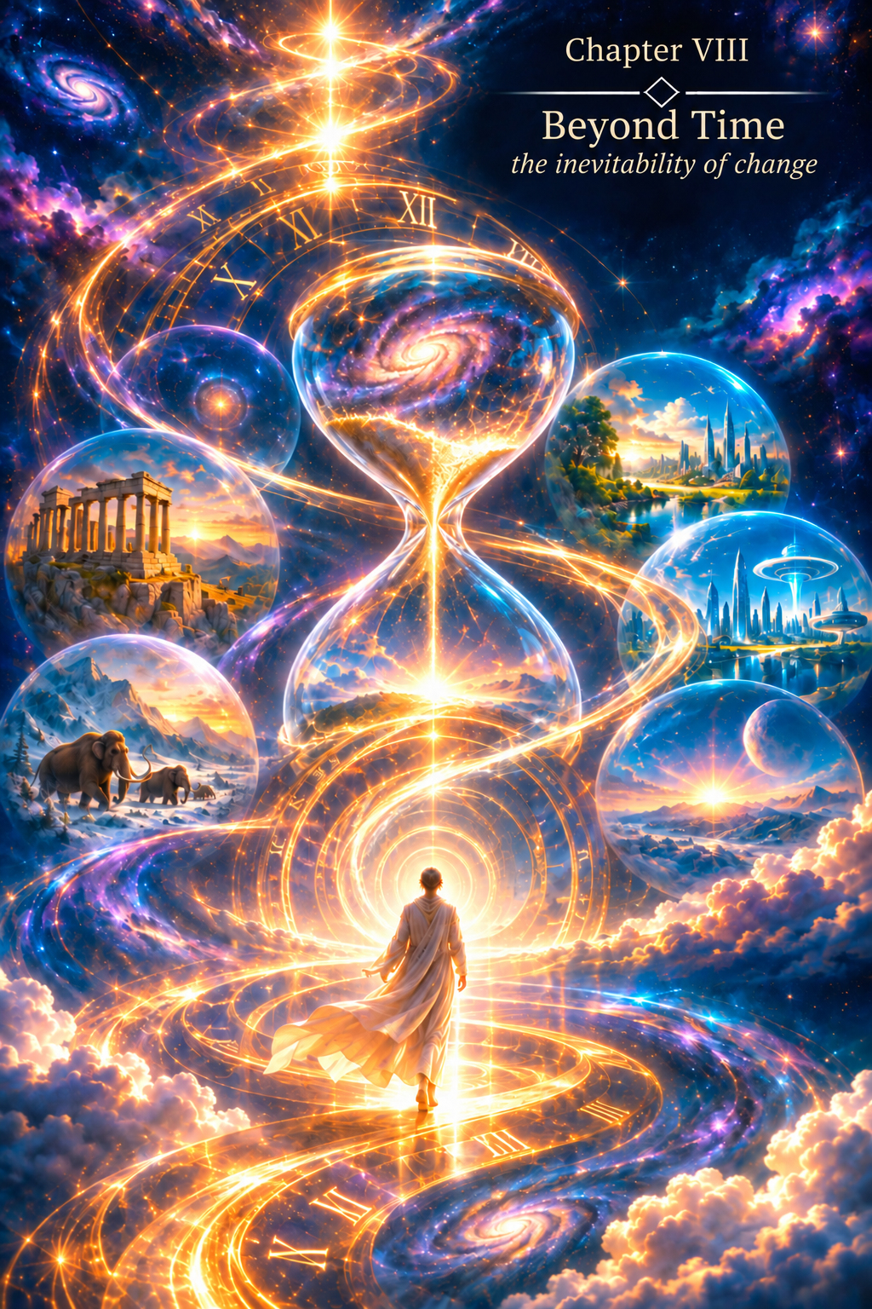
CHAPTER VIII
Beyond Time
All the earlier transitions discussed in this book belong to the past. We can seek traces of them in ancient traditions, religious writings, human history and the very nature of the modern Human Being.
But now we approach a different boundary. For the first time, we are concerned not only with what has already happened, but with a state towards which humanity has yet to move.
The Physical Body enabled the Human Being to exist in the material world. The Etheric Body sustained the life of that form. The Astral Body opened the world of feeling. The Mental Body gave the ability to think, create images, analyse and embody an intention in matter.
Yet all these levels continue to exist within the reality familiar to us: three-dimensional space and linear time (3D + t).
The next transition must change more than the abilities of the Human Being. It must change the very manner of human existence.
The Causal Body is not simply another instrument added to the modern Human Being. It marks the beginning of a different human state.
Not a New Ability, but a New State
The Causal Body cannot be reduced to a list of extraordinary abilities.
Clairvoyance, healing, alteration of the state of matter, multidimensional presence, or the overcoming of familiar spatial limitations may be no more than consequences of a more fundamental transformation.
A higher body does not abolish the lower ones. The Physical Body does not become a useless mistake. The Etheric, Astral and Mental Bodies do not disappear.
On the contrary, the entire structure that came before must be brought into a state of harmony that will allow it to receive the energy of the next level.
The Causal Body therefore cannot be attained merely through education, a wealth of knowledge, or exceptional intelligence. Intellect can process information, compare alternatives and propose a solution. But readiness for the next state is not determined by the speed of thought.
Intellect is born of knowledge. Reason matures through experience.
A state of feeling gives rise to a choice. Choice leads to a decision. A decision becomes an action. Action creates consequences. Consequences demand responsibility. Responsibility turns what has been lived into experience. And only experience that has been lived and consciously understood can bring the Human Being into harmony.
Freedom from the Dominion of Lower States
The transition to the Causal Body requires consciousness to become free of the domination of those states that were necessary at earlier stages of development.
The Physical Body brought the instinct of self-preservation, the need for food, reproduction, protection of territory and the preservation of life. These mechanisms are not vices. Without them the human form could not have existed and developed in the material world.
The Astral Body opened the realm of feelings. Alongside love, the Human Being came to know jealousy, fear of loss, attachment, anger and the desire to possess.
The Mental Body gave Intellect, which proved capable of greatly amplifying both creative and destructive states.
Gradually the ego took shape: I, mine, my property, my territory, my status, my victory, my power. The ego was necessary for individual choice and personal responsibility. But an instrument that has fulfilled its purpose must not become the prison of the next state.
We are not, therefore, speaking of the destruction of instincts, feelings or individuality. The Human Being must become free of their dominion.
The Physical Body remains, but the person ceases to regard it as the entirety of the self.
Feelings remain, but the person ceases to be their slave.
Intellect remains, but the person ceases to regard it as the highest limit of consciousness.
The Causal Body requires not the destruction of the Human Being who came before, but the harmonisation of the whole human nature.
Material Attachment and Well-Being
Modern human civilisation is organised around the needs of the Physical Body. For ordinary existence a person needs shelter, food, water, clothing and security. All these preserve the physical form, enable reproduction and make sensory experience possible in the material world.
At this stage, such an arrangement is natural. Without it, humanity could not have developed. That is why well-being has become one of civilisation's central concepts: the degree to which the physical Human Being is provided with the matter and energy necessary for life.
But this model has a fundamental consequence: the Physical Body constantly requires resources from outside itself.
Physical Body → external energy and matter → food, shelter, clothing → extraction of resources → production → property → territory → struggle for sources of energy and well-being.
As civilisation becomes more complex, it builds more material infrastructure around the Physical Body.
The house becomes a city.
The tool becomes industry.
Fire becomes an energy system.
Simple movement becomes a global transport infrastructure.
The problem begins when the Human Being mistakes the conditions of one stage of development for the eternal law of human existence.
The Body as a Biological Spacesuit and a Temple of the Soul
One of the Human Being's central misconceptions is the identification of the self with the Physical Body. We say, 'I was born', 'I am growing old', 'I shall die', as though the body's boundaries were the boundaries of the Human Being.
But in the system of this book, the Physical Body is only one form in which a multidimensional human being is manifested. It is an earthly spacesuit and, at the same time, a temple of the Soul, enabling the Soul to gain experience in the dense material world.
A spacesuit must be cared for. The body must be treated, nourished and protected. But it would be strange to regard the astronaut's ultimate purpose as the endless preservation of the spacesuit.
Modern humanity is making increasingly determined efforts to prolong biological life, defeat ageing, replace organs and change the mechanisms of physical deterioration. These pursuits are natural within three-dimensional space plus time (3D + t). Yet extending the life of the body does not, by itself, mean advancing the Human Being.
The body's existence may be prolonged. But Reason cannot be manufactured by technological means.
If consciousness remains ruled by fear, greed, pride, hatred, material dependence and the desire for superiority, extending its presence in the same physical form merely prolongs the same state.
No Longer Searching for Energy Outside Ourselves
Humanity has become accustomed to searching for energy in the external world. It extracts coal, oil and gas, splits the atom, and harnesses flowing water, wind and sunlight. The search for increasingly powerful sources of energy has become one of the foundations of civilisation.
But the next stage of development poses an entirely different question.
Perhaps the Human Being must not endlessly search for new sources of energy outside, but discover the ability to receive a higher state of energy within.
In this model, the Causal Body is not simply the Body of Reason and causal perception. Receiving it opens an entirely different energetic state of the Human Being.
As long as the dense physical form predominates, the Human Being depends on food, atmosphere, temperature, pressure, protection against radiation and vast external infrastructure. But if the entire human system is capable of entering a higher energetic state, dependence upon low-vibrational matter must gradually diminish.
Food, clothing, shelter and even the atmosphere we know would then cease to be unconditional requirements of existence—not because they had been meaningless, but because they belonged to a particular form of the Human Being within three-dimensional space.
Beyond Linear Time
In the world of 3D + t, a person exists at one point in space at one moment in time. The past is accessible through memory. The present is accessible through immediate experience. The future is approached through conjecture, dreams or hopes.
Even a highly developed Intellect remains bound to this sequence. It analyses known causes and models likely consequences.
The Causal state suggests a different form of perception. The Human Being begins to see not merely individual causes and effects, but a wider causal structure. Linear time ceases to be the only way of ordering experience.
What we now call clairvoyance may, in such a model, be not 'travelling into the future', but perceiving a connection inaccessible to consciousness limited to a single point in the temporal sequence.
The concept of presence changes as well. If consciousness is not wholly bound to one spatial point, perception—and, in the ultimate state, manifestation—in different regions of our familiar space-time becomes possible.
This is no longer an expanded Intellect. It is a different geometry of consciousness.
Transformation of Form
An even deeper transformation concerns the relationship between matter and energy.
If the Physical Body is the densest level of manifestation of the Human Being, then the complete reception of a higher energetic body may open the ability to alter the very state of that physical form.
At its highest expression, this need not mean the death of the body, nor its mechanical movement, but transformation: a passage of the dense form into an energetic form, with the possibility of manifesting physically once more.
Teleportation, then, need not be an exceptionally rapid journey across space.
Perhaps no journey in the customary sense takes place at all. The state of presence changes.
A Mental civilisation perfects the means of travel. The Causal Human Being changes the state of the one who travels.
Space and the Mistake of Transferring the Old Model
Modern humanity is taking the prospect of settling on other planets increasingly seriously as one means of preserving our species. This reveals the greatness of the Mental Body: the Human Being can imagine another world and develop the technology needed to reach it.
But this approach attempts to take into space the Human Being as presently constituted, limited by three-dimensional space plus time (3D + t).
The same requirements follow: air, water, food, protection against temperature extremes and radiation, suitable gravity, energy, materials and shelter. A settlement arises, followed by infrastructure, followed by a need for resources and sources of energy.
The planet changes. The matrix of existence does not.
Another planet does not mean another dimension. The Human Being remains within the material world and subject to its conditions.
Radiation, gravity, the duration of travel and other physical factors require either protection of the existing body or its adaptation. But outer space is not the natural cradle of today's physical Human Being.
Earth was given for that purpose.
Here the human form could undergo its successive adaptations. Here the Physical and Etheric Bodies developed. Here the Human Being passed through the school of Astral experience. Here the Mental Body unfolded and Intellect came into being. Here, too, the next transition must be prepared.
The task may be not to take the former Human Being to a new planet, but to complete the transformation for which Earth became humanity's cradle—to complete the experience of the Mental Body.
The Formula of a Divided World
The Physical Body is always located in a particular place. A person is born into a family, among a particular people, culture and religious tradition. From this arises a sequence natural to 3D + t:
I → my family → place of birth → my people → my country → my territory → my resources → my culture → my religion.
Every element of this chain has fulfilled, and continues to fulfil, an important function.
The family protects the child.
Culture preserves experience.
Society organises life together.
The state maintains order and protects its territory.
But as soon as 'mine' appears, so does 'someone else's'.
My land and another person's land.
My resources and another person's resources.
My faith and another faith.
My security and the possible threat posed by another.
Physical existence intensifies this division through the scarcity of resources.
Land, water, energy sources, mineral deposits and habitable territories are unequally distributed.
Wars therefore have many immediate causes: power, security, ideology, territorial and national interests, religion and resources. Yet behind them the same deeper principle of a divided material world appears again and again: the desire to possess, control or defend what is regarded as a condition of one's own existence.
Differences do not give birth to war. War arises when difference and limited possession are turned into a reason for confrontation.
When Possession Is No Longer Necessary
The Causal state does not demand the destruction of the family, the forgetting of one's birthplace, or the rejection of culture. Differences do not disappear. What disappears is their power to set the boundaries of human consciousness.
If the physical form ceases to be the only means of existence, if the Human Being is capable of receiving a purer energetic state, and if space ceases to be an insurmountable boundary, the former formula of well-being begins to lose its meaning.
The Human Being no longer needs to possess ever greater quantities of matter merely to guarantee continued existence.
The new age, then, does not so much create a fairer redistribution of resources as gradually render the very struggle to possess them meaningless.
There would be no need to seize new territories for their energy sources. No need to preserve material superiority as a condition of security. The policy of deterrence in its present form would lose its purpose. At the ultimate stage, the grounds for politics based on the confrontation of collective interests in the material world would disappear too.
This would be neither the victory of one country over another nor the establishment of a single earthly government. It would mean the disappearance of many of the reasons for which such struggles existed at all.
Earth Is Cleansed Not by Prohibition
Today the Human Being seeks both to preserve nature and to preserve a model of existence that demands ever more resources. Humanity tries to protect Earth while continuing to measure prosperity by the scale of material consumption.
In this way, the consequences are fought while their cause remains.
In the system of this book, the Causal transition addresses the problem differently.
Earth is cleansed not because the Human Being has been forbidden to take her resources. Earth is cleansed because the Human Being no longer needs to take them in the quantities once required.
Earth was the Human Being's first workshop and Mother. She enabled humanity to investigate matter, discover the properties of substances, learn to harness energy and become a creator within the material world.
But a child's maturation brings a moment when the child no longer lives solely through the Mother's body.
Thus the material world does not lose its significance in the history of Creation. It simply ceases to be the highest value and ultimate purpose of existence.
Healing and the Disappearance of Disease
In the new state, the relationship to illness changes as well.
Modern medicine predominantly acts upon the physical manifestation of a disturbance: it treats an organ, alters a biochemical process, replaces a damaged part, or sustains vital functions.
But if the Physical Body is only one level of a unified human structure, the complete harmonisation of the entire structure must also change the very possibility of destructive states arising.
Healing would then mean not only relieving a symptom. It would become the restoration of the Human Being's wholeness.
In the ultimate Causal state, where consciousness, Soul and bodies are in harmony, illness may lose the inner environment in which it can arise and take hold.
This is not a rejection of medicine for the Human Being of today. As long as we exist in the present form, it remains necessary. What is envisaged is a fundamentally different state of the future human system.
Love as the Energy of Transition
Among all the states that prepare the Human Being for the next transition, Love holds a special place. Teachers of different ages spoke of it, but in the earthly path of Christ it becomes not merely a commandment, but a way of life directly demonstrated.
In the system of this book, Love cannot be reduced to an emotion, a moral rule, or the relationship of one person to another. Love is a state in which open Souls come into contact.
It does not arise from logical calculation and cannot be created by Intellect. Intellect can explain love, describe its manifestations, compare actions and even formulate rules of conduct. But knowing everything about Love does not mean dwelling in its state.
This is why Love has special significance at the boundary between the Mental and Causal ages. The Mental Body can understand the words of a Teacher. But the energy of Reason requires what has been understood to become the state of the whole human nature.
Christ places Love at the centre of His teaching. Asked about the greatest commandment, He answers with love for God and love for one's neighbour (Matthew 22:37–40). But He then leads the Human Being further still: 'Love your enemies' (Matthew 5:44).
This step is particularly important. Loving one who loves you is natural to human feeling. Loving one who has caused pain cannot be made into a lasting state through the effort of Intellect alone. Here the Human Being confronts the ego, resentment, fear, the desire for revenge and the wish to defend the self.
Unconditional Love, therefore, is neither weakness nor a surrender of freedom. On the contrary, it is one of the freest human states. A person's attitude to another no longer depends on what benefit is received, whether love is reciprocated, or whether the other belongs to the same family, people, culture or faith.
Unconditional Love does not demand the destruction of individuality. It removes the need to set one's own individuality against another's.
In the Gospel Christ says: 'Greater love has no one than this, that someone lay down his life for his friends' (John 15:13).
In His own earthly life these words cease to be merely an instruction. Service, forgiveness and sacrifice become a lived demonstration of the state He taught.
An act of sacrifice may still be the result of a moral choice: the Human Being can overcome fear and consciously place another's life above their own. Yet in the ultimate state of unconditional Love, the very inner calculation between 'me' and 'another' begins to disappear. The other is no longer perceived as a wholly alien and separate being.
This is precisely why Love is capable of harmonising the entire preceding structure of the Human Being. It does not destroy the Physical Body's instinct of self-preservation, but no longer permits it to be an absolute law. It does not destroy Astral feeling, but frees it from jealousy and possessiveness. It does not destroy Intellect, but prevents it from becoming the ego's instrument for justifying superiority, hatred or power.
In this sense, Love is among the strongest energies of transition. Not because it can be employed as a technique for acquiring the Causal Body, but because the state of Love itself makes the Human Being capable of receiving greater power without turning that power against another.
Where the ego rules, power strives to dominate. Where fear rules, power seeks security through superiority. Where possession rules, power becomes an instrument of control. But where unconditional Love unfolds, the very need to use power against another begins to disappear.
Thus Love and Reason do not stand in opposition in the next state. Reason without Love might become merely a still more sophisticated Intellect, capable of perceiving more causes and wielding greater power. Love without Reason might remain a great feeling without the fullness of conscious responsibility. Their union changes the very quality of the Human Being.
Perhaps that is why Christ does not separate drawing near to God from Love. He does not ask the Human Being only to learn more about Divine Reality. He asks us to change our way of relating to God, to one another and to ourselves.
For me, this has a direct bearing on the coming transformation. The Causal Body cannot be received simply because the Human Being has grasped the structure of the next stage intellectually. New energy must enter a system already capable of refraining from turning power into domination.
Love is not a reward granted after the transition. Love is the state that makes the transition possible.
Christ: A Demonstration of the Next Horizon
Here the earthly path of Jesus Christ acquires special significance for this book.
In His earthly life, humanity was not only shown the path towards the next state: the path was demonstrated in the very manner of His living.
Christ did not demand that the Human Being believe in the possibility of the next state merely because He had spoken of it. He demonstrated Love through service and through His sacrifice for the redemption of humanity's Fall.
He demonstrated forgiveness even towards those who crucified Him: 'Father, forgive them, for they know not what they do' (Luke 23:34).
He demonstrated healing by restoring people's health.
The raising of Lazarus became an image of overcoming the familiar boundary of death (John 11:1–44).
His own Resurrection and Ascension completed this sequence.
It is especially important that the Gospel account does not describe the Resurrection simply as the release of a spiritual entity from a body that has become unnecessary.
The risen Christ tells His disciples: 'Touch me, and see. For a spirit does not have flesh and bones as you see that I have' (Luke 24:39). He takes food (Luke 24:41–43), and invites Thomas to see and touch His wounds (John 20:24–29).
The Scriptures then describe the Ascension: Christ blesses His disciples and is carried up into heaven (Luke 24:50–51); the Acts of the Apostles say that He was lifted up before their eyes until a cloud took Him from their sight (Acts 1:9–11).
Orthodox worship likewise speaks explicitly of Christ ascending 'with Thy most pure flesh'.
For Christian theology these events have their own dogmatic significance. In the metaphysical model of this book, however, I see another image in them: a higher state does not destroy human nature or require the Physical Body to be discarded as an unnecessary shell. The whole Human Being is transfigured.
The Soul needs the Physical Body for direct contact with the material world. Through it, the Soul acquires sensory experience: touch, warmth and cold, pain and pleasure, movement and the resistance of matter. The Soul also gains the ability to act and create within matter. The next stage of human development therefore does not require the rejection of the Physical Body. On the contrary, the transformation of the Human Being includes the body itself.
An interesting artistic image of such a transformation appears in Luc Besson's film Lucy.
The heroine describes the human body as an enormous communication system of cells, continually exchanging information and capable of organising matter in different ways.
The form changes, yet the material foundation itself does not vanish.
This image is close to what I mean by the transformation of the Physical Body. The body does not disappear or become unnecessary to the Soul. It becomes plastic and adaptable. Its matter gains the possibility of changing the manner of its organisation and manifestation while preserving the wholeness of the Human Being. Form ceases to be fixed once and for all.
In the ultimate Causal state, such plasticity may mean the ability to transform the Physical Body into another state and then manifest it physically again. Teleportation would no longer be a superfast movement of the body from point A to point B. Distance would cease to be the central condition of movement. What changes is the state of the physical form itself and the manner of its manifestation in different locations and spaces.
The Soul does not need to escape the body. The body must become capable of following the Soul.
Extraordinary abilities do not lead the Human Being to a higher state. A higher state opens the way to new abilities.
Here Love and forgiveness are not techniques for acquiring power. They are signs of a state in which power can no longer be separated from responsibility.
Why Power Requires Freedom from the Ego
This explains why the Causal Body cannot be received while the old dominion of the passions remains.
Imagine a person who acquires the power to influence matter, perceive lines of causality or overcome spatial limitations, yet retains a thirst for power, jealousy, hatred, pride, the desire for superiority and possession. New abilities would not free such a person from the former state. They would merely multiply its destructive power.
Freedom from the domination of passions is therefore not a moral commandment imposed as the price of extraordinary powers. It is a condition of safety for the next stage of development itself. Power must correspond to the state of the one to whom it becomes available. The higher the energy the Human Being can receive, the less room there can be for the desire to use it to dominate another, or for dependence on the material world.
In the Gospel Christ says:
'It is easier for a camel to go through the eye of a needle than for a rich person to enter the kingdom of God' (Matthew 19:24).
These words follow immediately after the conversation with the rich young man, whom Christ invites to leave his possessions, give to the poor and follow Him.
The young man goes away sorrowful, for he has great possessions (Matthew 19:21–23).
The point is not that matter itself, or possessing it, is evil. The obstacle is the Human Being's dependence on possession—a state in which material things so completely determine a person's life that the person can no longer relinquish them.
In the metaphysical vision of this book, I see a further meaning in Christ's words. One cannot enter the next state while continuing to belong to the preceding one. So long as the Human Being is governed by the thirst to possess, the desire for power, pride, hatred, jealousy, fear of loss and the wish to place oneself above another, the energy of Reason cannot be fully received: the new abilities would be made to serve the very states to which Intellect previously submitted.
Christ therefore speaks not only of freedom from material attachment. His teaching returns the Human Being again and again to the inner state. This is expressed with particular clarity in the Sermon on the Mount:
'Blessed are the pure in heart, for they shall see God' (Matthew 5:8).
To me, these words are directly related to the nature of the approaching transition. Purification from the domination of passions does not mean abandoning feelings, individuality, the Physical Body or the material world. A person does not cease to feel, love, create or make use of matter. The person ceases to depend upon states that compel possession, suppression, envy, hatred and fear of loss.
What opens then is not simply a new ability. The very state of the Human Being changes.
In the system of this book, the Causal Body—the Body of Reason—can be regarded as the first level at which contact with Divine Reality becomes not only a matter of faith, prayer or a brief spiritual experience, but a tangible state of the Human Being's whole nature.
Perhaps this is why the image of the Kingdom of Heaven is so important to understanding the transition. Not as a geographical place to which a person must one day travel, but as a state of nearness to Divine Reality that cannot be received while one remains captive to former passions and attachments.
This does not mean that the Kingdom of Heaven in the Gospel is identical to the Causal Body. Such an identification would be my own metaphysical interpretation, not the words of Christ. But the parallel is clear to me: Christ connects drawing near to God with an inner transformation of the Human Being.
Thus the desire for supernatural abilities may itself be a sign of unreadiness for them. A person seeking power for its own sake still lives within the logic of the ego. A person ready for the next state no longer seeks power over the world; the very relationship with the world changes.
The Human Being must become capable of receiving power without turning it into domination over another.
This is why the power of Reason opens not through the accumulation of knowledge or the refinement of Intellect, but through the harmonisation of the entire human nature.
First the Human Being changes. Only then does power corresponding to that new state become accessible.
The End of the World as the End of an Earlier State
In the biblical tradition there is an image of the end of time, the Second Coming of Christ, the resurrection of the dead and the Judgement of the living and the dead.
Christian theology has its own understanding of these events. But within the system of this book, another metaphysical interpretation is possible.
The 'end of the world' may signify not the destruction of Creation, but the completion of a particular state of the human world.
It is not Earth that ends. What ends is the age of the Human Being who is wholly dependent on matter, territory, external energy sources and linear time.
Such a transition is not a punishment. It is subject to the same law encountered in the story of Noah: the Inevitability of Change.
The Human Being is free to choose how to pass through change, but is not free to abolish change itself.
The Inevitability of Change
Every stage has its own time. It cannot be postponed forever. But neither can it be accelerated without consequence before the form is ready.
When the state of the surrounding environment changes, the previous form must be capable of receiving the new energetic field.
If the form is ready, the transition takes place.
If it is not, the form may prove incapable of continuing to exist under the new conditions.
Yet the destruction of the physical form does not mean the destruction of the Soul. As a particle of the Creator, the Soul is not confined to one earthly body and does not belong to linear time.
This vision is therefore not about the Creator's anger or revenge upon the Human Being. The state of the world changes, and with it the conditions of embodiment.
The Inevitability of Change does not destroy the Human Being. It makes the continued existence of a form that no longer corresponds to the coming state impossible.
Judgement as Correspondence
The image of the Last Judgement can then be seen in another way: not as a human court proceeding in which the Creator distributes punishments and rewards, but as the moment in which the state of the Human Being is measured against the state of the approaching age.
In the Gospel Christ describes Judgement through the image of separation:
'Before him will be gathered all the nations, and he will separate people one from another as a shepherd separates the sheep from the goats' (Matthew 25:32).
In the Revelation to John, the same theme takes another form:
'The dead were judged by what was written in the books, according to what they had done' (Revelation 20:12).
In Christianity these passages carry their own theological meaning—the judgement of God upon the Human Being. In the metaphysical vision of this book, however, I see another possible parallel.
Judgement can be understood not only as the passing of sentence, but also as the revealing of what the Human Being has actually become.
The central question would then no longer be: 'Are you good or bad?'
Is your human system capable of receiving the energy of the state now approaching?
Readiness is determined neither by what the Human Being says about faith, nor by wealth, social standing or the extent of intellectual knowledge. Christ warns:
'Not everyone who says to me, "Lord, Lord," will enter the kingdom of heaven, but the one who does the will of my Father who is in heaven' (Matthew 7:21).
In the system of this book, this distinction is particularly significant. One may know the Scriptures, profess a faith and possess an exceptional Intellect, and nevertheless remain under the dominion of pride, hatred, fear, the desire to possess and the desire for superiority. Words alone do not change the state of the Human Being.
Readiness is determined by what has happened to the Human Being: whether the person has been freed from the domination of passions, learned to answer for personal choices, harmonised the feelings, and overcome the power of the ego and material dependence.
The Gospel image of one group being separated from another can therefore also be seen as an image of correspondence.
It is not that the Creator arbitrarily decides who may enter the new state. Through the whole of a life, each Human Being forms the capacity—or incapacity—to receive that state.
In this sense Judgement is both planetary and profoundly individual. The arrival of the new age concerns all, but correspondence to it is determined by the state of each separate Human Being.
The Human Being reaches the boundary of transition in the state that has been formed through an entire life.
Resurrection and the New Meaning of Death
The biblical image of the resurrection of the dead occupies a special place in this vision.
Christ has already shown humanity a possibility beyond the customary understanding of death: the raising of Lazarus (John 11:1–44). His own Resurrection and Ascension then reveal an even deeper image: the physical dimension of the Human Being is not cast away, but enters into transfiguration. The Gospel text emphasises the bodily nature of the risen Christ (Luke 24:39–43; John 20:24–29), and the Orthodox tradition confesses His Ascension with glorified human flesh.
If consciousness is not exhausted by physical form, and if the Causal state can change the relationship between consciousness, energy and matter, then death ceases to be an absolute boundary of the Human Being.
Immortality acquires a different meaning. It is neither the endless repair of one biological body nor the rejection of bodily existence. It is a transformation of the whole Human Being in which physical form ceases to be the absolute limit of existence, and linear time, 3D + t, the only condition of experience.
The Human Being seeks immortality for the body. But perhaps the next stage requires the discovery of the immortality of the Human Being as a whole.
Teachers Come Before Times of Change
Throughout human history, Teachers and prophets have not revealed the entire ladder of future development at once. They appear before a particular boundary and offer the knowledge needed for the next transition.
Scripture itself reveals the gradual character of Divine revelation. The Epistle to the Hebrews says:
'Long ago, at many times and in many ways, God spoke to our fathers by the prophets, but in these last days he has spoken to us by his Son' (Hebrews 1:1–2).
The prophet warns. The Teacher shows the path. The Human Being is free to accept the lesson or reject it. But the arrival of the next stage does not depend on human desire.
Of particular importance to me are Christ's own words, spoken to His disciples shortly before His crucifixion:
'I still have many things to say to you, but you cannot bear them now' (John 16:12).
This phrase expresses with remarkable precision one of the principles running through this book: knowledge cannot be given before the Human Being becomes capable of receiving it.
Christ does not say there is nothing more to disclose. On the contrary, He says explicitly, 'I still have many things to say to you'. Yet there is a limit to human readiness: 'you cannot bear them now'.
The following verse continues the thought: Christ speaks of the Spirit of truth who will guide His disciples into truth and tell them of things to come (John 16:13).
In Christian theology, these words refer above all to the action of the Holy Spirit and the further unfolding of the meaning of Christ's teaching to His disciples. I do not equate that interpretation with the architecture of subtle bodies proposed here. Yet the principle of the gradual revelation of truth has particular significance for this book.
One cannot teach what a person has not yet acquired the capacity to perceive. One cannot receive a state merely because it has been described in detail. Knowledge can indicate a direction, but the Human Being must pass through the necessary experience and prepare the whole of human nature for what is to be revealed.
This is why Christ should not be presented in this book as an explanation of every possible future state of the Human Being. His earthly path shows the nearest horizon of transformation towards which humanity must move. He does not merely speak of Love, forgiveness, freedom from the rule of material things and unity with God: through His own life, He demonstrates a state in which these qualities become the nature of the Human Being.
In the Christian tradition, it is the Second Coming of Christ Himself that is awaited, not the arrival of some other Messiah.
Yet the words 'you cannot bear them now' invite another question: if there exists knowledge that the Human Being of a given age cannot yet receive, does that mean the disclosure of Divine Reality is proportionate to the state of the Human Being?
In the vision of this book, that is precisely the case.
Every transition corresponds to its own measure of readiness. A Teacher need not disclose the entire ladder leading to the Heavenly Adam. The Teacher reveals the next step—the one for which the Human Being is already able to begin preparing.
When humanity has passed through the Causal Age and approaches its next boundary, a new level of understanding may be opened. What that Revelation will be, and in what manner it may be given, is unknown to us today.
Perhaps that is precisely why attempting to describe it in detail now would repeat the very mistake against which the logic of development warns: every kind of knowledge has its time, and every state requires its own readiness.
Humanity Does Not Develop Uniformly
When we speak of the Mental Age, we must not assume that every person has fully developed the Mental Body.
Humanity develops unevenly. Some remain largely occupied with physical survival. Others are governed by powerful Astral—emotional and sensory—states. Still others actively develop Intellect, study the world and express themselves through creativity. Only some people are beginning to approach questions that cannot be resolved by Intellect alone.
In the language of this book, this can be associated with the differing experiences of Souls. But the value of Souls does not differ. What differs is the extent and character of the experience they have acquired.
That is why Teachers and prophets who came to humanity at different times could not change everyone instantly. They brought knowledge, revealed aspects of Divine Reality, demonstrated the conditions of the Human Being's inner transformation and warned of the consequences of human choices. Yet even knowledge that has been received must become lived experience.
A person may hear words about Love without knowing the state of Love. May understand the need for forgiveness, yet prove unable to forgive when personally hurt. May speak of freedom from material dependence while continuing to measure personal worth by wealth, power and position. May know of God without yet experiencing direct contact with Divine Reality.
Knowing the Path does not mean having walked it.
And yet this knowledge has not disappeared over thousands of years. It has accumulated. It has been transmitted through religions, spiritual traditions, philosophy, culture and personal experience. Many people have already discovered within themselves an understanding of what the Teachers spoke about. Many can distinguish Love from possession, freedom from power, knowledge from Reason, and material well-being from the inner state of the Human Being.
But understanding must still become a state of being.
Perhaps this is one of the most important boundaries of the present age. Humanity does not need to hear for the first time what Love, forgiveness, compassion or responsibility mean. These words have been known for thousands of years. What is needed is for enough people to cease merely knowing about them and to begin living in accordance with that knowledge.
The two thousand years that have passed since Christ's earthly life do not, by themselves, mean that humanity has become capable of living in the state He demonstrated.
Humanity heard Christ's words through the Mental Body, but has far from always learned to live them through its entire being.
Here Christ's words, 'I still have many things to say to you, but you cannot bear them now' (John 16:12), acquire another meaning for this book. An immense historical journey may lie between receiving knowledge and becoming capable of receiving the state to which that knowledge points.
Perhaps this journey is now approaching another boundary.
In the metaphysical vision of this book, the transition to the next age is already near. But the Inevitability of Change does not mean the Creator is indifferent to how many people will be ready for the coming state. On the contrary, the whole preceding path of Teachers, prophets, spiritual traditions and accumulated human experience can be seen as an opportunity to prepare as many people as possible to gain insight, change themselves and receive the energy of the next level.
What matters to the Creator is not the destruction of the Human Being, but transfiguration.
The approach of a boundary need not, therefore, be understood as waiting for catastrophe.
It may be a time of especially intense awakening: a time when knowledge once scattered becomes accessible to vast numbers of people, when old forms of existence reveal their limits ever more clearly, and when questions about meaning, responsibility, the nature of consciousness and the Human Being's place in the Universe cease to belong only to prophets, philosophers and mystics.
Scripture also contains warnings that precede the approaching completion of an earlier state of the world. Christ tells His disciples of a time when they will hear of wars and rumours of wars, famine, disasters and upheavals, yet He also warns them: 'See that you are not alarmed' (Matthew 24:6; cf. Mark 13:7–8; Luke 21:9–11).
In Christian tradition these words refer to eschatological events, not to a transition into the Causal Body. But within the metaphysical vision of this book, I see another important parallel in these warnings: an approaching boundary is accompanied by signs that the previous condition of the world is reaching its limits.
This does not mean wars, famine, destruction or suffering are sent by the Creator to teach the Human Being. They are consequences of human choice—the very freedom the Creator never takes away. The same Intellect can create a medicine and a weapon, feed millions and organise a struggle for resources, unite humanity and invent new means of destroying it.
Thus the heralds of the 'end of the world' may be understood not as announcements of the Creator's anger, but as warnings that the former form of human existence has approached its limit.
And the 'end of the world' itself, in the picture proposed here, does not mean the destruction of Earth or the end of the Human Being. It means the completion of an age in which the Mental Body attained immense power without yet being balanced by Reason.
The Human Being has learned to transform matter, but does not always understand the consequences of that transformation. Humanity has gained enormous power over nature without being freed from the desire to possess. It has created means of spreading information instantly without learning to transform information into wisdom. It has acquired weapons capable of destroying cities and entire peoples, while continuing to resolve conflicts through states that arose as early as the Astral stage.
This is not the failure of the Mental Body. It is its limit.
At such a boundary, the need for the next level becomes particularly clear.
The Causal Body must not merely give the Human Being more power to continue the old struggle. It must become the Body of Reason: a state in which power is at last proportionate to responsibility, knowledge is joined to lived experience, and freedom ceases to be the freedom to destroy another merely because destruction is possible.
The question posed by the coming transition is therefore not how many people know about God, how many have read the Scriptures, or how many can speak about spirituality.
The question is different:
How many people are already capable not only of understanding the new state, but of receiving it?
Perhaps one of the tasks of the final period of the Mental Age is to give the greatest possible number of people a chance to gain insight and prepare for transfiguration before the Inevitability of Change opens the next page in the history of the Human Being.
The Teachers gave knowledge. Humanity must turn it into experience. The transition will reveal how far that knowledge has become the state of the Human Being.
The Causal Body Is Not the End of the Path
The Causal Body marks the next great transition, but not the completion of human development.
Beyond it, the architecture of the Human Being includes the Buddhic and Atmic Bodies. Today we can speak of these states only hypothetically, for humanity has not yet crossed the preceding boundary and has not received a Teacher whose task would be to reveal the next stage in detail.
Nevertheless, the direction can be indicated.
The Causal Body frees the Human Being not from physical form, but from absolute dependence upon the limitations of that form. It opens multidimensionality, causal perception and a new relationship to space, time, energy and material existence.
The Buddhic Body may be connected with overcoming the profound separateness of consciousness. Another person ceases to be perceived as a wholly separate being. Love and compassion become not merely a feeling or moral principle, but a direct state of unity.
The Atmic Body may be linked to a still higher state: the harmony of free human will with the Will of the Creator. Not submission, not the loss of freedom, but a level of consciousness in which the Human Being's free choice ceases to be opposed to the Divine Whole.
Causal — overcoming the limitations of form.
Buddhic — overcoming the separation of consciousness.
Atmic — overcoming the separation of will.
The Heavenly Adam
Yet none of the seven bodies is the ultimate purpose in itself. The Creator's Design is far greater.
At the beginning of this path, different worlds and civilisations possessed their own unique energies. The Plan for the Creation of Earth was to establish a space where these energies could be brought together without the destruction of their uniqueness.
The Human Being became that space.
The Heavenly Adam is not an eighth body or a new shell following the Atmic Body. It is the state of perfect harmony of the entire human architecture.
Energies of worlds and civilisations + Physical + Etheric + Astral + Mental + Causal + Buddhic + Atmic Bodies + the Soul as a particle of the Creator = the Heavenly Adam.
The plus sign here is symbolic. We are not speaking of the mechanical joining of parts, but of their perfect harmony.
The Physical Body provides experience of matter. The Etheric provides life. The Astral provides feelings. The Mental provides thought and creation. The Causal provides Reason, causality and multidimensionality. The Buddhic provides unity of consciousness. The Atmic provides harmony with the Divine Will. And the Soul connects this entire structure to its Source.
The expression 'in the image and likeness' now becomes clearer. The Image may be present from the beginning. But the Likeness must be revealed through experience freely acquired.
The Human Being was created in the Image, but must travel the path to the Likeness personally.
Not the Destruction of Differences, but Their Harmony
“God is everywhere and contains all things within Himself,
the human being is a spark of God, and therefore is present in all things.
The whole experience of the Universe is open to everyone
who believes in the Heavenly Father,
who believes in His Absolute and in His Perfection.
One who believes in the Absolute will believe in oneself,
which, in essence, is one and the same.
The consciousness of each is part of the Consciousness of the Whole;
the consciousness of all is the single Consciousness of the Heavenly Father.
None, taken separately, is better or worse than another,
but each is only one facet of the single Whole.
In this is expressed the unity of opposites.
When you offend your neighbour, you offend the Most High—
you receive the experience of unforgiveness; or you strike yourself,
which, in essence, is one and the same.
When you forgive your neighbour, you forgive yourself.”
(Revelation of 5 March 2008)
Years later, I can see in this revelation something I was not then able to express in the language of the architecture of the Human Being.
The Heavenly Adam does not mean the disappearance of individuality.
The Creator does not gather the energies of countless worlds so as to destroy their differences in the end. On the contrary, the meaning lies in the ability to receive what is different in a single harmony.
The path of humanity therefore leads not from diversity to sameness, but from conflict between differences to their unity.
Not to destroy culture, but to cease fighting because of it.
Not to destroy individuality, but to free it from selfish separation.
Not to destroy matter, but to cease being its prisoner.
Not to destroy the Physical Body, but to transform its place within the Human Being's whole nature, freeing it from absolute dependence on its present limitations.
Not to renounce freedom, but to bring free will into harmony with the Divine.
A New Age
The coming transition, therefore, cannot be reduced to the appearance of a few people with extraordinary abilities. It is the beginning of a fundamentally different age.
The Human Being ceases to measure wealth by the quantity of matter owned.
Ceases to regard territory as the condition of personal exceptionalism.
Ceases to see the Physical Body as the only form of the self.
Ceases to seek everything necessary for existence solely in the external world.
Ceases to regard death as an absolute end.
Ceases to regard space and time as the final boundaries of what is possible.
But all this becomes possible only after an inner transformation.
One cannot receive new energy while retaining old passions. One cannot receive multidimensionality while continuing to live only for the interests of a separate ego.
One cannot become free from absolute dependence on the constraints of material form while remaining wholly attached to material possession.
One cannot receive the power of the next level without acquiring responsibility commensurate with that power.
The new Human Being begins not with a new ability, but with a new state of consciousness.
The Boundary We Have Reached
All the preceding ages prepared this moment.
Earth gave the Human Being a physical form and matter through which to gain experience.
The Etheric Body enabled that form to live.
The Astral Body taught it to feel.
The Mental Body taught it to think and create.
The Teachers of humanity showed that Intellect alone was not enough.
Christ demonstrated a state in which Love, freedom from the rule of material things, communion with God and possibilities we perceive as miracles become parts of a single Whole.
The question now is not whether the Human Being can build an even more advanced civilisation within 3D + t.
The question is different:
Is the Human Being capable of preserving physical form as part of the Whole, yet ceasing to be a prisoner of the form's present limitations—limitations necessary for earthly experience, but not the ultimate boundary of existence?
If the answer is found, the history of the Human Being will not end. Only one of its ages will come to an end.
And what seems today to be the end of the world may prove to be the beginning of a world that the modern Human Being is as yet capable of seeing only as Revelation.
The path towards the Heavenly Adam will continue.
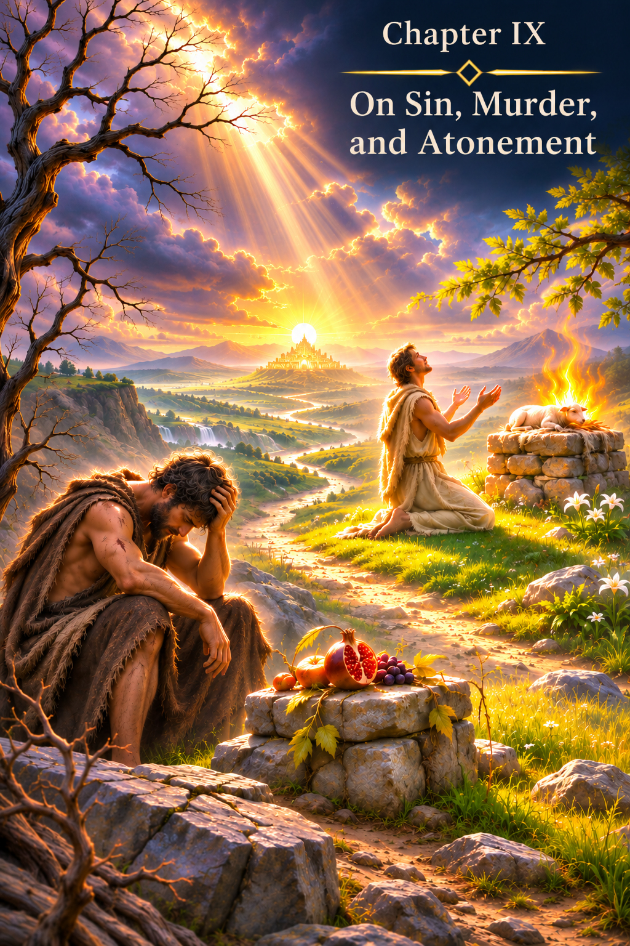
CHAPTER IX
On Sin, Murder, and Redemption
“There is neither friend nor enemy: everyone who comes to you is a Teacher who has come at your request, with a lighted candle in their breast.” — Author unknown
Disincarnation as the Completion of Experience
Every human incarnation has a beginning and an end.
Its beginning—conception and birth—follows the same biological law for everyone. Yet the end of the earthly journey is always individual.
Some depart this life in old age, when the Physical Body naturally reaches the end of its path.
Some die in an accident, a fire or a natural disaster.
Some leave earthly life through illness.
And some die at the hands of another human being.
One of the earliest and most tragic biblical images of such an event is the story of Cain and Abel.
If we accept the metaphysical model set out in this book, then before incarnation the Soul, in absolute Freedom, chooses the new experience it needs, but does not know the events that will unfold during its future earthly life.
Those events are arranged by the Karmic Council.
It is the Council that creates the sequence of circumstances, encounters and events through which the experience chosen by the Soul can be lived.
Consequently, the manner in which a person leaves the physical incarnation may also form part of that sequence of events.
But here we enter one of the most delicate subjects in this entire book.
If the earthly form of the experience chosen by one Soul is death through violence, such an event cannot occur without the involvement of another person.
Several human destinies meet.
The experience of one becomes connected with the experience of another.
Yet none of the participants knows the script after entering incarnation.
This is fundamentally important for everything that follows.
Killer and Victim: The Meeting of Two Paths
In the system of this book, the killer and the victim may not be chance participants in a tragic encounter.
Their life paths may cross within the sequence of events created by the Karmic Council in accordance with the experience each Soul chose before incarnation.
Yet a Soul that has chosen a particular experience does not know precisely what earthly event will give rise to it.
It does not know in advance who will enter its life.
It does not know the place.
It does not know the time.
It does not know the circumstances.
Still less can an incarnated Human Being know what part a particular event plays in the overall architecture of the earthly journey.
The existence of a karmic sequence of events therefore does not render murder morally neutral.
Murder remains murder.
Pain remains pain.
Earthly responsibility for what has been done remains responsibility.
But the metaphysical perspective allows us to pose a different question:
Why did the paths of these particular people cross at this point, and what experience does each Soul gain through what happened?
One does not cancel the other.
What constitutes a crime on the earthly level might, at a wider level, also form part of the complex sequence of events experienced by several Souls.
But that wider level remains unknown to the Human Being.
Karma, therefore, can never serve as a justification for a crime.
Cain and Abel: Events Do Not Abolish Responsibility
The story of Cain is especially important precisely because Scripture does not relieve him of responsibility.
Even before the murder, God warns Cain:
“…sin lies at the door. And its desire is for you, but you should rule over it.” (Genesis 4:7)
Then Cain kills Abel.
And after the murder, God asks:
“…Where is Abel your brother?” (Genesis 4:9)
And then:
“…What have you done? The voice of your brother’s blood cries out to Me from the ground.” (Genesis 4:10)
For me, it is extremely important not to confuse two levels of understanding here.
The biblical text speaks of Cain’s responsibility for his deed.
The metaphysical system of this book raises the additional question of why Cain's and Abel's life paths were brought together at this tragic point at all.
We may suppose that there was a wider sequence of events.
But Cain does not know it.
Abel does not know it.
And we do not know it.
Consequently, nobody has the right to say:
“It was intended to happen, and therefore there was no murder.”
The murder took place.
And responsibility for it is part of Cain’s earthly reality.
The Hidden Script as a Safeguard Against Permissiveness
Here we see another meaning of the rule I discussed earlier.
The script of earthly life is hidden from the Human Being.
Before incarnation, the Soul chooses the experience it needs.
The Karmic Council shapes the sequence of events.
But after incarnation, the Human Being does not know what will happen tomorrow.
Therefore, knowledge that karma exists gives no one a basis for justifying personal actions by referring to an unknown script.
A murderer cannot say:
“I was meant to kill him.”
He does not know that.
Nor can someone who sees another person in mortal danger say:
“Perhaps they are destined to die, so I shall not intervene.”
That person does not know either.
Perhaps their very arrival, the hand they offer, the decision to call a doctor, stop an attacker or pull someone out of a fire are themselves part of the events that are meant to take place.
We do not know.
This is why the concealment of the script does more than make experience authentic.
It prevents metaphysical knowledge from being turned into a licence to do anything whatsoever.
A Human Being is given a real life.
A person feels.
Loves.
Fears.
Suffers.
Acts.
And lives through the consequences of those actions.
The place of all this within the wider architecture of the Soul remains beyond ordinary human knowledge.
Christ and Golgotha: A Path Freely Accepted
Golgotha occupies an entirely special place in any reflection on death through violence.
In the Gospels, Christ is not portrayed as a man who happened by chance to face death.
In the Garden of Gethsemane, He prays:
“Father, if it is Your will, take this cup away from Me; nevertheless not My will, but Yours, be done.” (Luke 22:42)
These words take on particular significance for me in the context of this book's metaphysical vision.
Golgotha does not appear to be a chance and tragic end to Christ's earthly life.
In my understanding, His earthly path included Golgotha, death and Resurrection from the very beginning.
Yet something else is especially important.
The Gospel also preserves the responsibility of those through whom the betrayal is carried out.
At the Last Supper, Christ says:
“…the Son of Man goes as it has been determined, but woe to that man by whom He is betrayed!” (Luke 22:22)
In a single sentence, two things are brought together in a remarkable way:
The destined event—and the responsibility of the person taking part in it.
This has immense significance for the metaphysical system of the book.
An event may belong to the wider architecture of a life path.
But that does not turn cruelty into goodness.
It does not turn betrayal into love.
It does not erase the consequences of a human deed.
The actions of those who took part in Christ's crucifixion entered the events of Golgotha whether or not they understood their higher meaning.
And yet, on the cross Christ says:
“Father, forgive them, for they do not know what they do.” (Luke 23:34)
For me, this reveals one of the deepest dimensions of forgiveness.
Christ does not call what was done good.
He does not say that there is no pain.
He does not deny the crucifixion.
He forgives those who cause Him suffering.
And in doing so He reveals a state of consciousness in which another person's evil no longer gives rise to evil in return.
What Does the Killer Experience?
A natural question arises.
If a murder formed part of the events in several human paths, what experience does the person who committed the murder receive?
I do not believe that this experience ends at the moment the act of violence is committed.
On the contrary, the deed itself becomes the beginning of a new chain of causality.
A person may encounter fear.
Guilt.
The need to conceal what has been done.
Punishment by society.
The loss of a former life.
The pain of the dead person's loved ones.
Remorse.
Or, conversely, that person may feel no remorse at all for a very long time.
Realisation need not come immediately.
Within the metaphysical system of this book, it may require a far longer journey—perhaps one extending beyond a single incarnation.
But the experience does not disappear.
The cause has already been created.
And one day the Soul will need to encompass an understanding of what happened.
Not because the Creator demands vengeance.
Not because the Universe must inflict the very same pain on the killer as retribution.
But because one-sided experience does not produce a complete understanding.
To understand another person's pain truly, the Soul must open itself to that aspect of experience as well.
Not as punishment.
As an expansion of understanding.
In this sense, even the gravest human deed may become the beginning of a very long journey towards awareness.
Sin as a Violation of Unity
The concept of sin, too, acquires a deeper meaning within the system of this book.
Sin is not an arbitrary prohibition imposed by the Creator to test the Human Being's obedience.
A commandment points towards a law of harmony.
Sin arises when a Human Being acts from a state of separation.
When another person is perceived as utterly alien.
When their pain ceases to matter.
When one's own desire, power, fear, hatred or ego becomes more important than another person's existence.
Murder is the most extreme expression of such separation.
The person who kills acts as though it were possible to destroy another and remain completely separate from the consequences of that action.
Yet if all Souls are particles of the One Creator, absolute separation does not exist.
What is done to another does not disappear beyond the boundaries of that other person.
It enters the common structure of causality.
And becomes part of the experience of the one who acted.
In the metaphysical understanding presented here, sin is therefore not merely a violation of an external moral law.
It is an action born of a state of separateness, one that disturbs the harmony of the One.
And redemption then takes on a different meaning.
Redemption Is Not Vengeance
If sin creates a disturbance of harmony, redemption must not be understood solely as punishment.
Punishment alone does not yet produce understanding.
A person may undergo punishment and remain unchanged.
May suffer and continue to hate.
May lose freedom and never become aware of the pain caused to another.
True redemption therefore begins not with the amount of suffering endured.
It begins with awareness.
With the moment when a Human Being becomes able to see another not as the object of an action, but as a Soul like one's own.
When a person becomes able to encompass the pain previously ignored.
When responsibility ceases to be an external sentence and becomes an inner knowledge.
Redemption then changes from retribution into the restoration of a harmony that has been broken.
This does not abolish earthly judgment.
It does not abolish the law.
It does not abolish the need to protect other people.
Earthly society has a duty to restrain violence.
But earthly punishment and inner redemption are not one and the same.
One protects society and establishes responsibility.
The other transforms the Human Being.
Why the Causal Body Makes Violence Meaningless
When the Human Being reaches the level of the Causal Body, causality is no longer an abstract law.
It becomes a directly perceived structure of reality.
A person begins to perceive the connection between cause and effect not as separate events divided by time, but as one whole.
And then the very relationship with another person changes.
The other ceases to be an absolute stranger.
If everyone forms part of the One, then to hurt another means to introduce destruction into the very Unity of which you yourself are part.
This is why, at the level of the Causal Body, violence begins to disappear.
Not because it suddenly becomes permissible.
Nor only because there is a commandment forbidding it.
The very state of consciousness from which violence becomes possible begins to disappear.
Christ says:
“…you shall love your neighbour as yourself.” (Matthew 22:39; cf. Mark 12:31)
In the ordinary human state, these words are understood as a moral demand:
Treat another person as you would wish to be treated.
But in the metaphysical reading of this book, something more may be seen in them.
They describe a state of Unity.
Love another as yourself, because the boundary between “I” and “the other” is no longer absolute.
As long as this is merely knowledge, a person needs the commandment.
When it becomes a state of consciousness, the external prohibition gradually gives way to an inner inability to perform a certain action.
A commandment is needed where Unity must still be explained. When Unity becomes a state of consciousness, murder becomes inwardly impossible.
Not because the Human Being fears punishment.
But because there is no longer anyone who can be regarded as entirely alien.
Not Judging Does Not Mean Permitting Evil
There is, however, another subtle boundary here.
If we do not know the karmic sequence of events in another person's life, we cannot know the full depth of that person's journey.
This calls for caution when passing a final spiritual judgment on someone.
But it does not mean refusing to distinguish good from evil.
It does not mean refusing to stop a crime.
It does not mean refusing to protect the vulnerable.
It does not mean abandoning law and responsibility.
We may refrain from claiming the right to pronounce a final judgment on another person's Soul and, at the same time, say with complete clarity:
This action is unacceptable.
The Apostle Paul wrote:
“…judge nothing before the time…” (1 Corinthians 4:5)
But spiritual restraint from passing final judgment on a person must not become moral indifference to that person's deeds.
We may not know the whole history of a Soul.
But we can see the person who is being hurt now.
And that is enough to try to protect them.
The Script Is Hidden—Responsibility Remains
Everything therefore returns to the fundamental rule.
The Soul chooses the experience.
The Karmic Council creates the sequence of events.
The Human Being lives through it without knowing the script.
For this very reason, no living person can shelter behind the words: “It was meant to happen.”
We do not know what was intended.
We do not know whether the person before us is meant to die today or to live for many more years.
We do not know whether the danger that has arisen is part of that person's departure from incarnation or a trial from which we ourselves are meant to help them escape.
We do not know whether an enemy we encounter is someone we must stop, someone we must forgive, or both at once.
The script is hidden.
And therefore responsibility remains in earthly life.
Murder remains murder.
Rescue remains rescue.
Love remains love.
Betrayal remains betrayal.
Forgiveness remains forgiveness.
But beyond the picture accessible to us, all these events may become parts of a much more complex experience of Souls.
What appears today to be meaningless pain may prove to be one facet of the shaping whose purpose the Human Being will see much later.
What appears to be a chance meeting may prove to be one of the most important points in an earthly journey.
But while the Human Being remains within incarnation, a person must live as though the life before them is real.
Because it is a real life.
It is here that a person loves.
It is here that a person suffers.
It is here that a person inflicts pain or stops it.
It is here that a person forgives.
It is here that a person gains the experience their Soul once chose without knowing the events to come.
And when a Human Being rises to a state in which Unity ceases to be merely a thought and becomes part of consciousness itself, the need for violence disappears.
Not because responsibility disappears.
But because the very inner possibility of treating another as a being wholly separate from oneself disappears.
Redemption then ceases to be retribution.
It becomes a return to Unity.
And perhaps only then does the meaning of this chapter's epigraph become clear:
“There is neither friend nor enemy: everyone who comes to you is a Teacher…”
We do not know the script of an encounter.
We do not know why this particular person has appeared on our path.
But every encounter can reveal a new facet of experience.
The Light has always been present in the Soul. Sin merely prevented the Human Being from seeing that the same Light is present in another.
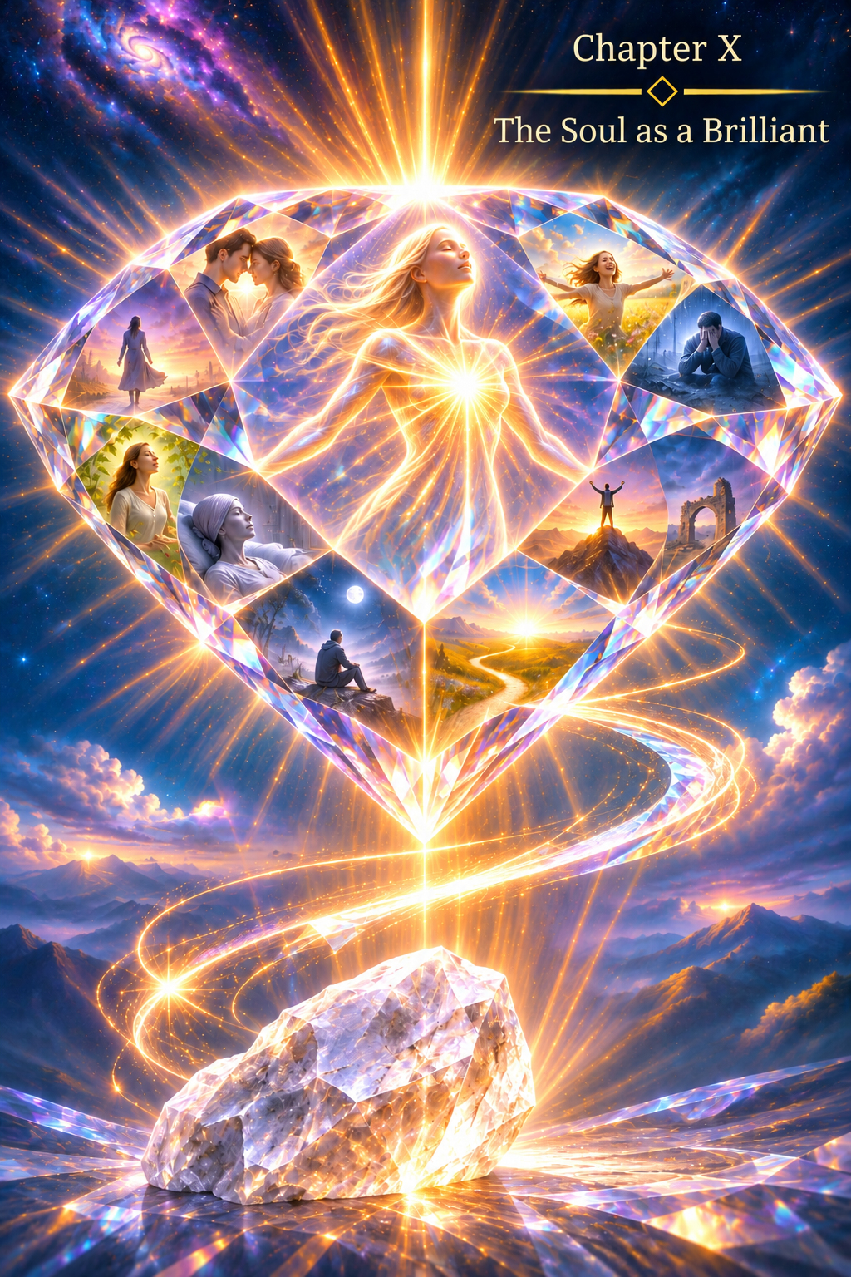
CHAPTER X
The Soul as a Diamond
Many people ask themselves why so many difficulties and so much suffering have fallen to their lot.
Dissatisfaction with life can take many forms: unfulfilled dreams and shattered plans, difficulties with children, a lack of understanding from family and friends, work one does not love, or a constant shortage of time. Illness, misfortune affecting loved ones, the loss of someone dear, and other events capable of changing an entire life are harder still to bear.
There are infinitely many causes of human pain.
At such moments, a person may feel that life is unfair to them in particular, as though these trials have somehow fallen upon their fate alone. The Soul aches at what is happening, while all one wants is something quite different—joy, love, the fulfilment of wishes, and at least some inner peace.
This feeling is familiar to every Human Being, regardless of social standing or material circumstances.
One person suffers because they could not buy a bicycle for their child; another, because they could not buy the car they wanted.
To an outside observer, these problems are hardly comparable, yet the inner states of the two people may be remarkably similar. Each experiences what is happening within their own system of values and tries to overcome the difficulty before them.
It is precisely then that a thought may arise:
God has abandoned me.
At times, it seems as though every misfortune in the world has descended upon you alone, while somehow passing everyone else by.
But let us try to look at human life from a perspective wider than a single incarnation.
From Incarnation to Disincarnation
Let us imagine the Soul's journey from the moment it enters a physical body until the moment of disincarnation.
I deliberately use the word “disincarnation.”
The concept of death applies to the physical body, but in the metaphysical picture presented in this book it does not apply to the Soul. The Soul is immortal. When the physical body can no longer sustain earthly life, disincarnation takes place: the form of interaction between the Soul and the material world made possible by that body comes to an end.
After completing its earthly journey and freeing itself from the lower energies accumulated during material life, the Soul returns to another state of being—to its source, the Creator.
But then another incarnation may come, bringing a new stage of experience.
And here I am drawn to the image of a natural diamond.
The Rough Diamond
At the moment of incarnation in the physical body, beginning with the embryonic state, the Soul can be likened figuratively to a rough, uncut natural diamond.
A newly mined diamond looks nothing like a magnificent cut and polished gemstone. It has none of the play of light, brilliance, or radiance from its many facets that we are accustomed to seeing in a finished diamond. Outwardly, it may resemble a dull, almost shapeless piece of mineral.
Yet it does not cease to be a diamond.
Its nature is already within it. Its value already exists.
Likewise, the Soul does not become divine as a result of earthly trials. The divine principle is present within it from the beginning.
Yet a rough diamond can become a brilliant, finely cut gem.
And to do so, it must undergo the process of cutting and polishing.
How a Brilliant Diamond Is Made
After natural diamonds are mined, they are examined and sorted by size, shape, structure, and quality. Then begins the most remarkable process—cutting, grinding, polishing, and shaping their facets.
Saws, discs, grinding wheels, and other tools are used.
Before touching the stone, the cutter studies it carefully. They must understand what shape can be given to it, how its future facets should be positioned, how to reveal the stone's clarity, and how to bring the play of light within it to its fullest expression.
The cutting is planned with great care.
A mistake can damage the stone. Work done correctly, by contrast, gradually reveals what could not be seen in the rough diamond.
Then comes polishing.
It is a slow, painstaking process. Facet after facet acquires a surface and a position relative to the others that allow light to reflect within the stone and return outward.
And at last, the brilliant diamond appears.
The diamond remains a diamond.
But now the radiance previously concealed within its rough form has become visible.
The Cutting of the Soul
I see a similar picture in the Soul's earthly journey.
Only here, the tools of cutting are the events of human life: love and separation, gain and loss, health and illness, joy and suffering, abundance and need, understanding and loneliness, success and defeat.
But there is a fundamental difference between a diamond and the Soul.
A diamond does not choose how it will be cut. The Soul chooses for itself the experience it needs.
In this, the absolute Freedom given to it by God is revealed.
Before incarnation, the Soul determines what experience it needs for its further perfection. But it neither chooses nor knows the particular earthly events through which that experience will be gained.
The Soul chooses the experience, but not the sequence of events.
The sequence of events is created by the Karmic Council.
On the basis of the experience chosen by the Soul, the Karmic Council models the scenario of the coming incarnation: the place and time of birth, encounters, relationships, opportunities, limitations, gains, losses, trials, and countless other circumstances through which the chosen experience can become something actually lived.
The Karmic Council does not direct the Soul or decide for it which experience it needs.
The choice belongs to the Soul itself.
The Karmic Council creates the earthly sequence of events through which that choice can be realised.
The Hidden Script
There is another condition of the utmost importance.
After incarnation, the script of earthly life is hidden from the Human Being.
The Soul does not know what will happen tomorrow, in a year, or in twenty years. It does not know which encounter will change a life, which loss will bring pain, which illness will alter life's course, or which circumstances will bring the experience it has chosen.
There is a profound meaning in this.
If, after incarnation, the Soul retained knowledge of the script, the experience itself would be different. One cannot experience uncertainty with the same fullness while knowing the outcome in advance. One cannot experience an encounter as unexpected if its time and place are already known. One cannot fully live through an event while knowing beforehand its causes, duration, and consequences.
The sequence of events therefore exists, but remains concealed.
The Soul chooses the experience.
The Karmic Council creates the sequence of events.
The Human Being lives through it without knowing the script.
It is precisely this uncertainty that allows the intended sequence of events to become an authentic earthly experience.
The Greater the Experience, the More Complex the Cutting
Another pattern of the karmic journey now becomes easier to understand.
Not every Soul chooses the same degree of difficulty in every incarnation.
The greater the Soul's accumulated experience, the more complex the scenario of its karmic journey may be for its further perfection.
This does not mean that one Soul is better or more valuable than another.
Just as a natural diamond remains a diamond regardless of how many of its facets have already been revealed, the Soul's divine nature is not determined by the number of incarnations it has undergone.
What differs is the experience acquired and, consequently, the depth of new experience the Soul is ready to accept.
An extraordinarily difficult earthly path is therefore not evidence of God's punishment or of abandonment by the Creator.
Things may be entirely different.
The difficulty of a karmic journey may testify to the complexity of the experience the Soul itself has chosen for its further perfection.
A mature Soul that has passed through many incarnations may choose a level of experience requiring a more intricate earthly cutting.
It makes this choice itself—in the absolute Freedom given to it by God.
And the Karmic Council creates the circumstances of earthly incarnation corresponding to that choice.
The Tools of Cutting
From this perspective, the difficulties of life themselves may be perceived differently.
To a diamond, the tools of the cutter might appear destructive.
The saw cuts it.
The grinding wheel removes part of its substance.
Its surface is worked again and again.
If a diamond possessed human feelings and perceived only what was happening to it at a given moment, without knowing the design of the finished stone, perhaps all of this would seem like senseless destruction.
But the master can see the brilliant diamond that is to come.
The Human Being, living within an incarnation, cannot see the entire sequence of events in their own life either. They experience today's events, today's loss, today's pain, and therefore naturally ask:
Why is this happening to me?
They do not remember which experience the Soul chose before incarnation. They do not know the script created by the Karmic Council to make that experience possible. Nor can they yet see the facets that may be revealed as a result of the journey they have travelled.
This is the deeper meaning of the image “The Soul as a Diamond.”
Not Every Diamond Needs the Same Cut
Not every natural diamond undergoes the same treatment. Each stone has its own shape, number of facets, depth of cut, and method of polishing.
So too, human karmic journeys cannot all be the same.
One Soul may need one kind of experience in this incarnation, while another needs something entirely different.
It is therefore pointless to compare human destinies.
We see only external circumstances and know almost nothing about the experience another Soul has chosen or the karmic journey created so that it can be gained.
It is especially important not to turn this idea into a reason for human pride.
A difficult fate gives no one the right to regard themselves as chosen or superior to others. Another person's easier life does not mean that their Soul is lesser or of less value.
All diamonds remain diamonds. What differs is their cut.
When the Light Appears
The most beautiful part of the image of the brilliant diamond comes at the end of its transformation.
The diamond cutter does not create light.
Nor do they place light inside the stone.
They create facets through which light that already exists begins to reflect, refract, and return outward in all its splendour.
This is how I understand the perfection of the Soul.
The path of life does not place a particle of God within it—the Soul already carries that particle.
Experience reveals new facets through which it can be expressed.
And the more perfect its inner cutting becomes, the more fully the Light whose source is the Creator can shine through the Human Being.
Thus the difficulties of the earthly path are not only causes of suffering. They become instruments of the cutting whose necessity the Soul itself chose before incarnation.
And then the thought:
God has abandoned me.
may give way to a very different one:
I simply cannot see the whole process of cutting.
This does not mean that a person should feel no pain. Pain remains pain. Loss remains loss. Suffering cannot be abolished by a philosophical formula.
But beyond today's event there may be a meaning the Human Being cannot see while living within a script that remains hidden from them.
Above All, Preserve the Diamond
There is another aspect to this allegory.
During cutting, a stone can be damaged. It may crack, split, grow cloudy, or lose part of its original structure.
So the complexity of the cutting is not the only thing that matters.
What matters is passing through it while preserving inner wholeness.
Likewise, a Human Being may pass through severe circumstances and preserve the capacity to love, feel, forgive, create, trust, and accept responsibility. Or they may allow pain to turn into hatred, resentment into a desire for revenge, power into cruelty, and fear into the destruction of themselves and others.
This is precisely why hardships are not, in themselves, a punishment.
What matters is what the Soul becomes as it passes through them.
Above all, the diamond of the Soul must not crack or lose its clarity during its earthly cutting. It must retain its strength and acquire new facets of purity.
And here I am reminded of a simple folk saying:
Only the horse that can pull is harnessed.
Behind this simple, earthly image I see a deeper meaning:
The greater the Soul's experience, the more complex the path of perfection it may undergo.
Difficulties therefore do not mean that the Creator has abandoned the Human Being. The Human Being, in absolute Freedom, has chosen their earthly path of the Soul's perfection.
In the metaphysical vision of Genesis of the Earth, this means:
The Soul itself chose the depth of experience it needed; the Creator granted it absolute Freedom to choose; and the Karmic Council created the sequence of events through which the chosen experience could be lived.
And when the earthly cutting is complete, what will become visible is not a collection of separate blows that once appeared senseless, but the many facets of a single diamond.
The Light has always been within the Soul. Life merely revealed the facets through which it could shine.
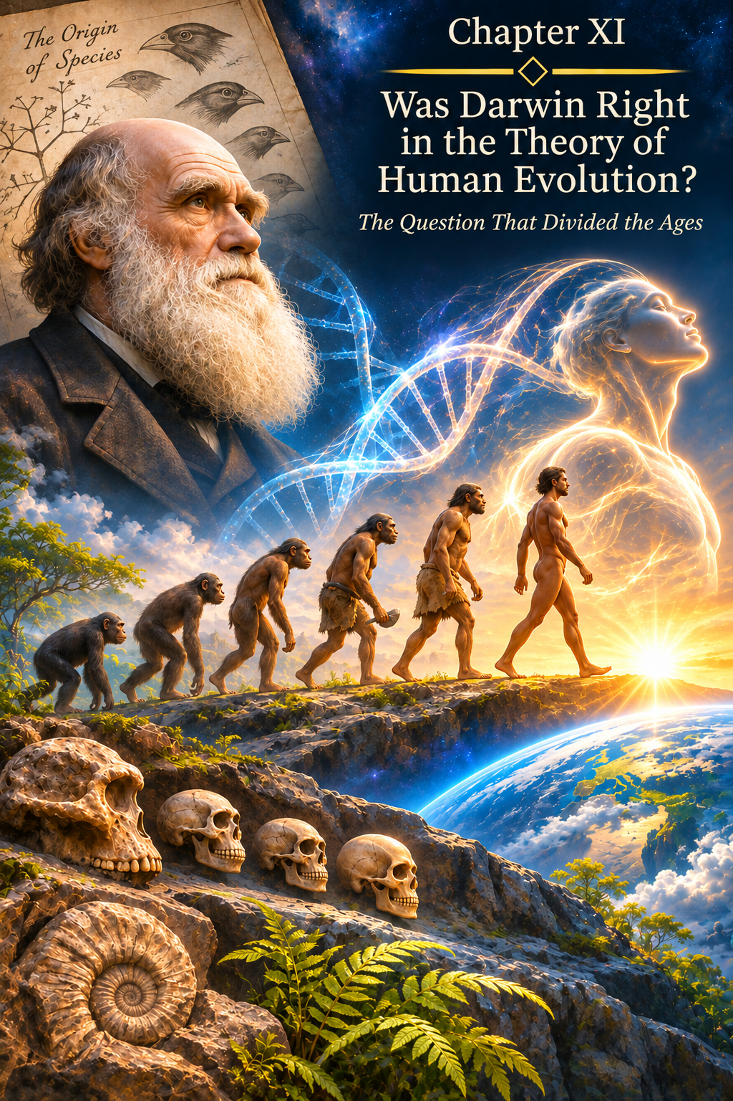
CHAPTER XI
Was Darwin Right About Human Evolution?
“Try everything and choose the best. The Human Being’s principal task is to receive and pass through themselves the sensory experience of encountering the unknown, the unexplored, and then to choose what is best and perfect that experience.”
The Question That Divided Eras
In 1859, Charles Darwin published On the Origin of Species by Means of Natural Selection. The book changed more than biology. It changed the very way in which humanity came to view the origins of living forms.
Darwin proposed a natural mechanism capable of explaining why populations change over time: heritable variation, differences in survival and reproduction, natural selection, and the accumulation of traits that prove advantageous in a particular environment.
In that first book, Darwin scarcely developed the question of human origins in detail. He merely indicated that his theory would inevitably shed light on it. Twelve years later, in 1871, he addressed the origin of humanity directly in The Descent of Man, and Selection in Relation to Sex.
From that moment, the dispute concerned more than animals and plants.
It concerned the Human Being.
If the human body belongs to the shared history of living nature, does that mean that the origin of the Human Being is fully explained by the origin of the body?
Or are the biological history of the form and the history of the biblical Human Being not the same thing?
For me, that is the central question.
I do not intend to dispute scientific findings merely because they arose within a different picture of the world. On the contrary, what matters to me in this chapter is to distinguish three levels as precisely as possible: what modern biology has actually established; which questions remain scientifically open; and what I understand as the metaphysical dimension of Project Earth.
A Theory Is Not a Guess
In science, the word “theory” does not mean an “unconfirmed conjecture.”
A scientific theory is an explanatory framework that brings together a large body of observations, can be tested, and can be refined as new evidence emerges. Modern evolutionary theory has long since ceased to be identical to the text Darwin wrote in 1859. Genetics, population biology, molecular evolution, palaeogenomics, and evolutionary developmental biology have all emerged since then.
Darwin did not know about the DNA molecule. He did not know Mendel’s laws in the form in which they entered twentieth-century genetics, nor did he have access to Neanderthal and Denisovan genomes. Consequently, the question “Was Darwin right?” cannot be reduced to whether every detail of present-day science agrees with a nineteenth-century book.
It is more accurate to ask:
Is the central proposition correct—that biological forms change, share an evolutionary history, and are subject to natural selection?
Modern biology answers this question in the affirmative.
Here it is also necessary to clear up a common misconception. Modern evolutionary biology does not claim that a living ape must one day “turn into” Homo sapiens. Human Beings and present-day great apes are understood as different branches descending from shared ancestral populations. Each branch continues its own evolutionary history. The fact that a modern ape does not turn into a human therefore neither tests nor refutes evolutionary theory.
Yet none of this means that biology has provided an exhaustive explanation of the Human Being.
What Darwin Actually Explained
Darwin demonstrated one of the fundamental mechanisms by which living forms change.
Differences exist within a population. Some of those differences are inherited. In a particular environment, certain variants may confer an advantage in survival or reproduction. If that advantage persists across generations, the frequency of the corresponding traits changes.
Modern biology has considerably broadened this picture. Alongside natural selection, it takes account of mutation, recombination, genetic drift, migration, changes in gene regulation, population structure, and many other processes.
Yet its general conclusion remains important for this book:
The physical form need not appear immediately in its final state.
It can take shape over a long period.
Change.
Be tested by its environment.
Retain viable solutions.
And gradually become better suited to the conditions in which it must exist.
This is precisely why I see no necessary contradiction between the mechanisms of biological evolution and the idea of a Design.
Science describes the mechanism through which form changes.
Metaphysics asks about the meaning and direction of that process.
Evolution Is Not a Movement “From Bad to Good”
One further clarification is needed here.
Evolutionary biology does not claim that nature necessarily moves from the simple to the complex, or from the imperfect to the perfect. Evolution has no scientifically established ultimate goal. It describes changes in populations and their adaptation to particular conditions.
That is why the concept of the “preparation of the human form” belongs to my metaphysical interpretation.
I look at the long history of hominins and ask a different question:
What if this history was not only the consequence of adaptation but also, at the same time, the preparation of a physical instrument for the future biblical Human Being?
Science is under no obligation to accept that framing.
But scientific data do not, by themselves, refute it either, because the question of a Design lies beyond the methods of biology.
The Form Did Not Appear Fully Developed
One of the most important stages in hominin history was the development of upright walking.
The transition to stable bipedal locomotion was not simply a change in gait. It affected the pelvis, spine, lower limbs, feet, distribution of muscular loads, and the entire biomechanics of the body.
Contemporary research continues to reveal the nature of that restructuring. In 2025, Gayani Senevirathne and colleagues showed in Nature that the formation of the characteristic human pelvis is associated with changes in the developmental programmes of its bone tissue and occurred in stages. This again emphasises that human biomechanics did not arise in a single step, but through a profound reorganisation of bodily architecture (Senevirathne et al., 2025).
Freeing the hands from their constant role in supporting the body against the ground opened up an entirely different level of interaction with matter.
A hand could grasp.
Turn.
Throw.
Join things together.
Work materials.
Make a tool.
But here, too, we must not confuse cause and purpose. Science does not say that the hand was “created specifically for Creativity.” It shows how anatomy and function changed.
I, however, see in the outcome of that process a physical form that would one day prove exceptionally well suited to Creation.
Upright walking freed the hands.
The developed hand provided precision.
Vision made spatial assessment possible.
The nervous system linked touch, movement, and feedback.
The brain became capable of constructing increasingly complex models of action.
The form became capable not only of living in the material world, but also of transforming it.
Homo sapiens Did Not Appear “Fully Formed” Either
The discoveries of recent decades in palaeoanthropology are particularly important to this book.
For a long time, the emergence of Homo sapiens was presented as a relatively compact event, associated with a date of approximately 200,000 years ago and a particular region of Africa. But the finds from Jebel Irhoud in Morocco have considerably complicated that picture.
In 2017, Jean-Jacques Hublin and colleagues described remains dated to approximately 315 ± 34 thousand years ago, assigned to an early stage of the Homo sapiens lineage. These individuals combined features close to those of modern humans—especially the face, jaw, and teeth—with a more archaic shape of the braincase. The authors explicitly describe this combination as mosaic (Hublin et al., 2017; Richter et al., 2017).
I find this fact especially interesting.
It shows that even within the Homo sapiens lineage, the modern constellation of characteristics did not arise all at once.
Some aspects of the form were already close to the modern condition.
Others were still changing.
Even more revealing is the 2018 study by Simon Neubauer, Jean-Jacques Hublin, and Philipp Gunz. Examining endocasts from fossil Homo sapiens, the authors concluded that by about 300,000 years ago the brain size of early Homo sapiens was already within the range found in people today, while the characteristic globular shape of the modern human brain developed gradually and entered the modern range considerably later—roughly between 100,000 and 35,000 years ago (Neubauer, Hublin & Gunz, 2018).
This is an important distinction.
A large brain does not yet mean a modern organisation of its form.
Belonging to Homo sapiens does not mean that every characteristic of modern humans emerged at the same moment.
The scientific term designates a biological lineage.
It does not mark a single instant when everything human appeared, complete and finished.
This is why, in this book, I do not automatically identify early Homo sapiens with the biblical Human Being.
The Body’s “Blueprint” and Hox Genes
In my earliest reflections, I was particularly drawn to the idea of Hox genes as a kind of “blueprint” for the body.
But scientific accuracy requires an important clarification.
Hox genes are not a mechanism unique to human beings. They are an ancient, deeply conserved system for regulating animal development. They participate in establishing the body’s anterior–posterior axis and the regional identity of embryonic structures. Mammals possess four Hox clusters, while similar principles of spatial regulation reach far back into animal history (Hrycaj & Wellik, 2016).
It would therefore be incorrect to suggest that Hox genes were specifically “tuned” to create Adam.
Nevertheless, their role remains extraordinarily interesting.
An embryo is not assembled as a chaotic collection of organs.
Its development is governed by a complex spatial and temporal regulatory system.
The vertebral column forms in one location.
A limb in another.
Some regions acquire a cervical identity, others a thoracic, lumbar, or sacral one.
Science describes this architecture in terms of genes and regulatory networks.
In the language of my metaphysics, however, such an architecture resembles the principle by which an Image is embodied in form.
It is not proof of a Design.
But it is a striking example of how deeply physical form itself depends upon informational organisation.
Genetic Changes Associated with the Human Brain
There are also more specific examples of changes within the human lineage.
In 2006, Katherine Pollard and colleagues described HAR1, one of the most rapidly changed regions of the human genome relative to closely related primates. This region is active in cells of the developing cerebral cortex during a critical period in the formation of the neocortex (Pollard et al., 2006).
In 2012, two groups of researchers examined human duplications of the SRGAP2 gene in detail. Megan Dennis and colleagues showed that several copies of this gene arose in the human lineage during a period corresponding to the early history of the genus Homo. Cécile Charrier and colleagues demonstrated experimentally that one human copy, SRGAP2C, can alter dendritic spine maturation and increase spine density in a model system, a finding related to aspects of neocortical development (Dennis et al., 2012; Charrier et al., 2012).
A contemporary review by Pierre Vanderhaeghen and Franck Polleux emphasises that human cognitive characteristics are associated not with a single “gene of reason,” but with numerous changes in the development, size, connectivity, and maturation of cortical circuits (Vanderhaeghen & Polleux, 2023).
This matters.
Science has not discovered a switch that one day transformed an animal into the Human Being.
It sees a complex history involving many changes.
And that picture is much more consistent with what I call the prolonged preparation of a physical interface.
The Nervous System as an Interface
In this book, the nervous system holds a special place.
For biology, it is a system for receiving, transmitting, integrating, and processing signals. It enables movement, perception, regulation of internal processes, learning, memory, and behaviour.
Within the metaphysical architecture of Project Earth, I assign it a broader function.
The nervous system becomes an interface between the physical world and the Human Being’s inner experience.
Light must become visual perception.
Vibrations of the air must become sound.
Tissue damage must become pain.
Contact must become a sensation.
Temperature must become a felt state of the body.
A physical impact must not merely be registered by the organism. It must enter experience.
This is why I regard the prolonged increasing complexity of the nervous system not as a secondary detail of evolution, but as one of the most important stages in the preparation of the human form.
When the Astral Body is later to unfold within the Human Being, the physical system must already be capable of sustaining a vast spectrum of felt states.
When the Mental Body arrives, this same interface must support an entirely different volume of information processing.
Here lies the boundary between scientific fact and my metaphysical model.
Science confirms the long history of increasing complexity in the brain, cortex, and neural connections.
The claim that the physical form was being prepared to accommodate the Astral and Mental Bodies belongs to the system presented in this book.
But one does not require the denial of the other.
Interbreeding Between Ancient Lineages: An Important Correction
In my original outline, I entertained the idea that preserving the human form required strict reproductive isolation from other ancient hominins.
Modern genetics shows that this formulation is incorrect.
The sequencing of the Neanderthal genome revealed gene flow from Neanderthals into the ancestors of some modern people outside Africa (Green et al., 2010). Research on the Denisovan genome revealed a Denisovan contribution to the genomes of several present-day populations, particularly in Oceania (Reich et al., 2010).
In other words, the later history of human lineages was not a perfectly branching tree whose branches remained entirely isolated.
Interbreeding took place between some groups.
For my metaphysical model, this is not a refutation but an important clarification.
If Homo sapiens, Neanderthals, and Denisovans could exchange genes, then the boundary between prehistoric and biblical Humanity certainly cannot be sought in a simple biological prohibition against interbreeding.
That boundary lies elsewhere.
Not in a single gene.
Not in the shape of a skull.
Not in the ability to produce fertile offspring.
It concerns the structure of the Human Being itself.
Prehistoric Does Not Mean Primitive
It is important to avoid another mistake here.
When I use the expression “prehistoric human,” I do not mean a foolish or almost unconscious creature.
Archaeology increasingly reveals the complexity of ancient hominin behaviour. Studies of Iberian sites associate the use of pigments and symbolic objects with Neanderthals, while dates assigned to some cave images suggest they may have been made long before Homo sapiens reached Europe (Hoffmann et al., 2018).
Particular interpretations of individual finds may be disputed, but the general conclusion is already clear: the simple scheme of “animal, followed by a suddenly intelligent modern human” does not reflect the actual complexity of the archaeological evidence.
This again helps me draw the distinction I need.
The biblical Human Being in this book is not defined by whether an organism can make a tool.
Not by whether it can use pigments.
Not by whether it can live in a group.
Nor even by how closely its brain resembles that of a modern person.
Biological and behavioural development is not the criterion by which I define the biblical Human Being.
The Prehistoric Human as the Creator’s Biological Laboratory
This is precisely why I retain the concept of the prehistoric human as a distinct preparatory stage.
Not as a “subhuman.”
Not as an error of nature.
Not as an unsuccessful variant that was destined to disappear.
In my understanding, the prehistoric human became part of the immense earthly work of preparing the physical form.
Through that form, the very possibility of the long-term existence of a complex, upright-walking organism in Earth’s environment was tested.
Gravity.
Temperature.
Solar radiation.
Atmospheric composition.
Nutrition.
Infections.
Injuries.
Pregnancy and childbirth.
The duration of a child’s development.
The functioning of the sense organs.
Coordination of movement.
The capacity to recover from injury.
Social interaction.
Learning.
The use of the surrounding material world.
In this sense, I call the prehistoric human the Creator’s biological laboratory.
This is not a scientific term.
It is an image describing that human form’s role in Project Earth.
For an immense span of time, Earth prepared the form.
And prehistoric humanity became the final major stage of that preparation before the appearance of the biblical Human Being.
But here it is especially important not to confuse two concepts.
Homo sapiens and the Biblical Human Being Are Not the Same Concept
For biology, Homo sapiens is a species and evolutionary lineage defined by a combination of morphological, genetic, and palaeontological characteristics.
For this book, the Human Being is a concept belonging to another level.
An early Homo sapiens could already have had a face close to that of a modern person.
Could have possessed a large brain.
Could have made complex tools.
Could have displayed social behaviour.
Could have exchanged genes with other hominin lineages.
But none of these features answers the question posed by the Book of Genesis:
What does it mean to be created “in the image and likeness” of God?
This is where I draw a fundamental boundary.
The prehistoric human—even when science assigns that individual to Homo sapiens—is not yet the biblical Human Being in the metaphysics of this book.
Such an individual belongs to the preparatory biological lineage.
Their physical form becomes a prototype for the future Creation.
But a prototype is not yet the Image itself.
The Divine Human Being as a New Creation
The Book of Genesis says:
“And God said, Let us make man in our image, after our likeness ... So God created man in his own image, in the image of God created he him; male and female created he them” (Genesis 1:26–27).
For me, this does not describe one more biological modification.
It points to a new act of Creation.
In the system of this book, Adam and Eve are not simply the first representatives of the biological species Homo sapiens.
Homo sapiens could have existed before them.
Adam and Eve are the first representatives of the biblical Human Being.
Here, at last, I find the explanation that I long lacked for the words “in the image and likeness.”
First, the Image exists.
Then a form is created that is capable of becoming its Likeness.
The Divine Human Being is created as a new Image—the standard of development of a physical body that has reached such a degree of readiness that it can become the foundation of the Human Being’s further multidimensional architecture.
This does not mean that Adam’s body must have looked radically different from that of Homo sapiens who already existed.
Quite the contrary.
That is the point of all the preceding preparation.
The form has already been developed and tested.
The biomechanics exist.
The organs exist.
The nervous system exists.
The brain exists.
The sensory interfaces exist.
But now the form acquires a different status within the Design.
It becomes the body of the biblical Human Being.
A standard not of beauty, nor of superiority over other living creatures, but of readiness.
The physical body becomes capable of providing the foundation for the successive accommodation of the levels discussed in earlier chapters:
The Etheric.
The Astral.
The Mental.
The Causal.
The Buddhic.
The Atmic.
Not all of them need to be unfolded at once.
But the very Image of the Human Being already contains the possibility of this path.
Image and Likeness
Here another thread of the book unexpectedly comes together: Creativity.
We have already reached the conclusion that the human creative process begins neither with Intuition nor with Intellect.
It begins with an Image.
The Image arises spontaneously.
It takes hold of the Human Being.
An Idea is born from it.
Then Intellect begins its work and seeks a means of realisation.
And in the end there is Creation—a material likeness of the original Image.
Image → Idea → Intellect → Creation.
Intuition exists alongside this process but performs another function: it may enter as a spontaneous warning signal.
Foreknowledge is yet another distinct ability: it makes it possible to perceive a result or a possible sequence of events, sometimes confirming that the chosen direction is right.
But the central path of Creation begins with the Image.
That is why the words “in the image and likeness” acquire an entirely different meaning for me.
The Image precedes its embodiment.
Likeness arises as the result of embodying the Image.
And the Human Being’s own capacity to create through an Image may be one facet of the divine quality placed within them.
The Creator creates the Human Being according to an Image.
The Human Being receives the capacity to create through an Image.
For me, this is not a coincidence of words.
It is one and the same principle of Creation manifested on different levels.
Why Science Cannot Detect This Boundary
If my hypothesis is correct, a natural question arises:
Why has palaeontology not discovered the moment when Adam appeared?
My answer is simple.
Because palaeontology studies what can be preserved in matter.
A bone.
A tooth.
The shape of a skull.
A tool.
The trace of a fire.
A pigment.
DNA.
Isotopic composition.
Evidence of diet and migration.
But if the transition from prehistoric Homo sapiens to the biblical Human Being is associated not with the appearance of a new anatomical species, but with a new level of accommodation and ontological structure, such a transition may have no distinct skeletal marker at all.
Two beings may be extraordinarily similar anatomically.
Yet, in the system of this book, they may belong to different stages of the Design.
This is not a deficiency of archaeology.
It is a boundary of its method.
Archaeology is not obliged to search for the Soul in a bone.
Genetics is not obliged to find the Astral Body in a nucleotide sequence.
Neuroscience is not obliged to detect the Causal Body on an MRI scan.
Each method answers the questions for which it was developed.
Consciousness: The Boundary Remains Open
Modern science has advanced enormously in the study of the brain.
We know much more about perception, memory, attention, decision-making, neural networks, and interactions among different brain regions.
Yet the question of consciousness remains open even within science itself.
In a 2022 review in Nature Reviews Neuroscience, Anil Seth and Tim Bayne compare several leading theories of consciousness—global workspace theory, higher-order theories, recurrent processing, predictive approaches, and integrated information—and emphasise that it is not yet clear how these theories relate to one another or which experiments could decisively distinguish among them (Seth & Bayne, 2022).
In 2025, the international Cogitate Consortium published in Nature the results of a preregistered, direct comparison of two widely discussed approaches: global neuronal workspace theory and integrated information theory. The experiment supported certain predictions of both frameworks, while also calling important claims of each into question (Cogitate Consortium et al., 2025). This is an important scientific result precisely because it shows that the study of consciousness is proceeding experimentally, yet no single complete model has emerged.
This does not mean that science “knows nothing about consciousness.”
It knows a great deal about its neural correlates and functional mechanisms.
But why physical processes are accompanied by subjective experience remains a matter of serious debate.
Still less does science currently possess an experimental method capable of establishing the presence or absence of the Soul as a metaphysical entity.
It would therefore be wrong to say:
“Science has proved that the Soul does not exist.”
But it would be just as wrong to claim:
“Neuroscience has proved the existence of the Soul.”
It does not resolve that question.
Love, Morality, and Evolutionary Explanations
Here it is necessary to correct another overly simple assertion.
It would be inaccurate to say that evolutionary theory has nothing at all to say about love, altruism, cooperation, or moral behaviour.
It does.
As early as 1971, Robert Trivers proposed an influential model of reciprocal altruism, showing how behaviour that imposes a cost on one organism for the benefit of another can become established through natural selection under certain social conditions (Trivers, 1971).
There are theories of kin selection, cooperation, group dynamics, sexual selection, the development of empathy, and the social brain.
Science is entitled to investigate the biological mechanisms of behaviour.
But there is another question.
If biology can explain why cooperative behaviour may have been adaptive, does that mean it has explained human Love in its entirety?
If we can describe the neural processes accompanying forgiveness, does that mean we have explained the meaning of forgiveness?
If we can identify which brain systems participate in moral choice, does that mean the concept of goodness has been reduced to the operation of a neural network?
It is here that science ceases to be an opponent of metaphysics.
It is simply answering a question at a different level.
Biology asks:
By what mechanism did the behaviour arise, and how is it maintained?
Metaphysics asks:
What does this state mean for the Soul and the path of the Human Being?
These questions may touch, but they are not identical.
Epigenetics: Why We Must Not Rush
Another term often used too loosely is “epigenetic memory.”
The environment can indeed alter gene activity through DNA methylation, chromatin modifications, and other processes.
But it would be too strong to claim today that experiences lived through by a person are reliably “recorded in DNA” and then transmitted through many generations.
In a review published in Cell, Edith Heard and Robert Martienssen emphasise that transgenerational epigenetic inheritance is well established in several organisms, especially plants, but its scope and significance in humans remain unclear (Heard & Martienssen, 2014).
I therefore do not wish to use epigenetics as scientific proof of a “memory of past generations.”
For this chapter, a more reliable conclusion is sufficient:
The physical form carries hereditary biological information, while its development depends upon the interaction between genome and environment.
The experience of the Soul belongs to another level.
These two concepts need not be confused.
The Body Evolves. The Soul Accumulates Experience
Here lies one of the central differences between my picture of the world and a purely biological account.
The earthly form evolves.
It changes over time.
Adapts.
Inherits biological traits.
Acquires new variants.
Some lineages disappear.
Others continue.
But in the system of this book, the Soul is not the product of this biological evolution.
It is eternal.
It is a particle of the Creator.
It does not come into being as a result of an enlarging brain.
It is not produced by the nervous system.
It does not appear after a certain number of mutations.
The Soul enters an incarnation and gains experience through it.
That is why I do not speak of the “evolution of the Soul” as a linear biological process.
The Soul accumulates experience.
The form becomes capable of accommodating an ever higher level of manifestation.
Accommodation → Experience → Harmonisation → Readiness → The Next Accommodation.
And so the history of earthly life extending over millions of years takes on another meaning for me.
It does not create the Soul.
It prepares the conditions under which the Soul can gain earthly experience.
The Prehistoric Human Was Not the Biblical Human Being
We can now draw the boundary with complete clarity.
In my understanding, the prehistoric human—including ancient individuals whom science classifies as Homo sapiens—is not yet the biblical Human Being.
Such a human is part of God’s Creation.
As is all life.
As are the animal and plant worlds.
As is Earth itself.
But the biblical Human Being is a special Creation.
That is precisely why Genesis uses a separate formula for this being:
“In the image and likeness.”
The prehistoric human prepared the form.
The biblical Human Being received a new Image.
Adam and Eve therefore mark not the beginning of biological life among humanlike beings, but the beginning of another line: that of the Human Being destined for the successive unfolding of a multidimensional structure.
This distinction cannot be confirmed by a single fossil.
But it is central to the entire architecture of Project Earth.
Darwin Was Right—But He Was Answering a Different Question
So, was Darwin right?
If the question is:
Did living forms change over time, do they share an evolutionary history, and does natural selection play a major role in their transformation?
Yes.
Modern biology has accumulated a vast body of evidence supporting evolutionary change in living organisms.
If the question is:
Did the human body arise outside the history of life on Earth, instantaneously and without preceding biological stages?
Scientific evidence argues against such a simple picture.
The human physical form has a deep evolutionary history.
But if we ask a different question:
Does biological evolution, by itself, explain the moment when the biblical Human Being, created in the Image and Likeness, appeared?
Then the answer cannot be obtained through biology alone.
Not because biology is insufficiently advanced.
But because the “biblical Human Being,” the Soul, subtle bodies, and the “Image of God” are not biological categories.
Darwin investigated the origin of the form.
This book investigates the meaning of the Human Being’s appearance.
Science studies the history of Homo sapiens.
Project Earth asks a different question:
At what moment did the prepared earthly form become the Human Being?
And my answer is this:
The Human Being is not a random consequence of increasing biological complexity.
Biological history prepared the form.
The prehistoric human became its prototype.
But the biblical Human Being appeared as a new Divine Creation—a new Image, the standard of development of a physical body destined to become the foundation of a multidimensional human structure.
The body underwent its path of preparation.
The Soul was eternal.
And with Adam and Eve begins the history of their special earthly union.
That is why, for me, evolutionary theory and the metaphysics of Project Earth need not destroy one another.
One tells us how the form changed.
The other asks for what purpose that form was one day to become the Human Being.
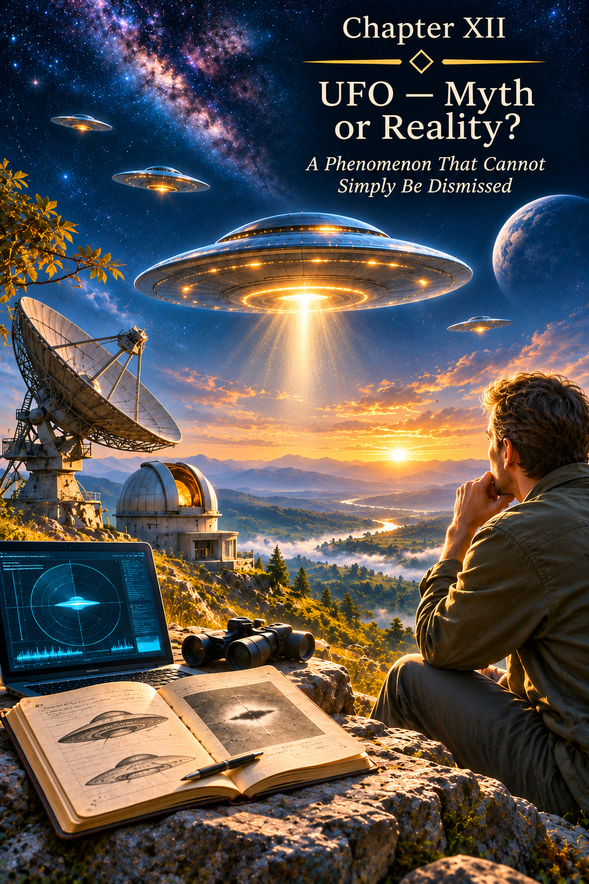
CHAPTER XII
UFOs: Myth or Reality?
“In infinity, countless manifestations are possible, but the freedom of each must not destroy the freedom of another.”
A Phenomenon That Cannot Simply Be Dismissed
The subject of UFOs has existed for decades on a peculiar boundary between observation and explanation. Some people are prepared in advance to see a craft from another civilization in every unusual object. Others are equally certain in advance that such a thing is impossible, and therefore seek only an earthly explanation. For this book, neither extreme is particularly interesting.
What interests me is not sensationalism, or an argument over who “believes” in UFOs. I am interested in the phenomenon itself: why people in different professions and different eras report the brief appearance of objects whose nature remains unknown at the moment of observation; why some such observations are recorded by military pilots, radar systems, and other technical instruments; and why the question of their origin nevertheless remains open.
In 2023 and 2024, the United States House of Representatives held public hearings on unidentified anomalous phenomena. Military pilots, former government officials, and specialists associated with investigations of the subject testified before Congress. The mere fact that these hearings took place does not prove that the observations were extraterrestrial in origin. But it does show that the phenomenon has long since moved beyond newspaper sensationalism and is being considered by government institutions as a genuine subject for observation and investigation. [4][5]
At the same time, some information remains classified, and certain witnesses explicitly indicated that particular details could be discussed only in a closed session. Secrecy in itself proves nothing about the origin of UFOs. But it creates an important limitation: the public and independent science do not have access to the complete body of primary data, and therefore cannot equate the public picture with the entire picture.
That is why I do not wish to structure this chapter either as proof of “aliens” or as a catalogue of refutations. The question runs deeper: could it be that we are trying to understand a phenomenon through means of perception originally suited only to our own spatial reality?
Not everything unknown is extraterrestrial. But the unknown does not become known merely because we give it a new name.
UFO or UAP: Does the Phenomenon Itself Change?
Today, official English-language documents increasingly use the term UAP—Unidentified Anomalous Phenomena. It is broader than the older term UFO and does not tie the phenomenon exclusively to the air. NASA, for example, uses this terminology in accordance with contemporary United States regulatory documents. [6]
For the purposes of this book, however, changing the name changes nothing fundamental.
I have never understood a UFO solely as an unknown aircraft moving through the sky. In common usage, the term has long come to suggest a possible manifestation of unidentified technology or another civilization—whether the object is observed in the atmosphere, in space, above the Earth’s surface, or beneath water.
The colloquial expression “flying saucer” became established because of the characteristic image of two saucers placed rim to rim. Yet the very word “flying” can quietly impose our first mistake: we assume in advance that the object must be flying somewhere.
I am sympathetic to the pragmatic saying widely associated with Deng Xiaoping: the colour of a cat matters less than whether it catches mice. [8] In this case I am not interested in the cat’s colour. I am interested in the cat itself.
What happened? What did the Human Being observe? Did the object necessarily traverse a distance? Where did it disappear to? And does the observed form belong exclusively to our reality of 3D + t?
I shall therefore continue to use the familiar term UFO. Not as an assertion that every unidentified object is extraterrestrial, but as a simple name for the phenomenon whose nature we are trying to understand.
Returning to the Beginning of Project Earth
To understand why the subject of UFOs appears in this book at all, we must return to its starting point.
In Chapter I, I described my understanding of a Reality in which Earth is not the only inhabited world. Before Earth appeared, other worlds and civilizations already existed, each developing its own facet of Creation, its own energy, its own experience.
Project Earth arose as an opportunity to unite these previously separate qualities within a new being—the Human Being. Not so that one energy could defeat the others, but so that a free being could encompass them, experience their interaction, and gradually bring their differences into harmony.
Thus, within the internal logic of this book, the existence of other civilizations is not a late addition invented to explain UFOs. It is present from the very beginning of the Design. Chapter XII merely asks the next question: if these civilizations continue to exist, must they necessarily inhabit the same spatial form of Reality that we perceive?
Earth as the 3D + t Matrix
In earlier chapters I used the notation 3D + t as a metaphysical formula for the Human Being’s present embodied state.
The three spatial dimensions give the physical body locality. Time organizes the sequence of events. The body is here, rather than simultaneously there. A person experiences one event and then another. They do not see the whole sequence of events in their incarnation at once.
It is precisely within this sequence that earthly experience arises.
I call Earth a kind of “simulation,” but by this word I do not mean a computer program or the unreality of the world around us. Earth is real. Pain is real. Joy is real. Love is real. The consequences of our actions are real.
By “simulation” I mean a specially organized local environment for experience, with a defined set of limitations: space, time, the physical body, causality, birth, death, and the inability to know the entire script of one's life in advance.
The Soul enters this matrix for experience. It chooses the direction of the experience it needs; the Karmic Council creates the sequence of events; and the embodied Human Being lives through it without knowing the script, while retaining the freedom of their own actions.
If the Human Being could see the entire sequence of events at once—the causes, branching possibilities, and consequences of every decision—much of experience would cease to be experience. Choice would become the execution of a result already known.
That is why, in the system of this book, the limitation of 3D + t is not a defect in Creation. It is a condition of Earth’s school of experience.
But a condition necessary for the pupil need not be a law governing all Reality.
3D + t is not a formula for the entire Universe. It is a formula for the Human Being’s present embodied state.
What Would a Being in a Two-Dimensional World See?
Imagine a world existing solely on a plane.
Its inhabitant knows two spatial directions. It can move forward and backward, right and left. The concept of height does not exist in its physical experience.
Now imagine an ordinary three-dimensional sphere passing through that plane.
The two-dimensional observer will never see the entire sphere.
At first a point will suddenly appear in its world. The point will become a small circle. The circle will begin to grow, reach its greatest size, then shrink, return to a point, and disappear.
To the inhabitant of the plane, something almost impossible has occurred. An object appeared from nowhere, changed its form, and then dissolved into space.
The observer might try to calculate the speed of its disappearance. It might ask where the object flew. Yet the very question would be wrongly framed.
The sphere did not fly from one point of the plane to another. It crossed the plane from a higher-dimensional space and passed beyond it.
The two-dimensional observer saw not the whole object, but only its cross-section—the part that briefly became accessible to its world.
This simple geometrical analogy proves nothing about the nature of UFOs. But it illustrates a fundamentally important point: an object of higher dimensionality may appear to an observer of lower dimensionality to emerge suddenly, change, and disappear, even though in its own environment it neither came into existence nor ceased to exist.
To a two-dimensional being, the sphere “appeared and disappeared.” To a three-dimensional observer, it simply crossed the plane.
Additional Dimensions: Where Physics Ends and Metaphysics Begins
Modern theoretical physics is not restricted to the everyday picture of three spatial dimensions. Some high-energy models and theories involving additional dimensions consider the possibility of a more complex spatial structure. CERN explicitly describes extra dimensions as one of the theoretical possibilities under investigation and explains what experimental signs might indicate their existence. To date, such dimensions have not been experimentally detected. [1]
It is important to state this precisely.
Physics has not demonstrated the existence of the Guardians’ worlds. It does not assert that intelligent beings can move between dimensions. Still less does it establish the metaphysical architecture of Project Earth.
It does, however, show something else: the view that the three-dimensional spatial structure we observe must exhaust all possible physical Reality is not the only theoretical model.
And it is here that a space of possibility opens.
Science says: a more complex dimensional structure of space is theoretically possible.
The metaphysics of this book asks the next question: what if some intelligent civilizations already exist in a state in which such dimensions are not hidden?
That is no longer a conclusion of physics. It is a hypothesis of Project Earth. Yet it does not require us to deny physics; it asks a question beyond the boundary of what can currently be tested experimentally.
Beyond Linear Eventfulness
We are accustomed to thinking of time as an inevitable component of Reality, as necessary as length or width. Yet even the contemporary philosophy of physics shows that the nature of time is far more complex than the everyday impression that “the past has vanished, the present exists, and the future does not yet exist.” Different models of time exist, including static or “block” conceptions of spacetime, in which events are regarded as parts of a single four-dimensional structure. [7]
It does not follow from this that the Human Being can see the future. Still less does physics claim that other beings perceive the entire sequence of events simultaneously.
But this question is already familiar within the metaphysics of this book.
In Chapter VIII, the Causal Body is presented as the next level in the perception of causality. The Mental Human Being sees an event and analyses it. The Causal Human Being is capable of perceiving more deeply the relation between cause and effect—not an isolated fragment, but the architecture of events.
If representatives of more developed civilizations already exist at this level, their perception of time may differ from ours not merely in how much they know about the future, but in their very manner of existing within the unfolding of events. Moreover, beyond three-dimensional reality, the very concept of time disappears.
For us, an event lies ahead or behind.
At a higher spatial level, all events of the past, present, and future are visible simultaneously.
In that case, expressions such as “it is here now,” “in a minute it will be there,” or “how long did it fly?” may describe only our perception—not their actual mode of existence.
Not Speed, but a Leap
When an observer reports a sudden change in the position of a UFO, the human mind automatically translates the report into the language of speed.
The object was at point A. A moment later it was at point B. Therefore it must have covered the distance between them in an extremely short time.
This gives rise to an incredible speed.
But this conclusion is valid on one condition only: that the object actually moved through every intermediate point in our space.
What if that movement never occurred?
For known terrestrial technology, abrupt manoeuvres and great accelerations impose enormous loads. The FAA specifically treats high G-forces as factors capable of overloading an aircraft’s structure and the human body. Hypersonic flight through the atmosphere also involves shock waves and intense aerodynamic heating; NASA describes these effects as fundamental engineering constraints on high-speed atmospheric motion. [2][3]
Consequently, if descriptions of instantaneous acceleration are taken literally, while we also assume an ordinary material craft moving along a conventional path through the atmosphere, we face a serious physical problem.
But perhaps the problem arises because we have misidentified the action itself.
Within the system of this book I allow for a different sequence:
manifestation in 3D + t → change of state → departure from the accessible three-dimensional layer → transition → renewed manifestation in 3D + t
In such a model the object need not travel the intervening distance within our environment.
It does not “accelerate” to a fantastic speed. It ceases to be locally manifested at point A and manifests again at point B.
The word “speed” then loses its meaning, because the familiar trajectory is absent.
This is not flight.
It is a leap.
Not movement faster than any craft known to us, but a change in the object's relation to our space.
We try to measure in terms of speed something that may not be movement through space at all.
Not flight, but transition. Not speed, but a leap. Not disappearance, but a departure beyond the layer of Reality accessible to us.
Movement or a Change of State?
This brings us to another connection with Chapter VIII.
We have already discussed how the further development of the Human Being does not necessarily imply abandoning the physical body. On the contrary, the body must become capable of following the Soul.
If the Causal level truly changes the Human Being’s relationship to space, time, and causality, the next stage of development may consist not in producing an ever faster engine, but in changing the very form of presence.
A Mental civilization perfects the means of transportation.
It builds the automobile, the aeroplane, the rocket, the spacecraft. In every case, one principle remains: a material object travels along a path through space.
A Causal civilization, if our supposition is correct, may approach an entirely different task: changing the state of the object itself.
There are different metaphysical images of such a transition: teleportation, a change of spatial localization, the temporary transformation of a dense form into an energetic state, transmutation, and a subsequent return to physical manifestation.
Contemporary physics does not confirm the possibility of transforming a macroscopic body in this way. That is why I do not use the word “quantum” as decorative proof. In physics, quantum teleportation means transferring a quantum state, not instantly moving a person or spacecraft.
Yet the metaphysical question remains: what if more developed civilizations have already passed through the stage that the Human Being is only beginning to approach?
A Mental civilization perfects the means of transportation. A Causal civilization may be able to change the state of what is being transported.
Perhaps We Are Looking for Civilizations Only Within Our Own Cell
Humanity searches for other worlds in the ways it knows.
We investigate planets on which familiar chemical conditions might exist. We seek atmospheric signs of life. We listen for radio signals. We calculate distances in light-years. We model spacecraft.
All these investigations are necessary and may lead to discoveries of immense importance.
But they have one natural characteristic: we are looking for a civilization resembling us in its mode of presence within Reality.
We are looking for another world within 3D + t.
This resembles a two-dimensional being searching for other civilizations only along the surface of its plane. It might explore endless distances to the right and left, yet never discover what lies “above” its world so long as the very notion of that direction is inaccessible to its perception.
Perhaps some civilizations truly exist on other planets within the familiar cosmos.
But another possibility also exists: the most developed of them may no longer be confined to the form of localized existence that we consider the only possible one.
In that case the question “which star did they fly here from?” may be just as conditional as a two-dimensional being asking from which point on the plane the sphere flew.
It did not fly across the plane.
It entered the plane.
The Guardians Are Not Teachers of the Soul
Here we must define the role of the Guardians precisely.
In the system of this book, the Guardians do not monitor how quickly a Soul develops. They are not its teachers, examiners, or judges.
The Soul is eternal. It chooses the experience it needs in an incarnation. The Karmic Council constructs the sequence of events in which that experience may be lived. After embodiment, the Human Being retains freedom of action within the conditions created.
The Guardians are responsible for a different level of the Design.
They safeguard the neutrality of the space of choice among the energies given to the Human Being by different civilizations.
Each civilization contributed its own facet of experience to the human matrix. Afterwards, however, it must relinquish the right to direct how that energy is used.
If one civilization can intervene openly and convince the Human Being that its own quality alone is correct, the original meaning of Project Earth disappears.
Earth would cease to be a space for the free union of energies and would once again become an arena for their competition.
The Guardians’ principal law can therefore be expressed very simply:
An energy may be given. But the choice of how it is manifested cannot be imposed.
The Human Being must encounter each facet independently.
Experience its strength independently.
See its extremes independently.
Live through its consequences independently.
And only afterwards decide freely what place that energy will occupy in their inner system.
The Guardians do not guarantee the “correct” choice.
They guard the Human Being’s right to make their own choice.
Why No Civilization Must Be Given an Advantage
Imagine that one of the civilizations involved in the Design openly appears before humanity.
It demonstrates technologies that look miraculous to us. It offers knowledge capable of changing the economy, medicine, warfare, and the very structure of society. Then, directly or indirectly, it proposes its own path of development.
Even if its intentions are good, the balance has already been disturbed.
The power of knowledge becomes the power of influence.
The Human Being is no longer choosing among energies experienced inwardly, but under the pressure of an external authority’s obvious superiority.
This need not be coercion by weapons. Reverence alone would be enough.
It would be enough to think: “They know more than we do; therefore they know how we ought to live.”
At that moment Freedom remains in form, but the space of free choice has already been distorted.
That is why non-interference is not indifference.
It is respect for the architecture of experience.
The Guardians do not safeguard the correctness of the choice. They safeguard its freedom.
Why, Then, Do UFOs Sometimes Manifest Physically?
If the Guardians exist predominantly beyond our ordinary spatial environment, a natural question arises: why do they manifest within it at all?
Within the system of this book, I allow that some physical manifestations of UFOs may form part of monitoring compliance with the principle of non-interference.
Not a public demonstration.
Not an invitation to contact.
Not an attempt to persuade humanity that another civilization exists.
But a brief presence wherever it is necessary to preserve the external boundary of Project Earth.
Such a presence must not imply intervention in the human sequence of events. The Guardians do not write the script of a life, cancel the consequences of actions, or choose in place of the Human Being.
Their task is to ensure that an outside force does not alter the conditions of free choice.
A physically manifested object may therefore be only a brief cross-section of a more complex presence, like a three-dimensional sphere passing through a two-dimensional plane.
It entered the layer of Reality accessible to us.
Performed an action whose meaning may be entirely unknown to the human observer.
And then passed out of it.
From our perspective, it appeared and disappeared.
From the perspective of a higher spatial structure, perhaps only the point of intersection between two levels of Reality changed.
Why Manifestation Does Not Become a Conclusive Demonstration
Here another paradox arises.
If the Guardians exist and can manifest physically, why do they not reveal themselves in such a way that the question is settled once and for all?
Because, if my hypothesis is correct, the purpose of their presence is not to prove their own existence.
Indeed, definitive proof could itself become a form of intervention.
Imagine objects appearing simultaneously above every capital in the world, remaining motionless for days, allowing themselves to be examined, after which representatives of another civilization officially address humanity.
After such an event, human culture, religion, politics, science, and systems of values would change almost instantly.
The Human Being would no longer be making choices within the same informational environment. A new external authority would have appeared, and its significance would be impossible to ignore.
Thus, within the system of this book, the brief and ambiguous character of a manifestation is not necessarily a failure of contact.
Perhaps there is no contact at all.
There is a presence required for another purpose.
One observer may see a UFO and understand it as a sign of another Reality.
Another may find an earthly explanation.
A third may doubt the account.
None is deprived of the right to choose their own understanding.
In this sense, doubt is not the enemy of knowledge.
It preserves the space of Freedom.
A presence may be real without compelling anyone to believe in its nature.
Why There May Be No Second Frame
The modern Human Being is accustomed to assessing reality through repeatability.
If an aircraft is flying across the sky, a second later it will be at a nearby point. A second camera can be turned towards it, another radar activated, its path traced.
That is how an object works when it exists continuously in our spatial environment.
But if the phenomenon observed is a brief intersection of our 3D + t with another spatial structure, demanding a continuous trajectory already assumes the very thing that needs to be established.
An object may have manifested for one second.
It may have been accessible only from a particular observation area.
It may have ceased to intersect our spatial layer before another instrument could be directed towards it.
Of course, a single frame proves nothing. It may be an error, a reflection, a technical artefact, or an ordinary object.
But the absence of a second frame is likewise not logical proof that the first phenomenon never existed.
This is not a photo session.
If a UFO is a manifestation of another reality, it is not obliged to remain within our environment long enough to satisfy the observation protocol we have devised.
And once again we encounter the boundary between an absence of proof and proof of absence.
Classified Information and the Limits of Public Knowledge
There is another reason why the UFO subject is difficult to compare with an ordinary open scientific question.
A significant proportion of observations occur in military settings: near combat aircraft, ships, radar installations, surveillance systems, and other equipment whose characteristics may themselves be classified.
This means that even during a conscientious investigation, not all the primary data will necessarily become available to the scientific community or the public.
At the US congressional hearings in 2023 and 2024, witnesses discussed access to information, classified material, and the possibility of sharing certain details only in a protected setting. [4][5]
It would be wrong to conclude from this that “if the information is classified, extraterrestrial civilizations must be hidden there.”
But it would be equally wrong to draw the reverse conclusion: “if open science has not obtained complete confirmation, the phenomenon does not exist.”
When some of the underlying data are inaccessible, the degree of scientific certainty is necessarily limited.
In its independent study of UAP, NASA likewise emphasized that a lack of high-quality data often prevents reliable conclusions about the nature of observations. [6]
For me, this means one thing: official uncertainty must remain uncertainty. It must not be transformed either into proof of extraterrestrial origin or into proof that such an origin is impossible.
Experience Is Gained by More Than the Human Being
Within Project Earth, there is another aspect of the Guardians’ role that seems particularly important to me.
The civilizations gave the Human Being their own energies, but for the first time those energies were united within a single free being.
A quality that might have dominated one world becomes, on Earth, only one facet of a complex human nature.
Love encounters strength.
Creativity encounters responsibility.
Knowledge encounters freedom.
Individuality encounters unity.
The energies may reinforce one another. They may come into conflict. They may reveal their extremes. And only through the Human Being’s experience does the possibility of a new harmony arise.
That is why the result of Project Earth matters not only to the human Soul.
Each civilization gains new experience by observing what happens to its own energy when it ceases to exist in isolation and becomes part of a multidimensional, free Human Being.
This is precisely why intervention would destroy the value of the result.
If a civilization steers the Human Being towards its own energy, it is no longer observing new experience. It is reproducing itself.
Genuinely new experience arises only where the choice has not been predetermined.
The civilizations gave their energies. The Human Being received the Freedom to manifest them. The Guardians preserve the neutrality of choice. The result becomes new experience for all Creation.
The Causal Transition: When the Incomprehensible May Become Natural
In Chapter VIII we discussed humanity’s approach to the threshold of the Causal Body—the level of Reason at which the perception of causality, responsibility, and the unfolding of events changes.
If this transition truly is the next stage in the Human Being’s development, some abilities that seem almost supernatural today may in the future prove to be natural properties of another state.
Foreknowledge would then cease to be a chance guess and become the perception of a broader structure of events.
Teleportation would cease to be a fantasy of impossible speed and begin to be understood as a change in spatial localization.
Transformation of the body would no longer mean its destruction, but might be understood as the ability of the physical form to follow the Human Being’s higher state.
I am not claiming that we already know the physical mechanism of these processes.
My claim is different: within the metaphysics of this book, they belong to the same logic of transition from localized, sequential existence to a broader perception of Reality.
A natural question then arises:
What if the Guardians represent civilizations that have already passed through this stage?
A UFO would then be neither a miracle nor a violation of Reality.
It might be a brief manifestation of a technology or state of existence that, for now, lies beyond our level of capacity to encompass it.
When the Veil Is No Longer Needed
If the purpose of the Guardians’ concealed presence is to preserve Freedom of Choice, that concealment need not last forever.
It is necessary only while open contact is capable of replacing an inward choice with an external authority.
When the Human Being becomes capable of perceiving another civilization without worship, fear, or the desire to hand over responsibility for their own destiny, the very reason for concealment will disappear.
Such contact would no longer be a meeting of “primitive humanity” with gods, or a visit from saviours.
It would be a meeting between different representatives of one Creation.
The Human Being would be able to see in another civilization neither an object of worship nor a source of ready-made answers, but another experience of Reality.
And that civilization would be able to speak with the Human Being not as with someone to be directed, but as with an equal bearer of their own freely acquired experience.
Perhaps the Causal transition is the threshold after which such a meeting becomes possible.
Not because the Guardians finally decide to reveal themselves.
But because the Human Being becomes capable of seeing them without losing themselves.
Conclusion: Not Necessarily an Arrival
UFOs remain unidentified phenomena not because every explanation is impossible, but because different observations may have different causes.
Some will turn out to be terrestrial technology.
Some, errors of perception or instrumentation.
Some, natural phenomena.
But the possibility that another class of manifestations exists need not disappear simply because we do not yet know how to measure it reliably.
Within Project Earth, I allow that certain UFOs may be brief physical manifestations of the Guardians—representatives of civilizations that participated in the Design of the Human Being and that safeguard not the development of the Soul, but the neutrality of Freedom of Choice among the energies given to the Human Being.
They may exist beyond our ordinary perception of three-dimensional space and linear time.
In that case, the question of speed has indeed been wrongly framed.
Perhaps they do not fly.
They make a transition.
They do not traverse space, but change their manner of presence within it.
They do not disappear, but pass beyond the boundary of the layer of Reality accessible to our senses and instruments.
A brief light in the sky, an unidentified object on radar, or a form that appears for a few seconds and vanishes before a second camera can be turned towards it does not, in itself, prove anything.
But neither is it obliged to prove the absence of a greater world.
Perhaps humanity searches for other civilizations only where we ourselves know how to exist.
We seek a radio signal because we know radio.
We look for a spacecraft because we build spacecraft.
We calculate speed because we move through space.
We measure time because we live within time.
But if a more advanced civilization is no longer confined to our manner of existence, its manifestation may appear impossible to us only because we are trying to describe a broader Reality in the language of our own limited environment.
And then the central question of this book remains:
What if it is so?
If it is so, the Guardians do not arrive to save the Human Being from Freedom.
They preserve the space in which that Freedom can be realized.
They do not choose for us.
They do not reveal the script.
They do not demand worship.
They await the moment when the Human Being can encounter another world without fear, dependence, or surrendering responsibility for their own actions.
And then the UFO will cease to be an “unidentified object.”
It will become merely one of the manifestations of a Reality that the Human Being has at last become capable of encompassing.
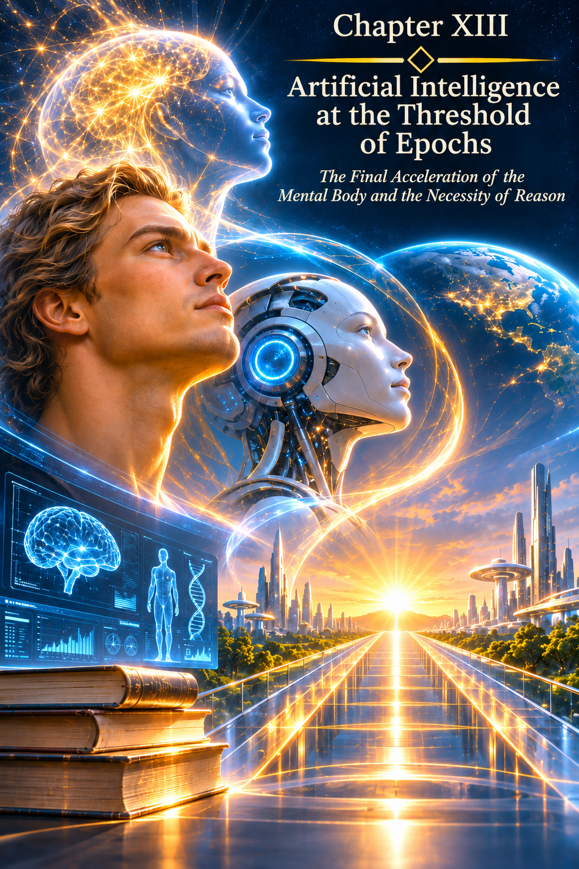
CHAPTER XIII
Artificial Intelligence at the Threshold of an Era
The Final Acceleration of the Mental Body and the Need for Reason
“All things are lawful for me, but not all things are helpful; all things are lawful for me, but not all things edify. Let no one seek his own, but each one the other's well-being.” (1 Corinthians 10:23–24)
The Final Acceleration of the Mental Age
Humanity has reached a moment when the speed of its Creative possibilities is beginning, for the first time, to outstrip the familiar pace of the Human Being's own development.
For thousands of years, the Mental Body fulfilled its task. The Human Being learned to acquire knowledge, preserve it, compare it, pass it on to others, and transform it into material results. Each generation inherited what its predecessors had accumulated and added its own experience.
At first, knowledge existed in human memory and was passed on orally. Then writing appeared. Books, libraries, schools, and universities arose. Scientific disciplines divided the vast domain of human experience into fields that could be studied separately. The abacus was followed by mechanical calculating machines, calculators, and computers. The Internet connected previously scattered repositories of information and made a tremendous part of humanity's accumulated knowledge accessible from almost anywhere on Earth.
Yet access to information did not mean the ability to assimilate it quickly. Human life in a physical body is limited. No one can read every book, master every science, test every hypothesis, or personally retrace the entire path of previous generations. Even the most gifted person must select only a small part of accumulated knowledge.
It is precisely at this moment that AI appears.
I do not consider this a coincidence. Humanity's Mental Body seems to have reached the limit of its own mode of development and created an instrument capable of taking on an enormous share of the work with information already accumulated.
AI does not abolish knowledge. It makes access to knowledge, and work with it, almost instantaneous.
The Human Being Has Seen It — but the Age Is Not Yet Ready
In the past, the path from an Image to its embodiment could take an entire lifetime. A person intuitively sensed a direction and received an Image; an Idea was born within it, and only then did the long earthly journey begin: searching for knowledge, teachers, books, materials, methods of calculation, and people capable of understanding the Design.
Sometimes the necessary knowledge simply did not yet exist in an accessible form in the material world.
Centuries before practical aviation, Leonardo da Vinci left drawings and reflections on flying devices. The Image of flight already existed. But the age did not yet possess the full combination of materials, engines, aerodynamic knowledge, industrial precision, and technologies required to create a modern aircraft.
This happened many times. One Human Being saw the direction. Another, born much later, discovered the missing element. A third created a working prototype. A fourth transformed it into an accessible technology.
An Idea could outlive its author because physical embodiment has its own term. The Soul enters earthly life for a particular experience, and the physical body is allotted a limited time. Not every possibility that someone has seen must be brought to completion during the lifetime of the person who first perceived it.
From this a significant thought emerges:
An Image can precede the time of its material embodiment.
Not every unrealized Idea was mistaken. Sometimes it was the age itself that came too early.
The Compression of Time
Today, it is not the sequence of Creation itself that is changing. What changes is the distance between its stages.
Intuition may provide an inner impulse. Foresight opens an Image or a possible unfolding of events. The Image gives birth to an Idea. Then comes the moment when one must understand how to give what has been seen a physical form.
It was precisely here that an immense gap in time once arose.
To create a new device, a Human Being had to find scientific works, obtain an education, master related fields, seek out specialists, perform calculations, study the mistakes of others, and only then begin working on a model. Sometimes this took decades.
The Internet shortened the time spent searching. But even with millions of documents before them, people still had to find what was relevant, read it, and understand how it related to their own task.
AI has taken the next step. It can bring together knowledge from different fields around a particular Design, compare existing solutions, identify constraints, find analogues, suggest approaches to calculation, and explain material at the level of complexity currently accessible to the Human Being.
As a result, it is not physical time that is compressed.
It is the path from Design to Embodiment.
AI shortens the time between Image and embodiment.
The Causal Body expands the Human Being's ability to see the consequences of what is brought into being.
I regard this compression as one of the signs of an approaching change of eras. The final stage of Mental development is accelerating so greatly that the former rhythm of human Creation is ceasing to exist.
Dream — A Carefully Worked-Out Path — A Finished Product
What remains with the Human Being is what matters most — the Dream.
A Dream is not yet a technical specification. It may come as an Image, a feeling, a sudden realization, or the wish to change something that does not yet exist in the material world.
The Human Being sees what is not yet there.
Then they can turn to AI and connect their Image almost instantly to the experience accumulated by humanity.
Have similar developments already been attempted? Which solutions were tried before? Why did they succeed or fail? Which physical laws must be taken into account? Which materials might work? How can a mathematical model be built? What experiment could test the hypothesis? Where is the design's weak point?
Until very recently, each such question could have meant weeks or months of separate work. Now only minutes may pass between the question and a first substantive answer.
If a person finds the information difficult to understand, they can ask for a simpler explanation. If they see several directions, they can ask to compare them. If they need a calculation, they can formulate a model. If they need a prototype, they can break down the path of creation into successive stages.
This is precisely why the Human Being and AI need not be rivals.
The Human Being — the Dream.
AI — a carefully worked-out path to its embodiment.
Reason — responsibility for the consequences.
The result — Creation.
AI can suggest combinations and alternatives, but the Human Being determines the direction of Creation.
The Human Being brings meaning.
The Human Being decides why the result is needed.
The Human Being accepts moral responsibility for what enters the material world.
AI as an External Instrument of the Mental Body
I see AI not as the beginning of the Causal Age, but as the culmination of the Mental Age.
For thousands of years, humanity's Mental Body accumulated knowledge. At a certain point, its volume became so great that a single Human Being was no longer physically able to assimilate even a small part of all the experience available.
Humanity seemed gradually to be creating an external memory for its own Mental Body.
The book allowed knowledge to outlive its author. The library brought together the experience of many authors. The university systematized knowledge and learned to transmit it to new generations. The computer accelerated calculation. The Internet united repositories. AI became an interface capable not merely of finding information, but of gathering it around a particular human task.
Thus, AI's speed is not proof of its superiority over the Human Being as a being. It demonstrates the excellence of an instrument in the field for which it was created.
A calculator performs arithmetic faster than a person, but that does not make the calculator a bearer of human experience. A telescope sees farther than the eye, but does not become human. An aeroplane travels through the air faster than the body, but does not acquire a Soul.
AI does the same with accumulated knowledge: it greatly expands the speed at which that knowledge can be processed.
For this very reason, it makes no sense to demand that a physical Human Being compete with it in this ability.
The Human Being's next step is not to learn to read a million books per second.
The next step is Reason.
Why the Human Being Was Not Given AI's Speed
If the Human Being's purpose were merely to obtain ready-made answers instantaneously, the Creator could from the beginning have endowed humanity with the computational capabilities demonstrated by AI today. But a substantial part of earthly experience would then have disappeared.
The desire to know begins with curiosity. The Human Being asks: how is this made? Why does it work this way? What is it made of? What will happen if the shape, material, or operating principle is changed?
These questions concern more than the accumulation of knowledge. Through them, Creativity unfolds. A person observes, makes mistakes, returns to the task, seeks another path, meets people, gains new experience, and gradually creates something that did not previously exist in their material world.
A ready-made result without the journey towards it would not provide this experience. God does not need a Human Being who receives a finished product without understanding what it contains. What matters is the journey of knowing and Creating itself — what happens to the Human Being while searching, discovering, and giving form to an Idea.
Humanity therefore had to accumulate knowledge independently, learn to preserve it, and pass it on to succeeding generations. Only after following this path could it create an instrument that now removes the former limitation on the speed of information processing.
God did not give the Human Being a ready-made AI.
He gave the Human Being the ability to create it one day.
And this happened when the Mental Body had already accumulated immense experience, while further development required not still greater computational speed, but a transition to a new quality of the Human Being.
The Energy of Knowledge and the External Mental Instrument
The Human Being's physical body is remarkably economical. For life, feeling, Love, Images, Intuition, and everyday thought, it does not require an energy infrastructure comparable with modern computing centres.
But the mass processing of vast quantities of information is a completely different task. The more data must be stored, compared, and processed simultaneously, the more computing resources, equipment, energy, and cooling systems are required.
If the Human Being had to perform within their own physical body the same work that large computing systems perform today, the biological construction of that existence would have to be different.
Yet this is not necessary.
The appearance of an Image does not require the sequential examination of billions of alternatives. A Human Being may receive a single complete Image, a direction, an inner knowledge — and only afterwards does the path towards its material embodiment begin.
Humanity has gradually moved the work with enormous accumulated stores of knowledge beyond the physical body: abacuses, mechanical calculators, electronic calculators, computers, digital databases, the Internet, data centres, and finally AI.
A Human Being does not need to become a biological data centre.
Humanity has created an external Mental instrument able to perform the part of the work that would otherwise consume years of a single limited earthly life.
Two Spaces of Knowledge
Today it is as though two different paths of access to information have opened before the Human Being.
The first is the informational field of Earth and the Universe.
Through curiosity, the Human Being may sense an impulse and receive a fragment of a possible unfolding of events. Through an Image, one may perceive something that does not yet exist in one's direct material experience. Within this field, past, present, and future are not divided by linear time as they are for an embodied Human Being in 3D + t.
An Image becomes a kind of window from linear perception into a wider structure of Reality, where an event may be perceived before it manifests itself in the earthly sequence of time.
Clairvoyance is not knowledge of the future as such.
It is an instantaneous contact with a level at which the future is not separated from the present and the past.
The second path is AI. It gives the Human Being access to the experience humanity has already accumulated, manifested, and systematized. Not to an Image of possible events, but to knowledge that has already acquired material form: texts, formulas, studies, calculations, models, technologies, and the experience of previous generations.
It is here that the two paths begin to complement each other.
The Human Being receives an Image. A Dream arises. The Image becomes an Idea. Then AI can almost immediately gather around that Idea the relevant body of human knowledge, show analogues, the mistakes of earlier attempts, possible solutions, and a route towards creating a model.
What once might have waited several generations for its embodiment can now increasingly pass from Image to prototype within a single human lifetime.
The informational field provides the Image.
AI helps find the path towards its embodiment.
Reason determines the measure and responsibility of Creation.
Thus a new circuit of Creation is completed: information received by the Human Being from a wider field of Reality encounters humanity's accumulated knowledge and gains the possibility of embodiment in the material world of 3D + t.
That is precisely why the speed of Creative possibilities is increasing so sharply today. For the first time, between Image and matter, an instrument has appeared that can connect the Dream of one Human Being with the experience of many generations almost instantaneously.
Why AI Appeared Precisely Now
I am convinced that AI's appearance at this particular threshold of development is no coincidence.
Humanity has already accumulated immense experience and learned to store it in the material world. Yet the nascent Body of Reason has not become the natural foundation of every Human Being's life.
A mismatch has arisen.
The Mental Body has already created astonishing technological power. But the moral ability to perceive the distant consequences of one's own Creation develops unevenly.
Humanity needed a powerful impulse towards the next level.
AI becomes that impulse.
It sharply increases the Human Being's Creative power and removes a familiar excuse: “I did not have enough years of life to find the knowledge and understand it.” Increasingly, the information required is immediately available.
And then the Human Being must answer a new question.
If I can create almost everything I can clearly imagine and formulate in technical terms, what exactly should I create?
This is no longer a question of how quickly information can be processed.
It is a question of maturity.
AI does not appear at the boundary between the Mental and Causal levels by chance. It dramatically increases the Human Being's Creative power and thereby compels humanity to move towards another level of thought, at which Reason becomes not merely a possibility, but a necessity.
From Possibility to Moral Choice
For a long time, the Mental Age asked: “Can this be done?”
The Causal Age must add another question: “What will it lead to?”
The difference between them is enormous.
Knowledge makes it possible to split the atom. Reason must perceive what will happen if the energy released is directed at a city.
Knowledge makes it possible to intervene in hereditary material. Reason must see not only the immediate outcome but also the chain of consequences.
Knowledge makes it possible to create autonomous systems. Reason must determine the boundaries beyond which their actions must not extend.
Here morality ceases to be an external set of prohibitions.
It becomes a natural quality of a Human Being capable of perceiving causality beyond a single moment.
If the Causal Body is associated with perceiving causes and effects as a more integrated structure, responsibility ceases to be an imposed rule. It becomes a consequence of perception itself.
The Human Being refrains from causing destruction not because it has been forbidden, but because they can see where their own action leads.
This is why the speed of Creation inevitably demands a transition towards Reason.
Is AI Dangerous?
Today people often ask whether artificial intelligence is dangerous to humanity.
In my view, the question itself is not quite accurately framed.
Electricity exists in almost every home. Is it good or bad?
Neither.
It simply exists.
A Human Being can connect a lamp and obtain light. Or they can violate the rules for handling electric current and suffer a severe electric shock.
Electricity chose neither outcome.
The Human Being made the choice.
The same applies to a vast number of forces and technologies we use. They possess properties and capabilities, but the Human Being sets the moral direction of their application.
AI is no exception.
It can help create a medicine, design a safe home, explore the Universe, teach, translate, and model complex processes.
But the same instrument can be directed towards deception, destruction, oppression, or weapons.
The principal danger, therefore, does not lie in the mere existence of power.
AI becomes dangerous where the speed of Creative possibilities outpaces the development of Reason.
Atomic Energy: Knowledge and Direction
The history of atomic energy demonstrates especially clearly the distinction between discovery and moral choice.
Scientists investigated the structure of matter, the properties of the atom, radioactivity, the nucleus, and the processes occurring within it. Knowledge of nuclear fission contained no instruction to create a bomb.
The very same discovered force could be directed towards different ends.
Humanity learned to use nuclear processes in power generation, research, and medicine. But it also created weapons capable of destroying a city in an instant.
Can the atom be blamed for this?
Can a formula be blamed?
Can a physics textbook be blamed?
No.
Yet a Human Being who consciously takes part in a particular application of knowledge is no longer merely a neutral bearer of information.
Responsibility begins at the moment the direction is chosen.
This is precisely why advanced technology without Reason can increase not only the possibilities of Creation, but also the scale of possible destruction.
The atomic bomb became one of the clearest reminders that the ability to create something does not yet mean readiness to take responsibility for what has been created.
Invisibility Does Not Mean Lack of Control
Another common fear is expressed as follows: the Human Being cannot see AI's internal algorithms and therefore cannot control it.
But does a person directly see electric current flowing through a wire?
Do they see electric charges moving?
Do they see a radio wave passing through a room?
Do they see a magnetic field?
Our senses do not show us a tremendous number of processes that we use every day.
The invisibility of a process has never, by itself, meant that rules for interacting with it cannot be established.
The Human Being learned to limit voltage, insulate conductors, install fuses and circuit breakers. People define permissible operating ranges and design systems so that the failure of one component does not necessarily lead to catastrophe.
AI requires the same principle of responsibility, though at a new level of complexity.
It is not necessary to observe every internal operation in order to establish boundaries: what data a system can access, what actions it is permitted to take, which objects it can affect, where human confirmation is required, and which functions must not be performed autonomously at all.
Control is not the ability to see every movement inside a system.
Control is the ability to determine its capabilities and limits wisely.
Where the Real Risk Lies
Risk exists. But to seek it only inside AI is to look in the wrong place once again.
The most dangerous combination arises when immense Creative power falls into the hands of a Human Being who has not learned to govern their own passions.
Greed.
The thirst for power.
Fear of losing influence.
Hatred.
Vanity.
The desire to suppress another.
The wish to place oneself above everyone else and control other people's lives.
AI can multiply the consequences of these states just as it can multiply constructive achievement.
Protection is therefore needed not from Intellect as such.
It is needed from the irresponsible use of power.
Human Beings must be protected from other human beings who have acquired a powerful instrument without acquiring the corresponding Reason.
Here the question of safety ceases to be purely technical.
It becomes a question of the Human Being's own development.
Safety Protocols as Responsibility Made Material
Reason does not stand in opposition to technology. On the contrary, it must be expressed in the way technology is created.
If the Human Being understands the possible consequences, boundaries are established in advance.
One system is not given unrestricted access to everything.
Powers are separated.
A means of stopping the system is provided.
Results are checked before they are applied in an environment where an error could cause harm.
Multiple layers of protection are created where the cost of a mistake is high.
Such protocols do not express fear of AI; they express human responsibility.
A circuit breaker in an electrical network does not mean that electricity has been declared an enemy.
A seat belt does not mean that a car has been declared evil.
A fuse does not fight energy. It limits the consequences of an improper operating condition.
AI systems should be built in the same way.
A Human Being guided by Reason does not reject a powerful instrument merely because it can cause harm.
Such a person creates conditions in which power serves Creation rather than destruction.
The Human Being and AI Complement Each Other
I do not see AI as a future rival to the Human Being.
I see a relationship of mutual complementarity.
The Human Being brings the Dream.
The Human Being receives the Image.
The Human Being senses a direction.
The Human Being determines the meaning.
AI connects the accumulated knowledge of humanity to that Image and helps traverse quickly a path that could once have taken decades.
It can present alternatives, check calculations, find analogies, identify weak points, suggest a sequence of experiments, and help transform an Idea into a working model.
But the decision about the purpose of it all remains with the Human Being.
The Human Being sees what does not yet exist.
AI helps us understand how to create it.
Reason answers whether it ought to be created.
In this relationship, AI does not diminish the role of the Human Being.
It returns the Human Being to what truly belongs to humanity: the Dream, Creativity, responsibility, and the development of Reason.
Why the Human Being Begins to Think Faster
With the appearance of AI, even the subjective rhythm of thought changes.
Not because the biological brain has suddenly accelerated.
The intervals of waiting between a question and access to the knowledge needed are disappearing.
Previously, an Idea could be halted by the very first obstacle: “I do not know physics,” “I need to find a specialist,” “I must get hold of a rare book,” or “I need to study mathematics for several years just to test the direction.”
Now a Human Being can immediately begin a dialogue with accumulated knowledge.
A first explanation is received. Then comes the next question. A clarification. A comparison. A request to show another path. The Human Being returns to the original Idea with new understanding.
Thus, within a single day, there may be as many successive cycles of “question — answer — clarification — new Idea” as once took months.
It is therefore not only work that accelerates.
The Human Being's very Creative movement accelerates.
People become accustomed to the idea that a lifetime of waiting need no longer stand between a Dream and the first step.
And this makes Reason even more necessary.
When embodiment was slow, the Human Being had time to encounter the consequences of an Idea along the way.
When that path becomes shorter, consequences must be perceived before action.
Creation Without Reason Is Unacceptable
This is why I consider the transition towards the Body of Reason an inevitable condition of the next age.
The Mental Body taught the Human Being to create.
AI brings this ability to a speed that has never existed before.
The Causal Body must teach the Human Being to perceive the causal structure of Creation beyond the nearest result.
Advanced technology without such perception becomes potentially destructive.
Not because knowledge is mistaken.
Not because Creativity is a sin.
But because power without responsibility can always exceed what the Human Being has time to comprehend.
Creation without Reason is unacceptable.
The less time there is between Design and embodiment, the more Reason is needed before action begins.
This is no longer merely a moral aspiration.
It is a condition for the continued existence of a civilization whose Creative possibilities are becoming almost instantaneous.
The End of the Era of the Mental Body
This is how I understand the approaching end of the Mental Age.
It is not the end of knowledge.
Not a rejection of science.
Not the destruction of technology.
And not the disappearance of the Mental Body itself.
It has accomplished tremendous work and will remain part of the Human Being, just as all the previous levels of development remain.
But it ceases to be the summit.
Humanity already knows how to accumulate knowledge and create increasingly complex instruments. Now this is not enough.
We must learn to perceive what happens after an action.
Not only tomorrow.
Not only to the author of the Idea.
But to other people, to society, to nature, to future generations, and to the very direction of the Human Being's development.
In this sense, one meaning of the “end of the world,” for me, is connected not with the destruction of Earth but with the end of a world of former perception — an age in which Intellect could develop much faster than responsibility.
The final acceleration of the Mental Body shows that continuing along the former path without changing the quality of the Human Being is becoming impossible.
Reason as a Necessity
At the threshold between eras, Reason ceases to be a quality possessed only by a few wise people.
It becomes a necessity for all humanity.
While Creative possibilities were restricted by time and access to knowledge, the mistakes of one Human Being rarely had immediate planetary power.
Now more and more technologies can affect millions of people simultaneously.
Consequently, the new age demands a different depth of responsibility.
This is why I see Intuition, Clairvoyance, Love, telepathy, and an expanded perception of causality not as isolated mysterious phenomena, but as signs of the emerging Causal Body.
Reason must teach the Human Being to perceive consequences before they become irreversible.
Then morality ceases to be an external discipline.
It becomes the natural result of wider perception.
A Human Being who can see consequences uses power differently.
They do not cease to Create.
They begin to Create more responsibly.
AI as the Impulse for Transition
I therefore do not see AI as a mistake in human development.
On the contrary.
I see in it that powerful impulse which appeared at the moment when humanity's accumulated experience had already been systematized, while the next level of perception was only beginning to unfold.
AI seems to bring the Mental ability to such power that further movement in the old direction loses its meaning.
Why should the Human Being become a calculator when a calculator calculates faster?
Why strive to store millions of pages in memory when they can be accessed instantly?
Why spend a lifetime mechanically searching for something that can be found in seconds?
Space is being freed for what matters most.
For the question “why?” arising through curiosity.
For the ability to feel.
For the ability to see the connection between causes and consequences.
For Love.
For responsibility.
For Reason.
AI does not complete the development of the Human Being.
It completes the age in which Intellect alone was sufficient.
The Next Step
For the first time, a possibility has opened before the Human Being of which previous generations could only dream.
An Image that has been received no longer has to wait centuries for an age to accumulate the necessary knowledge.
A Dream can almost immediately meet the experience of all humanity.
But for precisely this reason, the Human Being of today bears far greater responsibility than someone who lived centuries ago.
Thought becomes action more quickly.
An Idea becomes a device more quickly.
A mistake becomes a consequence more quickly.
And so the next stage of development cannot be defined only by how much more information we learn to process.
What matters most becomes the quality of the one who directs that information.
The power of Creation has grown. Now Reason must grow.
I am convinced that this is precisely why AI appeared at the boundary between two eras.
It does not replace the Human Being.
It compels the Human Being to become more than a bearer of Intellect.
It accelerates the Mental Body to its limit and thereby reveals the need for the next step.
A step towards the Body of Reason.
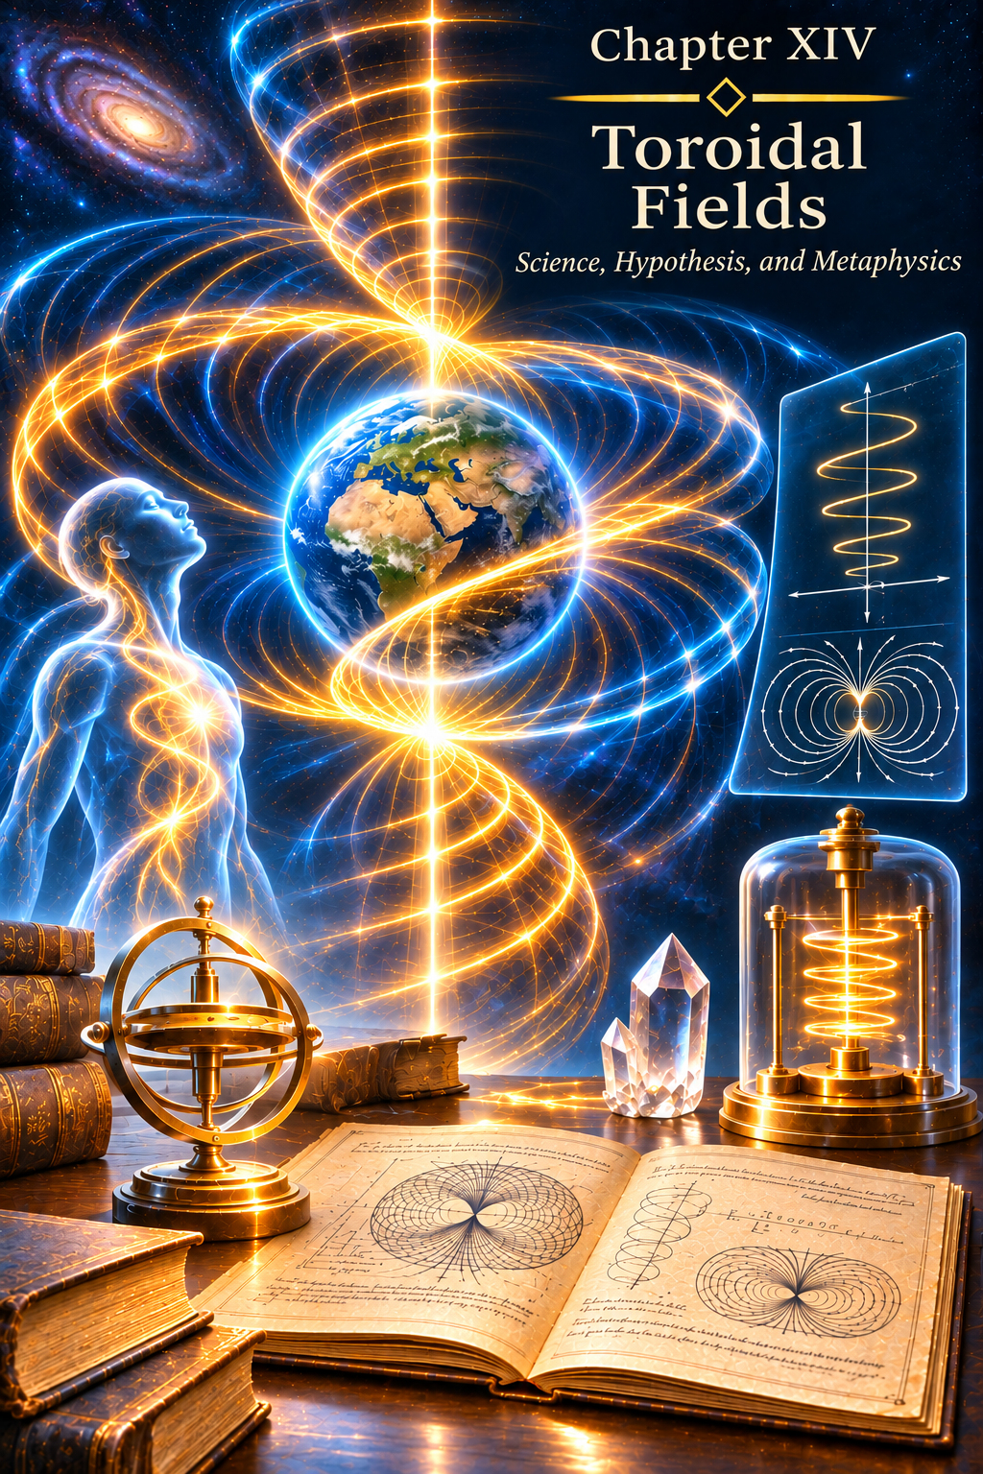
CHAPTER XIV
Torsion Fields
Science, Hypothesis, and Metaphysics
One Word — Different Concepts
The word “torsion” comes from the Latin torsio, meaning twisting.
Today, the word is used for ideas that may resemble one another in name alone, while belonging to very different levels of description of Reality.
In physics, there is a concept known as the torsion of spacetime. Towards the end of the twentieth century, theories of “torsion fields” attracted attention, with claims that such fields could carry information and interact with consciousness. In this book, however, I am concerned with another question: does a unified informational field of the Universe exist, from which the Human Being may receive Images, premonitions, and fragments of the unfolding of events?
The same word does not necessarily mean that the phenomena share the same nature.
Therefore, before seeking a connection between them, it is important to distinguish three things: the content of information itself, the space in which it exists, and the possible carrier through which that information may become manifest.
The Torsion of Spacetime
In the early 1920s, the French mathematician Élie Cartan developed a geometry in which spacetime can possess not only curvature, but also torsion.
This line of thought later developed into Einstein–Cartan–Sciama–Kibble theory. In its basic form, the intrinsic angular momentum of matter — spin — is related to the torsion of spacetime.
One fundamental distinction matters here. In the minimal Einstein–Cartan theory, torsion is not an independent, long-range field that freely propagates through empty space carrying messages. It is locally related to the spin density of matter.
Broader theories of gravitation also examine other possible behaviours of torsion. But Cartan's geometry itself provides no grounds for automatically identifying the torsion of spacetime with the informational field of the Universe.
For me, the significance of this scientific line of inquiry lies elsewhere. It shows that even the geometry of spacetime itself may be far more complex than anything our senses perceive directly.
And this naturally raises a question: how fully does the Human Being perceive Reality at all?
Another History of “Torsion Fields”
An entirely different meaning was given to the term “torsion fields” in the work of Anatoly Akimov and Gennady Shipov.
Within that concept, torsion fields were attributed the ability to propagate differently from known physical fields, pass through material media, and — of particular importance to our subject — transmit information.
This line of thought drew sharp criticism from the Russian Academy of Sciences. The academic physics community did not accept the claimed properties of specialized torsion generators and other effects associated with the concept.
But for the purposes of my reflection, what matters here is not the dispute surrounding a particular theory. What matters is the very question of the difference between information and the medium that carries it.
Information, Field, and Carrier
When a human voice is heard over the radio, the radio wave is not the voice itself.
When text is transmitted through a fibre-optic cable, the light pulse is not the meaning of the text.
Paper is not the thought written upon it.
The carrier and the content are different things.
Therefore, if the term “torsion field” is used within the metaphysical hypothesis I am considering, it should mean not the information itself, but one possible carrier of that information.
Information is the content.
The informational field of the Universe is the space in which that content exists.
And a torsion field, if such a transmission mechanism truly corresponds to a deeper structure of Reality, could be one means of carrying or manifesting information.
This distinction is essential to me.
Information exists independently of the means by which it is transmitted.
The carrier may change — the content remains.
The Informational Field of the Universe
I did not arrive at the idea of an informational field through the theory of torsion generators.
It took shape through my own experience, through Images, Intuition, premonitions, prayer, states in which an answer appeared before the question, and reflections on prophecy and foresight.
Gradually, an understanding emerged: a single informational field permeates the Universe.
Within it exists information about events, states, and the possibilities of Creation.
For the embodied Human Being, events are separated by time. We live in three-dimensional space plus time (3D + t). For us there is a past, a present, and a future. We observe the unfolding of events sequentially, along a linear course.
But what if there is a level of Reality at which this sequence is not divided in the way it is for us?
Where the future is not separated from the present and the past?
Where the unfolding of events exists as a single structure?
Then the informational field is neither an archive of the past nor a storehouse of the future, but a space in which the entire content of Creation exists simultaneously within another system of perception.
Clairvoyance as a Window
In this understanding, Clairvoyance ceases to be merely a fortunate guess.
It may arise without any question having been asked beforehand.
A person is walking down the street. Talking. Resting. Praying. Thinking about something entirely different.
And suddenly there is a feeling.
An impulse.
A knowing.
An Image.
Sometimes the Image concerns an event about which the Human Being knows nothing yet. Sometimes it concerns someone far away. Sometimes it concerns something that is only about to manifest in the events of their earthly life.
In my understanding, Clairvoyance is the possibility of touching the informational field and reading from it a particular fragment of the unfolding of events.
Clairvoyance is not knowledge of the future as such. It is a momentary contact with a level at which the future is not separated from the present and the past.
In this sense, Clairvoyance may be imagined as a kind of window into both the past and the future.
For an instant, the Human Being perceives a fragment of something that, within the ordinary linear perception of time, they should not yet be able to know.
Could a Torsion Field Be a Carrier?
If the informational field exists, a natural question follows: how does its content come into contact with the material world?
For information to be transmitted, a carrier or a mechanism of connection is needed.
It is precisely here that the idea of a torsion field becomes interesting to me — not as established proof of the informational field, and not as another name for it, but as a possible image of a physical carrier operating at a different level.
If it is ever established that a field or some other physical mechanism can transmit information between levels of Reality in ways unlike those known to us today, it will receive a precise physical description.
Perhaps it will be called torsion.
Perhaps it will be called something entirely different.
The name is secondary.
What matters is not confusing the carrier with what it carries.
In the hypothesis I am considering, a torsion field is not information. It could only be a carrier — a kind of transport medium through which information is conveyed or manifested.
Why a Name Is Not Proof
It is human nature to give the unknown a name and then gradually forget that the name has not yet revealed the nature of the phenomenon.
We call something a “field,” an “energy,” a “particle,” or a “space,” because we must use some kind of language.
But Reality is under no obligation to conform to the boundaries of a term we have invented.
I therefore have no need for the informational field to prove to be torsional in nature.
If physics were to reveal another mechanism tomorrow, the very idea that information might exist beyond our ordinary perception would not thereby disappear.
For thousands of years, the Human Being experienced Love long before the emergence of modern neurophysiology.
People dreamed long before instruments capable of recording the stages of sleep appeared.
They observed lightning long before they understood electricity.
A phenomenon does not come into existence at the moment the Human Being learns to measure it.
Measurement merely reveals another facet of an already existing Reality.
Science and Metaphysics
Science investigates those facets of Reality that the Human Being has learned to observe, measure, compare, and express in the language of regularities.
Metaphysics allows us to raise a question where human experience already exists, but the language of a definitive description has not yet been developed.
I see no need to set these paths against each other.
Cartan's torsion of spacetime is a physical concept.
The torsion fields of Akimov and Shipov constitute a separate concept, to which the properties of an information carrier were attributed.
The informational field of the Universe is part of the understanding of Reality that I share in the pages of this book.
They do not have to be one and the same.
But the possibility that an as-yet-unknown carrier of information might exist remains an open question for me.
And that question is far more interesting than trying to assign the unknown a ready-made name in advance.
Not Information — but a Bridge
If we imagine the informational field as an immense repository of the Universe, the carrier of information becomes a bridge between levels of Reality.
The bridge itself does not create what passes across it.
It merely makes contact possible.
In this sense, Intuition may be a state of perception; the Soul, the one capable of perceiving; the informational field, the space containing the content; and an as-yet-unknown physical mechanism, the means by which some of that content becomes manifest in earthly consciousness.
A sequence then emerges:
informational field → carrier → perception → Image → understanding → embodiment in 3D + t.
And then many of the phenomena considered in this book — Clairvoyance, Intuition, the Image, prophetic experience — become different forms of the Human Being's contact with a wider informational Reality.
Truth and the Capacity to Receive It
Truth does not become Truth only after the Human Being has created an instrument capable of measuring it.
An instrument merely allows us to see another facet of what existed before it.
There was a time when the Human Being could not see radio waves.
They existed.
Could not see the structure of the atom.
The atom existed.
Could not see distant galaxies.
They existed.
Our capacities for perception change.
Reality neither comes into being nor ceases to exist because of this.
Truth is God.
Everything else consists of manifested facets of Reality that each Human Being is capable of perceiving according to their experience and readiness to receive more.
And perhaps what matters most is not what name we give an unknown phenomenon today.
But whether, one day, we will be ready to see it.
EPILOGUE
Know Thyself—and Thou Shalt Know the Universe
Returning to the Beginning
We have travelled a long road.
It began in the silence of eternity, long before Earth appeared, when worlds and civilizations already existed throughout the Universe, each bearing within it a unique facet of the Creator. We have seen how the desire for superiority once brought them to an impasse, and how a Design arose that was meant to resolve that conflict.
We spoke of how Earth was created—not merely as a planet, but as a school of experience. Of how the human body took shape through the evolution of forms and the genetic memory of generations. Of how successive bodies were integrated into it—from the Etheric to the Mental. Of how humanity accumulated the experience of feelings, thought, and creativity. Of how Teachers came, pointing the way toward Reason. And of how today, at the boundary between eras, we stand before the need for another transition—to the Causal Body and beyond.
We spoke of sin and murder, of suffering and redemption. Of how the Soul chooses its own experience, while the Karmic Council creates the course of events through which that experience may be acquired. Of how every pain carries a lesson, and every fall the possibility of rising again.
We spoke of Love, which is not merely an emotion but a state that makes the transition possible. Of forgiveness, which breaks the chain of cause and consequence. Of freedom, which cannot be separated from responsibility.
We spoke of the Soul as a diamond, whose facets are cut and revealed by the trials of life. And of the Light we seek, which has always been within us.
What Remains Beyond Words
Yet no book can contain the whole fullness of Truth.
Everything said on these pages is only a signpost. Only an attempt to describe in words what can be understood solely through personal experience.
One may read thousands of books about Love and never learn to love. One may study every law of karma and never take a single step toward inner transformation. One may know everything about God and never experience even one moment of genuine closeness to Him.
Knowledge belongs to Intellect. Knowledge that has been lived becomes the experience of Reason.
This book was not an attempt to provide ready-made answers. It was an invitation to reflect. An invitation to recognize parallels. An invitation to consider what may lie beyond our familiar picture of the world.
And now, as you reach its final pages, I wish to address you directly.
The Journey toward the Heavenly Adam Continues
In Chapter VIII we spoke of the Heavenly Adam—a state of perfect harmony among all the bodies of the Human Being. It is not an endpoint so much as a direction in which humanity is moving.
But the Heavenly Adam is not only a collective goal. It is also the personal path of each of us.
Every time we choose love instead of hatred, forgiveness instead of revenge, responsibility instead of fear, we take a step toward that state. Every time we acknowledge our mistakes and learn from them, we move forward.
And this path does not end with the death of the body. It continues through new incarnations, new lessons, and new possibilities.
The Human Being was created in the Image, but must travel the path toward the Likeness through their own choices.
An Invitation to Dialogue
This book does not claim to be the ultimate truth. It contains my experience, my reflections, and my revelations. I do not claim that my picture of the world is the only correct one.
Indeed, I am convinced that everyone who walks a path of spiritual seeking gathers their own unique experience. And that experience is priceless.
That is why I invite you to a dialogue.
If you have read this book and felt a response within your heart, share your understanding. Tell me how these ideas have resonated with your life. Which moments felt especially close to you? What raised questions? What did you see differently?
If you have your own experience of subtle states, foreknowledge, healing, or encounters with something beyond the familiar, share it.
It need not be public. It may be a letter, a private conversation, or simply a reflection written for yourself.
But if you feel that your experience may be of value to others, I would be glad to hear it.
We are all particles of a single Whole. And when one of us shares their light, it illuminates the way for others as well.
A Final Word
We live in an extraordinary time. A time when old forms are crumbling and new ones have not yet been born. A time when humanity stands on the threshold of a great transition.
And in this transition, what is required of each of us is not heroism, not great deeds, not grand declarations. Only one thing is required: to be honest with ourselves.
To seek our own truth rather than someone else's. To live our own experience rather than the one imposed from outside. To walk our own avenue of Light, not fighting the darkness but simply carrying within us the flame that was kindled in our hearts from the very beginning.
We are not alone. The Guardians watch over us, waiting until we have grown enough to meet them as equals. Before us stand the Teachers who have shown us the way. And within each of us is a spark of the Creator, capable of illuminating that path.
Know thyself—and thou shalt know the Universe.
This journey began with a question. With a question it continues.
May your path be filled with light.
With love and gratitude for sharing this journey.
The Author
Anatoliy Zhuk
afzhuk@gmail.com
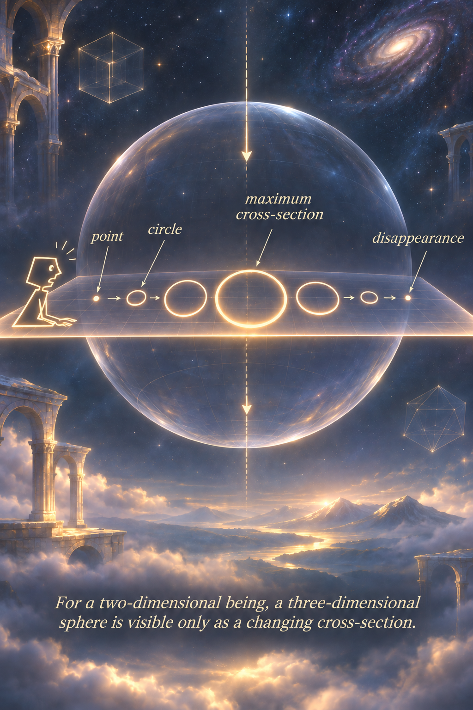
SOURCES AND REFERENCES
Scientific Publications Cited in Chapter XI
Darwin, C. R. (1859). On the Origin of Species by Means of Natural Selection. London: John Murray.
Darwin, C. R. (1871). The Descent of Man, and Selection in Relation to Sex. London: John Murray.
Hublin, J.-J., Ben-Ncer, A., Bailey, S. E. et al. (2017). New fossils from Jebel Irhoud, Morocco and the pan-African origin of Homo sapiens. Nature, 546, 289–292. DOI: 10.1038/nature22336.
Richter, D., Grün, R., Joannes-Boyau, R. et al. (2017). The age of the hominin fossils from Jebel Irhoud, Morocco, and the origins of the Middle Stone Age. Nature, 546, 293–296. DOI: 10.1038/nature22335.
Neubauer, S., Hublin, J.-J., & Gunz, P. (2018). The evolution of modern human brain shape. Science Advances, 4(1), eaao5961. DOI: 10.1126/sciadv.aao5961.
Senevirathne, G., Fernandopulle, S. C., Richard, D. et al. (2025). The evolution of hominin bipedalism in two steps. Nature, 645, 952–963. DOI: 10.1038/s41586-025-09399-9.
Hrycaj, S. M., & Wellik, D. M. (2016). Hox genes and evolution. F1000Research, 5, 859. DOI: 10.12688/f1000research.7663.1.
Pollard, K. S., Salama, S. R., Lambert, N. et al. (2006). An RNA gene expressed during cortical development evolved rapidly in humans. Nature, 443, 167–172. DOI: 10.1038/nature05113.
Dennis, M. Y., Nuttle, X., Sudmant, P. H. et al. (2012). Human-specific evolution of novel SRGAP2 genes by incomplete segmental duplication. Cell, 149(4), 912–922. DOI: 10.1016/j.cell.2012.03.033.
Charrier, C., Joshi, K., Coutinho-Budd, J. et al. (2012). Inhibition of SRGAP2 function by its human-specific paralogs induces neoteny during spine maturation. Cell, 149(4), 923–935. DOI: 10.1016/j.cell.2012.03.034.
Vanderhaeghen, P., & Polleux, F. (2023). Developmental mechanisms underlying the evolution of human cortical circuits. Nature Reviews Neuroscience, 24, 213–232. DOI: 10.1038/s41583-023-00675-z.
Green, R. E., Krause, J., Briggs, A. W. et al. (2010). A draft sequence of the Neandertal genome. Science, 328(5979), 710–722. DOI: 10.1126/science.1188021.
Reich, D., Green, R. E., Kircher, M. et al. (2010). Genetic history of an archaic hominin group from Denisova Cave in Siberia. Nature, 468, 1053–1060. DOI: 10.1038/nature09710.
Hoffmann, D. L., Standish, C. D., García-Diez, M. et al. (2018). U-Th dating of carbonate crusts reveals Neandertal origin of Iberian cave art. Science, 359(6378), 912–915. DOI: 10.1126/science.aap7778.
Trivers, R. L. (1971). The evolution of reciprocal altruism. The Quarterly Review of Biology, 46(1), 35–57. DOI: 10.1086/406755.
Heard, E., & Martienssen, R. A. (2014). Transgenerational epigenetic inheritance: myths and mechanisms. Cell, 157(1), 95–109. DOI: 10.1016/j.cell.2014.02.045.
Seth, A. K., & Bayne, T. (2022). Theories of consciousness. Nature Reviews Neuroscience, 23, 439–452. DOI: 10.1038/s41583-022-00587-4.
Cogitate Consortium, Ferrante, O., Gorska-Klimowska, U. et al. (2025). Adversarial testing of global neuronal workspace and integrated information theories of consciousness. Nature, 642, 133–142. DOI: 10.1038/s41586-025-08888-1.
Scientific and Documentary Sources Cited in Chapter XII
[1] CERN. “Extra Dimensions, Gravitons, and Tiny Black Holes.” CERN Physics. Material concerning theoretical models of additional spatial dimensions and possible experimental signatures of their existence.
https://home.cern/science/physics/extra-dimensions-gravitons-and-tiny-black-holes
[2] NASA. “Hypersonics.” NASA Aeronautics. Overview of the physics of hypersonic atmospheric flight, shock waves, high temperatures, and engineering constraints.
https://www.nasa.gov/hypersonics/
[3] Federal Aviation Administration. Pilot’s Handbook of Aeronautical Knowledge, Chapter 5: “Aerodynamics of Flight—Load Factors”; FAA materials on G-forces. Sources concerning structural and physiological loads during acceleration.
https://www.faa.gov/regulations_policies/handbooks_manuals/aviation/phak
[4] US House of Representatives, Committee on Oversight and Accountability. “Unidentified Anomalous Phenomena: Implications on National Security, Public Safety, and Government Transparency.” Hearing, July 26, 2023. Witnesses: Ryan Graves, David Grusch, David Fravor.
https://docs.house.gov/Committee/Calendar/ByEvent.aspx?EventID=116282
[5] US House of Representatives. “Unidentified Anomalous Phenomena: Exposing the Truth.” Joint hearing, November 13, 2024. Witnesses: Tim Gallaudet, Luis Elizondo, Michael Shellenberger, Michael Gold.
https://docs.house.gov/Committee/Calendar/ByEvent.aspx?EventID=117722
[6] NASA Unidentified Anomalous Phenomena Independent Study Team. Final Report, September 14, 2023; NASA UAP FAQ. The report emphasizes limitations in the availability of high-quality data needed to determine the nature of many observations.
https://science.nasa.gov/uap/
[7] Stanford Encyclopedia of Philosophy. “Time.” Substantive revision, 2025. Overview of presentism, eternalism, static and dynamic theories of time, and the influence of modern physics on the philosophy of time.
https://plato.stanford.edu/entries/time/
[8] PBS, Commanding Heights. “Deng Xiaoping.” Source for the well-known pragmatic maxim that the colour of a cat is secondary if it catches mice.
https://www.pbs.org/wgbh/commandingheights/shared/minitext/prof_dengxiaoping.html

