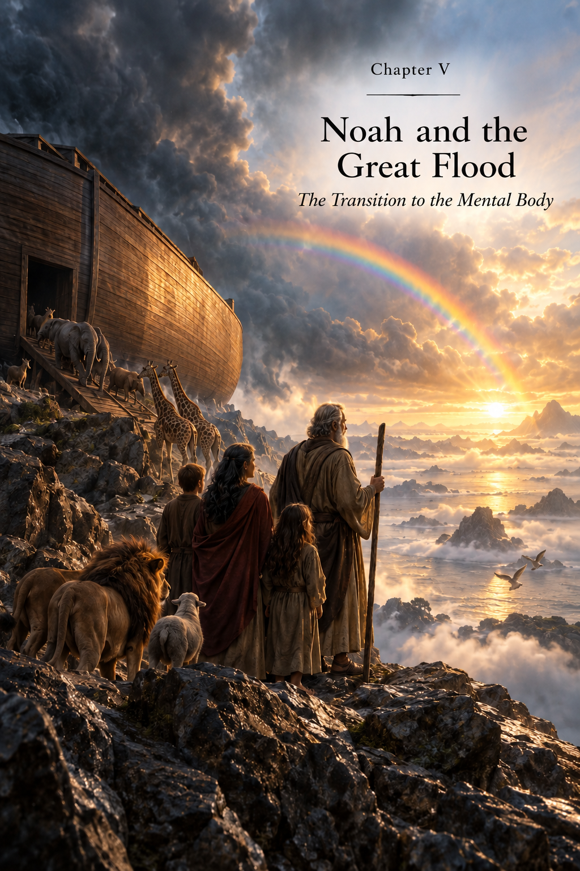

CHAPTER V
Noah and the Great Flood
The Transition to the Mental Body
The Flood Is Not a Punishment
The story of Adam and Eve opens, in this book, the age of the Astral Body — an age in which the Human learns to feel.
Love, jealousy, fear, compassion, anger, attachment, joy, and grief become part of human experience. The Human no longer merely exists within nature. He experiences his own existence.
But development cannot stop at feeling.
A moment comes when the Human must learn to understand what he experiences, to perceive the patterns of the surrounding world, to create an inner image of the future, and consciously transform matter.
For this, a new state is required — the Mental Body.
And it is precisely at the threshold of this transition that the image of Noah and the Great Flood appears in humanity’s ancient memory.
The biblical account of the Great Flood is traditionally associated with humanity’s moral corruption and with divine judgment.
Within the metaphysical system of this book, however, this image acquires another reading.
The Flood can be seen not as an expression of the Creator’s wrath, as though He had decided to destroy His own creation, but as a boundary between two states of the Human.
The preceding human form had fulfilled its task.
The Physical Body had been formed.
The Etheric Body sustained its vitality.
The Astral Body opened the world of feelings and enabled humanity to accumulate an immense emotional experience.
But the next stage required energy of a different level.
The arrival of this stage could not be postponed indefinitely.
The Creator does not punish the Human for not yet having become something else. A time comes when the form itself must be ready for the next state.
A New Energy
Each succeeding body does not merely add a new function.
It carries a higher energetic state.
The Etheric Body could be accommodated by a physical form prepared to sustain life.
The Astral Body required a form capable of withstanding the world of feelings.
The Mental Body was to open an entirely new capacity — thought.
But thought, in the human sense, is not merely passive perception.
It makes it possible to create an image of something that does not yet exist.
To compare.
To remember.
To analyze.
To build causal connections.
To choose among alternatives.
And, most importantly, consciously to change the surrounding world.
This is already an immense power.
Therefore, a form capable of accommodating the Mental Body had to be prepared not only physically, but through the whole preceding history of its development.
Why the Transition Is Dangerous
Higher energy is not a reward.
It is a load.
If a structure is unable to hold it, the new state does not develop that structure — it destroys it.
We have already encountered this principle before.
One cannot build another storey if the foundation cannot bear its weight.
One cannot endlessly increase the voltage in a system without changing the system itself.
In the same way, the human form had to reach a state in which the new energy could not merely be perceived for a moment, but could be stably accommodated.
Every new body is preceded by the readiness of a form capable of receiving it.
Noah
At this point Noah appears.
In the traditional account, he is set apart from the surrounding humanity and is given the possibility of saving his family.
Within our system, this may be read as the image of a Human whose physical and energetic structure was already prepared for the next transition.
Noah does not become chosen because the Creator arbitrarily preferred one person to all others.
He becomes the one through whom the human line can be preserved and continued in a new state.
This is a fundamental distinction.
Here, chosenness does not mean privilege.
It means readiness and responsibility.
Noah is preserved not because the other Souls have ceased to matter to the Creator. Through him, a form capable of continuing the next stage of human development with the higher-vibrational energy of the Mental Body accommodated within it is preserved.
Why the Family Is Preserved
Noah does not enter the Ark alone.
His family is preserved with him.
In biological terms, this ensures the continuation of the human race.
But within the logic of this book, its meaning is deeper.
The new age requires not the appearance of one exceptional Human, but the possibility of forming a new human generation.
One prepared form does not yet create humanity.
A line is needed through which the new quality can become a stable property of future incarnations.
Therefore Noah’s family becomes a bridge.
Through it, the human form continues to exist beyond the boundary of the Flood.
The Ark
The image of the Ark can likewise be understood more broadly than literal rescue from water.
The Ark preserves what must pass from the old world into the new.
Humanity does not begin again from absolute zero after the Flood.
Everything acquired before must be preserved.
The Physical form.
Vital energy.
Instincts.
Astral experience.
The continuity of generations.
The memory of the human path.
The next stage does not destroy the preceding ones.
It is built upon them.
The Ark becomes an image of carrying accumulated experience across the boundary between ages.
What Happens to the Others
If the Flood is a transition rather than a punishment, an inevitable question arises: what happens to those whose physical bodies are unable to cross this boundary, unable to receive the energy of the higher plane?
Within the system of this book, we must distinguish the Soul from the form of its earthly incarnation.
The Physical Body belongs to the material world.
It is born, changes, and disintegrates.
But the Soul is not exhausted by a single physical body.
It is part of the Creator and continues its path beyond one earthly life.
Therefore, the destruction of the former physical form does not mean the destruction of the Human himself.
The Souls of those who could not pass through the transition in their former bodies are given the possibility of incarnating again — now in human forms of the new state.
Thus the experience already acquired is preserved, while the instrument through which that experience continues is changed.
The Flood does not destroy the Soul. It brings to an end the existence of a form that no longer corresponds to the stage that is beginning.
Not Punishment, but the Inevitability of Change
Here, for the first time, one of the principal laws to which we will return more than once becomes especially clear — the Inevitability of Change.
In development, moments arrive that cannot be cancelled.
One can prepare for them.
One can resist them.
One can try to hold on to what has been.
But the transition itself comes when its time arrives.
A child cannot remain a child forever.
A seed cannot remain a seed indefinitely once the process of growth has begun.
And humanity cannot remain forever fixed in one energetic state.
The Human is free to choose how to pass through change. But the Human is not free to cancel change itself.
This does not abolish freedom.
Freedom exists within Law.
The Human chooses his attitude.
He chooses his action.
He chooses the degree of his own readiness.
But he does not determine whether the development of Creation itself will continue.
Why Change Cannot Be Forced
The Inevitability of Change has another side as well.
If a transition whose time has come cannot be postponed indefinitely, neither can it be accelerated with impunity before readiness has been achieved.
Higher energy introduced into an unprepared structure can destroy it.
Therefore, the very process of Creation contains sequence.
First the foundation is formed.
Then it receives experience.
Then it is harmonized.
Only after that does the possibility arise for the stable accommodation of the next level.
One cannot skip a stage without living through that for which it was created.
This is why humanity needed a long Astral age.
Feelings had to become part of the Human before he received an Intellect capable of multiplying the consequences of those feelings.
After the Flood
After the transition, a new stage begins.
The Human continues to feel.
But now he gradually acquires the ability to observe his own feelings and the surrounding world.
He begins to compare.
To notice repetition.
To remember patterns.
To transmit accumulated knowledge.
To create increasingly complex inner images.
Gradually there is born what will become the principal instrument of the new age — the Intellect.
If the Astral Body opened the question:
What do I feel?
then the Mental Body adds:
What does this mean? Why is this happening? What can I do?
This is a fundamentally different level of interaction with the world.
Intellect
Intellect enables the Human to work with information.
It can receive information through the senses, retain it, compare it, analyze it, and turn it into a decision.
The Human no longer has to begin every experience from the beginning.
He can remember.
Learn.
Pass knowledge to another.
Create a system.
Predict a result.
Choose the most effective option.
Thus begins the gradual movement from simple adaptation to the surrounding world toward its conscious transformation.
But an important boundary must be drawn immediately.
Intellect is not a source of information. It is the capacity to work with information.
It is rational.
It analyzes.
It creates alternatives.
It seeks a solution.
And it is precisely this capacity that will open to the Human the previously unseen world of Creativity.
A New Danger
But together with Intellect, a new danger arises.
The Mental Body does not abolish the Astral Body.
The Human continues to love and hate.
To fear.
To be jealous.
To desire.
To strive for power.
The difference is that his feelings now receive an extraordinarily powerful instrument.
Anger armed with Intellect can create weapons.
Fear can build a system of suppression.
Greed can devise methods of endless accumulation.
The desire for superiority can create mechanisms of power over others.
But the same Intellect, joined with love, curiosity, and the desire to create, can build a home, write music, create a medicine, and explore the stars.
The new body does not automatically make the Human better. It expands the space of his freedom and the power of the consequences of his choice.
The Mental Age
From this moment begins the age in which humanity will gradually learn to create civilization.
Complex tools will appear.
Writing.
Mathematics.
Architecture.
Philosophy.
Science.
Art.
Technology.
The Human will investigate the Earth ever more deeply and transform it ever more actively.
He will learn to preserve knowledge so that the experience of one generation becomes the starting point of the next.
The pace of development will multiply.
But responsibility will grow with it.
Because the capacity to create inevitably raises the question of what the new is being created for.
Each New Body Accommodates the Previous Ones
The transition after the Flood does not turn the Human into a purely Mental being.
All his preceding history continues to live within him.
The Physical Body preserves the connection with the material world.
The Etheric sustains life.
The Astral continues to feel.
The Mental begins to think.
And further development now depends not only on the strength of each level, but on their ability to exist together.
If Intellect is completely subordinated to fear, it amplifies fear.
If feelings are separated from an understanding of consequences, they continue to govern action.
If physical desires become the sole purpose of Intellect, civilization turns all its knowledge into a means of satisfying material needs.
Therefore, the further task is not to displace the lower bodies.
It is to harmonize them.
The evolution of the Human is not the replacement of one body by another, but the successive expansion of the capacity to accommodate an increasingly complex wholeness.
From Feeling to Thought
Thus, within the system of this book, the Great Flood becomes not a story about the end of humanity, but a story about its continuation.
One form of existence comes to an end.
Another begins.
Astral experience does not disappear.
It becomes the foundation upon which thought begins to develop.
The Human, who previously experienced the world primarily through feeling, now gains the possibility of investigating it.
He no longer merely fears thunder.
He begins to ask why thunder occurs.
He does not merely rejoice at the harvest.
He tries to understand what the harvest depends upon.
He does not merely look at the stars.
He begins to seek the pattern of their movement.
The question “What do I feel?” is gradually supplemented by the question “Why?”
And with this question a new human age begins.
Noah carries across the Flood not only human life. He carries the Human to the threshold of thought.
Before the Age of Creativity
The Mental Body will give the Human a capacity he did not previously possess on such a scale.
He will be able to create within himself an image of the future and embody it in matter.
The Earth will become not only his home, but also his workshop.
Stone will become a tool.
Clay — a vessel.
Ore — metal.
Metal — a mechanism.
Observation — knowledge.
Knowledge — technology.
Thus the Human will gradually begin not only to live within Creation, but himself to become a participant in the creative process.
But together with this power, a new question will arise, one that will one day bring him to the next boundary:
If I am capable of creating this — does that mean I should create it?
Intellect alone will no longer be able to answer this question.
But before then, humanity still had to pass through the entire great age of the Mental Body — the age of Intellect and Creation.

