Merging Data with Power BI (Power Query)
Data: Best and worst US states for retirement
April 21, 2024

Objectives:
- To extract 2 datasets from a website and load them into Power BI
- To cleanse the data
- To merge the 2 datasets and apply left join.

- Load data from spreadsheet
We will upload data about ranking of different US States in terms of affordability, well-being, culture & diversity, weather and crime.

- Go to https://www.bankrate.com/retirement/best-and-worst-states-for-retirement/
- Scroll down the page to the table as shown below. Click Download data.
Filename: Sheet 1.csv

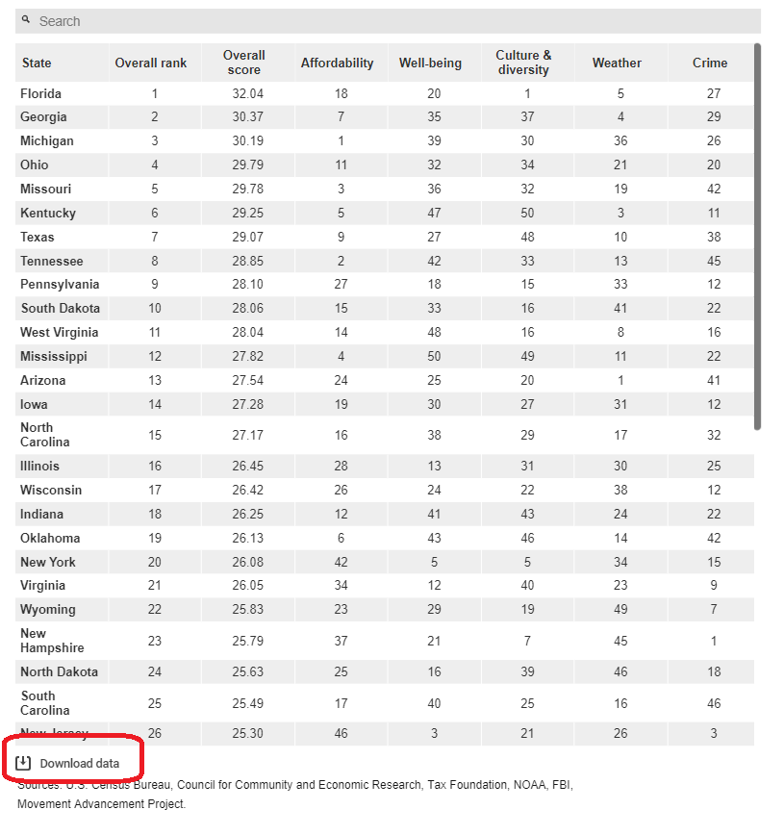

- Launch Power BI.
- Go to Home -> Get Data -> Text/csv. Select Sheet 1.xls. Click Transform Data.
- Check if the data types are correct.

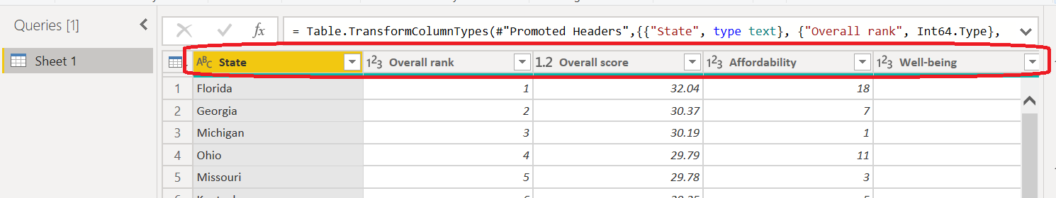

- Rename the query to States for Retirement.

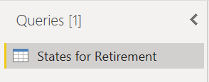

- Click Close and Apply.
- Save your project file.

- Load the data from web
We will load 2 columns from the data - US States and their abbreviations.
- Go to Home -> Get Data -> Web. Click Connect.
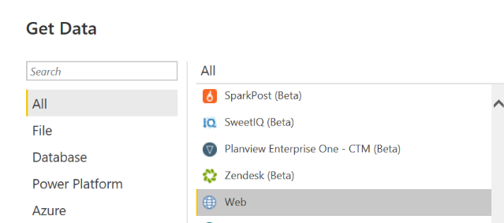

- In the dialogue box, paste the URL - https://en.wikipedia.org/wiki/List_of_U.S._state_abbreviations and click OK.

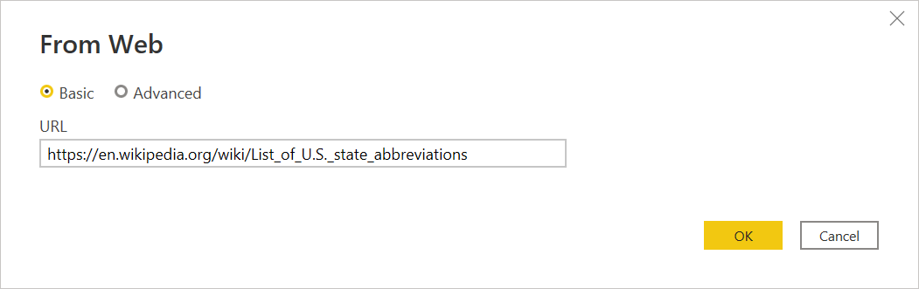

- If Access Web Content pops up, make sure Anonymous is selected at the left panel. Click Connect.
- Select Codes and abbreviations for US states, … Click Transform.

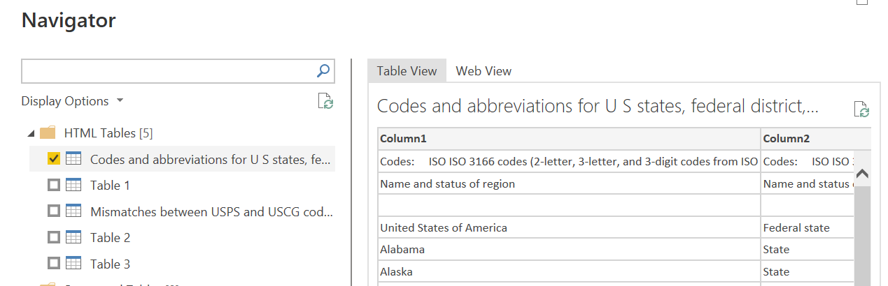

- Cleanse the data
- Go to Remove Rows -> Remove Top Rows. Indicate 3 rows. Click OK.
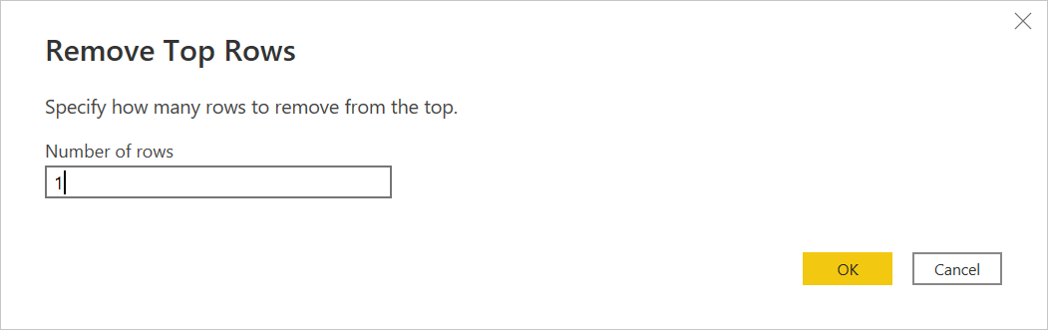
- Click Use First Row as Headers.

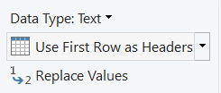

- We only need the 3 columns United Stated of America, Federal State and US.
Click Choose Columns -> Choose Columns.

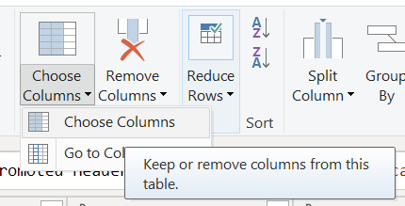

- Check these columns and click OK.

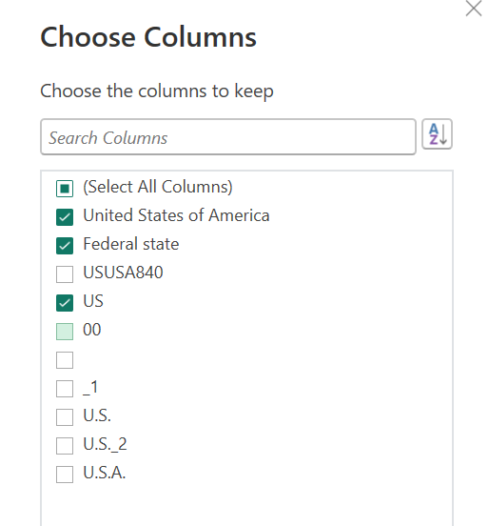

- Filter the data to display all States only. Click the down arrow next to Federal State. Click Text Filters -> Equals.
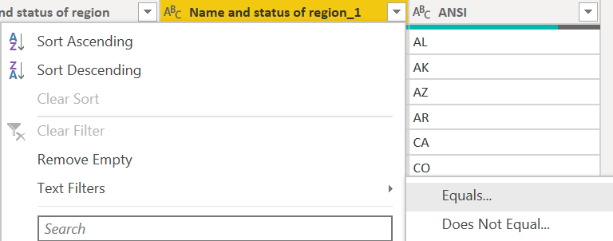

- Filter the rows to be equal to “State”. Click OK.
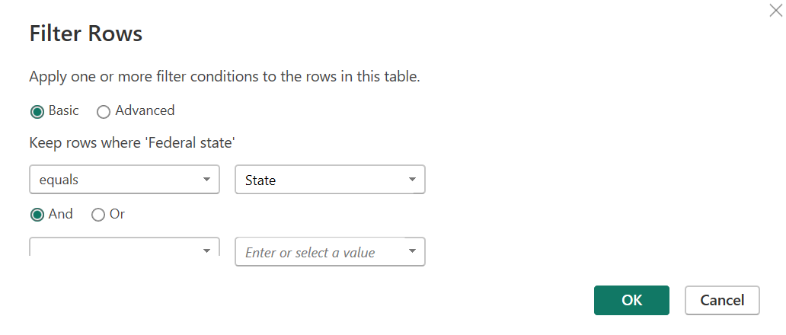

You should now only have 50 rows.

- Click Close & Apply. Save your project file. You now have 2 query tables loaded into Power BI.

- Merge the queries – Left Join
- In Power Query Editor, select the States for Retirement.
- Go to Combine -> Merge Queries -> Merge Queries as New.

In the Merge window, only the first query is selected.
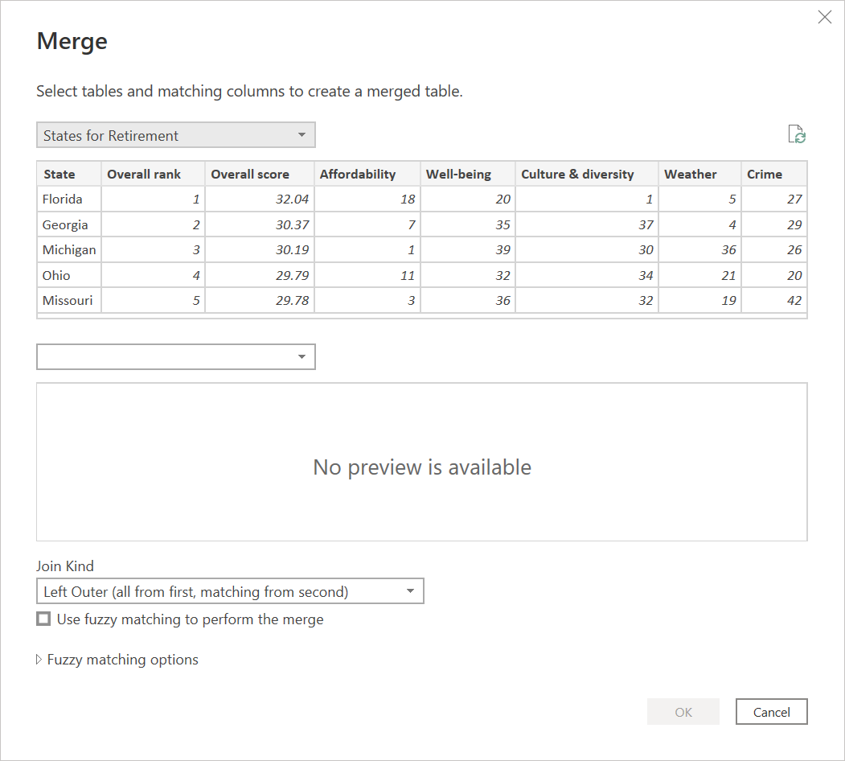
- Select the second query. It now displays the rows.
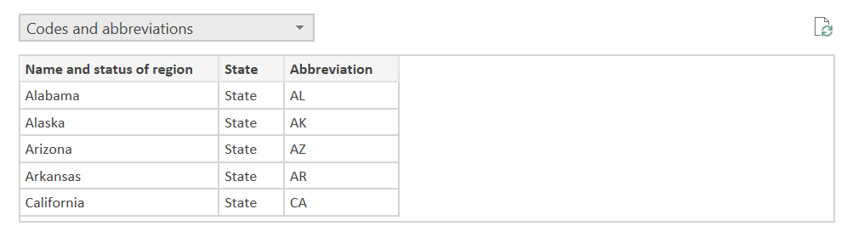

- Select the State from States for Retirement. (The State column is your primary key in this table query.)
Select Name and status of region from Codes and abbreviations. (The Name and status of region column is your primary key in this table query.)
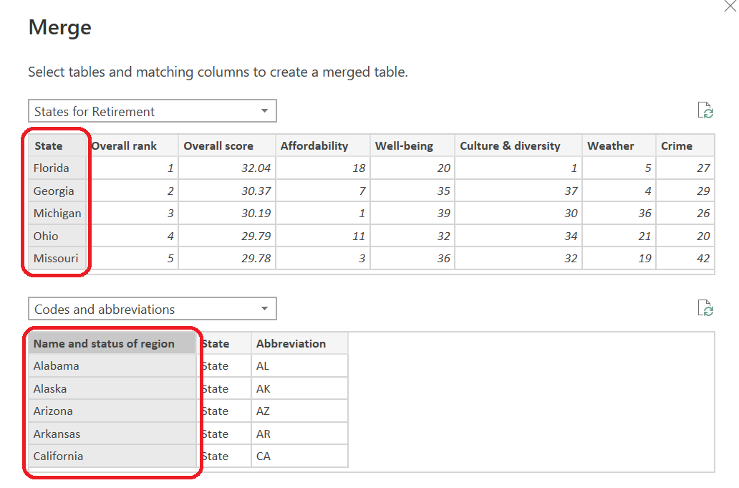
- Select the Join Kind. In this case, select Left Outer Join. It will get all records from the 1st query and the matching records in the 2nd query.



- Click OK.
- If you get this message, click Ignore Privacy Levels… Click Save.
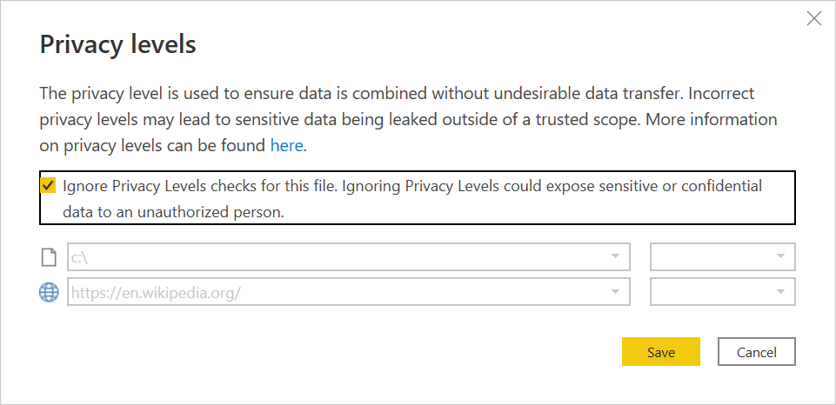
You now have a new query table which has all the columns from States for Retirement and with additional column named Code and abbreviations.
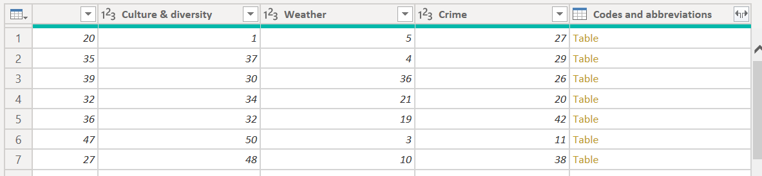
- Expand Codes and abbreviations. Click the 2 arrow heads.
- We only want to show the column US (which is the abbreviation). Tick US. Click OK.
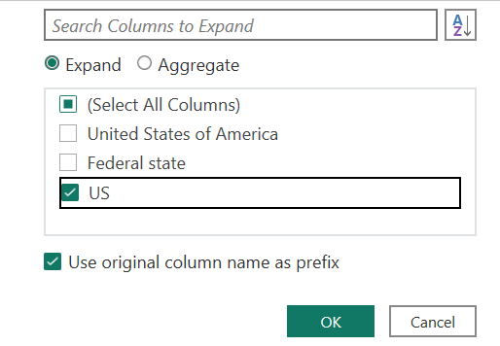
It now displays the US values.
- Rename the column to Abbreviation.
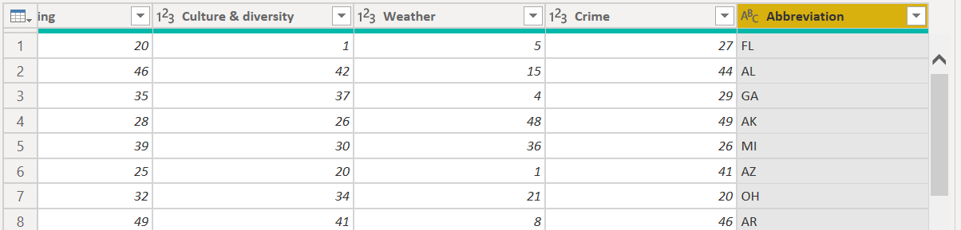
- Rename the new query table to Retirement States with Rank.
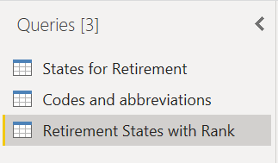
- Hide the queries for States for Retirement and Codes and abbreviations.
- Click Close & Apply. Save your project file.

- Visualize your data – Create Heatmap
- From the Visualizations panel, click Table. The Table visual is added to the report canvas.
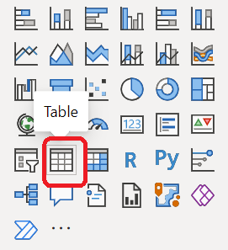

- Make sure the Table visual is selected. Tick the following attributes starting the Abbreviations, then Overall rank, Affordability, Crime, Culture & diversity, Well-being and Weather.
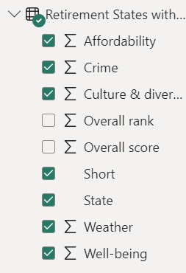

Notice the column headers are prefixed with Sum of. Change it to Don’t Summarize.
- Go to the Columns panel. Select an attribute and click the arrow head beside it. Select Don’t Summarize. Do this for all attribute with numeric values.
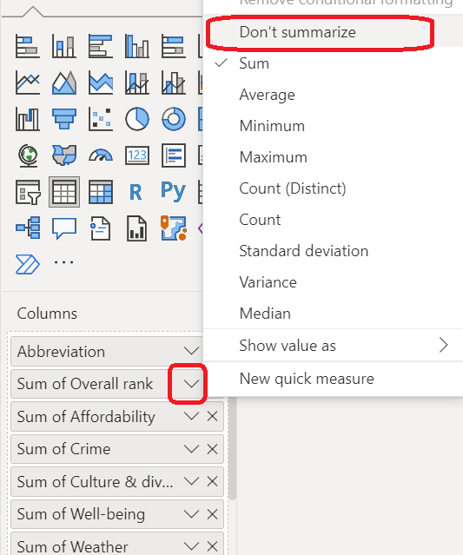
- Select an attribute and click the arrow head beside it. Select Conditional formatting -> Background color.
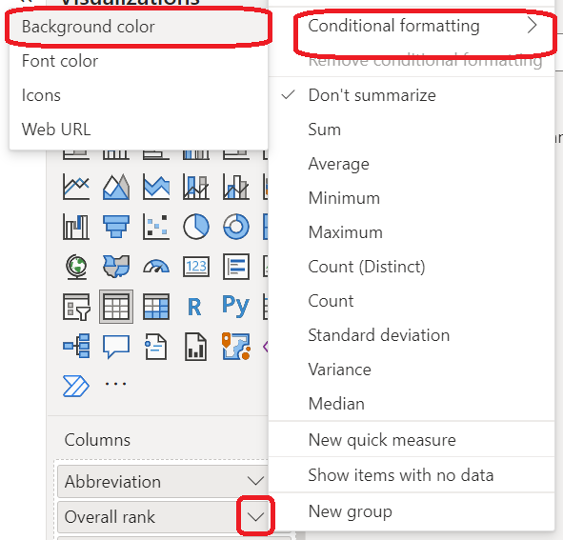
- Select a lighter color for the Minimum and a darker color for the Maximum. Click OK.
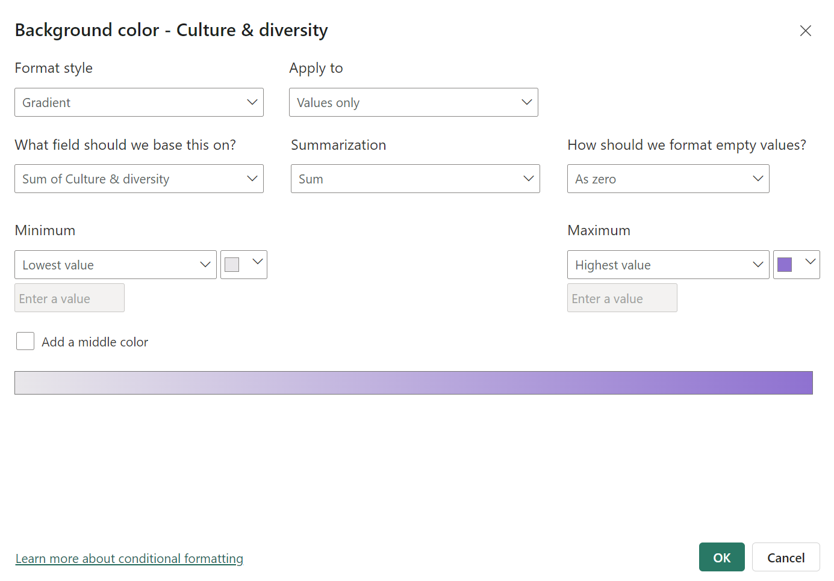

Notice the color for the Overall rank attribute. With the color, it is easy to see which has the highest value and which has the lowest value.

- Do steps #3-5 to the other numeric attributes.
- Increase the font size of the values. Select the Table visual, go to Visualization -> Format visual -> Visual -> Values.
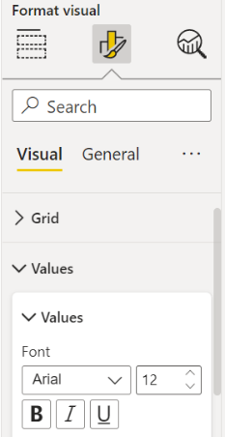
- Increase the font size of the column headers. Go to Visualization -> Format visual -> Visual -> Column headers.
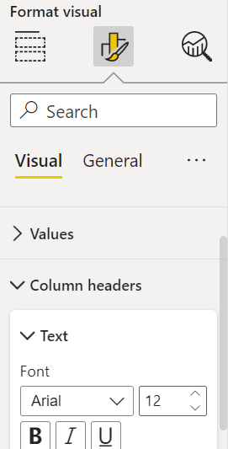
- Hide the row for the Total. Go to Visualization -> Format visual -> Visual -> Totals -> Values. Switch it off.

Your heatmap should be similar with this.

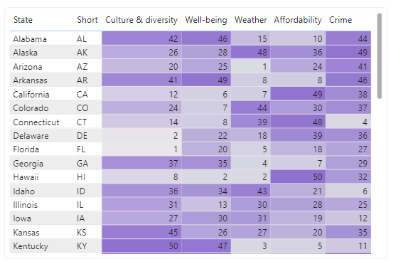

- Visualize your data – Map
- From the Visualizations panel, click Map. The Map visual is added to the report canvas.

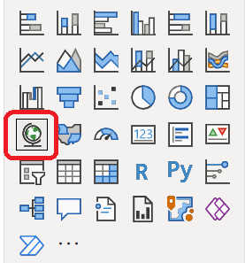
- Drag State to Location. Drag Crime to Bubble size.
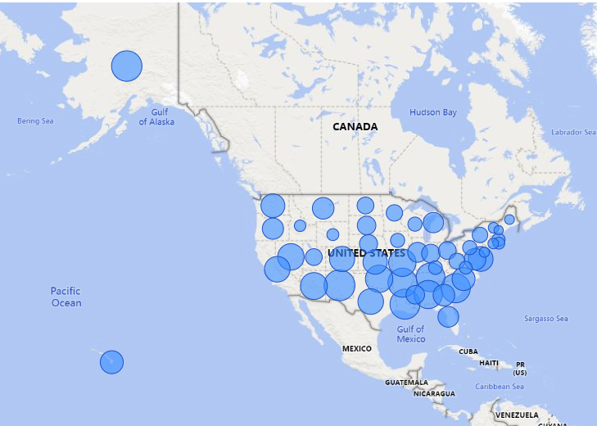
The size of the bubble is based on the number of crimes in the state. Which state has the highest crime rate?
- Go to Format visual and change the bubble color and title.

- Go to General -> Title. Change the title to Crime by State. Change the font to Arial. Increase the font size to 18. Se the horizontal alignment to center.
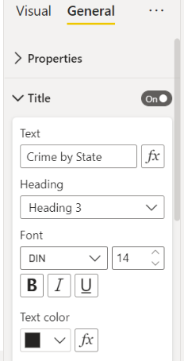
Your map should be similar with this.
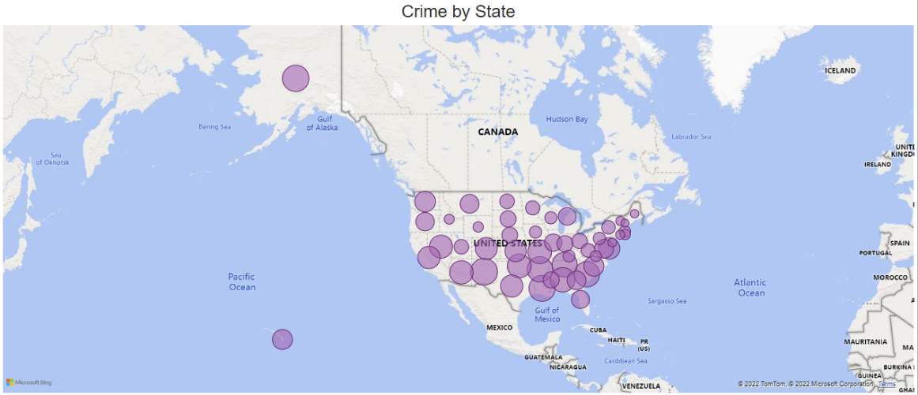

- Create a scatterplot to show the relationship between affordability and overall score
- Create a vertical bar chart showing the ranking.
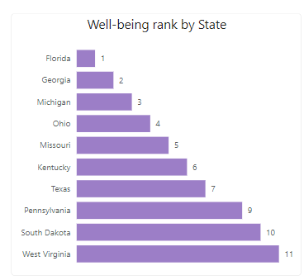

Summary
In this exercise, we merged 2 tables (using left out join), which resulted into a new table having the required attributes from 2 tables. The resulting table does now comply with the normalization rule but is sometimes necessary to decrease the time to query tables and thus increase performance. Your visual or ML model will have faster performance if it is accessing 1 table query or view instead of accessing multiple tables.

