MET CS 555 Term Project
10 points

1. Assignment Description
Select a small data set from the available public data sets (you can find a list of public data sets here http://www.teymourian.de/public-data-sets-for-data-analytic-projects/ ).

Describe a research scenario and specify a research question based on data analytic methods that we learned in our class, for example methods like, one and two sample means, t-test, correlation tests, simple and multiple linear regression, ANOVA and ANCOVA, one and two-Sample Tests for Proportions and logistic regression.

Clean up your data and reduce it to no more than 500 observations if your data set is large.

2. Research Scenario Description (no more than 200 words)
Describe your research scenario in no more than 200 words. This is a general description of the use case. Similar to our class examples, we first describe the overall scenario and then we specify a specific research question based on it.

The research scenario is analyzing the overdose deaths in the United States. Through several different visualizations, I will be displaying the trends of overall deaths across several years as well as plotting different causes of death and calculating their correlations. My main research question pertains to opioids. My assumption is that there are more overdose deaths caused by prescription opioids than heroin and will test that hypothesis using several methods.

3. Describe the data set (no more than 200 words)
Describe briefly the data set. Describe each columns of the data set if you use the column in your analysis. Clean up your data before usage, for example you can remove the outliers. Remove unused columns. If possible provide a Link to the main data set source.

Original Dataset: Products - Vital Statistics Rapid Release - Provisional Drug Overdose Data (cdc.gov)

The original .csv dataset has 12 columns and 53191 rows

I kept the following columns:
State: state abbreviation
Year
Indicator *** : Type of overdose
Data Value: Number of overdoses
State Name

There 12 different indicators. I kept the following 3 and transposed them into new columns:
Cocaine
Heroin
Natural, semi-synthetic, & synthetic opioids, incl. methadone (T40.2-T40.4)

I’ve removed the following Columns:
Month
Period
Percent Complete
Percent Pending Investigation
Footnote
Footnote Symbol
Predicted Value

I’ve removed the following values from “States”
United States
New York City
Washington DC

I removed the following from “Year”
2015 - incomplete

I ran a pivot in excelon indicator and year to have state yearly totals for each indicator

The resulting dataset has 315 rows and 6 columns

3. Research Question (no more than 100 words)
Describe briefly in one or two sentences the main research question. This is similar to the last sentence of our class examples.

The main question I wanted to research is if prescription opioids cause more deaths than the illegal opioid heroin as well as the correlation of the two. I was also interested in creating visualizations of the data and doing analysis to find other interesting things about the dataset.

4. Your solution R code
Copy your R code here. Start from read the data from a data file. Keep the following data read line.
This is similar to one of our R code examples.
rm(list=ls()); cat("\014")
#Set directory
setwd("C:/Users/HP/Documents/555")
getwd()

devtools::install_github("UrbanInstitute/urbnmapr")

library(tidyverse)
library(urbnmapr)

states_sf <- get_urbn_map("states", sf = TRUE)
states_sf

#Import spreadsheet
od_data = read.csv("OD_Dataset3.csv", header = TRUE)
od_data

#Create Totals column
od_data$Total <- (od_data$Cocaine + od_data$Heroin + od_data$Opioids)
od_data

attach(od_data)

df1 <- data.frame(od_data)
df1

#Yearly subset for map
d2016 <- subset(df1, df1$Year==2016)
d2017 <- subset(df1, df1$Year==2017)
d2018 <- subset(df1, df1$Year==2018)
d2019 <- subset(df1, df1$Year==2019)
d2020 <- subset(df1, df1$Year==2020)
d2021 <- subset(df1, df1$Year==2021)
d2022 <- subset(df1, df1$Year==2022)

#Plot Yearly on map
d2016 %>%
left_join(states, by = "state_name") %>%
ggplot(mapping = aes(long, lat,group = group, fill = Total)) +
geom_polygon(color = "blue", size = 0.25) +
coord_map(projection = "albers", lat0 = 39, lat1 = 45)+
labs(fill = "2016 Deaths")

d2017 %>%
left_join(states, by = "state_name") %>%
ggplot(mapping = aes(long, lat,group = group, fill = Total)) +
geom_polygon(color = "blue", size = 0.25) +
coord_map(projection = "albers", lat0 = 39, lat1 = 45)+
labs(fill = "2017 Deaths")

d2018 %>%
left_join(states, by = "state_name") %>%
ggplot(mapping = aes(long, lat,group = group, fill = Total)) +
geom_polygon(color = "blue", size = 0.25) +
coord_map(projection = "albers", lat0 = 39, lat1 = 45)+
labs(fill = "2018 Deaths")

d2019 %>%
left_join(states, by = "state_name") %>%
ggplot(mapping = aes(long, lat,group = group, fill = Total)) +
geom_polygon(color = "blue", size = 0.25) +
coord_map(projection = "albers", lat0 = 39, lat1 = 45)+
labs(fill = "2019 Deaths")

d2020 %>%
left_join(states, by = "state_name") %>%
ggplot(mapping = aes(long, lat,group = group, fill = Total)) +
geom_polygon(color = "blue", size = 0.25) +
coord_map(projection = "albers", lat0 = 39, lat1 = 45)+
labs(fill = "2020 Deaths")

d2021 %>%
left_join(states, by = "state_name") %>%
ggplot(mapping = aes(long, lat,group = group, fill = Total)) +
geom_polygon(color = "blue", size = 0.25) +
coord_map(projection = "albers", lat0 = 39, lat1 = 45)+
labs(fill = "2021 Deaths")

#2022 has is less because there is no November & December
d2022 %>%
left_join(states, by = "state_name") %>%
ggplot(mapping = aes(long, lat,group = group, fill = Total, main = "Overdoeses 2022")) +
geom_polygon(color = "blue", size = 0.25) +
coord_map(projection = "albers", lat0 = 39, lat1 = 45)+
labs(fill = "2022 Deaths (Thousands)")

library(rgl)

#Line graph of each drug variable
mycolors <- c('royalblue1', 'darkcyan', 'oldlace')
data$color <- mycolors[State]
data$color

grp_year <- od_data %>% group_by(Year) %>% summarise(cocaine = sum(Cocaine),
opioids = sum(Opioids), heroin = sum(Heroin))

op <- as.numeric(grp_year$opioids)
co <- as.numeric(grp_year$cocaine)
he <- as.numeric(grp_year$heroin)
he

#Histogram of each variable
hist(op, main = "Histogram of Opioids")
hist(co, main = "Histogram of Cocaine")
hist(he, main = "Histogram of Heroin")

#Line graph of each drug variable
library(reshape2)

df2 <- melt(grp_year , id.vars = 'Year', variable.name = 'deaths')
df2
ggplot(subset(df2, df2$Year<2022), aes(Year, value/1000)) +
geom_line(aes(colour = deaths))

#examine correlation

plot(Opioids, Heroin, col = "blue",
xlab= "Opioids", ylab = "Heroin",
main = "Opioids vs. Heroin")

cor(Cocaine, Heroin)
cor(Cocaine, Opioids)
cor(Opioids, Heroin)

install.packages("ggplot2")
install.packages("GGally")

library("ggplot2")
library("GGally")
ggpairs(od_data, columns=3:5)

#Boxplot of each variable
boxplot(Opioids, Heroin, Cocaine, main="Deaths",xlab="Opioids Herion Cocaine", ylab="Deaths")

#Compare sample means
mean(Cocaine)
mean(Heroin)
mean(Opioids)

sd(Cocaine)
sd(Heroin)
sd(Opioids)

n <- length(Opioids)
n
t1 = (mean(Opioids)-mean(Heroin))/(sd(Heroin/sqrt(n)))
t1
qt(.90,313)

#One Sided
#Find T critical Value
#Find F critical Value
qt(.95,313)
qf(.95,1,313)
confint(m, level = .95)

# Perform Linear Regression
m <- lm(Opioids ~ Heroin)
summary(m)

#Multiple Linear Regression :Analyze different attributes against total
m2 <- lm(Total~ Heroin + Cocaine)
summary(m2)

m3 <- lm(Total~ Heroin + Opioids)
summary(m3)

m4 <- lm(Total~ Cocaine + Opioids)
summary(m4)

# Perform Anova
anova(m)

#Predict Totals for 2022
d2022$predict <- predict(m, d2022)
d2022

5. Execute your R code, Copy and Paste results here in this Box.
Run your code and copy the output of your code to here.

Dataset with added aggregate totals column
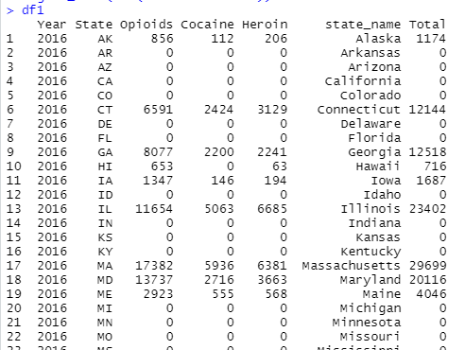

A couple of states were mising the granular data that I used in the dataset. In 2016 the highest amount of deaths per year reported were 50K
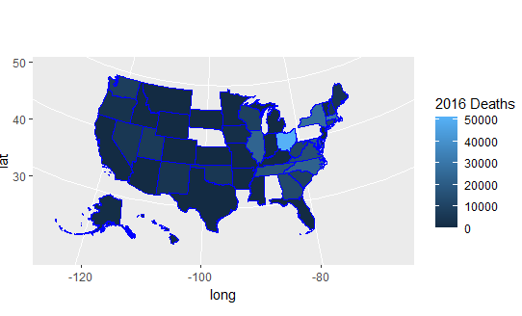

In 2021, the range of deaths reached 100K

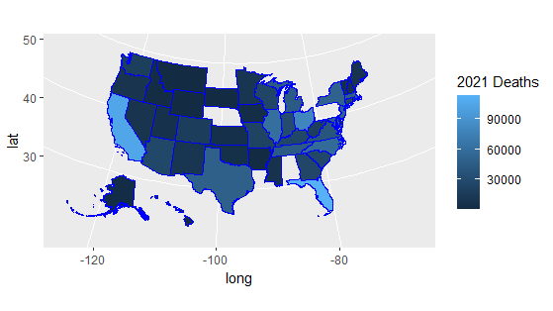

There has been a sharp increase in overdoses since Covid, for illegal drugs cocaine has surpassed heroin.

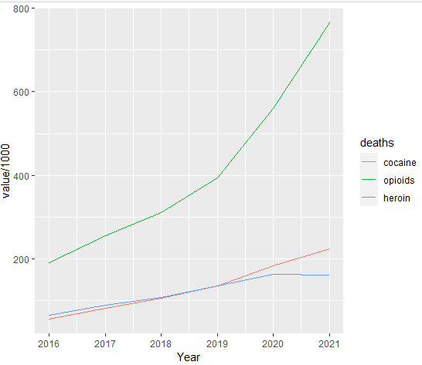

Correlation
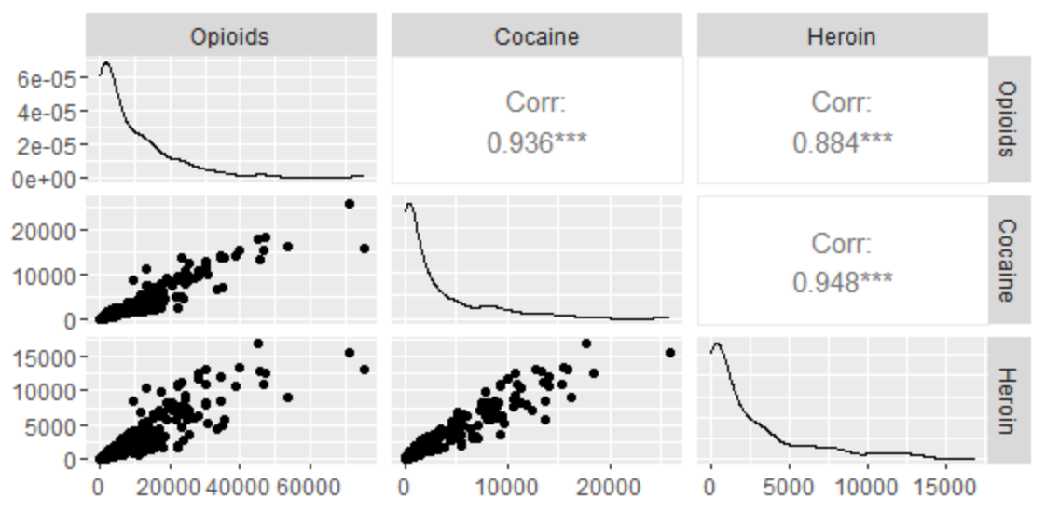

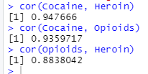

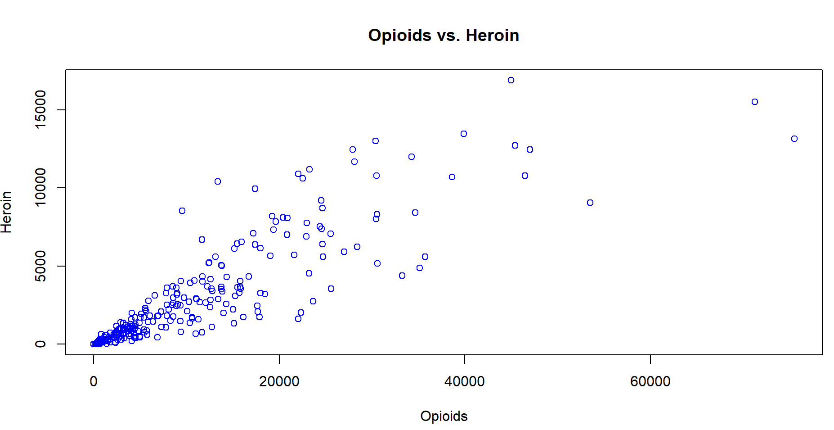

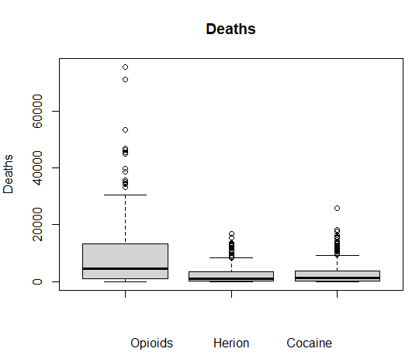

Compare Sample Means:
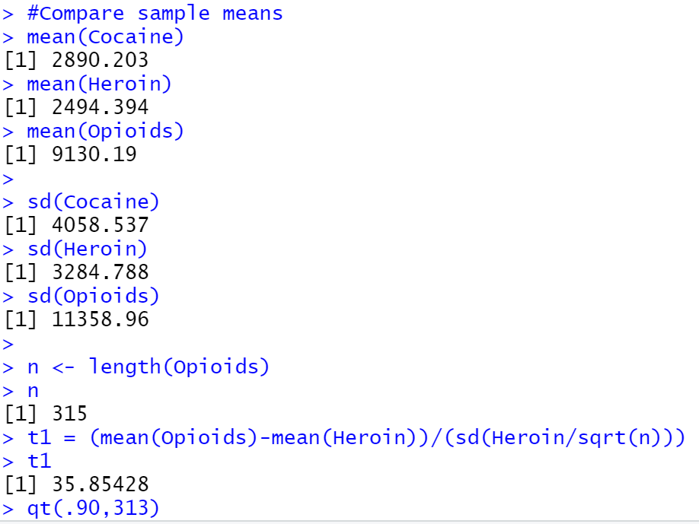

Means of heroin and opioids are not equal.

Linear Regression:
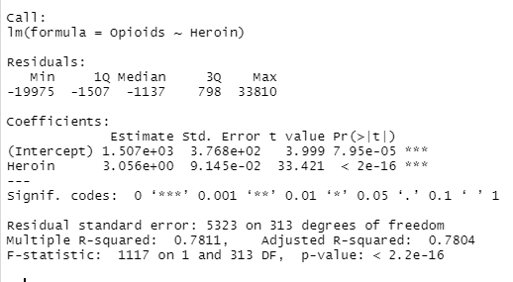
Confidence intercal, T & F critical values

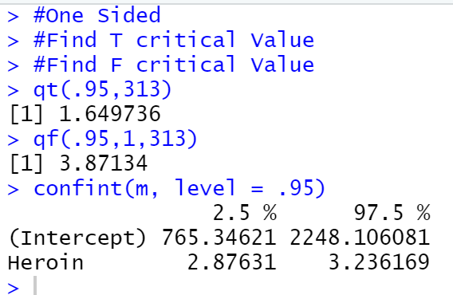
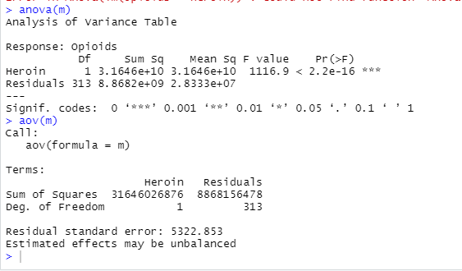

Heroin Deaths are not greater than opioids. T value and F values are greater than the critical values

6. State Your Conclusion (no more than 100 words)
State the conclusion so that a none-statistician can understand.

Heroin and Prescription Opioids are positively correlated, they both increase. Prescription opioids cause more deaths than heroin. The average deaths due to opioids are 3 times greater than heroin. The overall number of overdoses is rising in the United States with California and Florida having the most deaths per state. The

Solution Submission

- Fill up this word file and upload it.
- Upload your data set. This is the data set after cleaning (a small CSV file)
- Upload your R file as a file with name “mini-project-solution.R”

Grading will be done based on
- Originality of selected data set and data analysis approach
- Data Preparation set and cleanup
- General Correctness of data analysis
- Quality of your R code and output results
- Correct final conclusion

