Antonio Figueroa

ASL- Solo Project

**PRD**

Project Description:

This app allows the user to quickly book appointments with a barbershop service. The app provides all available times for the day and a link to book an appointment on the selected time. The user will be prompted to login or signup. The date selected will be carried until session variable for “logged” is true. When logged becomes true, if there’s a session for “selectedDate” , the app will render a “makeAppoinment” form with the selected time already populated on the fields. The home page will also have a link to a YouTube video that will teach the user how to use the app.

When the user logs in, they will be taken to their dashboard. There they’ll see a welcome message and two action buttons, “View Appointments” and “Make Appointment”. By clicking on “View Appointments” the user loads a list of all scheduled appointments. There the user can cancel, or edit and appointment. At the bottom of the list the page loads a “Make Appointment” button incase the user decides to add a second appointment. The “Make Appointment” buttons take the use to a form which Accepts a time, date, and barber. They can submit their appointment and the page loads a confirmation page, and asks the user if they want to see their appointment.

** V2:

For version two of this assignment, I plan to add a manage account functionality that allows the user to add family members to their account. I would also implement a limit of appointments per week per family member in the account. On the make appointment form, I would like to implement functionality that would:

1. Only let them to select a barber once the date and time are filled.
2. When these two fields are filled, query all barbers available at this time
3. For each barber returned print them inside a option tag.

Wireframes:

1. Home and Calendar API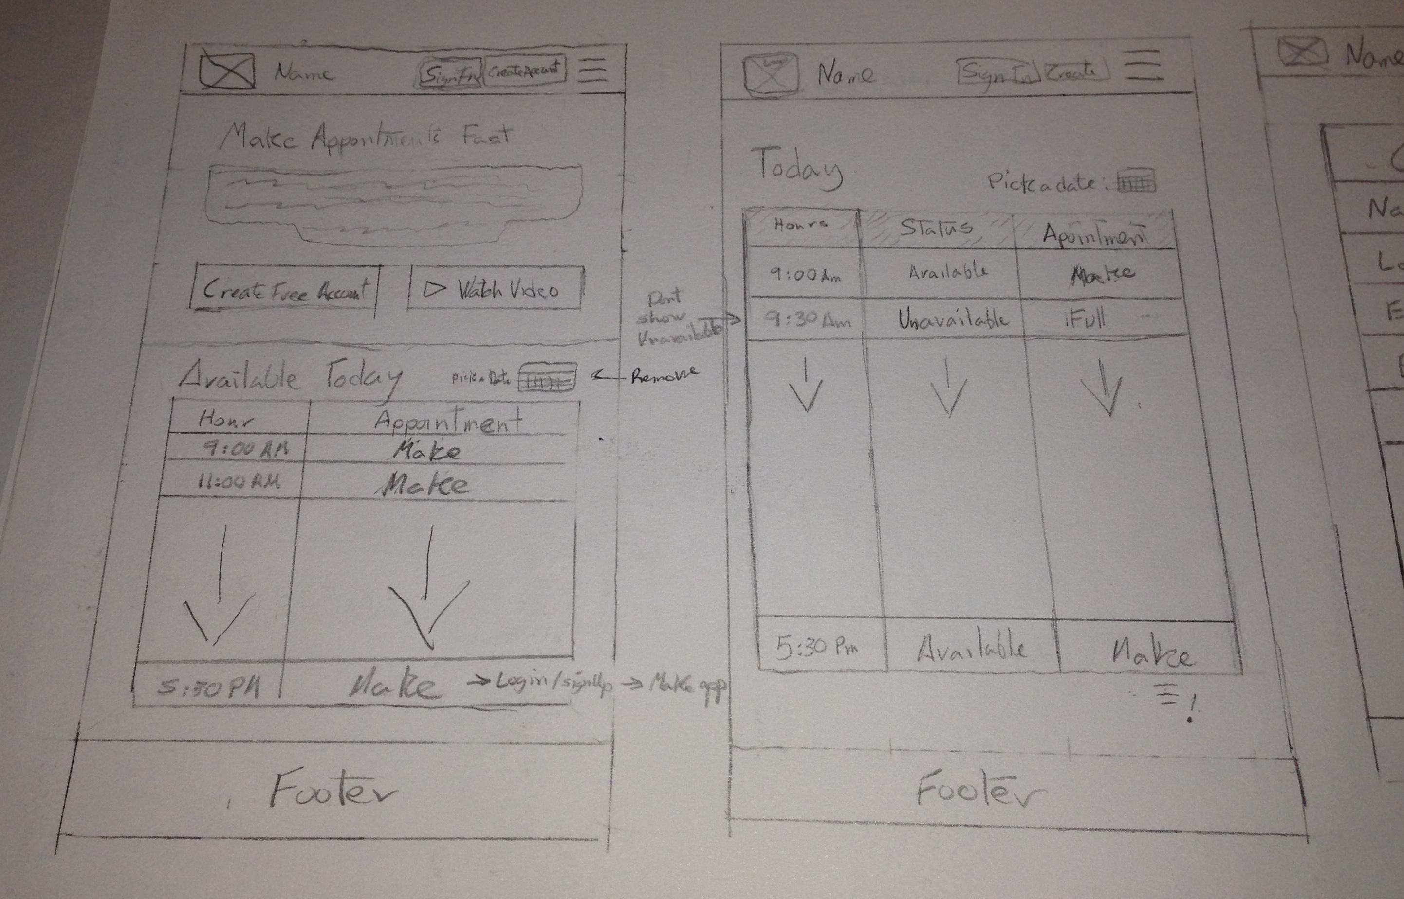
2. Login / Signup
3. Users Dashboard and My Appointments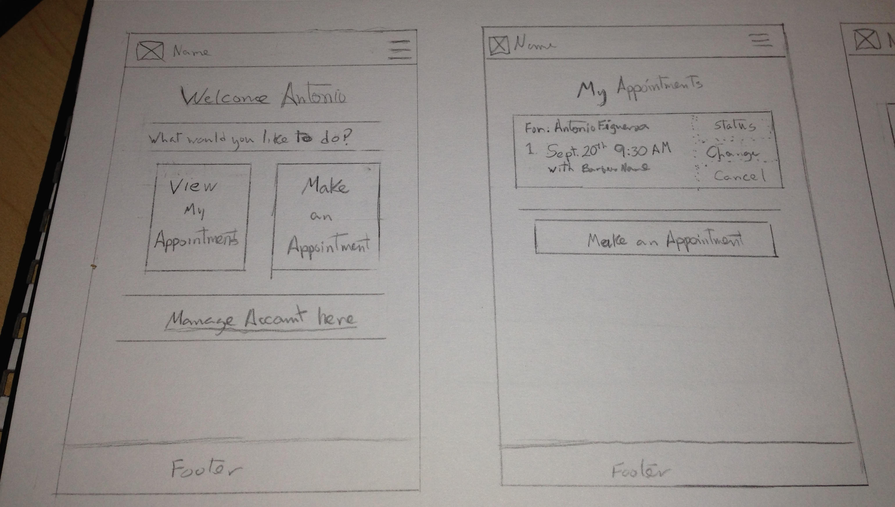
4. Make Appointment (filled) 