

Detailed Error Reports
Technical Definition Deliverable

RICE ID: NBTY-VCI-REP-02
Version: 0.1

Table of Contents

1. Specification 3
2. Design 4
2.1 Assumptions 4
2.2 Concerning program details 4
2.3 Concerning error handling 4
2.4 Technical Flow Diagram 5
2.5 Technical Description of the Conversion Program(s) 6
2.6 Input/Output Files and Tables 6
2.7 Descriptive Flexfields 6
2.8 Flexfield Name 6
2.9 Value Sets 7
2.10 Database Objects 7
2.11 Database Object Definitions 8
2.11.1. Tables 8
2.11.2. Table Name 8
2.12 Views 8
2.12.1. View Name 8
2.13 Source Tables 8
2.14 Join Condition 9
2.15 Public Synonyms 9
2.16 Grants 9
2.17 Index Design 9
3. Error Handling 10
3.1 Request Log Output 10
4. Data Conversion Verification 11
5. Operating Specifications 12
5.1 Processing Details 12
5.2 Incompatibilities 12
5.3 Dependencies/Scheduling Considerations 12
5.4 Restart/Recover Instructions 12
5.5 Expected Duration 12
5.6 Volume 12
5.7 Performance Considerations 12
5.8 Security Requirements 12
6. Unit Testing Requirements 14
6.1 Test Data Requirements 14
7. Issues Documentation 17
Appendix 18

Specification

Functional Design Reference: |  | AP350 Detailed Error Reports
Related Technical Design(s): |  | N/A
Conversion Short Description: |  | This report will print out the detailed errors encountered during the current load of legacy extracted files to EBS/ASCP
Data Mapping: |  | N/A
Development Complexity: |  | Simple
From System: |  | EBS/ASCP
From System Contact: |  | N/A
To System: |  | N/A
To System Contact: |  | N/A
OS: |  | N/A
Hardware: |  | N/A
Estimated Production Date: |  | N/A
Other Affected Applications: |  | N/A
Comments: |  | N/A
Related Modules | Module Type |  | Relation Type
N/A | N/A |  | N/A

Design

Assumptions
Assumption
- Output file will be CSV format.
- Report is an extract of the actual error records, no summing, formatting, transformation.
- Reports will contain “AS IS” error messages logged in the staging/interface tables.
- Report will contain only the current load errors encountered.

Concerning program details

- The program will generate the detailed error report in .csv file.
- The report contains all columns of the staging/interface tables.
- The report will contain the errors for the current load only.
- After generating the report, the file will be sent to identified recipients.
- There will be Generate Detailed error report program for every object in the EBS/ASCP Request set load.

Concerning error handling
N/A

Technical Flow Diagram

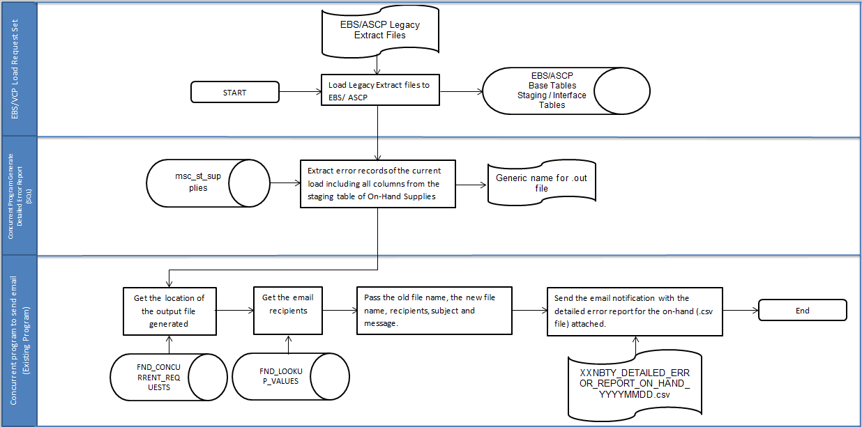

Technical Description of the Conversion Program(s)
The Program will do the following:

- Run the concurrent program XXNBTY Generate Detailed Error Report. There are no parameters needed for the program.
- Validate if there are any error records for the current load in the staging/interface table.
  - If there are no errors for the current load, send an email with the message “There were no errors encountered during the load for OBJECT_NAME”.
  - If there are errors encountered, proceed to step 3.
- Generate an .out file that contains the records with errors from the staging/interface table. The file contains all columns from the staging/interface table separated by comma.
- Get the location of the file generated to be passed to the shell script.
- Get the email recipients from look ups table to be passed to the shell script.
- Call the concurrent program for the shell script. Pass the old file name, new file name, recipients, subject and message to be used for sending the email notification.
- Using the parameters passed by the package, create the .csv file and send the email notification to the recipients passed.

Input/Output Files and Tables

Input Files/Tables | Output Files/Tables
N/A | XXNBTY_DETAILED_ERROR_REPORT_RICEFW_YYYYMMDD.csv

Descriptive Flexfields
N/A

Flexfield Name

Segment Name | Number | Prompt | Column | Value Set | Displayed?/ Enabled? | Default Type/ Default Value | Required?
N/A | N/A | N/A | N/A | N/A | N/A | N/A | N/A
N/A | N/A | N/A | N/A | N/A | N/A | N/A | N/A

Value Sets

Value Set | List Type | Format Type | Size | Validation Type | Validation/Values
N/A | N/A | N/A | N/A | N/A | N/A
N/A | N/A | N/A | N/A | N/A | N/A

Database Objects

Object Name | Object Type | Status (new or exists) | Schema | Key, Index Information | Purpose/ Description | Comments
XXNBTY_BOM_ST_COMPONENT | Table | Exists |  |  | Custom Staging Table For BOM
XXNBTY_CUST_ST_BOM_INT | Table | Exists |  |  | Custom Staging Table For BOM
BOM_INVENTORY_COMPS_INTERFACE | Table | Exists |  |  | Interface Table for BOM
BOM_BILL_OF_MTLS_INTERFACE | Table | Exists |  |  | Interface Table for BOM
MSC_ST_SUPPLIES | Table | Exists |  |  | Custom Staging Table For ON HAND DATA
MSC_ST_SUPPLIES | Table | Exists |  |  | Custom Staging Table For IN-TRANSIT
MSC_ST_SUPPLIES | Table | Exists |  |  | Custom Staging Table For WORK ORDERS
MSC_ST_DEMANDS | Table | Exists |  |  | Custom Staging Table For WIP
MSC_ST_SALES_ORDERS | Table | Exists |  |  | Custom Staging Table For Sales Order
XXMSC_CUS_COST_TBL | Table | Exists |  |  | Custom Staging Table For Item Cost
XXNBTY_FM_MATL_DTL_STG | Table | Exists |  |  | Custom Staging Table For Recipe
XXNBTY_FM_FORM_MST_B_STG | Table | Exists |  |  | Custom Staging Table For Recipe
XXNBTY_FRMLA_UPLOAD | Table | Exists |  |  | Custom Staging Table For Recipe
XXNBTY_BATCH_ST_INT | Table | Exists |  |  | Custom Staging Table For Batch
XXNBTY_CUST_STG_TBL | Table | Exists |  |  | Custom Staging Table For Customer Interface
RA_CUSTOMERS_INTERFACE_ALL | Table | Exists |  |  | Interface Table For Customer Interface
FND_LOOKUP_VALUES | Table | Exists |  |  | Table for Recipients

Database Object Definitions

Tables
N/A

Table Name
Column Name | Key | Type | Size | Null Allowed? | Unique? | Default | Description
N/A | N/A | N/A | N/A | N/A | N/A | N/A | N/A
N/A | N/A | N/A | N/A | N/A | N/A | N/A | N/A

Views

View Name
N/A

Source Tables
N/A

Join Condition
List the joins needed to create the view listed above.

View Column | Source Table Column or Expression
N/A | N/A
N/A | N/A

Public Synonyms
N/A

Grants
N/A

Index Design
If there are indexes, provide the index information in the table below.

Index Name | Table/Column Name | Unique?
N/A | N/A | N/A
N/A | N/A | N/A

Error Handling
Follow the instructions for more information on what to include in the table below.

Potential Errors | Possible Reasons | Solution Strategy
No data collected or pulled out in the staging table. | - No error records found in the interface and staging table. | - This scenario is normal. No solution is required. Email notifications will sent with description “No errors encountered during loading of data.”
. txt file was not collected or pulled out in the UNIX server. | - System is down.  - Directory of output file has been changed. | - Check the system.  - Check the correct directory.

Request Log Output
.out file will be created in the UNIX output directory to be converted to.csv file. The .csv file will be sent to the recipients.

Data Conversion Verification

All output files are located in the UNIX output file directory.

Check the output file directory in the UNIX server.

.csv file will be sent through email.

Operating Specifications

Processing Details
TBD

Incompatibilities
N/A

Dependencies/Scheduling Considerations

The EBS/ASCP Request Set for the Legacy file loads should run first. Error records from the run will be the ones generated for this report.

Restart/Recover Instructions
N/A

Expected Duration
N/A

Volume
N/A

Performance Considerations
N/A

Security Requirements

Only Authorized Users will have access to the interface process.

The purpose of this section of the functional specification is to ensure that internal controls are designed, implemented and tested as part of the development of interface routines. Internal controls are designed to achieve the following for all interfaces in scope of the ERP program.

- Completeness of data sent and received between application systems
- Integrity of the data accepted into production application systems
- Timeliness of information accepted into production application systems
- Sequence of information being interfaced is correct

Internal Control Requirements
The total number of records sent from source systems are reconciled to the total number of records received in the destination systems (this ensures completeness of data).
Errors within interface files are rejected, or placed in staging tables for correction. They are not accepted into production tables unless the tables are specifically used for housing records in error.
Service/batch accounts assigned to interface routines are assigned logical access to those application and system functions that they require to perform their intended function. All other logical access is restricted (i.e., power or super user access is restricted).
Duplicate interface files are identified and rejected prior to hitting production (this ensures that duplicate data is not accepted into production systems).
Interfaces are sent in the proper sequence and are not skipped.

Unit Testing Requirements

Test | Expected Results
- Output file is in CSV format | The report can be opened in CSV format.
- Output file will contain all the errors encountered during the load | The report will contain all errors logged into the staging/interface tables.
- Output file will be attached in the email notification | The report will be attached in the email.

Test Data Requirements

FOR BOM
SELECT *
FROM xxnbty_bom_st_component
WHERE process_flag = '3'
AND TRUNC(creation_date) = TRUNC(SYSDATE);

SELECT *
FROM xxnbty_cust_st_bom_int
WHERE process_flag = '3'
AND TRUNC(creation_date) = TRUNC(SYSDATE);

SELECT *
FROM bom_inventory_comps_interface
WHERE process_flag = '3';

SELECT *
FROM bom_bill_of_mtls_interface
WHERE process_flag = '3';

FOR FORMULA
SELECT *
FROM xxnbty_fm_form_mst_b_stg
WHERE status NOT IN (‘P’, ‘V’);

SELECT *
FROM xxnbty_frmla_upload
WHERE attribute29 NOT IN (‘P’, ‘V’)
AND TRUNC(creation_date) = TRUNC(SYSDATE);

SELECT *
FROM xxnbty_fm_matl_dtl_stg
WHERE status NOT IN ('P', 'V');

FOR BATCH
SELECT *
FROM xxnbty_batch_int_st
WHERE error_description IS NOT NULL
AND TRUNC(creation_date) = TRUNC(SYSDATE);

FOR CUSTOMER INTERFACE
SELECT *
FROM xxnbty_cust_stg_tbl
WHERE process_flag = 'E'
AND TRUNC(creation_date) = TRUNC(SYSDATE);

SELECT *
FROM ra_customers_interface_all
WHERE interface_status IS NOT NULL;

FOR ON-HAND DATA
SELECT *
FROM msc_st_supplies
WHERE process_flag = '3'
AND order_type = '18'
AND TRUNC(creation_date) = TRUNC(SYSDATE);

FOR IN-TRANSIT
SELECT *
FROM msc_st_supplies
WHERE process_flag = '3'
AND order_type = '11'
AND TRUNC(creation_date) = TRUNC(SYSDATE);

FOR WORK ORDERS
SELECT *
FROM msc_st_supplies
WHERE process_flag = '3'
AND order_type = '3'
AND TRUNC(creation_date) = TRUNC(SYSDATE);

FOR WIP
SELECT *
FROM msc_st_demands
WHERE process_flag = '3'
AND TRUNC(creation_date) = TRUNC(SYSDATE);

FOR SALES ORDERS
SELECT *
FROM msc_st_sales_orders
WHERE process_flag = '3'
AND TRUNC(creation_date) = TRUNC(SYSDATE);

FOR ITEM COSTS
SELECT *
FROM xxmsc_cus_cost_tbl
WHERE status = 'E'
AND TRUNC(creation_date) = TRUNC(SYSDATE);

Issues Documentation

# | Raised By | Issue | Date Needed | Resolution/Answer | Date Completed | Resolved By
N/A | N/A | N/A | N/A | N/A | N/A | N/A
N/A | N/A | N/A | N/A | N/A | N/A | N/A

Appendix
N/A

Revision History

Date | Version | Description | Author
5/16/2015 | 0.1 | Initial Document | Albert John Flores

