

Detailed Error Reports
Technical Definition Deliverable

RICE ID: NBTY-VCI-REP-02
Version: 0.1

Table of Contents

1. Specification 3
2. Design 4
2.1 Assumptions 4
2.2 Concerning program details 4
2.3 Concerning error handling 4
2.4 Technical Flow Diagram 5
2.5 Technical Description of the Conversion Program(s) 6
2.6 Input/Output Files and Tables 6
2.7 Descriptive Flexfields 6
2.8 Flexfield Name 6
2.9 Value Sets 7
2.10 Database Objects 7
2.11 Database Object Definitions 7
2.11.1. Tables 7
2.11.2. Table Name 7
2.12 Views 7
2.12.1. View Name 7
2.13 Source Tables 7
2.14 Join Condition 8
2.15 Public Synonyms 8
2.16 Grants 8
2.17 Index Design 8
3. Error Handling 9
3.1 Request Log Output 9
4. Data Conversion Verification 10
5. Operating Specifications 11
5.1 Processing Details 11
5.2 Incompatibilities 11
5.3 Dependencies/Scheduling Considerations 11
5.4 Restart/Recover Instructions 11
5.5 Expected Duration 11
5.6 Volume 11
5.7 Performance Considerations 11
5.8 Security Requirements 11
6. Unit Testing Requirements 13
6.1 Test Data Requirements 13
7. Issues Documentation 14
Appendix 15

Specification

Functional Design Reference: |  | AP350 Detailed Error Reports
Related Technical Design(s): |  | N/A
Conversion Short Description: |  | This report will print out the detailed errors encountered during the current load of legacy extracted files to EBS/ASCP
Data Mapping: |  | N/A
Development Complexity: |  | Simple
From System: |  | EBS/ASCP
From System Contact: |  | N/A
To System: |  | N/A
To System Contact: |  | N/A
OS: |  | N/A
Hardware: |  | N/A
Estimated Production Date: |  | N/A
Other Affected Applications: |  | N/A
Comments: |  | N/A
Related Modules | Module Type |  | Relation Type
N/A | N/A |  | N/A

Design

Assumptions
Assumption
- Output file will be CSV format.
- Report is an extract of the actual error records, no summing, formatting, transformation.
- Reports will contain “AS IS” error messages logged in the staging/interface tables.
- Report will contain only the current load errors encountered.

Concerning program details

- The program will generate the detailed error report in .csv file.
- The report contains all columns of the staging/interface tables.
- The report will contain the errors for the current load only.
- After generating the report, the file will be sent to identified recipients.
- There will be Generate Detailed error report program for every object in the EBS/ASCP Request set load.

Concerning error handling
N/A

Technical Flow Diagram

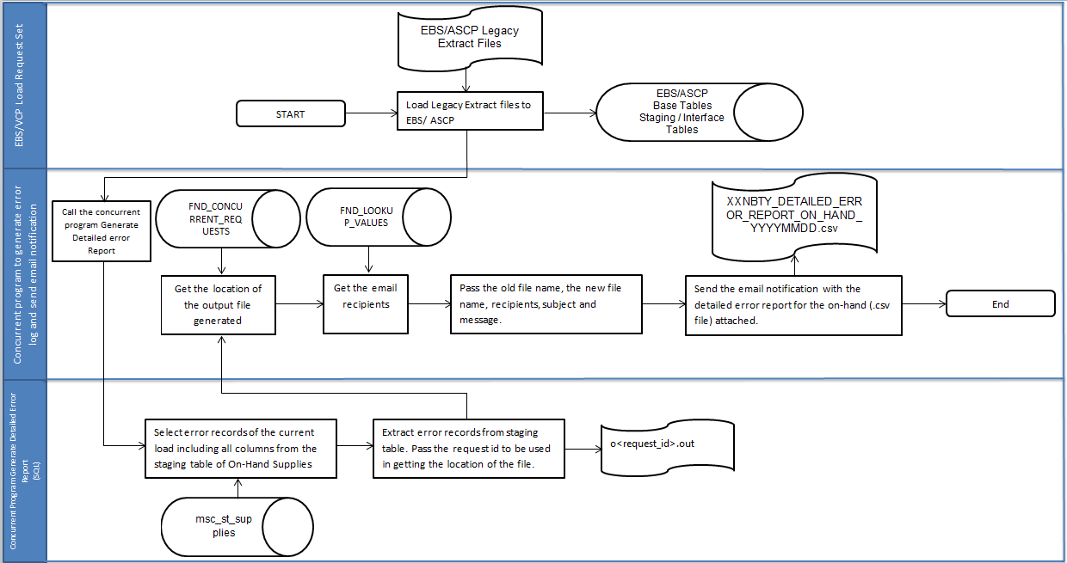

Technical Description of the Conversion Program(s)
The Program will do the following:

- After the run of the EBS/ASCP Load Request set, the Existing concurrent program Generate error log and send email notification will run.
- Call the concurrent program to generate detailed error report for on hand supplies.
- Generate an .out file that contains the records with errors from the staging table of on hand. The file contains all columns from the table separated by comma.
- Get the location of the file generated to be passed to the shell script.
- Get the email recipients from look ups table to be passed to the shell script.
- Call the concurrent program for the shell script. Pass the old file name, new file name, recipients, subject and message to be used for sending the email notification.
- Using the parameters passed by the package, create the .csv file and send the email notification to the recipients passed.

Input/Output Files and Tables

Input Files/Tables | Output Files/Tables
N/A | XXNBTY_DETAILED_ERROR_REPORT_ON_HAND_YYYYMMDD.csv

Descriptive Flexfields
N/A

Flexfield Name

Segment Name | Number | Prompt | Column | Value Set | Displayed?/ Enabled? | Default Type/ Default Value | Required?
N/A | N/A | N/A | N/A | N/A | N/A | N/A | N/A
N/A | N/A | N/A | N/A | N/A | N/A | N/A | N/A

Value Sets

Value Set | List Type | Format Type | Size | Validation Type | Validation/Values
N/A | N/A | N/A | N/A | N/A | N/A
N/A | N/A | N/A | N/A | N/A | N/A

Database Objects

Object Name | Object Type | Status (new or exists) | Schema | Key, Index Information | Purpose/ Description | Comments
MSC_ST_SUPPLIES | Table | Exists |  |  | Custom Staging Table For ON HAND DATA
FND_LOOKUP_VALUES | Table | Exists |  |  | Table for Recipients

Database Object Definitions

Tables
N/A

Table Name
Column Name | Key | Type | Size | Null Allowed? | Unique? | Default | Description
N/A | N/A | N/A | N/A | N/A | N/A | N/A | N/A
N/A | N/A | N/A | N/A | N/A | N/A | N/A | N/A

Views

View Name
N/A

Source Tables
N/A

Join Condition
List the joins needed to create the view listed above.

View Column | Source Table Column or Expression
N/A | N/A
N/A | N/A

Public Synonyms
N/A

Grants
N/A

Index Design
If there are indexes, provide the index information in the table below.

Index Name | Table/Column Name | Unique?
N/A | N/A | N/A
N/A | N/A | N/A

Error Handling
Follow the instructions for more information on what to include in the table below.

Potential Errors | Possible Reasons | Solution Strategy
No data collected or pulled out in the staging table. | - No error records found in the interface and staging table. | - This scenario is normal. No solution is required. Email notifications will sent with description “No errors encountered during loading of data.”
.out file was not collected or pulled out in the UNIX server. | - System is down.  - Directory of output file has been changed. | - Check the system.  - Check the correct directory.

Request Log Output
.out file will be created in the UNIX output directory to be converted to.csv file. The .csv file will be sent to the recipients.

Data Conversion Verification

All output files are located in the UNIX output file directory.

Check the output file directory in the UNIX server.

.csv file will be sent through email.

Operating Specifications

Processing Details
TBD

Incompatibilities
N/A

Dependencies/Scheduling Considerations

The EBS/ASCP Request Set for the Legacy file loads should run first. Error records from the run will be the ones generated for this report.

Restart/Recover Instructions
N/A

Expected Duration
N/A

Volume
N/A

Performance Considerations
N/A

Security Requirements

Only Authorized Users will have access to the interface process.

The purpose of this section of the functional specification is to ensure that internal controls are designed, implemented and tested as part of the development of interface routines. Internal controls are designed to achieve the following for all interfaces in scope of the ERP program.

- Completeness of data sent and received between application systems
- Integrity of the data accepted into production application systems
- Timeliness of information accepted into production application systems
- Sequence of information being interfaced is correct

Internal Control Requirements
The total number of records sent from source systems are reconciled to the total number of records received in the destination systems (this ensures completeness of data).
Errors within interface files are rejected, or placed in staging tables for correction. They are not accepted into production tables unless the tables are specifically used for housing records in error.
Service/batch accounts assigned to interface routines are assigned logical access to those application and system functions that they require to perform their intended function. All other logical access is restricted (i.e., power or super user access is restricted).
Duplicate interface files are identified and rejected prior to hitting production (this ensures that duplicate data is not accepted into production systems).
Interfaces are sent in the proper sequence and are not skipped.

Unit Testing Requirements

Test | Expected Results
- Output file is in CSV format | The report can be opened in CSV format.
- Output file will contain all the errors encountered during the load | The report will contain all errors logged into the staging/interface tables.
- Output file will be attached in the email notification | The report will be attached in the email.

Test Data Requirements

FOR ON-HAND DATA
SELECT *
FROM msc_st_supplies
WHERE process_flag = '3'
AND order_type = '18'
AND TRUNC(creation_date) = TRUNC(SYSDATE);

Issues Documentation

# | Raised By | Issue | Date Needed | Resolution/Answer | Date Completed | Resolved By
N/A | N/A | N/A | N/A | N/A | N/A | N/A
N/A | N/A | N/A | N/A | N/A | N/A | N/A

Appendix
N/A

Revision History

Date | Version | Description | Author
5/16/2015 | 0.1 | Initial Document | Albert John Flores

