PROJECT DISPATCH - BUILD PLAN

News & Article Platform
Architecture and Security Blueprint
A full-featured news publishing platform: admins and moderators author and manage articles with photo, video and link embeds; readers register, comment, react and share to social media. Stack: Next.js 15 (App Router), PostgreSQL + Prisma, Auth.js, TypeScript strict. Prepared 2026-09-16.

1. Overview & goals
The platform has two audiences with very different needs: a small internal newsroom (admins, moderators) publishing time-sensitive content, and a large public readership that consumes, comments on, and redistributes that content. This plan is scoped end-to-end - architecture, data, features, and hardening - for a full-featured build, sequenced into shippable phases.
Design priorities, in order: (1) content integrity - only authorized staff can publish or alter what's on the site; (2) reader trust & safety - comments and accounts can't be trivially abused; (3) availability - the site stays up and fast under real news-traffic spikes; (4) reach - content is easy to find, read, and share.

2. System architecture
Next.js (App Router) is recommended as the single full-stack codebase: React Server Components render article pages on the server (fast, good SEO), while API routes / Server Actions handle mutations. PostgreSQL via Prisma ORM is the system of record; Redis (Upstash) backs rate limiting and caches; media lives in S3-compatible object storage, never on the app server's disk.
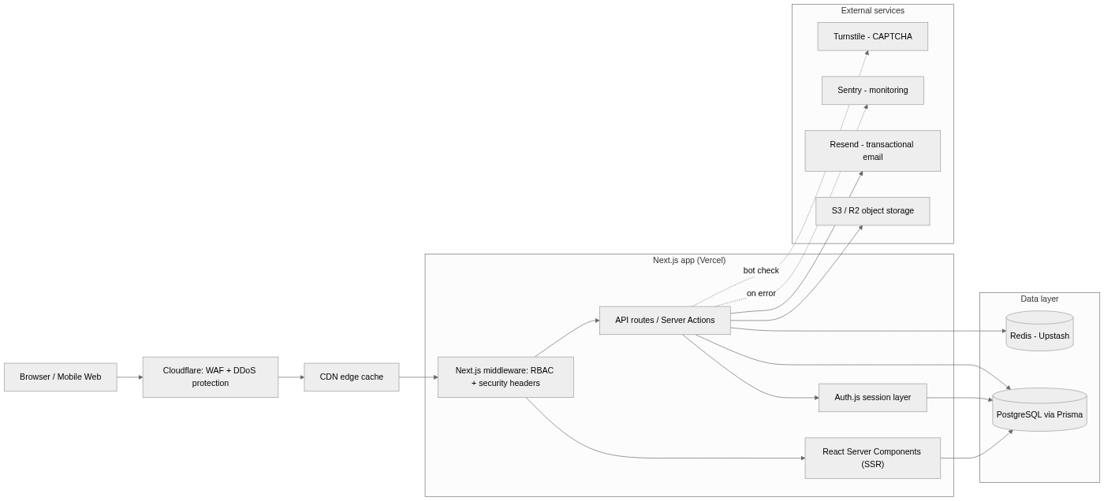
Why this shape: putting all authorization checks in one middleware layer plus server-side handlers (never in client components alone) means there is one place to audit for access-control bugs. Cloudflare in front absorbs volumetric attacks before they reach the app - important for a news site, which is a predictable target during controversial stories.

3. Roles & permissions
Four roles, enforced server-side on every request - a role claim in a cookie or JWT is never trusted by itself; each handler re-checks the user's current role against the database.
Action | Guest | Reader | Moderator | Admin
Read published articles, share to social | Yes | Yes | Yes | Yes
Register, comment, react, bookmark, follow | - | Yes | Yes | Yes
Write & edit own draft articles, upload photo/video/links | - | - | Yes | Yes
Publish / schedule / unpublish articles | - | - | Yes | Yes
Edit or unpublish another author's article | - | - | - | Yes
Approve / hide / delete comments, mute or ban readers | - | - | Yes | Yes
Manage categories, tags, homepage layout | - | - | - | Yes
Manage staff accounts & roles | - | - | - | Yes
View analytics dashboard | - | - | Yes | Yes
View audit log, change site & security settings | - | - | - | Yes
Recommended refinement
As the newsroom grows past a handful of people, split "Moderator" into Editor (writes/publishes content, no user-management power) and Moderator (manages comments/reports, no publishing power). Role is stored as an extensible enum, so this is a config change, not a rewrite.

4. Data model
Core entities and relationships. Every mutable content table carries a status and timestamps so nothing is destructively deleted from the reader's perspective - comments and articles are soft-removed (status flag) and remain in the audit trail.
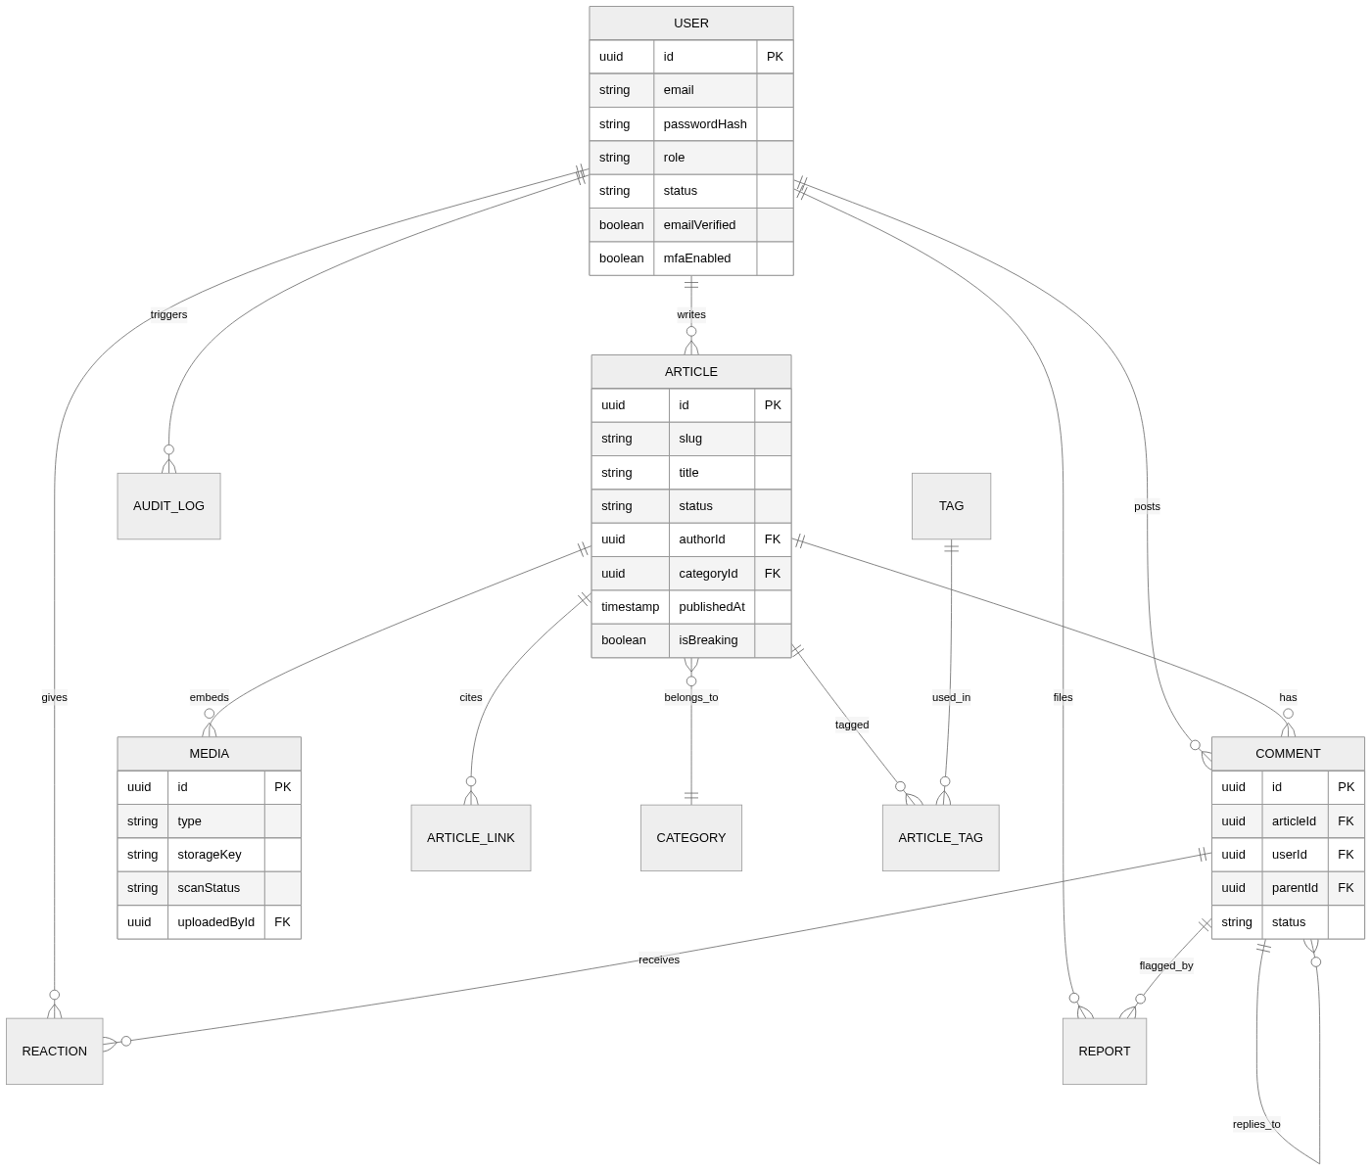

Notable design choices
- Article body is stored as structured JSON (from a Tiptap/Lexical rich-text editor), not raw HTML from the client - HTML is generated server-side from the JSON through a strict sanitizer allowlist at render time. This closes off stored-XSS via the editor.
- Media rows track scanStatus (pending / clean / flagged) - an uploaded file is not publicly served until it passes processing and a malware scan.
- Comment is self-referencing via parentId for threaded replies, and carries a status (pending / approved / hidden / deleted) so moderation never hard-deletes user content pre-review.
- AuditLog is append-only: every admin/moderator action (publish, delete, ban, role change) writes a row with actor, action, target, IP, and timestamp. No update or delete API - only inserts.

5. Core features

Newsroom (Admin / Moderator)
- Rich-text article editor with inline photo/video embeds, pull quotes, and external link cards (auto-fetches title/preview via a server-side proxy, never client-side, to avoid leaking reader IPs to third parties)
- Draft > In Review > Scheduled > Published > Archived workflow with per-transition permission checks
- Direct-to-storage media upload (photo/video) with progress, client-side type/size pre-check, and server-side re-validation
- Breaking-news flag that triggers push/email alerts to subscribed readers
- Category, tag, and homepage/section layout management
- Comment moderation queue: approve, hide, delete, ban author, with bulk actions
- Analytics dashboard: views, read-time, referrers, top shares, comment volume
- Full audit log viewer (admin only)

Reader experience
- Register / log in (email+password, optional Google OAuth), email verification, password reset
- Comment with nested replies, like/react, report abusive comments
- Follow authors, categories, or topics; save/bookmark articles for later
- One-click share to X, Facebook, WhatsApp, LinkedIn, email, and copy-link - via Open Graph / Twitter Card meta tags so shared links render a rich preview
- Full-text search with filters (category, date, author)
- Optional push/email notifications for breaking news and followed topics
- Account settings: profile, notification preferences, connected devices/sessions ("log out everywhere"), data export/delete

Platform-wide
- SEO: server-rendered pages, sitemap.xml, RSS feed, JSON-LD NewsArticle structured data
- Accessibility: semantic HTML, keyboard navigation, alt text required on images at upload
- i18n-ready content model (locale field on Article) even if only one locale ships at launch

6. Security blueprint
A news site is a realistic target: defacement is reputationally catastrophic, comment sections attract spam/abuse at scale, and breaking stories bring traffic spikes attackers can hide inside. Security is treated as a feature with its own acceptance criteria, not a pass at the end.

Authentication & sessions
- Passwords hashed with Argon2id (not bcrypt/MD5/SHA); minimum length 12, checked against the HaveIBeenPwned breached-password API (k-anonymity, no plaintext leaves the server)
- Auth.js with database-backed sessions (not stateless-only JWTs) so any session can be instantly revoked - required for "log out everywhere" and for killing a compromised account
- Session cookies: httpOnly, secure, sameSite=lax, short expiry with sliding renewal
- Exponential backoff + account lockout after repeated failed logins, tracked per account and per IP so an attacker can't just rotate accounts to dodge the lockout
- Mandatory TOTP-based MFA for Admin accounts; optional (encouraged) for Moderators and readers
- Email verification required before an account can publish, comment, or upload - cuts off the cheapest bot-signup path

Authorization (RBAC)
- Every API route / Server Action re-checks role and resource ownership server-side - a hidden admin button on the client is not a security control, only a UX one
- Centralized middleware gates all /dashboard/* and admin API routes before they execute
- Principle of least privilege: Moderators can unpublish but not permanently delete; only Admins can change roles or delete accounts

Input handling & injection defense
- Every input validated server-side with Zod schemas - client-side validation is UX sugar only, never trusted
- All database access through Prisma's parameterized queries; no raw string-concatenated SQL, anywhere
- Rich article content is sanitized server-side with a strict tag/attribute allowlist (DOMPurify on the server) both on save and on render - defense in depth in case a bad row ever gets in
- React's default escaping is relied on everywhere; dangerouslySetInnerHTML is used in exactly one place (the sanitized article renderer) and nowhere else in the codebase
File upload attack surface
Uploads are the highest-risk feature on this kind of site, so they get their own hardened path:
- Files go client > pre-signed URL > object storage directly, never through the app server's own disk or memory
- Type is verified by magic bytes, not filename/extension; size capped per media type
- Images are re-encoded (via sharp) and videos transcoded - this strips embedded scripts/EXIF and neutralizes polyglot-file attacks
- Every upload is malware-scanned before its scanStatus flips to "clean" and it becomes publicly reachable
- Media is served from a separate, cookie-less subdomain/CDN so a compromised media file can't ride the main site's session cookies

Network & browser-side defenses
- Strict Content-Security-Policy (no unsafe-inline scripts; nonces for the few inline scripts that are unavoidable)
- HSTS with preload, X-Content-Type-Options: nosniff, X-Frame-Options: DENY, Referrer-Policy: strict-origin-when-cross-origin, locked-down Permissions-Policy
- HTTPS enforced everywhere; HTTP requests redirected at the edge
- Cloudflare (or equivalent) in front for WAF rules and DDoS absorption before traffic reaches the app

Rate limiting & abuse prevention
- Redis-backed rate limits on login, registration, comment posting, password reset, and search - tuned separately per endpoint
- Cloudflare Turnstile (CAPTCHA) on registration and after repeated login failures
- New accounts' first comments enter the moderation queue by default; trust is earned over time
- Link-density / keyword heuristics flag likely spam for moderator review rather than auto-posting it

Secrets, dependencies & supply chain
- All secrets live in the hosting platform's environment/secret manager, per environment; nothing sensitive is ever committed - only a .env.example ships in the repo
- Dependabot / npm audit wired into CI; patches for auth- and sanitization-related packages are treated as urgent
- Any third-party script (analytics, share widgets) loads with Subresource Integrity where possible, and is reviewed before adoption

Logging, monitoring & audit trail
- Append-only audit log for every privileged action (publish, delete, role change, ban) - actor, action, target, IP, timestamp, never editable
- Centralized error tracking (Sentry) with PII scrubbing before events leave the server
- Alerting on anomalies: spikes in failed logins, 5xx rates, or comment-posting velocity

Data protection & incident response
- TLS in transit; encryption at rest via the managed Postgres provider
- PII minimization - only what's operationally needed is stored, with a data export/delete flow for user requests
- Automated daily backups with point-in-time recovery, and a periodically tested restore drill (an untested backup is not a backup)
- Written incident runbook: detect > contain (revoke sessions, rotate secrets) > eradicate > recover > post-mortem

OWASP Top 10 (2021) - mapping
Risk | Mitigation in this design
A01 Broken access control | Server-side RBAC on every route; centralized middleware; resource-ownership checks
A02 Cryptographic failures | Argon2id hashing, TLS everywhere, encrypted-at-rest DB, no secrets in code/repo
A03 Injection | Prisma parameterized queries; Zod validation on every input; sanitized rich-text rendering
A04 Insecure design | Threat-modeled upload path, moderation-by-default for new accounts, least-privilege roles
A05 Security misconfiguration | CSP/HSTS/security headers via middleware; environment-scoped secrets; hardened defaults, no debug endpoints in prod
A06 Vulnerable components | Dependabot + audit in CI; minimal, vetted dependency set for auth/sanitization
A07 Auth & session failures | Revocable DB sessions, lockout/backoff, MFA for staff, breached-password checks
A08 Data integrity failures | Signed, scanned, re-encoded uploads; append-only audit log; CI-gated deploys
A09 Logging & monitoring failures | Structured audit log, Sentry error tracking, anomaly alerting
A10 Server-side request forgery | Link-preview fetcher runs server-side with an allowlisted/validated URL scheme and no access to internal network ranges

7. Infrastructure & deployment
Layer | Choice | Why
Hosting | Vercel | First-class Next.js support, automatic HTTPS/edge network, per-PR preview deploys
Database | Managed Postgres (Neon / RDS) | Automated backups, point-in-time recovery, connection pooling
Media storage | Cloudflare R2 or S3 + CDN | Cookie-less origin, cheap egress, direct-upload support
Cache / rate limiting | Upstash Redis | Serverless-friendly, low-latency counters for limits and view counts
Email | Resend / SES | Transactional email for verification, reset, notifications
Search | Postgres full-text search, then Meilisearch if scaling | Start simple; swap in a dedicated engine only once volume justifies it
Edge security | Cloudflare (proxy mode) | WAF, DDoS mitigation, Turnstile CAPTCHA
CI/CD | GitHub Actions | Lint, typecheck, test, dependency audit gate every merge; preview per PR
Environments: local > per-PR preview > staging (mirrors prod, used to test security patches safely) > production.

8. Project structure
app/
(public)/ home, category pages, /article/[slug], /author/[handle], /search
(auth)/ login, register, verify-email, reset-password
(dashboard)/ admin + moderator area, gated by middleware
articles/ media/ comments/ users/ analytics/ settings/
api/ route handlers not covered by server actions

components/
article/ editor/ comment/ layout/ ui/

lib/
auth.ts Auth.js config
db.ts Prisma client singleton
validation/ Zod schemas, one per resource
sanitize.ts server-side HTML sanitizer allowlist
rateLimit.ts Upstash-backed limiters
storage.ts pre-signed upload URL issuance
email.ts transactional email senders

prisma/
schema.prisma
migrations/

middleware.ts RBAC gate + security headers, runs before every request
tests/
unit/ integration/ e2e/ (Playwright)

9. Build roadmap
Full feature set, sequenced so every phase ships something runnable and security is built in from phase 1, not bolted on at the end.
Phase | Focus | Scope
Phase 0 | Foundation | Repo, Next.js + TypeScript strict mode, Prisma schema, CI pipeline (lint/typecheck/test/audit), staging environment.
Phase 1 | Identity & access | Registration, login, email verification, password reset, Auth.js sessions, RBAC middleware, audit log table. Nothing else ships until this is solid.
Phase 2 | Article authoring | Rich-text editor, draft/publish workflow, direct-to-storage photo/video upload with scanning + re-encoding, link embeds, categories/tags.
Phase 3 | Public reading experience | Home/category/article pages (SSR), SEO metadata, Open Graph share cards, sitemap/RSS.
Phase 4 | Engagement | Comments with threading, moderation queue, reactions, bookmarks, follows, social share buttons, rate limiting + CAPTCHA on write actions.
Phase 5 | Newsroom tooling | Admin dashboard: analytics, comment moderation UI, user/role management, audit log viewer, breaking-news alerts.
Phase 6 | Hardening & launch prep | Full OWASP Top 10 pass, CSP/security headers finalized, MFA for staff, backup/restore drill, external security review, load test.
Phase 7 | Post-launch | Search upgrade, push notifications, i18n, personalization - layered on once the core is stable in production.

10. Testing & QA
- Unit tests (Vitest): validation schemas, sanitizer allowlist, permission-check helpers
- Integration tests: every API route tested for the happy path and for unauthorized access - a Reader token hitting an Admin route must fail, every time, as a regression gate
- End-to-end (Playwright): register > verify > login, author writes > publishes > reader comments > shares, moderator hides a comment
- Automated security scan in CI (OWASP ZAP baseline) plus a manual penetration test pass before launch
- Accessibility checks on core templates (article page, comment form, dashboard)

11. Appendix: key packages
Concern | Package
Framework | next, react, typescript
Database | prisma, @prisma/client
Auth | next-auth (Auth.js), argon2
Validation | zod
Sanitization | dompurify, jsdom
Rich text editor | @tiptap/react or lexical
Image processing | sharp
Rate limiting | @upstash/ratelimit, @upstash/redis
Email | resend
Monitoring | @sentry/nextjs
Testing | vitest, @playwright/test
Project Dispatch - architecture & security plan. Prepared as a starting blueprint; role split, search engine, and notification stack are the easiest levers to revisit once real traffic patterns are known.

