Assignment 01 – Student Admission Eligibility Checker
Topics Covered
- Variables
- Data Types
- User Input & Output
- Operators
- Type Casting
Business Scenario
A training institute is conducting admissions for a Data Analyst program.
The admission team wants a simple Python application that collects student details and determines whether the student is eligible for admission.
Requirements
- Accept:
  - Student Name
  - Age
  - Degree
  - Percentage
- Display details.
- Determine eligibility:
  - Percentage >= 60 → Eligible
  - Percentage < 60 → Not Eligible
- Calculate:
  - Years remaining to reach age 30
  - Percentage required to reach 100
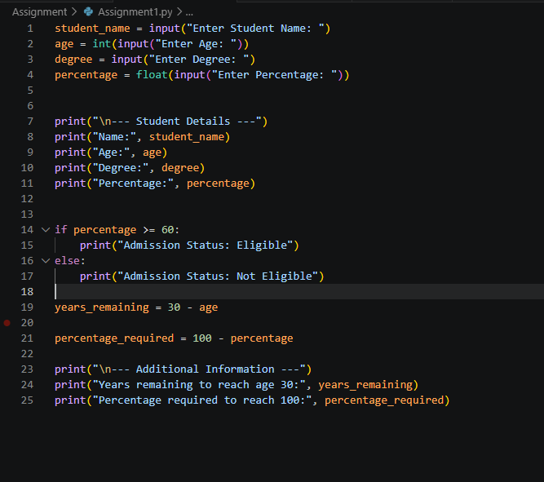

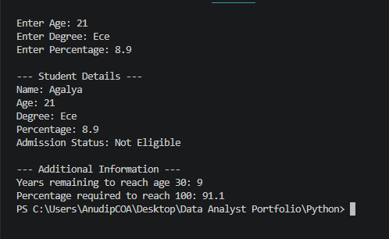
Deliverables
- Python Program
- Screenshot of Output
- GitHub Repository Link

