**NOISE POLLUTION MONITORING PHASE-4**

IoT Noise pollution monitoring project, it can enhance the functionality and user experience by incorporating web development technologies. Here's how can integrate web technologies into various aspects of the project:

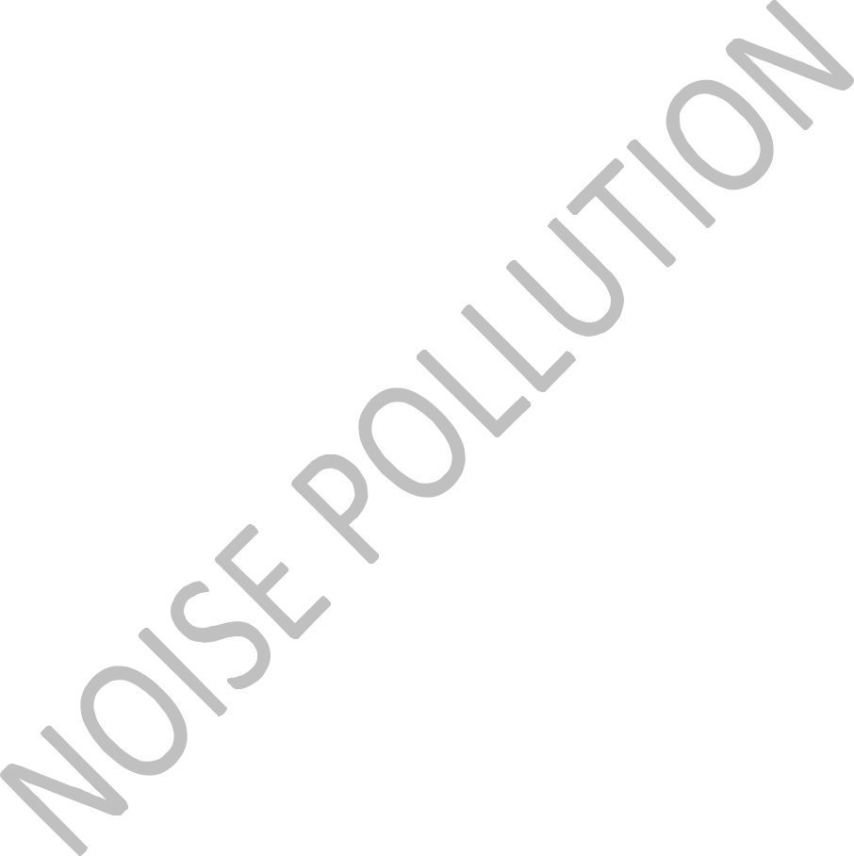

1. **Data Visualization:**
   * **Real-time Dashboard:** Create a web-based dashboard to display real-time noise level data from your IoT sensors. Use technologies like HTML, CSS, and JavaScript to build interactive charts and graphs for visualizing noise levels.
   * **Maps Integration:** Overlay noise sensor data on a map using tools like Google Maps or Leaflet. This can help users visualize noise levels in different geographic locations.

2. **User Interaction:**

* + **User Registration and Authentication:** Implement user accounts with authentication to allow users to access their data securely. You can use technologies like OAuth or Firebase for this purpose.
  + **Alerts and Notifications:** Allow users to set noise level thresholds and receive alerts or notifications via email, SMS, or push notifications when these thresholds are exceeded. Use web technologies to manage and trigger these alerts.

1. **Remote Control:**
   * **Remote Configuration:** Enable users to remotely configure IoT devices, such as adjusting sensitivity or updating firmware via a web interface.
   * **Data Management:** Allow users to remotely download historical data, set data storage preferences, and manage their IoT devices through a web portal.
2. **Data Storage and Analysis:**

* + **Cloud Integration:** Utilize cloud platforms like AWS, Azure, or Google Cloud for secure storage and analysis of sensor data. You can use cloud databases like AWS DynamoDB, Azure SQL Database, or Firebase Realtime Database.
  + **Data Analytics:** Implement data analysis and reporting features on the web portal to provide insights into noise patterns, trends, and historical data. Use tools like Python, R, or JavaScript libraries for data analysis.

1. **User Interface Design:**
   * **Responsive Design:** Ensure that the web application is responsive, so users can access it from various devices, including smartphones, tablets, and desktop computers.
   * **User-Friendly UI:** Design an intuitive and user-friendly interface to make it easy for users to navigate the web portal and access the information they need.
2. **Scalability:**
   * **Load Balancing:** Implement load balancing and scaling to handle increased traffic as more users access the web portal. Cloud-based solutions can be helpful for this.
   * **Database Scaling:** Ensure your database can scale to accommodate a growing volume of data.
3. **Security:**
   * **Data Encryption:** Encrypt data both in transit and at rest to ensure the security of sensitive information.
   * **Access Control:** Implement role-based access control to restrict access to sensitive features and data.
4. **APIs:**
   * **Expose APIs:** Provide APIs for third-party integration, allowing other developers to build applications on top of your data or services.
5. **Documentation:**
   * **User Guides:** Create user documentation and help guides for users to understand how to use the web portal effectively.



By integrating these web development technologies into your IoT noise pollution monitoring project, you can provide a seamless and feature-rich user experience while making data more accessible and actionable for your users.

Certainly! Integrating web development technologies can significantly enhance the functionality and user experience of your IoT noise pollution monitoring project. Here's how you can incorporate web technologies into various aspects of the project:



1. **Real-time Data Visualization:**
   * **Web Dashboards:** Create interactive web dashboards using technologies like HTML, CSS, and JavaScript frameworks (such as React or Angular) to display real-time noise levels, trends, and historical data.
   * **Data Analytics:** Use web-based tools like D3.js or Chart.js to create visually appealing charts and graphs for in-depth data analysis and pattern recognition.
2. **User Interface and User Experience:**
   * **Responsive Design:** Ensure the web interface is responsive, allowing users to access the platform seamlessly across various devices (desktops, tablets, smartphones).
   * **User Profiles:** Implement user authentication and create user profiles where users can customize settings, set noise level thresholds, and receive personalized notifications.
   * **Intuitive UI/UX:** Design an intuitive and user-friendly interface to make it easy for users to navigate, interpret data, and configure monitoring settings.
3. **Alerts and Notifications:**
   * **Push Notifications:** Utilize web push notification APIs to send real-time alerts to users' devices when noise levels exceed predefined thresholds.
   * **Email/SMS Alerts:** Implement email and SMS notifications to alert users about significant noise events or when certain conditions are met.

1. **Data Storage and Analysis:**
   * **Cloud Storage:** Store IoT data securely in cloud databases (e.g., Firebase, AWS DynamoDB) for easy accessibility, scalability, and backup.
   * **Server-side Scripting:** Use server-side scripting languages like Node.js to handle data processing, analysis, and database interactions.
2. **Mapping and Geolocation:**
   * **Interactive Maps:** Integrate interactive maps (Google Maps API, Leaflet) to display noise levels geographically, allowing users to zoom in/out and explore different areas.
   * **Geofencing:** Implement geofencing technology to define specific geographical zones and trigger alerts when noise levels within these zones exceed the defined limits.
3. **Historical Data and Reporting:**
   * **Data Logging:** Store historical data for future analysis and generate reports on noise trends, peak hours, and patterns.
   * **Data Export:** Allow users to export data in various formats (CSV, PDF) for offline analysis and reporting purposes.
4. **Remote Control and Monitoring:**
   * **Remote Configuration:** Enable users to remotely configure IoT devices through the web interface, adjusting monitoring parameters and device settings.
   * **Remote Monitoring:** Provide a live stream or periodic updates of noise levels through the web platform, allowing users to monitor the environment remotely.
5. **Integration with Other Systems:**
   * **API Integrations:** Create APIs to allow integration with third-party applications, smart home systems, or city infrastructure for a broader impact.
   * **Data Sharing:** Implement data sharing features, enabling users to share noise data on social media or with local authorities for community awareness and action.
6. **Security and Privacy:**



* **Encryption:** Ensure end-to-end encryption for data transmission and storage to maintain data security and user privacy.
* **Access Control:** Implement role-based access control (RBAC) to restrict access to sensitive features and data based on user roles.

Integrating web development technologies into your IoT noise pollution monitoring project can significantly enhance its functionality and user experience. Here's how you can incorporate web technologies into various aspects of the project:



1. **Real-time Data Visualization**:

* Use web technologies like HTML, CSS, and JavaScript to create a web-based dashboard. This dashboard can display real-time noise pollution data obtained from your IoT sensors. You can use libraries like D3.js or Chart.js to create interactive and visually

appealing charts and graphs.

1. **Remote Monitoring**:
   * Build a web application that allows users to access and monitor noise pollution data remotely. Users can log in and view data from any device with an internet connection. You can use frameworks like React or Angular for building responsive and dynamic web applications.
2. **Data Storage and Retrieval**:
   * Implement a backend server using technologies like Node.js, Django, or Flask to store and manage the sensor data. You can use databases like MongoDB or MySQL to store historical data. This backend can also serve as an API to retrieve data for the web application.
3. **User Alerts and Notifications**:
   * Implement a notification system that can send alerts to users when noise pollution levels exceed predefined thresholds. This can be done using technologies like WebSockets for real-time notifications or email/SMS notifications through web APIs.
4. **User Management and Authentication**:

Create user accounts and authentication mechanisms to ensure data privacy and security.

1. **Geospatial Visualization**:
   * If your sensors are distributed across different locations, you can use web mapping libraries like Leaflet or Google Maps API to visualize noise pollution data on a map. This can provide users with a geographical perspective of the noise pollution in different areas.
2. **Historical Data Analysis**:
   * Implement data analysis tools in your web application to allow users to view historical trends and patterns in noise pollution. You can use libraries like pandas and NumPy (Python) or data visualization tools like Tableau for more advanced analysis.
3. **Mobile Compatibility**:
   * Ensure that your web application is mobile-friendly, as users may want to access noise pollution data on their smartphones. Using responsive design and frameworks like Bootstrap can help in achieving this.
4. **Data Export and Reporting**:
   * Provide the option for users to export data or generate reports from the web application. This can be useful for research, compliance reporting, or other purposes.



By integrating web development technologies in these ways, your IoT noise pollution monitoring project can offer a more comprehensive, accessible, and user-friendly experience, making it easier for users to monitor and address noise pollution concerns.

**Program :**

Creating a Python script to measure noise pollution is a complex task that typically involves using specialized hardware, such as a sound level meter, and possibly a database to store and analyze the collected data. I can provide you with a basic example of how to record and log noise levels using a simple microphone and the **sounddevice** library. Keep in mind that this is a very basic implementation for demonstration purposes and should not be used for any serious noise pollution monitoring.

To get started, you'll need to install the **sounddevice** library, which allows you to access the microphone:



import sounddevice as sd

import numpy as np

import csv

import datetime

import time

# Parameters

duration = 10 # Recording duration in seconds

sample_rate = 44100 # Sample rate in Hz

log_file = "noise_levels.csv"

def record_noise():

print("Recording noise levels...")

audio_data = sd.rec(int(duration * sample_rate), samplerate=sample_rate, channels=1, dtype="float32")

sd.wait()

* Calculate the average amplitude amplitude = np.mean(np.abs(audio_data))

return amplitude



def log_noise_level(amplitude):

timestamp = datetime.datetime.now().strftime("%Y-%m-%d %H:%M:%S")

with open(log_file, "a") as file:

writer = csv.writer(file)

writer.writerow([timestamp, amplitude])

if __name__ == "__main__":

while True:

try:

amplitude = record_noise()

log_noise_level(amplitude)

print(f"Noise level: {amplitude}")

time.sleep(60) # Record and log every 60 seconds

except KeyboardInterrupt:

print("Recording stopped.")

break

This script records noise levels for a specified duration (10 seconds in this example), calculates the average amplitude of the audio data, and logs the timestamp and amplitude to a CSV file. You can adjust the parameters like duration and the sleep interval to suit your needs.

Remember that this is a very basic example, and real noise pollution monitoring systems would require more advanced equipment, data analysis, and considerations for accuracy and environmental conditions.

