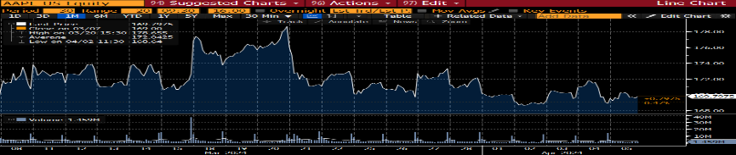

**Define each of those statistics and ratios (eleven in total)**

12M Tot Ret is the percentage change in the value of an investment over a 12-month period.

Beta vs SPX is a measure of a stock's volatility relative to the S&P 500 Index, with a beta greater than 1 indicating higher volatility and a beta less than 1 indicating lower volatility.

Est EPS is the projected earnings per share for a company over a specific period, based on forecasts or analyst estimates.

The P/E ratio: measures a company's stock price against its earnings per share.

Mkt Cap is the total value of a company's outstanding shares.

Px: stands for "Price," representing the current market value of a security.

In news of 2023-11-2, Apple's Q4 FY2023 revenue declined slightly to $90B

Apple's PE ratio of 26.7 can suggest expectations for strong future earnings growth or potential overvaluation.

Apple Inc.'s Px of $171.48 suggests strong investor confidence in its market dominance, innovation, and long-term potential.

Apple Inc.'s high P/B ratio indicates investor optimism about its intangible assets and future profitability.

**Apple Inc. (AAPL)**

Apple is a leading tech company that designs and sells innovative devices like iPhones, iPads, and Macs, along with software and services.

P/S Ratio is a valuation measure that compares a company's market cap to its revenue.

news of 2024-3-27, Apple's WWDC 2024 will take place online from June 11-15.

Bk Val Per Sh is a financial ratio that measures the book value of a company's equity per share.

Current Ratio is a liquidity ratio calculated as current assets divided by current liabilities.

**Tesla Inc. (TSLA)**

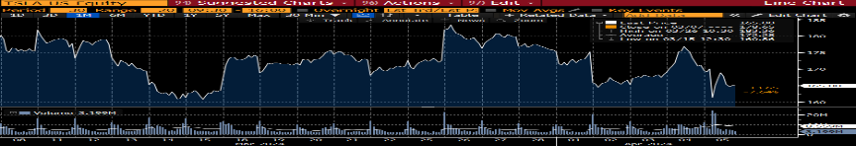

OPM is a financial measure that shows the percentage of revenue left after deducting cost of goods sold and operating expenses.

Price-to-Cash Flow Ratio (P/CF) is a valuation metric that compares a company's stock price to its cash flow from operations.

Tesla is an innovative company that produces electric vehicles and energy storage solutions, led by Elon Musk.

**The comparison of indicators.**

News of 2024-3-20 implies Tesla is the most popular automotive manufacturer among consumers.

Tesla's 67.3 PE ratio suggests investors anticipate significant growth due to its leading position in electric vehicle technology.

Tesla's market capitalization of $559.85 billion reflects investor confidence in its leadership in the electric vehicle industry and potential for future growth.

Tesla's P/S ratio of 5.8 indicates a high valuation relative to its sales, reflecting investor optimism about its growth prospects in the electric vehicle market.

The comparation of P/E implies TSLA’s P/E is far ahead others, meaning Tesla boasts the highest profitability among them.

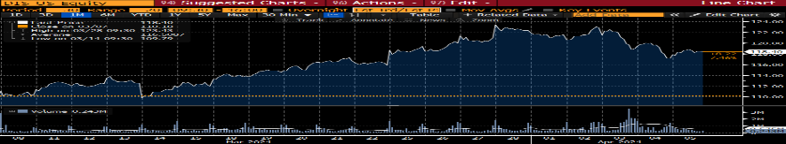

News of 2023-4-6, Disney+ is highlighting nature and conservation content during Earth Month, featuring National Geographic documentaries and Disney animated films promoting environmental awareness.

Disney with 38.7 PE ratio, indicating optimism about its growth in streaming and entertainment.

A P/S ratio of 2.5 for DIS implies that investors value its sales at a moderate level relative to its market capitalization, reflecting expectations of steady revenue growth.

DIS's market cap of $224.45 billion reflects its size and the market's confidence in its long-term business model.

In news of 2023-3-16, Marvel's Guardians Vol. 3 spotlights cast chemistry, and Disney+ adds Ant-Man sequel to its lineup.

The Walt Disney Company is a global entertainment powerhouse, known for its iconic films, theme parks, and media networks.

**The Walt Disney Company. (DIS)**

News of 2024-4-3 shows that Tesla's vehicle deliveries fell by 8.5% year-over-year in Q1 2024.

Apple Inc.'s market capitalization holds an absolute advantage, to the extent that it doesn't even register the other two companies' market caps on the chart, indicating that Apple is the largest company in terms of size.

**Citations:**

**AAPL：**

https://www.apple.com.cn/newsroom/2023/11/apple-reports-fourth-quarter-results/

Date: 2023-11-2

Prices of stocks: 175.52

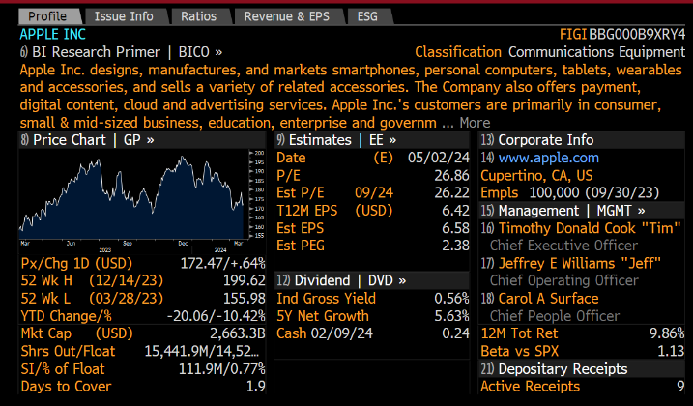https://www.apple.com.cn/newsroom/2024/03/apples-worldwide-developers-conference-returns-june-10-2024/

Date: 2024-3-27

Prices of stocks: 170.41

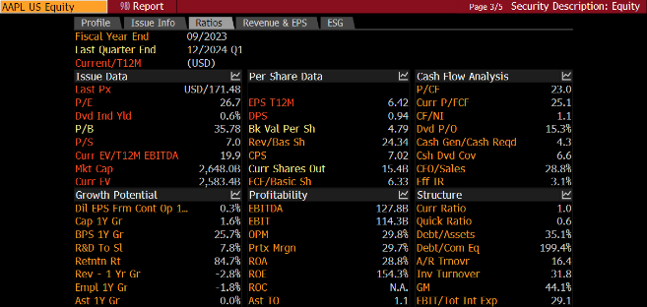

**TSLA：**

https://teslaside.com/news/16520/

Date: 2024-3-20

Prices of stocks: 175.09

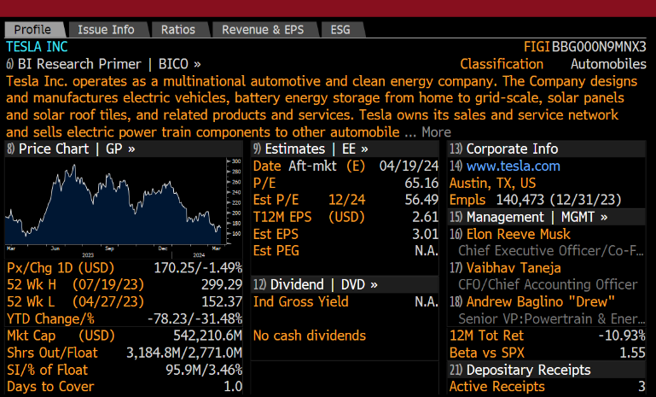https://teslaside.com/news/16996/

Date: 2024-4-3

Prices of stocks: 164.54

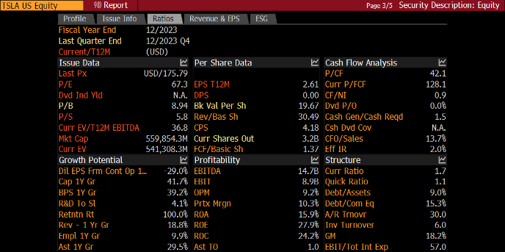

**DIS：**

https://news.disney.com/what-to-watch-disney-plus-march-2023

Date: 2023-3-16

Prices of stocks: 92.67

https://news.disney.com/what-to-watch-disney-plus-april-2023

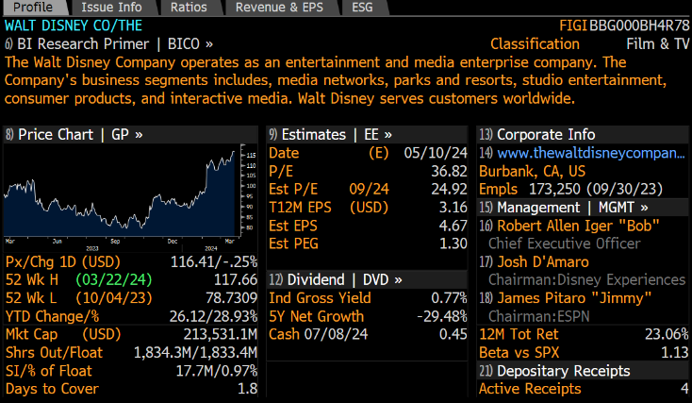Date: 2023-4-6

Prices of stocks: 99.44

