
CSAI2123
Introduction to Data Science
Project
26
/
27
Faculty of Applied Sciences
Student Name:
Bachelor of Science in Computing
Student No.:
Academic Year 2025/2026 Sem.1
Class No.:

(i) To deal with plagiarism, a zero mark will be given if your copy someone else's work or you let someone copy your work.
(ii) Every assignment/project submission must be attached with a signed 'Declaration of Use of Generative AI'.

Please provide a screenshot of the Python code snippet if the answer requires code examples. For all figures, you also need to set the title of the figure to your personal information. The title must strictly follow this format:
"Note: this figure was produced by [Your Name] (ID: [Your Student ID]) on [Date]"
For example: Note: this figure was produced by Jie Zhang (ID: P2026XXX) on 08/10/2026.

1. Problem Definition.
This project aims to develop a machine learning model to predict residential property prices (SALEPRICE) using structural, amenity, and temporal features from real estate sales data. The dataset includes key predictors like lot size (LOTAREA), building type (BLDGTYPE), house style (HOUSESTYLE), overall condition (OVERALLCOND), year built (YEARBUILT), and various quality ratings (e.g., KITCHENQUAL, HEATINGQC). The challenge lies in handling mixed data types—numeric (e.g., FULLBATH), ordinal (e.g., EXTERCOND: Poor to Excellent), and nominal (e.g., ROOFSTYLE)—while accounting for sparse features like pool quality (POOLQC) and nonlinear relationships with price.
Success will be measured by the model's ability to minimize prediction errors (RMSE) and explain price variance (R²) on testing data, providing actionable insights for buyers, sellers, and real estate professionals.
2. Data Collection.
The dataset (“Housing_Prices_Dataset.csv” provided in Cavans) comprises 1460 anonymized sales records of residential properties, with each observation representing a transaction between 2006–2010. It includes 30+ features spanning property characteristics (e.g., FOUNDATION, GARAGETYPE), amenities (e.g., FIREPLACES, FENCE), and sale timing (MOSOLD, YRSOLD). Data quality considerations include missing values (e.g., POOLQC for homes without pools) and ordinal variables requiring careful encoding (e.g., KITCHENQUAL's inherent hierarchy). The target variable, SALEPRICE, exhibits typical real estate skewness, necessitating potential transformation. More information about the dataset items is provided in the Appendix.
Collection methods likely involved public assessor records or MLS listings, with ethical safeguards to exclude personal identifiers. Geographic coverage and sampling biases (e.g., overrepresentation of certain property types) should be investigated to ensure model generalizability.

3. Data Preparation. (20 marks)
Data preparation is conducted to ensure that the dataset is in a suitable format for analysis. This process includes: (1)Data Cleaning: Addressing missing values, removing duplicates, and correcting errors in the dataset. (2) Data Transformation: Converting the data into a format appropriate for analysis, which includes reshaping, normalization, and encoding. Figure 1 shows the Figure 1. overview of the missing samples in the dataset, where the dark red line indicates the missing data.
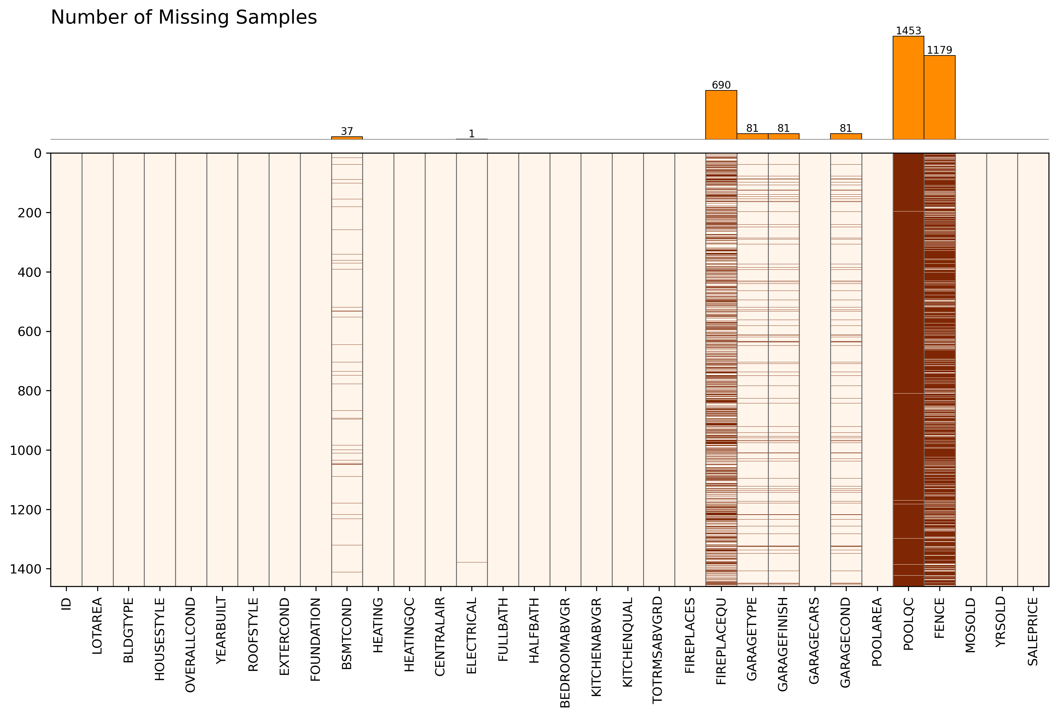
Figure 1. Overview of the missing samples in the dataset. In the heatmap, the dark red line indicates the missing data.
  - Data Cleaning: Provide the code snippet to compute the number of missing samples for each item. (4 marks)

  - Data Cleaning: Provide the heatmap and bar plot to show the missing data with Python code snippet using Matplotlib package (Both separated or integrated versions are acceptable.) It is required to make the consistency between the reference (Figure 1) and your produced figure. (10 marks)

3.3 Data transformation: In scikit-learn package, nominal_transformer and ordinal_transformer are responsible for encoding categorical features appropriately. A Python code snippet of data transformation for numeric, nominal, and ordinal features is provided as follows, (4 marks)
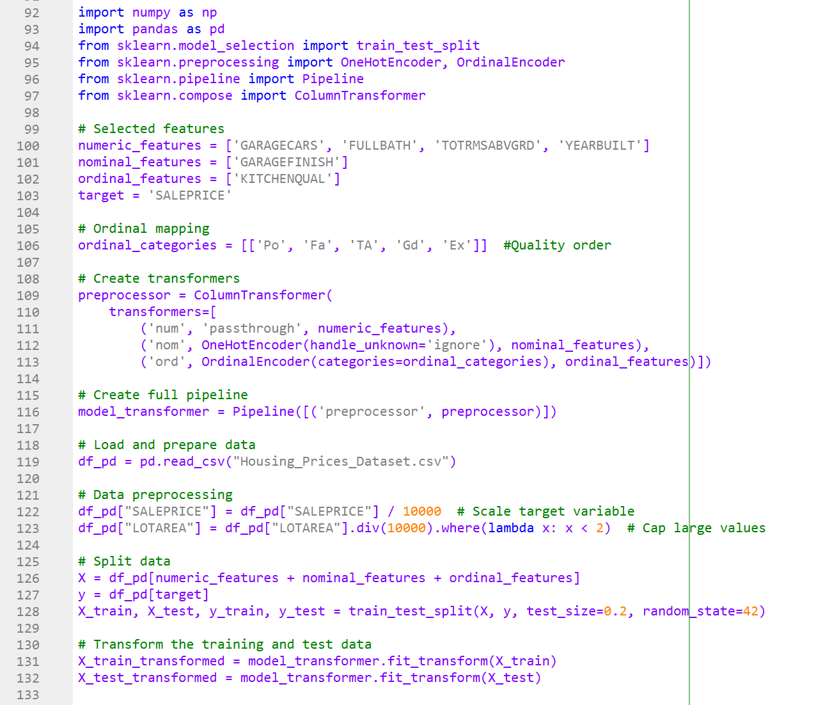
(1) What is the principal of the data transformer for nominal features (i.e., OneHotEncoder() function)? (1 mark)

(2) What is the transformed data for the element ('Fin') in the “GARAGEFINISH” feature? (1 mark)

(3) What is the principal of the data transformer for ordinal features? (i.e., OrdinalEncoder() function)? (1 mark)

(4) What is the transformed data for the element (TA) in the “KITCHENQUAL” feature? (1 mark)

  - Conclusion of data preparation. (2 marks)

4. Data Exploration. (22 marks)
Data exploration is a crucial step in the data analysis process, where analysts investigate datasets to understand their main characteristics, patterns, and relationships. This phase helps identify trends, anomalies, and insights that can inform further analysis or modeling. One important aspect of data exploration is correlation analysis, which examines the relationships between variables.

Correlation analysis helps determine the strength and direction of relationships between variables. It can reveal how changes in one variable might be associated with changes in another, providing valuable insights for decision-making and hypothesis testing. There are two main Types of correlation analysis:

- Correlation Between Numerical Variables:
- Pearson Correlation: Measures linear relationships between two continuous variables; suitable for normally distributed data.
- Kendall Tau Correlation: Assesses ordinal associations; suitable for non-parametric data and smaller sample sizes.
- Spearman Rank Correlation: Evaluates associations between ranked numerical variables; useful for non-normally distributed data.

The correlation values “Corr“can be interpreted as follows:
- 0.1 to 0.3: Weak correlation
- 0.3 to 0.5: Moderate correlation
- 0.5 to 0.7: Strong correlation
- 0.7 to 0.9: Very strong correlation
- 0.9 to 1.0: Perfect correlation

- Correlation with Categorical and Numerical Variables:
- Binary Categorical Variables: Use Point Biserial correlation or convert to numerical codes for Spearman or Kendall correlation.
- Ordinal Categorical Variables: Both Kendall and Spearman correlations are appropriate.
- Nominal Categorical Variables: For nominal variables with no inherent order, correlation coefficients are not appropriate. Instead, techniques like ANOVA or Chi-square tests should be used to analyze relationships, as these tests are designed for categorical data.

The Effect Size Benchmarks (η² = F/(F + df_error))) for the ANOVA F-statistic o can be interpreted as follows:
- η² ≥ 0.01: Small effect (weak correlation)
- η² ≥ 0.06: Medium effect (moderate correlation)
- η² ≥ 0.14: Large effect (strong correlation)

4.1 Perform the correlation analysis for numeric features, compute the Pearson correlation coefficients, and make the scatter subplots to show the correlation. There are no requirements for the consistency between the reference (Figure 2) and your produced figure. (10 marks)
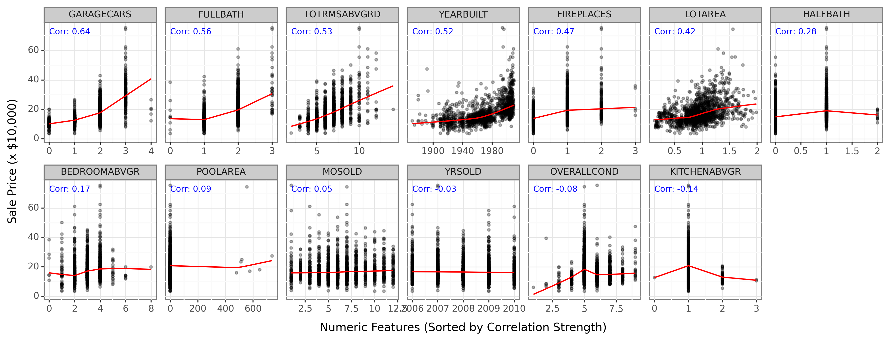
Figure 2. Correlation analysis results between the house sale price and numeric features.

4.2 Perform the correlation analysis for binary/ordinal features, compute the Spearman correlation coefficients, and make the violin subplots to show the correlation. There are no requirements for the consistency between the reference (Figure 4) and your produced figure. (10 marks)
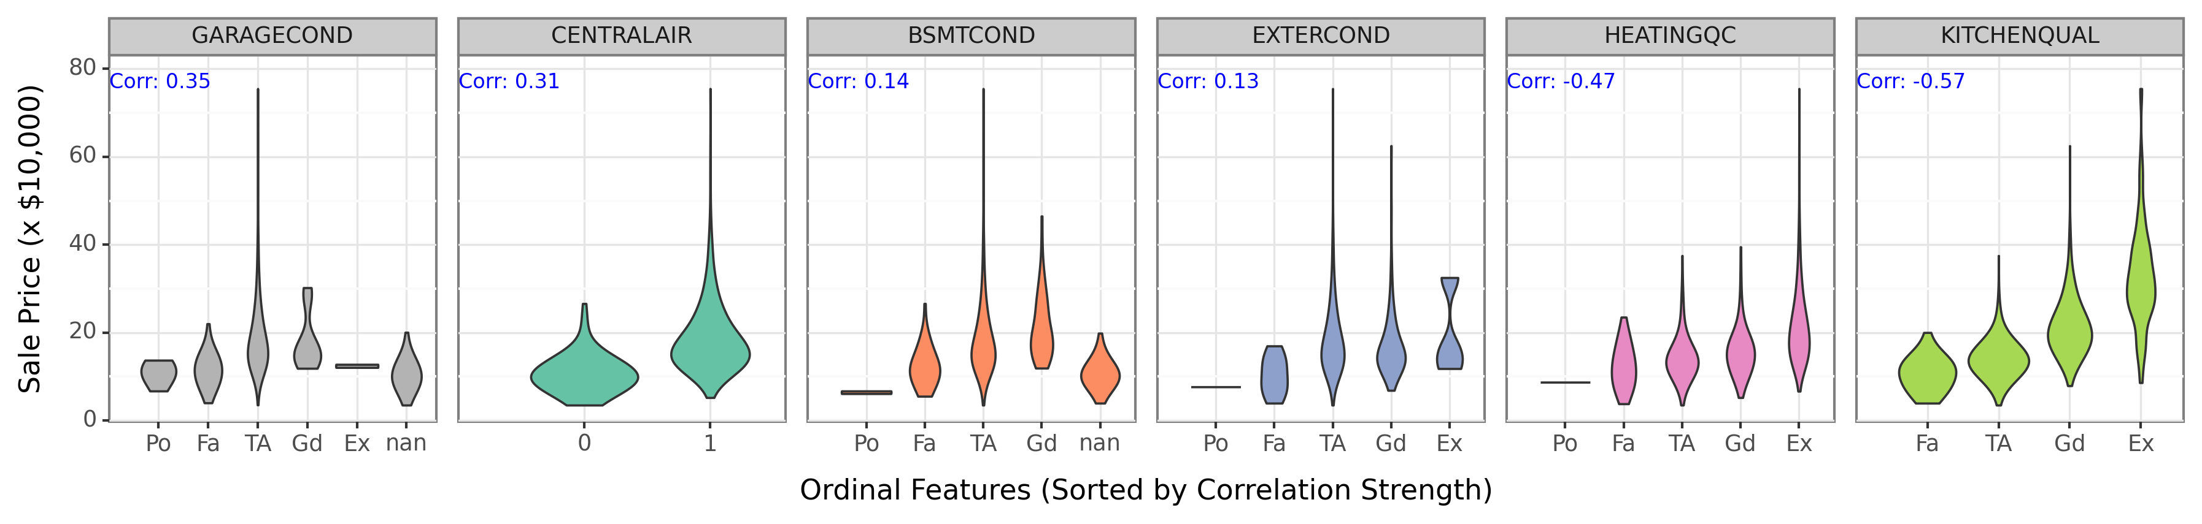
Figure 4. Correlation analysis results between the house sale price and binary/ordinal features.

4.4 Conclusion of data exploration. (2 marks)

5. Feature Engineering. (8 marks)
Feature engineering involves creating new features, transforming existing features, or select the right features to improve the performance of machine learning models. It is a critical stage in the pipeline that can significantly impact model accuracy.
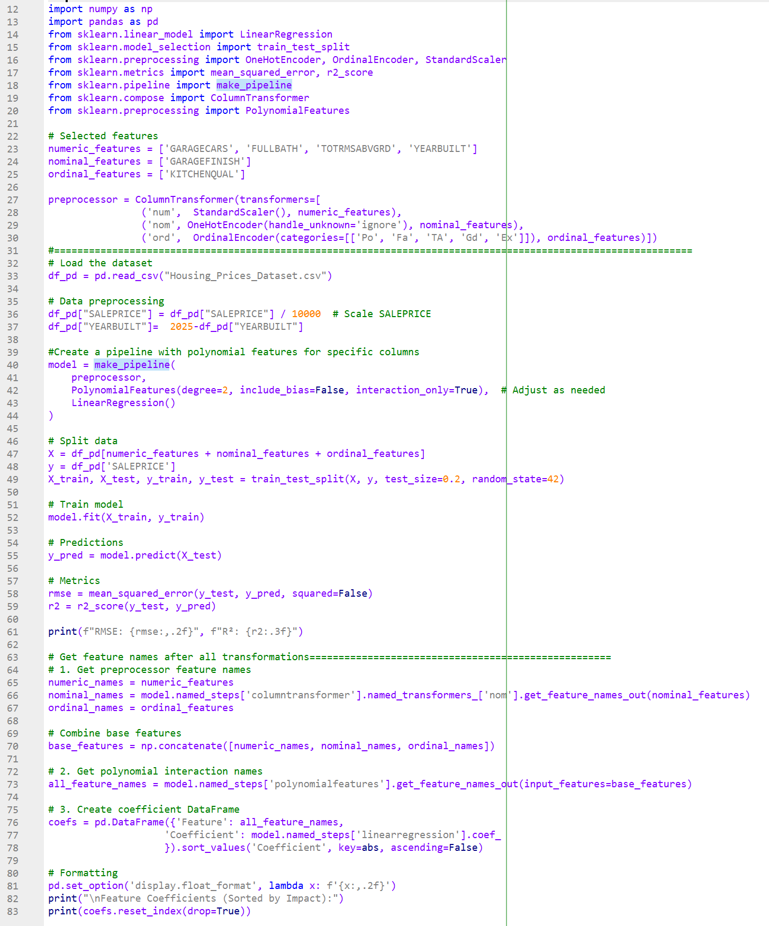

Please run the above Python code snippet to answer the following questions:
5.1 Explain the functionality of Line 42: (3 marks)
PolynomialFeatures(degree=2, include_bias=False, interaction_only=True)

5.2 Present the number of features used in this quadratic multivariate regression model. (1 mark)

5.3 Do all the features need to be used in the regression model? Why? (2 marks)

5.4 Does the feature engineering is needed in this the regression model? Why? (2 marks)

6. Model Creation. (10 marks)
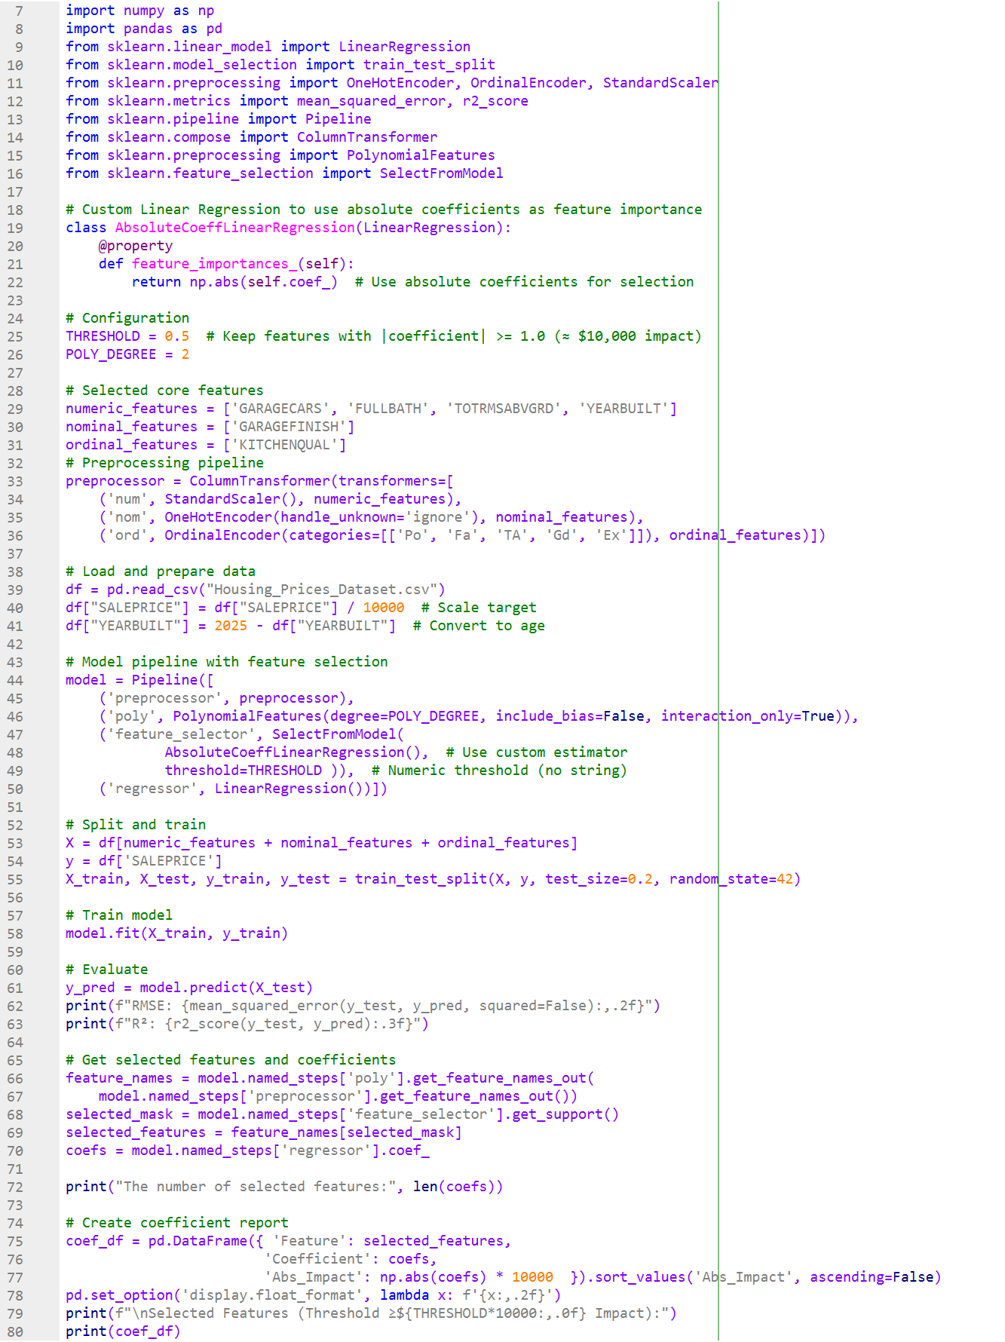
A quadratic multivariate regression model with the feature selection is developed to predict the housing price in the above code. Please run the above Python code snippet to answer the following questions:
6.1 What is the usage of the parameter “THRESHOLD”? (2 marks)

6.2 Make a line chart to show the relationship between the parameter “THRESHOLD” (X-axis values) and the RMSE (Y-axis values). (5 marks)

6.3 Select the proper parameter “THRESHOLD” and explain the reason. (3 marks)

7. Model Evaluation and Comparisons. (30 marks)
7.1 Use four numeric features (['GARAGECARS', 'FULLBATH', 'TOTRMSABVGRD', 'YEARBUILT']) to construct a multiple linear regression as the baseline to demonstrate the superiority of your developed regression model. In the model compassion, the same training and testing datasets are used as follows, (10 marks)
X_train, X_test, y_train, y_test = train_test_split(X, y, test_size=0.2, random_state=42)
Please provide the Python code snippets about the construction and evaluation of multiple linear regression using scikit-learn package, including RMSE and R² of testing datasets. (15 marks)

7.2 Please complete the Table 1. Quantitative comparisons of different regression models. (10 marks)
Table 1. Quantitative comparisons of different regression models.
Model | Number of input features | RMSE of testing datasets | R² of testing datasets
Multiple linear  regression model | 4
Quadratic multivariate regression model without feature engineering | 45 | 4.38 | 0.750
Quadratic multivariate regression model with feature engineering

7.3 Please make a scatter plot to show the comparison between actual vs. predicted sale prices for the multiple linear regression (refer to the Figure 5.) (5 marks)
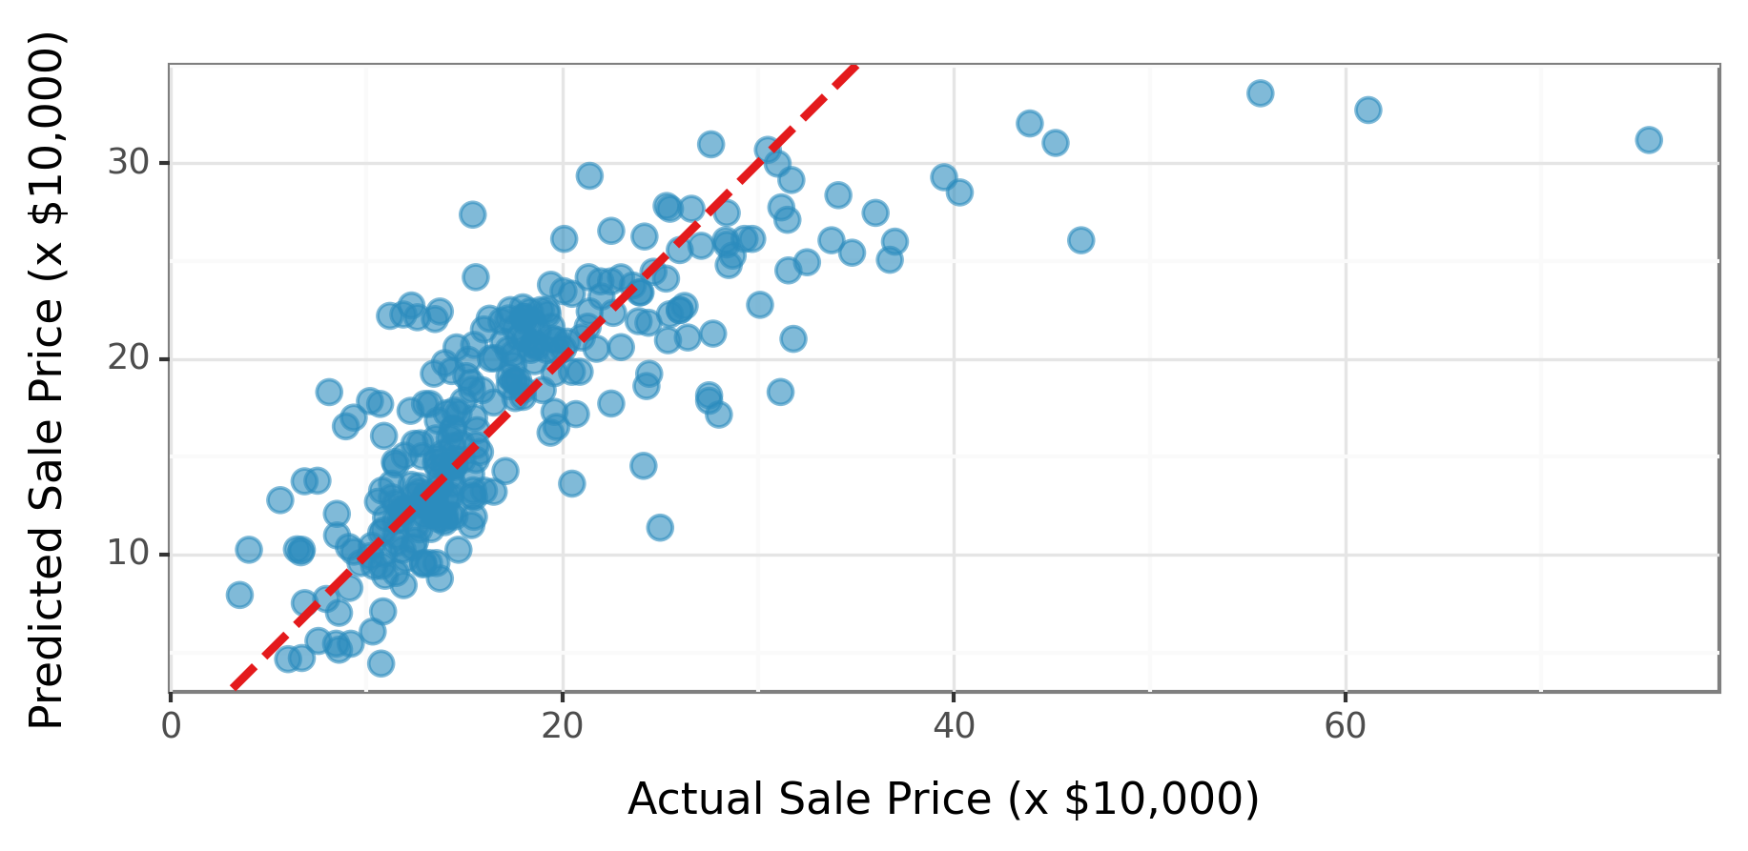
Figure 5. Comparison between actual vs. predicted sale prices for the linear regression model.

8. Conclusion and Discussions. (10 marks)
Analyze the regression results and address the following:
- Key Findings (4 marks)
  - Summarize the model’s performance (R², RMSE) and statistical significance of features (p-values).
  - Identify which features had the strongest/weakest impact on home prices, citing specific coefficients.
- Interpretation (3 marks)
  - Explain the practical implications of the results (e.g., why might bathrooms matter more than garage spaces?).
  - Discuss potential limitations (e.g., omitted variables like location, nonlinear relationships).
- Recommendations (3 marks)
  - Suggest one actionable insight for homeowners or realtors based on the results.
  - Propose one improvement for future modeling (e.g., adding geographic data).

Appendix

A. Dataset items definition

- ID: A unique identifier for each house entry.
- LOTAREA: The lot size of the property in square feet.
- BLDGTYPE: The type of building (e.g., single-family home, townhouse).
- HOUSESTYLE: The architectural style of the house (e.g., 1Story, 2Story).
- OVERALLCOND: The overall condition of the house on a scale (typically 1 to 10).
- YEARBUILT: The year the house was built.
- ROOFSTYLE: The style of the roof (e.g., Gable, Hip).
- EXTERCOND: The condition of the exterior material of the house.
- FOUNDATION: The type of foundation (e.g., PConc for Poured Concrete, CBlock for Concrete Block).
- BSMTCOND: The condition of the basement.
- HEATING: The type of heating system (e.g., GasA for gas, Elec for electric).
- HEATINGQC: The quality of the heating system.
- CENTRALAIR: Indicates whether the house has central air conditioning (Y/N).
- ELECTRICAL: The type of electrical system (e.g., SBrkr for circuit breakers).
- FULLBATH: The number of full bathrooms in the house.
- HALFBATH: The number of half bathrooms.
- BEDROOMABVGR: The number of bedrooms above ground level.
- KITCHENABVGR: The number of kitchens above ground level.
- KITCHENQUAL: The quality of the kitchen.
- TOTRMSABVGRD: Total number of rooms above ground (excluding bathrooms).
- FIREPLACES: The number of fireplaces in the house.
- FIREPLACEQU: The quality of the fireplace.
- GARAGETYPE: The type of garage (e.g., Attchd for attached, Detchd for detached).
- GARAGEFINISH: The finish of the garage (e.g., RFn for finished, Unf for unfinished).
- GARAGECARS: The capacity of the garage in terms of the number of cars it can hold.
- GARAGECOND: The condition of the garage.
- POOLAREA: The area of the pool (if any) in square feet.
- POOLQC: The quality of the pool.
- FENCE: The type of fencing around the property. (e.g., GdPrv = Good Privacy).
- MOSOLD: Month when the house was sold.
- YRSOLD: Year when the house was sold.
- SALEPRICE: The sale price of the house.

B. Dataset items categories

1. Numeric Columns (Continuous/Discrete)
Features | Description | Impact on Price
(2) LOTAREA | Lot size (sq. ft.) | Larger lots = higher value.
(5) OVERALLCOND | Overall condition (1-10 scale) | Higher rating = better price.
(6) YEARBUILT | Year the house was built | Newer homes often sell for more.
(15) FULLBATH | Number of full bathrooms | More bathrooms = higher value.
(16) HALFBATH | Number of half bathrooms | Adds convenience, may boost price.
(17) BEDROOMABVGR | Bedrooms above grade | More bedrooms = higher demand.
(18) KITCHENABVGR | Kitchens above grade | Extra kitchens may increase value.
(20) TOTRMSABVGRD | Total rooms above grade | More rooms = higher price.
(21) FIREPLACES | Number of fireplaces | Luxury feature, can increase value.
(25) GARAGECARS | Garage capacity (cars) | More space = higher value.
(27) POOLAREA | Pool size (sq. ft.) | Larger pools = luxury premium.
(3) MOSOLD | Month sold (1-12) | Seasonal trends may affect price.
(31) YRSOLD | Year sold (e.g., 2006-2010) | Market trends influence price.
(32) SALEPRICE | Sale price (target variable) | Dependent variable to predict.

2. Categorical Columns (Nominal/Ordinal)
2.1 Nominal (No inherent order)
Features | Description | Possible Values (Examples)
(3) BLDGTYPE | Building type | 1Fam (Single-family), 2FmCon, Duplex, Twnhs
(4) HOUSESTYLE | Architectural style | 1Story, 2Story, 1.5Fin, SplitLevel
(7) ROOFSTYLE | Roof design | Gable, Hip, Flat, Mansard
(9) FOUNDATION | Foundation type | PConc (Poured Concrete), CBlock, BrkTil, Slab
(11) HEATING | Heating system | GasA (Gas forced air), GasW (Gas water), Elec
(13) CENTRALAIR | Central air conditioning | Y (Yes), N (No)
(14) ELECTRICAL | Electrical system | SBrkr (Standard), FuseA, FuseF
(23) GARAGETYPE | Garage attachment | Attchd (Attached), Detchd, BuiltIn, None
(24) GARAGEFINISH | Garage interior finish | RFn (Finished), Unf (Unfinished), None
(29) FENCE | Fence quality | MnPrv (Privacy), GdWo (Good wood), None

2.2 Ordinal (Ranked categories)
Features | Description | Scale (Worst → Best)
(8) EXTERCOND | Exterior condition | Po → Ex
(10) BSMTCOND | Basement condition | Po → Ex
(12) HEATINGQC | Heating quality | Po → Ex
(19) KITCHENQUAL | Kitchen quality | Po → Ex
(22) FIREPLACEQU | Fireplace quality | Po → Ex
(26) GARAGECOND | Garage condition | Po → Ex
(28) POOLQC | Pool quality | Po → Ex

Note: Po: Poor < Fa: Fair < TA: Typical/Average < Gd: Good < Ex: Excellent

Declaration of the Use of Generative AI for Assessment Work
Student name: | _________________________________________
Student ID: | _________________________________________
Module Code: | _________________________________________
Assessment Title: | _____________________________________________________________________________________

Please make sure you understand the policy about using generative AI, and such use must be explicitly acknowledged. The teacher/supervisor responsible for the assessment will provide specific guidance regarding acceptable usage, based on the module learning outcomes and marking criteria of the assessment. Failure to follow the rules for your work constitutes academic dishonesty.
Please tick either one below.
☐ I have used generative AI in this assessment work
☐ I did not use generative AI in this assessment work (please go to sign)
Generative AI tool used (name and version): | ________________________________________________________
For each relevant area, briefly describe how the information was generated, as well as explain how the output was used in your work. Put N/A if not appropriate.
Type of Usage | Done by AI tools | Done by student
Brainstorming and idea generation
Rephrasing text or formulas or generating text applied directly to the task
Generating literature/background review
Coding programming tasks
Producing diagrams/figures
Analysing data
Other (please specify):

Student signature:
Date:

