Assignment - 2 Conversational AI

Anshuman Ghosh
Kakde Atharva Mahesh | 2024aa05224

Hybrid Retrieval-Augmented Generation (RAG) System on Wikipedia
This project implements a Hybrid RAG system combining Dense Retrieval, Sparse Retrieval (BM25), and Reciprocal Rank Fusion (RRF) over a dynamically constructed Wikipedia corpus.
It also includes automated evaluation, ablation studies, and LLM-based judging.

1. Dataset Requirements & Corpus Construction
The corpus consists of 500 Wikipedia articles:
- 200 Fixed URLs (constant across runs)
- 300 Random URLs (sampled per indexing run)
Each article is cleaned, chunked, embedded, and indexed for retrieval.

Corpus Pipeline
Script | Description
src/corpus/url_sampling.py | Connects to Wikipedia and samples 200 fixed URLs (currently configurable; default limit was 20)
src/corpus/fetch_wikipedia.py | Fetches Wikipedia page content and stores raw text with page titles
src/corpus/clean_text.py | Performs basic text cleaning
src/corpus/chunker.py | Sentence-based chunking (200–400 tokens with overlap) and metadata generation for BM25
src/corpus/clean_text.py --input data_random/cleaned_text --output data_random/cleaned_text_final | Cleans random dataset
src/corpus/clean_text.py --input data/cleaned_text --output data/cleaned_text_final | Cleans fixed dataset
src/corpus/embed.py | Generates dense embeddings and stores them in .jsonl format
src/corpus/bm25_embed.py | Builds BM25 index (bm25_index.json)
src/corpus/merge_embeddings.py | Merges fixed and random embeddings into data/embeddings_merged.jsonl

2. Hybrid RAG System
The retrieval system combines Dense, Sparse, and Hybrid (RRF) strategies.

Retrieval & Generation
Script | Description
src/retrieval/dense.py | Dense vector retrieval using sentence embeddings
src/retrieval/sparse.py | Sparse keyword-based retrieval using BM25
src/retrieval/hybrid.py | Hybrid retrieval combining dense and sparse results
src/retrieval/hybrid.py | Reciprocal Rank Fusion (RRF) implementation
src/retrieval/generator.py | LLM-based response generation
src/retrieval/test.py | Tests retrieval and outputs RRF scores for all chunk IDs
streamlit run app/app.py | Launches the interactive user interface

3. Automated Evaluation Framework
Automated evaluation is performed on 100 generated questions.

Evaluation Components
Script | Description
src/retrieval/qgenerator.py | Automated question generation from Wikipedia corpus
src/evaluation/eval_MRR.py | Mean Reciprocal Rank (MRR) evaluation (URL-level)
src/evaluation/ndcg.py | NDCG@K evaluation
src/evaluation/semantic_similarity.py | Semantic similarity evaluation (answer quality)
src/evaluation/ablation.py | Ablation study (Dense vs Sparse vs Hybrid)
src/evaluation/llm_as_judge.py | LLM-as-Judge evaluation (accuracy, completeness, relevance, coherence)

End-to-End Execution
All steps—from data collection to evaluation—can be executed using a single script (run.sh).

User Interface
- Clone https://github.com/AGDevOps78/rag-hybrid-wiki.git
- At vscode prompt change directory to path within rag-hybrid-wiki\app
- Ensure streamlit package is installed, if not run !pip install streamlit
Run command : streamlit run app/app.py | Launches the interactive user interface
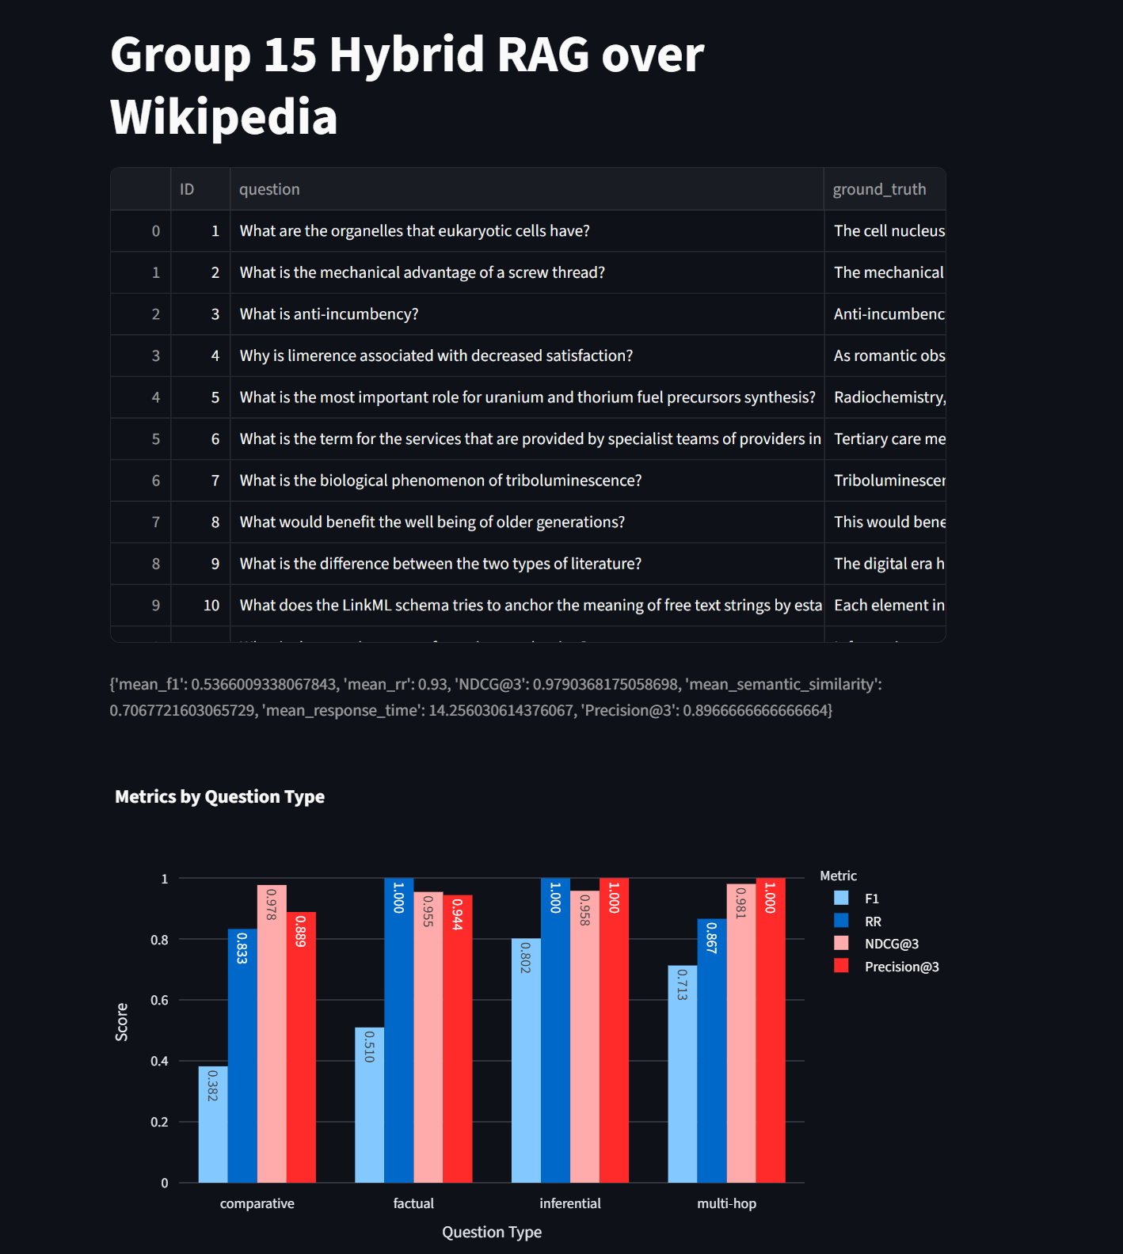
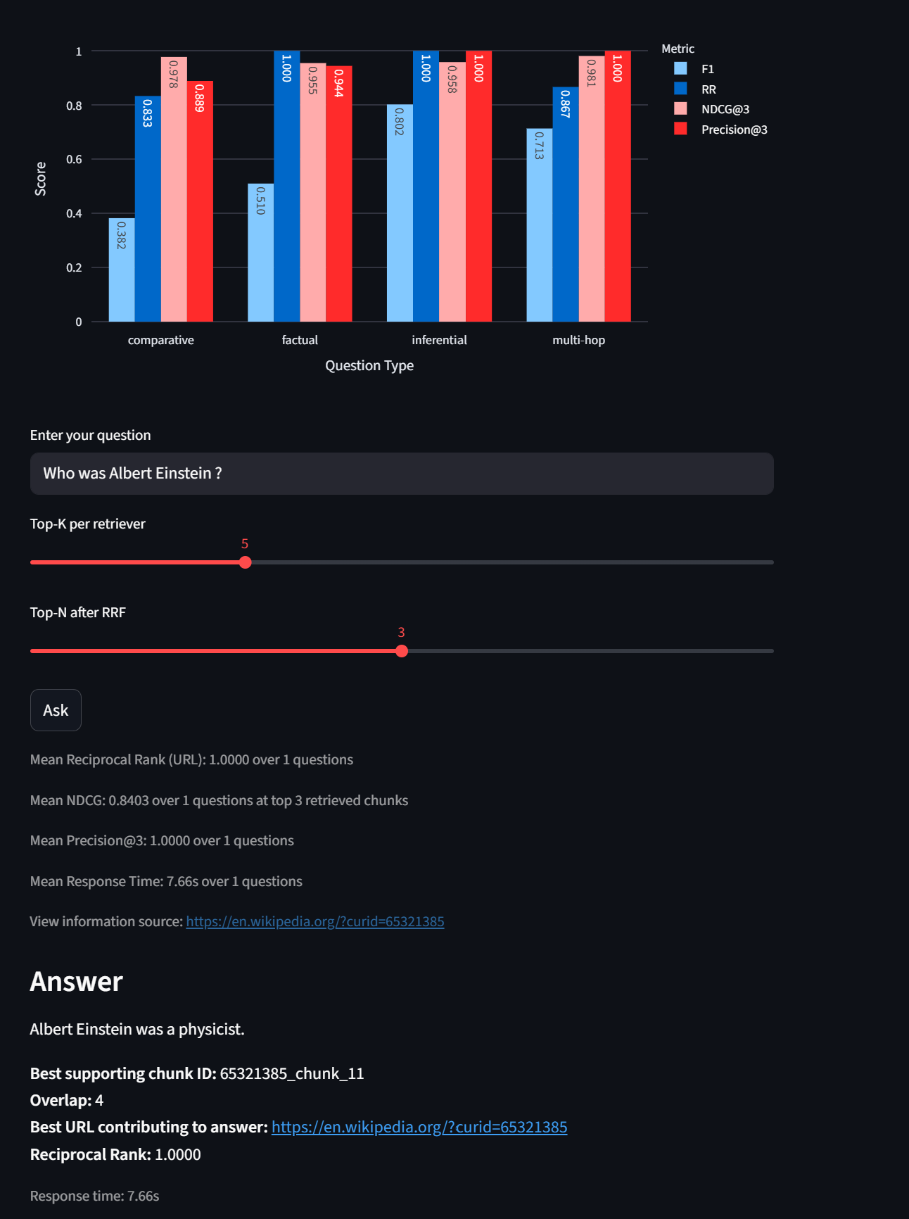
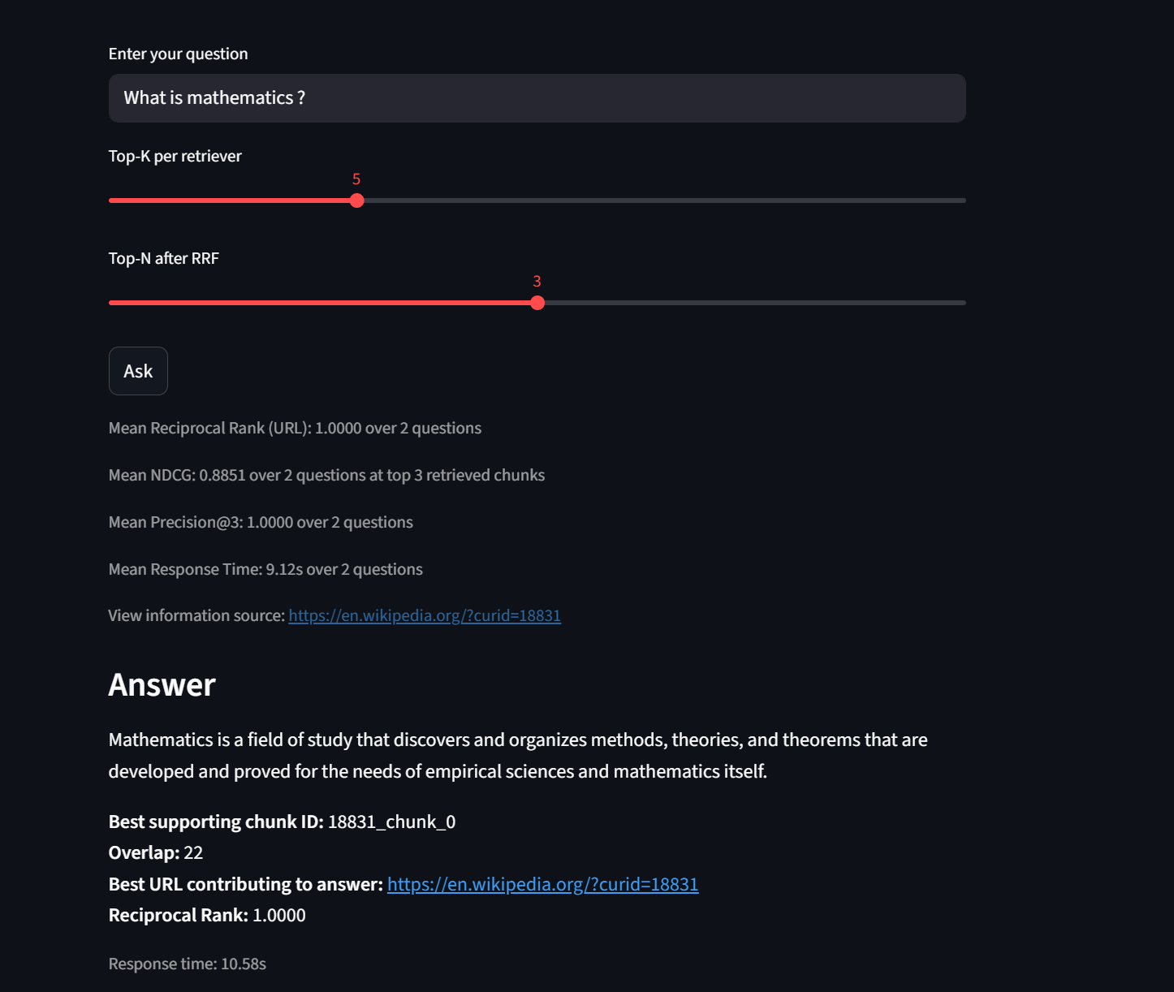
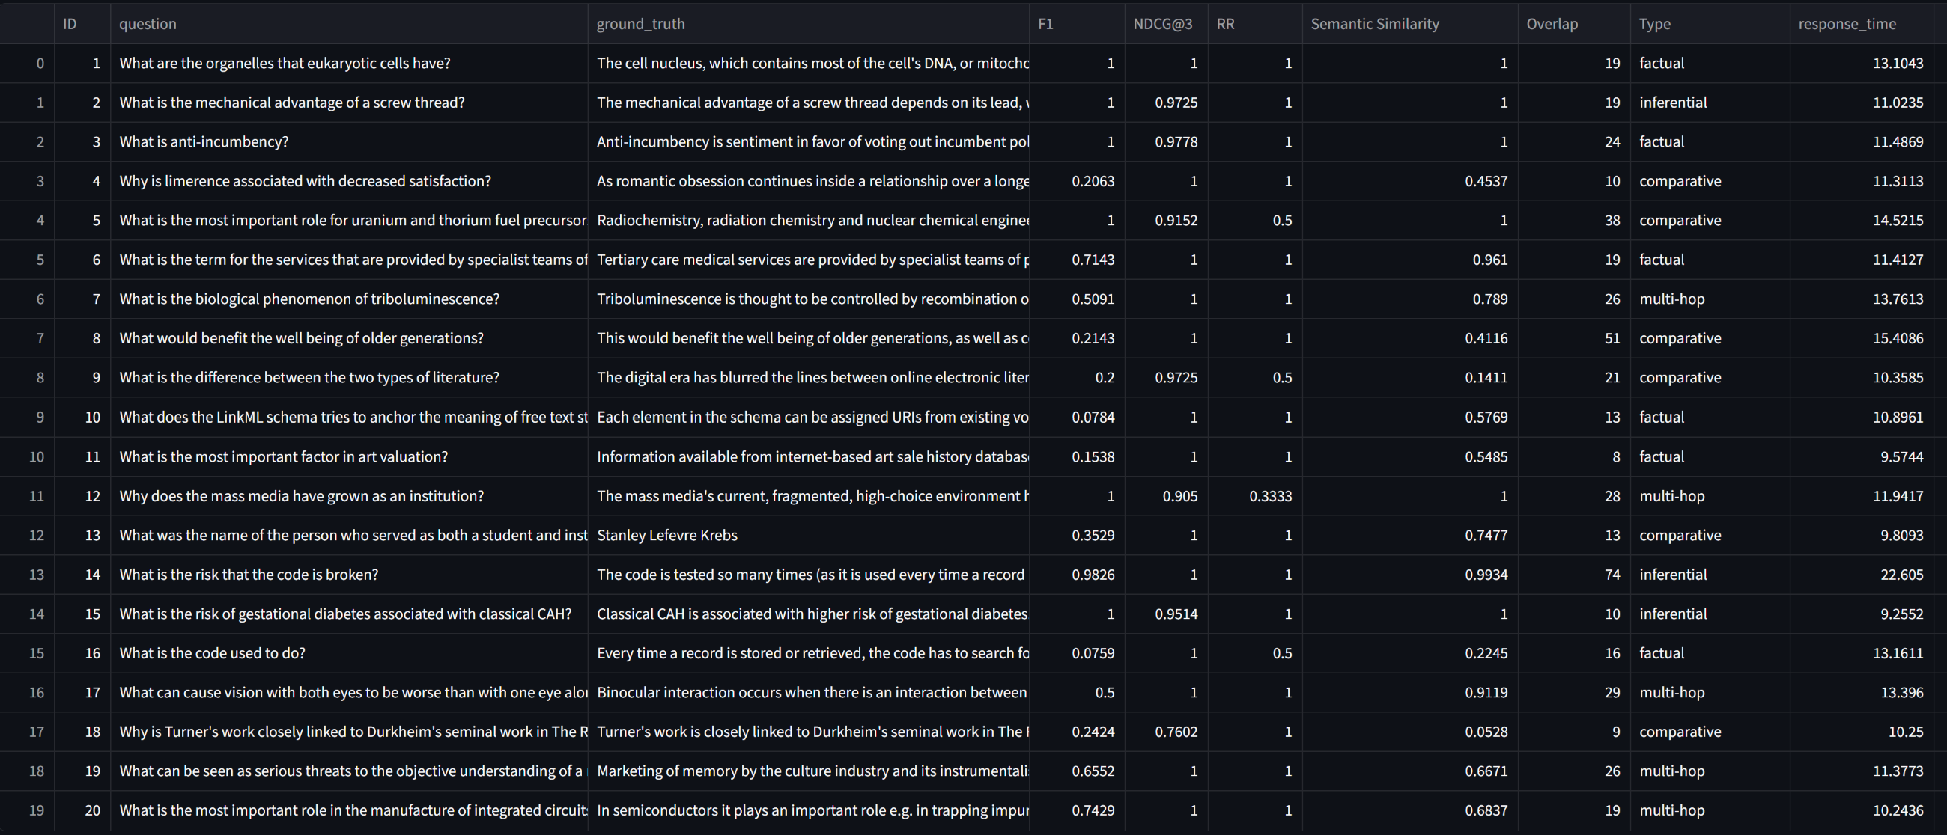

Evaluation Matrix:
answer-level evaluation : Set of 100 questions generated with randomly selected chunks and ground truth answers generated by the same SLM (Google-FLAN)

1.Semantic similarity between predicted and gold answer using cosine similarity of sentence embeddings from a pre-trained model (all-MiniLM-L6-v2).
This captures the overall semantic closeness of the generated answer to the ground truth answer, beyond just token overlap. It can recognize when two answers are saying the same thing in different words, which is important for evaluating generative models where exact token matches may be less common.
This works by encoding both the predicted answer and the gold answer into dense vector representations using the SentenceTransformer model, and then computing the cosine similarity between these two vectors.
Works better than simple token overlap metrics like F1 because it can capture semantic equivalence even when there are few or no shared tokens, as long as the overall meaning is similar.
However, it may not be as interpretable as token-based metrics and can sometimes give high similarity scores to answers that are semantically related but not actually correct. Therefore, it's best used in conjunction with other metrics like F1 for a more comprehensive evaluation
More useful for larger answers where there is more content to capture semantic meaning, and less useful for very short answers where token overlap may be more indicative of correctness.
:param pred: Answer generated by the RAG system for a given question from K-chunks. This is generated by a LLM (Google Flan-T5-Base) using retrieved K chunks as context.
:param gold: ground truth from a set of questions with known answers. Questions are generatred using SLM (Google Flan-T5-Base) supplying random retrieved chunks as context
ground truth answers are answers generated by the same model (Flan-T5-Base) with the same question but with gold retrieved chunks as context. This way we have a "best possible answer" for each question
that is still generated by the same model and not human annotated, which would be unfairly harsh.
2. F1 score:
F1 score between ground truth and predicted answer based on token overlap after normalization. (answer-level evaluation.
:param pred: Answer generated by the RAG system for a given question. This is generated by a LLM (Google Flan-T5-Base) using retrieved K chunks as context.
:param gold: ground truth from a set of questions with known answers. Questions are generated using SLM (Google Flan-T5-Base) supplying random retrieved chunks as context
ground truth answers are answers generated by the same model (Flan-T5-Base) with the same question but with gold retrieved chunks as context. This way we have a "best possible answer" for each question
that is still generated by the same model and not human annotated, which would be unfairly harsh.
The random questions and answers generated ensure no human bias, and when compared with the RAG generated answer, we can see how close the RAG system gets to the best possible answer at k chunks that the model can generate given perfect retrieval.
Overlap of tokens is computed after normalization which includes: Lowercasing, stop word removal, stemming, and punctuation removal. This is to ensure that we are comparing the core content of the answers rather than surface-level differences.
Retrieval level: Given the predicted answer and chunks check how relevant and grounded the answers are with the retrieved chunks . Higher score means more grounded, less chance of hallucination.

1. NDCG@K based on relevance scores computed from token overlap between the generated answer and the retrieved chunk text. (retrieval-level evaluation)
Advantage over precision@k is that it gives more weight to chunks that are more relevant (have higher token overlap) rather than treating all supporting chunks equally. That is NDCG@K score also gives feedback of the ranking quality.
This way we can capture not just whether a chunk supports the answer, but how strongly it supports it based on content overlap.
# Sort by rank (in case input isn't sorted)
# 1. remove stopwords from answer and chunk text
# 2. use PorterStemmer to stem tokens
# 2. compute relevance score based on overlap
# 3. compute DCG and IDCG
2. precision@k for supporting chunks in the top-K retrieved chunks.(retrieval-level evaluation)
Here we check how many of the top-K retrieved chunks are actually supporting the answer (based on token overlap) and compute precision accordingly.(count of supporting chunks in top-K / K).
This answers the question “Are all the chunks returned relevant?” if yes its 1. It does not consider the ranking of the chunk and treats all the chunks equally. We use this to check especially at lower K (k<5), if this is less, then it’s possible that 1 or more returned chunks are totally irrelevant
:param ranked_chunk_ids: List of chunk IDs in descending order of relevance.
:param supporting_chunk_ids: Set of chunk IDs that support the answer.
:param k: Number of top chunks to consider for precision calculation.

Why choose 2 each for answer quality and retrieval/grounding?
For answer quality, while F1 using token semantic “word for word match” is fast, and accurate for smaller sentences, If the 2 answers being compared, have large differences in word count, even though similar it returns lower score.
Word embedding based Semantic similarity ensures, similar meaning words are not penalized.
Averaging the 2 seems to give a better estimate of answer quality.
For Retrieval quality , we use precision@k to understand the over all quality of retrieved k-chunks. The more chunks we retrieve and supply to SLM involves more cost in terms of time, resource and tokens used. Given different values of K we try to determine at what K precision tends to 1. Here it seems 3 -5 is a good number
While precision @k gives information about overall retrieval relevance, it does not account for the ranking, which NDCG@k does, this helped, when tweaking the RRF calculation especially for hybrid retrieval

Results in - Python Notebook End-to-End Execution
An end-to-end flow ran on a python notebook. Refer to python_notebook.pynb.
A pdf for the same python notebook is also there for reference. Refer to python_notebook pdf.pdf

