Overview:
As a developer, it is essential for day to day working to be able to setup and use a basic “sandbox” scene in Unity to test your own work. In this lab, we’re going to take an overview of the Unity Interface and basic building skills that will allow you do this.

Project Setup:

- Create a New Unity Project:
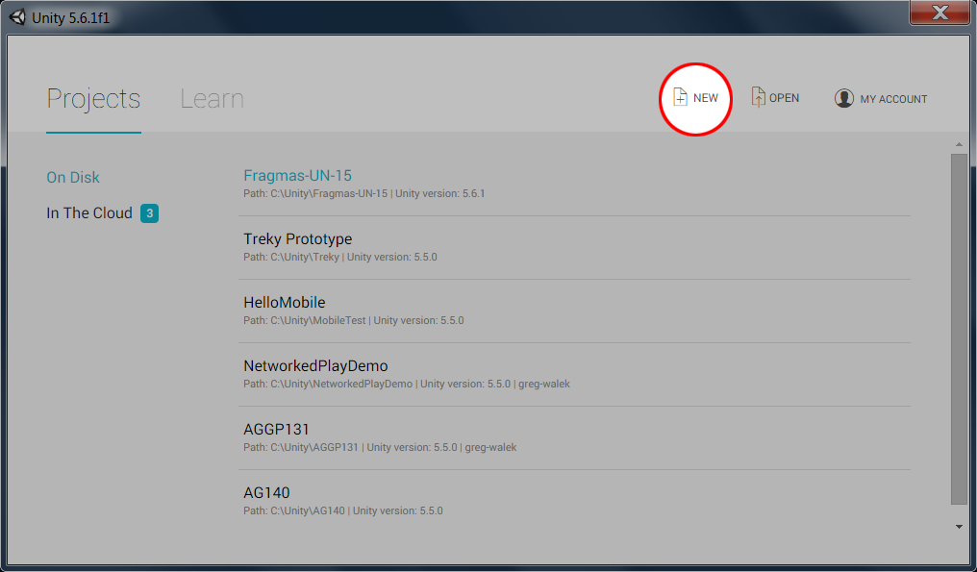

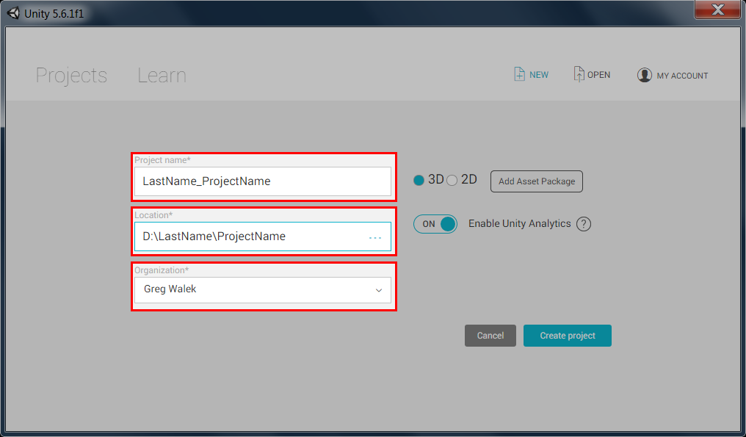
Top Box - Project Name:
In This course name your projects using LastName_ProjectName
Middle Box - Project Location:
Location where the project will be created.
If you are working on a lab machine, make sure you create a folder on the D: (Thaw) drive with your last name and save within a folder there.
Bottom Box – Organization:
This should be your name, or the name you entered when you created your Unity ID. (It should default to this)

- Add Standard Unity Packages for Character and Prototyping
  - They can be found in the menu bar from Assets -> Import Package

- Create 4 Materials.
  - One must be a flat color for the Albedo (Diffuse) property
  - One must use a Texture for the Albedo (Diffuse) property
    - You will need to import a texture to create this
  - Other Two materials are of your choice.

- Import an Audio File

Project Requirements:
Create a scene that you can navigate
- Have a Floor!
- Use a Prefab Character from Standard Assets
  - Don’t forget to setup a camera for RollerBall or 3rd Person controller.
  - Delete the Camera in Scene if you use the FPS controller.
- Use 3d Objects (right click from Hierarchy Tab)
- Use Meshes from Prototyping Assets
    - Make sure you add collision to these meshes
- Use all of the textures you’ve made
  - You are welcome to make more.
- Place your audio file in the level on a game object with an audio source component.
- Create a Prefab and use it multiple times.

