**AGGP 131**

**LAB 1**

**Readings:**

[**https://docs.microsoft.com/en-us/dotnet/csharp/tutorials/inheritance**](https://docs.microsoft.com/en-us/dotnet/csharp/tutorials/inheritance)

[**https://docs.microsoft.com/en-us/dotnet/csharp/programming-guide/classes-and-structs/inheritance**](https://docs.microsoft.com/en-us/dotnet/csharp/programming-guide/classes-and-structs/inheritance)

[**https://docs.microsoft.com/en-us/dotnet/csharp/language-reference/keywords/base**](https://docs.microsoft.com/en-us/dotnet/csharp/language-reference/keywords/base)

**https://docs.microsoft.com/en-us/dotnet/csharp/language-reference/keywords/override**

[**https://docs.unrealengine.com/latest/INT/GettingStarted/FromUnity/index.html**](https://docs.unrealengine.com/latest/INT/GettingStarted/FromUnity/index.html)

[**https://docs.unrealengine.com/latest/INT/Gameplay/Framework/\**](https://docs.unrealengine.com/latest/INT/Gameplay/Framework/\)

[**https://docs.unrealengine.com/latest/INT/Gameplay/Framework/QuickReference/index.html**](https://docs.unrealengine.com/latest/INT/Gameplay/Framework/QuickReference/index.html)

[**https://docs.unrealengine.com/latest/INT/Gameplay/index.html**](https://docs.unrealengine.com/latest/INT/Gameplay/index.html)

**PART 1 – Inheritance and Overrides Example:**

* This Assignment is C# Console Application
  + Name the project <LastName>_Lab1_InheritanceExample
* A Starting Application with a Test Class and method has been provided for you
* Create a set of 5 classes that inherit using the structure
  + Each Class will be in its own file.

Level1  
 |->Level2  
 |-> Level3   
 |-> Level4A  
 |-> Level4B

* Write the following methods in the classes
  + Have each method that prints a string that indicates the method was called.
  + Have the override methods indicate that it is an override
  + In class ‘Level1’
    - Add a new virtual method Method1
  + In class ‘Level2’
    - Add a new virtual method Method2
  + In class ‘Level3’
    - Add a new virtual method Method3
    - Add an override of Method2
  + In class ‘Level4A’
    - Add an override of Method3
      * This method will extend the method and then call the base version.
      * *You will see the output from Level 4A before you see the output from Level 3, which is the base.*
  + In class ‘Level4B’
    - Add an override of Method3
      * This method will call the base version and then extend the method.
      * *You will see the output from Level 3, which is the base, before the new output from Level4B*

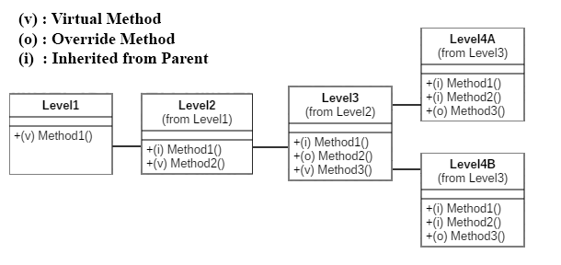

**The Output of your application look like the following:**

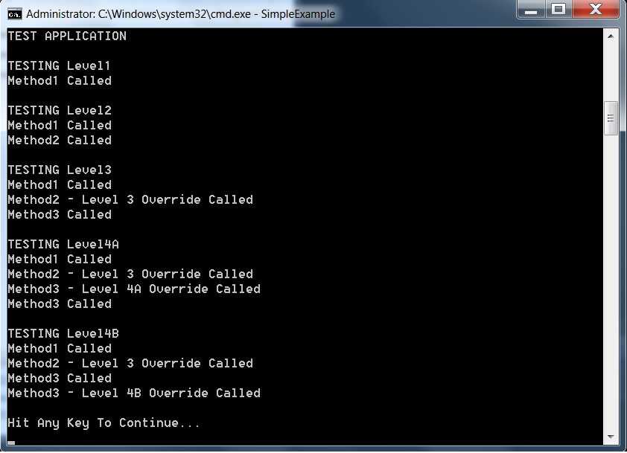

**PART 2 – C++ Example**

* Recreate Part 1 using C++
* You are responsible to port the test code to C++
  + **The Output of your C# and C++ projects will be the same!**
* Each C++ Classes will have a .h (header) and .cpp (code) files
* Your project will have 11 files total
  + 1 Code file ( .cpp ) will contain your void Main()
  + 5 Code Files ( .cpp ), 1 for each level
  + 5 Header files ( .h ), 1 for each level

**PART 3 – Unity Example**

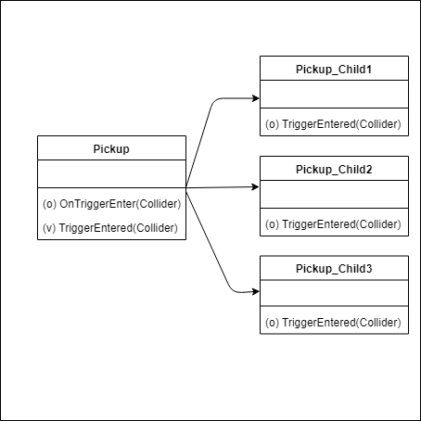

* Create a simple Unity project
* Create the scripts using the Diagram above
  + Create a Script “Pickup”
    - Add “TriggerEntered”
      * Public
      * Virtual
    - OnTriggerEnter
      * will call “TriggerEntered”
      * Destroy the Game Object
  + Create Three Child Classes of “Pickup”
    - This will override “TriggerEntered”
    - Each Child will do something different.
* Create 3 Prefabs using the child classes
* Create a simple scene to test.
* Extra Credit:
  + Have TriggerEntered return a boolean
  + Use this boolean to control if the game object is destroyed in OnTriggerEnter in the base Pickup Class.