**AG 131  
Lab 6 – Behaviors**

*Note: the Packages made for this lab assignment must be imported in 2018.3 or later.*

**Part 1: Vision**

Import Package labeled “Part1”

* Add a Nav Mesh to the scene.
* Add a sphere named “Move Location”
  + Give it a texture with color, please!
  + Remove the object’s Collider.
  + On Left Mouse Click
    - Perform raycast from the mouse location into the world.
    - If the raycast lands on the “Ground”, Move the Sphere to the location found.
* Add a Nav Mesh Agent to the Player
* Add a Script “NavMeshControl” to the player
  + This script will move the player to the MoveLocation sphere
  + This Script will stop the player when it is close enough to the Sphere
    - Set length as a pubic variable.
* Test this in Map01
* Test this in Map02
  + Make change to your script as needed.

**Part 2: Traffic Light**

Use Map01   
Import Package labeled “Part2”

* Create a script that implements a finite state machine for a traffic light
  + Use the System Diagram you created in the Prelab
  + Have public variables to hold time information for each state
* Show object states
  + Change the materials on the lights.
    - These Materials have been given to you
  + Use the “HandlesText” script to display Text in the Scene View.
    - Show state of the Traffic light and each Light

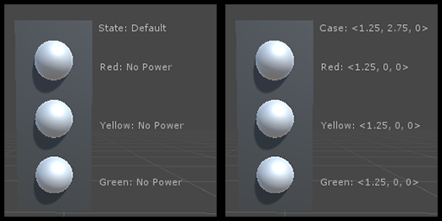

**Part 3: Patrol, Chase, Flee**

* Use Map01
* Place a MoveTo Sphere in the map.
  + (this one will be different from the one from Part 1)
* Use PathPoint prefabs to create a path around the moveto Sphere
* Create a script for an agent with three states
  + Patrol
    - Will circle MoveTo Sphere using path points
    - On SpaceBar Pressed, will enter Chase State
  + Chase
    - Will Move to the Move To Sphere
    - Upon reaching MoveTo Sphere, will enter Flee State
  + Flee
    - Will pick a random direction to move away from the MoveTo Sphere
    - Upon reaching a distance from the Sphere, will enter Patrol State