Unity: Week01 Setup

Android Environment Setup

Android Device: Enable Developer Options

Android Screen Capture

Note:

* For **Fall 2020**, we will be using **Unity 2019.4.x** (latest as of August 31st ), for both the AR and VR portion of this course.
* Android Development: At the time of writing, Unity performs better when installing the **Android Build Support module** and its sub-modules: **Android SDK & NDK Tools**, and **OpenJDK** through **Unity Hub**.
* Supported Android Devices: refer to the list of supported devices provided by Google, under “Android Play”: <https://developers.google.com/ar/discover/supported-devices#android_play>

# Android Environment Setup

1. Open Unity Hub and select **Installs** tab and then press the **ADD** button  
   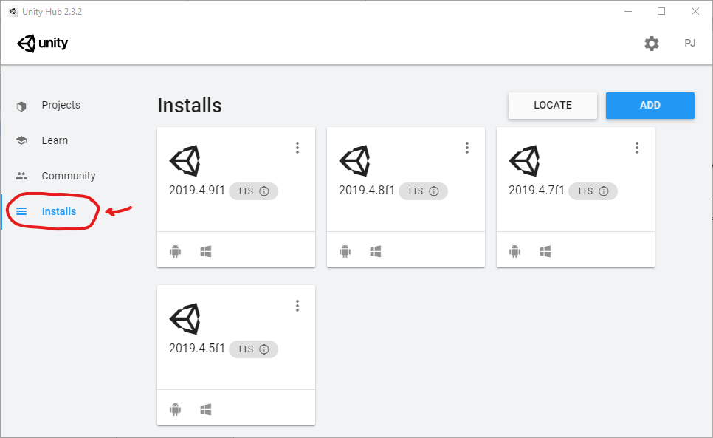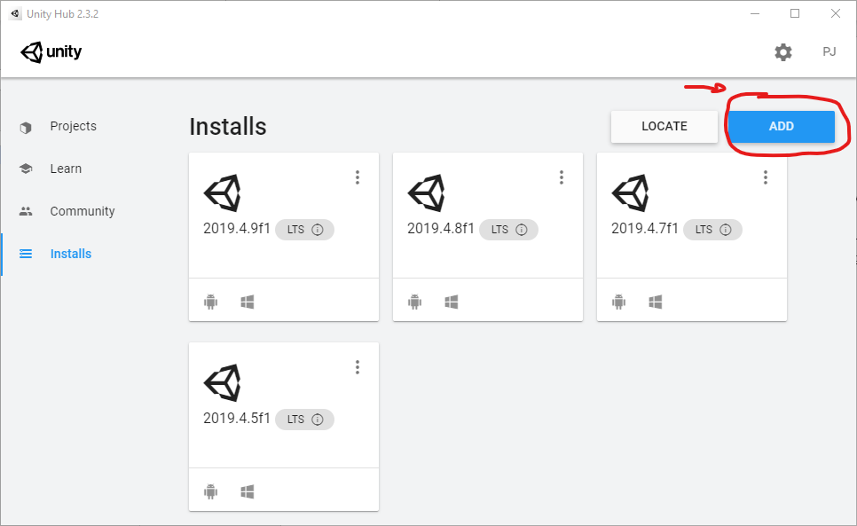
2. Choose the latest version of **Unity 2019.4.x (LTS)**, then select **NEXT**  
   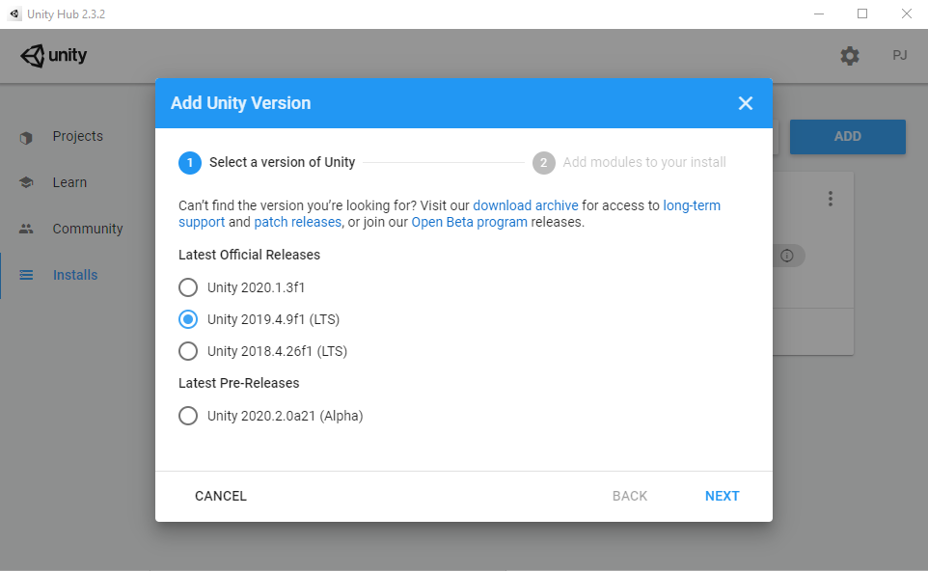
3. Make sure the following Modules are checked, then select **NEXT**:
   1. **Microsoft Visual Studio Community 2019**
   2. **Android Build Support**
      1. **Android SDK & NDK Tools**
      2. **OpenJDK**
      3. **Universal Windows Platform Build Support**
      4. 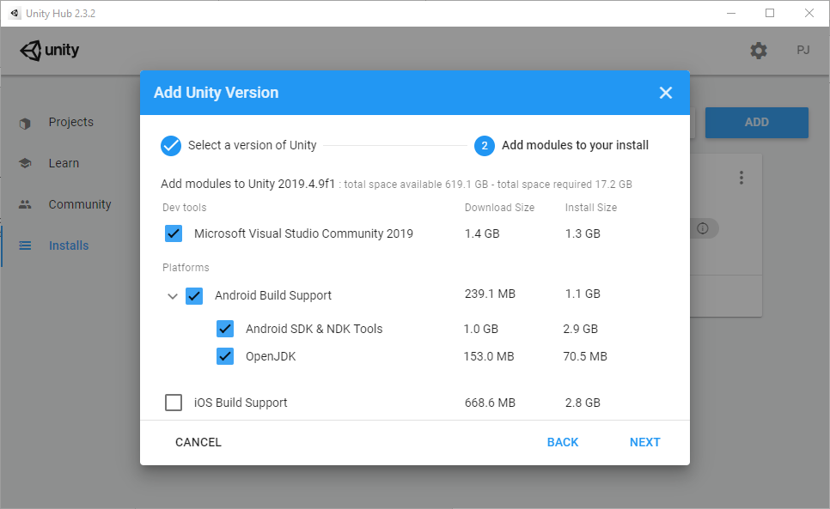
      5. 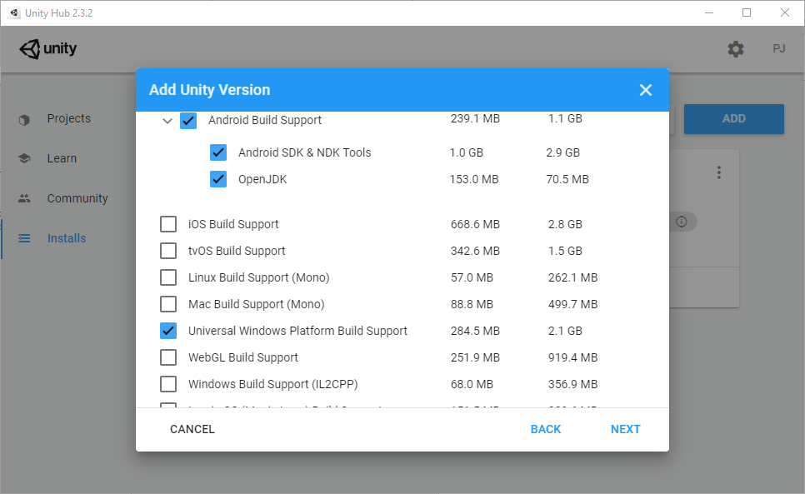
4. **Check** the agreement box for VS 2019 Community, then select **NEXT**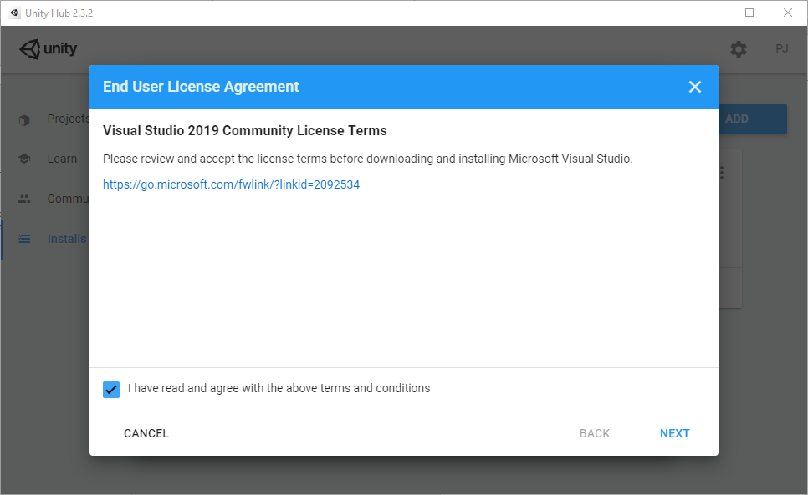
5. **Check** the agreement for Android SDK and NDK, then select **DONE**  
   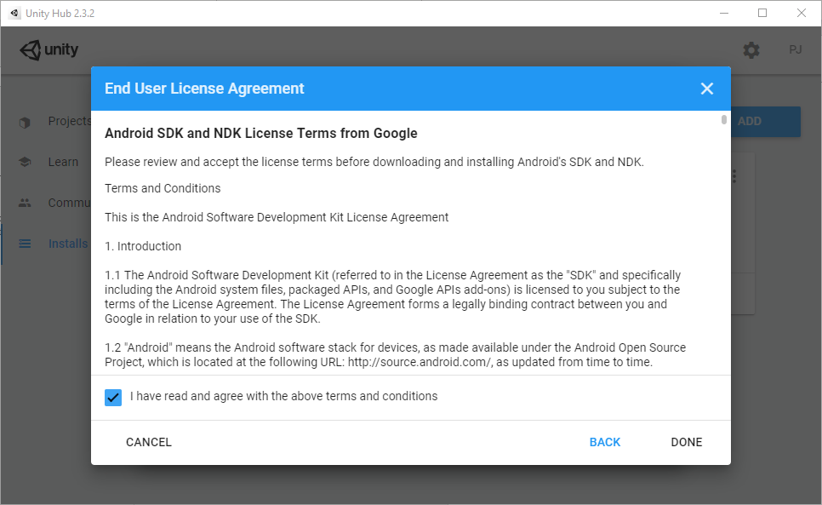
6. **Make** a sandwich while you wait for Unity to install  
   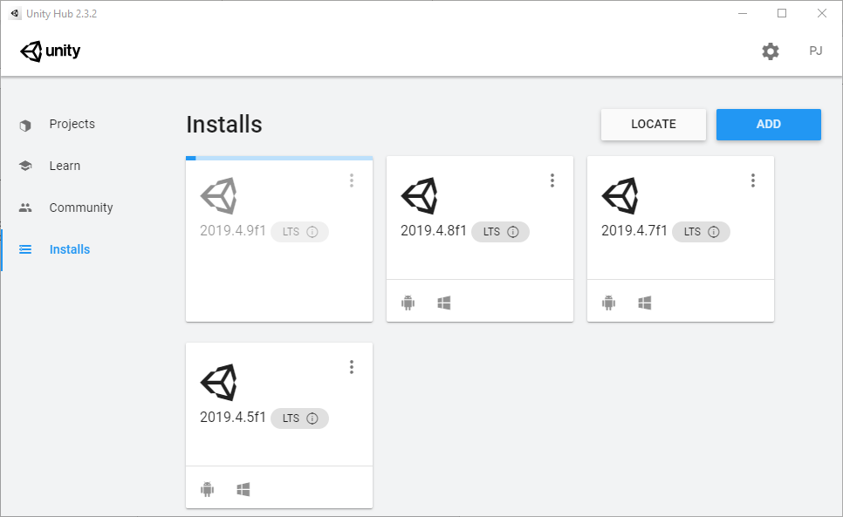

# Android Device: Enable Developer Options

To build to and debug Unity apps on an Android device, Developer Options needs to be enabled.

On your device:

1. Open **Settings**, and go to **System**.
2. Scroll down until you find **About Phone**, and select it.
3. Scroll down again until you find the **Build number**.
4. Tap the word Build **7 times**.
5. Go back to the previous screen, and select **Developer Options**.
6. Toggle the button at the top to enable Developer Options

Now enable USB Debugging:

1. Open **Settings**, and go to **Developer Options**.
2. Scroll down until you find **USB debugging**.
3. Toggle the button for USB debugging to on.

# Android Screen Capture

Screen capturing is required for each assignment. Options depend on the device you are using.

Pixel  
Samsung  
3rd Party Apps

## Pixel

Make sure your Pixel phone has been updated to Android 10, and Developer Options has been enabled.

1. Open the Developer Options menu.
2. Locate and select Feature Flags.

This screen will load a list of variables that can be enabled and disabled.

1. Look for “settings_screenrecord_long_press”.
2. Enable the setting with the toggle button to the right.

Screen recording is handled through the power menu by a “long press”.

1. Press and hold the power button.
2. Tap and hold **Screenshot** on the menu that pops up.
3. Choose **Start Recording** to begin recording your screen.

A warning window will pop up to remind you that *everything* will be recorded during the session, including private information that you may not want to be recorded, be advised.

Once you have finished recording, drag down the notification tray and tap “stop”. The system will process the recording, automatically saving it to the devices **“Movies” directory**.

## Samsung

1. From the home screen, swipe down to access the **Quick Panel** and select **Screen Recorder**.
2. Choose your preferred **Sound settings**, then tap **Start recording**.
   1. A countdown will appear before recording begins
   2. After the countdown, a small menu appears giving you options to:
      1. Edit
      2. Share
      3. Stop

When you are finished recording, press the **Stop** button on the Screen Recorder menu that appeared after the countdown. Alternatively, you can press the Screen Recorder button in the Quick Panel.

Pay attention to the warning message when selecting Sound settings, it reminds you that *everything* will be recorded, including private information that you may not want to be recorded, be advised.

Your recorded video file will automatically be saved to the devices **“Videos” directory**.

## 3rd Party Apps (FREE)

There are several screen recorder apps on the Play Store that are highly rated and free that you may choose to use instead of the built-in. Some have ads and in-app purchases, some are ad-free; all of them have common bugs and reported problems, so if one doesn’t work, try another. User discretion.

Common problems:

* Video fails to save after recording
* Lags the application you are trying to record
* Fails to record audio (at all or improperly)

A common problem when recording AR:

* When activated with the AR app open, the AR session is sometimes rebooted, losing plane tracking and object pose
  + I found it best to start recording before opening the app

Example 3rd Party Apps (Free):

* [Screen Recorder – No Ads](https://play.google.com/store/apps/details?id=com.kimcy929.screenrecorder) (but more likely to be buggy)
* [AZ Screen Recorder – Video Recorder, Livestream](https://play.google.com/store/apps/details?id=com.hecorat.screenrecorder.free) (ads and in-app purchases, but nice screen overlay menu, more options)