VR - Assignment 1

Application Development and Software Prototyping, Week 8

# Objectives

1. **Download and Install** the appropriate desktop app for your VR Head-mounted Display(HMD) device:
   1. **Mixed Reality Portal** app for **HMD Odyssey**
   2. **Oculus App** for **Rift, Rift S, Quest, Quest 2**
   3. **SteamVR** for Vive, Index
2. **Follow the setup process** for your device to ensure you are connected to your computer properly, that the head mounted display (HMD) is working, and your controllers are fully functioning.
   1. Make sure all the buttons on the controllers are working, etc.
   2. **If there is something wrong with your equipment, contact Professor Walek**
3. **Create** a new GitHub Repository for a new Unity 2019.4.9f1 Project
   1. ***Note***: Unlike AR, we will be using the same repository and Unity project for each VR assignment and the VR project.
4. In Unity, **install** the **XR Plugin Management** Package
   1. Windows > Package Manager > select XR Plugin Management > select Install
   2. 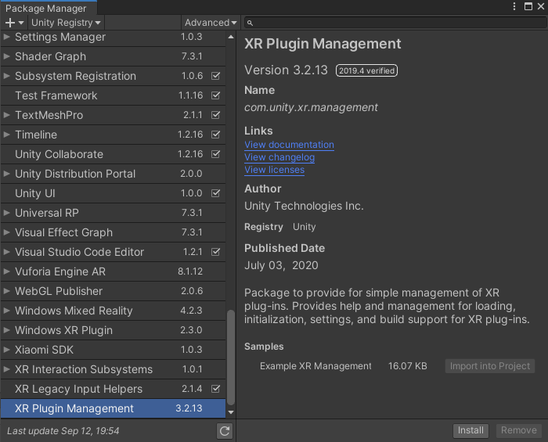
5. **Open XR Plugin Management** and **check the box** for the VR HMD Device you will be using
   1. Edit > Project Settings > XR Plug-in Management
   2. 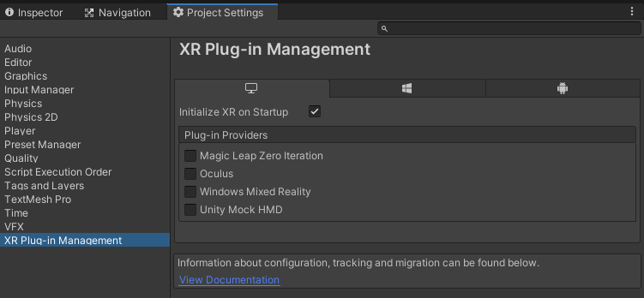
6. **Install** the **XR Interaction Toolkit** package
   1. **Window > Package Manager >** select **XR Interaction Toolkit,** select **Install**
7. **Create** a new **Scene**
8. **Delete** the **Main Camera**
9. **Add** the **Stationary XR Rig**
   1. Right-click in the hierarchy window or select GameObject **> XR > Stationary XR Rig**
   2. *This will automatically generate a GameObject called* **XR Interaction Manager,** which is a dependency for XR Intaractors and Interactables
10. **Create** a **3D Plane** at the 0,0,0 point in the world
11. **Create** a **Cube** object and place it at the center of the world, just above the plane
12. **Add** the **XR Grab** **Interactable** component to the Cube
    1. *This will automatically generate a RigidBody component*
13. With your HMD device connected, hit Play in the Unity editor and test the scene out with your controller.
    1. If your device does not register for Unity Play Mode, build the project to the device instead.
    2. The main objective for this lesson is to ensure your device is working, that it connects to Unity, and you can build an XR Application to it.

# Submission

1. Paste a link to your GitHub repository in the text editor in Canvas, ensuring it is a “link” by using the toolbar option for link.
2. Write the instructor a note below the repository link stating that your device works and that you had no issues  
   OR  
   If you have issues with your hardware, list out the issues and if you want to change out devices, talk to Professor Walek