**Technical Design Document**

**Astro Cell**

**Team: Matt Mills, Jared Matachun, Jamie Roeger, Ryan Black, Zach Spitzer**

Prisoner Mechanics

* Prisoner Win Conditions
* Inventory Mechanic
* Item Searching Mechanic
* Sabotaging Mechanic

Guard Mechanics

* Prisoner Search Mechanic
* Sabotage - Relief Item Crafting

Warden Mechanics

* Camera Mechanics
* Wardens Key Sabotage relief Item

Environment- Level Mechanics

* Ventilation System
* Item Transport Vent System

Crafting Mechanic

* Item Crafting

**Diagrams:**

* Class Hierarchy (What inherits from what & other relationships)

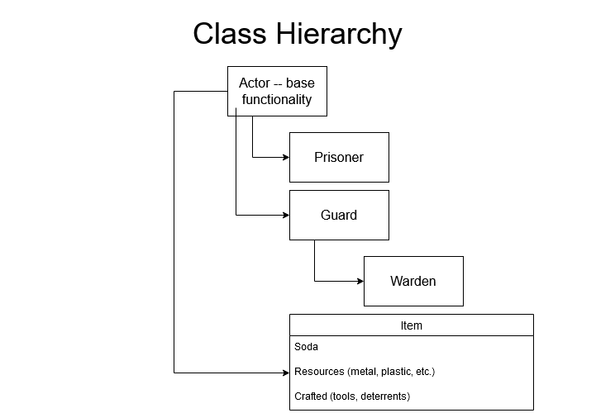

* Application Flow
  + (User Centric)

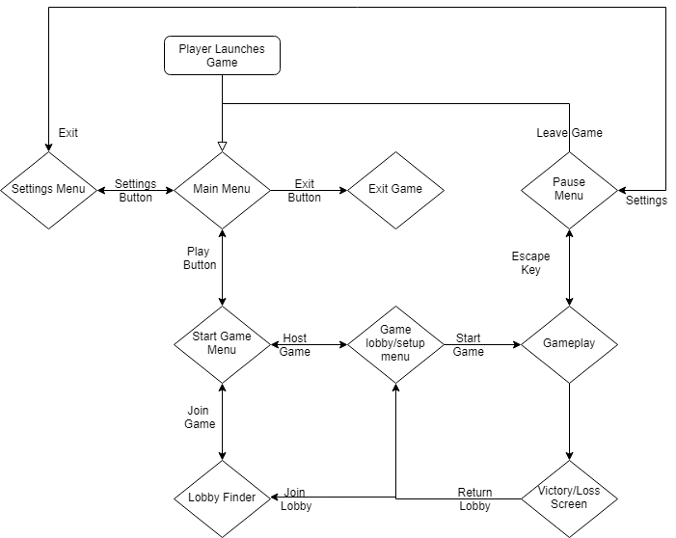

* Stages of A Round
  + (How the server will handle things)

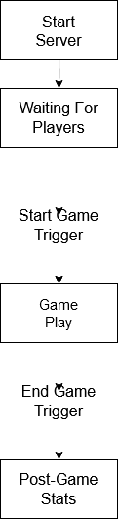

* Containers
  + Things that use containers
  + How Players use their “container”

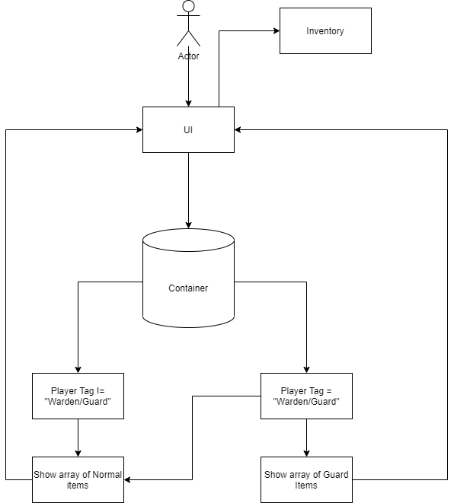

* Item Definition
  + Int ItemID
  + String ItemName
  + Image ItemImage
  + String ItemDescription
    - *Write stupid stuff here*
  + Bool IsContraband
  + Bool HasEffect
  + List<ItemEffects> Effects
  + Bool IsCrafted
  + Container LocationFoundAt
    - *This is filled when the item is spawned into a container.*
    - *This field isn’t affected by moving items from container to container.*

Prisoner Mechanics

**Prisoner Win Conditions:**

A list of items needed of the items required to meet the win condition, furthermore a description or waypoint of where to go to achieve win conditions. In code all UI stuff and a random generator for what win condition the prisoners have to meet.

IF prisoner interacts with win condition and has necessary items in inventory

Server: Trigger endgame

All: Endgame screen triggered

Show Win/Lose based on team

**Inventory Mechanic:**

A limit of 5 items per player we will have to code some type of storage system TBD. inventory will display as 5 u.i. Blocks at bottom of screen that will fill in with item card sprite.

* List of a an item class: List<Item> Inventory
* Iterator that keeps track of which item the player has selected in there inventory list
* Specific items inherit from the item class
* Containers also have a list: List<item> Container
* Player approaches container and gets a prompt to interact with it
* UI opens showing both player and container inventory
* Clicking on something in container moves it to empty slot in player inventory and vice versa
* If no empty slot is available nothing swaps

**Item Searching Mechanic:**

Another UI element that when a player searches a searchable object they can select items from a box of items that will fill up their inventory slots. Possible item grabbing cool down

IF player searches container they can open

Open Container Screen

Display Items in Container

IF player takes\places item

Move item to new container

Close Screen

Player: show indication they took\placed an item

IF player closes container

Close Screen

Player: indicated they closed the container

**Sabotaging Mechanic:**

Prisoners will bring a crafted item to a specific location to sabotage systems that the guards and wardens use. This mechanic will work by pressing a button if the prisoner is in the right location with the right item and the code in the background will apply debuffs to the guards or the camera system.

WHEN prisoner interacts with active sabotage location

Location: Disable location for Prisoners to sabotage

Location: Enable location for Guards to fix

ALL: Indicate Sabotage (Beastie boys playing the background)

Server: Apply Sabotage Effect

WHEN Guard interacts with sabotaged location with fix item

Location: Enable location for Prisoners to sabotage

Location: Disable location for Guards to fix

ALL: Indicate Sabotage has been fixed

Server: Remove Sabotage Effect

Guard Mechanics

**Prisoner Search Mechanics:**

When a guard searches a prisoner, a UI menu will appear showing an outline of the player, with 5 locations where they could be hiding items (Mouth, Body, Arms, Legs, and [REDACTED]), with a potential additional 2 if they have a backpack. The guard is allowed to search X items, where X is a set amount depending on how many times that player has been searched. If they discover an item with the CONTRABAND tag, the prisoner is sent back to their cell to wait out the time limit. If the guard can’t find any contraband, they are sent to the Armory to be debugged. The guards can also exit out of the menu if they feel like the prisoner doesn’t have anything or if they’re too afraid to get sent back.

IF guard interacts with prisoner

Start timer for this interaction

Guard: Open search menu

TODO: Rules for what the Guard sees should be here.

Prisoner: Open being searched menu

Prisoner’s Menu should show the items they have.

Also any info on if they might be busted for having contraband.

IF timer is reached

Both: Close Menus

Guard: Show indicator that they took too long to make a decision.

Prisoner: Show an indicator the Guard did not search

IF Guard closes Search

Both: Close Menus

Guard: Show Indicator confirming they closed search

Prisoner: Show an indicator the Guard did not search

IF Guard searches prisoner

Both: Close menu

IF Successful Search:

Guard: Give indicator of Success

Prisoner: Given indicator they got busted

Prisoner: Send to cell

ELSE (Failed Search)

Guard: Give Indicator of Failure

Guard: Send to debugging

Prisoner: Give indicator they got searched and were good.

**Sabotage-Relief item crafting:**

In the same containers as the prisoner items, the guards can find special items. When the prisoners sabotage the facility, the guards can use these items to craft different items to solve sabotages. Each item is highlighted when they’re in the storage containers, and when the sabotage begins, a list of items appears on the Guards UI. When they have the item crafted, they can go to the specified area and use the item to end the sabotage.

ON Search Container

IF Player = Guard/Warden

Items tagged Guard revealed

ELSE

Items tagged Guard not revealed

Warden Mechanics

**Camera Mechanics:**

In the center of the Warden’s Lounge is a set of computers. When the Warden uses these computers, he has a view of everywhere in the prison. This is done by setting screens to be different cameras throughout the prison. The Warden can only look at Three rooms at a time, and has to change rooms to find the prisoners (There is a drop down menu of all the rooms there are cameras in). While using cameras, the warden can use the intercom system to send alerts to guards and call out prisoners.

Array of Cameras [Brig, Mining, Mat Proc, Hangar, Morgue, Library, Storage, Cafe]

Camera 1: Brig

Camera 2: Mining

Camera 3: Mat Proc

[Change Camera 3]

Brig

Mining

[Mat Proc]

Hangar

Morgue

Library

Storage

Cafe

Select Cafe

Camera 3 Set to Cafe

Disbales lights on cameras in exited area, enables light in entered area

Camera 1: Brig

Camera 2: Mining

Camera 3: Cafe

**Sabotage-Warden’s Key**

The warden is the only character that starts with a special Warden’s Key item. This item is used to solve special sabotages. Certain Sabotage events have a Warden tag. These items can only be solved by the Warden with his Warden’s Key. The warden cannot lose the Warden’s Key, and it is not used for any crafting items. The warden also has an extra inventory slot for the Key, which cannot be replaced by any item.

IF Prisoner Sabotage tag = Warden

IF Guard is near Warden Fix

Pop-up appears “The Warden must fix this component”

IF Warden is near Warden Fix

Pop-up appears “Press [Button] to fix”

IF Warden inputs Button

Resolve Sabatoge

Environmental / Level Mechanics

**Ventilation System:**

Certain rooms in the map will have ventilation access shafts that a prisoner can climb into and navigate to other connected rooms. These can be used to evade guards and the warden in order to avoid being searched. However, a prisoner cannot hide inside a vent indefinitely; a guard can press a button to activate the air flow and push prisoners to the opposite side of the vent for capturing.

While Player is near vent

IF prisoner

Pop-up appears “Press [button] to enter vent”

IF [button]

Prisoner enters vent

ELSE IF Guard or Warden

Pop-up appears “Press [button] to flush vents”

IF [button]

FOR EACH prisoner in Vent

Move prisoner to end of Vent

**Item Transport Vent System:**

Prisoners can place items inside a vent system in order to transfer them to other locations. This prevents the risk of a prisoner being searched for contraband and being captured for it. This also will allow prisoners to consolidate their items into a centralized location for easy access.

While Player is near Item Vent

IF Prisoner

Pop-Up appears “Press [button] to store/get items”

IF [button]

Menu appears. Player’s inventory and Vent’s Inventory

Drag and drop items in and out of Inventories

Crafting Mechanics

**Item Crafting:**

Items are crafted inside a player’s inventory. In order to craft, the player must have the necessary components to craft their chosen item. Some items will need to be processed in specific areas before they can be used for crafting; for example, metal will need to be processed from ore in Material Processing before being used for crafting purposes.

IF player hits [button]

Menu appears with UI Buttons to craft items on the right and the inventory on the left

IF Item has Location marker

If player is at location

Button Pressable

Else

Button greyed out.

Pop up appears “This item must be crafted at [Location]

Else

Button pressable.

IF Player crafts item

Removes items from inventory

Gives player the crafted item.