Name: Agha Abdullah

Student ID: 30144234

Module Code: IS4S765

Module Title: Big Data and Analytics

Module Tutor: Paul Jarvis/Robert Berry

Assessment Type: Asynchronous Assessment

Assessment Title: Applying Data Analytics Techniques

Submission Date: 10th May 2025

Predicting Healthcare Charges and Bank Deposit Subscriptions Using Data Analytics Techniques

Introduction
In the data-driven economy of today, companies across different industries are increasingly relying on predictive analytics for informed decision-making. With predictive analytics, companies can analyze past data and project future outcomes, providing insights relevant to improving business functions, minimizing risk, and enhancing customer satisfaction (Halper, 2014). This study examines the application of two commonly established data analysis techniques like Multiple Linear Regression and Decision Tree Classification to two different datasets belonging to the health sector and the banking sector.
The health sector faces critical challenges in estimating medical bills, which are vital in helping insurance companies determine the right premiums to charge to their consumers. Healthcare cost estimation using population and lifestyle information is critical to insurers because it assists them in optimizing pricing, maximizing the management of risks, and ensuring financial viability (Taloba et al., 2022). A Multiple Linear Regression model is employed in the present work to examine the impact of different variables including body mass index, age, smoking status, gender, and number of dependents on the cost of care. The predictive model is aimed at delivering insights, which the insurance providers can use to alter premiums and maximize customer risk profiling.
At the same time, the banking industry also utilizes predictive modeling to segment clients by the likelihood of them enrolling for term deposits. Banks can employ such forecasts to influence targeted marketing, develop improved client acquisition techniques, and customize customer segmentation (Moro et al., 2014). In the research conducted for this project, the Decision Tree Classification model was used to predict whether an individual consumer would enroll for the term deposit or not leveraging the client's demographics and life characteristics. By recognizing key factors that influence consumers to decide, banks can utilize their marketing budget and resources better and increase the conversion rate (Zaki et al., 2024).
The aim of the present study is to illustrate how data analytics techniques can bridge the divide between data science and business strategy to achieve enhanced decision-making. Firms operating in the banking and healthcare industry can enhance risk management, reach the right customers with the right offers, and rationalize price models through the use of predictive analytics.

Technique 1: Linear Regression

Data Source
The dataset used in this analysis is sourced from Kaggle's Healthcare Insurance Dataset (website), which contains information on 1,338 individuals, including demographic details (e.g., age, sex, BMI, number of children) and healthcare costs (the charges). The target variable in this analysis is charges, the medical cost incurred by an individual. This dataset is publicly available and offers insights into healthcare expenses, which is essential for insurance companies to optimize their pricing models. By understanding which factors most significantly influence charges, insurers can adjust premiums accordingly and better manage risks.
Research Question 1:
How do demographic and lifestyle factors (age, BMI, smoking status, number of children, and sex) influence healthcare charges?
Research Question 2:
What are the key predictors of healthcare charges, and how can these insights inform risk management and premium adjustment strategies for insurance companies?

Methods
The primary technique applied in this analysis is Multiple Linear Regression, chosen for its ability to quantify the relationship between multiple independent variables (predictors) and a dependent continuous variable (charges). Linear regression models the relationship between charges and several independent factors, such as age, gender, BMI, children, and smoker status.
The model formula is as follows:
Charges = a₀ + b₁ (Gender) + b₂ (Age) + b₃ (BMI) + b₄ (Children) + b₅ (Smoker)

Before fitting the model, diagnostic tests were performed to validate the assumptions of normality, linearity, and homoscedasticity. The model was fitted in R using lm() function and the results were examined to assess each predictor variable's importance and influence on healthcare costs.
Results
Table 1 presents the Multiple Linear Regression model's findings, which clearly reveal that age, BMI, smoking status, and number of children significantly impacted healthcare expenditure, with being a smoker having the most substantial influence.
- R² = 0.750: This means that 75% of the dispersion in healthcare charges can be determined by the independent variables in the model.
- F-statistic = 798.02 (p < 0.001): The model is statistically significant.
Key findings from the regression analysis include:
- Age and BMI both have a positive relationship with charges, with BMI having the stronger impact (β = 322.36, p < 0.001).
- Smoker status is highly significant (β = 23,823.39, p < 0.001), indicating that smokers incur significantly higher healthcare costs.
- Sex was not found to be a significant predictor (p = 0.700), suggesting that gender does not significantly influence charges when controlling for other factors.

Table 1: Linear Regression Results
===============================================
Dependent variable:
---------------------------
charges
-----------------------------------------------
age 257.73***
(11.90)

bmi 322.36***
(27.42)

children 474.41***
(137.86)

Sex -128.64
(333.36)

Smoker 23,823.39***
(412.52)

Constant -12,052.46***
(951.26)

-----------------------------------------------
Observations 1,338
Residual Std. Error 6,069.73 (df = 1332)
F Statistic 798.02*** (df = 5; 1332)
R2 0.75
Adjusted R2 0.75
===============================================
p-value: *p<0.10; **p<0.05; ***p<0.01

Conclusion
The Multiple Linear Regression model shows that smoking status, BMI, and age are the most significant variables associated with healthcare expenses. Insurance companies may utilize this information to create more precise pricing strategies based on lifestyle and health characteristics. For example, smokers and people with a higher BMI may face higher mortality rates to reflect the higher risk of excessive medical bills. These insights are useful for better risk management and premium modifications in the insurance business. This study successfully answered Research Question 1 and Research Question 2 by identifying key predictors and demonstrating how they can inform risk management and pricing.

Technique 2: Decision Tree

Data Source
The Bank Marketing dataset was used for the Decision Tree analysis, sourced from Kaggle's (website). It contains 11,162 observations and 17 variables, including both demographic and behavioral data of customers. The key variables in this dataset include age, job status, marital status, academic level, housing status, loan status, and previous contact type. Deposit is a dependent variable, indicating whether a customer subscribed term deposit. This is a widely used dataset in marketing campaigns for predicting customer behavior, resulting in meaningful insights into targeting customers and segmentation.
Research Question 1:
What are the factors that contribute to estimating whether a customer subscribes to a bank term deposit?
Research Question 2:
Is a decision tree a good classification method to classify bank customers into subscribing to a term deposit and not subscribing to a bank term deposit?

Methods
In this study, a decision tree algorithm is used due to the simple and clear interpretable decision-making process, which is valuable for classification tasks. Before applying this method, exploratory data analysis is performed to address missing values, encode categorical variables, and remove outliers using the inner and outer fences technique. A 9:1 ratio is taken for data splitting into training and testing sets where the deposit is our target variable.
The rpart package is used in R software to fit the decision tree algorithm where the accuracy, recall, precession, and F1 score matrices is used as a model performance evaluation.

Results
The Decision Tree model achieved an accuracy of 81.78%, suggesting that the model is able to correctly classify whether a customer will subscribe to a deposit in 81.78% of cases. The model’s precision of 79.10% means that when the model predicted a subscription, it was correct 79.10% of the time. The recall score was 82.48%, indicating that the model identified 82.48% of the actual subscriptions. The F1 score was 80.75%, indicating a good balance between precision and recall.
The variable importance scores revealed the following insights as shown in Figure 1:
- Duration of contact (41%) was the most important predictor, indicating that the length of the customer interaction was crucial in determining subscription likelihood.
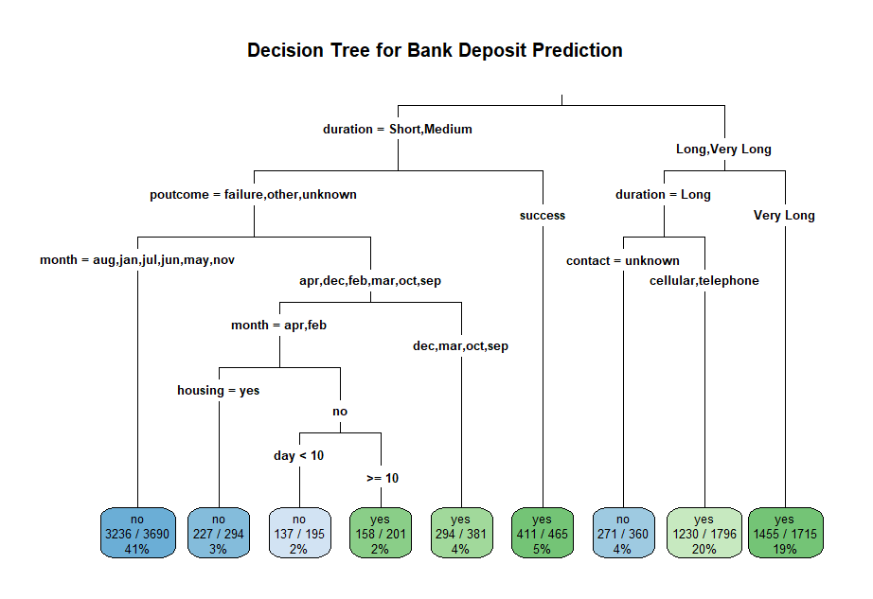
- Poutcome (outcome of previous marketing interactions) and month of contact also played significant roles, with importance scores of 19% and 20%, respectively.
Figure 1: Decision Tree plot

Conclusion
The results of the decision tree model show a satisfactory estimated customer subscription to a bank term deposit, with the most significant variable in the study being the duration of contact. The study highlights the significance of positive customer encounters in deciding whether they would subscribe to a deposit. Banks can utilize these results to optimize their marketing strategy and focus on consumers with longer period contacts or favorable prior outcomes. The Decision Tree framework's capability to provide simple and understandable decision rules makes it an effective tool for focused marketing actions. This analysis successfully addressed Research Question 1 and Research Question 2 by providing clear predictions on customer subscriptions.

Overall Conclusion
In this report, we used two different machine-learning techniques to solve significant business problems in the healthcare and banking sectors. One technique is the Linear Regression, and the other is the Decision tree classification. Both methods have been used in different situations. The results of the linear regression model effectively identified age, BMI, and smoking status as the most significant attributes of healthcare charges which offers insurers useful insights into risk assessment and premium modifications. On the other hand, the decision tree model efficiently classified customers of banks based on their likelihood to sign up for a term deposit, with duration of contact and prior interaction outcome appearing to be key predictors.
Both approaches revealed data analytics ability to improve decision-making, optimize pricing schemes, and more accurately target customers. The findings possess significant economic implications, allowing insurers and banks to improve their marketing strategies, risk management, and consumer engagement.

References
- Halper, F., 2014. Predictive analytics for business advantage. TDWI Research, pp.1-32.
- Taloba, A.I., Abd El-Aziz, R.M., Alshanbari, H.M. and El-Bagoury, A.A.H., 2022. Estimation and prediction of hospitalization and medical care costs using regression in machine learning. Journal of Healthcare Engineering, 2022(1), p.7969220.
- Moro, S., Cortez, P. and Rita, P., 2014. A data-driven approach to predict the success of bank telemarketing. Decision Support Systems, 62, pp.22-31.
- Zaki, A.M., Khodadadi, N., Hong Lim, W. and Towfek, S.K., 2024. Predictive Analytics and Machine Learning in Direct Marketing for Anticipating Bank Term Deposit Subscriptions. American Journal of Business & Operations Research, 11(1).
- Kaggle. (n.d.). Healthcare Insurance Dataset. Retrieved from

https://www.kaggle.com/datasets/mirichoi0218/insurance
- Kaggle. (n.d.). Bank Marketing Dataset. Retrieved from

https://www.kaggle.com/datasets/rouseguy/bankbalanced/?select=bank.csv

