The Science Behind the
Perfect Pinewood Performance

by Ron W.
Cub Scouts Pack 877
Ahwatukee Village, Phoenix AZ

Abstract

This paper derives a simple, analytic solution to the minimum time allowed by the laws of nature in which a Pinewood Derby car may traverse a given track. The solution for a given track configuration may be determined analytically by-hand given the formulas herein, or a computer program implementation of the technique is straightforward. Indeed, I have already implemented the technique as a JavaScript tool and posted it on the World Wide Web for general use. Probably too “deep” for anything but the most gifted Cub Scout, this paper would make an excellent problem/solution for first and second year students in college-level engineering/science. Appropriately tailored, it could also be used at the high-school level. But perhaps the best use is as “interesting reading” for Cub Scout parents and volunteers that ask themselves the question:

Is this car the best that it can be?

Background / Introduction

It’s been about 30 years since I was a Cub Scout and participated in a Pinewood Derby. But now that my son has joined the Scouts, his first derby is fast approaching (no pun intended). In thinking about building and racing a car, I began pondering the question:

How do we really know how great a car performs?

Sure, we can see which car wins a race against other cars. But that just tells us which one of the set is fastest. It does NOT tell us if the car is “the best that it can be.” In other words:

How close is the car to “perfection”?

Be sure to note that I’m not talking about the beauty, cool-ness, or creativity of the design. Those are subjective parameters and not easily measured. But on the other hand, SPEED is certainly a quantifiable measurement. And given the measured speed of the car, we should be able to determine its “efficiency”. That is:

Is the car as fast at the laws of physics allow? If not, how much slower is it?

Therefore, this paper (as well as the web pages, computer programs, and so on) was developed to analytically determine the minimum time that a “perfect” car could race down a derby track. The goal was to provide a model sufficiently generic to easily compute the minimum time allowed by the laws of nature for any specified track configuration.

The Solution

Newton’s Laws of motion tell us that:

The vector sum of the forces acting on a body is equal to the mass of that body multiplied by its vector acceleration:
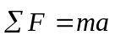
where:
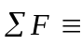 Vector sum of the forces acting on the body,
Mass of the body,
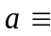 Vector acceleration of the body.
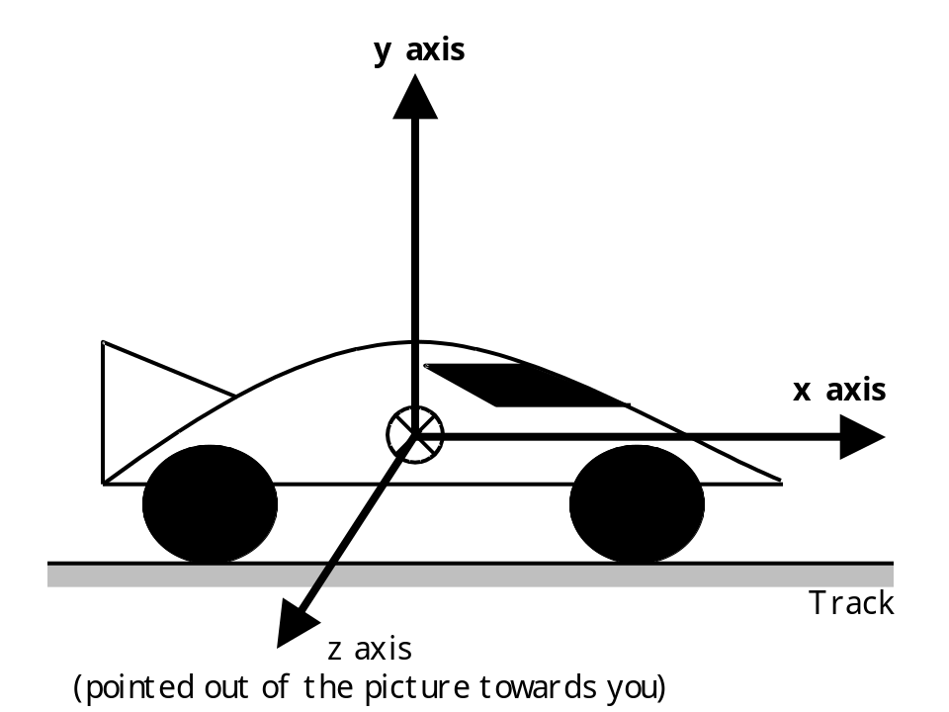

Given a 3-axis Cartesian coordinate system (x, y, z) like the one in the figure above, the vector form of the equation can be broken into it’s individual components:

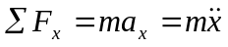
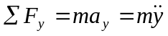
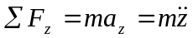
where:
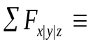 Sum of the forces acting on the body along the x, y, or z axis,
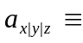 Acceleration of the body along the x, y, or z axis.

By placing the x-axis along the intended direction of travel (refer to the figure below), we need only consider acceleration (and therefore motion) in the x-axis. Acceleration along other axes will only result from off-nominal conditions (wheels misalignment, initial misalignment of vehicle on track, and so on). Since we are interested in determining optimal (perfect) performance, these sources of degradation are assumed to have been eliminated.
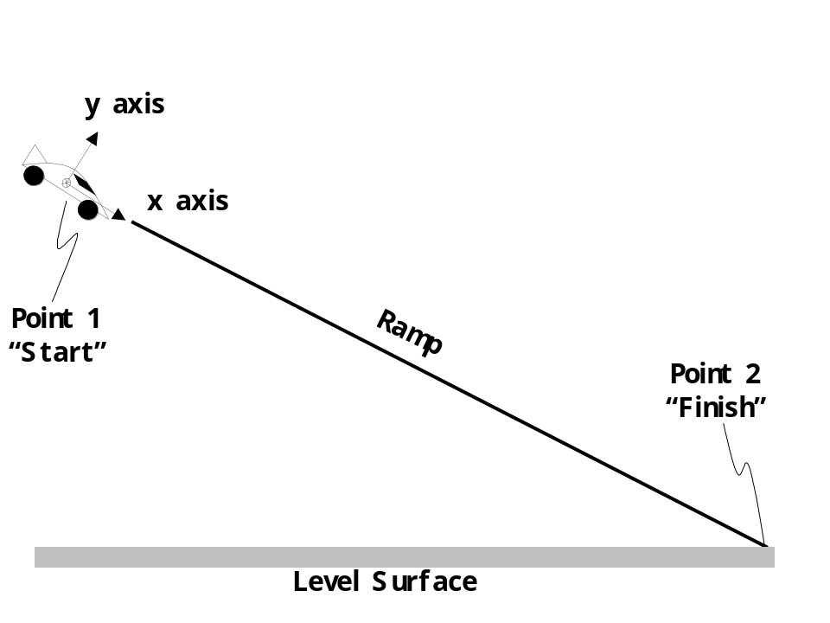

Therefore, we are left only with the following equation:

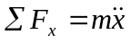

Under optimal conditions (e.g., no friction, drag, etc.), the only forces acting on the car are: 1) its own weight due the pull of gravity, and 2) the force of the ramp on the wheels of the car (keeping the car from falling through the ramp). Refer to the figure below:
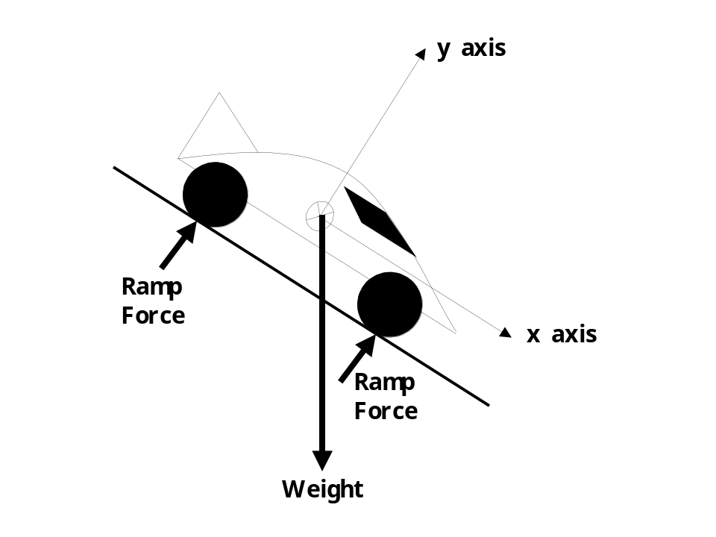
Knowing that the car cannot move in the “y” direction (can’t fall through the ramp), we can concern ourselves only with forces in the “x” direction. . The only force acting in the “x” direction is part of the Weight force (weight is acting along both “x” and “y” axes). To know how much of the Weight force is being applied to the “x” axis, we must determine the slope of the ramp. The illustration below shows that the ramp angle (, pronounced “thay-tah”) and how it relates to the component of weight along the “x” axis.

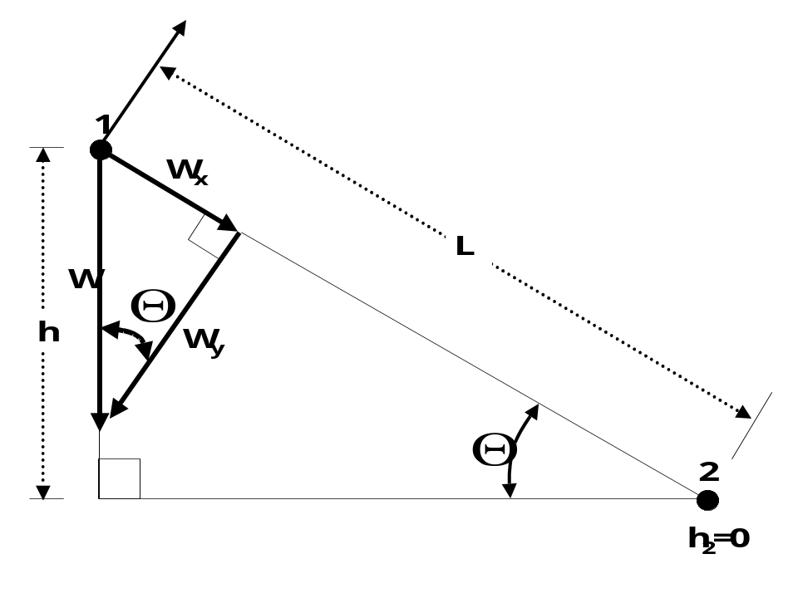

The slope of the ramp can be measured: 1) directly with the use of a protractor or other angle-measuring device, or 2) via measurements of the height and length of the track:

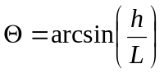

With the slope of the ramp now known, we can determine that the component of the weight along the “x” axis is:

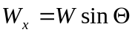

From grade school science, we also know that the weight of an object depends on its mass and the gravitational constant according to the following equation:

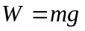
where:

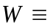 Weight of the object,
Mass of the object,
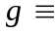 Gravitational pull (32.174 ft/s² or 9.81 m/s² on the Earth’s surface)

Now we can substitute terms in our equation for summation of forces in the “x” direction, and solve for the acceleration:

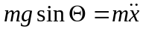
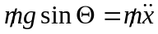
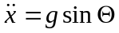

So, now we know that the acceleration of the car will be directly proportional to the gravity and to the slope of the ramp.

Sanity Checks:
- As we increase the slope of the ramp, the car will accelerate faster (because sin of the angle increases).
- As the slope of the ramp approaches 90 degrees (i.e., vertical), the car will accelerate downward as if the ramp did not exist at all (accelerate at the full value of the local gravity).
- As the slop of the ramp approaches 0 degrees (i.e., flat), the car will not accelerate at all. A car won’t accelerate along a level surface by itself.
- If we were on a bigger planet than the Earth (and therefore more gravity), the car would accelerate faster (and visa versa).

In the study of dynamics of solid bodies under constant acceleration (with a little bit of calculus), we find that the velocity (speed) of an object can be found by integrating both sides our original acceleration formula:

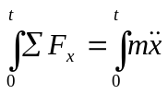

which, after being evaluated, results in:

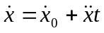

where:
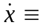Final velocity
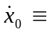Initial velocity
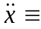Acceleration (constant)
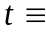Time of travel

By integrating both sides of the velocity equation:

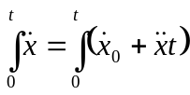

We arrive at the formula for the position of the body over time:

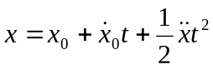
where:
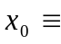Initial position
Initial velocity
Acceleration (constant)
Time of travel

The equation can be represented in familiar quadratic form as:

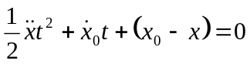

If we call from first-year algebra that a 2nd order quadratic equation of the form:

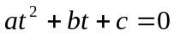

can be solved via the formula:
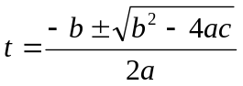

then we can set our values for a, b, and c as follows:

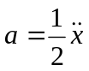

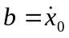

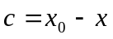

Furthermore, from our previous analysis, that the acceleration is:

We also know that 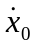 is simply our starting velocity (speed):

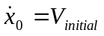

And lastly, we can recognize that the value for 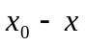 is simply the length of the section of track over which we’re traveling (with a negative sign):

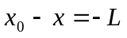

Therefore, we can substitute into the equation for time:

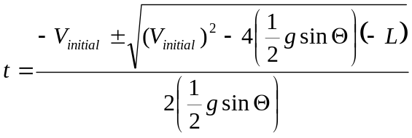

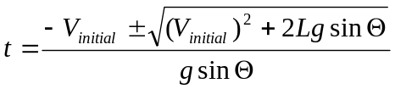

Since we know that the time will never be negative (ever heard of negative time?), we can eliminate one of the possible solutions (i.e., change the “”sign to just a “+”). This results in our final equation; specifying the time required to travel the desired distance:

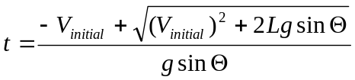

Now that we have determined the time required for the car to travel down a track of length “L”, we can use our velocity formula to figure out the speed the car will be traveling once it reaches the end of the track:

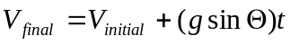

Therefore, given any ramp and the initial velocity (speed) that the car is traveling, we can calculate (in this order):

- The slope of the ramp: A) directly via a protector, or B) by measuring its height and length and employing the formula:

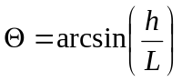

- The acceleration of the car down the ramp:

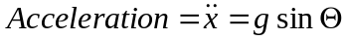

- The total time required to travel to the end of the track:

- The velocity of the car when it reaches the end of the track:

Now, let’s consider what happens if we have a two-segment track, where the slope of the each segment is different. Referring to the figure below, we’ll call the 1st segment of track “A” and the second segment “B”. Furthermore, we’ll designate the starting point, segment-to-segment joint, and ending point as “1, 2, and 3” respectively.

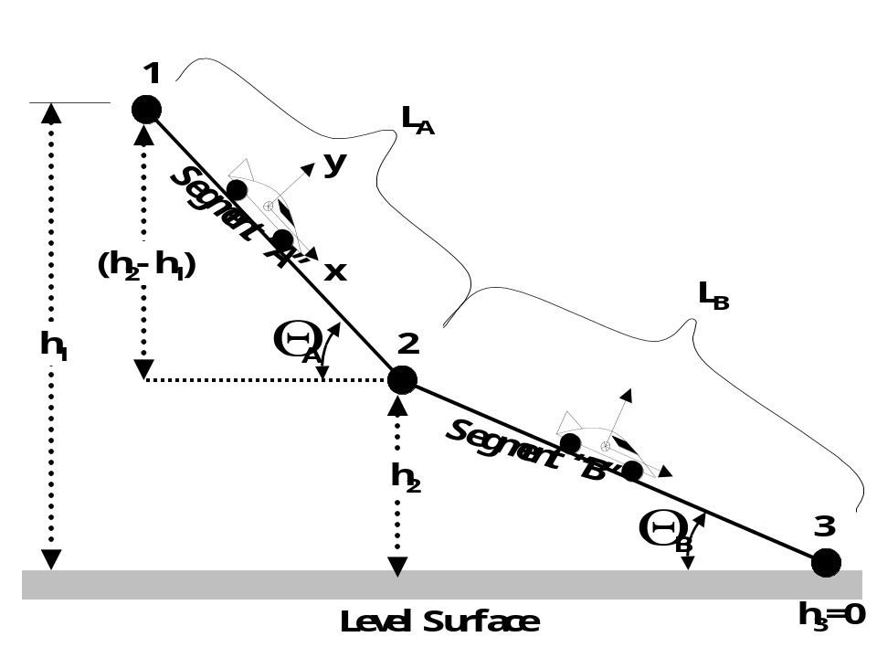

The distance between points 1 and 2 is the length of the first track segment (labeled “L_{A}”). The distance between points 2 and 3 is the length of the second track segment (labeled “L_{B}”).

We know that Derby races all start with the cars at rest (i.e., not moving), so they’re initial velocity (speed) at point “1” is zero. Additionally, we know (or can easily measure) the length of track segment A (“L_{A}”) and the slope of the ramp (“_{A}”). So given this knowledge, we can use our previous set of equations to determine the:

- Time required to travel from point “1” to “2”, and
- Velocity of the car when it reaches point “2”.

Now that we know the speed of the car at the end of the first track segment (i.e., the velocity at point “2”), we realize that:

The final speed at the end of the first track segment is EQUAL to the speed at the start of the second track segment:

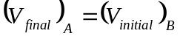

Knowing our initial velocity when at the start of track “B”, and by measuring the slope of track “B”, we can use the same set of equations (with our new numbers) to solve for the:

- Time required to travel from point “2” to “3”, and
- Velocity that the car will be traveling when it reaches point “3”.

Note that the velocity at point “3” is the speed the car will be traveling when it crosses the finish line.

And finally, since we know the time required to travel segment “A” and the time to travel segment “B”, the total time to travel the entire length of the track can be determined by simply adding the two together:

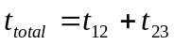

Now that we have figured out how to solve the problem for two segments of track, the idea can be expanded:

The same technique can be used for tracks of 3, 4, 5, or any number of segments.

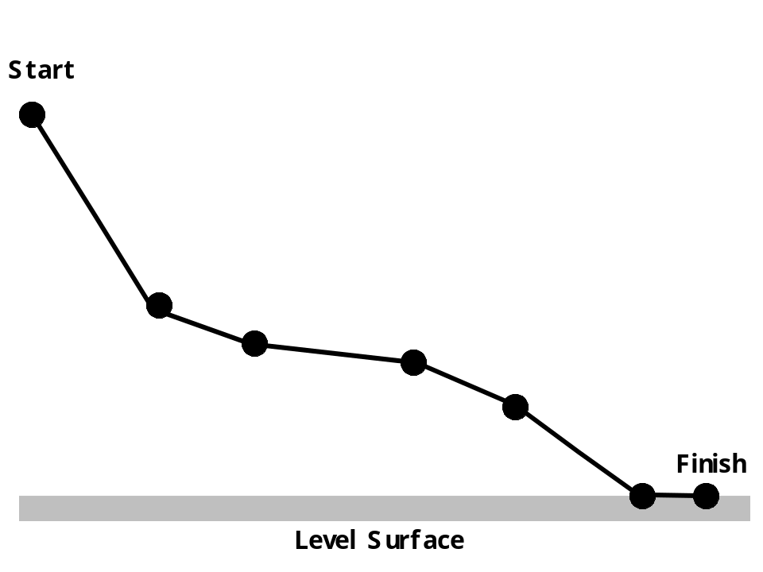

Even a complex, smoothly curving track can be accurately approximated with our method as illustrated below:

