MindLens: Mental Health Text Classification, with Machine Learning, Deep Learning and BERT plus Decision Threshold Optimization
Arnab Ghoshal - 2401030018
Rekha Kumari - 2301020783
Sourav Mahapatra - 2401030019
Aditya Ray - 2401030102
Department of Computer Science and Web Technology
C. V. Raman Global University, Bhubaneswar, Odisha, India
Abstract
Mental health related text has language patterns that can be studied using Natural Language Processing and machine learning methods to help with automatic mental health status classification. This study introduces a text classification system for recognizing depression-related and non-depression-related text using the Pirina Reddit Public Corpus. The data was cleaned by removing duplicates and preparing the text ending up with 1,840 records divided into two categories: depression and non-depression. A BERT model, called bert-base-uncased was trained using an 80:10:10 stratified train-validation-test split. The original BERT model reached a test accuracy of 94.02% with a precision of 92.69%, macro recall of 93.13%, macro F1-score of 92.90% and ROC-AUC of 98.11%. To make the classification decision boundary better a validation-based decision threshold optimization was used without involving the test set during the process. The best decision threshold was found to be 0.32 which gave 97.28% validation accuracy and 96.81% validation F1-score. When the chosen threshold was tested on the test set the model got 94.57% accuracy 93.52% macro precision, 93.52% macro recall and 93.52% macro F1-score. The optimized decision threshold gave an improvement over the original model while keeping a strict test evaluation process. The proposed system shows the power of transformer-based Natural Language Processing, for depression-related text classification and can act as a research tool and a screening aid. This system is not meant to take the place of mental health assessment or medical diagnosis.

Keywords: Mental Health, Depression Detection, Natural Language Processing, BERT, Binary Text Classification, Decision Threshold Optimization, Reddit, Deep Learning.
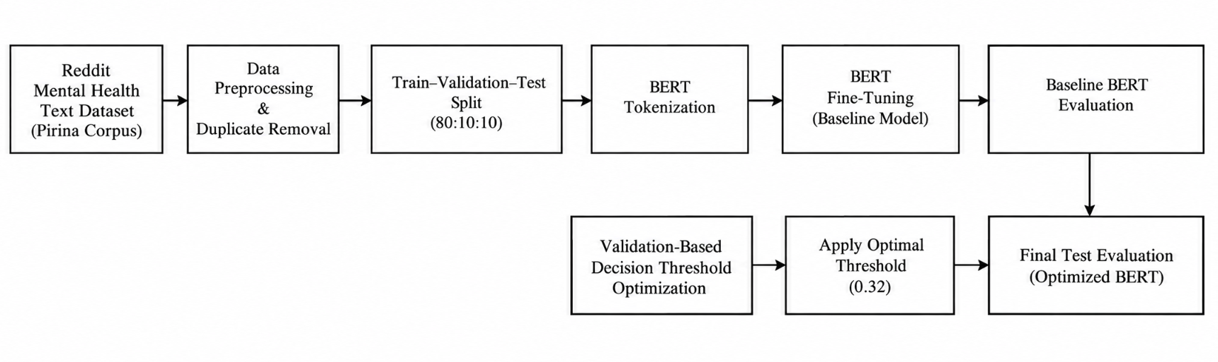
Fig. 1. This figure shows the workflow of the proposed binary mental health text classification pipeline, which uses BERT and applies decision threshold optimization. The binary mental health text classification pipeline is highlighted in Fig. 1.
1. INTRODUCTION
Mental health conditions impact how people manage emotions think, behave and interact with others. This creates a need for ways that are easy to access and can help spot problems early and offer structured help. The rise of communication and people writing their thoughts in text has led to big collections of language that can be studied using computers. Natural language processing or NLP is therefore a way to find language patterns linked to mental health problems.
Machine learning is being looked at more and more for predicting and classifying health issues. Madububambachu, Ukpebor and Ihezue reviewed machine learning and deep learning methods used for predicting health diagnoses. They found models like Support Vector Machines, Random Forest, neural networks and convolutional neural networks as some of the studied approaches. Their review also highlights problems like having data sets different types of mental health problems long-term data understanding how the models work and making sure the results are reliable [1].

Because of these problems this work. Tests MindLens, a platform that looks at text to help with mental health. In the MindLens system this study looks at separating texts into two groups: those that show signs of depression and those that do not. The study uses the Pirina Reddit Public Corpus for this task. After cleaning the data and removing duplicates there are 1,840 texts used for building and testing the models. The study uses a BERT model called bert-base-uncased, which is adjusted for the task of separating texts into two groups.
Another goal is to make the line between depression and non-depression clearer by using a method that changes the threshold for decisions. Different values, for this threshold are tested on a group of data and the one that works best is chosen. This chosen value is then used on a test group that was not used during the adjusting process. This way the BERT model that was improved is tested in a controlled way while the overall MindLens system stays the same.

Prior work has shown that machine learning can be used for mental health prediction tasks and for many different types of data such as clinical records, survey questions, social media posts, speech recordings, brain scans and body signals. The systematic review by Madububambachu and colleagues reports that different machine learning algorithms may work better for mental health conditions and for different datasets. The review also points out that high reported performance does not remove the need for stronger validation and for more diverse data [1].
Traditional text classification studies normally use TF-IDF or similar vector-space techniques because they are fast and easy to compute. Linear classifiers such as Support Vector Machines and Logistic Regression work well when the text representation is high-dimensional. Random Forest and Multinomial Naive Bayes give options that use ensemble and probabilistic ideas for text classification. These methods have become baselines for analysing mental health-related text although the feature-based representations can miss contextual relationships between words [2]–[5].
Recent advances in natural language processing have introduced transformer-based language models such as BERT, which give representations by looking at the surrounding words in a sentence. BERT can be fine-tuned for classification tasks and has therefore been studied for analysing mental health text and depression. In the study MindLens uses a pretrained BERT model to perform binary classification of depression and non-depression text from the Pirina Reddit Public Corpus.
In addition to choosing a model the decision threshold in classification can affect the final prediction. The default threshold is not always the choice, especially when the classes are imbalanced. Therefore the present work explores validation-based decision threshold optimisation as a step after BERT fine-tuning. The best threshold is chosen using the validation set. Then tested on an untouched test set giving a controlled evaluation, within the MindLens framework.
III. PROBLEM STATEMENT AND OBJECTIVES
The problem we look at in this study is how to automatically sort health text into two groups, depression or not depression using a transformer-based natural language processing method. The main challenge is to build a pipeline that clearly defines data preparation, model training, validation, threshold picking and final evaluation. The work uses the MindLens mental health text analysis platform focusing on a BERT-based classification module.The specific objectives are:
(1) to prepare and preprocess the Pirina Reddit Public Corpus for text classification;
(2) to fine-tune a pretrained BERT (bert-base-uncased) model for depression and non-depression classification;
(3) to evaluate the baseline BERT model using accuracy, macro precision, macro recall, macro F1-score and ROC-AUC;
(4) to optimize the classification decision threshold using only the validation set;
(5) to evaluate the threshold-optimized BERT model on a reserved and untouched test set.
In form the proposed MindLens architecture can be expressed as:
User text/voice input → text preparation → BERT tokenization → fine-tuned BERT model → decision threshold optimization → mental health classification result.Fig. 1 Illustrates the workflow of the proposed binary text classification module within the MindLens platform. The architecture is intentionally modular so that the trained classification component can be evaluated independently from the user-facing interface and can be extended in work with additional datasets, models or optimization techniques.
After inference the proposed model produces a predicted health class based on the probability generated by BERT and the selected decision threshold. The system is intended for assistive purposes and is not designed to provide autonomous clinical diagnosis. The MindLens platform maintains a user-facing framework in which the classification output can be presented with safety and non-diagnostic messaging.
The proposed classification module consists of a pretrained BERT model fine-tuned for text classification. A baseline BERT model is first. Evaluated using the predefined train-validation-test protocol. A subsequent threshold optimization stage searches for a decision boundary using validation predictions. The selected threshold is then applied to the test set to determine the final performance of the optimized model. This procedure allows the effect of threshold adjustment to be assessed without using test-set information during optimization.
At the input stage MindLens accepts information through its user-facing interface with the analytical pipeline operating on the resulting text. The text is processed using the BERT tokenizer. Converted into token IDs and attention masks required by the transformer model. The fine-tuned BERT model then generates class probabilities, for the two target classes. The decision threshold is applied to these probabilities to obtain the predicted class.
The proposed MindLens model is designed as an end-to-end mental health text classification pipeline that connects the user-facing platform with a transformer-based classification module. The system can therefore be viewed as five stages: input acquisition, text preparation and tokenization BERT fine-tuning, decision threshold optimization and final classification and presentation.
IV. DATASET AND PREPROCESSING
The present study uses the Pirina Reddit Public Corpus, which includes health-related text that has been labeled for binary classification. After removing one duplicate text entry a total of 1,840 unique text records are used for model development and evaluation. The dataset has two classes: Depression and Non-Depression. The class distribution is not balanced, with records related to depression making up the majority class. The final class distribution used in the study is shown in Table I.
Class | Samples | Share
Non - Depression | 548 | 29.78%
Depression | 1292 | 70.22%
In the BERT-based experiment I divided the dataset by using a split of 80 percent for training 10 percent for validation and 10 percent for testing. This produced 1,472 training samples, 184 validation samples and 184 test samples. I used the validation set to choose the model and set the decision threshold. I kept the test set untouched until the evaluation.
The preprocessing steps involve removing records and getting the text ready for the models. In the machine learning part I used numeric representations of text, like TF-IDF. In the deep learning part I used token-based representations that match the chosen network. BERT uses its pretrained tokenizer to turn the text into token IDs and attention masks instead of relying on hand-made TF-IDF features.
V. FEATURE SELECTION
After the text is preprocessed TF-IDF is used to turn the cleaned text into a feature set. The initial TF-IDF setup creates up to 5,000 features using unigram and bigram forms with term frequency. To make the feature space smaller and keep the useful features for classification, SelectKBest along, with the Chi-Square (χ²) statistical test is used. The top 2,000 features are chosen based on how they relate to the target class labels. The smaller feature space that is left is then used for training the machine learning models, including Logistic Regression, Linear SVM, Random Forest and Multinomial Naive Bayes.

VII. MACHINE LEARNING AND DEEP LEARNING METHODOLOGY
A. Classical Machine Learning Models
The machine learning branch uses the TF-IDF representation that was described earlier. I. Evaluate models such as Logistic Regression, Linear SVM, Random Forest and Multinomial Naive Bayes to establish comparative baselines.
Logistic Regression models the probability of each target class by learning feature weights. I apply L2 regularization to control model complexity and reduce overfitting in the text feature space.
Linear Support Vector Machine learns a separating hyperplane in the TF-IDF feature space. Its linear decision function makes it suitable for sparse textual representations.
Random Forest is a non-linear method consisting of multiple decision trees. The predictions from each tree are aggregated to produce the classification output.
Multinomial Naive Bayes provides a baseline that relies on class-conditional word probabilities and an assumption of conditional independence. Its low computational cost makes it useful for comparative evaluation.
B. Long Short-Term Memory Model
LSTM serves as a learning baseline to capture sequential dependencies in textual input. I convert the text into integer token sequences. Pad them to a fixed length. An embedding layer maps token IDs into vectors followed by an LSTM layer that learns sequential patterns. I use a dropout layer for regularization and a final classification layer outputs the predicted health category.
C. BERT-Based Classification
BERT is employed as a transformer-based deep learning model in the stage. I fine-tune the pretrained bert-base-uncased model for the health text classification task. Unlike the models BERT does not depend on manually crafted TF-IDF features. Instead its tokenizer turns input text into IDs and attention masks and the pretrained transformer learns contextual representations directly from the text.
D. Comparative Model Selection
After training I evaluate the machine learning and deep learning models using classification metrics, including accuracy, precision, recall and F1-score. I compare the models to find the performer. The initial MindLens benchmark identifies BERT as the deep learning model so I choose BERT for the focused optimization study that follows. This model comparison acts as the bridge, between the completed MindLens benchmark and the proposed BERT optimization research.
VI. EVALUATION PROTOCOL
The classical machine learning models are tested using a 80:20 train-test split. The random state is fixed at 42. Stratification makes sure the class distribution stays the same in both the training set and the test set. TF-IDF and Chi-Square feature selection are trained on the training data. Then they are used on the test data before making predictions. 04_Chi2_all_ml
The classical machine learning models are tested using accuracy, precision, recall and F1-score. Confusion matrices are also made to look at how many predictionsre correct and how many are wrong.
For the BERT-focused experiment a separate stratified 80:10:10 train-validation-test split is used. The validation set is used to check the model and choose the decision threshold. The test set is not touched until the evaluation.
VII. RESULTS AND DISCUSSION
- Model wise Performance Accuracy -:
The experimental results show that BERT provides the predictive performance among the machine learning and deep learning models that were tested. The BERT model reaches an accuracy of 94.02% and a macro F1-score of 92.90%. Among the machine learning models Linear SVM performs the best with an accuracy of 90.76% and an F1-score of 93.66%. Next comes Random Forest, with 88.59% accuracy and 92.22% F1-score. Logistic Regression follows with 87.50% accuracy and 91.76% F1-score. Multinomial Naive Bayes has an accuracy of 82.88% and an F1-score of 89.08%. The LSTM model achieves 90.22% accuracy and 92.97% F1-score. So BERT has the accuracy across all models tested. Meanwhile Linear SVM shows the performance, among the classical machine learning models.
Model | Precision | Recall | F1 | Accuracy
Logistic Regression | 85.33% | 99.22% | 91.76% | 87.50%
Linear SVM | 90.29% | 97.29% | 93.66% | 90.76%
Random Forest | 88.30% | 96.51% | 92.22% | 88.59%
Multinomial Naive Bayes | 80.56% | 99.61% | 89.08% | 82.88%
LSTM | 93.70% | 92.25% | 92.97% | 90.22%
BERT | 92.69% | 93.13% | 92.90% | 94.02%
TABLE III. EMPIRICAL BENCHMARK RESULTS REPORTED FOR THE CLASSICAL ML and DL MODELS.
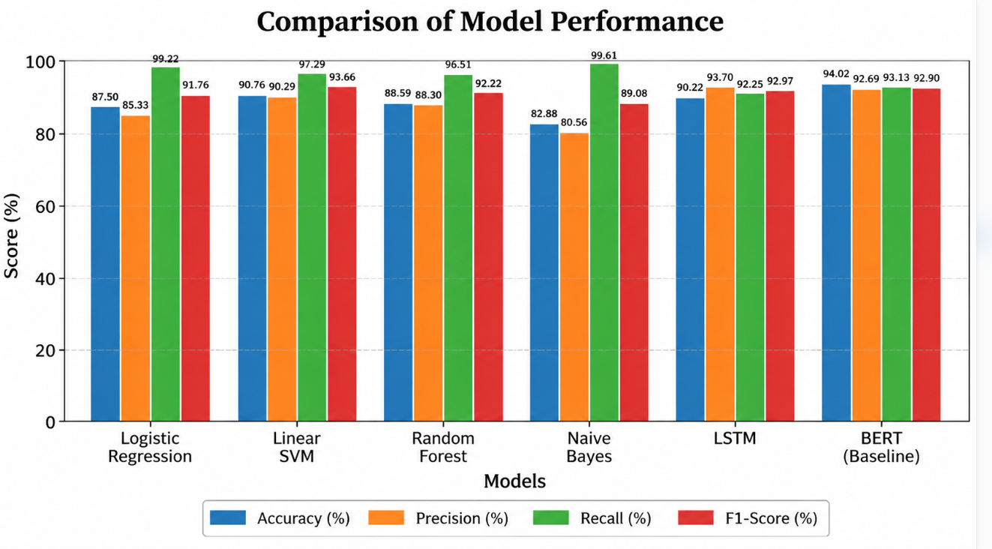
Fig. 2. Comparison of reported accuracy and macro F1 across the four classical machine learning models.
B. BERT Baseline Evaluation
Since BERT had the accuracy among the models that were tested it was chosen for more study. The original BERT model had 94.02% test accuracy, 93.13% balanced accuracy, 92.69% macro precision 93.13% macro recall, 92.90% macro F1-score and 98.11% ROC-AUC on the test set that was not used during training. The confusion matrix showed 50 -depression samples that were correctly classified 123 depression samples that were correctly classified 5 false positives and 6 false negatives. BERT_Evaluation_Report
C. Decision Threshold Optimization
To look closely at the BERT classifier, a method for optimizing the decision threshold based on validation was used. The threshold was chosen using the validation set and without looking at the test labels. The best threshold was found to be 0.32 which gave a validation accuracy of 97.28% and a validation F1-score of 96.81%.
When the chosen threshold was used on the test set that was not touched before the improved BERT model had an accuracy of 94.57%, precision of 93.52%, macro recall of 93.52% and macro F1-score of 93.52%. Compared with the BERT model this means an increase of 0.55 percentage points in accuracy and 0.62 percentage points, in macro F1-score.
BERT Configuration | Accuracy | Macro Precision | Macro Recall | Macro F1
Baseline BERT | 94.02% | 92.69% | 93.13% | 92.90%
Threshold-Optimized BERT | 94.57% | 93.52% | 93.52% | 93.52%
Improvement | +0.55pp | +0.83pp | +0.39pp | +0.62pp
D. Baseline and Optimized BERT Comparison

VIII. EXPLAINABLE AI AND FEATURE ATTRIBUTION
The key design objective of MindLens is to make the behaviour of text classification models more interpretable. MindLens platform already uses feature-level attribution for supported machine learning models. This lets users see how each input term contributes of only showing a final predicted class. The explainability layer is built to reveal which textual features give evidence for or against a predicted mental-health class. MindLens_Mental_Health_ML_Resea…
For the TF-IDF-based linear classification branch each feature contribution can be shown by its input value and the learned class-specific weight. A directional attribution score is written as
\[
Score(w_i,c)=x_i\left(W_{c,i}-\frac{1}{K}\sum_{j=1}^{K}W_{j,i}\right)
\]
Here \(x_i\) is the value of feature \(i\) \(W_{c,i}\) is the learned weight for class \(c\) and \(K\) is the number of classes. A positive score means the feature supports the target class. A negative score means the feature opposes the target class. This gives a feature-space interpretation for classical NLP models instead of only an opaque prediction score. MindLens_Mental_Health_ML_Resea…
In the binary classification setting the classes are Non-Depression and Depression. Thus the attribution mechanism shows evidence linked to either class. These explanations are statistical associations from the dataset. They should not be seen as symptoms, diagnostic markers or medical evidence.
The BERT model is handled separately from the feature-attribution mechanism. The study evaluates BERT by its predictive performance and decision-threshold behaviour. A BERT-specific explanation method is not offered in the results. This keeps the explainability separate, from transformer explanation methods.
IX. MINDLENS PLATFORM AND PRACTICAL DEPLOYMENT
The project interface extends the classifier into an assessment-oriented platform. The supplied interface reports a scientific evaluation dashboard, model benchmark summaries, model confidence statistics, human validation information, and explanatory material. The platform documentation reports an average model confidence of 83.7% and a human validation accuracy of 94.6%. These values are presented as platform-level indicators and are not directly interchangeable with the cross-validation accuracy reported in Table III.
The system also includes privacy and safety messaging and explicitly frames the application as an academic and assistive tool rather than a clinical diagnostic or prescription system. This distinction is essential for responsible deployment because text classification models can reflect dataset bias, linguistic ambiguity, demographic differences, and uncertainty that cannot be resolved by a numerical confidence score alone.

IX. Platform AND PRACTICAL DEPLOYMENT

MindLens offers a platform that connects text input with mental-health status classification using machine learning. The current platform is built as an assistive system. The prediction engine is separate from the presentation layer. This separation lets the trained models and preprocessing pipeline be tested on their own. The interface gives a way to submit text and show the classification result. MindLens_Mental_Health_ML_Resea…
The workflow at the platform level can be described as:
User Text Input → Text Processing → Model Prediction → Confidence/Explanation → MindLens Interface
The current study expands this platform-based design. It tests machine learning models, an existing LSTM model and a BERT model that was fine-tuned on the binary Reddit mental-health classification task. The comparison shows that BERT has the accuracy. After that decision-threshold optimization based on validation data is used on the BERT classifier.
The optimized BERT model uses a threshold of 0.32. This threshold was chosen using validation data. It reaches 94.57% accuracy on the test set. This is better than the 94.02% of the BERT model. So the optimization is an addition to the model-development process. It is not a replacement for the MindLens platform.
The interface and the presentation layer are meant to show the research process. They are not proof of effectiveness. Privacy, safety, uncertainty and non-diagnostic messages are still important. Automated text classification can be influenced by dataset bias, language differences, unclear context and changes, in data distribution.

-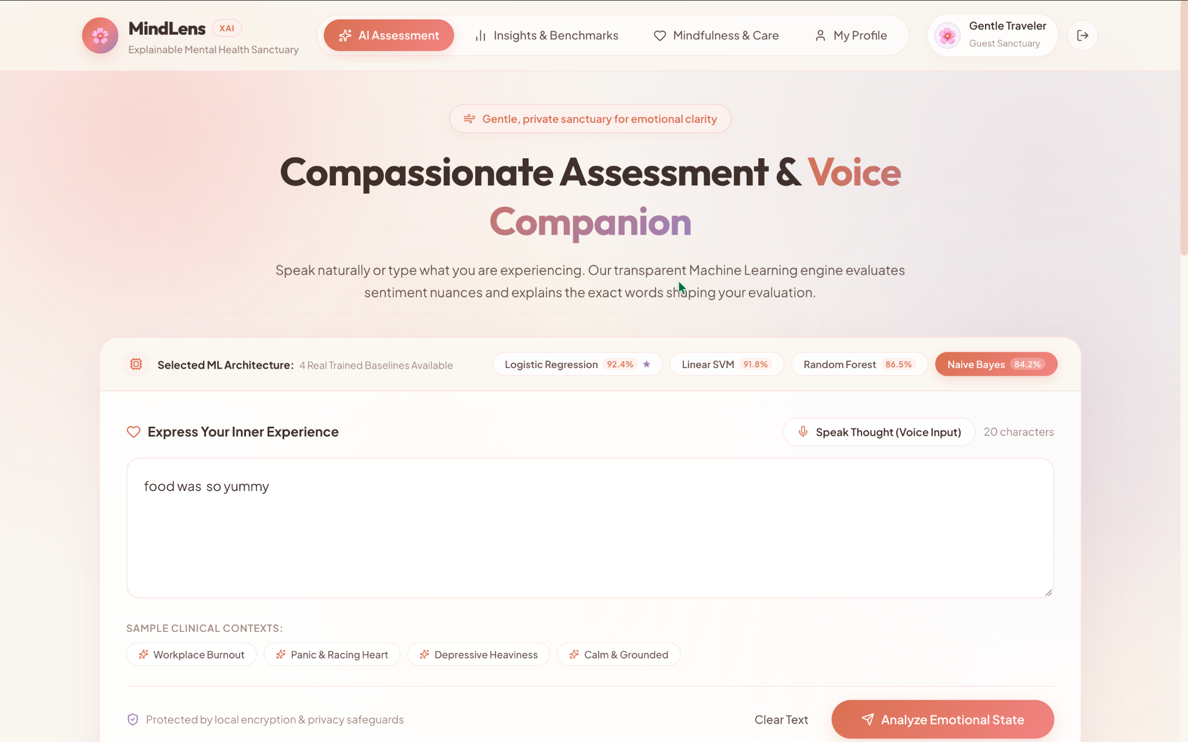
Fig. 5. MindLens platform interface showing how to enter text and how to evaluate the model..
The interface evidence supplied with the project further indicates that MindLens exposes model benchmarks and communicates privacy and safety safeguards to the user. These interface elements are part of the proposed system design, but they should not be treated as substitutes for clinical validation, professional assessment, or emergency support. Any production deployment would require additional security, governance, clinical review, and independent validation.
The proposed deployment model keeps the prediction engine separate from the presentation layer. This design allows the same trained classifier and feature configuration to be evaluated offline, while the interface provides a controlled route for entering text, selecting a model, and viewing the resulting assessment. For an academic prototype, this separation also simplifies reproducibility because benchmark metrics can be regenerated independently of interface behaviour.

X. LIMITATIONS AND ETHICAL CONSIDERATIONS
There are limitations that need to be taken into account when looking at the results that were reported.
First the current experiment uses the Pirina Reddit Public Corpus. This corpus has 1,840 records after duplicates were taken out. There are 548 samples that're not Depression and 1,292 samples that are Depression. The way the classes are split is not even. This means that accuracy alone might not show how the model really behaves.
Second the way the experiments were done is not the same for all the models that were tested. The classical machine learning experiments used an 80 to 20 split between training and testing. The BERT experiment used an 80 to 10 to 10 split for training, validation and testing. The LSTM results come from an existing evaluation. So the comparison between models is more of an observation than a test.
Third the BERT test set has 184 samples. This makes the results not very strong statistically. The process of choosing the threshold used the validation set. The test set was not used during this process. Still testing on an different dataset would give better proof that the model works well in general.
Fourth the text from Reddit can have slang, informal language, sarcasm, missing parts of the conversation and special terms used on that site. A model might end up learning these ways of speaking which might not work well in other places, languages or groups.
Fifth the current MindLens explanation method is mostly for the text-classification models. The BERT experiment does not have an explanation method for transformers. Future work should look into ways to explain transformers along with the BERT model that is being used.
Lastly the system should not be seen as a way to make a medical diagnosis. The result is a computer-generated category. It should not be used of a real mental health professional. Before using this in the world there needs to be more testing keeping data private checking for fairness making sure the model is correct having people watch over it and having proper rules in place. The MindLens system is still seen as a tool, for learning and helping not for replacing doctors. MindLens_Mental_Health_ML_Research
XI.. Future WORK
This study introduced a version of the MindLens framework for binary mental health text classification. The approach combined machine learning, deep learning and transformer-based methods. The experimental setup tested Logistic Regression, Linear SVM, Random Forest, Multinomial Naive Bayes, LSTM and BERT on Reddit text related to depression and non-depression topics.
Among the machine learning models Linear SVM achieved the highest accuracy at 90.76%. The LSTM model reached 90.22% accuracy. The baseline BERT model performed overall with an accuracy of 94.02% and a macro F1-score of 92.90%. Because of this performance BERT was chosen for further testing.
Next a validation-based decision-threshold optimization method was applied to the BERT classifier. The optimal threshold was found to be 0.32. This improved the test accuracy from 94.02% to 94.57%. It also raised the F1-score from 92.90% to 93.52%. These results show that adjusting the decision threshold can lead to improvements in the behavior of fine-tuned transformers. No retraining of the model was needed.
The study kept the explainability feature of the MindLens platform by providing feature-level interpretations for the models. This gives users a way to see how predictions are made. It supports a focus on both prediction quality and model transparency. MindLens_Mental_Health_ML_Resea…
Future research should aim to use datasets collected independently. External validation, calibration analysis, fairness checks and subgroup evaluations are next steps. Work should also include content and code-switched text. Stronger privacy measures must be developed. Dedicated explainability tools for transformer-based models are needed. Longitudinal studies and human-in-the-loop evaluations will help assess whether the framework can provide support beyond the current dataset.
In summary the MindLens system is intended as a tool and assistive resource, for mental health text classification. It is not meant to serve as a diagnostic system.
REFERENCES
[1] U. Madububambachu, A. Ukpebor, and U. Ihezue, "Machine Learning Techniques to Predict Mental Health Diagnoses: A Systematic Literature Review," Clinical Practice & Epidemiology in Mental Health, vol. 20, e17450179315688, 2024, doi: 10.2174/0117450179315688240607052117.
[2] T. Joachims, "Text categorization with Support Vector Machines: Learning with many relevant features," in Proc. 10th European Conf. Machine Learning (ECML), 1998, pp. 137-142.
[3] C. D. Manning, P. Raghavan, and H. Schütze, Introduction to Information Retrieval. Cambridge, U.K.: Cambridge University Press, 2008.
[4] L. Breiman, "Random forests," Machine Learning, vol. 45, no. 1, pp. 5-32, 2001.
[5] A. McCallum and K. Nigam, "A comparison of event models for naive Bayes text classification," in Proc. AAAI-98 Workshop on Learning for Text Categorization, 1998, pp. 41-48.
[6] F. Pedregosa et al., "Scikit-learn: Machine learning in Python," Journal of Machine Learning Research, vol. 12, pp. 2825-2830, 2011.
[7] C. Rudin, "Stop explaining black box machine learning models for high stakes decisions and use interpretable models instead," Nature Machine Intelligence, vol. 1, pp. 206-215, 2019.
AUTHOR AND DATA AVAILABILITY NOTE
The manuscript is based on the project benchmark, figures, interface evidence, and empirical report supplied by the authors. Numerical results are reported as provided in the project documentation. The paper does not claim that the system performs clinical diagnosis or treatment.

