IT 230 Coding Activity Submission Template

Submit your work on the coding activities for Modules One, Two, Three, Four, and Six in this document. In addition to this document, you should submit a ZIP file containing all your Visual Studio project files and source code that can be run in Visual Studio on a different computer.

For each coding activity, complete the following steps:

- Download and rename this document to meet the file naming conventions requested in the assignment instructions.
- Fill in the required information below by replacing the bracketed text with the relevant information.
- Submit this document and your ZIP file for grading and feedback. Your ZIP file should follow the same naming conventions.

Document your work in the coding activity by completing each of the following items:

- Provide a screenshot of the output that resulted from running your program successfully in Visual Studio. See the coding assignment instructions for an example of what should be included in the screenshot. Your screenshot must include the following elements:
  - Your last name as the first printed text on the screen
  - Verification that the program is fully functioning and data results are accurate for the given problem

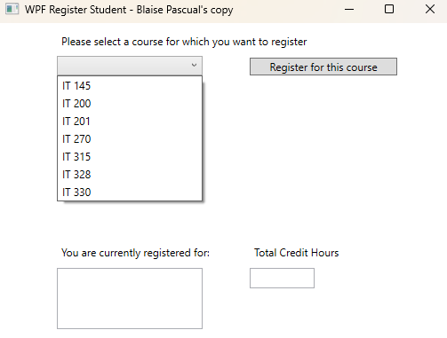
The program displays the initial user interface with a dropdown menu of available courses, a 'Register for this course' button, an empty registered courses list, and an empty Total Credit Hours field. The program is ready for user interaction.

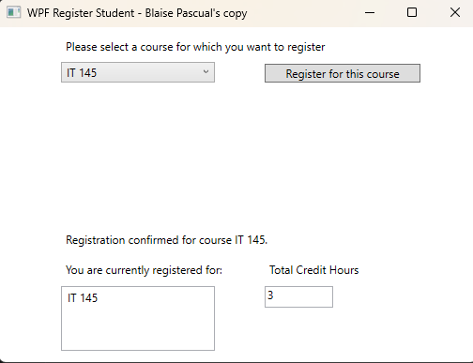
The user selects a course (e.g., IT 145) from the dropdown and clicks 'Register for this course.' The program validates the selection, confirms the registration, adds the course to the registered courses list, and updates the Total Credit Hours to 3.

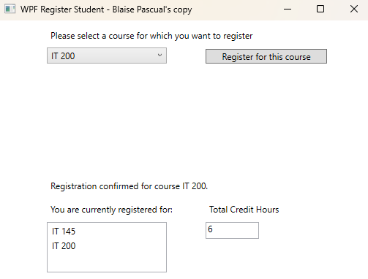
The user registers for a second course (e.g., IT 200). The program adds it to the registered courses list and updates the Total Credit Hours to 6, demonstrating that each course carries three credit hours and that the cumulative total is tracked correctly.

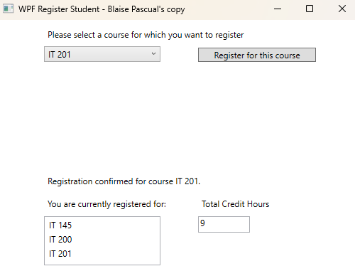
The user registers for a third course (e.g., IT 201). The registered courses list now shows three courses and the Total Credit Hours is updated to 9, which is the maximum allowed.

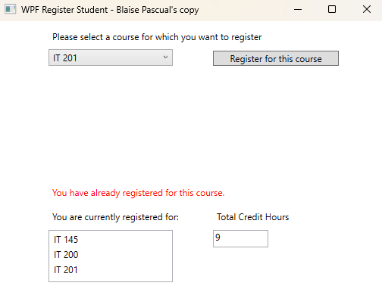
The user attempts to register for a course they have already registered for (e.g., IT 201). The program validates the selection against the business rule that prohibits duplicate registration and displays an error message: 'You have already registered for this course.’

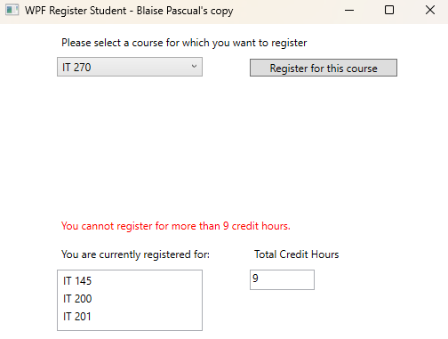

The user attempts to register for a fourth course (e.g., IT 270) after already registering for the maximum of nine credit hours. The program enforces the business rule limiting registration to no more than nine credit hours and displays an error message: 'You cannot register for more than 9 credit hours.'

- Copy and paste the source code text you wrote for this assignment from the *.cs file into the space below. Only providing the *.cs files or a screenshot does not meet the requirements for this part of the assignment. Code should be logically organized. It should also follow proper syntax and conventions noted in the Coding Activity Guidelines and Rubric.
using System;
using System.Collections.Generic;
using System.Linq;
using System.Text;
using System.Threading.Tasks;
using System.Windows;
using System.Windows.Controls;
using System.Windows.Data;
using System.Windows.Documents;
using System.Windows.Input;
using System.Windows.Media;
using System.Windows.Media.Imaging;
using System.Windows.Navigation;
using System.Windows.Shapes;

namespace WPFRegisterStudent
{
/// <summary>
/// Interaction logic for MainWindow.xaml
/// </summary>
public partial class MainWindow : Window
{
Course choice;
private int totalCreditHours = 0;

public MainWindow()
{
InitializeComponent();
}

private void Window_Loaded(object sender, RoutedEventArgs e)
{

Course course1 = new Course("IT 145");
Course course2 = new Course("IT 200");
Course course3 = new Course("IT 201");
Course course4 = new Course("IT 270");
Course course5 = new Course("IT 315");
Course course6 = new Course("IT 328");
Course course7 = new Course("IT 330");

this.comboBox.Items.Add(course1);
this.comboBox.Items.Add(course2);
this.comboBox.Items.Add(course3);
this.comboBox.Items.Add(course4);
this.comboBox.Items.Add(course5);
this.comboBox.Items.Add(course6);
this.comboBox.Items.Add(course7);

this.textBox.Text = "";
}

private void button_Click(object sender, RoutedEventArgs e)
{
choice = (Course)(this.comboBox.SelectedItem);

// TO DO - Create code to validate user selection (the choice object)
// and to display an error or a registation confirmation message accordinlgy
// Also update the total credit hours textbox if registration is confirmed for a selected course

if (choice == null)
{
this.label3.Foreground = Brushes.Red;
this.label3.Content = "Please select a course to register.";
return;
}

if (choice.IsRegisteredAlready())
{
this.label3.Foreground = Brushes.Red;
this.label3.Content = "You have already registered for this course.";
return;
}

if (totalCreditHours >= 9)
{
this.label3.Foreground = Brushes.Red;
this.label3.Content = "You cannot register for more than 9 credit hours.";
return;
}

choice.SetToRegistered();
totalCreditHours += 3;

this.listBox.Items.Add(choice.getName());
this.textBox.Text = totalCreditHours.ToString();

this.label3.Foreground = Brushes.Black;
this.label3.Content = "Registration confirmed for course " + choice.getName() + ".";
}

}
}

- Show that you understand the task by explaining the design of your program in the space below. Include the process and steps you took to write your code. Explain how you arrived at the solution to the problem and completed the activity.

The WPF Register Student program is designed to let a student register for courses using a graphical interface. The program has a dropdown menu (ComboBox) that lists seven IT courses, a "Register for this course" button, a ListBox that shows which courses the student has registered for, and a TextBox that displays the total credit hours. I also used a label to show confirmation or error messages to the user. The main logic lives inside the button_Click event handler in MainWindow.xaml.cs, and the program uses a Course class from Course.cs that keeps track of each course's name and whether it has already been registered for.
To write my code, I started by looking at what was already provided and figuring out what was missing. The button_Click method was mostly empty, so I needed to add the validation and registration logic there. First, I added a totalCreditHours variable to keep track of how many credits the student has signed up for. Then I wrote three if statements inside the button click handler: the first checks if the user actually selected a course, the second checks if they already registered for that course using the IsRegisteredAlready() method, and the third checks if they have already hit the 9 credit hour maximum. If any of those checks fail, the program shows a red error message. If all checks pass, the program marks the course as registered, adds 3 to the total credit hours, adds the course name to the ListBox, and updates the TextBox with the new total.

- Reflect on your learning experience and what you learned from completing the activity.

Completing this activity helped me understand how a WPF application works differently from a console application. In the console version, I used text input and output, but in WPF everything is event-driven. I learned how to work with UI elements like ComboBoxes, ListBoxes, TextBoxes, and Labels from the code-behind file. I also learned how to use the Brushes class to change the color of text for error and confirmation messages. Understanding how the XAML file defines the layout and the C# file handles the logic was a big takeaway for me.

I also got a better understanding of how to use classes and objects in a real program. The Course class acted like a library component that stored data and had methods I could call, like IsRegisteredAlready() and SetToRegistered(). This showed me how object-oriented programming keeps code organized and reusable. Writing the Boolean logic and branching with if statements to enforce the business rules gave me more confidence in translating real-world requirements into working code. Overall, this project connected a lot of the individual concepts I have been learning and showed me how they all come together in a complete application.

