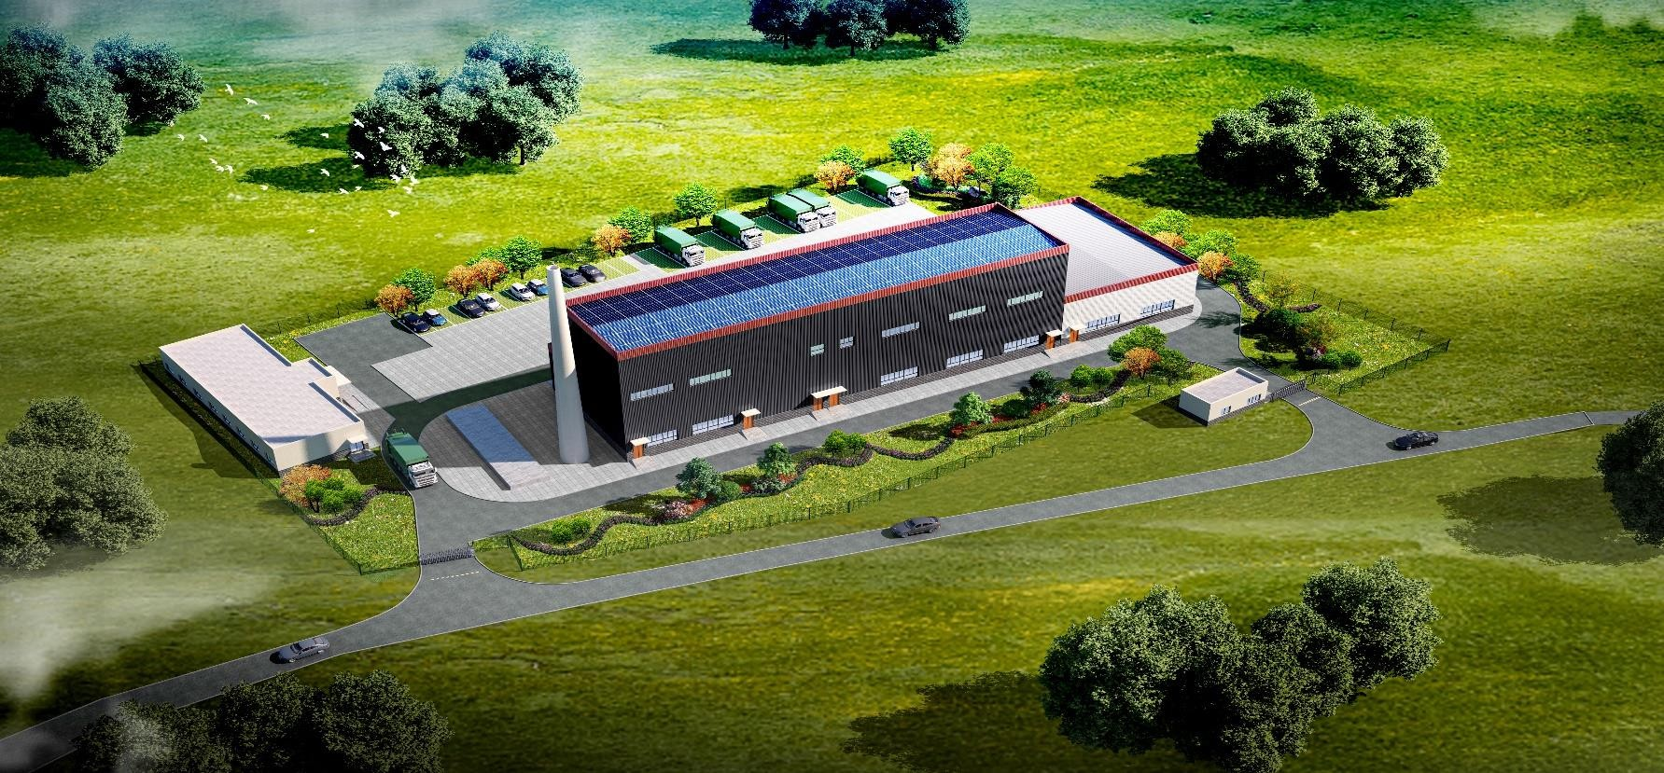
2026

Pyrolysis Gasification Treatment of 5 Tons of High-Calorific-Value Waste

Project Proposal

Harmless Technical Treatment of High-Calorific-Value Waste in Bangladesh

(5 tons/day)
Design Proposal

Table of Contents

Chapter 1 Project Overview 1
Chapter 2 Process and Technical Scheme 1
  - Determination of the Waste Treatment Technology 1
  - Process Scheme and Flow 2
    - Waste Receiving System 2
    - Plant Deodorization System 2
    - Feeding and Conveying System 3
    - High-Temperature Pyrolysis Gasification System 4
    - Waste Heat Recovery System 6
    - Flue Gas Purification System 7
    - Three-Waste (Bottom Ash, Fly Ash,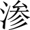 Leachate) Treatment System 14
    - Central Control System 15
  - Equipment List 15
  - Treatment Performance 17
  - Main Pollution Prevention and Control Measures and Mechanisms 18
    - Dioxin Removal Process 18
    - NOX Removal Process 18
    - Deacidification Process 19
Chapter 3 Engineering Design 19
  - Principles of Overall Scheme Design 19
  - General Layout 20
    - Project Site Planning Concepts Based on Layout and Site Selection Principles 20
Chapter 4 Project Implementation and Schedule 23
Chapter 5 Operating Cost Estimation 24
Chapter 6 Technical Features 25
  - Key Technologies 25
  - System Advantages 26
    - Small Footprint 26
    - Low Investment and Operating Cost 27
    - Low Pollution Generation, Compliant Emissions without Secondary Pollution 27
    - Fully Enclosed Operation with Automatic Control 27
    - On-Site and Nearby Harmless Treatment 27
Chapter 7 Reference Cases for Visits 28
  - Case Photos 34

Chapter 1 Project Overview

(1) | Project name: Bangladesh High-Calorific-Value Waste Harmless Treatment Project;
(2) | Designed daily processing capacity: 5 tons/day per set, with 1 project site to be established:
(3) | Equipment investment: RMB 8.6 million (ex-works price)
(4) | Project land area: 800m2
(5) | Waste conditions: waste with calorific value ≥900 kcal and moisture content ≤60%;
(6) | Energy required: (0# diesel or firewood) only for ignition and furnace curing; no additional fuel is required during normal operation;
(7) | Slag treatment: the bottom ash has met discharge standards and can be landfilled, used for road paving, or made into bricks at brick plants;
(8) | Service life: 15-20 years;
(9) | Flue gas emission targets: complying with the requirements of the Standard for Pollution Control on Municipal Solid Waste Incineration (GB18485-2014).

Process and Technical Scheme

Determination of the Waste Treatment Technology

The waste of this project is mainly industrial waste, such as packaging materials, with a moisture content of 5.7%, plastics 29%, paper 51%, foil/
composite materials 15%, others 5%, with a calorific value reaching 5400kcal/kg.
This type of industrial solid waste has a high unit calorific value, but the total amount of waste generated is small. The total chemical thermal power released by combustion is relatively limited. After heat exchange in the waste heat boiler, heat losses and thermodynamic cycle conversion, the maximum net output power of the system is only about 300 W, with a total daily power generation of 7.2kWh. Although the fuel itself has an excellent calorific value, the effective energy base available for power generation is very low. If a complete power generation set including waste heat boiler, steam turbine, generator and circulating water is equipped, the equipment investment, auxiliary energy consumption and O&M costs would far exceed the meager power generation revenue, and the overall energy conversion efficiency is low, with input exceeding output. Therefore, it is not recommended to install a power generation system in this project.
Considering that Bangladesh is located in a tropical monsoon climate zone where no heating is required in winter, if the waste heat of the plant has no other utilization value, it is discharged directly after heat exchange.
It is recommended to adopt a new treatment process combining high-temperature pyrolysis gasification with incineration, using a chain grate as the core component of incineration and enlarging the furnace cavity of the secondary combustion chamber to satisfy the flue gas residence time.

Process Scheme and Flow
The project process flow includes:
Waste Receiving → Conveying and Feeding System → High-Temperature Pyrolysis Gasification System → Waste Heat Recovery System → Flue Gas Purification System → Three-Waste (Bottom Ash, Fly Ash, Leachate) Treatment System → Central Control System
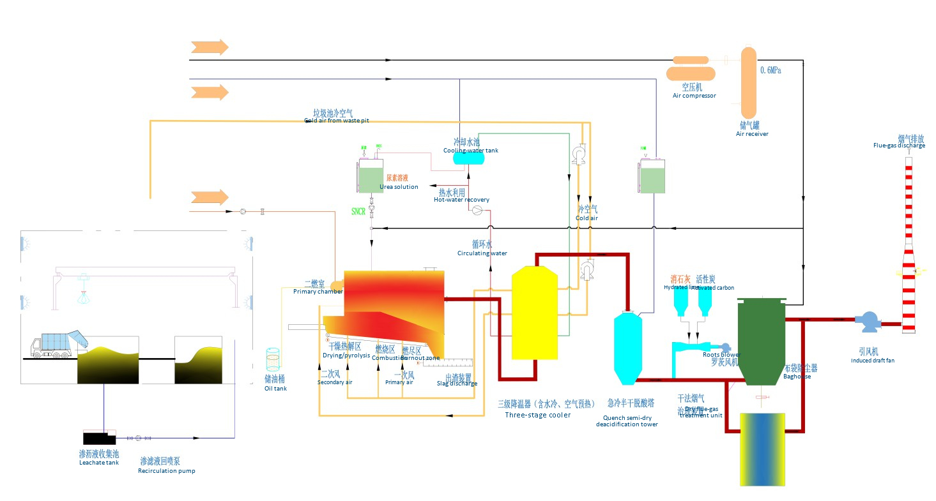

Waste Receiving System
Waste is transported to the incineration plant by waste trucks, weighed by the electronic truck scale, and then enters the tipping hall and is unloaded into the waste collection pit. The sufficient effective volume of the waste storage pit ensures the raw material supply of the pyrolysis furnace when the waste supply fluctuates severely, making the reaction in the furnace more stable.

Plant Deodorization System
It is composed of suction fans, spray deodorization system, etc., and adsorbs odor molecules in the air through deodorizer. The deodorizer quickly adsorbs odor molecules in the air through centrifugal atomization, and the microorganisms and enzymes it contains can decompose the adsorbed odorous substances in time.

Meanwhile, the highly active beneficial microbial flora contained in the deodorizer can inhibit the proliferation of spoilage microorganisms, thereby slowing down the generation of odorous gases. When the waste pyrolysis gasifier is in operation, the oxygen supply fan draws air from the waste storage pit to maintain the negative pressure state of the pit, with makeup air coming through the opening of the waste discharge doors. The biomass spray deodorization system is automatically started periodically to remove odor molecules in the room. With both schemes implemented simultaneously, odors can be well removed and odor escape prevented.
Odor Point | Location | Characteristics | Deodorization Measures
1 | Plant roads | - Dripping from waste trucks pollutes the road surface; deposited odorous gases exist  (Slight) | - Water flushing;  - Plant deodorizer spraying.
2 | Waste tipping hall | - Dripping from waste trucks pollutes the road surface; deposited odorous gases exist  (Severe)  - Odor from the waste bunker escapes through the discharge doors | - Enclosed structure with slightly negative pressure;  - Air curtains at the gates prevent odorous gas from escaping;  - Waste discharge doors are opened under the guidance of the central control room;  - Water flushing and plant deodorizer spraying.
3 | Waste pit | - Odor from waste fermentation; main components: H2S, NH3, SO2, CH4 and mercaptan | - Enclosed structure with slightly negative pressure;  - During normal operation, primary air is drawn from the upper part of the waste pit, and the odorous gas is burned and decomposed in the incinerator;  - When the incinerator is shut down, the odorous gas is drawn by the deodorizer  and discharged in compliance with standards after adsorption by the activated carbon device.
4 | 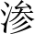 Leachate tank,  flushing corridor | - Area where leachate drainage converges,  strong odor | - Mechanical ventilation with fresh air drawn from outdoors  - Mechanical exhaust, with exhaust air sent to the waste pit
5 | Rear furnace area  (slag pit) | - Odor of residual organic matter after incineration  (Slight) | - High-level discharge  - Exhaust drawn into the secondary air fan
6 | Central control room and visitor corridor | - Escape of odor from waste storage,  odorous gas pollution from incineration (Slight) | 1. Effectively separated from odor sources, supplied with outdoor fresh air, and kept at positive pressure to prevent odor intrusion


Feeding and Conveying System

Waste Crane

      - The waste grab crane is one of the key process equipment of the pyrolysis gasification plant, directly affecting the operational reliability of the plant. Its main components are imported products.
      - The waste grab crane is located above the waste pit and is mainly responsible for feeding, handling,

turning over, sorting and stacking of incoming waste and transferred waste. This project is equipped with 1 single-girder grab crane.

      - The waste grab crane mainly consists of six major parts: single girder, crane travel mechanism, hoisting mechanism, trolley travel mechanism, electrical equipment and grab. Except for the electrical equipment, the other five parts have their own motors for separate driving, meeting the pile-turning and feeding requirements of production.
      - The grab is of the hydraulic multi-clamshell type.

The traveling grab crane grabs the waste into the receiving hopper of the double screw conveyor, and grabs the waste in the storage pit into the receiving hopper of the high-temperature pyrolysis gasifier, where it is pushed into the furnace by the hydraulic pusher device.

2.2.4 High-Temperature Pyrolysis Gasification System

Based on the chemical characteristics of different components in the waste, this technology efficiently combines waste pyrolysis gasification with oxygen-enriched combustion through staged combustion in the furnace, and is a treatment technology developed for mixed waste.
The main body is designed as two relatively independent units: a high-temperature pyrolysis gasification zone and a gas-solid separation combustion zone. The high-temperature pyrolysis gasification zone achieves full decomposition and carbonization of the organic matter in the waste, and the gas-solid separation combustion zone achieves full combustion and rendering harmless of the combustible gas and fixed carbon, organically combining pyrolysis gasification with high-temperature combustion throughout the process.
The grate of the primary combustion chamber is divided into a drying zone, a pyrolysis zone, a main combustion zone and a burnout zone. The drying and pyrolysis zone is located under the front arch, supplied with a small amount of high-temperature air by the first air chamber. After being dried in this zone, the waste is pyrolyzed into combustible gas (CH4, CO, etc.) in a reducing atmosphere; the gas-phase products enter the secondary combustion chamber and undergo oxygen-enriched combustion under the action of the secondary high-temperature air, with the temperature controlled above 850℃ to thoroughly decompose harmful gases and dioxins. The solid-phase products are fully burned in the combustion zone; in the burnout zone the residual carbon is basically burnt out, and the small remaining amount is re-burned in this section. The burnt slag falls into the slag collection hopper and is discharged into the slag room by the slag discharger.

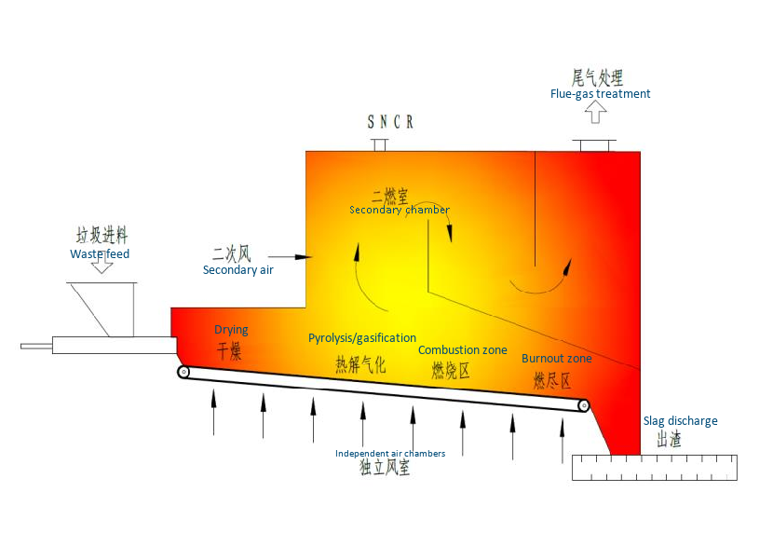
By regulating parameters such as the primary and secondary air velocity, air volume, temperature and feeding speed, staged combustion is performed to control the combustion conditions in the furnace and rationally distribute the release of chemical energy, so as to achieve complete burnout of the waste.
Schematic diagram of the working principle.
Grate design length 11m, width 0.8m; secondary combustion chamber space 21m3
Secondary combustion chamber outlet air volume: 5400Nm3/h; design temperature 850℃.
The burner uses natural gas or diesel fuel, with power of 1.1kw and calorific value greater than 30wkcal/h. When the furnace temperature is below 850℃, the burner starts automatically, and stops automatically after the temperature rises.
Slag discharger: combined screw + scraper with water seal. Its features are as follows:
      - The screw ash discharger discharges the ash and slag below the furnace body to the rear of the furnace body, closely connected with the scraper conveyor. Thanks to the water-seal structure, the scraper conveyor has perfect air tightness and can maintain the negative pressure of the furnace.
      - Thanks to the water seal, no dust is generated during slag discharge.
      - It can effectively remove the residual sewage, so that the moisture content of the slag is only 15～25%. Therefore, there is almost no
water leakage in the slag pit.
      - The water temperature in the slag discharger will be kept below 60℃.

2.2.5 Waste Heat Recovery System

The equipment of the waste heat utilization system mainly includes: integrated heat exchanger.

The water-cooled section uses the waste heat from waste combustion to output hot water (if there is no domestic hot water demand in the plant, it is directly cooled in circulation); while cooling the high-temperature flue gas, it maximizes the utilization of heat energy. The air-cooled section mainly uses the waste heat of the exhaust gas to heat the primary and secondary air, realizing resource recycling of waste treatment.
Structure and working principle: the equipment consists of cover plates, shell, heat exchange plates, manhole, flue gas inlet, flue gas outlet, water inlet, water outlet, exhaust port, etc. Under the action of the main fan, the flue gas side of the equipment maintains a certain negative pressure. The high-temperature flue gas enters from the flue gas inlet, flows through hundreds of partition intervals and flows out from the flue gas outlet. The cooling water pump pumps cold water in from the water inlet, which flows through the densely distributed lattice cavities and flows out from the water outlet. Since the flue gas temperature is higher than the cold water temperature, its heat is transferred to the cold water through the pipe wall, thereby lowering its own flue gas temperature and heating the water. The flue gas temperature is higher than the air temperature, so its own temperature is reduced while heating the oxygen supply air.
The new wide-channel plate heat exchanger has low turbulent flow velocity and a high heat transfer coefficient, which is 2 times that of the tubular type; the heat transfer coefficient is high, and the heat exchange area is about 1/2 of the tubular type; the structure is compact, with the heat exchange area per unit volume more than 3 times that of the tubular type, small footprint and light weight.
The intense turbulence of the fluid results in few deposits, easy cleaning and a very low fouling factor; the flow channels are smooth, with no dead corners, so dust accumulation is not easy.

2.2.6 Flue Gas Purification System

The flue gas purification system adopts the combination of "SNCR + semi-dry quenching deacidification tower + dry reaction device + activated carbon adsorption + bag filter technology", which can effectively remove NOx, dust, SO2, HCL, heavy metals and other pollutant components in the flue gas, so that the exhaust gas is discharged in compliance with standards.
The flue gas treatment equipment includes: SNCR denitration system, semi-dry quenching deacidification tower, dry reaction device, bag filter, induced draft fan, chimney and other equipment.
      - SNCR Denitration System

The SNCR denitration system performs high-temperature denitration of NOx in the flue gas at the high-temperature section in the furnace.

In the selective non-catalytic reduction (SNCR) nitrogen oxide removal process, the reducing agent is injected into the hot flue gas in the form of an aqueous solution (urea) or gas (ammonia).
Usually water is used as the driving carrier for urea solution injection. By controlling the amount of sprayed water, the injection distance of the urea solution can be effectively increased with little energy consumption, and it can also be used when necessary to lower the flue gas temperature, so that the urea reacts with the nitrogen oxides in the flue gas within the appropriate temperature range.
A CO(NH2)2 urea solution with a concentration of ~10％ is evenly stirred in the preparation tank and then sent to the urea storage tank for storage, and then boosted by the atomization pump into the nozzle. The nozzle is atomized by pressure and sprayed into the furnace. The flue gas is fully mixed with the atomized urea solution in the area below the nozzle, and the NOx components in the flue gas undergo a reduction reaction with CO(NH2)2 in the presence of O2, while the moisture of the urea solution is completely vaporized by the flue gas and carried away by it. When the ratio of CO(NH2)2 to NOx is 2:1, the NOx reduction efficiency is about 40%.

The solution preparation device is shown in the figure
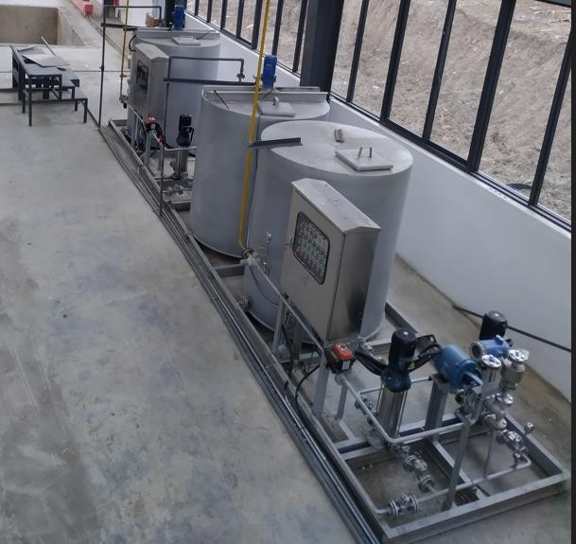

The denitration system adopts automatic adjustment control. The nitrogen oxide content in the discharged flue gas and the denitration agent form a control loop, and the denitration agent is automatically adjusted according to changes in the nitrogen oxide content.
Preparation tank material 304, volume 1m³
Atomizing spray gun Q=20kg/h, gun body 316L, nozzle 316L, pump Q=0.4m3/h, H=60m

      - Semi-Dry Quenching Deacidification Tower

The system adopts a counter-current quench tower, and the high-temperature flue gas enters from the bottom of the quench tower. Quenching lye is sprayed into the quench tower, and the quench water is quickly atomized by compressed air. The nozzle is of the double-layer multi-orifice type, increasing the water-gas contact area and accelerating the reaction rate.
The atomized quench water directly contacts the flue gas, causing the flue gas temperature to drop rapidly. Quenching from 400℃ to 200℃ — the setting of this temperature range avoids the dioxin re-synthesis temperature range, thereby achieving the purpose of suppressing the re-generation of dioxins. During the quenching process, in addition to cooling, it also has the functions of washing, dust removal and deacidification.
The atomization of the quench water is realized by the quench pump station, which consists of an atomization pump, spray guns, piping system, air path system, temperature detection system, etc.

The quench spray gun adopts a gas-liquid two-phase nozzle, spraying fine atomized water into the flue gas. The spray gun has two inputs: one for water and the other for compressed air. To effectively protect the downstream equipment, one quench pump is in use and one on standby.
The quench tower consists of the tower shell, anti-corrosion castable and dual-fluid spray system.

The quench tower is arranged vertically, lined with an anti-corrosion and heat insulation layer. Water spraying is used for cooling, and the quench water is atomized by compressed air.

The dual-fluid atomizing nozzle has a large spray diameter and wide coverage, mixing more fully with the flue gas, which is conducive to cooling and conditioning of the flue gas. The core of the dual-fluid spray system is the nozzle. In normal operation, compressed air and water at certain pressures need to be supplied to the nozzle simultaneously. Inside the nozzle, the compressed air and water strike each other several times to produce very fine particles. When the atomized particles mix with the high-temperature flue gas, they evaporate rapidly in a short time and carry away heat. With the selected spray gun at an appropriate compressed air pressure, 90% of the particles are smaller than 150μm, ensuring 100％ evaporation of the quench water and no wet bottom ("over-spray").
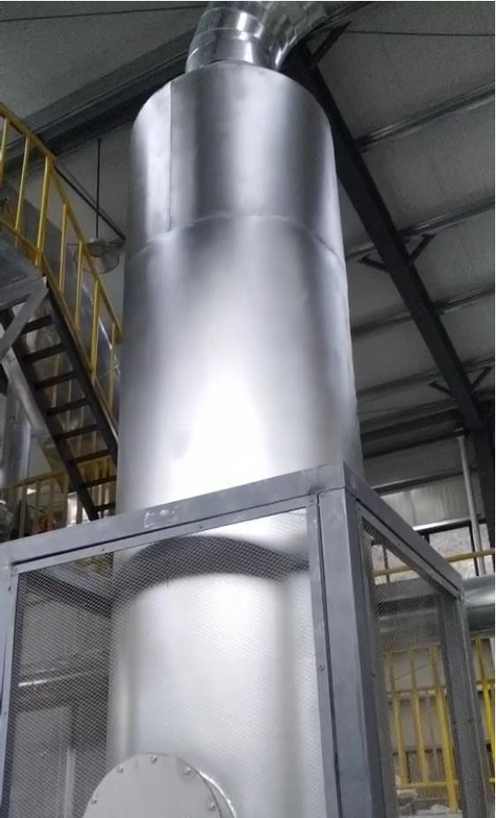
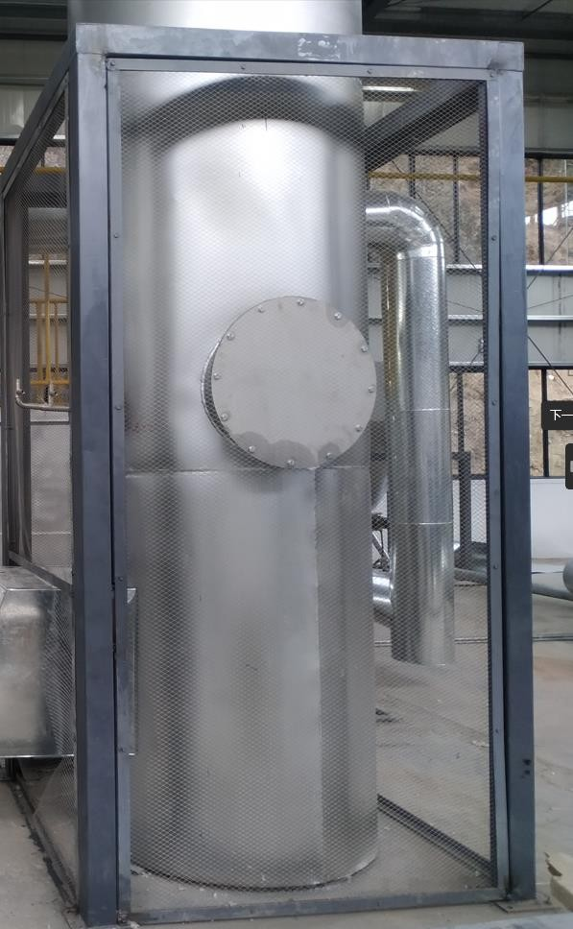
Semi-Dry Quenching Deacidification Tower

The quench water spray volume is regulated by the regulating valve, which is interlocked with the quench tower outlet temperature and automatically adjusted to ensure that the quench tower outlet temperature does not exceed 200℃, protecting the downstream equipment. The amount of lye added is controlled by the concentration of acidic pollutants in the flue gas discharge; under normal conditions the pH value of the water in the quench water tank is controlled at 9- 10.
Specification: Φ1500*6000mm
Material: Q235B + 120mm acid and alkali resistant castable
Atomization spray volume: 300Kg/h; gun body 316L, nozzle 316L

      - Dry Flue Gas Treatment Device

It mainly utilizes the surface adsorption characteristics of activated carbon and the neutralization reaction capacity of hydrated lime. A dry reaction device is arranged before the bag filter; the activated carbon and hydrated lime powder are fed into the Venturi duct by a small screw conveyor through a quantitative feeding device, where the harmful substances in the flue gas are adsorbed and reacted.
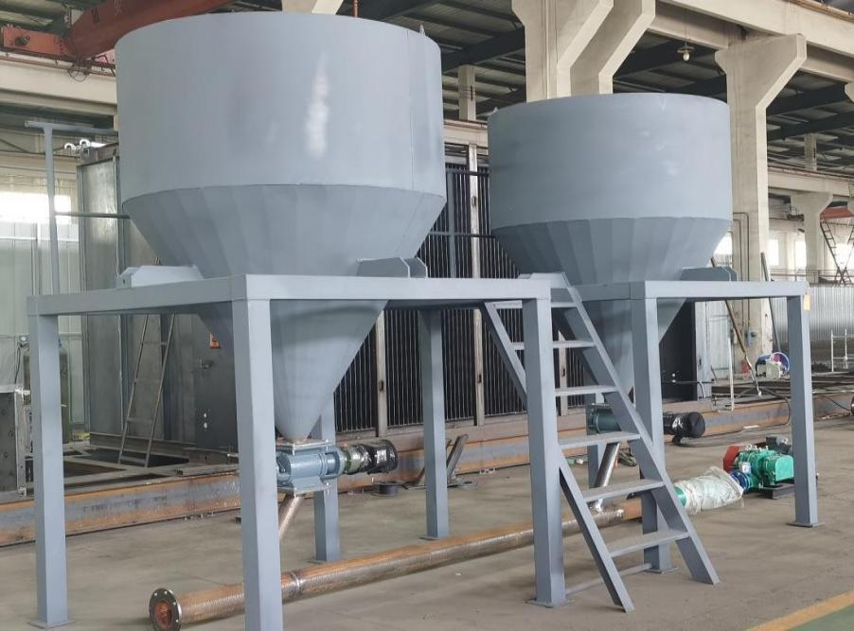

When the flue gas enters the bag filter, the unreacted activated carbon and hydrated lime powder are adsorbed on the surface of the filter bags, continuing to adsorb harmful substances and react with the residual acidic gases in the flue gas.

      - Bag Filter

This bag filter consists of a shell, filter bags, ash hopper, ash discharge device, support and pulse cleaning system, etc. When the dust-containing gas enters the filter from the air inlet, it first hits the inclined baffle in the middle of the air inlet, and the airflow turns and flows into the ash hopper. At the same time, the airflow speed slows down, and due to gravity settling, the coarse dust particles in the gas directly fall into the ash hopper, playing a pre-dusting role. The airflow entering the ash hopper then turns upward and passes through the filter bags with internal metal frames, where the dust is captured on the outer surface of the filter bags. The purified gas enters the clean chamber at the upper part of the filter bag room and is collected into the air outlet pipe for discharge.
The key equipment of the bag filter is the filter bag material. Since the 1980s, countries have been committed to the development of filter media technology, and modern technology often uses PTFE surface filter materials in bag filters, which has greatly improved the treatment of flue gas, chemical corrosion, clogging and rupture. The membrane filter bag uses the membrane surface with a uniform fine pore size to replace the function of the primary dust cake, making the dust penetration rate nearly zero. Due to the low friction coefficient, hydrophobicity, temperature resistance and anti-aging characteristics of the membrane material, it has excellent effects; during operation, the inside of the filter material is not easily blocked, can maintain a low pressure loss, improves the service life of the filter material and reduces operating costs. PTFE membrane-coated filter material has been used in incineration plants for nearly ten years, and its effectiveness not only captures fine dust emissions at the highest efficiency, but also ensures reliable system operation. PTFE membrane-coated filter bags can filter dust particles down to 0.3 microns. Dust cleaning adopts pulse high-pressure air jetting; reasonable pulse intervals and pulse widths, as well as the good cleaning performance of the filter bags, greatly ensure that the operating resistance of the equipment remains at a stable level, not exceeding 1500Pa, and keep the flue gas treatment volume always in a stable state, so that the whole system works in a highly efficient and stable environment.
The control objects of the filter include: cleaning control, ash discharge valve control, etc.

The filter has manual and automatic conversion functions, and requires operation both from the control room (plant-wide centralized or central control room) and locally. The specific control requirements of the filter are: ① cleaning control — when the pressure difference between the inlet and outlet exceeds the set pressure, the fixed differential pressure control starts and the pulse valves are automatically actuated for cleaning; through PLC programming, intermittent pulse cleaning actions with different intervals and different cycles can be realized, and when the cleaning of all filter bags is completed, the cleaning action is automatically completed. ② Manual opening and closing of the ash discharge valve.

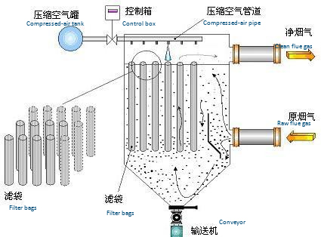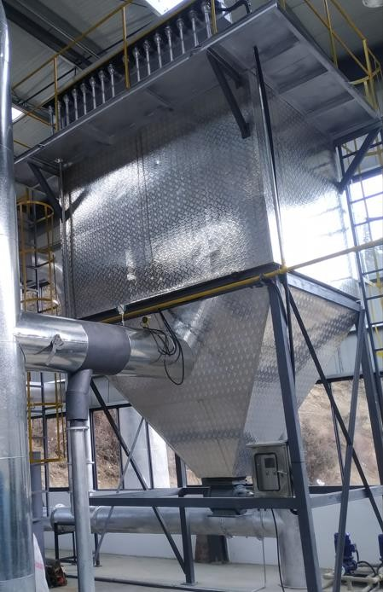

Electrostatic Precipitator

After the flue gas enters the high-voltage dust removal unit, under the action of the high-voltage pulse electrostatic field, the remaining oil mist and water are attached by high-density electrons or positive ions; after being charged, they migrate downward along the inner wall of the tube, and are collected and captured, producing ionization, adsorption, decomposition, carbonization and other phenomena.
On the inner wall of the tube acting as the dust collection electrode, the condensed water forms a liquid film that continuously deposits and flows downward under gravity, realizing the renewal and automatic cleaning of the electrode surface. The cleaned gas is discharged into the atmosphere by the exhaust fan at the rear of the purification device.
The wastewater collected at the bottom of the purifier tower includes condensed water, carbonized oil fume particles, and the oil-water mixture discharged by spraying.

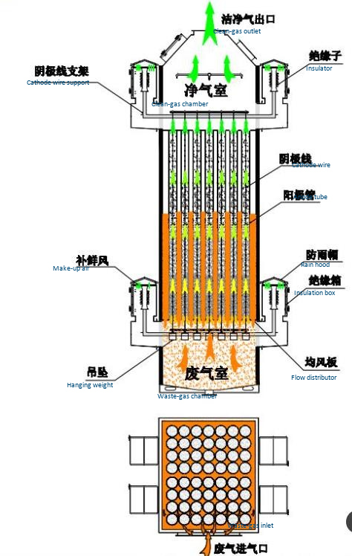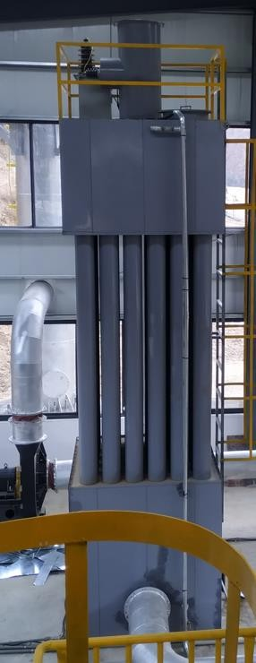

      - Chimney

Carbon steel + nano coating is used for anti-corrosion, with a height of 45 meters to ensure its service life. The chimney design is strictly implemented in accordance with the Standard for Pollution Control on Municipal Solid Waste Incineration (GB18485-2014), and conforms to the operating conditions of the complete equipment. In accordance with the Determination of Particulates and Sampling Methods for Gaseous Pollutants Emitted from Stationary Pollution Sources (GB/T16157-1996), permanent sampling holes are provided, and facilities for sampling and measurement are installed, for use at ~150℃.
Attached: test platform, flue gas analyzer port, drainage port, lightning protection grounding, etc.

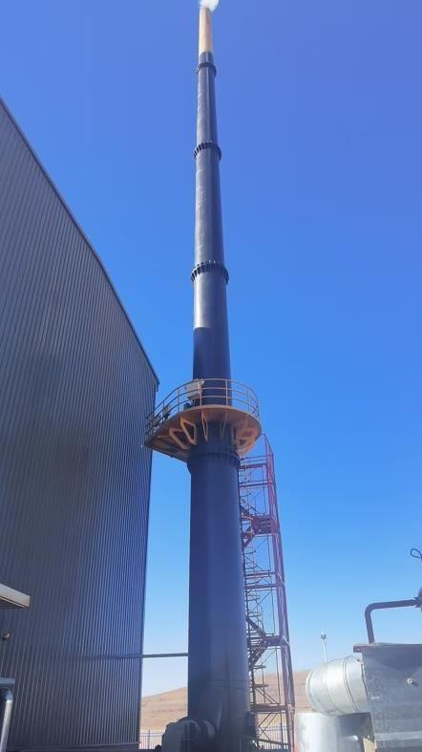

2.2.7 Three-Waste (Bottom Ash, Fly Ash, Leachate)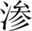 Treatment System

Bottom ash collection and disposal: the ash and slag under the grate fall periodically and automatically, and are discharged into the slag collection hopper via the screw conveyor; the burnt slag falls directly from the tail of the grate into the ash collection hopper, and is discharged directly to the slag room by the water-seal scraper slag discharger. According to test results it is determined to contain no toxic or harmful substances, belonging to non-hazardous waste, and can be sent to brick plants as raw material for comprehensive utilization or safely landfilled;
Fly ash collection and disposal: fly ash is hazardous waste and should undergo permanent solidification treatment. Treatment methods include the cement solidification method, melting solidification method, chemical agent method, etc. Currently the more commonly used is the "cement + chelating agent" stabilization treatment process, in which fly ash, cement, water and chelating agent are mixed in certain proportions. This method is simple and reliable in process and saves investment.
A semi-automatic solidification device can be added on site, or the fly ash can be sent directly to a qualified unit for disposal.
Leachate recovery and treatment system: on the side of the waste pit near the discharge doors, a continuous leachate collection trough is arranged along the entire length, covered with precast slabs on the upper part to isolate the waste. The leachate is collected through the trench into the leachate collection well.
The moisture content of the waste in this project is extremely low; the small amount of leachate can be directly re-sprayed into the furnace for high-temperature harmless disposal.

2.2.8 Central Control System

The design scope of the control system of this project mainly includes: the waste transport and receiving system, conveying system, pyrolysis gasification system, flue gas purification system, flue air system, steam-water system, thermal system, fuel oil system, plant power system, compressed air system, ash and slag system, etc.
In addition to the above systems, it also includes the industrial television monitoring system.

This project uses a PLC control system including electrical control cabinets, industrial controllers and other devices. The PLC program automatically adjusts the start/stop and variable-frequency speed regulation of motors to achieve stable control of the combustion temperature, oxygen supply, feed weight and time. The operating conditions and related process parameters of the whole system can be displayed on the computer screen for timely control. The control cabinet has two control modes: interlocked and individual. Alarms are provided for equipment faults, air supply pressure, etc., and fault signals are sent to the central control room. "Interlocked" operation: through the PLC, each electric actuator can be interlock-controlled or manually controlled individually; "individual" operation: the PLC cabinet can operate independently in "manual" or "automatic" mode.

2.3 Equipment List

5T/D Complete Waste Pyrolysis Gasification Treatment Plant
No. | Equipment No. | Item  Name | Specifications & Technical Data - -  Data | Qty
I | Feeding System
1 | ZT-1-1 | Feed hopper |  | 1
2 | ZT-1-2 | Traveling grab crane |  | 1
3 | ZT-1-3 | Hydraulic pusher system |  | 1
II | Pyrolysis Gasification System
1 | ZT-2-1 | Chain grate pyrolysis gasifier (including  secondary combustion chamber) | Processing capacity 5 tons/day, flue gas outlet temperature above 900℃ | 1

2 | ZT-2-2 | Thermal insulation |  | 1
3 | ZT-2-3 | Blower | Air volume: 3000Nm3/h Air pressure: 4500pa  5.5KW | 2
4 | ZT-2-4 | Combustion-support system (including burner,  oil tank) | Ignition burner 0.75kw, auxiliary burner 2.6  pump 0.37, with storage tank | 1
5 | ZT-2-5 | Slag removal system | 7.5Kw | 1
III | Flue Gas Treatment System
1 | ZT-3-1 | SNCR denitration unit | Including injection pump and storage tank; efficiency 20-50%; including injection pump, solution preparation and storage tank 2m3, concentration 5%-10%; designed flue gas volume 3000Nm3/h, calculated  as NO 400mg/Nm3 | 1
2 | ZT-3-2 | Air-cooled heat exchanger | Inlet flue gas temperature 900℃, flue gas volume  3000Nm3/h, outlet flue gas temperature 750℃ | 1
3 | ZT-3-3 | Water-cooled heat exchanger | Inlet flue gas temperature 750,℃, outlet flue gas temperature 400℃ | 1
4 | ZT-3-4 | Cooling tower | With water pump, circulating water 30T/h | 1
5 | ZT-3-5 | Semi-dry quench tower | Agitator 1.5KW, quench pump 0.55KW, quench ash discharge valve 1.5KW, including one complete supporting lime slurry  preparation system | 1
6 | ZT-3-6 | Dry Flue Gas Treatment Device | Activated carbon and quicklime are mixed, proportioned and sprayed evenly into the  flue duct, star-type regulating valve | 1
7 | ZT-3-7 | Bag Filter | Star-type discharge valve 0.55kw * 2, considering pulse  1.5KW; filter dust removal efficiency 99.90%, design air volume 3500Nm3/h, filtration area approx. 144m3  Outlet dust concentration 30mg/Nm3 | 1
8 | ZT-3-8 | Electrostatic Precipitator | 10KW | 1
9 | ZT-3-9 | Induced draft fan | Impeller material: SUS304 (anti-corrosion); temperature resistance: 200℃, design air volume 4000Nm3/h, pressure 5000PA  22KW with frequency converter | 1
10 | ZT-3-10 | Chimney | 45m | 1
IV | Electrical control, instruments and other accessories and spare parts
1 | ZT-4-1 | PLC electrical control system | Fully automatic control system | 1

2 | ZT-4-2 | Wiring and circuits | Including accessories | 1
3 | ZT-4-3 | Air compressor | 11kw | 1
4 | ZT-4-4 | Flue ducts and water pipes | Flue pipes, valves, elbows, including insulation and refractory  materials, etc. | 1
5 | ZT-4-5 | Valves and fittings | Fan inlet joints, inlet reducers, etc. | 1
6 | ZT-4-6 | Platforms, stairs and handrails |  | 1
7 | ZT-4-7 | Pipeline insulation |  | 1
8 | ZT-4-8 | Topcoat |  | 1

The complete standard configuration of the 5T/D equipment is quoted at RMB 8.60 million (tax-inclusive market price), excluding transportation, installation and commissioning.

2.4 Treatment Performance

Flue gas treatment of this technology: semi-dry + dry deacidification. After high-temperature decomposition and three-stage cooling, the flue gas enters the bag filter for dust removal, the deacidification device removes acidic gases, and after activated carbon adsorption it is discharged in compliance with standards. The slag is mechanically squeezed by the grate and magnetically separated by the magnetic separator, and discharged out of the furnace periodically. The secondary pollutants in the application of this technology are mainly dioxins, nitrogen oxides, carbon monoxide, sulfur dioxide, hydrogen chloride, mercury and its compounds in the flue gas. Their main control measures, hazards and treatment effects are shown in the table below.

Secondary Pollution and Control Table (mg/m3)

Secondary Pollutant | Test Result | Hazard | Control Measures | Treatment Effect
 |  |  | Combined use of activated carbon adsorption, bag filter, etc. | Stable compliant discharge
Particulate matter | 8.93 |  | Process interception of particulate matter. The intercepted fly ash is  solidified and stabilized and disposed of as hazardous waste in accordance
 |  | direct | with hazardous waste management requirements.
Carbon monoxide | 50 | pollutes the atmosphere and indirectly affects | Control the secondary combustion chamber temperature and flue gas residence time to  thoroughly control its generation.
Nitrogen oxides | 92 | water and soil
Sulfur dioxide | ND | environments. | Semi-dry deacidification
Hydrogen chloride | 1.22
Mercury and its compounds | ND |  | Activated carbon adsorption + bag filter
Cadmium, thallium and their compounds | ND |  | Activated carbon adsorption + bag filter

Antimony, arsenic, lead, chromium, cobalt, copper, manganese, nickel and  their compounds | 0.05 |  | Activated carbon adsorption + bag filter
Dioxins (ng  TEQ/m3) | 0.0063 | Carcinogenic | Control the secondary combustion chamber temperature and flue gas residence time to  Thoroughly decompose it; flue gas quenching measures are adopted to prevent the secondary synthesis of dioxins. | Far below the national standard

2.5 Main Pollution Prevention and Control Measures and Mechanisms

2.5.1 Dioxin Removal Process

First, the temperature in the primary combustion chamber is controlled at 600℃ to 800℃, and the oxygen supply is controlled to maintain a reducing atmosphere, so that copper, aluminum and iron will not be oxidized, no CuO is produced, and no CuCl2 is generated or present — thus there is no catalyst for dioxin re-synthesis (CuO, CuCl2 and other compounds). Without the catalysis of CuCl2 and carbon atoms, the synthesis of dioxins becomes impossible.
Second, through 3T+E combustion control, the unburned gas containing dioxins is completely burned, suppressing dioxin generation to the lowest level.
Third, the heat exchanger and the semi-dry quench tower are used to quench the flue gas, rapidly cooling it to 200℃, avoiding the dioxin re-formation temperature range.
Finally, activated carbon powder is sprayed through the dry reaction device to adsorb dioxins. After the flue gas enters the bag filter, the unreacted activated carbon continues to adsorb harmful substances, and solid particulates and solid-phase dioxins are efficiently intercepted by the bag filter.
2.5.2 NOX Removal Process

The chemical reaction equations are as follows:

Urea NH2CONH2+2NO+1/2O2=2N2+CO2+2H2O

Or ammonia water 4NH3+4NO+O2=4N2+6H2O

Through the above reactions, nitrogen, water and carbon dioxide are finally formed.

2.5.3 Deacidification Process

Through the dry reaction device, hydrated lime powder is sprayed into the Venturi duct to react chemically with the flue gas, achieving further deacidification. The basic chemical reaction equations are as follows:
SO3+Ca(OH)2=CaSO4+H2O SO2+Ca(OH)2=CaSO3+H2O 2HCl+Ca(OH)2= CaCl2+2H2O
2HF+Ca(OH)2=CaF2+2H2O

The hydrated lime spraying feeding device is used in the flue gas purification treatment system. The absorbent device is arranged between the quench tower and the bag filter. Through the absorbent mixer on the flue, the absorbent is evenly mixed into the flue gas and deposited on the bag walls of the bag filter, forming a filter cake, so that the deposited absorbent continues to absorb the gaseous pollutants in the flue gas.

Chapter 3 Engineering Design

Principles of Overall Scheme Design

The general layout has clear zoning and convenient management; pedestrian routes and vehicle routes are separated, transport access and exit are smooth, roads within the plant are unobstructed forming a ring route, meeting fire protection requirements; the flue gas emission of the main plant building is downwind, and offices and other living areas are upwind; full greening beautifies the environment, leaving no bare ground as far as possible.

General Layout

Project Site Planning Concepts Based on Layout and Site Selection Principles

      - Functional Zoning
According to the process flow, functions and wind direction, the buildings and structures in the plant are divided into three functional zones:

Office zone: including offices and parking lot. This is a relatively clean zone in the plant with high environmental requirements; it should be arranged away from various pollution sources and located on the upwind side of the prevailing wind direction.
Main production zone: including the waste storage pit, ash and slag collection area and resource recovery area. The main plant building is the main building of the plant; on the premise of meeting various protection distances, it can be close to the auxiliary production zones and the office building.
Heat supply station: including water pump house, cooling tower, water treatment device and clear water pool.

To facilitate the work of management personnel and external business contacts, the comprehensive office building is arranged near the plant gate and on the upwind side of the prevailing wind direction.
The open space between the office building and the main plant building is centrally arranged with greening as a protective isolation belt.

      - Main Items

- Main plant building of the waste pyrolysis gasification treatment station, including the following:

- 1 set of 5T/D pyrolysis gasifier and its supporting equipment;

- Waste transport tipping hall and pretreatment waste storage pit;

- Leachate collection area;

- Slag removal and ash collection area;

- Control and monitoring room;

- Auxiliary rooms

- Office area, mainly used for office, technology, exhibition center, reception room, meetings and shift dormitories, etc.

- Heat supply station, collecting pool, etc., used for heat supply to surrounding residents and enterprises/institutions, and for storing the plant-wide production and fire-fighting water.
- Preliminary Design Drawings

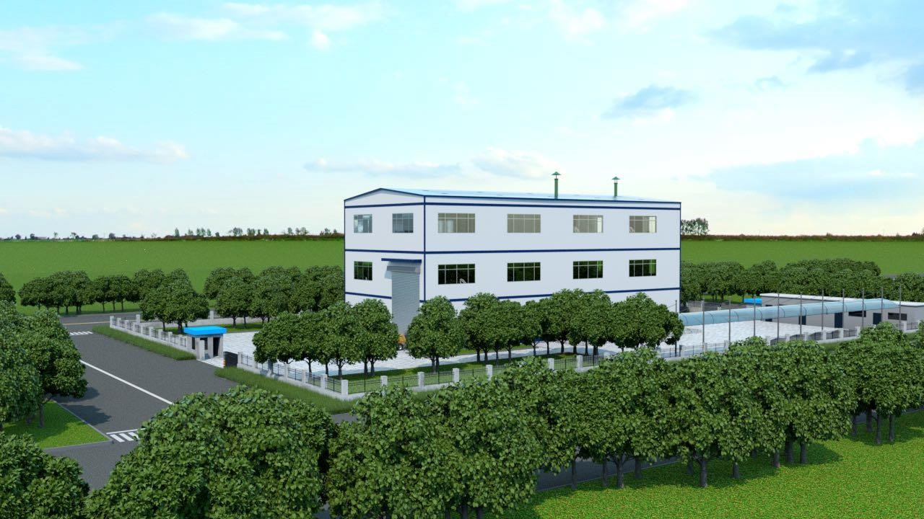

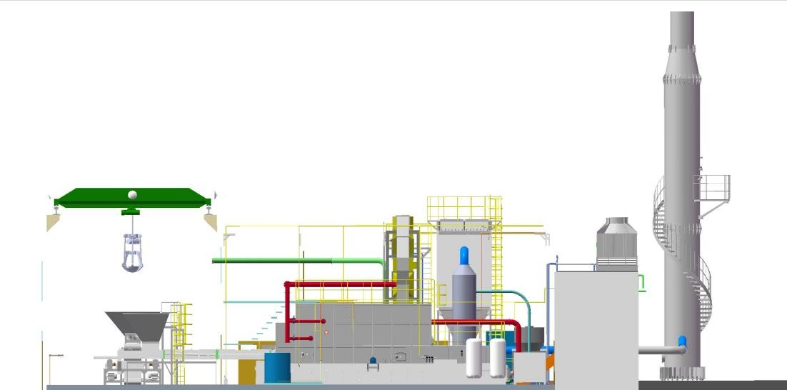
Complete equipment with a processing capacity of 5 tons/day, ordinary layout, main plant building area approx. 800m2. Height design: waste room 12m, main equipment plant 10m, auxiliary building 3m;


Chapter 4 Project Implementation and Schedule

The project implements the owner responsibility system. The owner entrusts the design, raises construction funds, organizes the bidding and tendering of the project, complies with the relevant requirements of the contract law, and organizes construction and production. The project duration is expected to be 120 days.

4-1 Installation and Commissioning Schedule

 | Timeline (Day **)
1 | Equipment design and fabrication | 1—60
2 | Equipment shipment |  | 61-67
3 | Equipment installation
3.1 | First installation of equipment |  |  | 68-88
3.2 | Second installation of equipment |  |  |  | 89-96
4 | Commissioning (training) |  |  |  |  | 97-104
5 | Furnace curing (training) |  |  |  |  |  | 105-113
6 | Trial operation (training) |  |  |  |  |  |  | 113-120

Chapter 5 Operating Cost Estimation
The design scale of this project is 5t/d. The unit operating cost of the project includes electricity fees, chemical fees, staff wages and maintenance management costs, as well as the calculated operating cost per ton of waste. See the table below; the specific calculation process is as follows:
- Electricity cost: the installed power is about 100kwh; some equipment runs continuously and some intermittently, converted into a daily consumption of 1080kw. The average industrial electricity price in Bangladesh is about 0.56 RMB/kWh, so the electricity cost is about 605 RMB/day.
- Chemical fees: including caustic soda, urea, activated carbon, quicklime, deodorizing liquid, water, etc. Considering that prices are lower than in China, the total daily consumption is estimated at about 100 RMB.
Total plant workforce: 7 persons (calculated at the Bangladesh average wage of 800 RMB/month)

No. | Position | Configuration | Shift system | Headcount
1 | Mechanical and electrical maintenance worker | 1 | 1 | 1
2 | Central control room operation and monitoring | 1 | 3 | 3
3 | Chemical preparation, slag discharge and patrol inspection | 1 | 3 | 3
 | Total |  |  | 7
③ Staff wages: 7 persons at (800 RMB/(person·month)) *12/365 = 184 RMB/day.
- Equipment maintenance cost: annual maintenance cost is 10,000 RMB, daily expenditure 27 RMB.
- Solid waste treatment cost: the bottom ash of this project can be recycled for brick making, generating additional value, which is not calculated here.

Item | Operating cost (RMB/day) | Operating cost (RMB/ton)
Electricity fee | 605 | 121
Chemical fees | 100 | 20
Worker wages | 184 | 36.8
Equipment maintenance cost | 27 | 5.4
Total | 916 | 181.2

Project Operating Cost Table
The above is only the estimated operating cost (the actual operating cost shall be adjusted according to the local labor, electricity price and environmental protection requirements, etc.).

Chapter 6 Technical Features

Key Technologies

- The mechanical movement of the grate realizes the physical and chemical changes of the waste at each stage, promoting waste combustion

- The waste in the furnace burns stably and relatively completely, with little fly ash and low loss on ignition

- Material on the grate burns in layers and zones

After entering the furnace, the material gradually moves backward with the grate. In the front part of the grate is the preheating and drying zone of the new material; then the material begins to pyrolyze and gasify (i.e. the release of waste volatiles), then ignites and enters the combustion zone; in the middle and rear part is the coke combustion zone, where oxidation and reduction reactions proceed simultaneously, releasing a large amount of heat. At the tail of the grate is the ash burnout zone, where the remaining residual coke in the ash is continuously burned and completely burnt out.
- Staged and controllable air supply on the grate

In the preheating and drying zone and the pyrolysis gasification zone (i.e. the release of waste volatiles), not much air is needed, while in the coke combustion zone sufficient air must be guaranteed to meet the oxygen required for combustion. To adapt to the different air volume requirements of each section of the grate combustion, the area under the grate is divided into several air chambers for staged air supply (primary air). Each air chamber is tightly sealed to prevent short circuits that would lose the regulating function. To make the air volume distribution uniform across the entire grate width, air is supplied from both sides. The air volume of each air chamber is regulated separately by an individual damper. The opening of each damper shall be determined through repeated operating tests according to the characteristics of different fuels to find the optimal opening position for material combustion. When the material characteristics change, it can be readjusted. This technology adopts staged air supply with adjustable air supply, avoiding the drawback of excess air at both the front and rear ends of the furnace and insufficient air in the middle, thereby achieving the best operating effect.

