* create the *monitoring* namespace:

$ kubectl apply -f namespace.yaml

* create the service account and cluster role with the permission of getting cluster info for prometheus.

$ kubectl apply -f prometheus-rbac.yaml

Note: If you were failed to create cluster role, create a cluster role binding to yourself first. (Email is **case-sensitive**)

$ kubectl create clusterrolebinding cluster-admin-binding --clusterrole=cluster-admin --user=${YOUR_EMAIL_ADDRESS}

* create the config for prometheus to collect data from Kubernetes

$ kubectl apply -f prometheus-config.yaml

* create the deployment of prometheus

$ kubectl apply -f prometheus-deploy.yaml

* create the prometheus service

$ kubectl -f apply prometheus-svc.yaml

* create the grafana deployment

$ kubectl apply -f grafana.yaml

* expose grafana deployment with kubectl expose

$ kubectl expose deployment grafana --type=LoadBalancer --namespace=monitoring

kubectl expose will create the service of LoadBalancer type for you, and if you run on GKE, Amazon EKS or other cloud providers, they will assign a public IP for this service. Get the IP via $ kubectl get svc -n monitoring

NAME TYPE CLUSTER-IP EXTERNAL-IP   
grafana LoadBalancer 10.7.245.47 ***{IP}***

Now you can access Grafana via http://*{IP}*:3000/

* create node-exporter daemon set to export node information

kubectl apply -f node-exporter.yaml

* create *kube-state-metrics* deployment to collect metrics about the cluster

kubectl apply -f state-metrics-deploy.yaml

* create the service account and cluster role with the permission of getting cluster info for state-metrics.

kubectl apply -f state-metrics-rbac.yaml

Now, configure your cluster setting on Grafana.

* Enable the app at http://*{IP}*:3000/plugins/grafana-kubernetes-app/edit
* Add a data source of prometheus type: http://*{IP}*:3000/datasources/new

https://miro.medium.com/max/38/1*GpshLEQrXPPIvo0RrkpxUA.png?q=20

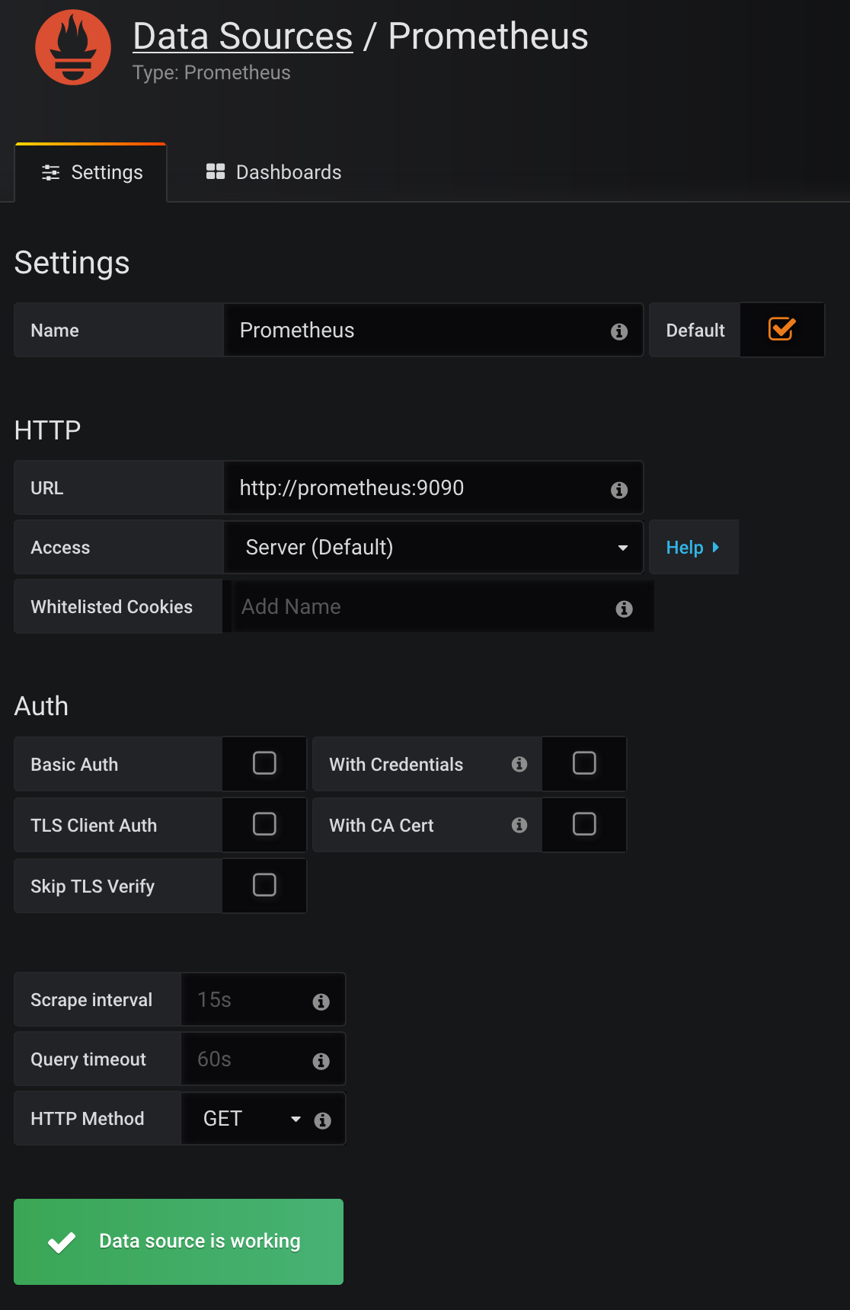

* Add a cluster at http://*{IP}*:3000/plugins/grafana-kubernetes-app/page/cluster-config with username/password and CA certificate.

https://miro.medium.com/max/50/1*KQ5M9-cQKBVlSq04l2WcJw.png?q=20

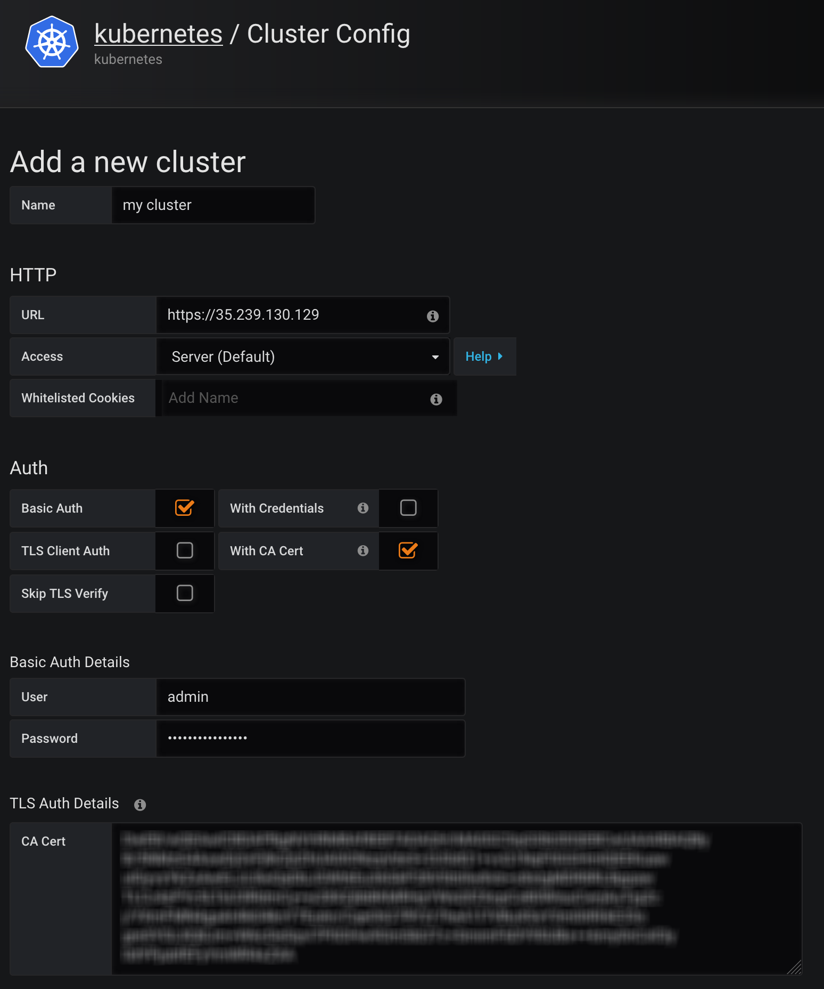

https://miro.medium.com/max/60/1*prKsnv2LBzpK4EKP97gjEQ.png?q=20

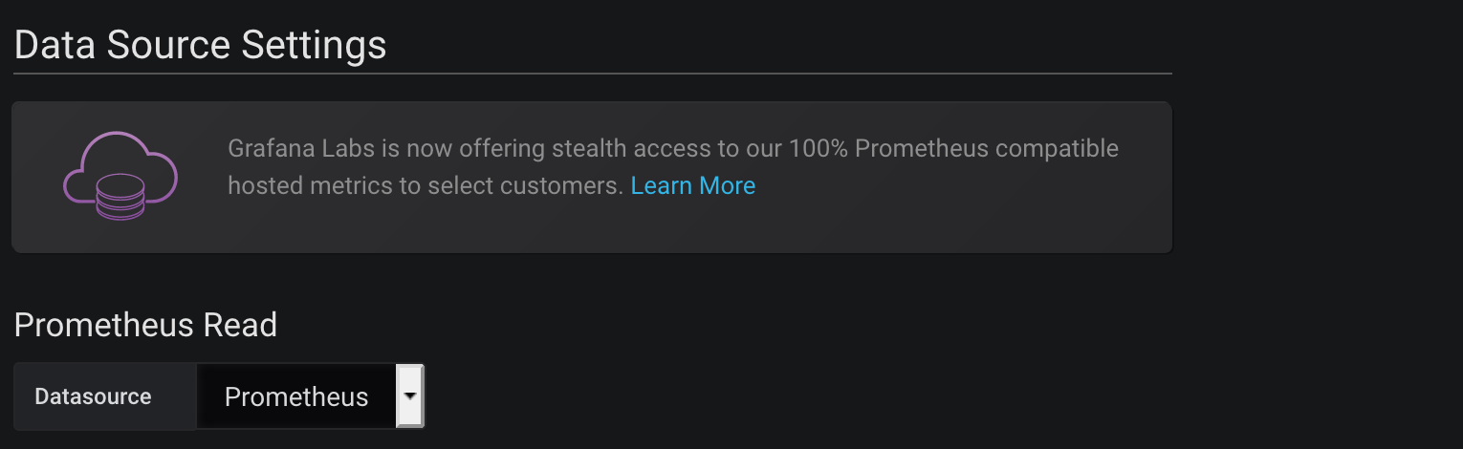

Yeah! Now you finally get the three built-in dashboards working