**WOMEN'S CHRISTIAN COLLEGE, CHENNAI-06.**



**CRUNCH**

**A Project Report**

***Submitted***

**S.AGNES ARUL TRINITA**

**(17BCA04)**

***in Partial fulfillment for the award of degree of***

**BACHELOR OF COMPUTER APPLICATIONS**

Under the guidance of

**Dr.R. Lakshmi devi.,Ph.D.**

**DEPARTMENT OF COMPUTER SCIENCE (BCA)**

**WOMEN'S CHRISTIAN COLLEGE, CHENNAI-06.**

**MARCH-2020.**

**CERTIFICATE**

This is to certify that the project work titled "CRUNCH" is a bonafide work done by **Ms. S.AGNES ARUL TRINITA (17BCA04)** in partial fulfillment of the requirement for the award of the degree of **BACHELOR OF COMPUTER APPLICATIONS** during the academic year **2019-2020.**

**Date External Examiner Internal Guide**

**Submitted for the viva-voce examination held on 20-3-17.**

**ACKNOWLEDGEMENT**

I thank God almighty, the power that guided me throughout the steps that I take in future. I thank him once again for given me such a tremendous facility to work on this project. I extend my deepest gratitude to out esteemed Principal Dr. Lillian I Jasper, for providing the means of attaining our most cherished goal by giving me permission to do the project work. I am proud and privileged to express my sincere gratitude and thanks to Ms. Sylvia Mary D, Head of the department of computer applications, for her consent and had shared the fruit of knowledge by constant guidance and support. My special thanks to my project guide Mrs. Lakshmi Devi who has been a supportive part of the project with her timely help and valuable advice and for her sustained support and encouragement throughout the project. I am also very thankful to our staff members for their encouragement towards our endeavour in making this project successful. Last but not the least, I would like to take this opportunity to thank my family and friends for their support and encouragement.

**TABLE OF CONTENTS**

|  |  |  |
| --- | --- | --- |
| **S.NO** | **CONTENTS** | **PAGE NO** |
| **1** | **INTRODUCTION** |  |
|  | 1.1 PROBLEM DEFINITION |  |
| **2** | **SYSTEM SPECIFICATION** |  |
|  | 2.1 HARDWARE REQUIREMENTS |  |
|  | 2.2 SOFTWARE REQUIREMENTS |  |
|  | 2.3 TECHNICAL PROFILE |  |
| **3** | **SYSTEM DESIGN** |  |
|  | 3.1 DATABASE DESIGN |  |
| **4** | **PROJECT DESCRIPTION** |  |
| **5** | **TESTING AND IMPLEMENTATION** |  |
| **6** | **FUTURE ENHANCEMENTS** |  |
| **7** | **CONCLUSION** |  |
| **8** | **BIBLIOGRAPHY** |  |
| **9** | **APPENDICES** |  |
|  | 9.1 SAMPLE CODE |  |
|  | 9.2 SCREEN SHOTS |  |

**ABSTRACT**

The project Gym management named **“CRUNCH”** is based on a concept of managing gym members and trainer record. The gym management system is solution fitness centres to manage the customers in an easier and more convenient way.

The user has to pass through a login system for using its features. The member can manage their record by giving member name, Address, Gender, Contact details and gym time. The trainer can add new trainer records by fixing their schedule and selecting their Equipments. This requires payment system for choosing equipments for trainers and trainer fee for members. It is a simple web application using c# language.

**INTRODUCTON**

**1.** **INTRODUCTION**

In these modern days, people use computer everywhere and they are very useful and helpful to our daily life. Like computers online websites has a crucial role in daily life. So this website aimed to develop a site based on gymnasium for people who wish to maintain their heath and body fitness regularly.

when people all over the world have become so much concerned about their health and diet but obvious that they continually seek out for gyms. This Gym management project CRUNCH is to provide a system which handles information of the people coming into the gym and maintaining their health care. It is a easy way to use gym and helps to keep record of members and trainers.

The project CRUNCH also allows the members to select the trainer that they prefer and time for their liking. The data from member details, trainer details, and schedule that the trainer will be available are stored in database.

**1.1 PROBLEM DEFINITION**

Any business that does not have a website is missing out on one of the most powerful marketing tools available to them. The main reason that it is important for businesses to have a website is how people are likely to find you. These days most people will go online and research products and companies before they make a purchase. For this reason of dependency on online, we develop a website for a gymnasium in which customer can get all information about the gymnasium and he/she can access or enrol at the gym via online

**SYSTEM**

**SPECIFICATION**

**2. SYSTEM SPECIFICATION**

The hardware and software requirements specification is the most important aspect of the project development. This provides a complete set of requirements including the entire device, databases and all other required programs.

**2.1 HARDWARE REQUIREMENTS**

Minimum RAM : 4.00 GB (1.38 GB usable)

System Type : 64-bit Operation System

Processor : Intel(R) Core(TM) i5-2540M CPU

Monitor : HP EliteBook 8460p

**2.2. SOFTWARE REQUIREMENTS**

* Operating System- Windows 7.
* Front End- ASP.NET C#
* back End- SQL Server 2005.
* IDE- Visual Studio 2008 Professional.

[

**2.3. TECHNICAL PROFILE**

**Overview of ASP.NET**

* ASP.NET is an open source server-side web application framework designed for web development to produce dynamic web pages. It was developed by Microsoft to allow programmers to build dynamic web sites, web applications and web services.

It was first released in January 2002 with version 1.0 of the .Net Framework, and is the successor to Microsoft’s Active Server Pages (ASP) technology.

ASP.Net is built on the Common Language Runtime (CLR), allowing programmers to write ASP.NET code using any supported .NET language. The ASP.NET SOAP extension framework allows ASP.NET components to process SOAP messages.

ASP.NET’s successor is ASP.NET Core. It is a re-implementation of ASP.NET as a modular web framework, together with other frameworks like Entity Framework. The new framework uses the new open-source .NET Compiler Platform and is cross platform. ASP.NET MVC, ASP.NET Web API, and ASP.NET Web Pages have merged into a unified MVC 6.

**INTRODUCTION ABOUT .NET**

**Overview of .Net Framework**

The .NET Framework is a new computing platform that simplifies application development in the highly distributed environment of the Internet. The .NET Framework is designed to fulfill the following objectives:

* To provide a consistent object-oriented programming environment whether object code is stored and executed locally, but Internet-distributed, or executed remotely.
* To provide a code-execution environment that minimizes software deployment and versioning conflicts.
* To provide a code-execution environment that guarantees safe execution of code, including code created by an unknown or semi-trusted third party.
* To provide a code-execution environment that eliminates the performance problems of scripted or interpreted environments.
* To make the developer experience consistent across widely varying types of applications, such as Windows-based applications and Web-based applications.
* To build all the communications on industry standards to ensure that code based on the .NET Framework can integrate with any other code.

The .NET Framework consists of the common language runtime and the .NET Framework class library. The common language runtime is the foundation of the .NET Framework. You can think of the runtime as an agent that manages code at execution time, providing core services such as memory management, thread management, and remoting, while also enforcing strict type safety and other forms of code accuracy that promote security and robustness. In fact, the concept of code management is a fundamental principle of the runtime. Code that targets the runtime is known as managed code, while code that does not target the runtime is known as unmanaged code. The class library is a comprehensive, object-oriented collection of reusable types that you can use to develop applications ranging from traditional command-line or graphical user interface (GUI) applications to applications based on the latest innovations provided by ASP.NET, such as Web Forms and XML Web services.

ASP.NET hosts the runtime to provide a scalable, server-side environment for managed code. ASP.NET works directly with the runtime to enable ASP.NET applications and XML Web services, both of which are discussed later in this topic.

Internet Explorer is an example of an unmanaged application that hosts the runtime. Using Internet Explorer to host the runtime enables you to embed managed components or Windows Forms controls in HTML documents. Hosting the runtime in this way makes managed mobile code possible, but with significant improvements that only managed code can offer, such as semi-trusted execution and isolated file storage.

**Features of the Common Language Runtime**

The common language runtime manages memory, thread execution, code execution, code safety verification, compilation, and other system services. These features are intrinsic to the managed code that runs on the common language runtime.

With regards to security, managed components are awarded varying degrees of trust, depending on a number of factors that include their origin. This means that a managed component might or might not be able to perform file-access operations, registry-access operations, or other sensitive functions, even if it is being used in the same active application.

The runtime enforces code access security. For example, users can trust that an executable embedded in a Web page can play an animation on screen or sing a song, but cannot access their personal data, file system, or network. The security features of the runtime thus enable legitimate Internet-deployed software to be exceptionally featuring rich.

The runtime also enforces code robustness by implementing a strict type-and-code-verification infrastructure called the common type system (CTS). The CTS ensures that all managed code is self-describing. The various Microsoft and third-party language compilers generate managed code that conforms to the CTS. This means that managed code can consume other managed types and instances, while strictly enforcing type fidelity and type safety.

In addition, the managed environment of the runtime eliminates many common software issues. The runtime automatically handles object layout and manages references to objects, releasing them when they are no longer being used. This automatic memory management resolves the two most common application errors, memory leaks and invalid memory references.

The runtime also accelerates developer productivity. For example, programmers can write applications in their development language of choice, in other languages by other developers. Any compiler vendor who chooses to target the runtime can do so. Language compilers that target the .Net Framework make the features of the .Net Framework available to existing code written in that language, greatly easing the migration process for existing applications.

The runtime is designed to enhance performance. Although the common language runtime provides many standard runtime services, managed code is never interpreted. A feature called just-in-time (JIT) compiling enables all managed code to run in the native machine language of the system on which it is executing. Meanwhile, the memory manager removes the possibilities of fragmented memory and increases memory locality-of-reference to further increase performance.

Finally, the runtime can be hosted by high-performance, server-side applications, such as Microsoft SQL Server and internet Information Services (IIS). This infrastructure enables you to use managed code to write your business logic, while still enjoying the superior performance of the industry’s best enterprise servers that support runtime hosting.

**SQL SERVER 2005**

Microsoft SQL Server is a relational database management system developed by Microsoft. As a database, it is just a software product whose primary function is to store and retrieve data as requested by the other software applications, be it those on the same computer or those running on another computer across a network.

There are at least a dozen different editions of Microsoft SQL Server at different audiences and for different workloads that store and retrieve data on the same computer, to millions of users and computer that access huge amounts of data from the internet at the same time.

**DATA RETREIVAL**

Data Retrieval in database management, involves extracting the wanted data from a database. The two primary forms of the retrieved data are reports and queries. In order to retrieve the desired data the user present a set of criteria by a query. Then the Database Management System (DBMS), software for managing databases, selects the demanded data from the database. The retrieved data may be stored in a file, printed, or viewed on the screen. A query language, such as Structured Query Language (SQL), is used to prepare the queries. SQL is an American National Standards Institute (ANSI) standardized query language developed specifically to write database queries. Each DBMS may have its own language, but most relational DBMS also support SQL.

**RDBMS**

Edgar.F.Codd invented the terminology ‘relational database’ at IBM**.**A relational database refers to a [database](https://techterms.com/definition/database) that stores data in a structured format, using [rows](https://techterms.com/definition/row) and [columns](https://techterms.com/definition/column). This makes it easy to locate and access specific values within the database. It is "relational" because the values within each [table](https://techterms.com/definition/table) are related to each other. Tables may also be related to other tables. The relational structure makes it possible to run [queries](https://techterms.com/definition/query) across multiple tables at once.

While a relational database describes the type of database an RDMBS manages, the RDBMS refers to the database [program](https://techterms.com/definition/program) itself. It is the software that executes queries on the data, including adding, updating, and searching for values. An RDBMS may also provide a visual representation of the data. For example, it may display data in a tables like a [spreadsheet](https://techterms.com/definition/spreadsheet), allowing you to view and even edit individual values in the table. Some RDMBS programs allow you to create forms that can streamline entering, editing, and deleting data.

**ADVANTAGES OF RDBMS**

* Easy to use.
* Secured in nature.
* Data manipulation can be done.
* Limits redundancy and replication of the data.
* Better data integrity.
* Offers logical database independants. It provides better backup and recovery procedures.
* Provides multiple interfaces.
* Multiple users can access the database which is not possible in DBMS.

**DISADVANTAGES OF RDBMS**

* Software is expensive.
* Complex software refers to expensive hardware and hence increases overall cost to avail the RDBMS service.
* It requires skilled human resources to implement.
* Certain applications are slow in processing.
* It is difficult to recover the lost data.

**PRIMARY KEY**

A primary key is a field in a table which uniquely identifies each row/record in a database table. Primary keys must contain unique values. A primary key column cannot have NULL values. A table can have only one primary key, which may consist of single or multiple fields. If a table has a primary key defined on any field(s), then you cannot have two records having the same value of that field(s).

* It must contain a unique value for each row of data.
* It cannot contain null values.

**FOREIGN KEY**

A foreign key is a key used to link two tables together. This is sometimes also called as a referencing key. A Foreign Key is a column or a combination of columns whose values match a Primary Key in a different table. The relationship between 2 tables matches the Primary Key in one of the tables with a Foreign Key in the second table. If a table has a primary key defined on any field(s), then you cannot have two records having the same value of that field(s).

**DATA ABSTRACTION**

Data abstraction is the reduction of a particular body of data to a simplified representation of the whole. [Abstraction](https://whatis.techtarget.com/definition/abstraction), in general, is the process of taking away or removing characteristics from something in order to reduce it to a set of essential characteristics. As in abstract art, the representation is likely to be one potential abstraction of a number of possibilities. A [database abstraction layer](https://whatis.techtarget.com/definition/database-abstraction-layer), for example, is one of a number of such possibilities.

Data abstraction is usually the first step in database design. A complete [database](https://searchsqlserver.techtarget.com/definition/database) is much too complex a system to be developed without first creating a simplified framework. Data abstraction makes it possible for the developer to start from essential elements -- data abstractions -- and incrementally add data detail to create the final system.

**SQL TABLES**

Tables are database objects that contain all the data in a database. In tables, data is logically organized in a row-and-column format similar to a spreadsheet. Each row represents a unique record, and each column represents a field in the record.

**SYSTEM DESIGN**

**3. SYSTEM DESIGN**

System design is the process of defining the architecture, modules, interfaces, and data for a system to satisfy specified requirements. System design could be seen as the application of system theory to product development

### Architectural design

The architectural design of a system emphasizes the design of the system architecture that describes the structure, behaviour and more views of that system and analysis.

### Logical design

The logical design of a system pertains to an abstract representation of the data flows, inputs and outputs of the system. This is often conducted via modelling, using an over-abstract (and sometimes graphical) model of the actual system. In the context of systems, designs are include.

### Physical design

The physical design relates to the actual input and output processes of the system. This is explained in terms of how data is input into a system, how it is verified, how it is processed, and how it is displayed.

**DATABASE DESIGN**

Database design is the process of producing a detailed data model of a database. This data model contains all the needed logical and physical design choices and physical storage parameters needed to generate a design in a data definition language, which can be used to create a database. A fully attributed data model contains detailed attributes for each entity.

The term database design can be used to describe many different parts of the design of an overall database system. Principally, and most correctly, it can be thought of as the logical design of the base data structures used to store the data. In the relational model, these are the tables and views. In an object classes and named relationships. However, the term database design could also be used to apply to the overall process of designing, not just the base data structures, but also the forms and queries used as part of the overall database application within database management system(DBMS).

**TABLE NAME : JOIN IN CRUNCH**

|  |  |  |  |
| --- | --- | --- | --- |
| **FIELD NAME** | **DATA TYPE** | **CONSTRAINT** |  |
| username | Int | PRIMARY KEY |  |
| password | Date | NOT NULL |  |
| Email | Varchar(50) | NOT NULL |  |
| phone | Varchar(20) | NOT NULL |  |
| Gender | Varchar(10) | NOT NULL |  |
| address | Varchar(10) | NOT NULL |  |
| bmi | Float | NOT NULL |  |
| Dob | Varchar(20) | NOT NULL |  |

**TABLE NAME : TRAINER SIGNUP**

|  |  |  |
| --- | --- | --- |
| **FIELD NAME** | **DATA TYPE** | **CONSTRAINT** |
| username | Int | PRIMARY KEY |
| password | Date | NOT NULL |
| Email | Varchar(50) | NOT NULL |
| phone | Varchar(20) | NOT NULL |
| Gender | Varchar(10) | NOT NULL |
| address | Varchar(10) | NOT NULL |
| injuries | Varchar(10) | NOT NULL |
| health | Varchar(10) | NOT NULL |

**TABLE NAME : SCHEDULE**

|  |  |  |
| --- | --- | --- |
| **FIELD NAME** | **DATA TYPE** | **CONSTRAINT** |
| Time | Int | NOT NULL |
| Date | Date | NOT NULL |

**PROJECT**

**DESCRIPTION**

**4. PROJECT DESCRIPTION**

This project “CRUNCH” is for those who run a gym business. The Gym Management requires a system that will handle all the necessary and minute details easily and proper database security accordingly to the user. They requires software, which will store data about members, employees, products, payroll, receipts of members & all transactions that occur in Gym.

* The main objective of the project is to design and develop a user friendly efficient computerized Gym Management System.
* An accurate system without any data redundancy.
* Secured data storage for Authority end.
* Secure the user ends data by providing each user’s own personal credentials.
* A flexible system which can maneuver the customer-staff relationship in an effective manner.
* To provide better graphical user interface.
* Computerization can be helpful as means of saving time & money.

**HOME PAGE**

The user can view the details of CRUNCH in the home page. This page also consists of log in and sign up module for members and trainers. This page has been created to facilitate the user to register for joining the crunch. Once the user has been registered, the user can be logged in using the username and password. The same goes for trainer.

**SELECTING TRAINER**

The member can select the trainer they prefer by choosing trainer in the list. After selecting the trainer the details of trainer of will be displayed below with the days and time that they would be available and you can pay for trainer that you prefer by clicking trainer fee.

**SCHEDULE PAGE**

After the trainer has logged in he/she can select the schedule in terms of days and time that are required.

**EQUIPMENT PAGE**

The Equipment page has the information about the equipments that the trainer be able to train the members. They can select the Equipment by choosing whether they can train for loosing weight or gaining weight. And can also be able to pay for Equipment they prefer.

**HITZONE**

The Hitzone page has the information about available classes like High Intensity Workout training, Hit workout classes like PunchHit, StrongHit, ExtremeHit

**TRAINING**

The Training page has the information about what kind of training people would choose. There is One-on wonderful Training where trainers use functional training equipments, and there is Personal training where trainers are certified professionals and provide limitless motivation for everyone.

**PAYMENT DETAILS**

The payment details page has the information about the payments required for trainer and the equipments that they have selected.

**ABOUT**

The About page has the information about the “No judgement” mantra and has the information about Crunch Family

**TESTING & IMPLEMENTATION**

**5. TESTING AND IMPLEMENTATION**

**TESTING**

Testing should be done through the implementation process. Even before and application is installed; it makes sense to verify that the basic platform is capable of achieving its design capabilities. System testing is a critical process. Testing is a process of executing a program with the explicit intension of finding errors that is making the program to fail. This helps in finding the bottle neck in the system. Executing a program in a stimulated environment performs testing. The feedback from testing phase generally produces changes in the software to deal with errors and failures that are uncovered.

**TESTCASES**

* Black Box Testing
* White Box Testing
* Integration Testing
* System Testing
* Unit Testing

**BLACK BOX TESTING**

In black box testing or functional testing test cases are decided. Test cases are decided on the basis of requirements or specifications of the program or module.Black box testing is done in the project to remove errors:

* Incorrect or missing function.
* Interface errors.
* Errors in data structure or external database access.
* Behavioural or performance error.

**WHITE BOX TESTING**

The White box testing or structural testing performs close operation of procedural details. They test the software logical path by having test cases exercising specific sets of condition and loops.

White box testing is done in the project to remove the errors:

* All modules path has been exercised at least once.
* Exercised on logical decisions.
* Executed all loops at their boundaries and within their operational bounds.
* Exercised internal data structure to ensure their validity.

**INTEGRATION TESTING**

This testing is done to tackle problems of interface that is putting all interfaces together. When the separate modules are put together in an integrated manner, this testing is performed. This testing is systematic technique. This technique is performed to check the data should not be lost across an interface.

**SYSTEM TESTING**

System testing is done when the entire system has been fully integrated. The purpose of the system testing is to test how the different modules interact with each other and whether the system provides the functionality that was expected.

Software testing is an investigation conducted to provide stakeholders with information about the quality of the product or service under test. Software testing also provides an objective, independent view of the software to allow the business to appreciate and understand the risks of software implementation.

* Meets the business and technical requirements that guided its design and development.
* Works as expected and
* Can be implemented with the same characteristics.

**UNIT TESTING**

It focuses on verification efforts of the smallest grid of software designing that it is a software component or module is tested. This testing is done at the coding phase. This testing uses a procedural design as guide to test major control path and uncovers errors within the module boundary.

Following test were performed during unit test:

* **MODULE INTERFACE TEST:** Module interface was tested to ensure information flow in and out of the program unit.
* **LOCAL DATA STRUCTURE TESTING:** Local data structure was tested to make surely that data store temporarily maintained their integrity during all steps in algorithm execution.
* **BOUNDARY CONDITION TESTING:** Boundary conditions were tested to make sure that the modules operate properly at boundaries.
* **INDEPENDENT PATH TESTING:** All independent paths through control structure were checked to make sure that all statements in a module has been executed.
* **ERROR HANDLING PATH TEST:** This is performed to handle exception.

**FUTURE ENHANCEMENTS**

**6.FUTURE ENHANCEMENTS**

To cater the requirements of the future enhancement of the site, necessary provision is made in the project such as any other unforeseen updating. So the user can access the information by editing or updating their details.

The technology is on the improvement trend from time to time. Bearing this in mind, the members can able to buy products for their health that they prefer in this website. They can also be able to choose the best trainer and time for their liking.

**7.CONCLUSION**

Therefore, briefly speaking about the development of the project, I conclude my project here saying that is not easy to develop a project until the developer has understood the process very well. The person should have sound knowledge about the software he/she is going to use to develop the application.

A website has been developed and tested with sample data. It can be observed that all the information required can be obtained easily with accuracy. The users with minimum knowledge of computers can easily understand. Various validation techniques are user to implement accuracy of data in all format of input. The user gets accurate and timely information from the project.

The system works efficiently as expected. This package has been designed user friendly. Performances of all activities are successful as expected and it also generated desired output. Thus the project has attained its goal of providing service to the student’s application.

**BIBLIOGRAPHY**

**8. BIBLIOGRAPHY**

**BOOK REFERENCES:**

* Beginning ASP.NET 4 in C# by ImarSpaanjars
* The Complete reference C# 4.0, Herbert Schildit
* C# 5.0 in a Nutshell: The Definitive Reference
* Database Concepts and Systems, Ivan Bayross, 3rd edition

**WEB REFERENCES:**

* [www.codeproject.com](http://www.codeproject.com)
* [www.aspdonet-suresh.com](http://www.aspdonet-suresh.com)
* [www.studentproject.com](http://www.studentproject.com)

**APPENDICES**

**9.APPENDICES**

**9.1 Sample Code**

**HOME PAGE:**

<%@ Page Language="C#" AutoEventWireup="true" CodeBehind="HOME.aspx.cs" Inherits="crunch._Default" %>

<!DOCTYPE html PUBLIC "-//W3C//DTD XHTML 1.0 Transitional//EN" "http://www.w3.org/TR/xhtml1/DTD/xhtml1-transitional.dtd">

<html xmlns="http://www.w3.org/1999/xhtml">

<head runat="server">

<title></title>

</head>

<body>

<form id="form1" runat="server">

<div style="width: 1283px; height: 155px;">

<br />

<asp:Label ID="Label1" runat="server" Font-Bold="True" Font-Italic="True"

Font-Names="Bauhaus 93" Font-Size="XX-Large" ForeColor="#666666"

Text="CRUNCH" BackColor="Silver"></asp:Label>

<asp:HyperLink

ID="HyperLink1" runat="server"

Font-Bold="True" Font-Names="Impact" Font-Size="Large"

ForeColor="#666666" NavigateUrl="~/JOIN IN CRUNCH.aspx" BackColor="White">JOIN IN CRUNCH</asp:HyperLink>

<asp:HyperLink

ID="HyperLink2" runat="server"

Font-Bold="True" Font-Names="Impact" Font-Size="Large"

ForeColor="#666666" Width="153px" BackColor="White" Height="21px"

style="margin-left: 0px; margin-bottom: 7px;"

NavigateUrl="~/MEMBER LOGIN.aspx">MEMBER LOGIN</asp:HyperLink>

<asp:HyperLink

ID="HyperLink7" runat="server" Font-Bold="True"

Font-Names="Impact" Font-Size="Large" ForeColor="#666666"

NavigateUrl="~/TRAINER SIGNUP.aspx">TRAINER SIGNUP</asp:HyperLink>

<asp:HyperLink ID="HyperLink8"

runat="server" Font-Bold="True" Font-Names="Impact" Font-Size="Large"

ForeColor="#666666" NavigateUrl="~/LOGIN TRAINER.aspx">TRAINER LOGIN</asp:HyperLink>

<br />

<div style="height: 27px; margin-top: 74px; width: 1206px; margin-bottom: 21px;">

<asp:HyperLink ID="HyperLink3" runat="server" BorderStyle="Groove"

Font-Bold="True" Font-Names="Impact" Font-Size="X-Large"

ForeColor="#999999" Width="135px" Height="27px"

style="margin-top: 24px; margin-left: 12px;"

NavigateUrl="~/HITZONE.aspx">HITZONE</asp:HyperLink>

<asp:HyperLink ID="HyperLink4" runat="server" BorderStyle="Groove"

Font-Bold="True" Font-Names="Impact" Font-Size="X-Large"

ForeColor="#999999" style="margin-left: 95px" Width="140px"

NavigateUrl="~/TRAINING.aspx">TRAINING</asp:HyperLink>

<asp:HyperLink ID="HyperLink9" runat="server" BorderStyle="Groove"

Font-Names="Impact" Font-Size="X-Large" ForeColor="Gray"

NavigateUrl="~/PAYMENT.aspx">PAYMENT DETAILS</asp:HyperLink>

<asp:HyperLink ID="HyperLink5" runat="server" BorderStyle="Groove"

Font-Bold="True" Font-Names="Impact" Font-Size="X-Large"

ForeColor="#999999" style="margin-left: 119px" Width="103px" Height="27px"

NavigateUrl="~/ABOUT.ASPX">ABOUT</asp:HyperLink>

</div>

</div>

<div>

</div>

<div style="background-image: url('images/fitness_man_gym_muscle_120438061.jpg'); background-position: center center; height: 820px; width: 1282px; margin-left: 1px; margin-top: 0px;">

<br />

<br />

<br />

<asp:Label ID="Label4" runat="server" Font-Bold="True" Font-Names="Forte"

Font-Size="XX-Large" ForeColor="#999999" Text="BE THE BEST YOU CAN BE"></asp:Label>

<asp:Label ID="Label2" runat="server" Font-Bold="True" Font-Names="Forte"

Font-Size="X-Large" ForeColor="#999999" Text="BE BETTER THAN YESTERDAY"></asp:Label>

<asp:Label ID="Label3" runat="server" Font-Bold="True" Font-Names="Forte"

Font-Size="X-Large" ForeColor="#999999" Text="DISCOVER YOUR POTENTIAL"></asp:Label>

&nbsp;

<br />

</div>

<div style="width: 1280px; height: 2242px">

<asp:Label ID="Label5" runat="server" Font-Names="Consolas" Font-Size="Large"

ForeColor="#666666"

Text="THE QUALITY OF YOUR HEALTH DETERMINES THE QUALITY OF YOUR LIFE AND NOTHING IS MORE IMPORTANT THAN THAT."

Font-Bold="True"></asp:Label>

<br />

<asp:Label ID="Label8" runat="server" Font-Size="XX-Large" ForeColor="#666666"

Text="*"></asp:Label>

<br />

<asp:Label

ID="Label6" runat="server" Font-Names="Cooper Black" Font-Size="X-Large"

ForeColor="#666666" Text="Welcome to crunch strength &amp; conditioning"></asp:Label>

<asp:Label ID="Label7" runat="server" Font-Names="Consolas" Font-Size="Large"

ForeColor="#666666"

Text="At crunch, we believe real fitness is about more than getting on a treadmill and watching TV—it's about strengthening and conditioning your body and mind so you can get out there, explore the world, seek new adventures and be the person you were meant to be."></asp:Label>

<asp:Label ID="Label9" runat="server" Font-Names="Consolas" Font-Size="Large"

ForeColor="#666666"

Text="Whether you’re new to fitness or an accomplished athlete, our coaches are highly trained and certified to help you set goals, teach proper form to prevent injury, and design training programs that include basic barbell exercises, olympic lifts, kettlebells, gymnastics, running, rowing, throwing, and a long list of bodyweight movements."></asp:Label>

<asp:Label ID="Label10" runat="server" Font-Names="Consolas" Font-Size="Large"

ForeColor="#666666"

Text="Here, you’ll never feel lost, alone or confused about what exercises to do or how to do them. That’s because our crunch includes a lot more than just a room full of equipment. Whether you’re looking for group classes or private training, we’ll take care of everything—just show up ready to move and let the transformation begin."></asp:Label>

<asp:Label ID="Label11" runat="server" Font-Names="Consolas" ForeColor="#666666"

Text="ALL LEVELS. ALL AGES. ALL WELCOME." Font-Bold="True"

Font-Size="Large"></asp:Label>

<asp:Label ID="Label13" runat="server" Font-Size="XX-Large" ForeColor="#666666"

Text="*"></asp:Label>

<asp:Label ID="Label12" runat="server" Font-Names="Cooper Black" Font-Size="Large"

ForeColor="#666666"

Text="We've got multiple programs and classes to help you meet your goals. Get ready to improve your life."></asp:Label>

<asp:Label ID="Label14" runat="server" Font-Names="Consolas"

Font-Size="XX-Large" ForeColor="#666666" Text="GENERAL FITNESS"

Font-Bold="True"></asp:Label>

<asp:Image ID="Image5" runat="server" Height="208px"

<asp:Label ID="Label15" runat="server" Font-Names="Consolas" Font-Size="Large"

ForeColor="#333333"

Text="We believe in constantly varied functional movements performed at a relatively high intensity. Our coaches will teach you everything you need to know to get in shape."></asp:Label>

<asp:Label ID="Label16" runat="server" Font-Names="Consolas"

Font-Size="XX-Large" ForeColor="#666666" Text="SPECIALITY TRAINING"

Font-Bold="True"></asp:Label>

<asp:Image ID="Image3" runat="server" Height="222px"

ImageUrl="~/images/images (8).jpg" style="margin-left: 829px" Width="411px" />

<asp:Label ID="Label17" runat="server" Font-Names="Consolas" Font-Size="Large"

ForeColor="#333333"

Text="If you're looking to take your fitness to the next level, or just change up your routine, we offer a range of specialty programs to keep you on your toes

<asp:Label ID="Label18" runat="server" Font-Names="Consolas"

Font-Size="XX-Large" ForeColor="#333333" Text="PERSONAL TRAINING"

Font-Bold="True"></asp:Label>

<asp:Image ID="Image4" runat="server" Height="257px"

ImageUrl="~/images/download.jpg"

style="margin-left: 29px" Width="405px" />

<asp:Label ID="Label19" runat="server" Font-Names="Consolas" Font-Size="Large"

Text="Personal training is one of the fastest, most successful and motivational ways to reach your fitness goals; as well, a fantastic way for members to interact with our coaches in a one-on-one setting"></asp:Label>

<asp:Label ID="Label21" runat="server" Font-Names="Consolas"

Font-Size="X-Large" ForeColor="#666666" Text="Connect with us!"></asp:Label>

<br />

</div>

</form>

</body>

</html>

**LOGIN PAGE:**

using System;

using System.Collections.Generic;

using System.Web;

using System.Web.UI;

using System.Web.UI.WebControls;

using System.Data.SqlClient;

using System.Configuration;

using System.Data;

namespace crunch

{

public partial class LOGIN_TRAINER : System.Web.UI.Page

{

SqlConnection con = new SqlConnection(@"Data Source=.\SQLEXPRESS;AttachDbFilename=C:\USERS\BCA-LAB\DOCUMENTS\VISUAL STUDIO 2010\PROJECTS\CRUNCH\CRUNCH\DATABASE1.MDF;Integrated Security=True;User Instance=True"); // making connection

protected void Page_Load(object sender, EventArgs e)

{

}

protected void Button1_Click(object sender, EventArgs e)

{

String check = "Select count(*) from trainer where username = '" + TextBox1.Text + "' and password = '" + TextBox2.Text + "' ";

SqlCommand com = new SqlCommand(check, con);

con.Open();

int temp = Convert.ToInt32(com.ExecuteScalar().ToString());

con.Close();

if (temp == 1)

{

Response.Redirect("~/login1.aspx");

}

else

{

Label4.Text = "username or password is invalid";

}

}

}

}

**9.2 SCREEN SHOTS:**

**HOME PAGE:**

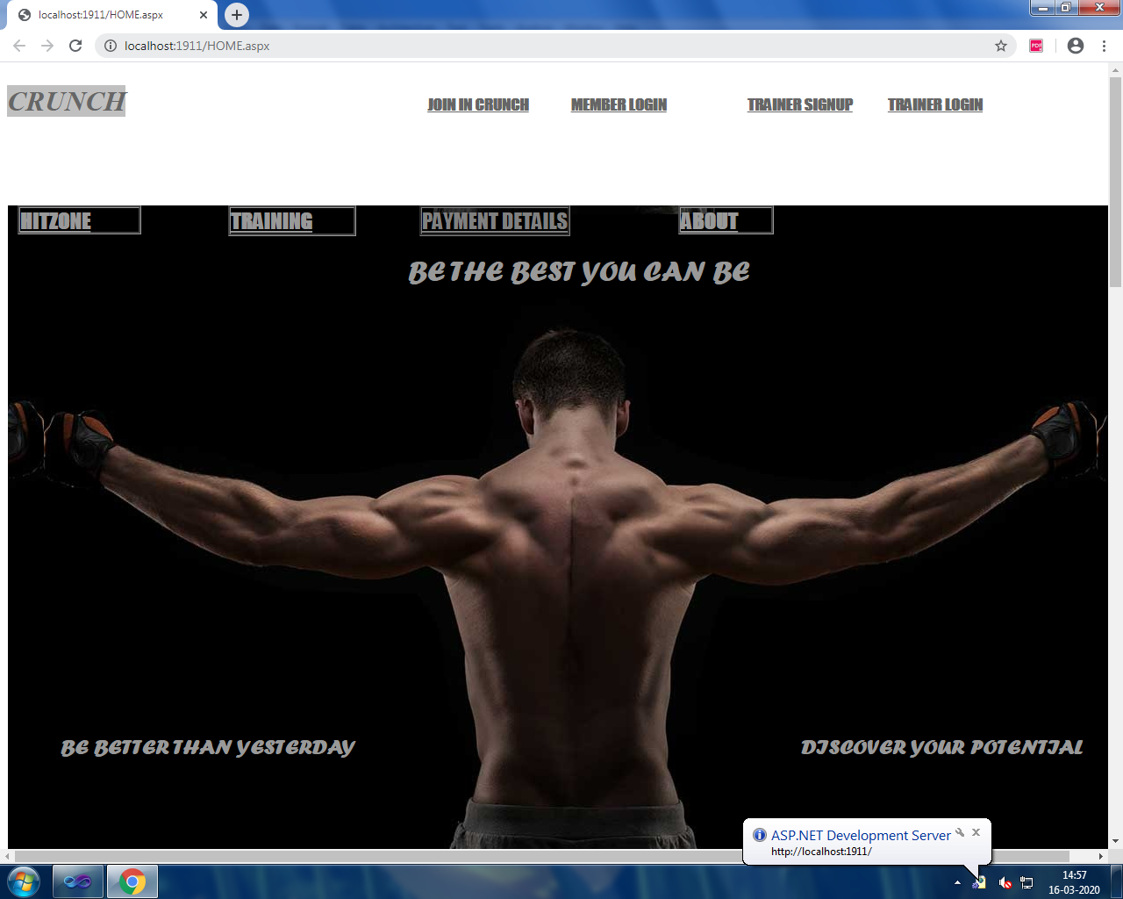

**MEMBER LOGIN:**

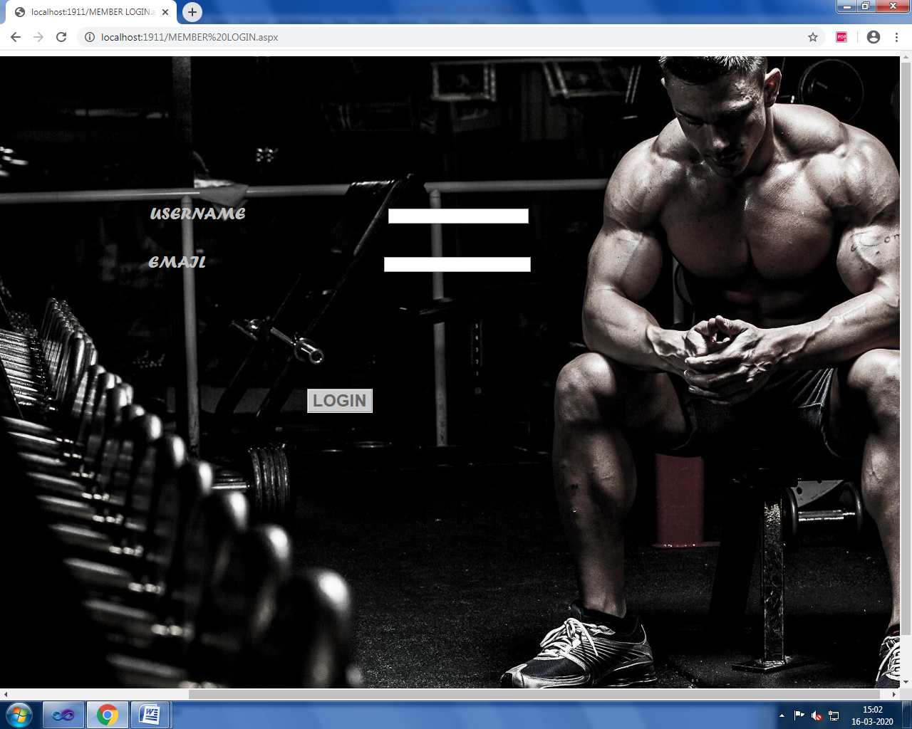

**JOIN IN CRUNCH:**

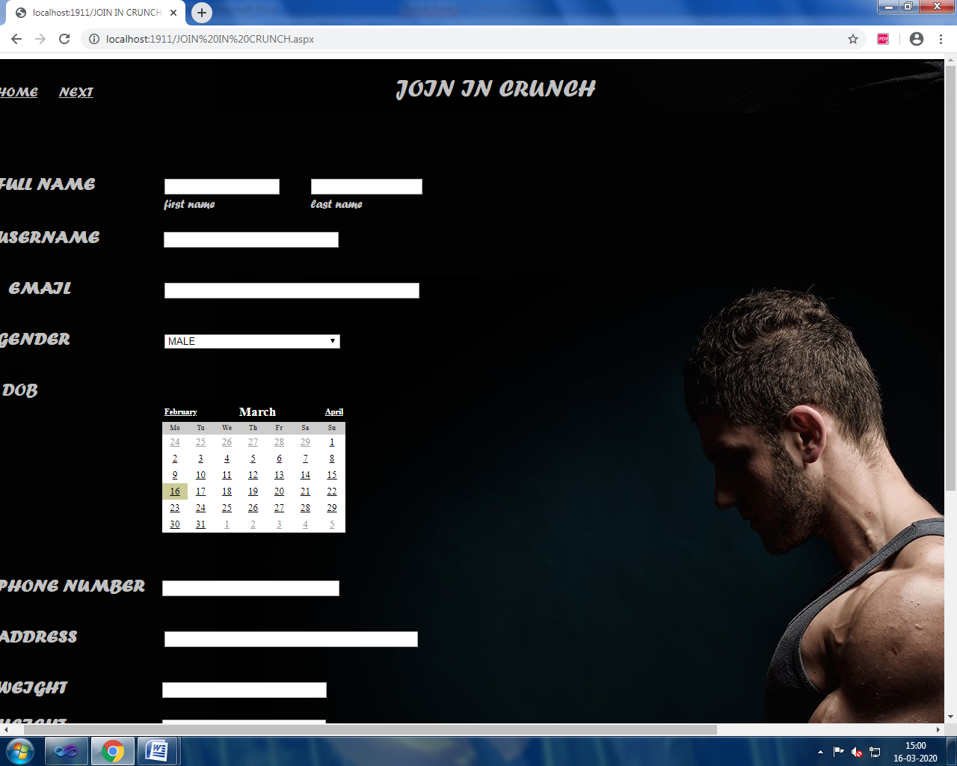

**TRAINER LOGIN:**