Gotham senior employee asking for training on the new app

Over the last 10 years of working at City Hall in Gotham, I’ve seen new technologies emerge. I’ve always tried to use the latest standards in my job by moving away from tables for layout and embracing new ideas. The biggest change seems to be coming up, with this time-tracking app, which I’d like to learn how to use.
Our tools are not easy to update and maintain through a custom built lists. However, I’ve heard of a software that will soon be available.
I’ve already asked a dedicated training and I’d like to sign-up to improve my skills and ensure our tool is secure and well adapted.”

Question from an employee to his Union Reps

Gotham City, September 2020
Dear colleagues from the Union,
As you probably know, we have this requirement for time tracking: We have to have meet a quota of at least 70% accounted for.
In the past couple weeks I experienced a slow time where I only tracked 10% of the time, since I work on crime scenes and clean them, my working time depends on variables that are out of my hands. Batman, the main reason for my job to exist, seems to be out sick or on holiday, lately. I told my manager about this before hand and we discussed it. I gave some ideas to keep busy but he declined, telling me to stay ready for big issues. He said to work on this year’s burying plan in the mean time, which I did. Finally he sees the low numbers and starts asking critical questions. He recommends some stuff to do, which I complete within the hour.
The team lead (who works in the City Hall), too, sees another low day of time tracking and asks, for the reason behind it. So i go through the same topic with him, too.
I told my manager ahead of time that I wouldn't have many hours to track, yet they don't acknowledge or believe me, that I did. On top of that, they seem not to be able to make the difference between the hours I work at night (80% of my job) and the regular office hours. What should my next response be?
Thanks,
John Doe

Answer from Union Reps
This is an issue for your reporting manager to resolve. I would advise taking the issue to him or her and having them suggest methods to ensure that you meet the time tracking goals which have been set for you. After all, that is their job to make certain that you are doing this, knowing that your hours are so flexible.
You should also let your reporting manager know that having to justifying your time tracking to separate entities (night/day) is very difficult and that you are concerned that it may result in "miscommunications" between him/her and the other person. Ask your manager how you can resolve this as again, helping you meet your goals is that person's job. And also to make sure this has an impact on your pay slip.
If your reporting manager is incompetent (sadly a frequent occurrence) or they are unwilling to challenge the other person, it may be advisable for you to ask for a meeting with both your manager and your team lead. At that meeting, ask them how you can resolve any discrepancies that they may have in your time tracking. By doing this, you'll have placed the issue in their court as again, their responsibility is to make certain that you are meeting your goals. Be sure we will look closer into this.

Various tweets/ anonymous emails from employees and citizens

Ask yourself - how would I feel if my workplace decided to suddenly track every little think I do on my computer. They say they are just curious and that this will not affect my salary or performance review. Would you feel a negative effect on your productivity, morale, motivation etc?

There's a "buzz phrase" at the moment that "you can't manage what you can't measure", which is usually used to suggest that you need to put metric in place in order to be able to drive business improvement.
Creating and monitoring metrics of any kind always carries the risk that over time, the metric (in this case time spent on-work activity) becomes more important than the main business goal (producing high quality working software in the shortest time possible.)
Each metric you add to your workload adds to the overhead you have in managing and supporting your team. A few excellent, direct metrics are usually better than a large number of indirect ones.
For a team to buy-in to a metric, they too have to understand how this is going to improve the main business goal of the team; if they can't - and you give them an opt out - I suspect they will use the opt-out. Especially when it comes to the non-computing side of the monitoring which sounds just as manual as a time sheet.
As the question stands, you haven't defined how the metric is going to improve your core activities. As a result, I think it will be very difficult to sell this to your team as a good idea.

I'd just heard people spout this out as a mantra recently - interesting how "control" has become "manage" in my neck of the woods. Either way I tend to spend a lot more time worrying about the sales pipeline than how many hours the developers spend actually at their computers (as opposed to problem solving over a game of pool); some are in at six am, some leave at eight pm, they are all there for the standup, stories are getting knocked off at a cracking pace and they are all happy. They have it under control (so I don't have to...)

This screams, "Management have already decided that Facebook and Youtube kill productivity and are looking for metrics to figure out where to place blame." This is a very dangerous approach because the assumption on what makes developers productive is made before any analysis is done.
If you want to sell this to employees, you have to make sure that the bosses understand that they will just alienate productive employees if they assume what makes a productive office before even gathering, let alone analyzing data.

To answer your actual question, your company almost certainly knows that the process is flawed. They probably want the figures for something other than actual planning, even if they say that's what its for. Mention it to your immediate boss, and then forget about it. By the way. there is nothing to stop you and your team from keeping accurate records of how long you spend on stuff, so that you can estimate your own work more accurately.

Warning from a manager to his top manager

From : middle term managers
To : top management
!! Issuing a warning !!
Timesheets, which do not factor in unpaid overtime (which a lot of us do), cannot be used to accurately gauge project cost and project time in the future, as overtime is not recorded on the timesheets.
when you want to measure worked hours for your internal project planning, it is usually much smarter to let people report the hours which were actually worked, regardless of what you can actually bill.
The difference between billable hours and non-billable hours is an important performance figure every company should be aware of. That means it is usually a good idea to report overtime hours as a separate figure in the timesheets.
But also keep in mind that unpaid overtime is a figure some companies, like ours, don't want to be aware of. There might be regulations in place which actually forbid unpaid overtime, but the business culture is creating so much pressure on individual employees that it still happens. So the overtime hours are kind of a big open secret everybody is aware of but nobody is allowed to admit. So the timesheets claim that everyone goes home on time and they pretend that all the work not represented in them is done overnight by magic overtime pixies.

Complaint letter from employee to the City Hall commission who decided to develop a time tracking app
I'm going to go against the grain a little here and say that these tools are often poisonous to development efforts. It is important to consider the reasons I feel upset about this new rule of tracking, if I understand well, all my activities during the working day.
I think it is frustrating me because working with a time tracker is monotonous busywork, and requires too much mental space to be possibly worth the effort. At our best as employees, we can often end up spending hours deep in thought and poking at details, during which time minor disruptions can actually result in major losses of headspace. But ultimately I came to the realization that I wasn't losing much time to the tool, and there were often short mental breaks in my work where I could make adjustments to my time tracking.
The process still frustrated me, however, and after discussion with my coworkers I was able to better articulate my grievances:
1) This is information which is readily available through our standups, and spending extra time on it getting the minor details written down is worthless.
2) Detailed time tracking is in this case the result of myopic micromanagement, and gives the impression that management is both incompetent and moderately hostile.
3) When operating in this fashion, I don't feel like I am being treated as a professional. While a time tracker may be useful for getting a better feel for sources of time loss, it is more often used as a means to make employees feel like they are being monitored at all times. It is largely used to increase pressure and stress on team members whom management feels they may squeeze a bit more work out of, while dodging coming off as the 'bad guy'.

Question from an employee to his manager

I have a question regarding my software developer job in Gotham. We have a big campus and I frequently have to walk between office buildings during my day. And i am an hourly contractor. I'd like to know if the time I spend walking should be counted towards the time I clock into my timesheet?
My employer is not very strict on keeping time, and it only takes me 5 minutes to do the walk. But I'm just spending much more time than that, because of the frequent jams caused by the consequences of Batman’s fights, and I keep wasting time and arriving later than expected.
Also, I have to walk, not drive, but if I were to drive, would I be keeping time as well in addition to recording the mileage for tax return? Thank you!

Question from an employee to his team

During my HR orientation I was told that logging correct hours is very important to the company as they hold random audits. I have been very compliant in making sure I show up on time (or if I run a little late, I'll work the equivalent time after work). Now I have to say that when it requires, I will stay at work all-night, even without OT, to get the job done. I'm very committed to my work.
However, I don't know how to handle lunches. For lunch, I always bring my lunch, and I eat at my desk. I either have something light, or soylent which means I'm doing something while eating, not just sitting around. We all have our hours publicly posted (just in case we need to get a hold of one another), and it seems that everyone logs stays here for 8.5 hours (with half an hour for lunch). But I feel like I'm getting a little cheated for working through my lunch (half)hour. The other employees are mixed between going home (if they live nearby), eating at their desk, or eating at the cafeteria.
Right now I get to work at 0800 and leave at 1730. (I do work an hour extra, but that's something else, just pretend 9 hours is the normal working week). So that adds up to 9 hours + half an hour for lunch. Is it appropriate to leave even before 1730 since I don't take that long for lunch, or should I just keep my head down and but in the extra 20 or so minutes for free?

Question from an manager to his top management

The project I currently work on is slipping and members of the team were requested to work overtime (if they want and paid), which is OK. On a meeting, I asked for a definition of "overtime", specifically if staying late, which I do, constitutes to overtime, versus working on weekends, which some people opted to. The answer was that only weekend time counts as such.
I feel puzzled because I had a tendency to stay late. I behave as basically asked to, I should stop when the clock says so, in order to create gaps which will be filled on weekends (so that I will get paid more), also I feel as-if I got a message that the time I put "doesn't count".
I also believe that behaving this way, I would sabotage my efforts and capability to deliver: Having to stop before finishing something, means that the next day, some time in order to get back on track will be needed...

Question from an manager to other managers

I’m having a look at the new app for time tracking. Looks cool. Should spare a lot of time dealing with excel tables.
A question, though… What if a member of the team forgets to clock out ? let’s say at the end of the last day of the month. I don’t seem to be able to validate his monthly timesheet. Should I send him an e-mail ?
This might become a problem, since I foresee that this issue will come up quite regularly.

Question from a gardener to his manager

Dear Sir,
I am writing on behalf of various job positions here, at Gotham, who depend on your department. I am a gardener for Gotham, and my job is already very difficult due the very small ammount of daylight we have in Gotham (probably less than in Transylvania), : now, I heard about this new time tracking thing…
How am I supposed to clock in on a computer when I do NOT have a computer ? I have one at home, but it is for my personal use, and in any case, I would not clock in before arriving at work, right ?
Besides, I generally only stop by the warehouse in the afternoon (I start work around 5 AM), being that I just drive straight to the place I’m supposed to take care of for the day.
Could you advise me on how to deal with these specific issues that I am not the only one to encounter ? (see Sanitation workers, policemen etc…)
Thanks in advance

Question from a disabled employee to the HR dept

Dear sir, madame,
I’d like to bring to your attention the fact that I will not be able to use your app for time tracking.
Indeed, I am visually challenged (I was wounded during the explosion of ACE chemicals a few years ago) and I am not able to use written electronic devices on my own.
Will there be a way for me to access this app ?

Joke printed and displayed on the door of the HR dept, earlier this week - anonymous sender

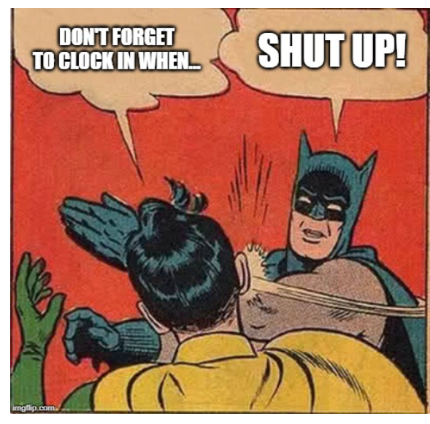

Question from a manager to his colleagues

Dear colleagues,
I guess you have heard about the new time tracking app we are supposed to use.
I thing that’s overall good news, since it will save us time with paperwork. Nevertheless, I can’t help being concerned about the way we will be able to manage constraints schedule (especially since Batman needs support from various departments whenever possible, at whatever time of day or night).
Is there a built-in system that highlights the constraints hours for 1) the employees who are concerned by them, 2) for us, the managers, who need to check that out, 3) the accounting dept, in order not to count those hours toward overtime, since it is regular working schedule.
Thank you for your help.

City hall commission to Mayor

Dear Mayor,
In relation to the announcement about the release of a time-tracking application for all City Hall workers, and because we value the quality of life of our fellow citizens, we would like to enquire about the possibility to have some kind of direct connection between the Bat-signal and the app.
As you can imagine, every time Batman, in his divine mercy, comes to Gotham’s rescue, this has budget consequences that can be very heavy for our city. Indeed, many departments of the city are affected by his brave actions, and must be available at any time.
Being able to link in some way the Bat-signal triggering to the app, would mean being able to set off the right teams at the right moment (instead of having them always ready, « just in case »). This is particularly true for the Police Department personnel, which is costing an arm and a leg.
Wayne Enterprise awards our budget with donations every year, and Bruce Wayne is so much concerned by the well being of his fellow citizens, that he might be open to increasing the amount of his donation this year, if this can help finding a solution.

Question from an employee to his manager

Dear managers,
i’m writing to complain about this new policy of time tracking.
I’ve been working for Gotham City for about 25 years now, and I can only witness how injustice unfolds in this town.
While Batman jumps from one building to another, slashing people and destroying complete blocks in the neighborhood, we, the employees, are subject to severe control of our work.
Needless to say, my job would be far easier if Batman did not step in and out of my compentence field whenever he feels like doing so.
What good would this control app do, when we all already know that the one who should actually be controlled is that bird-like thing called Batman ?

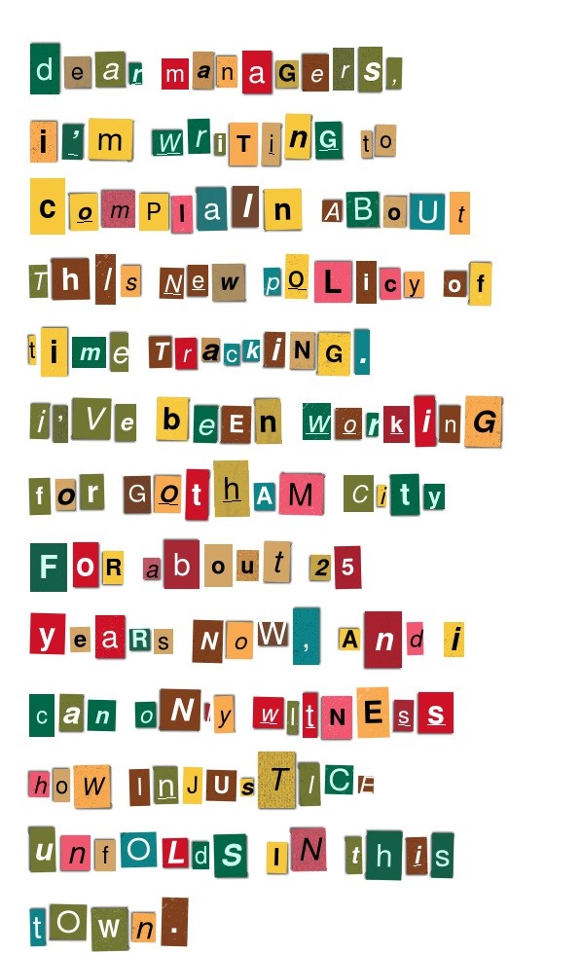




Complaint from a group of employees to their HR dept

From : sanitation team workers
To : HR dept
About : night shifts too often

We would like to complain about a huge problem in the organization of our shifts.
As sanitation team members, we are supposed to work on night shift regularly, nevertheless, it has become a difficult situation since we have been working almost always 3 days in a row on night shifts. We are supposed to share the night shifts among the workers of all the teams. May I remind you that working night shift has an increased rate of facing dangers, in Gotham, and he accounting dept has already ruled out the possibility for us to be paid more.
In the light of this info, we don’t see why we are not entitled to regular day shift just as other teams.
This is why we ask you to make sure this problem does not occur anymore, by organizing the shifts more accurately in the future.
Thanks in advance
(copy of this email has been sent to the Union representatives)

Question from a police officer to his chief officer

Dear boss,
I’m writing to you as a follow up on our conversation about the daily schedules regularly missing.
As I told you earlier today, I’ve been working as an Officer in Gotham Police dept for the last 10 years. I have a family and I would like to see my kids on a regular basis.
Now, since the schedules are made at the very last moment, it is never possible for me to schedule in advance any plans with my family.
I heard about the new app that’s going to be implemented, and I know I’m far from being the only person concerned by these scheduling issues. I hope the new software can help us do just that.

Request from the Union for more training and means

I am writing to submit a formal complaint of lack of training and of means to complete assigned missions to the company. It is unacceptable that an employer asks its employees to fill in a time tracking app without providing proper training, nor even just make sure every employee has access to the necessary technology to do so.
Of course, this may a disguised way to put older or less qualified workers in an awkward situation, and then be able to fire them.
All the Union Reps are very much aware of the shift in the City all policy that consists in taking the standards of large corporations (not to mention Wayne Enterprise, herein Gotham) and apply them to their employees.
This situation is unbearable and cannot persist : workers are being lied to and despoiled !
I trust that the company will take the Union Reps complaint seriously and look into this matter promptly. This situation is affecting the employees’ ability to do what is expected, and it could harm the already difficult relations between the staff and our fellow citizens, unless of course you’d prefer us to end this conflict up in a major strike that would encompass all the City Hall departments.

complaint from an employee to her manager

I heard it is hard for some employees to adapt to working non-traditional hours. Nearly every aspect of their work and family lives are affected. Therefore, the HR dept should arm their department heads with tools that can help employees.
Adapting to a new rotating work schedule is not as simple as repeating what was done with a previous schedule. Shift work schedules require employees to teach their bodies to do what is unnatural while remaining productive.
Management should provide information on how they can try to minimize these difficulties.
Injuries on the job may increase along with labor costs from sick leave, doctor’s appointments and possible workers comp claims.
Here are some necessary features that we need at any cost :
- Provide work schedules as often as possible based on business needs.
- Limit consecutive night schedules.
- Whenever possible, avoid assigning double shifts and overtime to employees who work rotating shifts.

As for the financial aspect is concerned, we also need to be able to count the hours done during night shifts towards the right hourly paylevel.
Working the night shift comes with its own detriments and risks, including fatigue, stress, and a higher risk of injury. For that reason, night shift workers and other workers working a less-than-desirable shift are known to be paid additional compensation called a shift differential.
According to the Fair Labor Standards Act (FLSA) :
“ The Fair Labor Standards Act (FLSA) requires extra pay for night work. Covered, nonexempt workers have to be paid not less than time and one-half the employee’s regular rate for time worked over 40 hours in a workweek.”
In order to abide by all the rules that you highlighed during your election campaign, I really think it is necessary to access all the required info as easily as possible from the time tracking app.
I’s also like to point out that I joined this team four years ago within a secretary role (email and agenda support).
Within that time, my personal skill-set has developed a lot and I find that, in addition to my official position, which is now Mayor’s personal assistant, I am undertaking project management (Agile PO), campaign management and internal communication.
While I am grateful to have a break from the otherwise monotonous and un-challenging role, this work is unrecognized in an official sense (job-title/compensation). There has also been no career development or education. I have expressed concerns regarding this to my supervisor multiple times but with no results.
I’m afraid to be considering as a serious option an open position in the financial branch of Wayne Corp, and I’m about to send them my application.

Question from an chief of staff to the HR dept

Hey Albert,
How are you doing ?
The guys told me about the new time tracking stuff that is being developped. He explained how it should work to the whole team (not very clearly, by the way).
From what I understand, each and every worker will have to clock in and out, and I will have to check them all before they can get paid, right ?
Do you have any idea of the quantity of work this is going to cause to me, and all the managers ? Check all the employees profiles, one by one ? Seriously ?!
Instead, woudn’t it be possible to just have one general clok in for each TEAM, instead of each person ? Since I’m the manager of the team, and everyone starts at the same time, and finishes at the same time, I could just clock in for everyone at once.
What do you think ?

Advice from a manager to his top management

Hi everybody,
I’m posting this message here for the whole group of managers to see it.
I was wondering about the way the new app for time tracking is going to work…
From my own experience, it’s really hard to leave the employees just declare the hours they work , without any control afterwards.
As you may know, I’m mainly on night shifts and my team is often called upon after Batman’s intervention : this is all very messy and I need to be sure that those who say they work are actually really there. It would be too easy for them to say they were there for, like 8 hours straight, while I know that we generally work for 4 to 5 hours in a row.
Is there a way to do that ?

Question/worries from an HR employee to her manager

Hello Team !
I was having a look at the email about the new app :
Do you guys know if it is going to manage days off, vacations, and sick leaves too ?
That would really be great, and makes a lot of sense : it would save us hours and hours of paperwork.
Any chance this request can be pushed to the dev team on the project ?
Thx !

Whistleblower from Police chief to the HR



From : Police chief Gordon
To : Head of HR of Gotham
About : keeping track of night shifts

Dear and estimated colleague,
I’d like to officially file a request regarding the new time tracking app that is being developped.
I guess that all the logistics have been thought about in advance (like the fact that the patrols do not have a computer inside each car, for example), but my request is on a more administrative aspect of the situation.
As you know, my officers, when called on patrols, work night shift on a regular basis, this is normal and expected. The problem stems from the fact that team leaders have no insight on « the big picture » and many policemen end up working night shifts too often (sometimes 3 times in a week).
The situation has been really tense lately, especially since my team feel like the population thinks that Batman is doing it all, and my guys are just too slow to act. This translates into deep concern and bad mood on the personnel, and elections are approaching.
I think that you clearly understand that it would be great to have a kind of « alert system » that could highlight those who have already done more than X night shift per month, or week, whatever. Managers try to do that already, but using Excel tables (or even paper tables), they are not as responsive as they should be.
In the hope of finding a solution for this issue, I’m always available for any detail.

Request from a top manager to the dev team

Dear colleague,
I have been able to check the functional specifications of the time tracking app we are expecting by the end of the month. It looks great, and I hope i twill save time and money to the City Hall teams and budget.
Nevertheless, I would like to add a feature, and I did not want it to appear as such on the functional specifications. This is a quite delicate matter, you see.
I would like to be able to give or take back permissions on the rights given to the managers. Indeed, I’m a bit worried about how trustworthy some of them may be, and I would like to make sure the administration can have an eye on that.
Maybe the current wave of violence and crime Gotham has gone through is making me a bit anxious and paranoid, but I’d feel a lot more safe with this type of safety feature available.
Let me know if you need more info, and I’ll be happy to meet you in the basement of Gotham shopping mall, underground 2, at 3am sharp. I’ll be wearing sunglasses and a grey trenchcoat.

Request from the DHR to the dev team

After deeply discussing at length the features that are really a must have on the new app, we’ve come to a tie on at least one major thing, that we absolutel need to get :
It has to be possible to display the hours that are to be paid at 1.5 the hourly rate (night shift), those which are to be paid hourly rate x2 (overtime after 40 hours per week), and those hours which can only be taken as compensation time, thus, not paid.
This is absolutely necessary, or else the pay slips will be a complete mess !
Thanks in advance

