This document will describe how to Interface a Teensy with a PS/2 laptop touchpad and send results over USB to a PC. The touchpad is from an HP Pavilion DV9000 laptop and is marked with part number 920-000702-04 Rev A. The following picture shows the touchpad with wires soldered to 5 volts, ground, clock, and data.

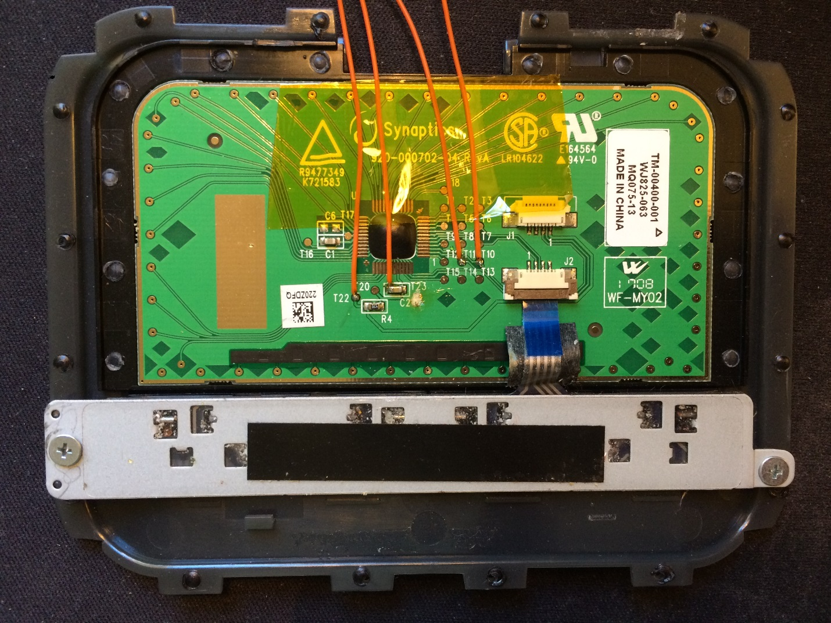

Wires connected between the touchpad and Teensy 3.2 are detailed below:

* T22 = 5V wired to the Teensy Vin pin
* T23 = Ground wired to the Teensy Ground pin It's hard to solder to T23 so I soldered to the ground side of bypass cap C2.
* T10 = Clock wired to Teensy I/O 14
* T11 = Data wired to Teensy I/O 15

I initially thought I needed to add pull up resistors on the clock and data signals because they measure open with an ohm meter. Once the touchpad is powered, the signals were pulled to 5 volts by active pull ups within the touchpad controller chip.

The PS/2 signals are at 5 volts from the touchpad to the Teensy 3.2. Luckily the 3.2 is 5 volt tolerant so it can receive 5 volt signals. The touchpad works fine with 3.3 volt signals from the Teensy 3.2.

A Teensy LC is not 5 volt tolerant so a level translator is needed for the clock and data signals.

The PS/2 code was originally from [Playground Arduino](http://playground.arduino.cc/uploads/ComponentLib/mouse.txt) but the interface to the PC was changed from RS232 serial to USB using the PJRC Mouse functions. I’ve been using this code for some time on my Raspberry Pi Sony Vaio laptop. I found that the PS/2 clock edge from the touchpad can be missed if the Teensy is interrupted by I2C or USB traffic. A missed clock will cause the “while loop” that is waiting for the edge to hang so I added a watchdog timer to break out of the loop.

The standalone touchpad code is at my [Github repo](https://github.com/thedalles77/USB_Laptop_Keyboard_Controller/blob/master/Example_Touchpads/Touchpad_3p2.ino).

The touchpad code integrated into the Dell D630 keyboard code is at my [Github repo](https://github.com/thedalles77/USB_Laptop_Keyboard_Controller/blob/master/Example_Keyboards/Dell_Latitude_D630/Dell_D630_Keyboard_and_Touchpad.ino).