**Topic Summary:**

Design a dashboard that displays between crime frequency and other indicators of quality of life by zip code in Atlanta so viewers can decide the best area to live in:

Variables we will be analyzing:

1. Frequency of crime reports
2. Median income per household
3. School Ranking
4. Median listing price of available properties

**Dataset(s):**

* <http://zipatlas.com/us/ga/atlanta/zip-code-comparison/median-household-income.htm>
* <https://github.com/dmitchell217/Atlanta-Neighborhoods/blob/master/static/data/crime_data.csv>
* <https://developer.schooldigger.com/>

**Visualization Inspiration:**

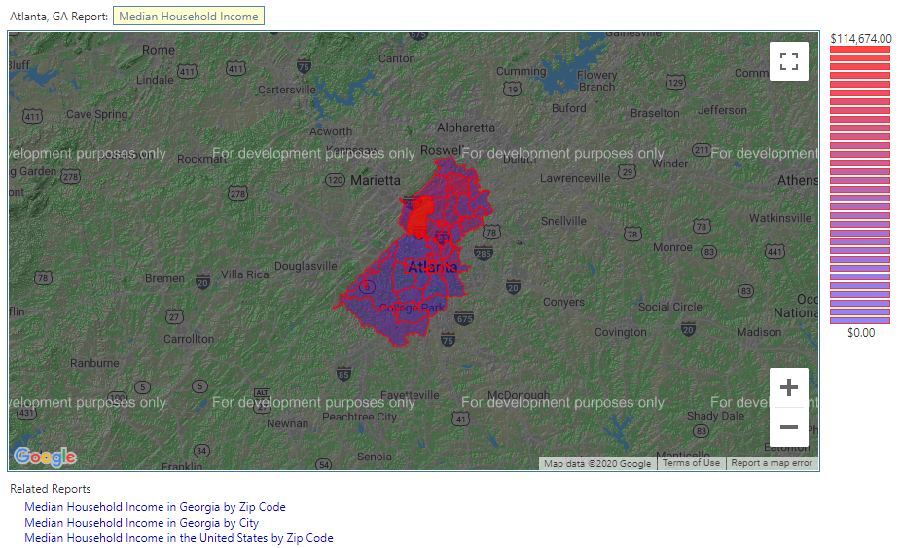

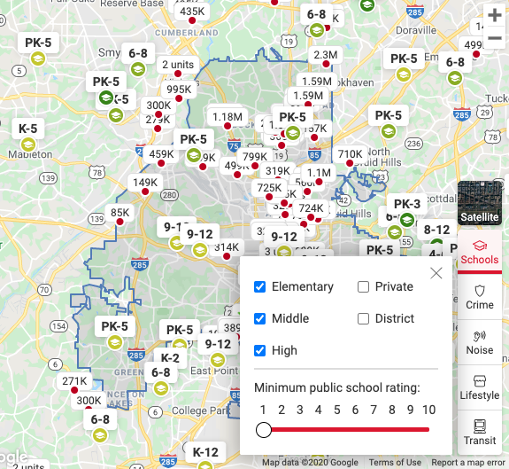

**Design Sketch:**

Dream Neighborhood Dashboard:

* Heat map of median income by zip code
* Markers for crime reports in the area
* Click on zip code on map container display:
  + Public school ratings
    - Filter menu for elementary, middle, high/public; private
  + Median Income
  + Median listing for prices available

GitHub Link: <https://github.com/dmitchell217/Atlanta-Neighborhoods>