**Exploring German Credit Dataset Using Decision Trees**

1. The class is classified using decision trees by the following steps :

* Firstly weka should be opened and then german credit dataset should be loaded.

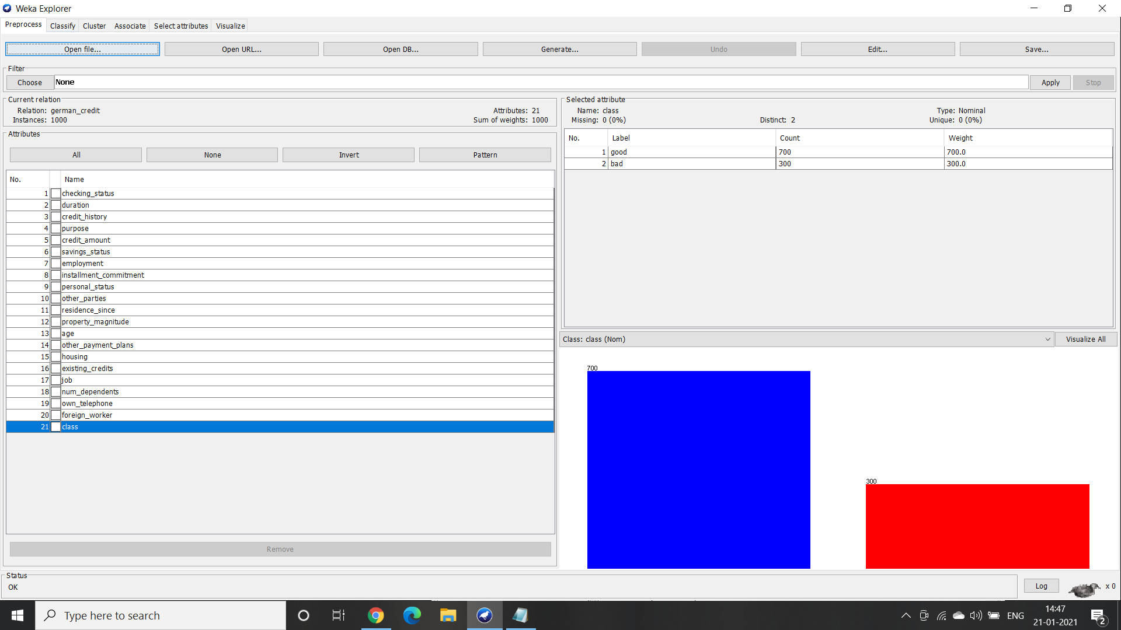

* Second, select the class attribute and click on the the classify button on the top

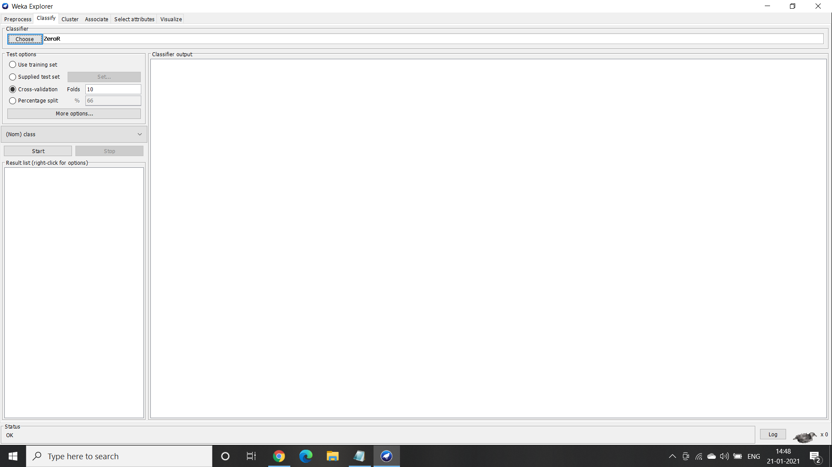

* Third, the training set option needs to be selected and then the J-48 classifier should be selected.

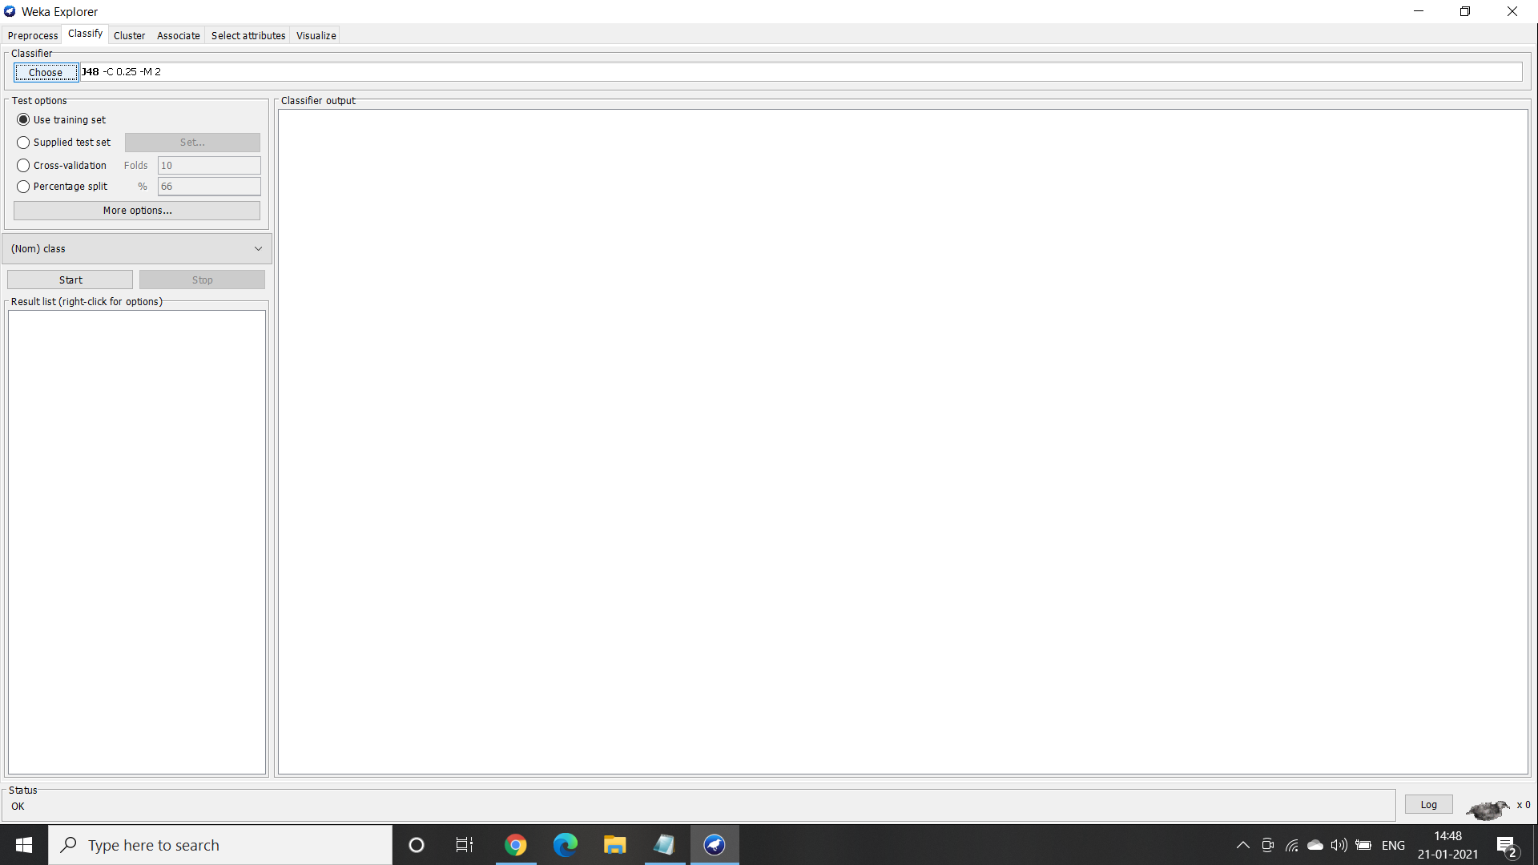

* Finally, by clicking on the start button placed towards the left we get the classifier output on to the right side.

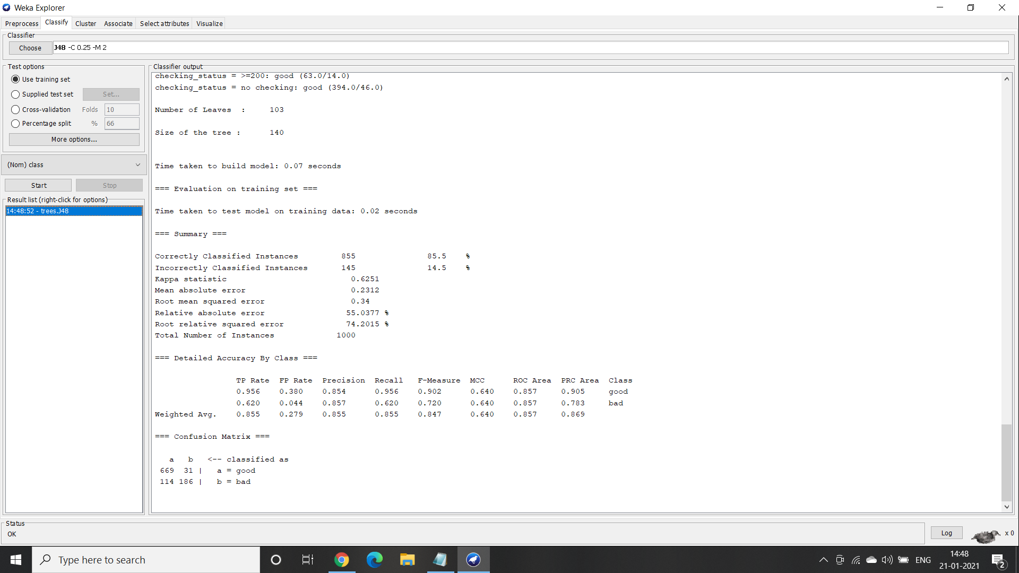

1. Size of the tree and number of leaves are 140 and 103 respectively. The time taken to build the model is 0.01 sec. Moreover when the percentage split was default i.e 66% and with the default cross validation folds as 10 the accuracy was 72.6471%.

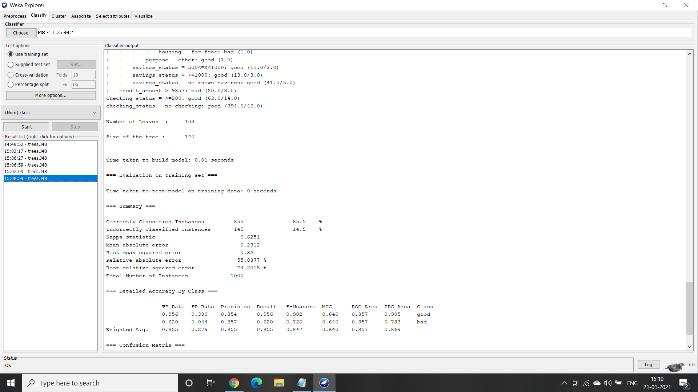

1. When the percentage split was increased from 70% with the same default cross validation folds as 10 the accuracy was 73.66 percent.

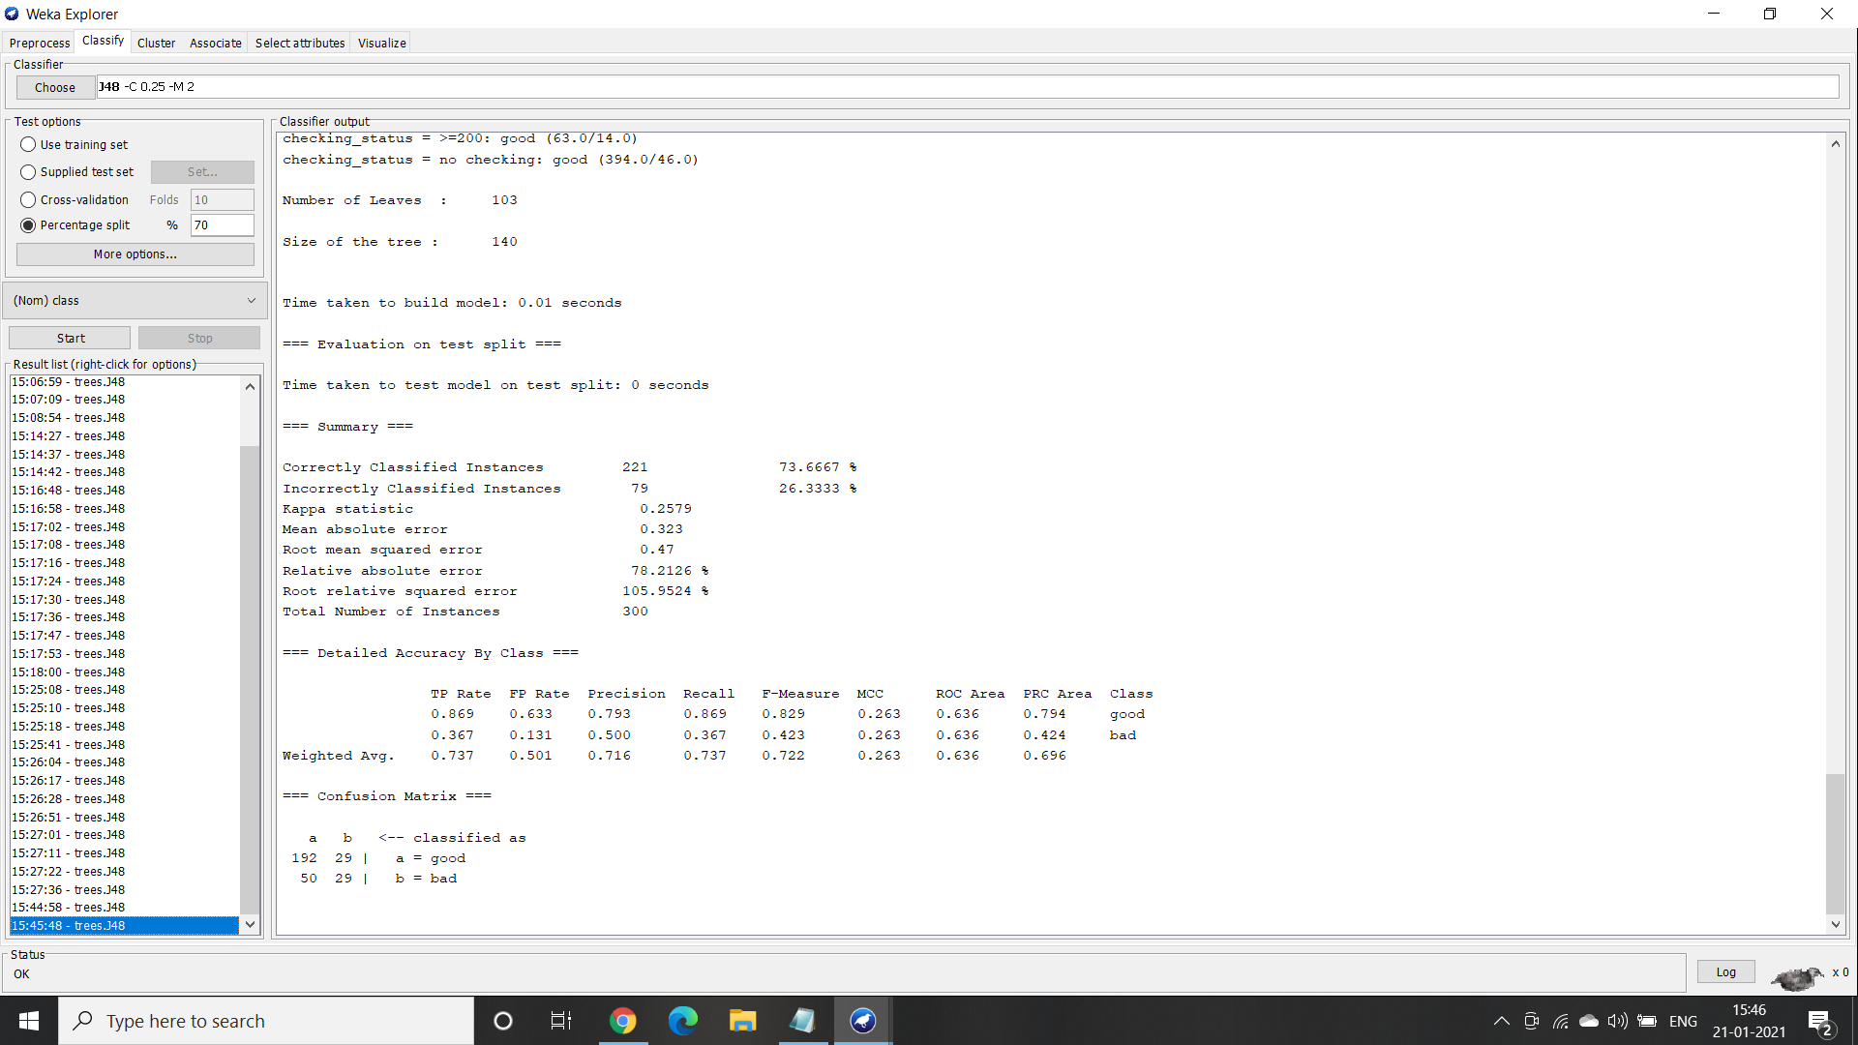

1. When the percentage split was increased from 75% with the same default cross validation folds as 10 the accuracy was 76 percent.

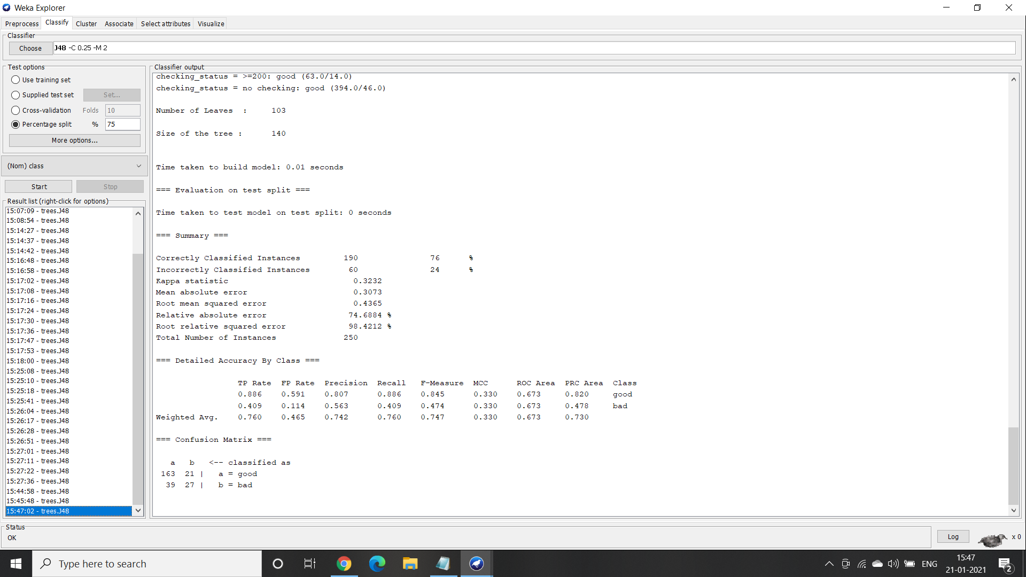

1. When the percentage split was increased from 80% with the same default cross validation folds as 10 the accuracy was 77 percent.

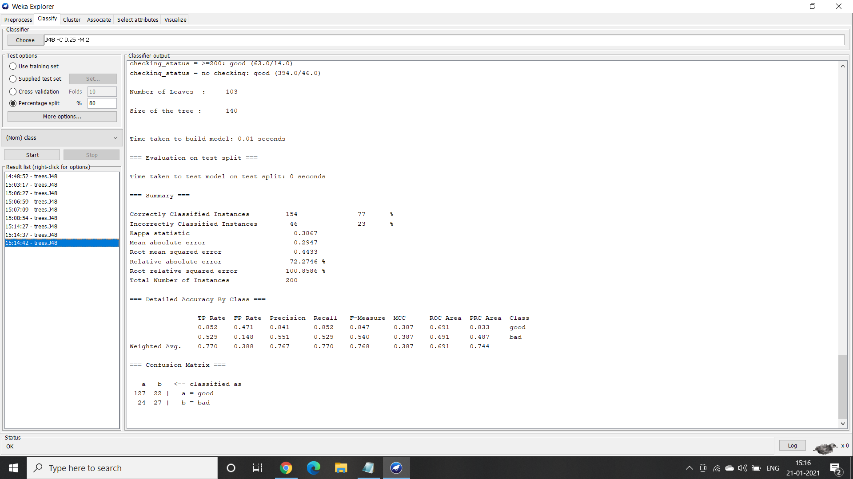

1. After trying out multiple combinations of percentage split and cross validation it is observed that the best accuracy i.e 77%.
2. Visualization of a decision tree -

