**Exploring German Credit Dataset Using Naive Bayes Classifier**

1. The class attribute is classified using naive bayes by the following steps :

* Firstly weka should be opened and then german credit dataset should be loaded.

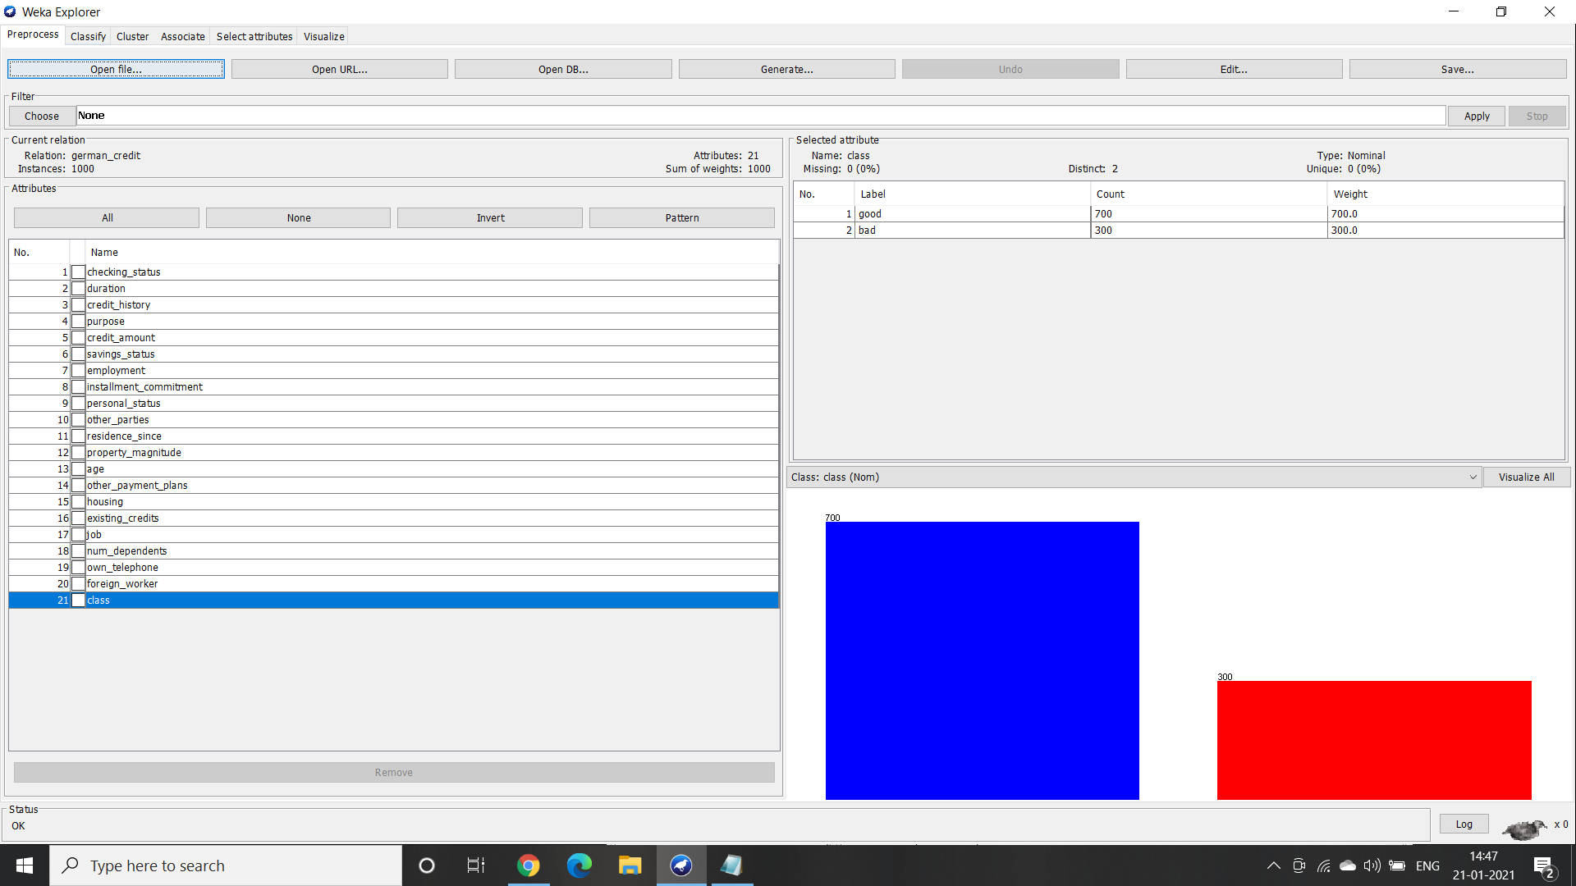

* Second, select the class attribute and click on the the classify button on the top

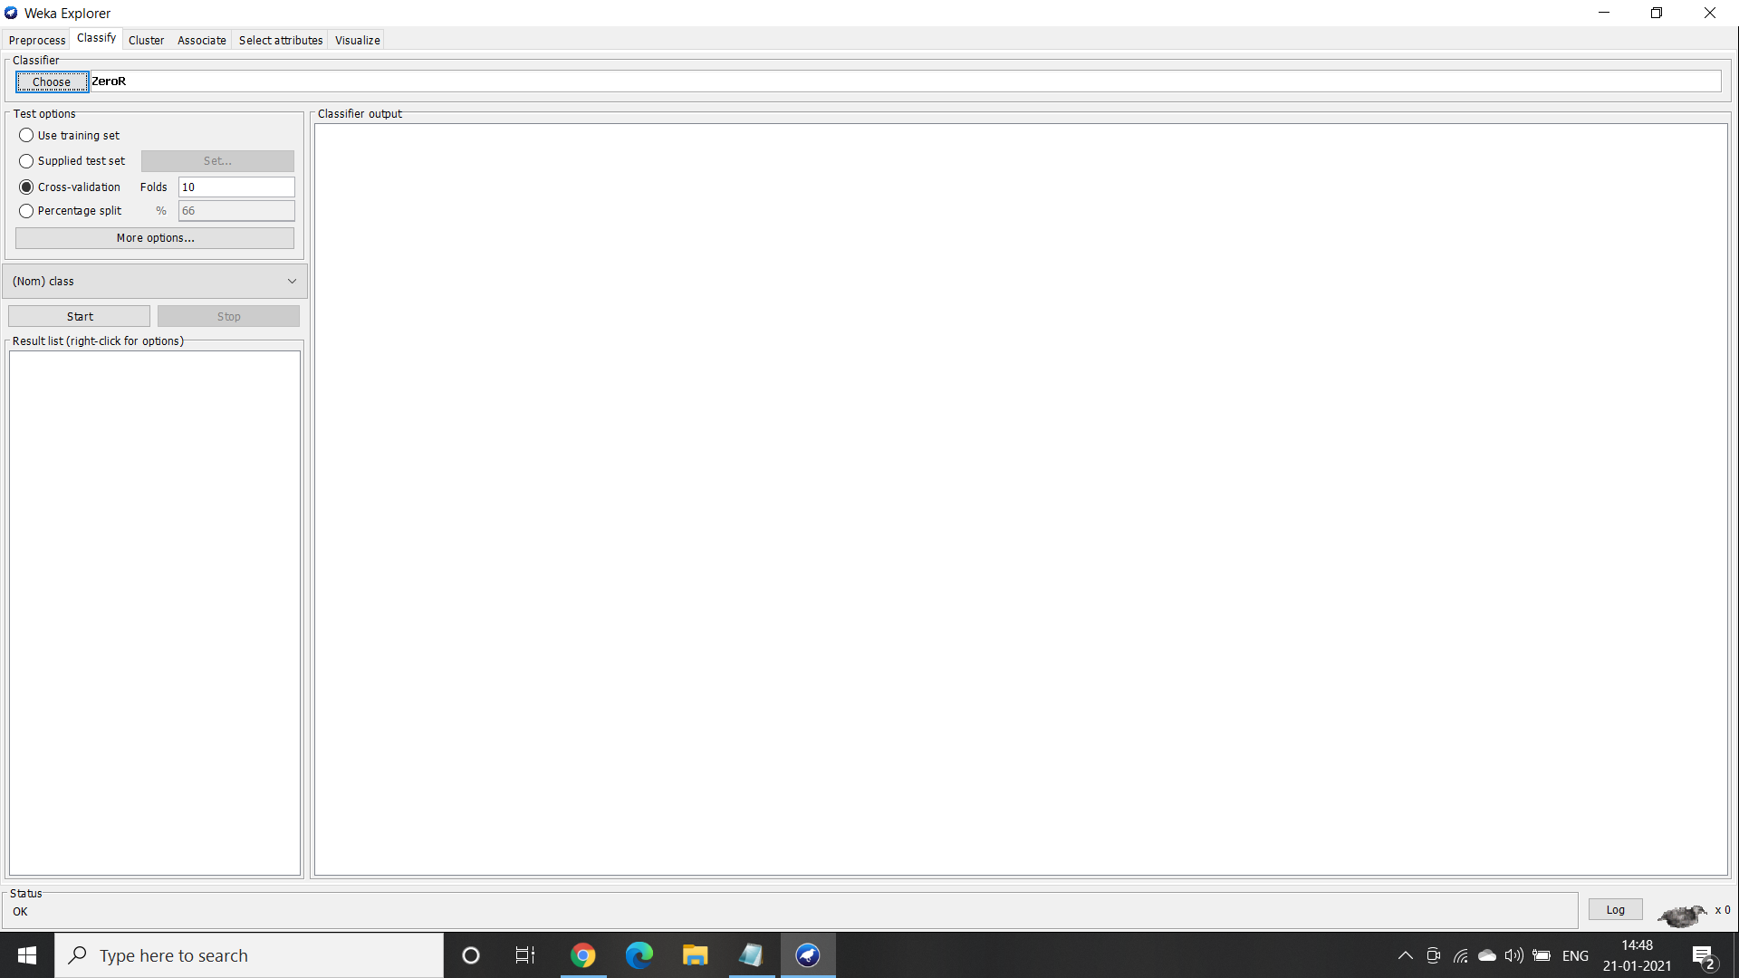

* Third, click on the choose button and then select the naive bayes classifier.

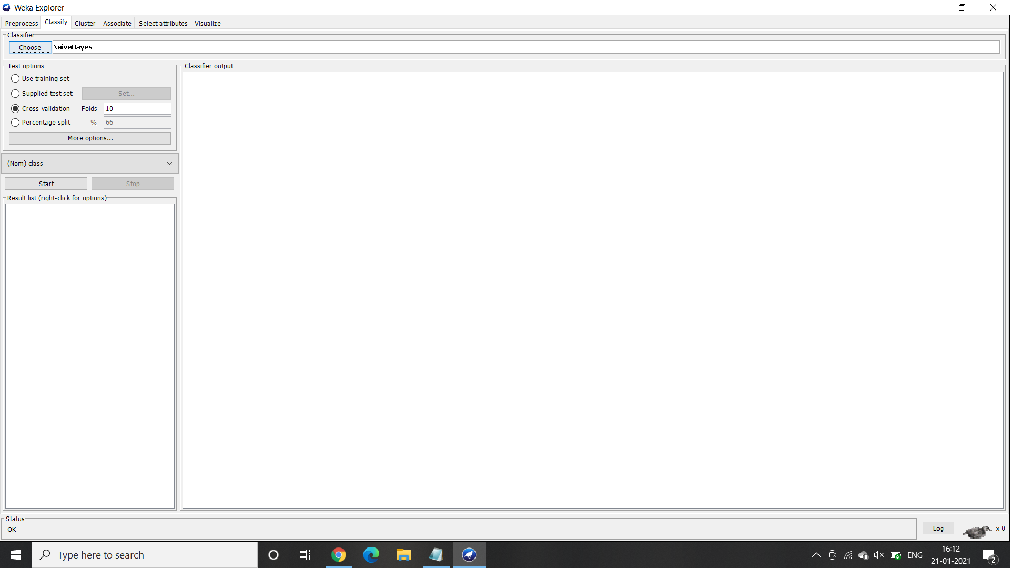

* Finally, by clicking on the start button placed towards the left we get the classifier output on to the right side.

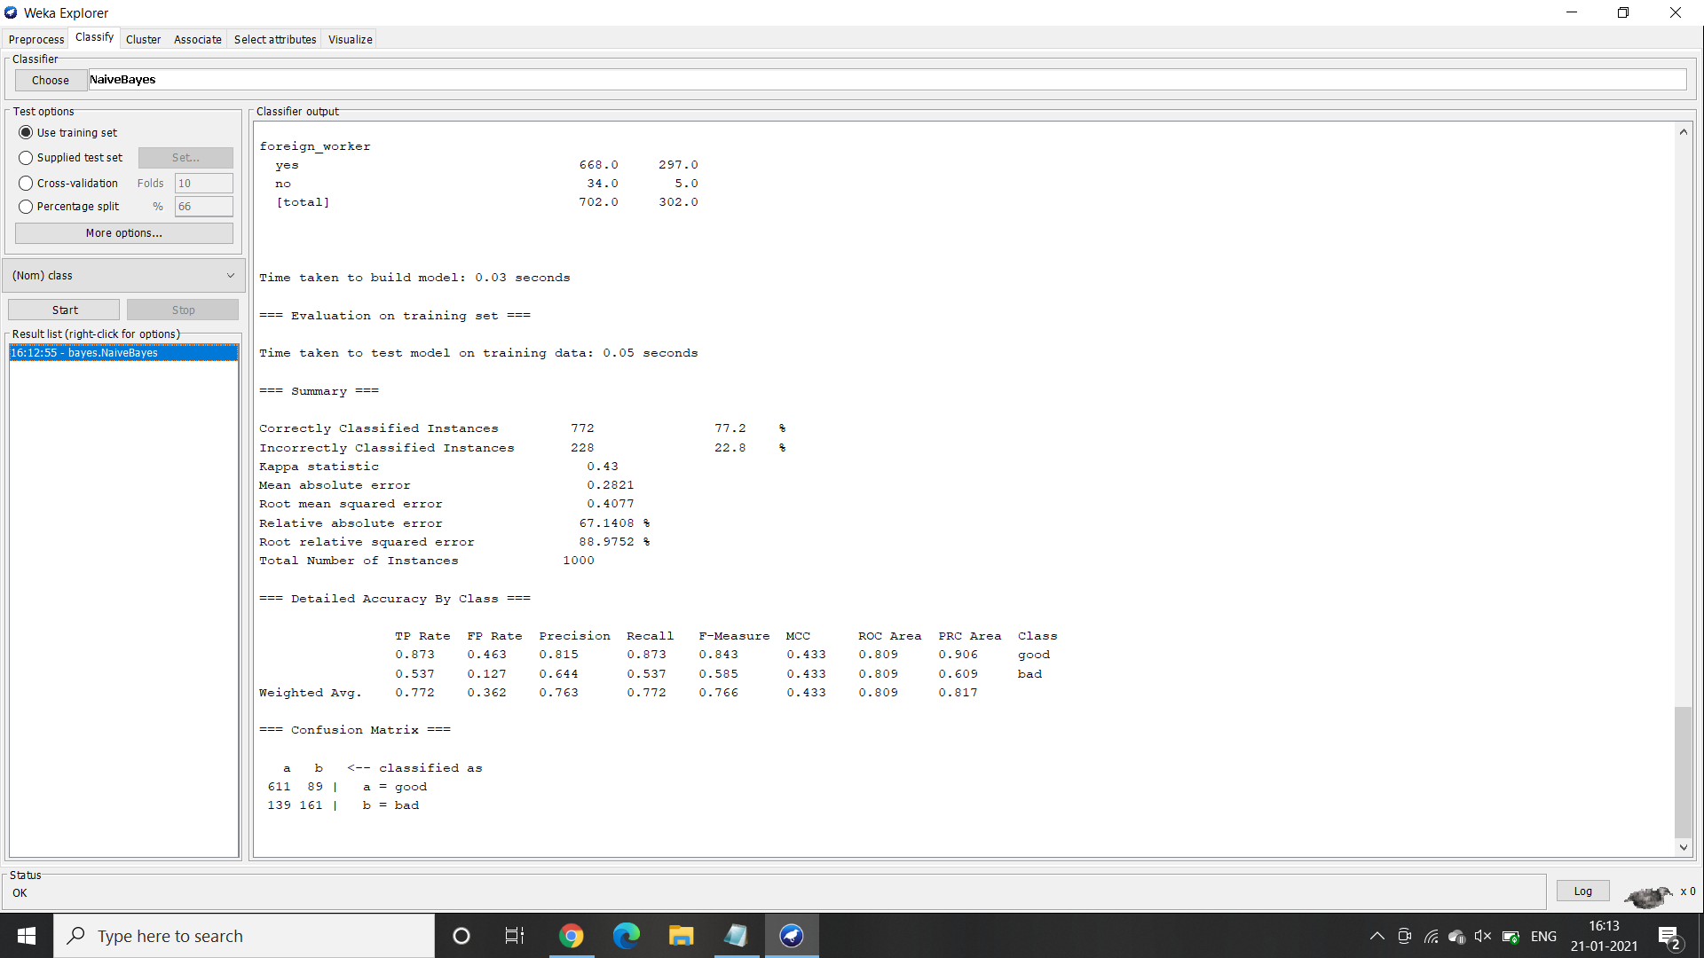

1. The time taken to build the model is 0.03 sec. Moreover when the percentage split was default i.e 66% and with the default cross validation folds as 10 the accuracy was 77.2%.



1. When the percentage split was increased from 70% with the same default cross validation folds as 10 the accuracy was 75.33 percent.

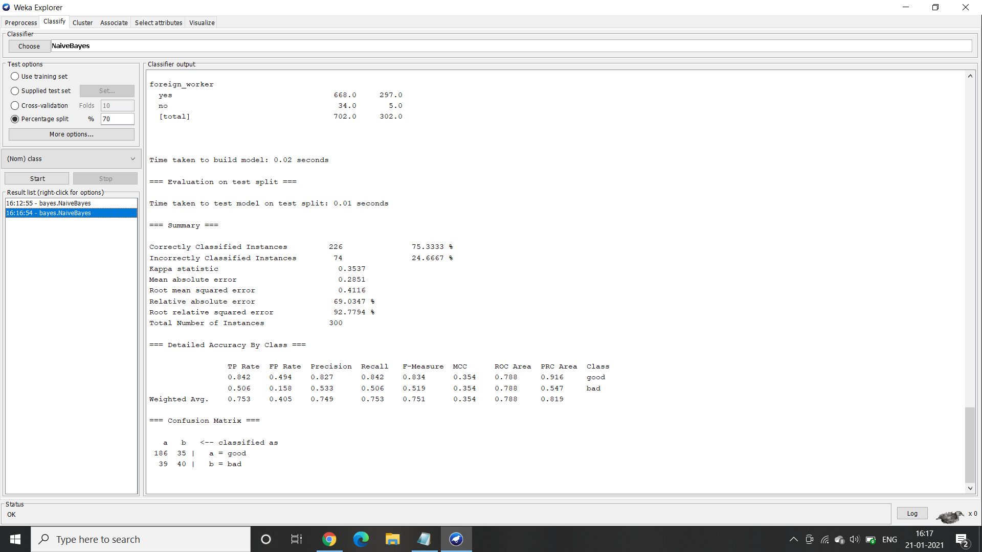

1. When the percentage split was increased from 75% with the same default cross validation folds as 10 the accuracy was 76.8 percent.

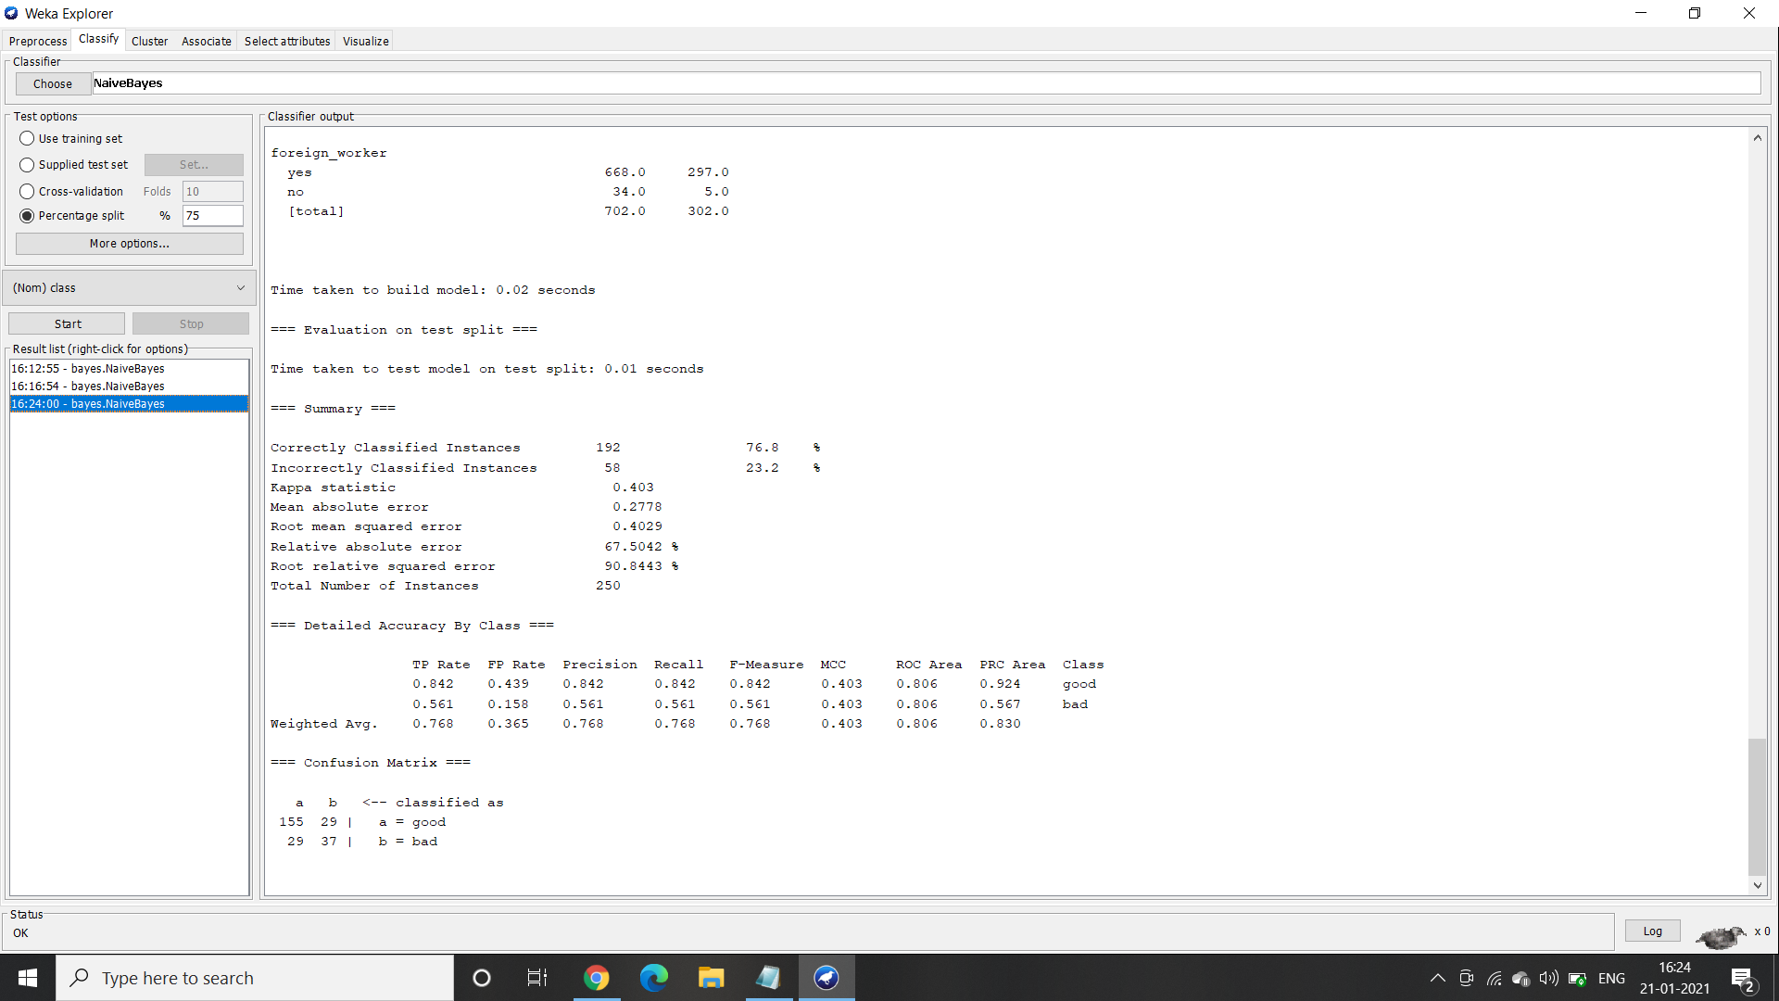

1. When the percentage split was increased from 80% with the same default cross validation folds as 10 the accuracy was 74.5 percent.

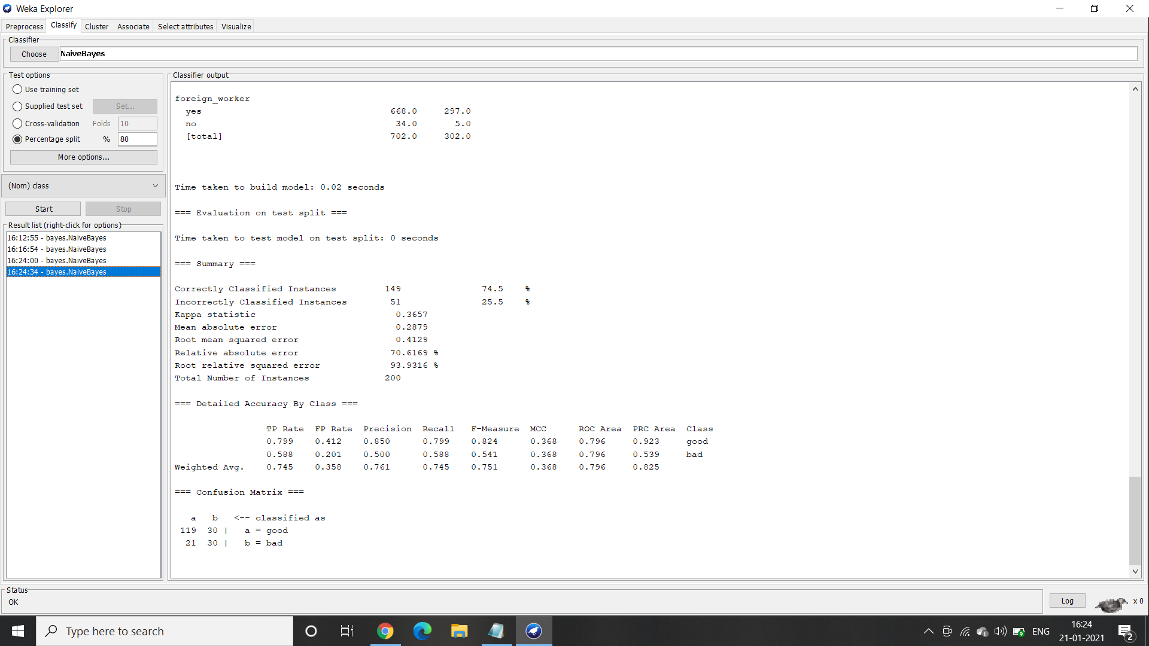

1. After trying out multiple combinations of percentage split and cross validation it is observed that the best accuracy i.e 77.2%.