GEMR:KG - GLOBAL EMERGING MARKET RISK KNOWLEDGE GRAPH

Adishesh Gonibeed Ravishankar, Hitesh Kolluru, Likitha Sathvik Potineni,
Lalitha Shreya Vanam, Hemakshi Pandey and Srividya K. Bansal

School of Computing and Augmented Intelligence, Arizona State University, Mesa, AZ, USA
ABSTRACT
A prevailing perception of high risk in emerging markets, often driven by incomplete and fragmented data, leads to capital misallocation and constrains of investment. While powerful datasets such as the World Bank’s Global Economic Monitor (GEM) and the Global Emerging Markets (GEMR) Risk Database provide extensive macroeconomic and credit risk information, respectively, they exist in silos, limiting holistic analysis. This paper introduces the Global Emerging Markets Risk Knowledge Graph (GEMR:KG), a novel system that integrates these disparate sources into a unified, semantically rich framework. GEMR:KG models entities including countries, loans, economic indicators, and crisis events, along with their complex interrelationships. This structure enables multi-relational queries that are currently infeasible, such as tracing the geographic contagion of defaults or identifying leading macroeconomic indicators of credit stress. The system features a dual interface querying capability, supporting both formal SPARQL for quantitative analysts.
KEYWORDS
Knowledge Graphs, Risk, Emerging Markets, World Bank, Ontology Engineering, Macroeconomic Indicators

INTRODUCTION
The analysis of risk in emerging markets is hampered by a fundamental challenge: data fragmentation. On one hand, the World Bank’s Global Economic Monitor (GEM) (World Bank, 2024) provides a rich,
high-frequency repository of macroeconomic indicators like GDP, inflation, and trade data. On the other hand, the Global Emerging Markets (GEMR) Risk Database (World Bank Group, 2025) offers unparalleled, granular data on private sector credit risk, including default and recovery rates over three decades. While invaluable on their own, these critical datasets exist in separate silos.
This separation makes it impossible to perform integrated analysis. An investor cannot easily query the relationship between a country’s currency fluctuations (from GEM) and the subsequent default rates in its manufacturing sector (from GEMR). This gap prevents a holistic understanding of risk dynamics and obscures important trends, such as the significant divergence between a country’s sovereign risk rating and the actual, often lower, credit risk of its private sector. To address this, we are developing the Global Emerging Markets Risk Knowledge Graph (GEMR:KG). Our goal is to create a unified system that integrates these two disparate datasets into a single, semantically connected network. To further enhance our analysis of non-economic factors, we have incorporated political risk data from the World Bank’s Governance Indicator Dataset (World Bank, 2024).
Within this context, this paper addresses four core challenges at the intersection of global finance, risk management, and data science. First, Inadequate Comprehensive Risk Modeling: traditional approaches struggle to integrate the multitude of dynamic variables required to assess true country-level risk, including macroeconomic indicators (GDP, CPI, external balances), financial and market data (commodity prices, currency volatility, default histories), crisis-specific behavior (e.g., foreign exchange shocks), non-economic factors (political instability, regulatory changes), and their temporal dynamics. Second, there is a poor understanding of systemic contagion: existing frameworks provide limited support for modeling geographic contagion and tracing the impact of one country’s default or currency shock on its neighbors and trade partners.

Third, stakeholders face difficulty in extracting actionable insights from complex datasets. Investors and policymakers lack tools that answer high-level questions directly, such as identifying indicators that best explain a crash in each market or understanding which countries share similar risk profiles for diversification. Finally, the underlying data remains inaccessible and siloed: financial, economic, and political information is distributed across heterogeneous databases and APIs that are difficult for non-technical users to query intuitively.
GEMR:KG is designed to tackle these four challenges by providing a unified, ontology-driven knowledge graph that integrates macroeconomic, governance, and credit-risk data, supports temporal and contagion reasoning, and exposes these capabilities through both SPARQL and an inter- active web interface.

LITERATURE REVIEW
The intersection of knowledge graphs (KGs), large language models (LLMs), and financial risk assessment represents a rapidly evolving research domain with significant implications for emerging market economies. This literature review synthesizes recent advances across multiple disciplines to contextualize our proposed framework for integrated financial risk assessment.

2.1 Knowledge Graphs for Financial Applications
Knowledge graphs (KGs) effectively represent complex financial relationships and enhance analytical depth. For example, Mitra et al. (2024) achieved 92% balanced accuracy in credit risk assessment for MSMEs by combining Relational Graph Convolutional Networks (RGCN) with Random Forest algorithms to model borrower-industry interactions. In supply chain contexts, Yang et al. (2021) identified hidden risk propagation patterns among 97K interconnected enterprises using graph mining demonstrating that network topology predicts financial distress more accurately than traditional ratios. Furthermore, Yang and Liao (2022) developed a multi-source data fusion integrating news corpora and corporate disclosures through dynamic KGs has proven superior to single-source methods for identifying emerging risks.

2.2 Macroeconomic and Risk Propagation Frameworks
Tilly and Livan (2021) validated that knowledge graphs constructed from news narratives significantly improve macroeconomic forecasting, noting that disease and economy-related themes show strong predictive power for industrial production. Their statistically validated filtering methodology provides a blueprint for extracting parsimonious, informative graph structures a principle extended to this financial risk context. Additionally, Li and Sanna Passino (2024) developed FinDKG, a dynamic knowledge graph framework that integrates temporal dynamics through quadruples (subject, relation, object, timestamp). Their KGTransformer architecture improved link prediction by ~10%, and while focused on thematic investing, their temporal modeling techniques inform the capture of evolving risk conditions in this system.

2.3 Financial Contagion and Systematic Risk
Glick and Rose (1999) established that currency crises propagate primarily via trade linkages rather than shared macroeconomic fundamentals, leading to synchronized exchange-market pressure among trade partners. This framework provides a canonical model for geographic contagion adapted here to default-risk contexts. Additionally, Galizia and Lund (2024) found that emerging market lending risks are often overestimated; their 30-year analysis of 15,000 loans revealed a 3.6% average default rate comparable to B-rated corporates in advanced economies and a 72% recovery rate. These findings validate the feasibility of integrated risk assessment while emphasizing the need for nuanced, data-driven approaches.

3. APPROACH

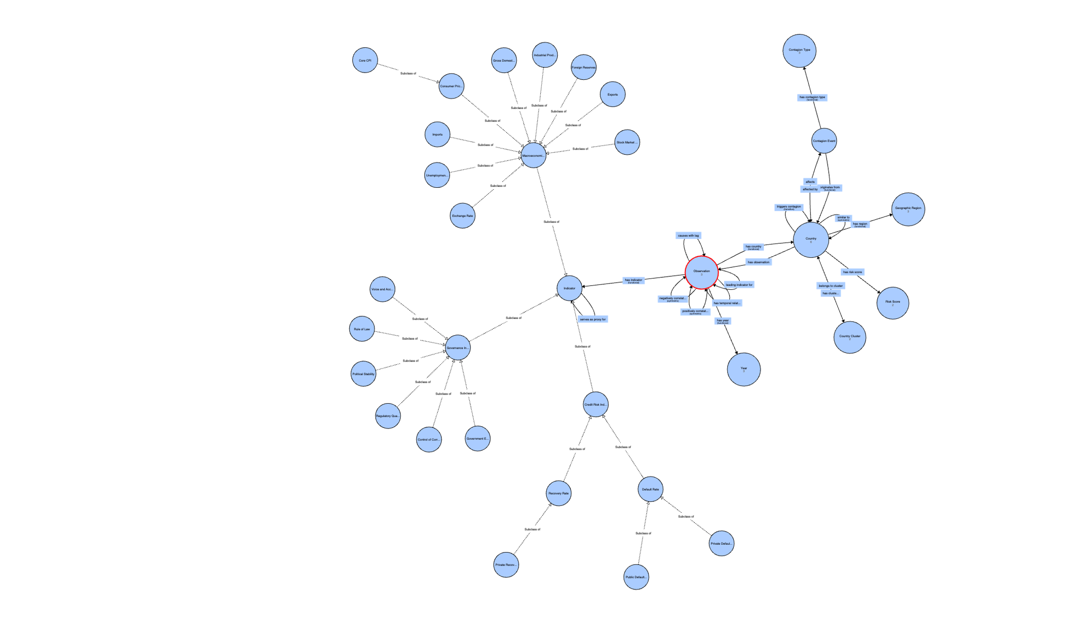
Figure 1. GEMR-KG Ontology Structure
Our approach to building the GEMR:KG system centers on the design and implementation of a comprehensive ontology that serves as the semantic foundation for integrating heterogeneous financial risk data. The ontology engineering process follows established best practices in knowledge representation while addressing the unique requirements of emerging market risk analysis.

3.1 Ontology Design and Architecture
The GEMR-KG ontology specifies the domain concepts and constraints required for unified risk assessment. It is structured around six core entity classes:
- Core Entities: The Country class represents the six target markets (Brazil, China, Mexico, Philippines, Poland, and Thailand). These are linked via Observations to specific Indicators and Years (2002–2023) to facilitate longitudinal analysis.
- Indicator Hierarchy: Three taxonomies are modeled: (1) Macroeconomic (e.g., GDP, CPI, trade balances); (2) Governance (WGI metrics like Rule of Law and Political Stability); and (3) Credit Risk (public/private default and recovery rates).
- Risk Assessment Framework: The RiskScore class computes composite stability metrics based on governance, economic health, default risk, vulnerability, and contagion exposure.
- Contagion & Clustering: Systemic risk is captured via ContagionEvent and ContagionType (trade, currency, or political). Transitive properties enable recursive traversal of multi-hop risk transmission. Regional groupings and similarity are managed through GeographicRegion and CountryCluster classes using the similarTo symmetric property.
- Temporal Relationships: To capture lagged causal effects, properties such as causesWithLag and leadingIndicatorFor are encoded based on validated statistical correlations.

3.2 Data Integration Strategy
The ontology functions as a sophisticated integration layer, engineered to semantically harmonize three distinct yet complementary data sources that are fundamental to modern risk assessment. It systematically ingests the World Bank’s Global Economic Monitor (GEM), leveraging a robust twenty-two-year longitudinal dataset of high frequency macroeconomic indicators to capture dynamic economic shifts. Parallel to this, it integrates the World Governance Indicators (WGI), which provide critical annual assessments of institutional quality across six foundational dimensions of governance. To address the financial stability of the private sector, the framework further incorporates the IFC GEMs DB, supplying granular, empirical statistics on credit risk and loan performance that are essential for modeling default probabilities and recovery rates. Data harmonization challenges including temporal alignment, unit standardization, and handling sparse coverage in credit risk data are addressed through explicit modeling of data quality attributes (dataAvailability, coverageRatio) and proxy relationships (servesAsProxyFor) within the ontology.

3.3 Ontology Rationale and Provenance
Our ontology provides a unified platform to harmonize data from the World Bank’s GEM, WGI, and GEMS databases. By extending the Financial Industry Business Ontology (FIBO), we ensure architectural trust while meeting specific emerging market risk requirements. A key feature is the modeling of temporal dependencies, treating time as a relational link for 22-year time-series analysis. Core entities Country, Indicator, and Observation map directly to these sources, enabling the traversal of complex paths like linking governance shifts to credit defaults over time. FIBO is the industry's business dictionary that standardizes data definitions.

4. IMPLEMENTATION
The GEMR:KG pipeline transforms raw data into a semantically rich knowledge graph through a multi-stage process:
- Data Ingestion & Cleaning: Raw CSV/XLSX files undergo schema validation and range checks. We use Python (Pandas) for currency normalization to USD, linear interpolation of missing values, and computation of growth metrics. The pipeline aligns daily market data with annual governance scores and generates temporal lags (t-1, t-2) for predictive modeling.
- Semantic Modeling: We constructed the domain ontology by extending the Financial Industry Business Ontology (FIBO) (EDM Council, 2024). The OWL schema was validated in Protege using reasoning checks to ensure consistency across economic and governance relationships.
- Graph Population: Using Ontotext Refine, processed tabular panels are mapped to ontology classes to generate RDF triples.
- Backend & Inference: The store is powered by a Dockerized GraphDB repository. It employs OWL 2 RL inference profiles to deduce implicit connections and utilizes caching for performance optimization.
- Frontend Architecture: The UI is built with React and Vite, communicating directly with GraphDB via parameterized SPARQL queries. This middleware-free architecture fetches JSON results directly, allowing for modular integration of future visual analytics.
The complete source code, ontology definitions, and documentation for the proposed system are available in this GitHub Repository – https://github.com/AGR19/GEMR-KG-Global-Emerging-Market-Risk-Knowledge-Graph

5. USER INTERFACE DESIGN
The GEMR:KG web application is designed with a dual-focus interface to accommodate both domain experts and general researchers, who prioritize visual insights. The user interface comprises two primary modules: the Analytical Dashboard and the Knowledge Hub.

Analytical Dashboard
The core interaction layer integrates visual exploration with semantic querying. A geospatial selection module implemented as an interactive 3D globe allows users to select target emerging market countries (e.g., Brazil), automatically filtering the downstream data context. A dynamic visualization pane renders time-series charts for selected indicators (e.g., “CPI Price Pct”) over the 2002–2023 period, highlighting trends and volatility spikes. The SPARQL editor at the center displays the active query and offers pre-defined templates (such as “Early Warning (Stock → Default)” or “Political Stability → GDP”), while the tabular results view in the right-hand panel presents query outputs in an exportable tabular format.

5.1.1 Querying with SPARQL
To validate the ontology’s analytical depth, we executed a series of queries ranging from basic data retrieval to complex predictive modeling. We specifically focus on validating contagion mechanisms, where financial distress spreads across borders. The grid below demonstrates the system’s ability to handle temporal lags, risk profiling, and contagion mechanics through concise SPARQL queries, and the figures show example visual outputs and interface views generated by these queries.

6. CHALLENGES AND LIMITATIONS
Developing GEMR: KG exposed two main limitations: (i) data scarcity and continuity: Many
high-quality financial datasets are paywalled or incomplete. The public subsets we use contain missing years and mixed reporting frequencies (daily vs. annual). We mitigate this with interpolation and unit harmonization, but sparse coverage still limits the granularity of our risk analysis compared with commercial systems. (ii) restricted temporal scope: After cleaning and alignment, our panel is effectively constrained to 2002–2023. As a result, GEMR:KG cannot yet model earlier crisis episodes such as the 1997 Asian Financial Crisis, which restricts long-run validation of contagion patterns.

7. CONCLUSIONS
The Global Emerging Markets Risk Knowledge Graph (GEMR:KG) addresses the critical challenge of data fragmentation in financial risk assessment by creating a unified semantic framework. Through the execution of advanced SPARQL queries, the system validated its ability to trace temporal dependencies, such as the lag between political instability and GDP decline, and to identify systemic vulnerabilities through
trade-based contagion. Ultimately, GEMR:KG empowers investors and policymakers to move beyond isolated statistics, offering a tool to visualize the intricate web of causal relationships that drive stability and risk in the global economy.

7.1 Strategic Significance and Analytical Utility of GEMR:KG
The Global Emerging Markets Risk Knowledge Graph (GEMR:KG) is designed to resolve the critical challenge of data fragmentation by integrating the World Bank’s Global Economic Monitor, the World Governance Indicators, and the Global Emerging Markets Risk Database into a unified, semantically connected network. This research serves a dual-purpose audience, providing quantitative analysts with formal SPARQL querying capabilities for multi-relational analysis while offering policymakers and general researchers an interactive web interface for geospatial and visual risk exploration. By modeling the complex interrelationships between macroeconomic indicators, governance quality, and credit performance, the system generates actionable intelligence regarding systemic contagion paths and temporal dependencies such as identifying how currency volatility in one region triggers lagged credit stress in another. Ultimately, this framework allows stakeholders to move beyond the limitations of isolated statistics to visualize the intricate web of causal relationships that drive global economic stability, specifically capturing the nuanced divergence between a country’s sovereign rating and the actual credit risk of its private sector.

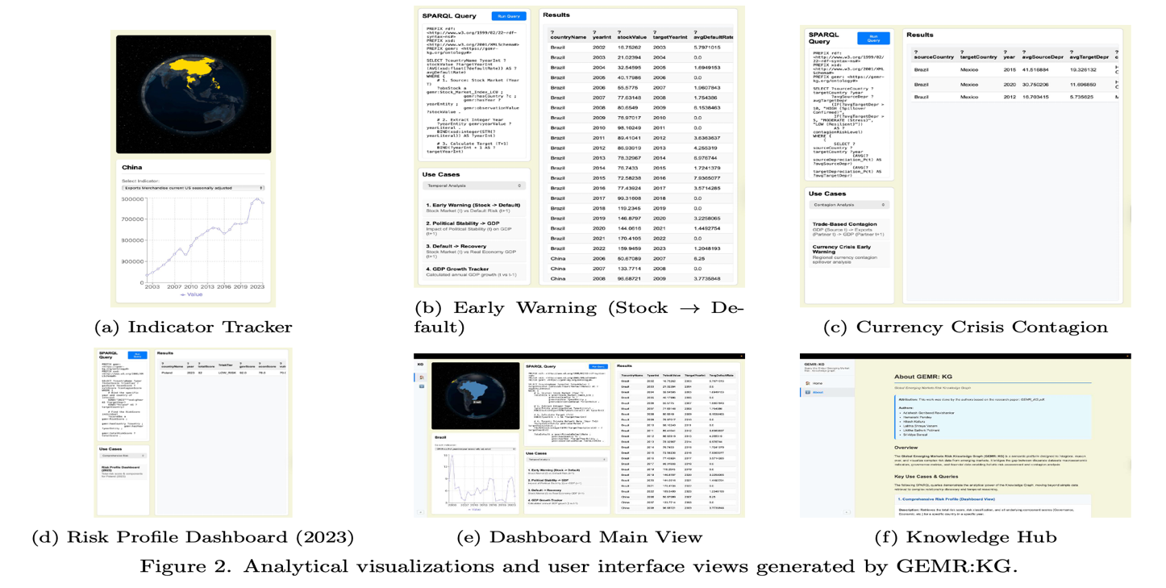
Figure 2. Analytical visualizations and user interface views generated by GEMR:KG

Comprehensive Data Retrieval  Fetch complete dataset (all indicators, years, values) for a specific country. Mirrors the IMF “Signal Approach” for aggregating risk factors (International Monetary Fund, 2017).  PREFIX gemr: <https :// gemr - kg. org/ ontology # > SELECT DISTINCT ? indicator ? year ? value WHERE {  ? obs a gemr: Observation ; gemr: hasCountry ? c ; gemr: hasIndicator ? indicator ;  gemr: hasYear ? yEnt ; gemr: observation Value ? val .  ? c gemr: countryName " Brazil" . ? yEnt gemr: yearValue ? year .  } ORDER BY ? indicator ? year | Comprehensive Risk Profiling  Retrieves total risk score, classification, and component scores. Provides a holistic snapshot of stability vs specific areas of concern.  PREFIX gemr: <https :// gemr - kg. org/ ontology # >  SELECT ? cName ? year ? total ? tier ? gov ? econ ? vuln WHERE { BIND (" 2023 " ^^ xsd : gYear AS ? tYear) BIND (" Poland " AS ?  tCtry)  ? sObs a gemr: RiskScore ; gemr: hasCountry ? c ; gemr: hasYear ? yEnt ; gemr: totalRiskScore ? total .  ? c gemr: countryName ? cName . ? yEnt gemr: yearValue ? year  .  FILTER (? year = ? tYear && STR (? cName ) = ? tCtry) OPTIONAL { ? sObs gemr: riskTier ? tier }  OPTIONAL { ? sObs gemr: governance Score ? gov } OPTIONAL { ? sObs gemr: economicHealth Score ? econ }  OPTIONAL { ? sObs gemr: external Vulnerability Score ? vuln  }  }
Early Warning: Stock vs Default  Analyzes Stock Market (Year T ) vs Private Default Rates (T + 1). Tests hypothesis that market sentiment precedes fundamental credit ratings (Wu, 2008).  SELECT?cName?yInt?stock(AVG(?defRate)AS?avgDef)WHERE{  ?obsSagemr:Stock_Market_Index_LCU;gemr:hasCountry?c  ;  gemr:hasYear?yE;gemr:observationValue?stock.  ?yEgemr:yearValue?yLit.BIND(xsd:integer(STR(?yLit))AS? yInt)  BIND(?yInt+1AS?tYInt)  ? tYEgemr:yearValue?tYLit.FILTER(xsd:integer(STR(?tYLit))=?tYInt)  ?obsDagemr:PrivateDefaultRate;gemr:hasCountry?c;gemr:hasYear?tYE;gemr:observationValue?defRate  .  ?cgemr:countryName?cName.  }GROUPBY?cName?yInt?stock?tYIntLIMIT50 | Political Stability Impact Tracker  Tracks negative Political Stability (T ) impact on GDP (T + 1). Validates the ‘Governance-Growth’ transmission channel (Aisen & Veiga, 2011).  SELECT?cName?yInt?gdp(AVG(?polStab)AS?avgPol)WHERE  {  ?obsPagemr:PoliticalStability;gemr:hasCountry?c; gemr:hasYear?yE;gemr:observationValue?polStab  .  FILTER(?polStab<0)  ?yEgemr:yearValue?yLit.BIND(xsd:integer(STR(?yLit)) AS?yInt)  BIND(?yInt+1AS?tYInt)  ?obsGagemr:GDP_CONST_2010_USD;gemr:hasCountry?c; gemr:hasYear?gYRaw;gemr:observationValue?gdp.  OPTIONAL{?gYRawgemr:yearValue?gYVal}BIND(COALESCE(xsd:integer(STR(?gYVal)),?gYRaw)AS?gYInt  )  FILTER(?gYInt=?tYInt)?cgemr:countryName?cName.  }GROUPBY?cName?yInt?tYInt?gdpLIMIT50
Default → Recovery Lag  Lag between stock market recovery and real economic (GDP) recovery after default. Asset prices often rebound earlier than real indicators (Kalesnik & Polychronopoulos,2020).  SELECT ? cName ? yT ? yTarget ? gdp ( AVG (? stk) AS ? avgStk) WHERE {  ? obsS a gemr: Stock_Market_Index_LCU ; gemr: hasCountry ? c  ;  gemr: hasYear ? yT_Raw ; gemr: observation Value ? stk  .  ? obsG a gemr: GDP_CONST_ 2010 _USD ; gemr: hasCountry ? c ; gemr: hasYear ? yTar_Raw ; gemr: observation Value ?  gdp .  OPTIONAL { ? yT_Raw gemr: yearValue ? yVT } OPTIONAL { ? yTar_Raw gemr: yearValue ? yVTar }  BIND ( COALESCE ( xsd : integer( STR (? yVT)), ? yT_Raw ) AS ? yT) BIND ( COALESCE ( xsd : integer( STR (? yVTar)), ? yTar_Raw ) AS ?  yTarget)  FILTER (? yTarget = ? yT + 1) ? c gemr: countryName ? cName .  } GROUP BY ? cName ? yT ? yTarget ? gdp | GDP Growth Tracker  Calculates annual GDP growth percentage. Provides a stan- dardized metric for comparing economic performance across economies.  SELECT ? cName ? year ? gdp Curr ? growth Pct WHERE {  ? obsG_T a gemr: GDP_CONST_ 2010 _USD ; gemr: hasCountry ? c ; gemr: hasYear ? yT_R ; gemr: observation Value ?  gdp Curr .  ? obsG_P a gemr: GDP_CONST_ 2010 _USD ; gemr: hasCountry ? c ; gemr: hasYear ? yP_R ; gemr: observation Value ?  gdp Prev .  OPTIONAL { ? yT_R gemr: yearValue ? yVT } OPTIONAL { ? yP_R gemr: yearValue ? yVP }  BIND ( COALESCE ( xsd : integer( STR (? yVT)), ? yT_R ) AS ? year) BIND ( COALESCE ( xsd : integer( STR (? yVP )), ? yP_R ) AS ? yPrev) FILTER (? yPrev = ? year - 1)  BIND (((? gdp Curr - ? gdp Prev)/? gdp Prev)*100 AS ? growth Pct)  ? c gemr: countryName ? cName .  } LIMIT 100
Figure 3. SPARQL Queries

Trade-Based Contagion  Traces economic shocks from Source to Dependent Partner via trade. Identifies spillover risks from major trading partners (Van Rijckeghem & Weder, 2003).  SELECT?src?ptnr?yT(AVG(?sGro)AS?aSGr)(AVG(?pExGr)AS? aPEx)  WHERE{  {?ptnrgemr:similarTo?source.}UNION  {?ptnrgemr:belongsToCluster?cl.?sourcegemr:belongsToCluster?cl.  FILTER(?source!=?ptnr)}UNION  {?sourcegemr:countryName?sN.?ptnrgemr:countryName  ?pN.  FILTER((STR(?sN)="Brazil"&&STR(?pN)="Mexico"))}  ?sourcegemr:countryName?src.?ptnrgemr:countryName?ptnr.  }GROUPBY?src?ptnr?yTLIMIT50 | Currency Crisis Early Warning  Detects regional currency contagion based on “Neighborhood Effects” in emerging markets (Basu, 2001).  SELECT?src?tgt?yr?sDep?tDep?riskWHERE{  {SELECT?src?tgt?yr(AVG(?sD_P)AS?sDep)(AVG(?tD_P)AS?tDep)  WHERE{  ?obsSagemr:Exchange_rate_new_LCU_per_USD;gemr:hasCountry?s;gemr:observationValue?sV .  VALUES(?sN?tN){("Brazil""Mexico")("Thailand""Philippines")}  ?sgemr:countryName?sN.?tgemr:countryName?tN.  ?sgemr:countryName?src.?tgemr:countryName?tgt  .  }GROUPBY?src?tgt?yr}  BIND(IF(?tDep>10,"HIGH",IF(?tDep>5,"MOD","LOW"))  AS?risk)  }
Figure 4. SPARQL Queries Contd
ACKNOWLEDGEMENTS
The authors thank the World Bank for the datasets and Google’s Gemini LLM for language editing assistance; all analyses and final text were reviewed, approved, and remain the sole responsibility of the authors.

REFERENCES
Aisen, A., & Veiga, F. J. (2011). How does political instability affect economic growth? IMF Working Paper WP/11/12. International Monetary Fund.
Basu, T. G. (2001). What drives contagion: Trade, neighborhood, or financial links? IMF Working Paper WP/01/29. International Monetary Fund.
EDM Council. (2024). Financial industry business ontology (fibo). [Online]. Available at: https://spec.edmcouncil.org/fibo/ontology
Galizia, F. and Lund, S. (2024). Reassessing risk in emerging market lending: Insights from GEMs consortium statistics. IFC research note. International Finance Corporation.
Glick, R., & Rose, A. K. (1999). Contagion and trade: Why are currency crises regional? Journal of International Money and Finance, 18(4), 603-617.
International Monetary Fund. (2017). Assessing country risk: Selected approaches. Technical note. Washington, DC, IMF.
Kalesnik, V., & Polychronopoulos, A. (2020). Value in recessions and recoveries. Technical report. Research Affiliates.
Li, X., & Sanna Passino, M. (2024). FinDKG: Dynamic knowledge graphs with large language models for detecting global trends in financial markets. arXiv preprint arXiv:2407.10909
Mitra, R., Dongre, A., Dangare, P., Goswami, A., & Tiwari, M. K. (2024). Knowledge graph driven credit risk assessment for micro, small and medium-sized enterprises. International Journal of Production Research, 62(12), 4273-4289.
The World Bank (2024). Worldwide governance indicators. Available at: https://www.worldbank. org/en/publication/worldwide-governance-indicators
Tilly, S., & Livan, G. (2021). Macroeconomic forecasting with statistically validated knowledge graphs. Expert Systems with Applications, 186, 115765.
Van Rijckeghem, C., & Weder, B. (2003). Spillovers through banking centers: A panel data analysis of bank flows. Journal of International Money and Finance, 22(4), 483-509.
World Bank (2024). Global economic monitor data catalog. Available at: https://datacatalog.worldbank.org/search/dataset/0037798/GlobalEconomicMonitor
World Bank Group (2025). Global emerging markets risk database (gems) consortium. Available at: https://www.worldbank.org/en/about/unit/brief/gems
Wu, T. (2008). The dynamic pricing of sovereign risk in emerging markets: Fundamentals and sentiment. Journal of International Money and Finance, 27(7), 1171-1188.
Yang, B., & Liao, Y. M. (2022). Research on enterprise risk knowledge graph based on multi-source data fusion. Neural Computing and Applications, 34(4), 2569-2582.
Yang, S., Zhang, Z., Zhou, J., Wang, Y., Sun, W., Zhong, X., Fang, Y., Yu, Q., & Qi, Y. (2021). Financial risk analysis for SMEs with graph-based supply chain mining. Proceedings of the 29th Intl. Joint Conference on AI (IJCAI), 4661-4667.

