Instagram Post Engagement — Mini AI/Data Project
Final Assignment Report
Agrima Sharma — July 2026

Problem Definition
This project analyzes engagement on my own Instagram account to answer a practical question: which post factors — media type, posting time, caption length, reach, saves, and views — most strongly predict whether a post gets High or Low engagement (likes), and can this be predicted reliably from the data?
This matters because understanding what actually drives engagement lets a content creator make evidence-based decisions about what to post and when, instead of guessing. Engagement also directly affects how many new people see future content, since Instagram's algorithm favors posts that already perform well early on.

Description of the Dataset
Source: personal Instagram account data export, pulled via the Meta Graph API.
Size: 140 rows (posts), 10 columns, spanning January 2024 to July 2026.
Column | Represents | Variable Type
id | Unique post identifier | Numeric (ID)
timestamp | Date/time the post was published | Date/time
media_type | VIDEO, IMAGE, or CAROUSEL_ALBUM | Categorical
caption | Text caption of the post | Text
like_count | Number of likes | Numeric (continuous)
comments_count | Number of comments | Numeric (continuous)
reach | Number of unique accounts reached | Numeric (continuous)
saved | Number of times the post was saved | Numeric (continuous)
views | Number of views (Reels/video content only) | Numeric (continuous)
permalink | URL to the post | Text / identifier
Target variable: engagement_label, engineered from like_count — 1 = High engagement (above the dataset median), 0 = Low engagement (at or below median). This turns the problem into binary classification.

Data Quality Issues

Missing Values
Identified: caption (8 missing), reach (4), saved (4), views (31).
Handled: caption filled with a placeholder; reach and saved imputed with the median (robust to outlier posts); views filled with 0.
Important finding: 100% of the missing views values belong to IMAGE or CAROUSEL_ALBUM posts. Instagram does not report a views metric for photo/carousel content at all — this is a platform limitation, not a data error, and it shapes how views can be compared across formats later in the analysis.

Duplicates
Identified: 0 full duplicate rows, 0 duplicate post IDs. Handled: drop_duplicates() applied as a safeguard, though none were actually present.

Inconsistent Categories
Identified: media_type contains exactly 3 clean values (VIDEO, IMAGE, CAROUSEL_ALBUM) — no typos or casing issues. Handled: string standardization (.str.strip().str.upper()) applied defensively.

Outliers
Identified: a small number of posts fall outside the normal IQR range for likes — the account's viral/breakout posts. Handled: kept rather than removed, since high performance is exactly the phenomenon this project studies, not noise.

Wrong Formats
Identified: timestamp was stored as plain text, not a real date, blocking any date-based analysis. Handled: converted with pd.to_datetime(), then used to derive hour, is_weekend, and month features.

Data Analysis

Mean, Median, Min, and Max
Metric | Mean | Median | Min | Max
Likes | 165.4 | 132.0 | 5 | 968
Comments | 21.4 | 7.5 | 0 | 1,508
Reach | 4,777.8 | 3,040.0 | 176 | 38,504
Saved | 14.6 | 8.0 | 0 | 141
Views | 5,318.3 | 2,857.0 | 0 | 70,609

Category Counts
VIDEO = 109 posts (77.9%), IMAGE = 21 posts (15.0%), CAROUSEL_ALBUM = 10 posts (7.1%). The account's content is heavily video/Reels-dominated.

Distributions
Every engagement metric is right-skewed — the mean is noticeably higher than the median in each case, meaning a small number of high-performing posts pull the average up while most posts perform closer to the median.

Relevant Summary Statistics
Correlation with likes: reach (0.91), views (0.75), and saved (0.74) are strongly correlated. Comments (0.13) are only weakly correlated, distorted by one outlier post with 1,508 comments.
A chi-square test of independence between media_type and engagement_label returned χ² ≈ 5.90, p ≈ 0.052 — right at the edge of conventional significance, suggesting media type alone has only a weak-to-borderline relationship with engagement.
An independent t-test comparing views between High and Low engagement posts found a highly significant difference (t ≈ 4.62, p < 0.001): High-engagement posts average ~8,362 views vs. ~2,275 for Low-engagement posts — views is a genuinely strong, statistically-backed signal.

Visualization 1 — Distribution of Likes
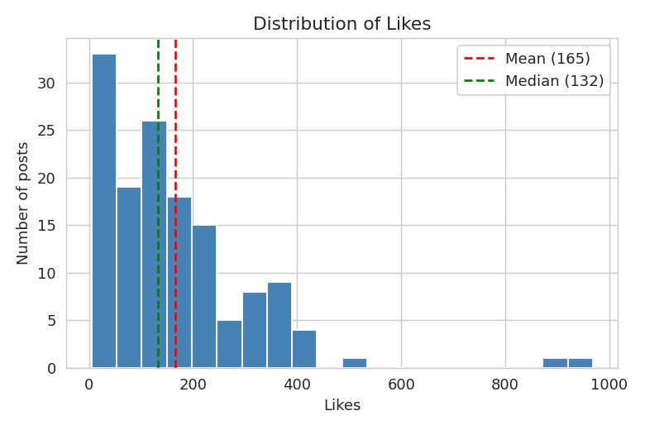
Figure 1. The gap between mean (165.4) and median (132.0) confirms a right-skewed distribution.

Visualization 2 — Average Views by Media Type
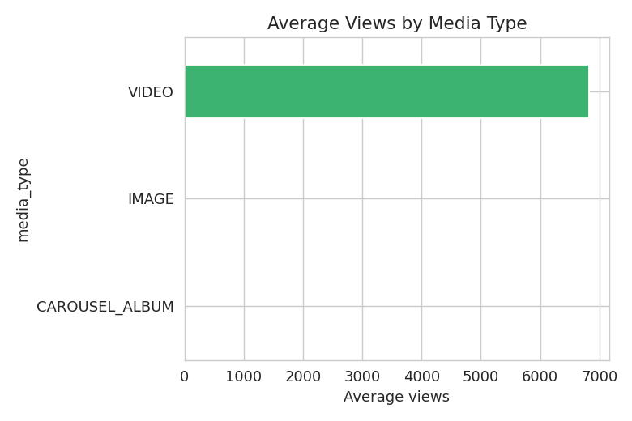
Figure 2. VIDEO (Reels) averages ~6,831 views/post; IMAGE and CAROUSEL_ALBUM show 0 because Instagram does not track views for those formats at all.

Visualization 3 — Average Reel Views by Month
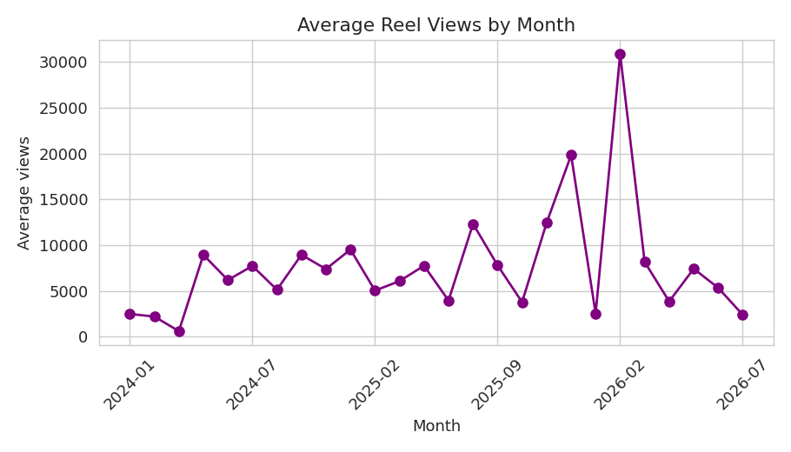
Figure 3. Monthly average Reel views range from ~600 to ~30,900 — a handful of breakout months drive most of the account's reach, rather than steady growth.

Visualization 4 — Correlation Heatmap
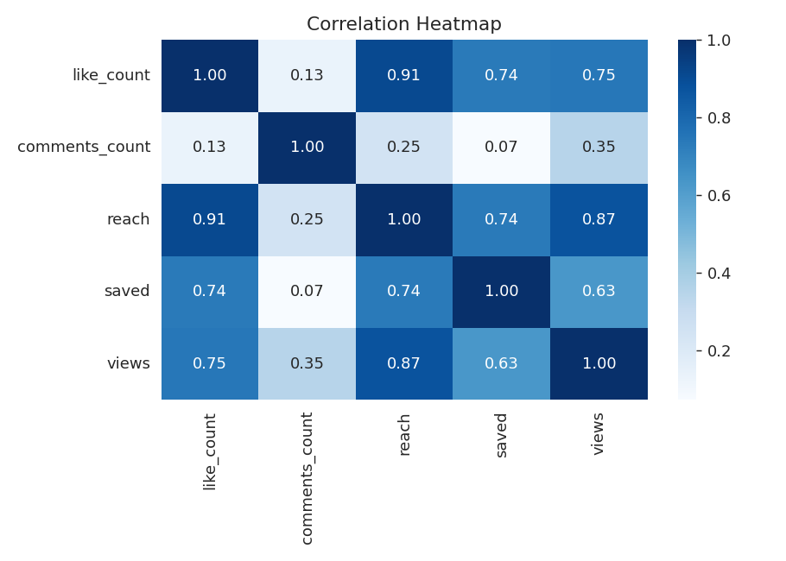
Figure 4. Reach and views correlate most strongly with likes; comments correlate the weakest, pulled down by an outlier post.

Simple Model — Classification
What is being predicted: whether a post is "High" or "Low" engagement — a binary category built from like_count split at the median. This is a Classification problem.
Features used: comments_count, saved, views, caption_length, hour, is_weekend, and media_type (one-hot encoded).

How the Data Was Split
80% training (112 posts), 20% testing (28 posts), stratified so both High and Low classes are represented proportionally (the classes are exactly balanced, 70/70), using a fixed random seed for reproducibility.

Models Tried and Evaluation Metrics
Six classifiers were trained and evaluated on the same split: Random Forest, KNN, Logistic Regression, XGBoost, AdaBoost, and SVC.
Model | Accuracy | Precision | Recall
Random Forest | 85.7% | 91.7% | 78.6%
KNN (k=5) | 85.7% | 91.7% | 78.6%
Logistic Regression | 85.7% | 91.7% | 78.6%
XGBoost | 85.7% | 85.7% | 85.7%
AdaBoost | 82.1% | 84.6% | 78.6%
SVC (RBF) | 50.0% | 50.0% | 100.0%

Explanation of Results
Random Forest, KNN, and Logistic Regression tied at 85.7% accuracy with an identical confusion matrix (13 correct Low, 11 correct High, 1 false alarm, 3 missed). XGBoost matched that accuracy with a more balanced result (12/12 correct, 2 misses each way) — meaning it catches one more genuine High-engagement post at the cost of one extra false alarm. AdaBoost trailed slightly (82.1%). SVC collapsed entirely (50% accuracy), predicting every single test post as "High engagement" — a clear sign that its RBF kernel needs feature scaling to be usable, since unscaled views (spanning 0-70,000+) completely dominates its distance calculation.
XGBoost is the recommended model: it reaches the same top accuracy as the tied group, but its balanced precision and recall (85.7%/85.7%) means it misses fewer genuine High-engagement posts — a more costly type of mistake for content strategy than one extra false alarm.

Insights Supported by Charts
- Likes are right-skewed (Figure 1) — the median (132) is a more realistic "typical" outcome than the mean (165.4), since a few high-performing posts pull the average up.
- Views exist only for Reels (Figure 2) — IMAGE and CAROUSEL_ALBUM posts get no views metric at all on Instagram, so views comparisons across formats are really "Reels vs. nothing."
- Reel view performance is spiky, not steadily growing (Figure 3) — a handful of standout months drive most of the account's reach; identifying what made those posts spike is the highest-leverage next analysis.
- Reach and views are the strongest engagement drivers (Figure 4) — comments are comparatively unreliable, distorted by a single outlier post.
- Views is a statistically significant predictor of engagement (t-test, p < 0.001), while media type (p ≈ 0.052) and caption length are not — engagement is driven more by how far a post actually reaches than by its format or wording.
- A simple model reliably separates High from Low engagement posts — the best models correctly classify 24 of 28 held-out posts (85.7% accuracy), well above the 50% baseline of guessing.

Final Conclusion

The Problem
Predict whether an Instagram post will be High or Low engagement, to guide content strategy with evidence instead of guesswork.

Key Findings
Reach, views, and saves are the strongest engagement signals; media type and caption length are, at best, weak predictors on their own; comment count is distorted by outliers and is not trustworthy in isolation; Reel view performance is driven by a small number of breakout months rather than steady growth.

Model Performance
Six classifiers were compared on the same split. Random Forest, KNN, and Logistic Regression tied for accuracy at 85.7%; XGBoost matched that accuracy with better-balanced precision and recall and is the recommended model; AdaBoost trailed slightly; SVC failed entirely without feature scaling.

What I Learned
Framing engagement as a High/Low classification problem works well even on a small, self-collected dataset. Comparing multiple model families surfaced a real, practical lesson: distance- and margin-based models (KNN, SVC) are far more sensitive to feature scale and dataset size than tree-based ensembles, and SVC's complete collapse here is the clearest demonstration of that in the whole project.

Limitations
- 140 posts is a modest dataset for machine learning; results may shift meaningfully as more posts are collected.
- The High/Low threshold is based on this dataset's own median and will move as the account grows.
- Caption content itself (beyond its length) was not analyzed.
- Views cannot be compared across media types because Instagram only tracks the metric for Reels.

