Automatic report for a Randomized Complete Block Design (RCBD)

International Potato Center

June 21, 2018

Table of Contents

# 1. Model specification and data description

There are data from 9 genotypes evaluated using a randomize complete block design with 2 blocks. The statistical model is

$$y_{ij}=μ+τ_{i}+β_{j}+ϵ_{ij}$$

where

* $y_{ij}$ is the observed response with genotype $i$ and block $j$.
* $μ$ is the mean response over all genotypes and blocks.
* $τ_{i}$ is the effect for genotype $i$.
* $β_{j}$ is the effect for block $j$.
* $ϵ_{ij}$ is the error term.

In this model we assume that the errors are independent and have a normal distribution with common variance, that is, $ϵ_{ij}∼N(0,σ_{ϵ}^{2})$.

# 2. Analysis for trait VW

## 2.1. ANOVA

You have fitted a linear model for a RCBD. The ANOVA table for your model is:

## Analysis of Variance Table  
##   
## Response: "VW"  
## Df Sum Sq Mean Sq F value Pr(>F)   
## INSTN 8 28.7778 3.5972 3.2785 0.05651 .  
## REP 1 0.2222 0.2222 0.2025 0.66463   
## Residuals 8 8.7778 1.0972   
## ---  
## Signif. codes: 0 '***' 0.001 '**' 0.01 '*' 0.05 '.' 0.1 ' ' 1

The coefficient of variation for this experiment is 5.855%. The p-value for genotypes is 0.05651 which is not significant at the 5% level.

## 2.2. Assumptions

Don’t forget the assumptions of the model. It is supposed that the errors are independent with a normal distribution and with the same variance for all the genotypes. The following plots must help you evaluate this:

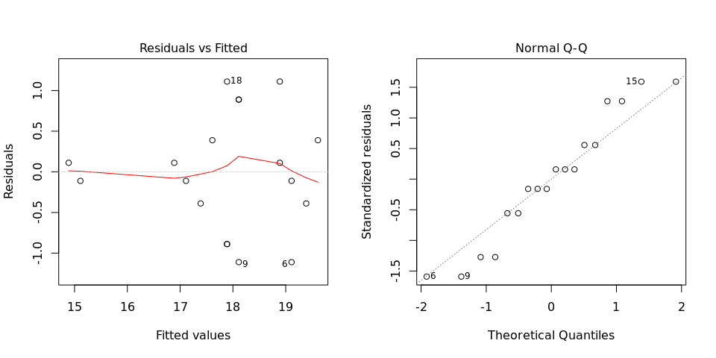

Any trend in the residuals in the left plot would violate the assumption of independence while a trend in the variability of the residuals –for instance a funnel shape– suggests heterogeneity of variances. Departures from the theoretical normal line on the right plot are symptoms of lack of normality.

## 2.3. Genotype means

Because the effect of genotypes was not significant in the ANOVA, multiple comparison tests are not presented. The means of your genotypes are:

## Beauregard Blesbok Brondal Cemsa Huambachero INA-100   
## 15.0 17.0 17.5 18.0 19.5 19.0   
## Jewel Jonathan Kemb-27   
## 18.0 19.0 18.0

It is always good to have some visualization of the data. Because the number of genotypes in your experiment is not so big, we can plot the data for each genotype:

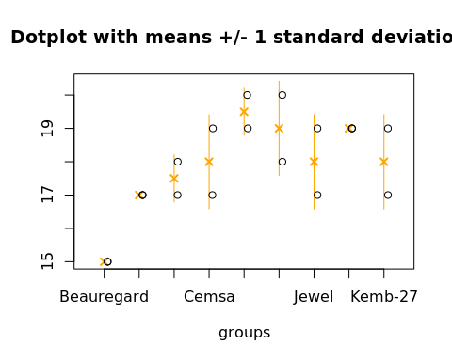

## 2.4. Variance components

Below are the variance components for this model, under the assumption that genotypes and blocks are random. Here the model is fitted using REML and missing values are not estimated.

## Variance Std.Dev.  
## INSTN 1.298611 1.139566  
## REP 0.000000 0.000000  
## Residual 1.000000 1.000000