Automatic report for a 2-factor factorial

International Potato Center

June 26, 2018

Table of Contents

# 1. Model specification and data description

The data frame has two factors with 2 and 46 levels. The experimental design is a randomized complete block design with 3 blocks. The statistical model is

$$y_{ijk}=μ+α_{i}+β_{j}+(αβ)_{ij}+γ_{k}+ϵ_{ijk}$$

where

* $y_{ijk}$ is the observed response with level $i$ of factor A, level $j$ of factor B, and block $k$.
* $μ$ is the mean response over all levels of factor A, factor B, and blocks.
* $α_{i}$ is the effect for level $i$ of factor A.
* $β_{j}$ is the effect for level $j$ of factor B.
* $(αβ)_{ij}$ is the interaction effect between level $i$ of factor A and level $j$ of factor B.
* $γ_{k}$ is the effect of block $k$.
* $ϵ_{ijk}$ is the error term.

In this model we assume that the errors are independent and have a normal distribution with common variance, that is, $ϵ_{ijk}∼N(0,σ_{ϵ}^{2})$.

# 2. Analysis for trait Marketable tuber weight per plant-kg/plant-CO_330:0000311

There are no missing values for this trait; the design is balanced.

## 2.1. Descriptive statistics

### 2.1.1. Means by factor A levels

## 1 2   
## 14.17645 10.21109

### 2.1.2. Means by factor B levels

## CIP392797.22 CIP700234 CIP700313 CIP700787 CIP701165   
## 8.960000 12.708333 8.841667 10.890000 10.603333   
## CIP701273 CIP701515 CIP701675 CIP701997 CIP702363   
## 15.150000 13.868333 11.836667 13.518333 14.988333   
## CIP702395 CIP702453 CIP702464 CIP702736 CIP702815   
## 11.436667 14.968333 18.123333 10.628333 12.496667   
## CIP703168 CIP703197 CIP703264 CIP703265 CIP703268   
## 11.473333 12.461667 9.906667 11.215000 14.070000   
## CIP703274 CIP703287 CIP703291 CIP703312 CIP703317   
## 13.620000 9.776667 18.670000 8.630000 10.001667   
## CIP703352 CIP703421 CIP703488 CIP703741 CIP703768   
## 12.778333 11.370000 10.986667 12.743333 10.823333   
## CIP703825 CIP703831 CIP703844 CIP703899 CIP703985   
## 13.893333 10.005000 9.183333 9.940000 10.743333   
## CIP704022 CIP704058 CIP704143 CIP704327 CIP704393   
## 6.671667 17.480000 14.355000 13.751667 27.318333   
## CIP704481 CIP705009 CIP705280 CIP705543 CIP706191   
## 9.258333 14.085000 9.691667 7.948333 7.690000   
## CIP707135   
## 11.353333

### 2.1.3. Means by factor A and factor B levels

## CIP392797.22 CIP700234 CIP700313 CIP700787 CIP701165 CIP701273 CIP701515  
## 1 9.693333 15.05667 9.910000 10.95667 17.07667 13.92 12.11333  
## 2 8.226667 10.36000 7.773333 10.82333 4.13000 16.38 15.62333  
## CIP701675 CIP701997 CIP702363 CIP702395 CIP702453 CIP702464 CIP702736  
## 1 12.41000 14.06667 13.76667 11.79333 16.43000 20.45667 14.480000  
## 2 11.26333 12.97000 16.21000 11.08000 13.50667 15.79000 6.776667  
## CIP702815 CIP703168 CIP703197 CIP703264 CIP703265 CIP703268 CIP703274  
## 1 13.08333 18.60667 12.26000 8.963333 11.84333 13.37333 16.32  
## 2 11.91000 4.34000 12.66333 10.850000 10.58667 14.76667 10.92  
## CIP703287 CIP703291 CIP703312 CIP703317 CIP703352 CIP703421 CIP703488  
## 1 10.540000 24.41333 10.546667 10.31333 15.39333 13.583333 10.50333  
## 2 9.013333 12.92667 6.713333 9.69000 10.16333 9.156667 11.47000  
## CIP703741 CIP703768 CIP703825 CIP703831 CIP703844 CIP703899 CIP703985  
## 1 16.140000 18.370000 18.340000 15.94 13.90667 11.206667 13.423333  
## 2 9.346667 3.276667 9.446667 4.07 4.46000 8.673333 8.063333  
## CIP704022 CIP704058 CIP704143 CIP704327 CIP704393 CIP704481 CIP705009  
## 1 10.01333 16.34333 15.73333 15.97000 33.58000 14.703333 14.37667  
## 2 3.33000 18.61667 12.97667 11.53333 21.05667 3.813333 13.79333  
## CIP705280 CIP705543 CIP706191 CIP707135  
## 1 14.34333 9.236667 7.643333 10.97333  
## 2 5.04000 6.660000 7.736667 11.73333

## 2.2. ANOVA

### 2.2.1. Checking assumptions

As it was stated in section 1, it is supposed that the error has a normal distribution with the same variance for all the combinations among the levels of both factors. The following plots help to evaluate this assumptions:

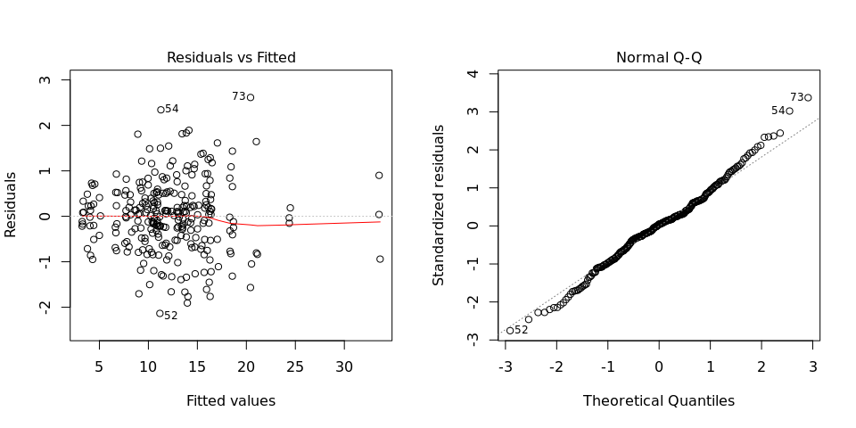

Funnel shapes for the first plot may suggest heterogeneity of variances while departures from the theoretical normal line are symptoms of lack of normality.

### 2.2.2. ANOVA table

## Analysis of Variance Table  
##   
## Response: "Marketable tuber weight per plant-kg/plant-CO_330:0000311"  
## Df Sum Sq  
## Land levellingTotal number of levelling passes 1 1085.0  
## VARIETIES 45 3308.2  
## BLOCK 2 0.7  
## Land levellingTotal number of levelling passes:VARIETIES 45 1640.5  
## Residuals 182 165.8  
## Mean Sq F value  
## Land levellingTotal number of levelling passes 1084.96 1190.767  
## VARIETIES 73.51 80.684  
## BLOCK 0.35 0.384  
## Land levellingTotal number of levelling passes:VARIETIES 36.46 40.011  
## Residuals 0.91   
## Pr(>F)   
## Land levellingTotal number of levelling passes <2e-16 ***  
## VARIETIES <2e-16 ***  
## BLOCK 0.6817   
## Land levellingTotal number of levelling passes:VARIETIES <2e-16 ***  
## Residuals   
## ---  
## Signif. codes: 0 '***' 0.001 '**' 0.01 '*' 0.05 '.' 0.1 ' ' 1